PSY3109 Social Motivation
WEEK ONE
- Heider-Simmel Illusion; people attributing motivation to even simple behaviour by only watching
Psychology of Motivation
- Study of purposive action
  - Purposive action = behavior
  - Focus of motivation & emotion research on processes within individual
- Dale Schunk, Ellen Usher: “Motivation refers to process whereby goal-directed activities are energized, directed, sustained.”
  - Initiation
  - Direction
  - Energy/Intensity
  - Persistence of Behavior
Behaviorism
- Behaviorist psychologists specifically ignored/downplayed concept of motivation within individual being studied
CRITIQUES:
    - External rewards MAY diminish intrinsic motivation
      - Pizza Hut free pizza for reading discontinued, for example
    - Behaviorism doesn’t account for anything non-observable
    - Only accounts for learning through direct experience with environment
    - Does not explain some learning (recognition of new language patterns by young children, for example) for which there is no reinforcement mechanism
    - Research states animals can adapt reinforced patterns to new info
Study of Motivation
- What starts a sequence of behaviour?
- How is behaviour sustained over time?
- Why is behaviour directed toward some ends and away from others?
- Why does behaviour change its direction?
- Why does behaviour stop?
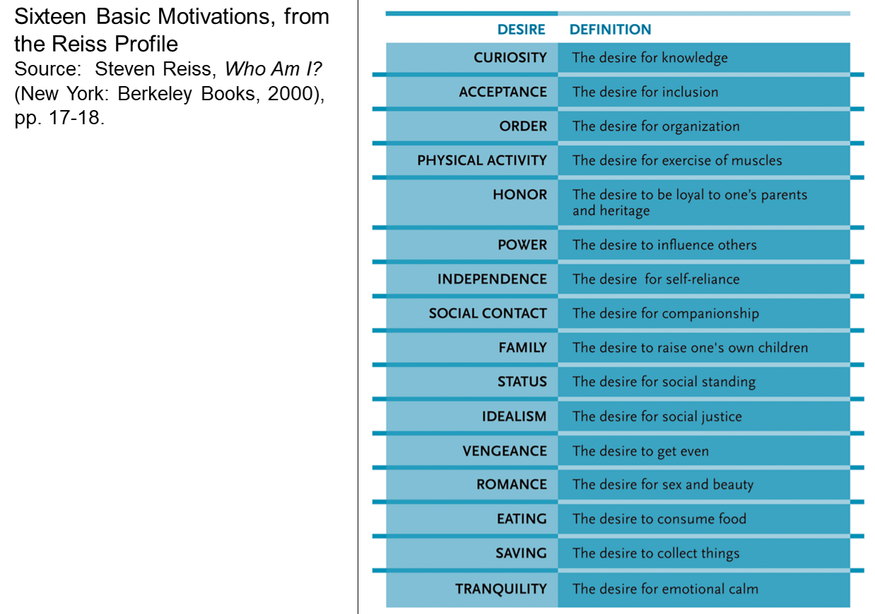
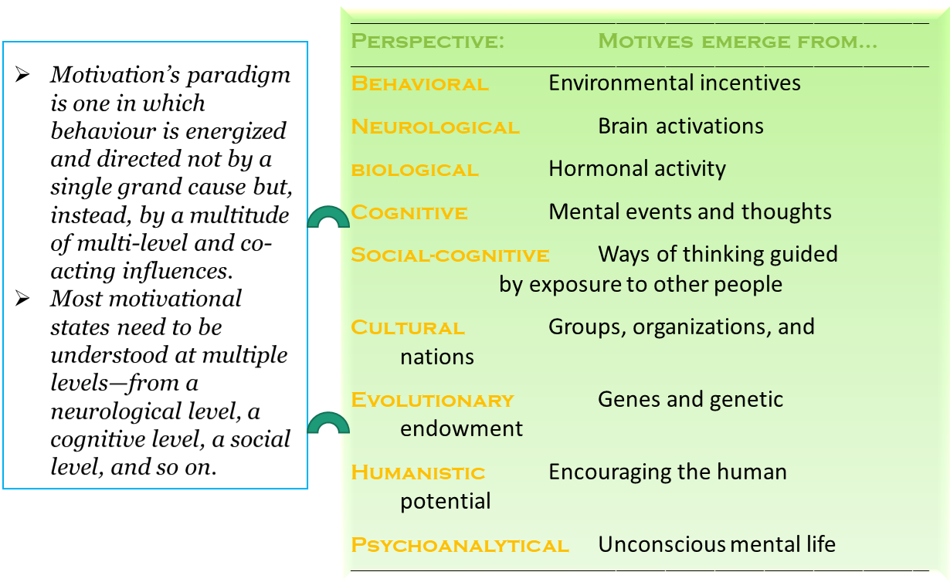
THEREFORE: we can use motivational theories to solve practical problems (E.D., addiction, etc.)
Aristotle
- Peri Psyches: heart is excited as soon as contemplating decisions, whether we want to reject or make plans with it
- Seven causes (predates Freud’s pleasure-pain principle) for every action
  - Chance
  - Nature (natural forces originating in the body, such as desire for hunger and thirst and sex)
  - Compulsions
  - Habit
  - Reasoning
  - Anger
  - Appetite
Descartes
- Passions of the Soul:
  - Wonder
  - Love
  - Hatred
  - Desire
  - Joy
  - Sadness
Hume
- Treatise of Human Nature:
  - reason alone doesn’t motivate action but requires cooperation of some separate factor to bring that action
  - needed a separate desire factor to motivate our purposive actions
  - not always motivated by passion, however – referred to as calm passions when we think carefully and plan our actions

