Prologue: THE STORY OF PSYCHOLOGY (only pp. 1-13)
Chapter 1: THINKING CRITICALLY WITH PSYCHOLOGICAL SCIENCE (pp. 19- 47)
Chapter 2: THE BIOLOGY OF MIND (pp. 51-87)

Chapter 3: CONSCIOUSNESS AND THE TWO-TRACK MIND (pp. 91-130)

Brain States and Consciousness:
Defining consciousness:
- Psychologists define consciousness as our awareness of ourselves and our environment allowing us to over time assemble information to reflect on past and plan for the future doing all this to focus and free some attention when learning complex concepts or behaviors
  - There are different states of consciousness we “flit” b/n
Some states occur spontaneously | Daydreaming | Drowsiness | Dreaming
Some states are physiologically induced | Hallucination | Orgasm | Food or oxygen starvation
Some are psychologically induced | Sensory deprivation | Hypnosis | Meditation

- Qualia: The ability to experience or feel also referred to as a state
- Consciousness helps to address “in the moment” situations but act in our long-term interest by promoting survival and anticipating how we are perceived by others.
- Consciousness is the subjective experience of the mind’s activity
- Even with such explanations of consciousness the “hard problem” still exists, how do private, subjective experiences come to be? or how does consciousness emerge from the brain? or how do brain cells jabbering to one another create our awareness of the taste of a taco, the idea of infinity, or the feeling of fright. Thus, the question of how consciousness arises from the material brain is the hard question.
  - Easy questions: What is the relationship b/n electromagnetic radiation, sound waves, and conscious experiences? (Psychophysics), OR What is the relationship b/n brain activity and cognitive activity? (Cognitive Neuroscience) Easy in the sense that it can be conducted and measured…

The Biology of Consciousness:
- Cognitive Neuroscience:
  - study of the brain activity (states) linking mental processes(cognition) to conscious experiences (perception, thinking, memory, and language)
- Dual Processing: The Two Track Mind
  - Our cognition works on two levels the High road (conscious Deliberate and reflective) and Low road (unconscious automatic, intuitive) – Called Dual Processing
    - The Low Road Process work is not consciously accessible; but result of process enters conscious awareness and can be utilized when needed
    - The High Road The process is consciously accessible, both the process work (as your making the effort think of it) and the end product of said process enters conscious awareness and can be utilized when needed.
  - Human brain thus, converts conscious knowledge into unconscious knowledge
    - New tasks involve conscious processing until they become unconscious
      - Ex. Reading, Driving
  - Cognitive neuroscience indicates a majority of our processing occurs unconsciously
  - Blind sight A process where the person can respond to visual stimuli without consciously experiencing it, such as slipping post card into mail slots
    - Thus, our vision is a dual-processing system
      - Where the visual perception track enables to think and plan future actions, where the visual action track guides our movements
  - For skilled athletes action precedes awareness, thus the actual decision to move occurs when the brain activity crosses a threshold, which happens to coincide with the average “time of awareness of intention to move”

Selective Attention:
- Unconscious parallel processing is faster than sequential conscious processing, although both are vital
- Parallel Processing:
  - Enables the processing of multiple aspects of a problem simultaneously (a natural process for many functions)
    - Sequential conscious processing is much better for new problems unlearned, requiring focused attention.
- Selective Attention:
  - A type of conscious processing focusing on a particular stimulus
    - Example of this is the cocktail party effect many people talking but you can zone in on the person of interest
  - Multitasking Dividing attention b/n 2 tasks Ex. Distracted Driving
- Selective Inattention:
  - Result of selective attention, where one is blind to all but a sliver of visual stimuli in the conscious awareness.
    - Ex. Gorilla in Basketball example
  - This is referred to as Inattentional blindness failing to see visible objects when our attention is directed elsewhere
    - Other forms include Inattentional deafness
    - A subcategory of inattentional blindness is called “Change Blindness”
      - Defined as the failure to notice changes in the environment
        - Ex. When giving directions to a construction worker, during a staged interruption the worker is replaced with another worker and people fail to notice the change
        - Other forms of this can be Change deafness

Sleep and Dreams
Biological Rhythms and Sleep:
- Our body had two biological rhythms, [1] the 24-hour biological clock circadian rhythm and [2] our 90-minute sleep cycle, REM sleep.
- Circadian Rhythm:
  - A rhythm that coincides with the that of the day, Morning Body temp rises and beginning to fall as night approaches, thus, thinking is sharpest and memory most accurate when we are at our daily peak in circadian arousal
    - Age and experiences can alter said circadian rhythm
- Sleep Stages:
  - Sleep over takes us consciousness fades as a different brain rhythm begins to take over, the 90 minutes 4-part cycle called REM sleep.
    - “Rapid eye movement” sleep is a recurring sleep stage during which vivid dreams commonly occur
    - Also referred to ask paradoxical sleep b/c muscles are relaxed (except for minor twitches)
    - Found due to study of the Electroencephalogram (EEG)
      - A device that measures brain waves the coordinated firing of large collections of neurons across the brain
      - The graph will show various frequencies (waves) of the sleep cycle with the slow brain waves of a relaxed, awake state coming first
        - Our Brain in its awake mental activity state depicts beta waves
        - The first of the cycle being the non-REM stage 1 sleep (NREM-1), which is of theta brain waves, you may experience hallucinations such as hypnagogic sensations that later may be incorporated into memories lasting 5-10 minutes
        - NREM-2 has more irregular waves called sleep spindles (burst of activity) this stage lasts about 20 minutes
        - NREM-3 (Delta wavesindicator of larger slow brain waves associated with deep sleep), spend 30 mins in this stage and is also towards the end of this stage that most children wet the bed along with children spending more time in this stage
        - After this cycle, one will return through the NREM-2 stage (spending half of your night in said stage) to the REM stage.
        - REM (paradoxical sleep) stage lasts for about 10 minutes, a stage where brain waves speed up, along with heart rate and breathing, along with sleep paralysis and genital arousal, every 30 secs the eyes will dart around
          - Darting is a sign of dreaming about to begin
        - The brain’s motor cortex is active during REM sleep, but the brainstem blocks the message leaving muscles relaxed, so much so that one is in a sort of sleep paralysis with the occasional twitches
    - These cycles last about 90 minutes for younger adults (more frequently for adults + older)
    - As the night progress the stage 3 becomes more brief (deep sleep becomes briefer till non-existent)
    - REM and stage 2 becomes more longer as the night progress and the total 20-25% of the night is spent in REM sleep (100 minutes ish)
  - What Affects Our Sleep Patterns?
    - Bright morning light tweaks the circadian rhythm clock by activating the light sensitive retinal proteins (photoreceptors) which trigger the brains suprachiasmatic nucleus (SCN – a pair of grain-of-rice-sized 10,000 cell clusters in the hypothalamus) to decrease the production of sleep-inducing hormone melatonin by the brain’s pineal gland in the morning and increase it in the evening (due to lack of light).

Why Do We Sleep?
- For five reasons
  - Sleep protects A species sleep pattern tends to suit is ecological niche (also from injury, and predators)
    - Ex. Animals with the greatest need to graze and lack of ability to hide sleep less
  - Sleep helps recuperate Restores immune system, repairs brain tissue (repairing neurons from free radical damage), sleep sweeps the brain for toxic metabolic waste products
  - Sleep helps restore and rebuild our fading memories of the day’s experience Sleep can take recent experiences stored in the hippocampus and transfers them to the long-term storage in the cortex, thus, less sleep = less memory consolidation
  - Sleep feeds creative thinking Dreams can inspire noteworthy artists and scientific achievements.
    - Thus, a good idea is to ponder a problem just before bed and then sleep on it
  - Sleep supports growth During DEEP sleep pituitary gland releases the growth hormone, needed for muscle growth. As we age, less and less of this hormone is produced, thus, spend less time sleeping

Sleep Deprivation and Sleep Disorders
- Effects of Sleep Loss:
  - Over a period of sleep loss, one acquires a sleep debt that cannot be satisfied by one long sleep,
  - Sleep loss is a predictor of depression
    - Due to REM’s stage of sleep processing the emotional experiences, helping to protect against depression
  - Sleep deprivation or an accumulation of a sleep debt leads to
    - Gain weight
    - It increases the hunger arousing hormone (ghrelin), and decreasing the hunger-suppressing hormone (leptin)
    - Decreases metabolic rate, a gauge of energy use
    - Increases cortisol, a stress hormone which stimulate fat production
    - Enhances limbic brain response to the sight of food and decreases cortical inhibition
    - Thus children/adults who sleep far less are fatter than average
    - suppression of immune cells leading to viral infections and cancer
      - Thus, those who sleep 7-8 hours live longer than those who don’t
  - When one is sleepy, the frontal lobe is not able to make a fast enough or sound enough decision, resulting in misfortune
  - A solution to said sleep deprivation especially for students it to add 15 minutes of extra sleep each day from their “average” bed time.
- Major Sleep Disorders:
  - Insomnia:
    - Recurring difficulty falling or staying asleep
      - The “quick fix” is often sleeping pills and alcohol this just reduces REM sleep, this often build up a tolerance in individuals leading to a need of a stager dosage for any effect to occur and thus over dosage can be fatal
      - Actual fix includes: manage stress, exercise regularly, relax before bedtime, hide clock face, sleep on a regular schedule, avoid caffeine after early afternoon
  - Narcolepsy:
    - A sleepy disorder where overwhelming sleep attacks take over an individual (occur periodically)
      - Lasting about 5 minutes
      - Can either be intense sleepiness or full on collapse into REM sleep
      - Can be a due to a genetic predisposition
      - Can also be due to a lack of hypothalamic cells that produce the neurotransmitter orexin (hypocretin) which stimulates wakefulness
  - Sleep Apnea:
    - A condition where one has temporary cessations of breathing during sleep and leading to repeated momentary awakenings
      - Hard to detect as it comes off as snoring to the viewer and can be fatal, leading to a fatigued and depressed individual leading to lacking deep sleep with no memory the morning of the multiple awakenings
    - This condition leads to obesity particularly among overweight men
    - Solution is to wear a breathing mask that keeps the individual’s airways open while they sleep (CPAP – Continuous positive airway pressure)
  - Night Terrors:
    - Targeted to children mainly, occur usually during the first few hours of NREM-3 stage, which leads children screaming in terror, increased heart rate, breathing rate, they may sit up, walk around and talk but will not remember this episode the next morning
  - Sleep Walking:
    - Also, mainly occurring or seen in children, much like narcolepsy (genetically predisposition), is usually harmless and occurs mainly during NREM-3 stage
      - These children may have their eyes open with a blank stare that shuffle more then walk with poor coordination and are often not aware of this the next morning.
  - Sleep Talking:
    - Much like sleep walking mainly seen in children, can occur in any sleep stage, and usually is just unintelligible mumbling

Dreams
- What We Dream:
  - Often a sequence of images, emotions, and thoughts passing through a sleeping person’s mind
    - Can be vivid, or a narrative(story), and is not remembered well the morning of
  - Our two-track mind continues to monito our environment while we sleep, sensory stimuli-a particular odor or a phone’s riving, can be woven into a dream
  - Remember anything done 5 minutes before one falls asleep, is often forgotten the morning of
    - Thus, the morning of get up and stay awake for a few minutes to remember the dream
- Why We Dream:
  - To satisfy our own wishes (Freud’s Wish-fulfilment) Sigmund Freud – Believed that our dreams comprised of two concepts the manifest content and the latent content
    - Where the manifest content would be the explicitly obvious story line, whereas the latent content is the unconscious drives and wishes that would be expressed implicitly (often sexual)
  - To file away memories (Information –Processing) Thus one needs REM stage of sleep to consolidate memories or any new learned concepts/material, memory consolidation may also occur during non-REM sleep
  - To develop and preserve neural pathways (Physiological function) Spending time in REM sleep preserves and expands the brain’s neural pathways, thus, dreams may serve as a physiological developmental function, providing the sleeping brain with periodic stimulation.
  - To make sense of neural static (Neural Activation) Other theories justify that dreaming may be the brains method of synthesizing random neural activity (or static) which when paired with the limbic system’s emotional tone one can produce much the same hallucinations a neurosurgeon can by stimulating parts of the cortex, all within the brain without the frontal lobe regions (hence, the illogical dreams). Follows the “activation-synthesis theory”.
  - To reflect cognitive development (Cognitive Development)Dreams are an indication of cognitive development and brain maturation. They are simulating reality by utilizing acquired knowledge and concepts, thus, they must also be using the same cognition features utilized when one is awake. Thus, from the cognitive perspective dreams are a result of top-down processing.
    - Dreams only occur when [1] a loss of conscious attention, [2] an absence of external stimuli, and [3] sufficient brain activation, such as REM sleep.
  - REM Rebound: the increased stage occurrence of REM sleep to increase in response to REM sleep deprivation

Drugs and Consciousness
Tolerance and Addiction
- Some individuals develop a substance use disorder
  - Such substances are psychoactive drugs, that chemicals change perceptions and moods
- When does drug use become a disorder:
  - Mild problem if 2-3 indicators are present, moderate problem if 4-5 indicators are present, severe if 6 or more indicators are present, indicators are established by the American Psychiatric Association.
- Tolerance: is the concept of where an individual’s brain chemistry adapts to offset the effects of drug use, thus, one needs to increase duration or concentration to achieve the same effects leading to addiction/fatal consequences
  - Can lead to effects of withdrawal if the addicted user tries to quit

Types of Psychoactive Drugs
- There are three major psychoactive drugs, depressants, stimulants and hallucinogens, that work at the brain’s synapses, stimulating, inhibiting or mimicking the neurotransmitters, or other chemical messengers.
- Depressants: Are drugs that calm neural activity and slow body functions
  - Ex. Alcohol, barbiturates(tranquilizers), opiates
- Stimulants: excite neural activity and speeds up body functions, dilate pupils/increase breathing and heart rates, increasing blood sugar levels, causing a drop-in appetite… Energy and self-confidence also rise
  - Ex. Caffeine, nicotine, the amphetamines, cocaine, methamphetamines, ecstasy
- Hallucinogens: Distort perceptions and evoke sensory images in the absences of sensory input or stimuli
  - Ex. LSD, MDMA, Marijuana, or lack of oxygen/extreme sensory deprivation

Influences on Drug Use
- Biological Influences
  - Some individuals may be more vulnerable to the effects of particular drugs due to genetics and or certain coupling effects of strains of brain chemicals, such as dopamine balance
- Psychological and Social-Cultural Influences
  - Among young adults and youth, the feeling that life is meaningless and directionless is common and this can lead to temporary dulling of pain by psychoactive drugs the wrong method to cope
  - Peer pressure?

Chapter 6: SENSATION AND PERCEPTION (pp. 229-274)

Chapter 7: LEARNING (only pp. 279-311)

Basic Learning Concepts and Classical Conditioning
How Do We Learn?
- Learning a process of acquiring new and relatively enduring information or behaviors (Through High Road)
  - We can learn to expect/prepare for events that lead to food or pain (classical conditioning) and we learn to repeat or avoid task that reward or punish us (operant conditioning) and we learn these things by watching others, through language, and we learn things we neither experienced nor observed (cognitive learning)
- How do we learn?
  - We learn by association, to connect certain events the occur together
    - Use this connection to predict certain outcomes
- Associative learning:
  - This process of learning associations is conditioning and take two forms
    - Classical Conditioning:
      - Learn to associate two stimuli, and thus, to anticipate events. The association is between two stimuli that we do not control and we respond automatically Respondent behavior
        - Ex. Flashing of light before the thunder & lightning come (you associate these)
    - Operant Conditioning:
      - Learn to associate a response (our behavior) and its consequence, thus, we repeat acts followed by good results and avoid those followed by bad results these association produce an Operant behavior
  - These two types of conditioning can occur together
  - Respondent Behavior: behavior that occurs as an automatic response to some stimulus
  - Operant Behavior: behavior that operates on the environment, producing consequences
- Cognitive Learning:
  - There is another form of learning where through acquiring mental information it guides our behavior
    - Observational Learning: A sub type of cognitive learning, where by one learns by observing events, watching others, or through language, instead of self-interaction with a stimulus.

Classical Conditioning (CC)
- Came about through Ivan Pavlov’s experiments and is considered to be biologically adaptive because it helps humans
  - John B. Watson’s idea lead to the formation of the Behaviorism view of psychology
    - Behaviorism:
      - The view that psychology should only be an [1] objective science that [2] studies behavior without any reference to introspection (mental processes) many people agree with [1] but not with [2]
- Pavlov’s Experiments (Classical Conditioning with disdain for “mentalistic” concepts)
  - Before Conditioning
    - Present the test subject with an unconditioned stimulus (US) such as food and it will produce the unconditioned response
      - Unconditioned stimulus (US) In CC, a stimulus that unconditionally-naturally and automatically evokes or triggers a response (UR)
      - Unconditioned response (UR) In CC, unlearned naturally occurring response (such as salivation) to an US such as food in mouth
    - Now present a neutral stimulus (such as a tone/sound) Notice no response like salivation
  - During Conditioning
    - Pair a Neutral Stimulus (NS) with the unconditioned stimulus (US) to evoke the unconditioned response (UR) and voila you have conditioned the subject to associate the two stimuli to an event
  - After Conditioning
    - The neutral stimulus now becomes the conditioned stimulus as it evokes the now conditioned response (salvation) when the original unconditioned stimulus (food) isn’t present.
  - Thus, Conditioned = learned and Unconditioned = unlearned
  - Pavlov then came up with five major conditioning processes (abbreviated to AESGD):
    - Acquisition: Is the initial stage, when one links a neutral stimulus and an unconditioned stimulus so that the NS begins to evoke the unconditioned response
      - Remember that the NS has to come before presenting the US so that the association can form before the UR is evoked.
      - Acquisition can lead to higher-order conditioning where a first order CS when paired with a different NS by way of association lead to it becoming a CS now called second-order conditioning which is weaker.
        - Ex. When a tone(CS) that trigger salvation when paired with a light (NS) begins to elicit the subject to predict the tone and then the salvation to food now becoming a second-order conditioning stimulus (2CS).
    - Extinction: A process where repetition of the CS (tone) occurred with no presentation of the US (food), this lead to a diminish in the CR (salvation), but when given a few hours before the next CS, once presented with the CS the CR repapered.
    - Spontaneous Recovery: When the CR repapered, this was called the spontaneous recovery, or reappearance of a (weakened) CR after the pause, thus Pavlov came to the conclusion that extinction was only suppressing the CR rather than eliminating it.
    - Generalization: Eliciting the CR to a stimulus that is very similar to the CS
      - Toddlers taught to fear moving cars, also become afraid of moving trucks
    - Discrimination: The ability to distinguish between a CS from other similar neutral stimuli
- Applications of Classical Conditioning:
  - Advertising
  - Phobia Therapy
  - Farm Animals
  - Drug Programs

Operant Conditioning
- Operant conditioning is when organisms associate their own actions with consequences
  - Action + reinforces = more of that action (strengthened)
  - Actions + punishments = less of the action (diminished)

Skinner’s Experiments
- Utilized Edward L. Thorndike’s Law of Effect: Rewarded behavior is likely to recur whereas punished behavior is less likely to recur, to develop behavioral technology to demonstrate behavior control
  - He became modern behaviorism’s most influential and controversial figures.
- Such technology included an operant chamber contains a bar or key that an animal can manipulate to obtain a food or water reinforcer; attached devices record the animal’s rate of bar pressing or key pecking.
- Reinforcement: where an event (receiving food) strengthens (increases the frequency of) a preceding response (pressing a button to deliver said food)
- Shaping Behavior:
  - To elicit a certain behavior from an animal Skinner utilized the concept of shaping which is to elicit the desired behavior by studying the original natural behavior, building on said behavior in intervals using reinforces such as food to guide it closer and closer to the desired behavior and only then giving it food when it had performed the desired behavior. (Successive Approximations)
    - Ex. Discriminative Stimulus: stimulus that signals that a response will be rewarded
- Types of Reinforces:
  - Positive Reinforcement
    - Increasing behaviors by presenting a positive reinforcer that strengthens the response, when presented after.
  - Negative Reinforcement
    - Increasing a behavior by reducing negative stimuli using a negative reinforcer any stimulus that when removed produces relief response, it strengthens the relief response as more of the behavior occurs) Not a punishment both lead to a desirable outcome from the original behavior
  - Thus, Reinforcement is any consequence as a result of a behavior that strengthens said behavior/action.
  - Primary and Conditioned Reinforcers (can be positive or negative):
    - Primary Reinforcer:
      - An unlearned innate stimulus (unconditioned) that satisfies a biological need
        - Ex. Getting food when you’re hungry or taking medication to relive pain
    - Conditioned Reinforcer (aka. Secondary Reinforcer):
      - Will utilize the power of a primary reinforcer by associating itself with it to increase or decrease a certain response/behavior
        - Ex. Rat with the primary reinforcer of food when hungry will associate the light that when turned on delivers food will associate the two to reinforce the behavior to satisfying its hunger the innate
  - Immediate and Delayed Reinforcers:
    - Immediate Reinforcers often are sometimes more alluring that delayed reinforcement
      - Examples include watching late night TV for the immediate pleasure than the delayed reinforcement of being alert and awake in the morning having gone to bed early.
  - Reinforcement Schedules:
    - A Pattern that defines how often a desired response will be reinforced
    - There are two types of reinforcement schedules Continuous and Partial (intermittent)
    - Continuous Reinforcement Schedule:
      - Reinforcing the desired response every time it occurs faster mastery of desired behavior down side it the expectation of the reinforcement will be strong thus, the extinction of the desired response will increase although there is still the spontaneous recovery of said response
      - Although this type of reinforcement is rare in the real world not always going to be presented with the reinforcement (see below).
    - Partial (Intermittent) Reinforcement Schedule:
      - In which the desired response is sometimes reinforces, and sometimes not.
      - This can lead to slower learning
      - Less of an extinction due to less of an expectation
      - Ex. Slot machine reward gamblers the same way unpredictably
      - Skinner then formed 4 schedules that are either rigidly fixed or unpredictably variable.
        - Fixed-Ratio Schedules
          - Reinforcing behavior after a set number of responses, such as 1 food reward for every 10 pecks (1:10), resulting in the pecking rate/responding rate to increase drastically to receive more food.
        - Variable-Ratio Schedules
          - Reinforce behavior after a variable number of responses, such as after 10 responses and then sometimes after 30 – unpredictable, resulting in a high response rate knowing that after receiving a reinforcement the next one is bound to come eventually, thus, it’ll come faster if response rate increases.
        - Fixed-Interval Schedules
          - Reinforcement of behavior is based on a fixed time interval after the first response, resulting in animals responding more frequently as the anticipated reward time draws near but drops after reward is given, producing a choppy stop-start pattern than a steady rate of response.
        - Variable-Interval Schedules
          - Reinforce the first response after a varying time interval unknown to the subject, resulting in a slow/steady responses rate, as there is no knowing when the wait time (for the reward to present itself) is over.
      - In general, for partial reinforcement schedules, response rate is higher for a ratio schedule where one is in control of the amount of responses whereas the interval schedule (or the time game) produces less of a response rate due to it being dependent on an uncontrollable factor of time.
      - Responding is also more consistent with a fixed schedule than with a variable schedule due to a sense of anticipation of the reward being near then not knowing anything at all
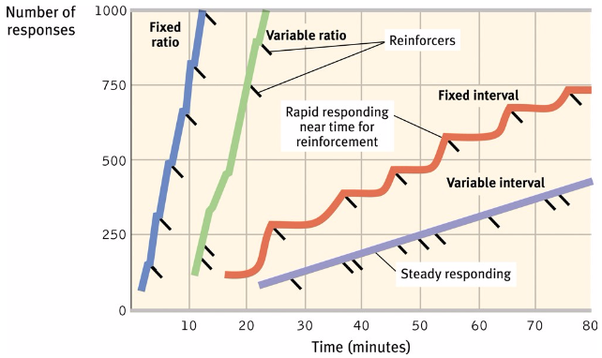
- Punishments
  - Reinforcement increases a certain behavior, punishment works by decreasing the frequency of a preceding behavior.
  - There are two types of punishments these being a positive and negative punishments
  - Positive punishments
    - When one administers an undesired stimulus, thus the subject will refrain from said behavior, that elicits the stimulus
  - Negative Punishment
    - When one takes away a desired stimulus, thus the subject will refrain from said behavior to keep the desired stimulus.
  - Parents that utilize physical punishment to address unwanted behaviors result sin 4 drawbacks
    - Punished behavior is suppressed, not forgotten. This temporary state may (negatively) reinforce parent’s punishing behavior
    - Punishment teaches discrimination among situation. In operant conditioning, discrimination occurs when an organism learns that certain responses, but not others will be reinforced.
    - Punishment can teach fear and thus generalization b/n associations can be detrimental.
    - Physical punishment may increase aggression by modeling aggression as a way to cope with problem
  - What punishments just teaches it how to avoid it, better to encourage certain desired behaviors through reinforcement
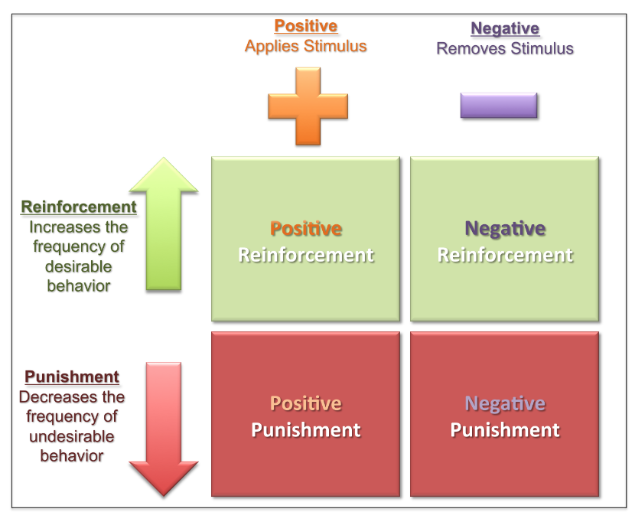

Contrasting Classical and Operant Conditioning
- Both classical and operant conditioning are types of associative learning, both involving the AESGD concepts.
- Although Classical is the association of two uncontrollable stimuli that evokes a respondent behavior, whereas operant conditioning is where one elicits a behavior that is associated with the consequence that it produces and can be either rewarded or punished resulting in an operant behavior.
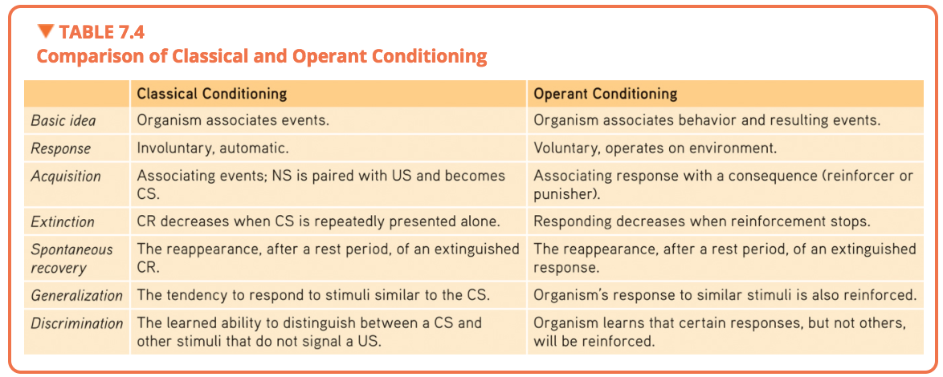

Biology, Cognition, and Learning
Biological Constraints on Conditioning
- Limits on Classical Conditioning
  - Animal’s capacity for conditioning is constrained by its biology, each specie’s predisposition prepares it to learn the associations that enhances its survival.
    - Ex. Taste Aversions
- Limits on Operant Conditioning
  - Biological constraints predispose organisms to learn associations that are naturally adaptive
    - Ex. A pigeon flapping to avoid being shocked or pecking to obtain food vice versa is unnatural

Cognition’s Influence on Conditioning
- Cognitive processes and Classical Conditioning
  - Countering Pavlov’s and Watson’s ideas on “mentalistic” concepts, behaviorists believe that cognitive processes show the animals can learn predictability of an event.
    - Animals will always predict the association that is stronger/reliable between the conditioned response and the unconditioned stimulus along with other neutral stimuli.
- Cognitive Processes and Operant Conditioning
  - More than just an association between a response and a consequence, along with the always present cognition
  - One can exhibit a cognitive map that can be evoked by rewarding the subject with a reinforcement that elicits this acquired knowledge to help them complete or exhibit the behavior to obtain more of the reward thus a showcase of latent learning…
  - Cognitive perspective can show limits on rewards from reinforcers
    - Intrinsic Learning (Fueled by curiosity/interest)
      - A desire to perform a behavior effectively for its own sake
        - Rewarding someone for this behavior can deter them from performing it again
    - Extrinsic learning (Fueled by incentive)
      - A desire to perform a behavior to receive a promised reward or avoid threatened punishment
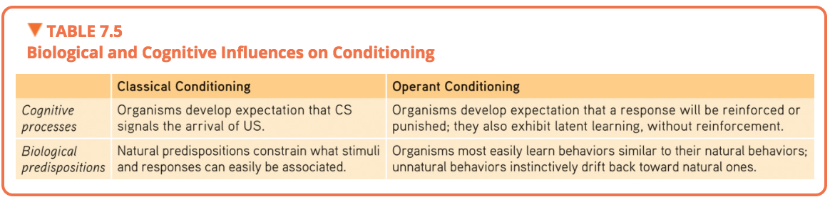

Learning by Observation
- Observational Learning, is the idea of learning without direct experience, by watching and imitating others
  - This can lead to learning various behaviors by observing or imitating others, a process called modelling.
    - Vicariously by association, one can experience vicarious reinforcement or vicarious punishment especially if the model is much like the observer.
- Mirrors and Imitation in the Brain:
  - Frontal lobe neurons that some scientists believe fire when performing certain actions or when observing another doing so
    - Frontal lobe is associated with planning movement
  - Thus, it is believed that these neurons provide the neural basis for imitation
- Applications of Observational Learning:
  - Prosocial Effects
    - A Prosocial model: a positive, constructive, helpful model, where one can hopefully imitate through the use of mirror-neurons/brain networks.
    - Antisocial model draws upon imitating behavior that is opposite to that of the prosocial effect.

Chapter 8: MEMORY (pp. 317-351)

Studying and Encoding Memories
Studying Memory
- Memory is learning that persists over time that has been acquired and stored and can be retrieved.
- Measuring Retention (3 types):
  - Recall: retrieving information that is not currently being thought of (conscious awareness) but was learned at an earlier time often tested through fill-in-the-black questions
  - Recognition: identifying items previously learned often tested through a multiple-choice test
  - Relearning: learning something more quickly the second time around having had studied the material or information at a later date
  - Hermann Ebbinghaus came to the affirmation of relearning and its rehearsal (overlearning) demonstrates an increase in retention, especially when practiced in distributed time
- Memory Models:
  - The information-processing model
    - Get information into our brain – encoding
    - Retaining said acquired information is –storage
    - Retrieval of said information at a later date – retrieval
  - Our processing of information is by means of parallel processing
    - A by-product of this is the connectionism processing model, where one views memories as products of interconnected neural networks that can retrieve memories from particular activation patterns within said neural pathways connections change as new information is learned, forming and strengthening neural pathways,
  - A general model of memory-forming process
    - Obtain information as a fleeting sensory memory
    - Process this information into a short-term memory, thus encoding it through rehearsal (relearning)
    - Thereby rehearsal, one is able to move it along to long-term memory
    - Other factors have now been added such as working memory and automatic processing
  - Working memory:
    - Is paired with short-term memory a small, brief storage space for recent thoughts and experiences, during whichshort term memory + long-term (retrieved) memory can be paired this is considered to be an active processing system

Encoding Memories
- Dual-Track Memory: Effortful Versus Automatic:
  - Our conscious track processes our explicit memory (or declarative memory) vs the unconscious processing implicit memory (or non-declarative memories)
  - Encoding of explicit memories occurs through the conscious effortful processing vs the information that is skipped is collected by the automatic processing system into direct storage.
- Automatic Processing and Implicit Memories:
  - Implicit memories are those that are procedural for automatic skills, and classically conditioned associations among stimuli, this automatic processing system processes in 3 main categories, Space, Time, and Frequency
    - Space: encode where information is located on a page when studying
    - Time: encode the sequence of events in your day
    - Frequency: encode the number of times certain events occur without conscious awareness
  - The two-track mind enables us to simultaneously split information into different components through, vision, thinking, and memory, most of these for the unconscious track work together in parallel processing.
- Effortful Processing and Explicit Memories:
  - Most automatic processing’s, used to require effortful processing the conscious mind and its attention to learn the skill for long-term memory encoding, but once there, rehearsal can occur through automatic-processing.
  - Sensory memory (Active process)):
    - Feeds into our working/short-term memory, encoding through, images, scenes, echo’s, of sounds
    - Iconic memory: a fleeting sensory memory of visual stimuli – often lasting very short time(1/10s)
    - Echoic memory: a fleeting memory of auditory stimuli – longer lasting then iconic memory(3s-4s).
  - Capacity of Short-Term and Working Memory:
    - This is an active stage where incoming encoding sensory memory is linked with stored memories
    - The capacity of this memory is very short only being able to remember about 7 digits, 6 letters and 5 words of bits of information in a short period of time
      - Capacity is affected by age and other factors of health younger larger working capacity thus, more ability to multi-task
    - Those with larger working memory capacities are usually of higher intelligence and can juggle multiple items while processing information able to retain more information after sleep as well
- Effortful Processing Strategies:
  - Chunking:
    - Organizing items into familiar, manageable units-enables us to recall it more easily due to it being in a personally meaningful arrangement.
  - Mnemonics: using vivid imagery, one is better able to remember concrete, visualizable words then abstract ones
    - The peg-word system: using visual imagery skill to memorize a jingle “one is bun” thus to associate a grocery list with visual images to better encode these into the working memory especially if paired with chunking (called acronyms)
  - Hierarchies:
    - Processing information not only in chucks but in hierarchies composed of a few broad concepts dived and subdivided into narrower concepts and facts, helps us retrieve information efficiently along with encoding.
- Distributed Practice:
  - We encode information better when distributed using the spacing effect
    - Spacing effect: the tendency for distributed study or practice to yield better long-term retention than is achieved through massed study or practice.
      - One studying at this level has been mastered further studying will be insufficient
  - We can encode through another system known as the massed practice, where cramming can produce speedy-short-term learning retention and feeling of confidence
  - One effective way to distribute practice is repeated self-testing, called the testing effect where, one can assess learning and improve it by retrieval methods.
  - Levels of processing
    - Two types of processing verbal information which affects our long-term retention
      - Shallow Processing: encoding on the basic level based on the structure or appearance of words such as a word sound
      - Deep Processing: encoding semantically, based on the meaning of the words better type of retention
- Making Material Personally Meaningful:
  - We process information more easily if it is meaningful to us on a personal level
    - Thus, the amount remembered depends both on the time spent learning and on your making it meaningful for deep processing

Storing and Retrieving Memories
Memory Storage
- Retaining Information in the Brain
  - Memories are brain-based, but are distributed in components over a network of locations.
  - Explicit Memory System: The Frontal Lobes and Hippocampus
    - The frontal lobes and hippocampus processes and stores explicit memories, along with the frontal lobes each processing different forms of memories, the left being more numeric and the right more visual
    - The hippocampus located near the temporal lobes neural center acts a “save” button for explicit memories, thus, are active when people are forming explicit memories of names, images, and events
      - Thus, damage to the hippocampus can disrupt recollection of explicit memories, damage to the left side can impair numeric/verbal memories, whereas damage to the right, affects visual memories.
    - Although memories are not stored in the hippocampus, it remains there as a short-term/working memory area yet to be stored somewhere else.
    - To store a memory for longer-term the processes is called memory consolidation
      - With sleep supporting memory consolidation from the hippocampus region
      - This processing is all going to be stored in the cortex for long-term storage and retrieval
  - Implicit Memory System: The cerebellum and Basal Ganglia
    - If you lose your frontal lobes and hippocampus one can still thanks to automatic processing, lay down implicit memories for skills and newly conditioned associations
    - The cerebellum plays a role in forming and storing implicit memories, if damaged then people cannot develop certain conditioned reflexes, and thus are also unable to learn conditioned associations through classical conditioning.
    - The basal ganglia are responsible for the formation of procedural memories involved in motor movement with communication with the cortex in a one-way street thus, not sending information back to the cortex for conscious awareness. Ex. Bicycle
      - Explains Infantile Amnesia hippocampus last structure to mature
  - The Amygdala, Emotions, and Memory
    - Emotions can trigger stress hormones to influence memory formation
      - Stress provokes the amygdala to initiate memory trace in the frontal lobes and basal ganglia and to boost activity in the brain’s memory forming areas.
      - Usually triggers emotion-related memory formation
        - Can lead to “flashbulb memories” a clear memory of an emotionally significant moment or event.
  - Synaptic Changes
    - When learning one can increase the release of certain neurotransmitters such as serotonin (slugs) that increase the efficiency of transmitting signals, thus, experience and learning increases
    - When stimulating human memory-circuit connections, sensitivity to that region and this will allow sending neurons to prompt the release of their neurotransmitters along with more neural connections
    - This type of increase neural efficiency of potential neural firing is called Long-term potentiation (LTP) provides basis for learning and remembering associations
      - Thus, to increase learning one can take drugs which are LTP-enhancing of the neurotransmitter glutamate or develop drugs to boost production of CREB
        - CREB a process that produces proteins to reshape synapse and transfer short-term memory to long-term memory.
    - Although in the meantime one can just use sleep and study tactics to improve memory retention.
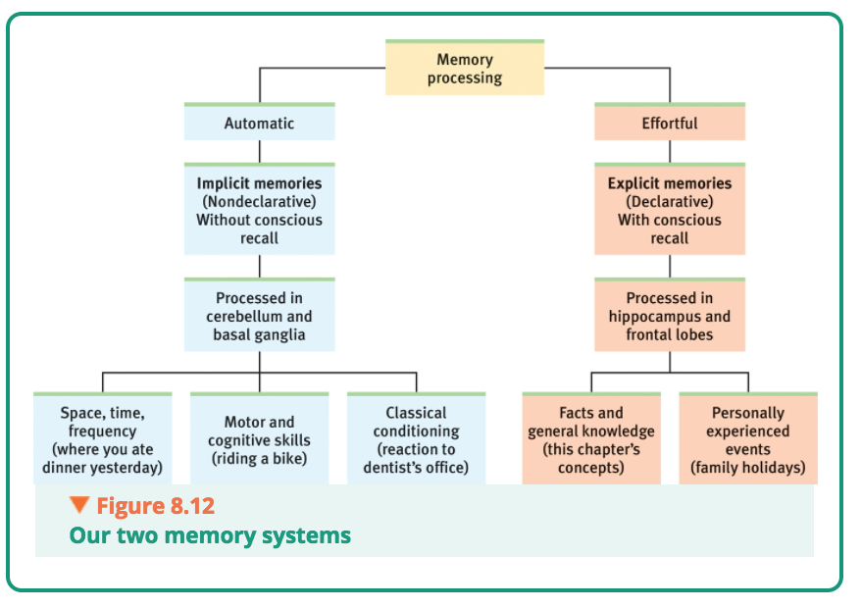

Memory Retrieval
- Retrieval Cues
  - Memories held in storage as a web of associations/interconnected with others thus, when one encodes a bit or piece of information it is often associated with other bits of information already known or currently knowing such as a name with that of a face/body/color
    - These bits of association help with retrieval clues that help with retrieval of a name given the face/association
    - These retrieval cues are best when they are encoded at the time of the memory smells, tastes and sights that can evoke a memory of a person event, are best when occurring together
  - Priming:
    - Associations can be activated without conscious awareness referred to as priming
    - Considered to be “memory less memory” where an individual when thinking/retrieving one memory can spark the retrieval of an association to that memory that never or does not occur.
      - Ex. Seeing a missing child poster assuming some adult-child interaction of kidnapping, when the poster is already gone yet the association is there thus, will be retrieved
    - Priming can also influence behavior people primed with money words are more selfish/materialistic
  - Context-Dependent Memory
    - When one places themselves at the location of a memory to better recall/retrieve its associations,
      - Thus, to better recall experiences its best to locate where they occurred and go there for recollection of said experiences
        - Encoding-Specificity-Principleidea that cues and contexts specific to a particular memory will be most effective in helping us recall it
  - State-Dependent Memory
    - When learning is done in a certain state – drunk or sober, it is best recalled when in that same state, other example could include mood states when memories formed leading to mood congruent memory
      - Mood-Congruent memory: tendency to recall past experiences that are consistent with one’s current good or bad mood
  - Serial Position Effect:
    - Another type of memory retrieval effect is the serial position effect where, we recall best the last (a recency effect) and the first (a primacy effect) on a list of items/names usually forgetting the past as it was not maintained in the working memory long enough.

Forgetting, Memory Construction, and Improving Memory
Forgetting
- Forgetting and the Two-Track Mind
  - Anterograde Amnesia: an inability to form new memories usually after damage/removal of hippocampus
  - Retrograde Amnesia: an inability to retrieve information from one’s past
    - Often people’s automatic processing system remains intact despite losing the effortful processing system
- Encoding Failure:
  - Age can affect encoding efficiency, also without encoding effort, many potential memories never from
- Storage Decay:
  - Even after encoding a memory, loss of said memory can still occur
  - According to Ebbinghaus, the course of forgetting is initially rapid, then levels off with time (forgetting curve)
  - Memories can sometimes never be encoded, or were discarded (decayed), while others are out of reach
- Retrieval Failure
  - Forgetting could be due to disruptions in retrieval, long-term stored memories can sometimes be affected by interference and or motivated forgetting.
    - Interference
      - When memory retrieval of stored information comes back cluttered instead of focused out, there are two types of interference Proactive interference and Retroactive interference
        - Proactive (forward facing) interference refers to when already learned information clouds your judgements of recalling new information
        - Retroactive (backward facing) interference refers to when learning something new, encoding said information disrupts retrieval of the already old information
    - Motivated Forgetting
      - Sigmund Freud – Would argue that our memory systems self-censored this information proposing we repress painful and unacceptable memories to protect our self-concept and to minimize anxiety
      - It’s easier to forget unwanted neutral information harder to forget emotion events

Memory Construction Errors
- Memory is not precise we reweave memories and constantly revise them every time we retrieve them a process called reconsolidation thus replacing the original with a slightly modified version
- Misinformation and Imagination Effects:
  - Misinformation Effect: When misleading information (connotation of words) has corrupted one’s memory of an event
  - Imagining: The process where one imagines a false but realistic event can thus create false memories known as imagination inflation.
- Source Amnesia:
  - The “source misattribution”: attributing to the wrong source an event that we have experienced, heard about, read about, or imagined
    - Songwriters may think they are being creative but really, they are plagiarizing something they heard and misattributing it to their brain as the source
    - Source amnesia can explain déjà vu – The feeling of familiarity with a stimulus without a clear idea of where we encountered it
    - Familiarity can be attributed to the temporal lobes and we consciously remember details thanks to the frontal lobes and the hippocampus regions of the brain, thus, when out of sync we may feel the feeling of familiarity to a stimulus and not consciously recall its origins.
- Discerning True and False Memories:
  - Memory construction and reproduction alters which memories are true and which are false
  - False memories can be persistent
- Children’s Eyewitness Recall:
  - They can be good at recalling info if not being subjected to leading questions …

Improving Memory
- Rehearse Repeatedly
- Make the material meaningful
- Activate Retrieval Cues
- Use Mnemonic Devices
- Minimize Interference
- Sleep More
- Test your own knowledge, both to rehearse it and to find out what you don’t yet know

Chapter 11: WHAT DRIVES US: HUNGER, SEX, FRIENDSHIP, AND ACHIEVEMENT (pp. 419-455)

Basic Motivational Concepts
- Definition of motivation according to psychologists is the need or desire that energizes and directs behavior of this motivated behavior there are 4 perspectives:
  - Instinct Theory (now replaced by evolutionary perspective) focuses on genetically predisposed behaviors
  - Drive-Reduction Theory focuses on our responses to our inner pushes or our drives
  - Arousal Theory focusing on finding the right level of stimulation
  - Abraham Maslow’s Hierarchy of Needs Theory of focusing on the priority of some needs over others

Instincts and Evolutionary Psychology
- Due to Charles Darwin, it was classified that all sorts of behaviors were due to instincts
  - Instincts: a complex behavior that is rigidly patterned throughout species and is unlearned
    - These instincts are directed by physiological and psychological needs and wants
- Theory does not explain all human behaviors, does provide insight as to why certain genes predispose some species to certain behaviors
  - Ex. baby sucking its thumb, and a bird can only build it’s kind of nest, salmon return to birthplace

Drives and Incentives
- A physiological need (need for water) created an aroused state that drives an organism to reduce the need
  - As a physiological need increase, so does psychological drive – an aroused, motivated state
- This theory relies heavily on homeostasis – body’s need to maintain a constant internal state
- We can be pushed to reduce drives by incentives, positive or negative environmental stimuli that lure or repel us
  - Ex. Hunger and baking pizza

Optimum Arousal
- Some motivated behaviors actually increase arousal
- High arousal individuals will most likely seek out intense music, novel foods, and risky behaviors and careers
- Human motivation aims not to eliminate arousal but to seek out optimum levels of arousal.
- When all biological needs are satisfied, one is driven to experience stimulation
  - Lacking stimulation one feels bored and thus finds ways to increase optimum levels of arousal
- Yerks-Dodson Law – suggesting that moderate arousal would lead to optimal performance
  - That performance increases with arousal up to a point, beyond of which performance decreases.

A Hierarchy of Motives
- Some needs take priority, can be psychological or physiological
- Maslow described these priorities as a hierarchy of needs
- This hierarchy is consisting of the follow
  - Physiological Needs
  - Safety Needs
  - Belongingness and Love Needs
  - Esteem Needs
  - Self-actualization Needs
  - Self-transcendence

Hunger
- Starvation/Hunger and even being thirsty, fatigued, or sexually arouse, can lead to little else seeming of importance.

The Physiology of Hunger
- Hunger usually occurs due to stomach contractions but, evidence shows that removal of the stomach can still persist feelings of hunger
- Due to the homeostatic system, one is able to regulate the need of consuming food to maintain normal body weight
- Body Chemistry and the Brain:
  - Blood sugar glucose: Insulin hormone secreted by the pancreases diminished blood glucose, partly by converting it to stored fat.
    - Thus, when blood glucose levels are low, brain will trigger hunger, it also keeps tabs on signals from the stomach, intestines, and liver to know if glucose is being deposited or withdrawn to determine if motivation to eat or not is needed.
    - Several neural areas in hypothalamus (ex. Arcuate nucleus), have secreting appetite-stimulating hormones
      - If area is damaged then even when physically starving one may not have the desire to eat
    - Other neural areas secrete appetite-suppressing hormones and if damaged will always feel hungry even when physically unable to eat
    - Blood vessels connect to the hypothalamus to sense blood chemistry and responds to levels of apatite hormones such as ghrelin produced by the gastrointestinal tract
      - Other appetite hormones include, leptin, orexin (also for stimulating wakefulness)
  - Pairing brain activity, and appetite-hormones explains why the body’s predisposition to maintain itself at a particular weight, the processing of returning to a stable weight is called returning to your set point
  - Regulation of weight occurs through the control of food intake and energy output, and the basal metabolic rate
    - BMR – the rate at which your body expends energy when resting
    - The set point can always vary and is not set in stone; thus, it has been revised to now be called the settling point, which changes in response to caloric intake and expenditure of energy.

The Psychology of Hunger
- Knowing when to eat involves memory of our last meal
- Taste Preferences: Biology and Culture:
  - Genetics plays a role in the preference for sweet and salty tastes along with others,
  - Culture, and geographic location influence the taste aversions one develops long with being conditioned to like certain tastes
  - Other biological examples include pregnancy where taste aversions develop, during the most vulnerable period to the fetus/embryo,
- Situational Influences on Eating:
  - Ecology of Eating:
    - Social Facilitation: Presence of others amplifies our natural behavior tendencies, thus, one eats more at parties
    - Unit Bias: When offered supersized standard portions, people put away more calories portion sizes matter, when offered a bigger plate, individuals eat more
    - Food Variety: When offered a variety of portions or food type we often eat more than when offered

Obesity and Weight Control
- Obesity is socially toxic affecting self-image/esteem and leads to lower psychological well-being among women especially and increases depression
- The Physiology of Obesity:
  - Overweight considered by the World Health Organization to have a BMI of 25+, someone obese has a BMI of 30+
- Obesity increases risk of diabetes, high blood pressure, heart disease, gallstones, arthritis, and certain types of cancer,
- Extreme obesity can lead to suicidal behaviors
- Women’s obesity has been linked to a risk for late-life cognitive decline, such as Alzheimer’s disease and brain tissue loss
- Set Point and Metabolism:
  - When one is fat one needs less food to maintain the new body weight as fat has a lower metabolic rate than does muscle, requiring less food energy to maintain
  - Thus, when an overweight person’s body drops below the set point (settling point), it triggers more hunger and less metabolism, thus the body adapts to this starvation by burning off fewer calories.
- The Genetic Factor:
  - Genetics do influence our body weight
  - People’s weights resemble those of their biological parents
  - Identical twins have closely similar weights, even when raised apart
- The Food and Activity Factors
  - Environmental factors can influence obesity
  - Those who suffer from sleep loss are vulnerable to obesity
    - Sleep deprivation leads to levels of leptin (hunger-suppressing) to fall and ghrelin to rise
  - Social influence is another, where if one has an obese friend, the chances of the other friends increase to become obese.
  - Fattening World: Where jobs are becoming more sedentary and consumption of food is increasing much like an animal feedlot. transportation changing seat size to accommodate the girth growth lol
- Genes today mostly determine why one person today is heavier than their counterparts, and environment mostly determines why people today are heavier than their counterparts 50 years ago.

Sexual Motivation
The Physiology of Sex
- Sex is not like hunger as it is not an actual need, but yet we are still motivated by it…
- Hormones and Sexual Behavior
  - Forces that drive sexual behavior, include sex hormones
    - Men testosterone
    - Women Estrogen (estradiol)
    - Their influences
      - During prenatal period and developments into males/females
      - During puberty
      - After puberty, activate sexual behavior
  - Women become sexually fertile or receptive when they peak at their estrogen hormonal levels and thus begin ovulation thus, injection of estrogen can make one receptive
  - Male hormone levels remain relatively constant and injection hardly does anything
  - Women have testosterone levels as well not as high as men, but they do need to be there as removal of the ovaries or adrenal glands diminish sexual behavior
  - In men with low levels of testosterone, injection of testosterone increased sexual desire
    - Thus, sexual arousal can be a cause and a consequence of increased testosterone levels
  - Large Hormonal surges or declines for both men and women occur at two predictable points in a life span and one unpredictable one
    - The pubertal surge in sex hormones triggers developmental of sex characteristics and sexual interest
    - In later life, estrogen levels fall and women experience menopause
    - For some surgery or drugs may cause hormonal shifts
  - Biology is a necessary but not sufficient explanation of human sexual behavior as better completed by psychological perspective
- The Sexual Response Cycle:
  - Consist of 4 cycles:
    - Excitement:
      - Arousal of the genital area of both male and females with blood rushing to those areas
    - Plateau:
      - The peak of breathing, pulse and blood pressure rates some continuing, orgasm feels imminent
    - Orgasm:
      - Muscle contractions appear all over the body, increasing breathing, pulse and blood pressure rates.
      - Women’s arousal facilitates the propulsion of sperm from penis, while position uterus to receive sperm.
      - Pleasurable feeling of sexual release seems much the same for both sexes
      - PET scans showed that the same subcortical regions of the brain were active during orgasms for men and women.
    - Resolution:
      - Body returns to unaroused state as the genital blood vessels release their accumulated blood, men then enter a refractory period that lasts from a few minutes to a day or more
      - Women have much shorter refractory periods
- Sexual Dysfunctions and Paraphilias
  - Sexual dysfunctions problems that impair sexual arousal or functioning
    - Ex. Erectile disorder – male often helped with Viagra
    - Ex. Female orgasmic disorder – due to infrequently or never experiencing orgasm
  - Paraphilias
    - People who experience sexual desire, but they direct it in unusual ways, and is considered to be a disorder if
      - A person experiences distress from an unusual sexual interest or
      - It entails harm or risk of harm to others
      - Examples include, necrophilia, exhibitionism, pedophilia
- Sexually Transmitted Infections
  - STI/STD – 1 million people around the world acquire one every day
    - Teen girls more susceptible to said infections/disease due to their low antibodies count
  - HIV (human immunodeficiency virus) the virus that causes AIDS
  - AIDS depletes the immune system, leaving the person susceptible to infections
    - Often found to affect women due to the male carrying more of the disease and thus transfer rates are faster?
  - HPV (human papilloma virus) – often transferred by oral sex and is
    - Most HPV infections can be prevented with vaccinations before sexual contact.

The Psychology of Sex
- External Stimuli
  - Men/Women become aroused when they see, hear, or read erotic material
    - Increasing exposure to erotic stimuli, emotional response often lessens or habituates
    - Exposure to explicit material can have the following adverse effects:
      - Rape acceptance
      - Devaluing partner
      - Diminished Satisfaction
- Imagined Stimuli
  - The stimuli inside our heads can influence sexual arousal and desire, people can become sexually aroused not only by memories of prior sexual activities but also by fantasies
- Teen Pregnancy
  - Have increased
  - What produces sexual activity/pregnancy?
    - Minimal communication about birth control
    - Guilt related to sexual activity
    - Alcohol use
    - Mass media norm of unprotected promiscuity
  - Reasons people delayed or restrained from sex
    - High Intelligence
    - Religious engagement
    - Father presence
    - Participation in service learning programs

Sexual Orientation
- Sexual Orientation: The numbers
  - 3-4% of men are homosexuals and 2% for females
  - Sexual orientation is viewed as neither willfully chosen nor willfully changed
  - Women’s sexual drive and interests are more flexible and varying than are adult men’s.
    - Can be denoted as erotic plasticity
- Origins of Sexual Orientation
  - Our sexual orientation is something we do not choose and mostly for men cannot change
  - Homosexual behavior does not always indicate homosexual orientation
  - Still being studied upon not definitive result of the origin of one sexuality
  - Gay-Straight Brain Differences:
    - Brains differ with sexual orientation
    - The hypothalamus according to LeVay is an important neural pathway engaged in sexual behavior and believes that brain anatomy influences sexual orientation.
    - Reponses to hormone derived sexual scents also points to a brain difference
  - Genetic Influences:
    - Homosexuality does appear to run in families
      - Possibly that multiple genes un interaction with others influence, shape sexual orientation
  - Prenatal Influences
    - In some cases, prenatal hormone conditions have altered a fetus’ sexual orientation
    - Thus, female fetuses most exposed to testosterone and male fetuses least exposed to testosterone, appear most likely later to exhibit gender atypical traits and to experience same-sex desire
- Gay-Straight Trait Differences
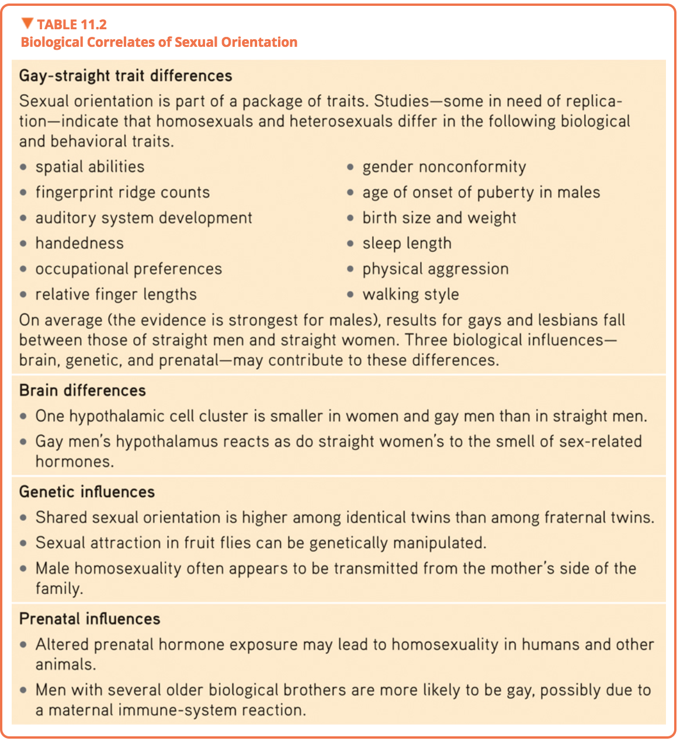

Sex and Human Values
- Men and women can achieve greater satisfaction and experience a much greater surge in the prolactin hormone associated with their loved one
Affiliation and Achievement
The Need to Belong
- Our Affiliation need seems to be a basic human motivation, most of us seek to affiliate with others, even to become strongly attached to certain others in enduring, close relationships
- Affiliation Need: the need to build relationships and to feel part of a group
- The Benefits of Belonging:
  - Social bond boosted our ancestors chance of survival
  - When our need for relatedness is satisfied in balance with two other psychological needs –autonomy and competence – we experience a deep sense of well-being, and our self-esteem rides high
  - Pictures of you loved ones activate a brain region associated with safety – the prefrontal cortex- dampens feeling of physical pain
  - For immigrant and refugees moving alone to new places, the stress and loneliness can be depressing
  - Social isolation can put us at a risk for mental decline and ill health
- The Pain of Being Shut Out
  - Ostracism: deliberate social exclusion of individuals or groups
  - Such ostracism can elicit increased activity in brain areas, such as the anterior cingulate cortex, that also activates in response to physical pain
  - Pain reliever acetaminophen relives/lessens social as well as physical pain
- Connecting and Social Networking
  - Social effects of Social Networking
    - Is strengthening the connections with the -variety of people we already know
    - The net result is an imbalance between face-to-face and online social connection
    - Texting, tweeting, and e-mailing are rewarding but eye-to-eye conversation is even more so
    - Your online presence may indeed reflect the real you!
Achievement Motivation
- The more we achieve the more we may need to achieve (Cristina Yang)
- Achievement Motivation: a desire for significant accomplishment, for mastering skills or ideas, for control, and for attaining a high standard
- Those who are more ambitious, energetic and persistent were more successful
  - As children they had more active hobbies and as adults participated in groups and sports
  - Superstar achievers, are it seems, distinguished both by their extraordinary daily discipline and by their extraordinary natural talent
  - This passionate dedication is called Grit
  - Grit: in psychology, passion and perseverance in the pursuit of long-term goals

Chapter 12: EMOTIONS, STRESS, AND HEALTH (only pp. 459-487)

Introduction to Emotion
Emotion: Arousal, Behaviour, and Cognition
- Emotions are a mix of …
  - Arousal of the body
  - Behavior often expressive
  - Cognition: Conscious experience, including thoughts and feelings
- Puzzle for psychologist is to figure out 2 things
  - [1] Does arousal come before or after emotional feelings
  - [2] How does cognition and feeling interact, does cognition always come before emotion
- Historical Emotion Theories
  - James-Lange Theory: Arousal Comes Before Emotion
    - Suggests that our experience of emotion is due to our awareness of our physiological responses to emotion-arousing-stimuli such as crying, trembling.
  - Cannon-Bad Theory: Arousal and Emotion Occur Simultaneously
    - Describes our bodily responses and experienced emotions occurs separately but simultaneously
- Schachter and Singer Two-Factor Theory: Arousal + Label = Emotion
  - Believed that emotions have 2 ingredients
    - [1] Physical Arousal
    - [2] Cognitive Appraisal
    - Sleepover Effect: a stirred-up state can be experience as one emotion or another, depending on how we interpret and label it.
    - Point to remember: Arousal fuels emotion, Cognition channels it to a specific emotion.
- Zajonc, LeDoux, and Lazarus: Does Cognition Always Precede Emotion?
  - We actually have many emotional reactions apart from, or even before, our interpretation of a situation
  - Emotions such as hatred and love travel the High road of consciousness, where a stimulus following this path would travel (by way of the thalamus) to the brain’s cortex, analyzed by amygdala (emotion-control center)
  - Sometimes the emotions such as simple likes and dislikes and fears take what is called the low road or unconscious one, where a neural shortcut that bypasses the cortex, would travel from the thalamus directly to the amygdala.
  - Amygdala sends more neural projections up to the cortex than it receives back, making it easier for feeling to overcome our thinking
  - Both Zajonc and LeDoux believe that certain emotional reactions involve no deliberate thinking
  - Lazarus, believed that our brain processes vast amounts of information without our conscious awareness, and that some emotional responses do not require conscious thinking.
    - He then said that emotions arise when we appraise an event as harmless or dangerous, whether we truly know it or not.

Embodied Emotion
- Emotions and the Autonomic Nervous System
  - In stressful situations, the sympathetic division of the autonomic nervous system (ANS) prepares your body for action by reducing energy requiring forces such as digestion to direct it to areas of need for bracings heart rate increases
    - Directs adrenal glands to release stress hormones such as epinephrine (adrenaline) and norepinephrine (noradrenaline) to provide energy and the liver pours extra sugar into bloodstream.
  - Parasympathetic division of ANS gradually calms your body, as stress hormones slowly leave blood stream.
  - Thus, the question is do different emotions have distinct arousal fingerprints
- The Physiology of Emotions
  - Different emotions can share common biological signatures
  - Insula – Brain region that serves many different emotions, and it activated when we experience various negative social emotions, such as lust, pride, disgust
  - During fear brow muscles tense, during joy muscles in cheeks and under eyes pull into a smile
  - Different emotions have different brain circuits, thus, one can, using an EEG show that emotions activate different areas of the brain’s cortex.
  - Negative emotions trigger the right prefrontal cortex
  - Positive emotions trigger the left prefrontal cortex
  - Not easy to differentiate between emotions when tracking HR, breathing and perspiration, but differences can be seen in, facial expression and brain activity.
  - Anterior cingulate cortex activated when one lies along with the left prefrontal cortex….

Expressing Emotion
Detecting Emotion in Others
- Most of use read nonverbal cues and nonverbal threats well
- Experience can sensitize us to particular emotions
  - Children abused, are much quicker than others to spot the signals of anger
- It’s hard to detect deceiving expressions
  - Distracting people, rather than encouraging them to think deeply, increases their lie-detection accuracy
- Introverts tend to excel at reading others’ emotions, while extraverts are generally easier to read
- Due to online/written communication we can fall prey to egocentrism: failing to perceive how others interpret our messages
Gender, Emotion, and Nonverbal Behavior
- Women generally do surpass men at reading people’s emotional cues
- Women’s nonverbal sensitivity helps explain their greater emotional literacy
- Girls/Women express stronger emotion than boys/men do
- Anger more masculine vs happiness
- Women more empathetic than men

Culture and Emotional Expression
- Meaning of gestures varies with culture
- Facial Gestures are quite universal among cultural backgrounds
- Musical emotions of expression also cross cultures
  - Happy music and Sad music quite similar
- Facial muscles speak a universal language
- Its adaptive for us to interpret faces in particular contexts
  - Such as judging an angry face in a frightening situation as fearful
- Although facial language is universal, the degree of expressing said facial expressions varies

The Effects of Facial Expressions
- Facial Feedback Effect: the tendency of facial muscle state to trigger corresponding feelings such as fear, anger, or happiness
  - Sub example…Behavior Feedback Effect: where behavior can influence our own or others’ thoughts, feelings, and actions

Experiencing Emotion
- Emotional experience is placed along two dimensions, positive-versus-negative valence, and lo-versus-high arousal

Anger
- Fear triggers flight whereas anger triggers fight
- Chronic hostility is linked with heart disease
- Individualistic cultures encourage people to vent their rage
- Cultures where people’s identity is centered more on the group, anger is seen as a threat to their interdependent harmony of said group
- Catharsis: we can achieve emotional release through aggressive action or fantasy
- Expressing anger can be temporarily calming
  - Although acting angrier according to behavior feedback effect one can get more violent/aggressive
- Venting to reduce anger just makes one angrier
- Ways to manage anger
  - Wait reduce psychological arousal
  - Find a healthy distraction or support
  - Distance yourself try to move away from the situation mentally
- Anger if used wisely, can communicate strength and competence and also motivates people to take action and achieve goals
- Forgiveness releases anger and calms the body

Happiness
- Feel-good, Do-good phenomenon
  - People’s tendency to be helpful when already in a good mood
    - Reverse is also true, that doing good promotes feeling good
- Positive Psychology
  - The scientific study of human flourishing, with goals of discovering and promoting strengths and virtues that help individuals and communities to thrive
    - This subfield includes studies of subjective well-being
      - Subjective Well-Being: Self-perceived happiness or satisfaction with life, measured through physical and economic indicators to evaluate quality of life.
  - First Pillar : Positive Well-being
- The Short Life of Emotional Ups and Downs
  - Most positive mood days are Friday and Saturday
  - Over the long run our emotional ups and downs tend to balance out, in fact people tend to bounce back from a bad day to a better-than-usual good mood the following day.
  - Grief over a loved one or anxiety after sever trauma can linger, but even tragedy is mot permanently depressing
  - We overestimate the duration of our emotions and underestimate our ability and capacity to adapt
- Wealth and Well-Being
  - Wealth to a point does correlate with happiness
  - Once one has enough money for comfort and security, piling up more and more matters less and less
  - Economic growth in affluent countries had provided no apparent boost to morale or social well-being
- Two Psychological Phenomena: Adaptation and Comparison
  - Happiness Is Relative to Our Own Experience
    - The adaptation-level phenomenon describes our tendency to judge various stimuli in comparison with our past experiences.
    - Thus, we have neutral levels where certain sound, light, or income is neither too much or too little and is used by as a gauge to from judgements
    - Feelings pf satisfaction and dissatisfaction, success and failure are judgements we make based partly on our prior experience.
  - Happiness Is Relative to Others’ Success
    - We are always comparing ourselves to others
    - When we sense we are worse off than others with whom we compare ourselves we are experiencing relative deprivation, where the perception that one is worse off relative to those with whom one compares oneself.
  - You cannot get away from envy by means of success alone
  - Reversing comparing ourselves to those better off creating envy, being grateful of what one has to those less fortunate boosts our contentment.
  - Places with greater income inequality have higher crime rates/lower life expectancy
- What Predicts our Happiness Levels?
  - Difference in levels of happiness can be due to genetics
  - Personal and cultural history can influence what gives us happiness
  - National and Geographic location can affect a person’s happiness levels
- Evidence-Based Suggestions for a Happier Life
  - Realize the enduring happiness may not come from financial success
  - Take control of your time
  - Act happy
  - See work and leisure that engage your skills
  - Buy shared experiences rather than things
  - Join the “movement” movement
  - Give your body the sleep it wants
  - Give priority to close relationships
  - Focus beyond self
  - Count your blessings and record your gratitude
  - Nurture your spiritual life

