Acid Base Titrations

Written by:

TA:

Date: November 13th 2018

Experiment 4. Acid Base Titrations

Introduction

Acids are substances that we call proton donors; when dissolved in water, they will donate their protons (H⁺) to the water (Venkateswaran). Acids that only have one proton to donate are called monoprotic and those capable of donating more than one proton are called polyprotic (Spohrer). Acids are also considered electron pair acceptors. In contrast, bases are substances that are described as hydroxide (OH⁻) donors when dissolved in water. We can also consider bases as proton acceptors and electron pair acceptors. A reaction between an acid and a base is called neutralization reaction, which results in the formation of water and a salt (Venkateswaran).

We can describe acids and bases by their strength and concentration. Strong acids and bases dissociate completely when added to water, whereas weak acids and bases do not dissociate completely in the presence of water (Venkateswaran). We can evaluate the strength of an acid or a base by looking at its pK_{a} and pK_{b} , respectively. “The pK_{a} is the negative base-10 logarithm of the acid dissociation constant (K_{a}) of a solution.”(Helmenstine). The pK_{b} has the same meaning as the pK_{a} but, for a base (4). The lower the pK_{a} or the pK_{b} , the stronger the acid or base is, respectively (Helmenstine). The pK_{a} and the pK_{b} can be determined with the following formulas:

pK_{a} = -log₁₀ K_{a}

pK_{b} = -log₁₀ K_{b}

As for the concentration of an acid or base, it depends on how much water was added to it. A more concentrated solution will have more base or acid and less water. A less concentrated solution will have less base or acid and more water. The concentration of a solution is measured in moles of solute per litre of solution; in this case, the solute is the acid or the base and the solution is the amount of water (solvent) and the amount of solute. This is demonstrated by the following expression (Venkateswaran):

Concentration (mol/L) = Amount of Solute (mol) / Volume of Solution (L)

We can calculate the concentration of a diluted solution made from a stock solution as well as determine how much stock solution or water is needed to make a diluted solution with a specific concentration by using the following formula:

C₁V₁ = C₂V₂
Where,

C₁ is the concentration of the stock solution (mol/L)
V₁ is the volume of the stock solution (L)
C₂ is the concentration of the diluted solution (mol/L)
V₂ is volume of the diluted solution (L)

The previous formula is not valid for all stoichiometries. A general equation of the one above would be the following:

C₁V₁ = (b/a) C₂V₂
where,
a is the coefficient of the acid
b is the coefficient of the base

We can determine the unknown concentration of an acid or base in a sample by using a procedure known as titration. The solution that is being added is called the titrant; when the titrant has a known concentration, it is a standard solution (Olmsted). The solution with an unknown concentration is called the analyte (Xavier). A titration consists of adding a known concentration of a basic solution to an acid that has an unknown concentration until the amount of base and acid are equal. In the case of an unknown concentration of a base, a known concentration of an acidic solution is added to the base until the amount of base and acid are equal. In a titration, the point at which the amount of acid and the amount of base are equal is called the equivalence point; at this point, there are enough hydroxide ions present in the solution to react with all the acidic protons (Olmsted).

A titration curve can have one or more equivalence points, depending on whether the acid is monoprotic or polyprotic. Titrations involving monoprotic acids will only have one equivalence point as only one proton can be donated per molecule of acid; the monoprotic used in this experiment is HCl. Titrations involving polyprotic acids will have more than one equivalence point as many protons can be donated per molecule of acid; an unknown diprotic acid is used in this experiment, resulting in two equivalence points (Spohrer).

Most bases and acids are colourless, making the equivalence point difficult to identify during a titration. Thus, to visually detect the equivalence point, an indicator is used. Indicators are weak acids that dissociate to a certain extent, depending on the pH of the solution. The undissociated and the dissociated species that make up the indicator will possess different colours. Each indicator only works within a certain pH range. The point at which the colour of the indicator changes is called the endpoint. Choosing an appropriate indicator for a titration will ensure that the endpoint is close to the equivalence point, making it possible to easily identify the equivalence point. (Venkateswaran).

Procedure
As described in the lab introduction: Venkateswaran, Rashmi What in The World isn’t Chemistry: Acid Base Titrations Experiment 4, 2018. P. 79-83.

Data

Amount of concentrated NaOH used in dilution to make NaOH solution (titrant): 4.08 ml

Table 1: pH at the equivalence point and the endpoint of each titration trial of HCl, a monoprotic acid, with NaOH (endpoints extrapolated from graphs shown in figures 1, 2, 3, and 4).
Trials | Equivalence point | pH at endpoint
1 | 5.31 | 5.41
2 | 12.44 | 12.54
3 | 7.66 | 7.76
4 | 6.02 | 6.12

Table 2: Volume of NaOH used in each titration trial of HCl, a monoprotic acid, to reach the equivalence point.
Trials | Volume of NaOH used to reach equivalence point (ml)
1 | 9.50
2 | 9.75
3 | 11.24
4 | 10.85

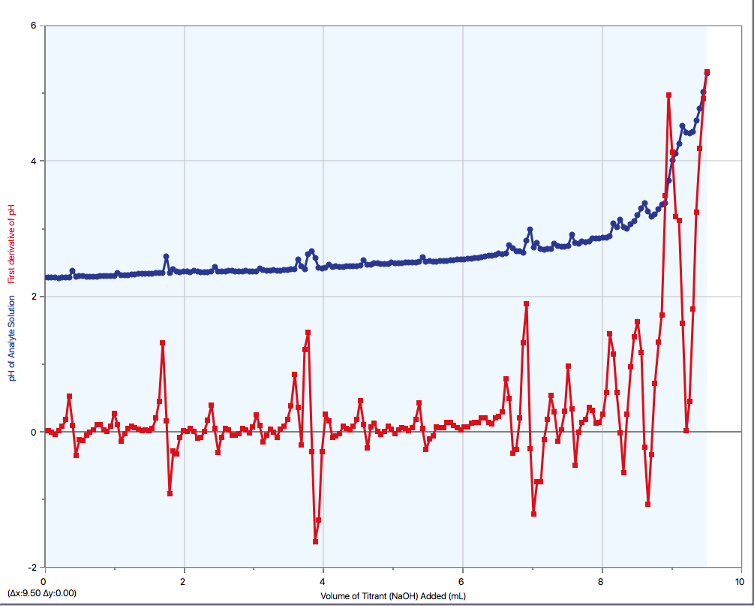
Figure 1: Trial 1. Graph displaying the first derivative of the pH as well as the change in pH of the analyte during the titration of HCl , a monoprotic acid, with NaOH, the titrant.
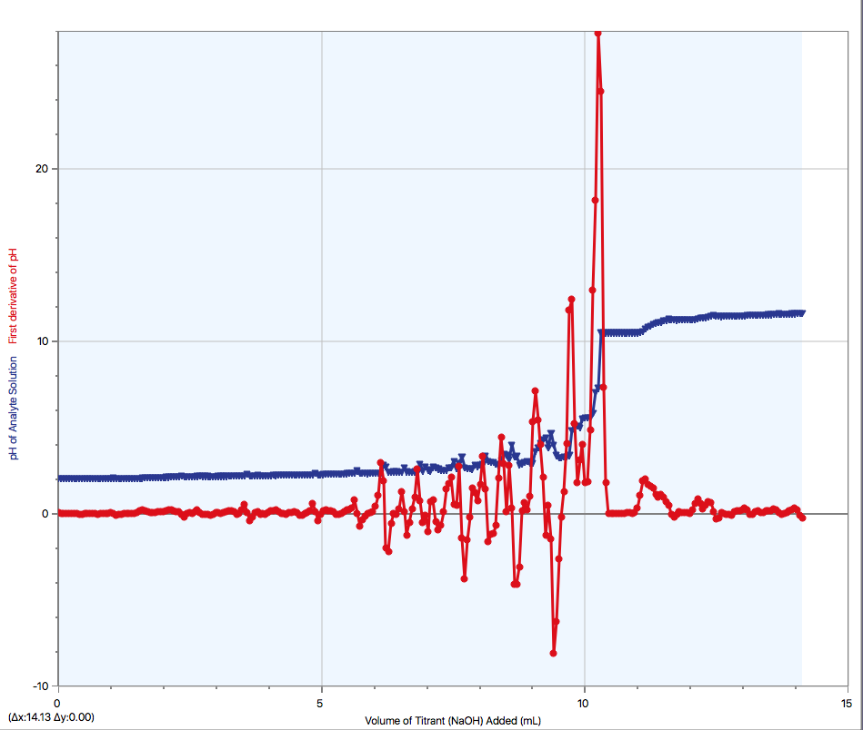
Figure 2: Trial 2. Graph displaying the first derivative of the pH as well as the change in pH of the analyte during the titration of HCl , a monoprotic acid, with NaOH, the titrant.

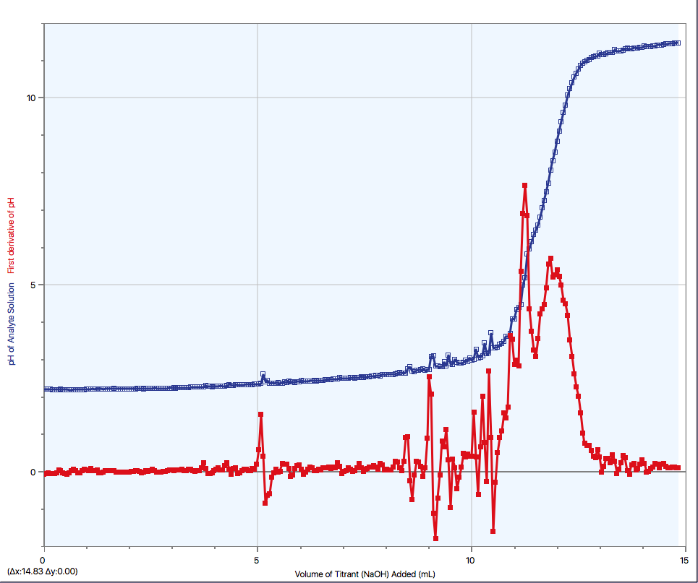
Figure 3: Trial 3. Graph displaying the first derivative of the pH as well as the change in pH of the analyte during the titration of HCl , a monoprotic acid, with NaOH, the titrant.

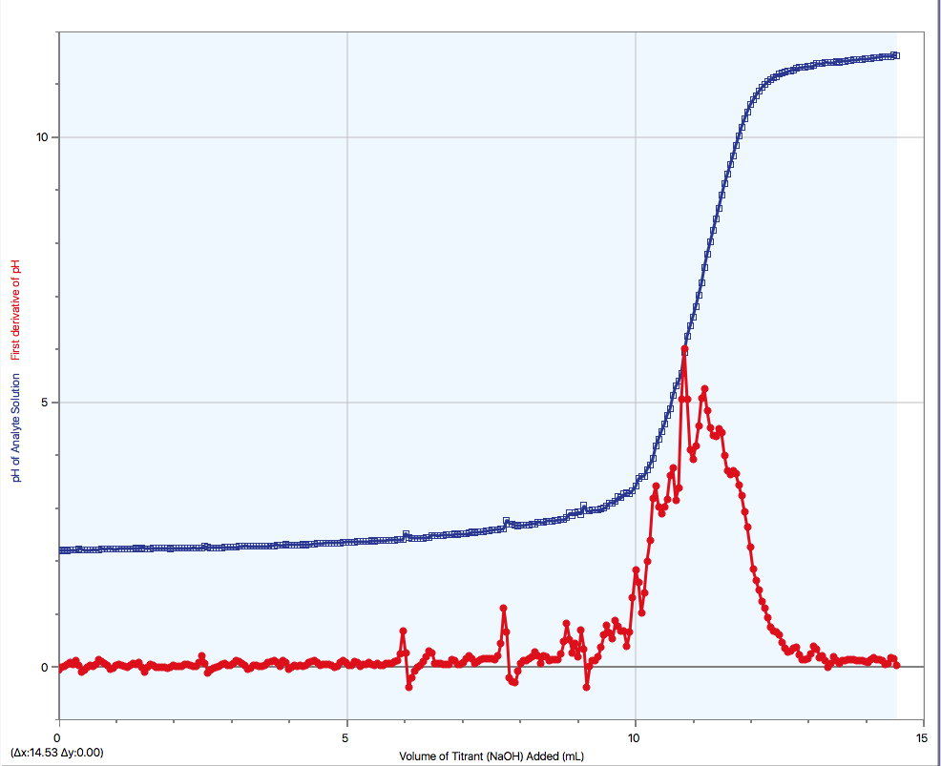
Figure 4: Trial 4. Graph displaying the first derivative of the pH as well as the change in pH of the analyte during the titration of HCl , a monoprotic acid, with NaOH, the titrant.

Table 3: pH at the equivalence points and endpoints of each titration trial of unknown acid #2 , a diprotic acid, with NaOH (endpoints extrapolated from graphs shown in figures 5, 6, and 7).

Trials | pH at equivalence points |  | pH at endpoint
Trials | 1st | 2nd | pH at endpoint
1 | 4.22 | 5.18 | 5.28
2 | 4.31 | 4.46 | 4.56
3 | 12.14 | ---- | ----

Table 4: Volume of NaOH used in each titration trial of unknown acid #2, a diprotic acid, to reach the equivalence point.

Trials | Volume of NaOH used to reach first equivalence point (ml) | Volume of NaOH used to reach second equivalence point (ml)
1 | 5.32 | 13.18
2 | 6.37 | 13.43
3 | 6.82 | -------

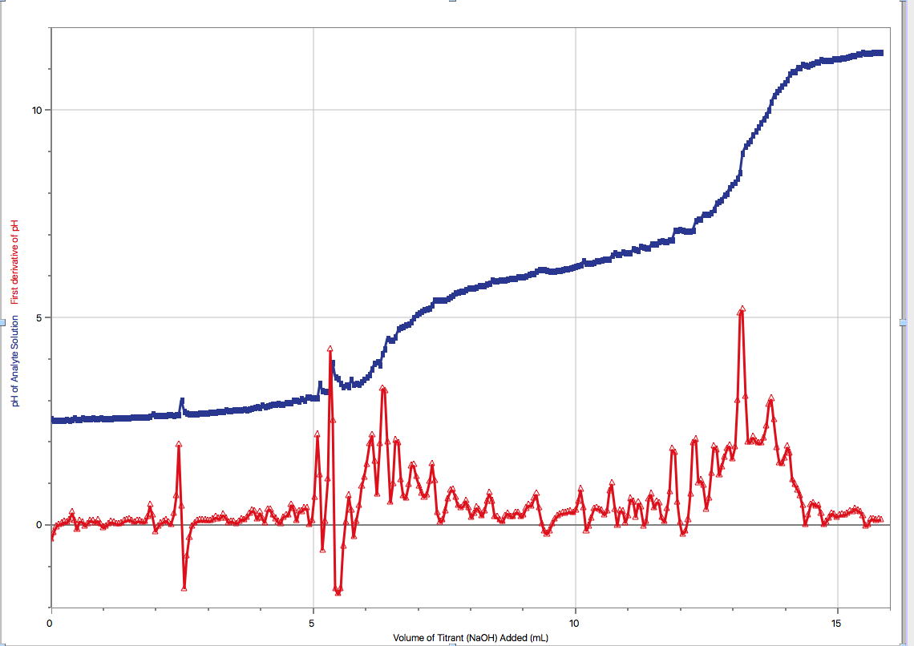
Figure 5: Trial 1. Graph displaying the first derivative of the pH as well as the change in pH of the analyte during the titration of unknown acid #2, a diprotic acid, with NaOH, the titrant.

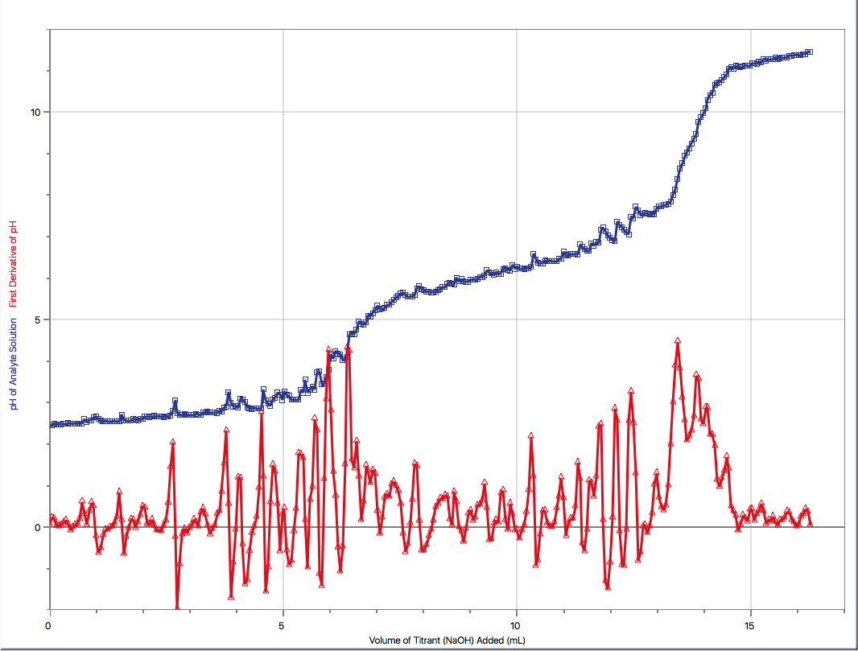
Figure 6: Trial 2. Graph displaying the first derivative of the pH as well as the change in pH of the analyte during the titration of unknown acid #2, a diprotic acid, with NaOH, the titrant.

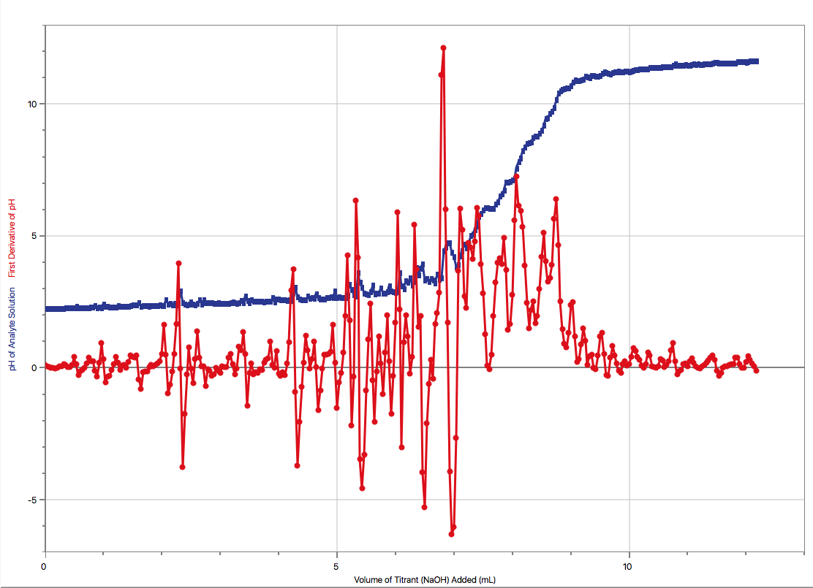

Figure 7: Trial 3. Graph displaying the first derivative of the pH as well as the change in pH of the analyte during the titration of unknown acid #2 , a diprotic acid, with NaOH, the titrant.

Calculations

1. Approximate concentration of NaOH solution.

V_{NaOH} = 4.08 ml x (1 L / 1000 ml) = 4.08x10⁻³ L
C_{NaOH} = 6M
V_{NaOH Solution} = 250 ml x (1 L / 1000 ml) = 0.250 L
C_{NaOH Solution}= ?

C_{NaOH}V_{NaOH} = C_{NaOH Solution}V_{NaOH Solution}

6M x 4.08x10⁻³ L = C_{NaOH Solution} x 0.250 L

C_{NaOH Solution} = (6M x 4.08 x10⁻³ L) / (0.250 L)
= 9 x 10⁻² mol/L

2. Sample calculation of the exact concentration of NaOH (trial 1)

Balanced equation: HCl + NaOH ⇌ NaCl + H₂O

V_{HCl} = 10 ml x (1 L/1000 ml) = 0.01 L
C_{HCl} = 0.100 mol/L
V_{NaOH} = 9.50 ml x (1 L/1000 ml) = 0.0095 L
C_{NaOH} = ?
a = 1
b = 1
C_{HCl} V_{HCl} = (b/a) C_{NaOH}V_{NaOH}
0.100 mol/L x 0.01 L = (1/1) C_{NaOH} x 0.0095 L
C_{NaOH}= (0.100 mol/L x 0.01 L)/ 0.0095 L
= 1 x 10⁻¹ mol/L

Table 5: Exact concentration of NaOH solution for each titration trial of HCl and average NaOH concentration.
Trial | C_{NaOH}
1 | 1 x 10⁻¹ mol/L
2 | 1 x 10⁻¹ mol/L
3 | 8 x 10⁻² mol/L
4 | 9 x 10⁻² mol/L
AVERAGE | 9 x 10⁻² mol/L

3. Sample calculation of the concentration of unknown diprotic acid #2 (trial 1)

Balanced equation: H₂A_{(aq)} + 2NaOH_{(aq)} ⇌ Na₂A_{(aq)} + 2H₂O_{(aq)}

C_{NaOH} = 9 x 10⁻² mol/L
V_{NaOH} = 5.32 ml x (1 L/1000 ml) = 0.00532 L
C_{acid} = ?
V_{acid} = 10 ml x (1 L/1000 ml) = 0.01 L
a = 1
b = 2
(b/a) C_{acid} V_{acid} = C_{NaOH}V_{NaOH}
(2/1) C_{acid} x 0.01 L = 9 x 10⁻² mol/L x0.00532 L
C_{acid}= ((9 x 10⁻² mol/L x0.01318 L) / 0.01 L)/2
= 2 x 10⁻² mol/L

Table 6: Concentration of unknown diprotic acid #2 for each titration trial and average concentration.
Trials | C_{acid}
1 | 2 x 10⁻² mol/L
2 | 3 x 10⁻² mol/L
3 | 3 x 10⁻² mol/L
AVERAGE | 2 x 10⁻² mol/L

Discussion

Before starting the experiment, a NaOH solution had to be made by dilution. It was important to know how much of the concentrated NaOH was used in this dilution to be able to approximately calculate the solution’s concentration.

The human errors that were committed during the lab may also have an effect on the results. For instance, the endpoint was not recorded for any of the trials. Because the endpoints were not noted during the lab, they had to be estimated with the help of the graphed titration curves. Assuming that an appropriate indicator was chosen, we can make the assumption that the endpoints are near the equivalence points. Usually, the endpoint occurs right after the equivalence point; for this reason, 0.10 was added to the pH of the equivalence points to estimate the pH of endpoints. We could of also assumed that the titrations were perfect and concluded that the endpoints and the equivalence points are identical (Gillespie). This error could result in the underestimation or overestimation of the endpoints.

Another human error occurred while gathering the data to create the graphs of the titration curves. In the first trial of the titration of HCl (figure 1), the data collection was stopped before the point at which the pH of the solution reached at least 11. This error resulted in not obtaining a graph of the titration curve in its entirety. In the third trial of the titration of the diprotic acid (figure 7), the calibration of the data collecting tool was unintentionally disrupted; this resulted in a distorted titration curve shape and the inability to provide data for a second equivalence point and endpoint, as seen in table 3.

An important human error that must be taken in account is that the amount of base used in each trial was noted instead of the amount of acid that was used. As the procedure indicates to use approximately 10 ml of acid in each trial, it was assumed in the calculations that exactly 10 ml of acid was used each time. This error could affect the calculated concentration of unknown acid #2, resulting in the concentration either being too high or too low.

A general error that may happen during a titration experiment is the identification of the endpoint. Different individuals may identify the endpoint at different shades of colour of the indicator, resulting in the recording of various possible endpoints. This could result in overshooting the endpoint, meaning recording the endpoint when the colour of the solution is too dark. Surpassing the true endpoint means that there is an excess of the titrant, NaOH in this case, that has been added to the solution; this will make the concentration of the solution appear higher than it actually is when doing the calculations (Stapleton).

Another possible source of error that will have an effect on the results is not properly rinsing the burets. The burets were rinsed with distilled water to remove contaminants from previous experiments. However, the burets was not rinsed with the solutions afterwards. This will result in solutions with lower concentrations. The lower concentrations of the solutions will alter the amount of titrant needed to reach the equilibrium and endpoint. As the volume of titrant is used in the calculation of concentration, this error will cause inaccuracy in the concentration that has been calculated (Stapleton).

As previously mentioned, the endpoints were approximated to be right after the equivalence points, assuming that the titration was not perfect and that the equivalence point and endpoint are not the same. Considering this, the volume of NaOH will be higher at the endpoints than the volume observed at the equivalence points determined by Logger Pro.

The overall balanced chemical equation that represents the species found in the solution in the titration of unknown acid #2 is the following:

H₂A_{(aq)} + 2NaOH_{(aq)} ⇌ Na₂A_{(aq)} + 2H₂O_{(aq)}
Where,

H₂A represents the unknown diprotic acid

We can explain what is happening at each part of the titration curve of a diprotic acid by using the titration curve of trial 1 as an example.

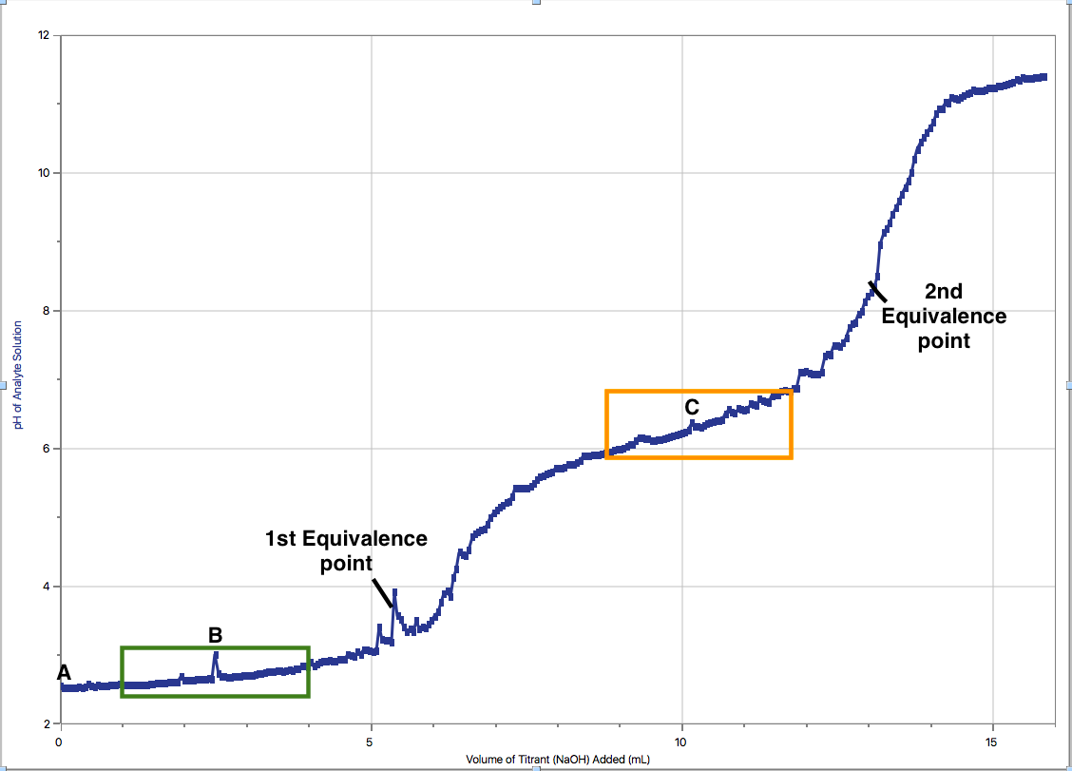
Figure 8: Trial 1 of titration of unknown acid #2 with NaOH, annotated.

When no base has been added, only the unknown acid is present in solution thus, the pH of the solution is low (point A).

In the area between the beginning and the first equivalence point, there is a region where the pH stays relatively constant; this is called the first buffer region (boxed in green). Within this buffer region, a single acid dissociation happens. This dissociation happens between the unknown acid, H₂A, and water, which forms a hydronium ion and the conjugate base, HA⁻; this can be represented by the following chemical equation (Evans):
H₂A + H₂O ⇌ HA⁻ + H₃O⁺

The point in the centre of the buffer region (B) is also the point where the volume is halfway to the volume of base needed to reach the equilibrium point. At point B, the pH of the solution is equal to the pK_{a}1 of the acid. This can be explained by what is happening in this buffer region. Throughout the buffer region, pH = pK_{a} of acid +log([A⁻]/[HA]). The concentrations of A⁻ and HA are equal at B because half of the HA that was present at the beginning has been consumed and half of the amount of A⁻ have been produced by this point. By plugging the equal concentrations in the previous expression, log([A⁻]/[HA]) = 1, leaving only pH = pK_{a}. At point C, where the curve a little more stable, marks where the first part of the titration ends and where the second one begins (Evans).

In this second part of the titration, the dissociation of the remaining proton of the diprotic acid occurs in the second buffer region (boxed in orange). This dissociation turns HA⁻ into A⁻² as more base is added. This dissociation can be represented by the following chemical equation (Evans):

HA⁻ + H₂O ⇌ H₃O⁺ + A⁻²

At point C, there is a negligible amount of the diprotic acid that remains. The second equivalence point indicates that enough base has been added to use up all of the diprotic acid. Point C, which is located between both equivalence points, also marks the point where the pH of the solution is equal to the pK_{a}2 of the acid. At point B, there is mostly HA⁻ present and at the second equivalence point, mostly A⁻² is present; this means that at point C, the concentration of HA⁻ and A⁻² are equal (Evans).

After reaching the second equivalence point, more base is added causing the pH of the solution to slowly approach the pH of the base (Evans).

Works Cited

Evans, Michael. YouTube, YouTube, 12 Apr. 2016, www.youtube.com/watch?v=cOuqLXezSS0.

Dr. Rashmi Venkateswaran, Acid Base Titrations, 2018.

Gillespie, Claire. “Definition of Endpoint Titration.” Sciencing, 15 May 2018, sciencing.com/definition-endpoint-titration-5172167.html.

Helmenstine, Anne Marie. “What Is PKa in Chemistry? Definition and Examples.” Thoughtco., Thoughtco, 15 Sept. 2017, https://www.thoughtco.com/what-is-pka-in-chemistry-605521

Helmenstine, Anne Marie. “What Is PKb in Chemistry? Definition and Examples.” Thoughtco., Thoughtco, 6 Sept. 2018, www.thoughtco.com/what-is-pkb-in-chemistry-605522.

Olmsted, John, et al. Chemistry. John Wiley & Sons Canada Ltd., 2016. P. 784. Print.

Olmsted, John, et al. Chemistry. John Wiley & Sons Canada Ltd., 2016. P. 786. Print.

Spohrer, Christopher, and Zach Wyatt. “Polyprotic Acids & Bases.” Chemistry LibreTexts, Libretexts, 16 Mar. 2018, chem.libretexts.org/Textbook_Maps/Physical_and_Theoretical_Chemistry_Textbook_Maps/Supplemental_Modules_(Physical_and_Theoretical_Chemistry)/Acids_and_Bases/Monoprotic_Versus_Polyprotic_Acids_And_Bases/Polyprotic_Acids_and_Bases_1.

Stapleton, Bill. “Random and Systematic Errors in Titrations.” YouTube, 4 Apr. 2017, www.youtube.com/watch?v=ZHDNbC8j390.

Xavier, Lauren. “Titration Fundamentals.” Chemistry LibreTexts, Libretexts, 21 July 2016, chem.libretexts.org/Demos,_Techniques,_and_Experiments/General_Lab_Techniques/Titration/Titration_Fundamentals

Raw Data

Partial representation of data collected in the standardization of HCl with NaOH
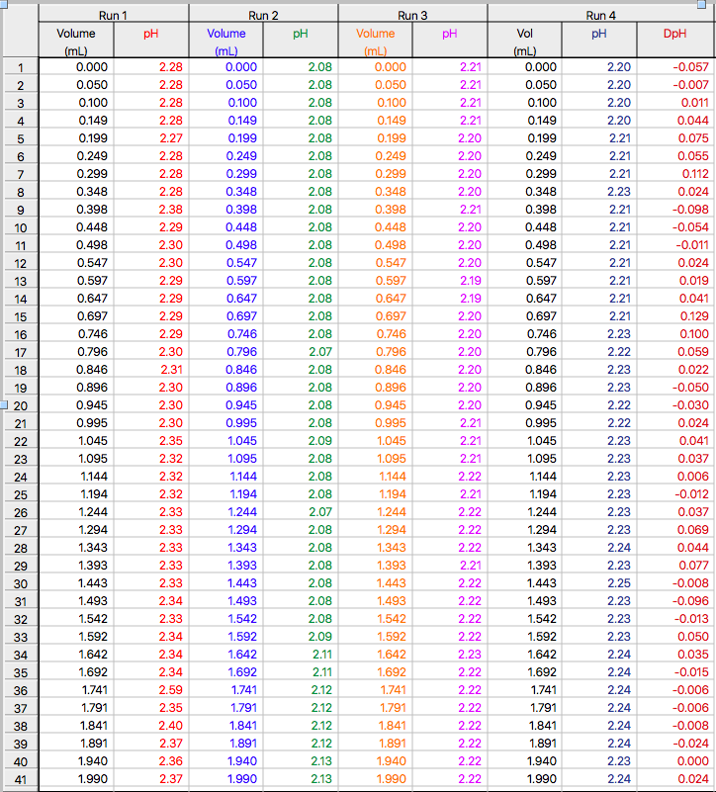

Partial representation of data collected in the standardization of an unknown diprotic acid with NaOH (trials 1 and 2)
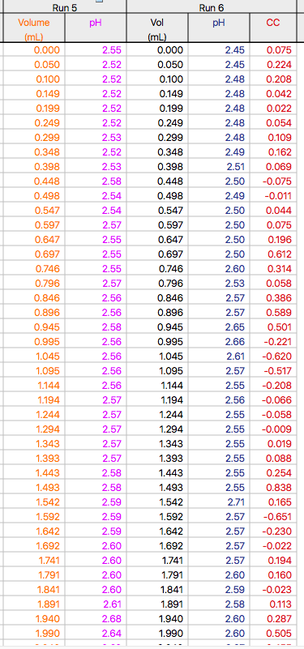

Partial representation of data collected in the standardization of an unknown diprotic acid with NaOH (trial 3)


