Block 2
Column and Thin Layer Chromatography

Introduction

In this experiment, column and thin layer chromatography were explored. Chromatography is used to purify the desired final product and to separate compounds based on their polarity.¹
Column chromatography is used to separate large quantities of material. The column is packed with a stationary phase, such as silica gel, and then a solvent is used as the mobile phase. The chosen mixture is then adsorbed to the top of the silica gel and numerous fractions are obtained by elution. Gravity will draw the mobile phase down through the column and will be collected in test tubes. Silica gel is very polar, therefore more polar molecules will have a greater attraction to the silica gel and elute slower than less polar molecules. Therefore, the less polar components of the mixture will elute first out of the column since it will have a weaker attraction with the silica gel, while the more polar components of the mixture will elute later on.²
Thin layer chromatography (TLC) is used for reaction monitoring or to determine the purity of the sample. In this experiment, thin layer chromatography was used to monitor the separation of the two unknown components (biphenyl and benzil) in the sample mixture provided. Each fraction was spotted on a TLC plate and the reaction was monitored by how far the spots travelled up the TLC plates. TLC plates also use silica gel as the stationary phase, and a solvent as the mobile phase.³ Each fraction resulting from the column chromatography was spotted on a TLC plate to monitor the separation of the mixture. If the separation was successful, it would be suspected that the less polar component would have been present in the first few fractions, while the more polar component would have been present in the last few fractions. The movement of components is described by the R_{f} value, defined as the displacement of the component divided by the displacement of the solvent.³ That being said, the first few columns should have a high R_{f} value, since they will not have a very strong attraction to the silica gel and travel up the plate by capillary action with the mobile phase. In comparison, the last few columns should have a low R_{f} value, since they will have a stronger attraction with the silica gel and essentially “stick” to the silica gel.
Thin layer chromatography was also used to determine the optimal solvent to use in the column chromatography. The goal of this was to find a solvent system in which the difference in retention time (how long the components take to pass through a column) between the components in the mixture is maximal. The solvent is usually a mixture between a polar and a non-polar solvent, mixed in an appropriate ratio to obtain the most advantageous polarity for separation of the components. Thin layer chromatography is used to test-run solvent systems in various ratios until the optimal solvent is found. The target system is one where the slower component has an R_{f} of approximately 0.35. The difference in retention time that are too close together or too far apart will result in an unsuccessful separation by column chromatography.⁴

Procedure
As followed in the CHM3126 Lab Manual for the “Column and Thin Layer Chromatography” experiment.

Modifications
No modifications done.

Observations and Results

Table 1. Observations over the course of performing Column and Thin Layer Chromatography on a sample of two components (benzil and biphenyl)
Step | Observation
Dissolving sample in solvent (1:1 hexanes:CH₂Cl₂) | - Yellow solution formed
Loading column with dissolved sample | - Yellow solution adhered to top of silica slurry  - Sand ran dry while silica did not
Eluting 12 fractions | - Yellow solution gradually eluted out of the tube  - Fractions 2-3 were a translucent yellow while the rest were clear
Evaporating solvent using a rotary evaporator on solution obtained from fraction 1 | - White solid formed around edges of round bottom flask
Evaporating solvent using a rotary evaporator on solution obtained from combining fractions 7-12 | - A very small amount of white residual formed around edges of round bottom flask

Table 2. Results of the Column and Thin Layer Chromatography
Product | Appearance | Amount Obtained (g) | Theoretically Amount (g) | Yield (%)
Biphenyl | White powder | 0.0036 | 0.15 ± 0.06 | 1.71-4.00
Benzil | White Residual | Too minimal to be obtained | 0.15 ± 0.06 | -

TLC Plates

TLC Plates used to determine optimum solvent:
* Note: solvent systems used listed below TLC plate

TLC #1 TLC #2 TLC #3 TLC #4

TLC plates obtained from fractions acquired from column chromatography:
Solvent system used for all TLC Plates below: 1:1 hexanes:CH₂Cl₂

TLC #5 TLC #6 TLC #7 TLC #8 TLC #9 TLC #10

Note: the fraction numbers of the sample mixture are labelled above in the TLC images. For example, the first TLC plate was spotted by fractions 1 and 2 resulting from the silica gel chromatography.

Table 3. Sample Calculation of R_{f} Calculation.
TLC Number and Spotting Lane | Distance traveled by solute (cm) | Distance traveled by solvent (cm) | R_{f} Calculation
5-F1 | 3.6 | 4.5 | $$R_{f}=\frac{3.6}{4.5}$$  $$=0.80$$
NMR Spectra

Biphenyl:

Product obtained from fraction 1

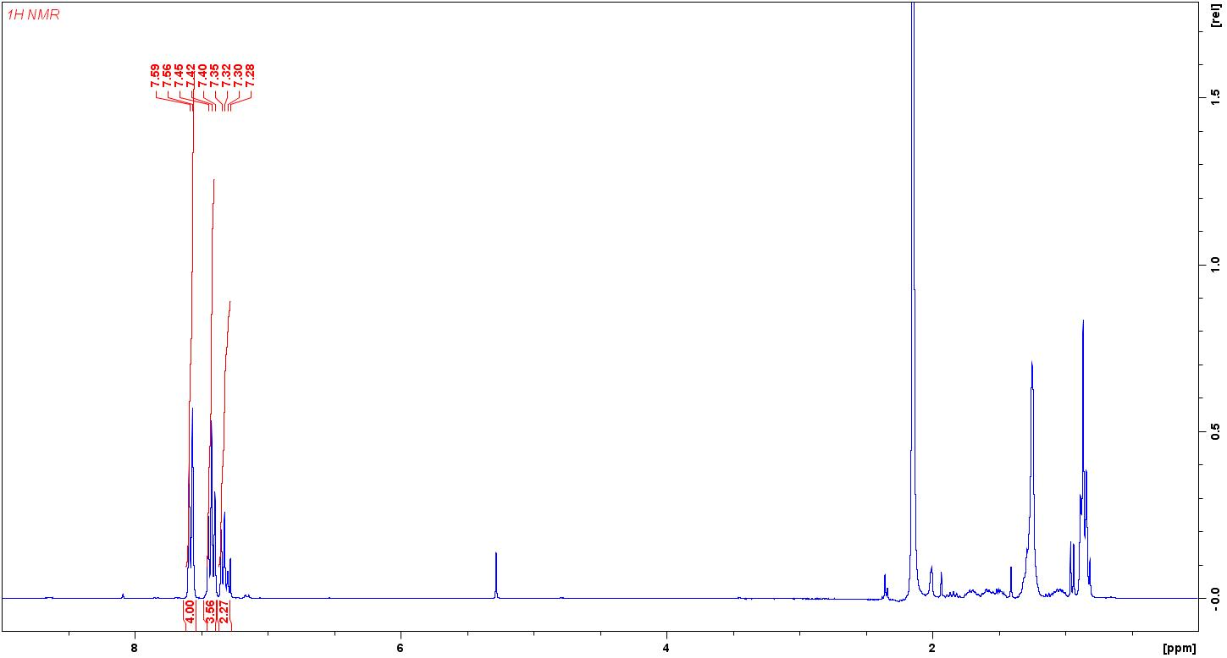
Figure 1. ¹H NMR spectra obtained of the product obtained from fraction 1 after column chromatography.

Table 4. ¹H NMR data of the product obtained from fraction 1 after column chromatography.
Peak (ppm) | Proton Label | Integration (#H) | J Coupling (Hz) | Multiplicity
7.59-7.56 | A | 4 | 9 | d
7.45-7.40 | B | 4 | - | m
7.32-7.28 | C | 2 | - | m

Benzil:

Product obtained from fractions 7-12

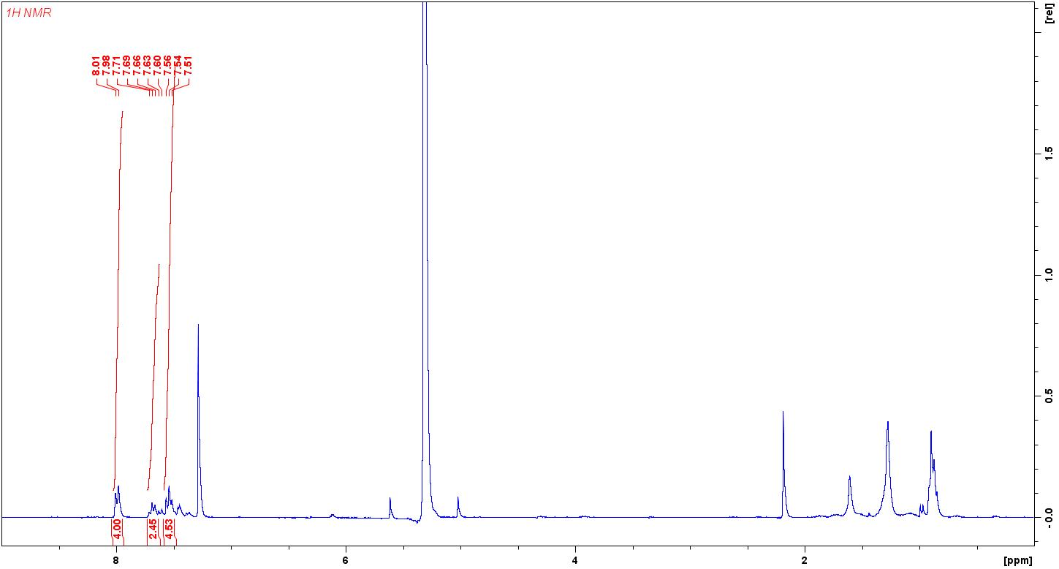
Figure 2. ¹H NMR spectra obtained of the product obtained from fractions 7-12 after column chromatography.

Table 5. ¹H NMR data of the product obtained from fractions 7-12 after column chromatography.
Peak (ppm) | Proton Label | Integration (#H) | J Coupling (Hz) | Multiplicity
8.01-7.98 | A | 4 | 9 | d
7.71-7.60 | B | 2 | - | m
7.56-7.51 | C | 4 | - | m

Discussion

The goal of this experiment was to separate a pre-weighed sample mixture containing biphenyl and benzil using column chromatography. This entailed determining the optimal solvent to use by thin layer chromatography, eluting the fractions using column chromatography, then determining the purity and yield of the separation.
The first step of determining the optimal solvent by thin layer chromatography resulted in the decision to use a solvent system of 1:1 hexanes:CH₂Cl₂. It can be seen on TLC #1 in the “TLC Plates” section above that this ratio of hexanes and dichloromethane resulted in the maximal distance of retention times between the two components. Additionally, column chromatography works best when the slower component has an R_{f} value of approximately 0.35.⁴ It can be seen on TLC #1 that the slower component had an R_{f} value of 0.29, and therefore the 1:1 ratio of hexanes:CH₂Cl₂ was the one that was chosen. It can be seen in TLCs #2 and #3 that increasing the polarity of the solvent resulted in higher R_{f} while decreasing the polarity resulted in lower R_{f} values. This makes sense since the more polar solvent can form more interactions with the stationary silica phase, therefore, the interaction with the spotted sample will decrease. That being said, a more polar solvent system will result in higher R_{f} values.
After choosing the optimal solvent system, the column was packed and loaded with the sample mixture. The sample was loaded and adsorbed to the silica gel successfully. This was evident because the yellow mixture was clearly visible at the top of the silica gel and under the sand. As the fractions were collected, it was apparent that the yellow sample slowly eluted out of the column. This elution resulted in a total of 12 fractions, where fractions 2 and 3 were yellow while the other columns were clear. This seemed to be evident that the separation was successful since the yellow compound was clearly visible travelling down the column.
After the fractions were obtained, TLCs were taken of each fraction and the fractions with the same R_{f} values were combined to have one sample of each component of the mixture. By looking at the TLC plates above, it is clear that fractions 2-6 had both compounds present in the test tube. Therefore, fraction 1 was put aside and was determined that it contained the less polar compound due to the high R_{f} value. Fractions 7-12 were put aside and combined, and determined that it contain the more polar compound due to the low R_{f} values. Since fractions 2-6 had both compounds present, these were disposed. Since biphenyl is less polar than benzil, it was suspected that biphenyl was present in fraction 1 while benzil was present in fractions 7-12.
After dissolving the solvent using a rotary evaporator, the product obtained from fraction 1 was present as a white powder along the edges of the flask. In comparison, the product obtained from fractions 7-12 was extremely small, and present as a white residual on the edges of the flask. After using the rotary evaporator, it was evident that the percentage yields of each compound were very low. A percentage yield of 1.71-4.00% was obtained for biphenyl, while a percentage yield of benzil could not have been calculated since the product obtained was so minimal. This unsuccessful separation could have been due to a number of reasons such as: letting the column run dry resulting in the silica to crack, accidentally mixing up the solvent system ratio, or simply not packing the column properly – too much silica slurry was added to the column and as a result, there was not enough room for 8 cm of solvent to be poured on top. It is also likely that the fractions 2-6 were the ones that had the majority of the mixture in them, however since they were disposed did not count towards the final yield. This is even more likely since fractions 2-3 were the ones that were yellow. On TLC #7 spotted by fractions 5 and 6, the spots with the higher R_{f} value were much paler than the ones with the low R_{f} values. It could be possible that only small traces of the low polarity component (biphenyl) were present in these fractions and it might have been a better idea to include fractions 5 and 6 in the combination of fractions 7-12. Additionally, the spots from fractions 7-12 were somewhat pale as well. This could be due to only a small amount of benzil being present in these fractions, and would explain the extremely low yield.
Although a low yield was obtained, the ¹H NMR spectra acquired displays that the separation was somewhat successful. The first fraction was verified to be the less polar compound, biphenyl, while fractions 7-12 were verified to be the more polar compound, benzil. This was verified since Figure 1, displaying the biphenyl spectrum, has the aromatic peaks from 7.59-7.28. In comparison, Figure 2, displaying the benzil spectrum, has the aromatic peaks from 8.01-7.51. Since benzil is more electronegative than biphenyl, it is expected that the aromatic region would be shifted slightly to the left of the spectrum, which is clearly evident in the spectra obtained. It is also very odd that the aromatic peaks present in Figure 2 are very small. They should have had a similar height to what is seen in Figure 1.
In addition, there are many impurities in both ¹H NMR spectra obtained. In Figure 1, there is a peak at approximately 5.30 ppm which is likely a result of dichloromethane used in the solvent system. There are also numerous peaks in the range from approximately 2.40 ppm to 0.70 ppm. These could be a result of hexanes used in the solvent system or acetone that was used to clean the lab equipment and not dried properly before starting the experiment. In Figure 2, there is a clear chloroform peak at 7.26 ppm. This could have resulted if the deuterated- chloroform bottle was left open. There is also a very large peak at around 5.40 ppm which again could have been a result of dichloromethane present. Similarly, there are numerous peaks from approximately 2.10 ppm to 0.70 ppm which could have been a result of hexanes or acetone present in the product. Lastly, it is strange that the first peaks in Figure 1 and 2 (7.59-7.56 ppm and 8.01-7.98 ppm, respectively) are both present as doublets. Looking at the suspected product structures, it is clear that these should have been present as doublet of doublet of doublet of doublets (dddd).
In conclusion, column chromatography is a great way to purify crude mixtures to obtain the desired final product. Column chromatography is one of the most rapid and reliable methods to separate mixtures and purify crude products⁵, and can be done so at quite high yields if done accurately.

Questions

- Which of the following sets of compounds is likely to have the largest R_{f} on a typical silica gel TLC? Give a reason for your choice.

The second molecule above would have the largest R_{f} value due to the methyl group present. Since methyl groups are non-polar, the second molecule is slightly less polar than the first and therefore will have a larger R_{f} value

The second molecule would have the largest R_{f} value due to the long hydrocarbon chain present. Hydrocarbons are non-polar, therefore the second molecule is less polar than the first and therefore would have a larger R_{f} value.

The first molecule would have the largest R_{f} value due to the weaker dipole than the second molecule. The first molecule has one partial dipole pointing up and one pointing down as a result of the two electronegative groups present in the para direction. These dipoles would therefore cancel each other out, making this molecule the least polar out of the two. In contrast, the second molecule has two electronegative functional groups in the ortho position, creating a partial dipole in that direction (diagonally right and up), making this molecule more polar than the first.

- You are given a mixture of biphenyl, benzyl amide and benzyl amine. The sample is spotted on a TLC plate and eluted. Predict the relative R_{f} values for the three components.

Biphenyl is the least polar and therefore would have the highest R_{f} value around 0.80. Benzyl amide is the most polar and therefore would have the lowest R_{f} value, likely around 0.35 if using the optimal solvent. The polarity of benzyl amine is between the two, and therefore would have an R_{f} value of between 0.35-0.80.

- A blue compound was placed on the top of a chromatography column and solvent was immediately added to fill the reservoir. The entire volume of solvent in the reservoir turned blue. No separation was realized during elution of this column. What went wrong? How could this be corrected?

It is likely that the blue compound did not adsorb to the top of the silica. This could have resulted if the individual did not let the sand run dry enough in order for the blue compound to adsorb. If adsorption did not occur, the blue compound would simply dissolve into the solvent and result in the entire volume of solvent in the reservoir turning blue. This can be corrected by allowing the compound to properly adsorb to the top of the silica gel by running the column until the sand runs dry before adding any solvent.

- A yellow compound is placed on a column and the column is eluted with hexanes. After a large volume of solvent has been collected but the yellow band is still at the top of the column. What should be done to recover the yellow compound? How could this experiment have been done better?

It is likely that the yellow compound is too polar to be eluted with hexanes. This would cause the yellow compound to stick to the polar silica gel and not elute properly out of the column. To recover the yellow compound, a more polar solvent can be added to the column, such as dichloromethane. This experiment could have been done better by determining the optimal solvent system using TLC before running the column. A higher polarity solvent should have been used for the mobile phase, which would result in a better separation of the yellow compound. This can be done by mixing hexanes and dichloromethane in an appropriate ratio to obtain the desired polarity of the mobile phase, allowing the yellow compound to elute properly.

- Indicate how the following errors could be corrected.

  - A mixture of 1,2-dimethylbenzene and 1,3-dimethylbenzene shows one spot with an R_{f} of 0.96 when eluted with ethyl acetate.

Eluting the mixture of 1,2-dimethylbenzene and 1,3-dimethylbenzene with a lower polarity solvent system will result in two spots with lower R_{f} values. Adding a non-polar solvent such as hexanes in an appropriate ratio to ethyl acetate could fix the problem.

  - A mixture of adipic acid and benzoic acid gives one spot with an R_{f} of 0.03 when eluted with hexanes.

Eluting the mixture of adipic acid and benzoic acid with a higher polarity solvent will result in two spots with higher R_{f} values. Adding a polar solvent such as ethyl acetate in an appropriate ratio to hexanes could fix the problem.

References

¹ The Basics of Running a Chromatography Column. (2016, August 07). Retrieved October 7, 2018, from https://bitesizebio.com/29947/basics-chromatography-column/

² Clark, J. (2007). Column chromatography. Retrieved October 6, 2018, from https://www.chemguide.co.uk/analysis/chromatography/column.html

³ Clark, J. (2007). Thin layer chromatography. Retrieved October 6, 2018, from https://www.chemguide.co.uk/analysis/chromatography/thinlayer.html#top

⁴ Millar, S. (2012, July 3). Tips and Tricks for the Lab: Column Choices. Retrieved October 7, 2018, from https://www.chemistryviews.org/details/education/2101817/Tips_and_Tricks_for_the_Lab_Column_Choices.html

⁵ Franco, J. (n.d.). JoVE. Retrieved October 7, 2018, from https://www.jove.com/science-education/10217/column-chromatography

