A Kinetic Study: Catalase

Name, St. #

Teaching Assistant:

Wednesday, November 21st, 2018

University of Ottawa

Introduction:

Catalase
Enzymes are large proteins that can act as catalysts and lower the activation energy of a chemical reaction and speed up the reaction (Sciencing, 2018). Catalase is an enzyme found in many organisms. It’s main role is to catalyse hydrogen peroxide which forms from metabolism of fats and carbohydrates into oxygen and water (Sciencing, 2018). Hydrogen peroxide has very harmful effects to the organism’s body. It is destructive to many tissues and membranes and therefore the presence of catalase to decompose hydrogen peroxide is crucial to life. The chemical equation below is catalysed by catalase.

2 H2O2 (aq) → 2 H2O (l) + O2 (g)

Catalase has a channel into which H2O2 can attach to (UCSB scienceline, 2002). This channel includes a heme group which has an iron molecule bound in the centre of a porphyrin ring (UCSB scienceline, 2002). The iron acts as a reducing agent for the reaction. This reaction with catalase has is known and supported to be a two-step mechanism;

[catalase-Fe(III)] + H2O2 → H2O + [catalase-Fe(IV)=O]
[catalase-Fe(IV)=O] + H2O2 → H2O + O2 + [catalase-Fe(III)]

In the first part of the reaction Fe(III) is oxidized to Fe(IV). Hydrogen peroxide bounds to the heme group and oxidizes it to Fe(IV) (UCSB scienceline, 2002);

[catalase-Fe(III)] + H2O2 → H2O + [catalase-Fe(IV)=O]

In the second part of the reaction the enzyme will go to the Fe(III) form by using up a second molecule of hydrogen peroxide and reducing it to water (UCSB scienceline, 2002). This releases water and oxygen.

[catalase-Fe(IV)=O] + H2O2 → H2O + O2 + [catalase-Fe(III)]

This catalase activity is mostly carried out in the liver, kidney and red blood cells. Catalase speeds up the activity by lowering the required activation energy to break the bonds between H2O2 molecules (Sciencing, 2018). The rate of this reaction can be written as follows;

Rate = k$[H2O2]^{x}[catalyst]^{y}$

Where k is the rate constant for the reaction, x is the order of the reaction with respect to H2O2 concentration, and y is the order of the reaction with respect to catalyst concentration.

Chemical kinetics
Kinetics means study of motion. It originates from the Greek kinesis, meaning movement (Chieh). Chemical kinetics is a branch of physical chemistry. It is the study of a chemical reaction and its reaction rate as well as focusing and analyzing the effects of different variables/concentrations, re-arrangement of atoms, intermediates, etc (Leidler, 2013). This helps to know the factors that affect chemical reaction rates and gives an idea as to how to make a chemical reaction more useful and less time consuming.

Reaction rate
The rate law is an expression that relates the concentration of reactants and rate constant to the reaction rate (Libretexts, 2016). The rate constant, k, is a constant value that is the same for the chemical reaction at a particular temperature. The rate law equation can be expressed as follows;

Rate=k$[A]^{x^{}}[B]^{y}$

Where x is the order of reaction with respect to reactant A and y is the order of reaction with respect to reactant B. The reaction rate is dependant on rate constant and can be dependent on the concentrations of the reactants (if the order with respect to a reactant is 0 then the concentration of that reactant does not affect the reaction rate).

Order of a reaction
The overall order of the reaction is dependent on the orders with respect to each reactant (Libretexts, 2016). The overall order can be found by adding x and y in the reaction rate equation (Libretexts, 2016). The respective orders can be very useful to know to increase the effectiveness of an experiment. For example, if the order with respect to one of the reactants is zero, then adding more of that reactant does not aid in causing the chemical reaction to happen at a faster rate. This only wastes the resources and time. The order of a reaction is always found experimentally it can not be calculated.

The Arrhenius equation
An increase in temperature causes the molecules involved in a chemical reaction to move faster as their kinetic energy increases (Libretexts, 2017). This causes the reactants to collide more frequently and therefore making the chemical reaction that they are involved in occur at a higher rate (collision theory). In 1899, the Swedish chemist Svante Arrhenius came up with one of the most important equations in physical chemistry relating rate constant to temperature (Libretexts, 2017);

k = A$e^{-Ea/RT}$

Where k is the rate constant, e is the base in natural logarithms (a number), Ea is the activation energy, R is the gas constant (8.314 J/KT), T is temperature in kelvins and A is the pre-exponential factor (the fraction of molecules that would react if either the activation energy was 0, or if the kinetic energy of all molecules exceeded Ea).

This relationship suggests that the lower the activation energy and the higher the temperature, the rate constant will be higher (Libretexts, 2017). Hence, this will also increase the reaction rate and rate constant, k, is a factor that is being multiplied in the rate constant equation.

This expression can also be written as the more convenient form;

ln k = ln A - Ea/RT

Activation energy
Activation energy is the minimum amount of energy required for activating molecules or atoms to undergo transformation and enter the transition state and forming products (Libretexts, 2017). Only the molecules and atoms that have this energy will react. One way to find activation energy is by experimentally measuring rate constants, k, at two different temperatures (Libretexts, 2017). The equation below can be used to then solve for Ea;

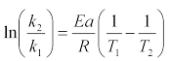

Activation energy can also be found graphically by having a graph of lnk vs. 1/T which would have a slope of Ea/R. From this relationship, by rearrangement Ea can be found (Libretexts, 2017).

Materials:

- Gas pressure sensor
- LabQuest 2
- Thermometer
- Lettuce
- Blender
- Hydrogen Peroxide
- Distilled Water
- Pipette
- Erlenmeyer flask
- Ice water bath
- Hot Plate
- Usb for collection of data from labquest
- Cloth for strainage of catalase

Procedure:

- In order to extract catalase from the lettuce, start by blending a certain amount of lettuce with water (just enough to make the texture of a smoothie) in a blender. After the lettuce is well blended, strain the content/mixture using the strainage cloth to allow the water and catalase mixture to separate from the other contents of the lettuce. This allows the pulp of the lettuce and the catalase of the lettuce to be separated into two.
- Repeat step 1 until an approximate amount of 100-200 mL of catalase is retrieved (depends on how many trials the experiment calls for).
- Note: Keep the catalase extract in an ice-water bath to maintain catalase activity.
- In order to measure the oxygen produced, attach a gas pressure sensor to the stopper of the erlenmeyer flask.
- In the erlenmeyer, place 2 mL of hydrogen peroxide.
- In a small glass cylindrical tube, place 10mL of the extracted catalase in the small glass tube.
- Measure the temperature of the catalase. Record this temperature.
- Now, gently place this tube into the erlenmeyer flask containing the peroxide, ensuring there is no unwarranted mixture of the catalase and peroxide until the experiment is ready to proceed.
- Using a rubber stopper (which contains an attachment to the gas pressure sensor), block the flask from any escaping oxygen which would cause discrepancies in the results.
- Once ready, mix the contents of the flask and the cylindrical tube in the flask, allowing for the reaction to begin. Note: When stirring the flask, make sure not to stir too aggressively to prevent possible damage to any equipment.
- Note the changing concentration of oxygen through the gas pressure sensor which is attached through the rubber stopper (lab quest is able to measure the max pressure reached after the reaction is complete).
- Change the concentration of hydrogen peroxide, repeating the same steps and measure the pressure of oxygen each time to find the partial order of the hydrogen peroxide.
- Through the use of the formula, one can solve for the value of x which is the partial order. R1/R2=([H₂O₂#1]/[H₂O₂#2])^{x} (note: K values cancelled out and equated to 1)
- Solve for the variable x, which is the partial order of the hydrogen peroxide (note: R1 and R2 are the changes in pressure over the change in time).
- Repeat steps 11 through 13 for the catalase in order to find the partial order of the catalase.
- Using the formula, Ea= ln(K₂/K₁)*R/ ((1/T₂)-(1/T₁)) , one can calculate the activation energy of the decomposition of hydrogen peroxide.
- Repeat steps 5 through 15 with a different temperature using a hotplate and ice water bath. An important aspect to note is the fact that the reaction proceeds very quickly, thus most of the activity occurs within the first half of the reaction.
- Use the equation in step 15 to find the activation energy.

Observations:

Table 1.0: Temperatures and Pressures Due to Varying Hydrogen Peroxide Concentrations
Part B - Hydrogen Peroxide Variations
 | Initial Temperature (ºC) | Final Temperature  (ºC) | Initial Pressure(kPa) | Final Pressure(kPa)
[H2O2] = 0.004L * 0.75 w/w H2O / 0.014L
Trial 1 | 22.7 | 16.6 | 101.42 | 110.59
Trial 2 | 25.2 | 19.5 | 101.18 | 111.04
Trial 3 | 23.1 | 19.8 | 101.65 | 110.78
[H2O2] = 0.003L * 0.75 w/w H2O) / 0.014L
Trial 1 | 23.4 | 17.7 | 101.27 | 108.60
Trial 2 | 24.2 | 21.1 | 101.52 | 107.89
Trial 3 | 23.8 | 16.9 | 101.41 | 108.08
[H2O2] - 0.002L * 0.75 w/w H2O / 0.014L
Trial 1 | 22.3 | 21.3 | 100.5 | 104.31
Trial 2 * | 23.2 | 20.3 | 100.07 | 100.36
Trial 3 | 21.4 | 20.8 | 101.06 | 104.95
Trial 4 | 21.5 | 21.4 | 100.36 | 102.63
Trial 5 | 21.6 | 20.6 | 100.66 | 103.47

Table 2.0: Temperatures and Pressures of Varying Temperatures of Catalase
Part C - Temperature Variation for Catalase Catalyzed Reaction
 | Initial Temperature (ºC) | Final Temperature (^{O}C) | Initial Pressure (Kpa) | Final Pressure  (kPa)
[H2O2] - 0.002L * 0.75 w/w H2O / 0.014L
Trial 1 | 23.3 | 23.3 | 100.82 | 102.37
Trial 2 | 22.9 | 22.9 | 101.47 | 105.73
Trial 3 | 23.1 | 22.9 | 101.4 | 101.53
[H2O2] - 0.002L * 0.75 w/w H2O / 0.014L
Trial 1 | 10.1 | 19.0 | 101.53 | 103.15
Trial 2 | 9.5 | 18.4 | 101.67 | 106.63
Trial 3 | 10 | 14.9 | 101.86 | 106.50
[H2O2] - 0.002L * 0.75 w/w H2O / 0.014L
Trial 1 | 34.7 | 24.6 | 101.34 | 105.14
Trial 2 | 33.2 | 24.6 | 101.21 | 102.89
Trial 3 | 35.7 | 23.8 | 101.08 | 104.31

Table 3.0: Temperature and Pressures of KI Catalyzed Reaction
Part D - Temperature Variation for KI Catalyzed Reaction
 | Temperature (ºC) | Initial Pressure (kPa) | Final Pressure (kPa)
[KI] = 0.004L * 0.1M / 0.014L
Trial 1 | 40 | 100.94 | 105.45
Trial 2 | 40 | 100.94 | 102.49
Trial 3 | 40 | 99.78 | 103.77
Trial 1 | 55 | 99.65 | 104.23
Trial 2 | 55 | 101.33 | 106.93
Trial 3 | 55 | 99.26 | 105.90
Trial 1 | 70 | 99.59 | 107.19
Trial 2 | 70 | 100.1 | 108.22
Trial 3 | 70 | 101.26 | 112.79

Graph 1.0: Part B 4mL H2O2 Trial 1
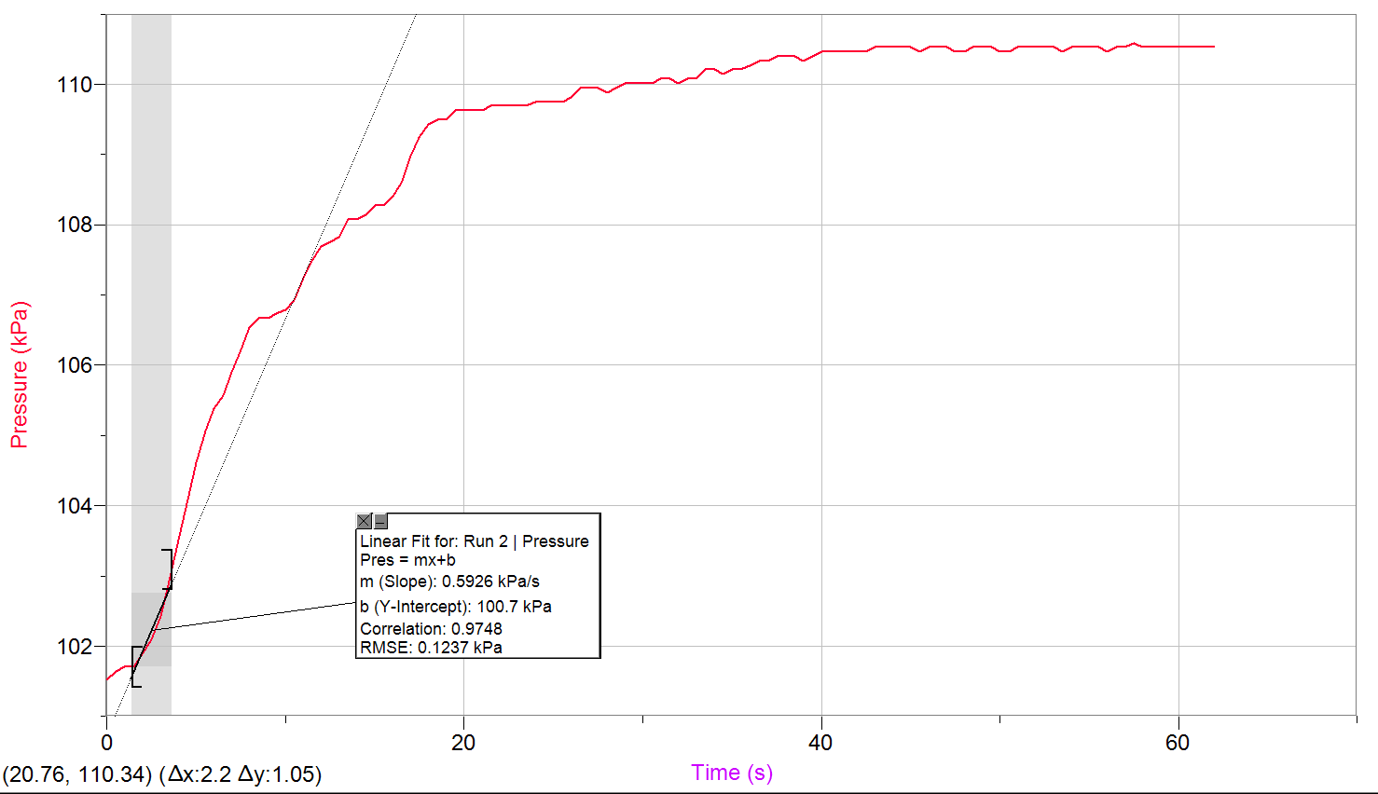

Graph 1.1: Part B 4mLH2O2 Trial 2
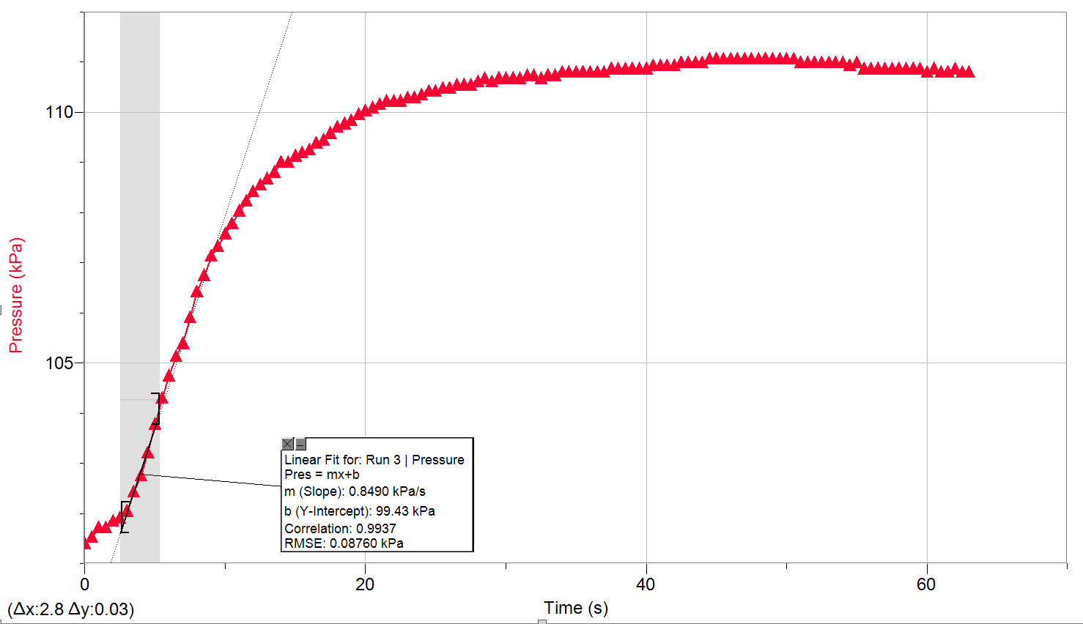

Graph 1.2: Part B 4mL H2O2 Trial 3
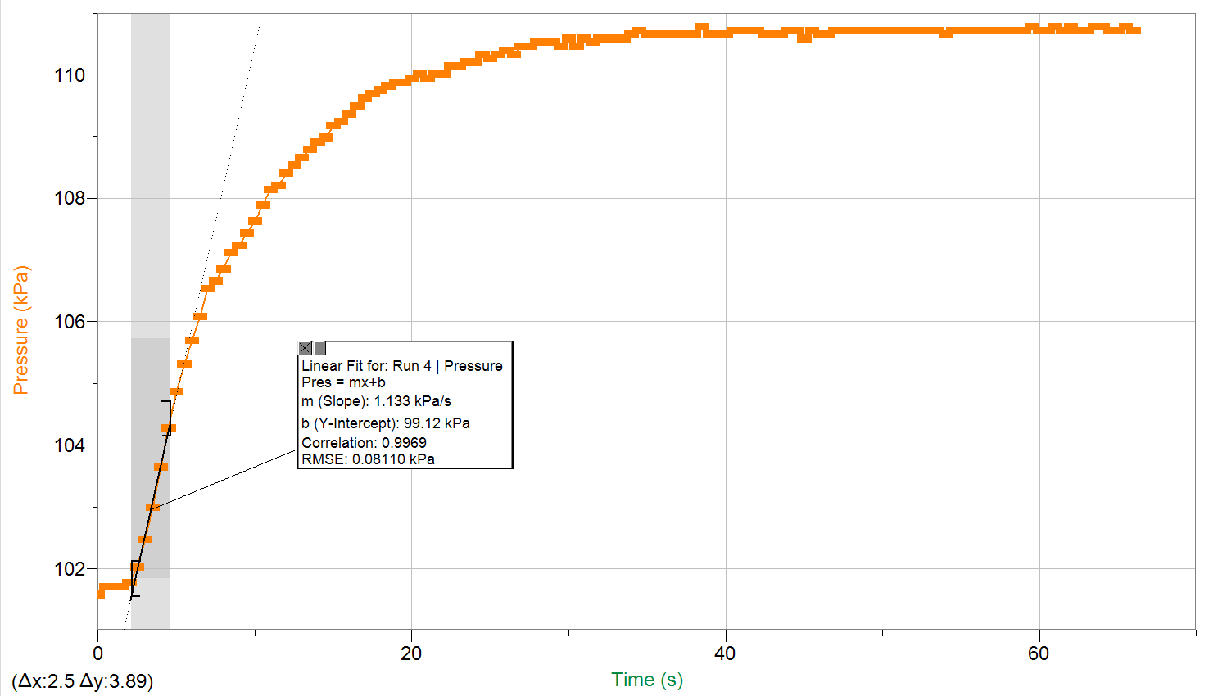

Graph 1.3: Part B 3mL H2O2 1 mL H2O Trial 1
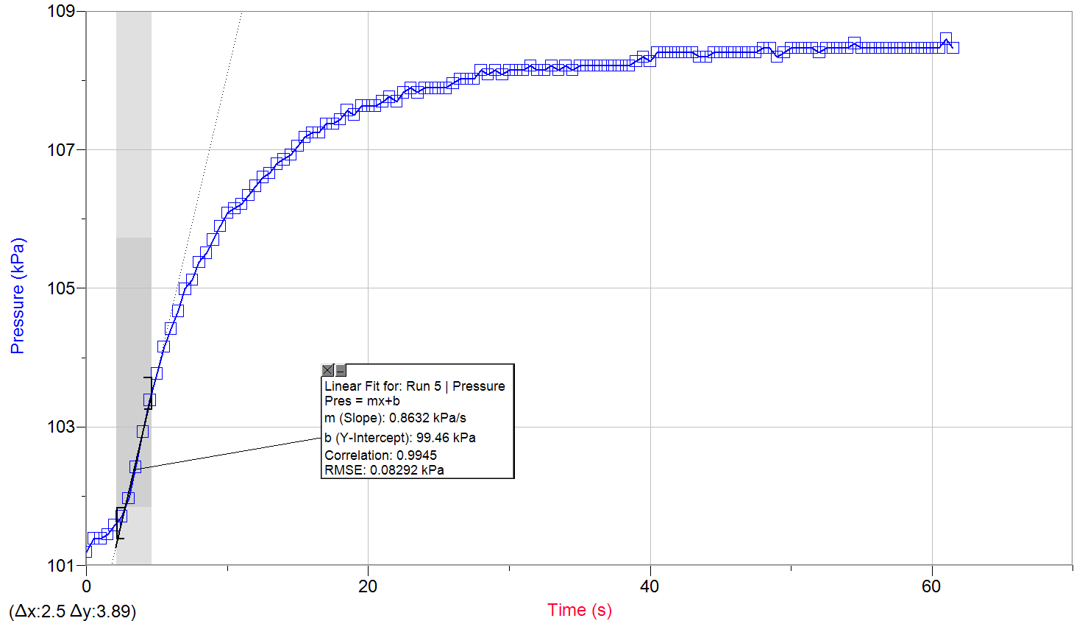

Graph 1.4: Part B 3mL H2O2 1 mL H2O Trial 2
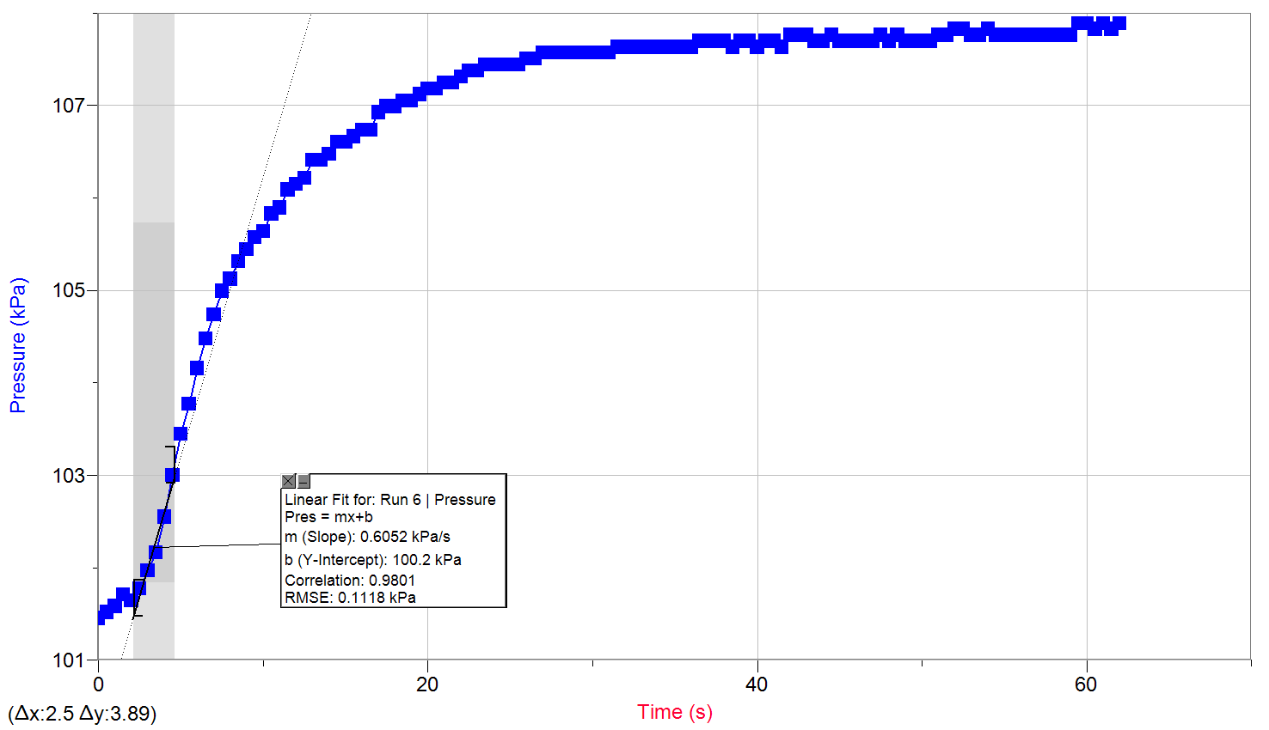

Graph 1.5: Part B 3mL H2O2 1 mL H2O Trial 3
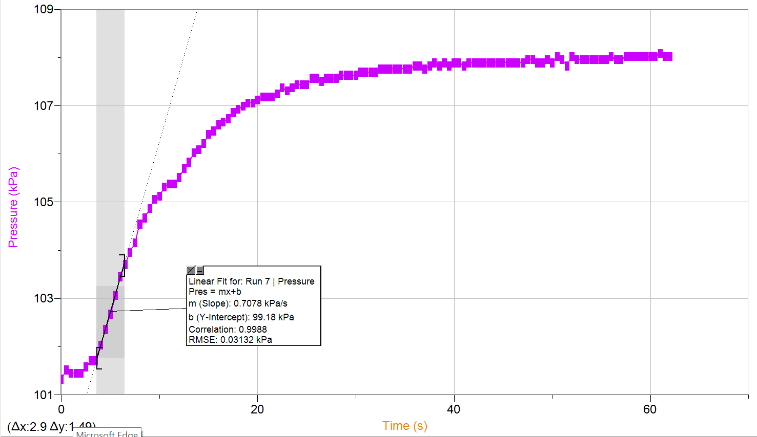

Graph 1.6: Pressure Versus Time: Trial 1 (2mL H₂O₂ with 2mL H₂O)
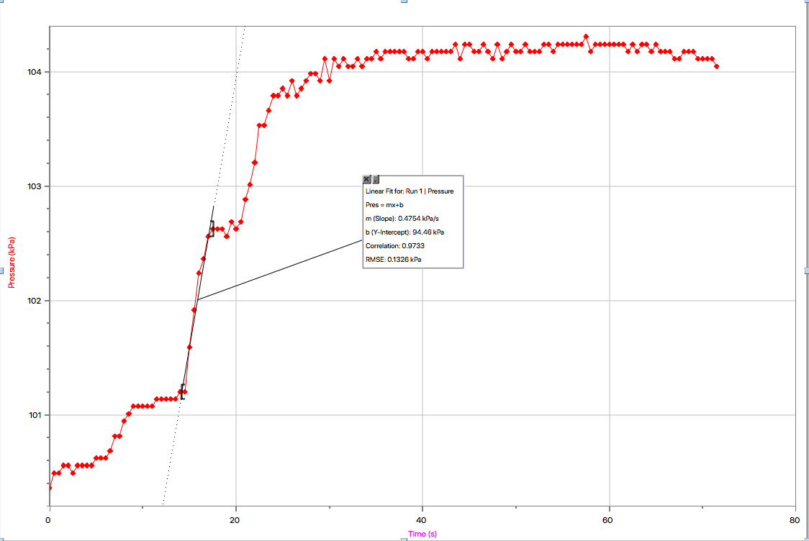
Graph 1.7: Pressure Versus Time: Trial 2 (2mL H₂O₂ with 2mL H₂O)
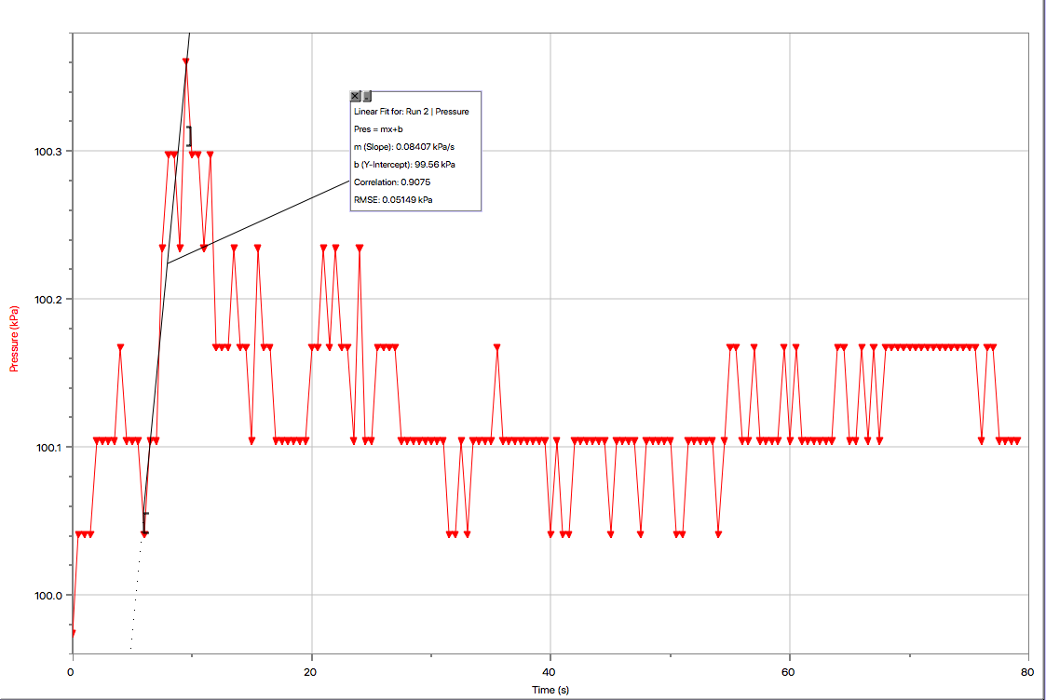
Graph 1.8: Pressure Versus Time: Trial 3 (2mL H₂O₂ with 2mL H₂O)
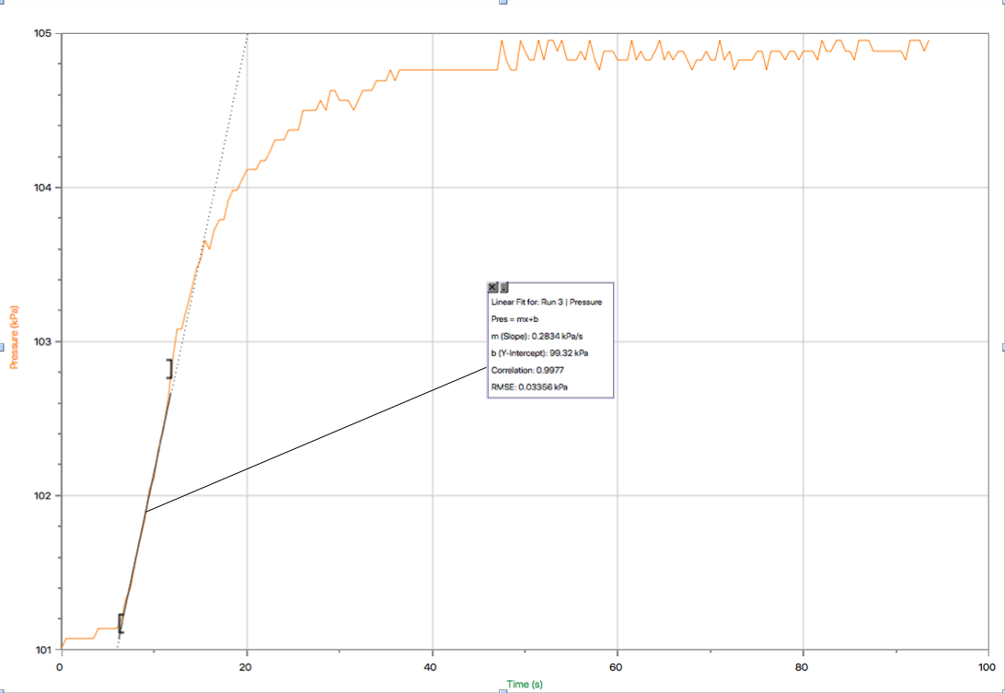
Graph 1.9: Pressure Versus Time: Trial 4 (2mL H₂O₂ with 2mL H₂O)
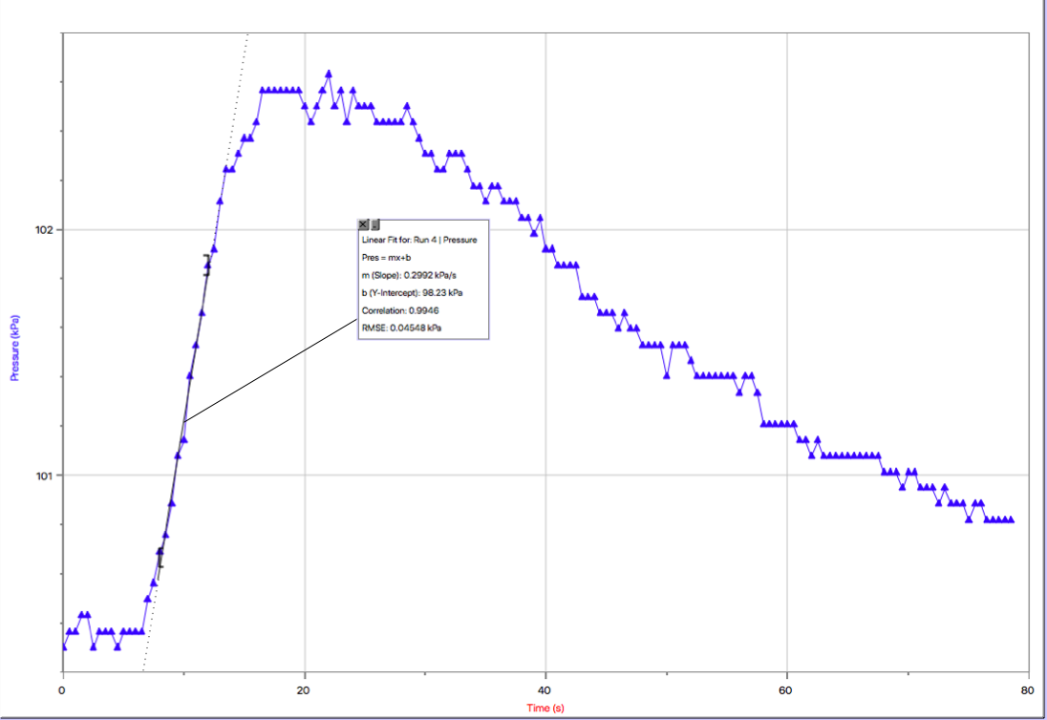

Graph 2.0:Pressure Versus Time: Trial 5 (2mL H₂O₂ with 2mL H₂O)
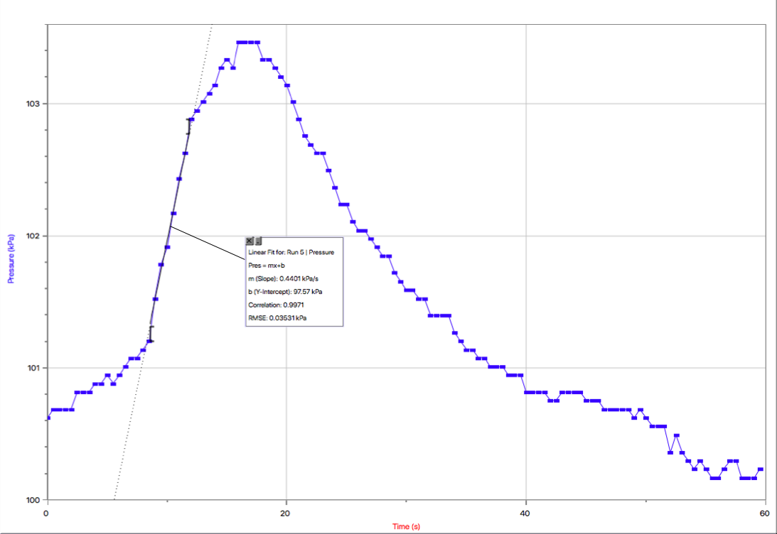

Graph 2.1: Part C Room Temperature Trial 1
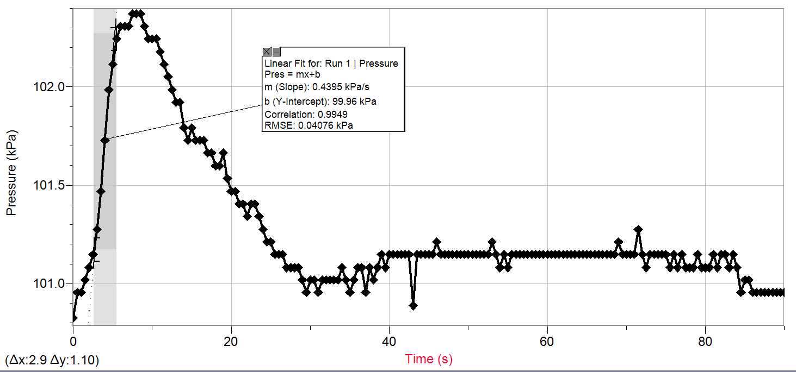

Graph 2.2: Part C Room Temperature Trial 2
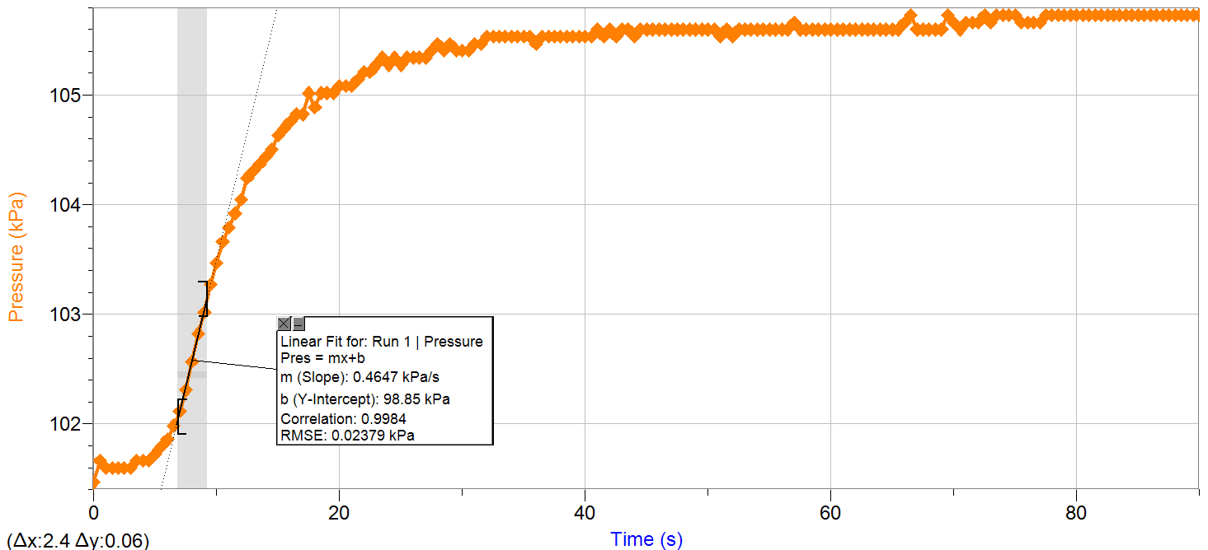

Graph 2.3: Part C Room Temperature Trial 3
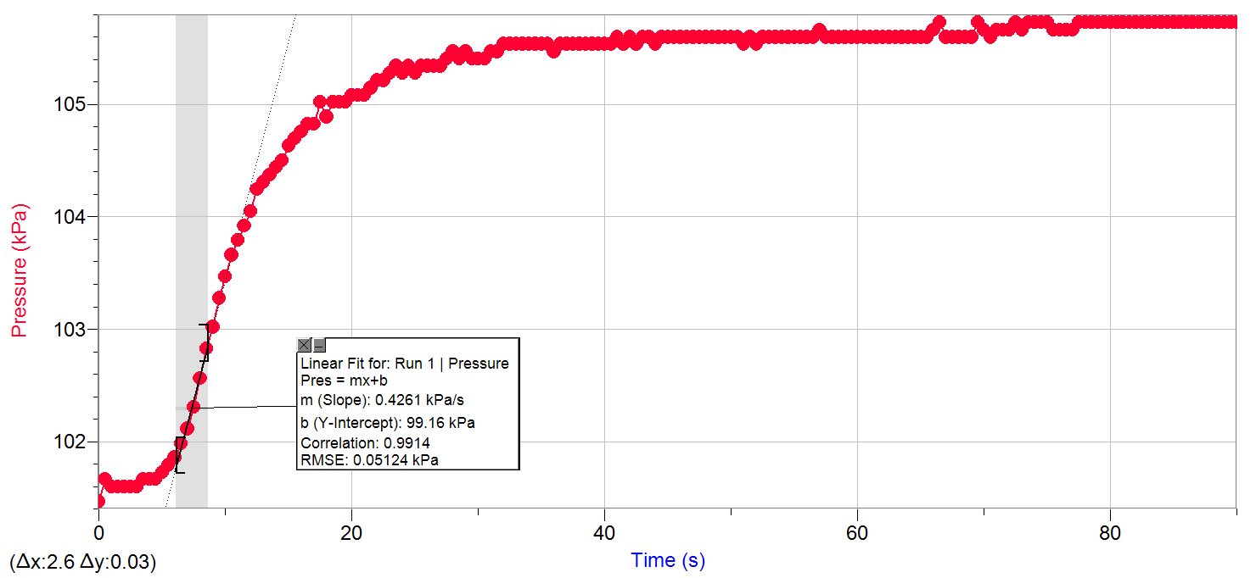

Graph 2.4: Part C Ice Water Bath Trial 1
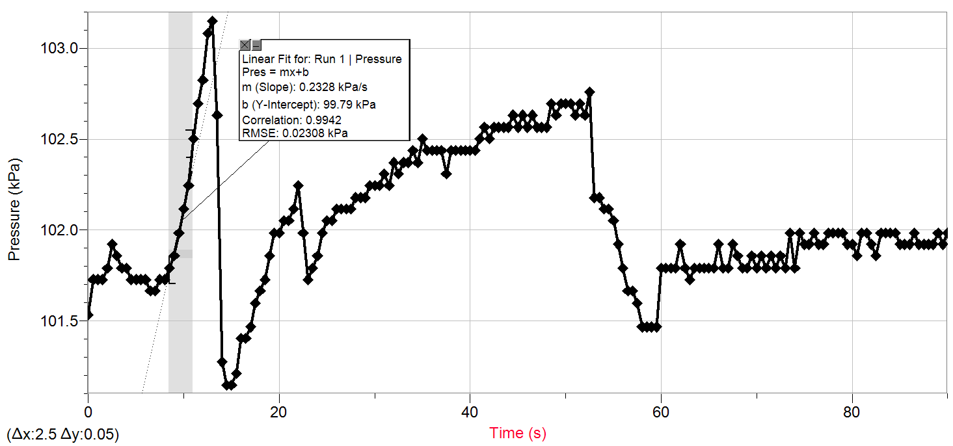

Graph 2.5: Part C Ice Water Bath Trial 2
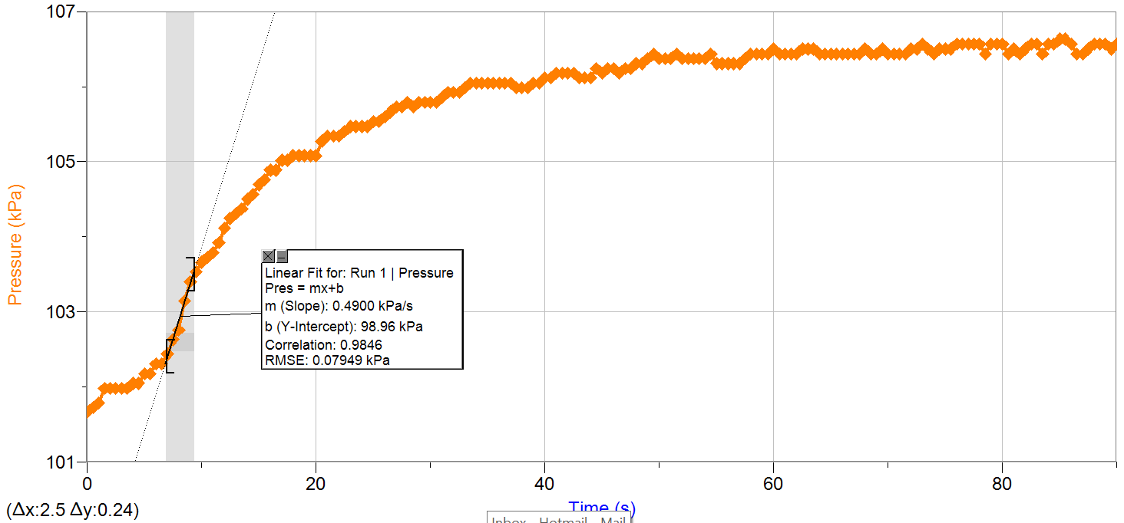

Graph 2.6: Part C Ice Water Bath Trial 3
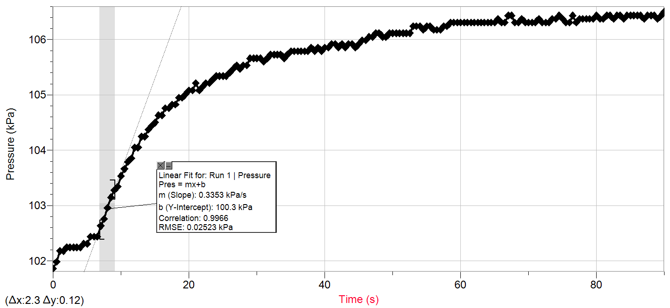

Graph 2.7: Part C Hot Water Bath Trial 1
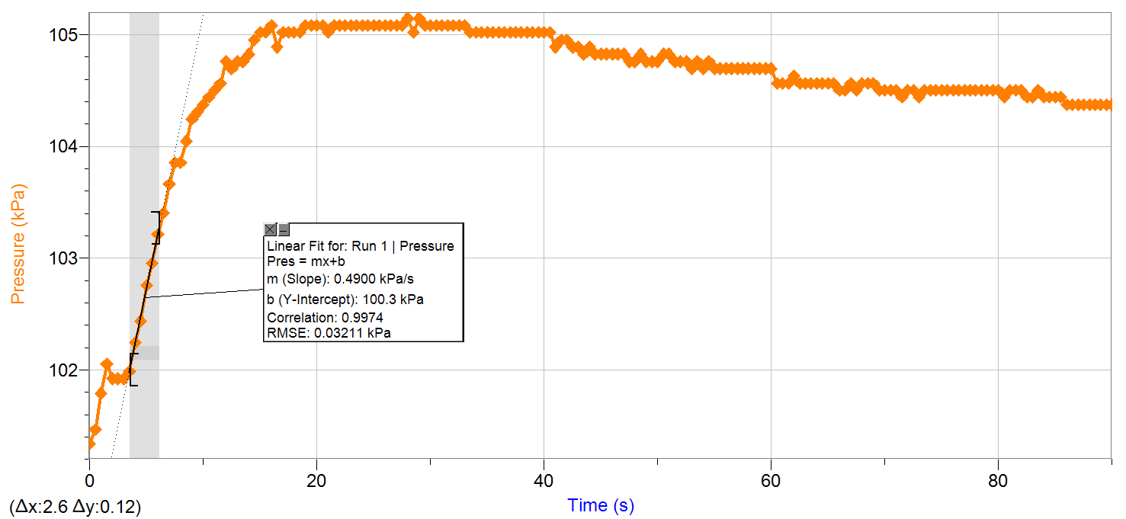

Graph 2.8: Part C Hot Water Bath Trial 2
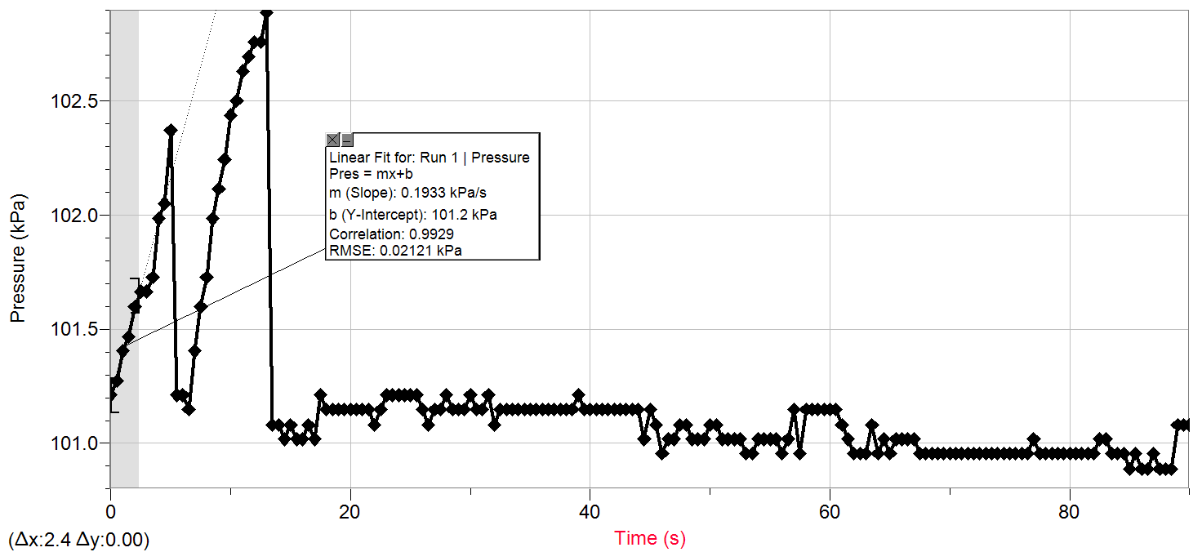

Graph 2.9: Part C Hot Water Bath Trial 3
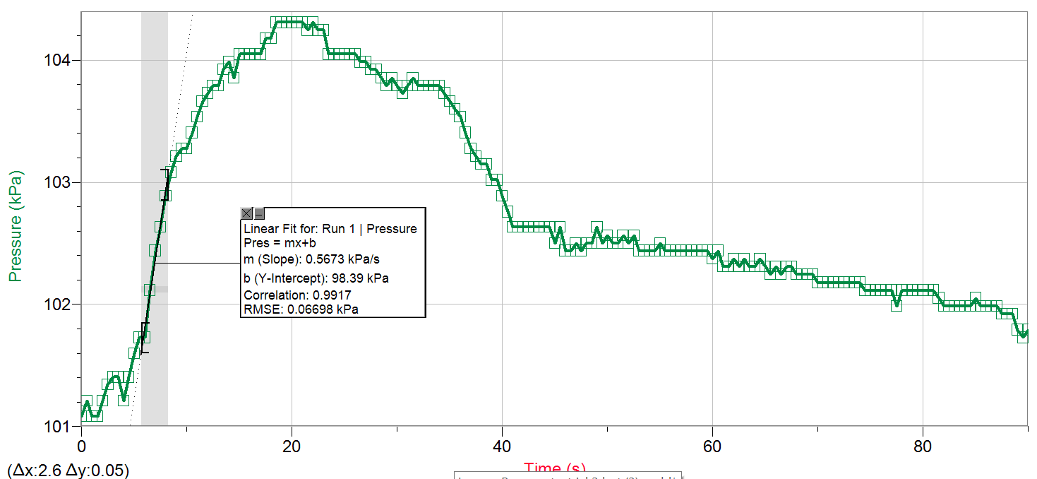

Graph 3.0: Part D Temperature Variation with KI Catalyzed Reaction: Trial 1 (40ºC)
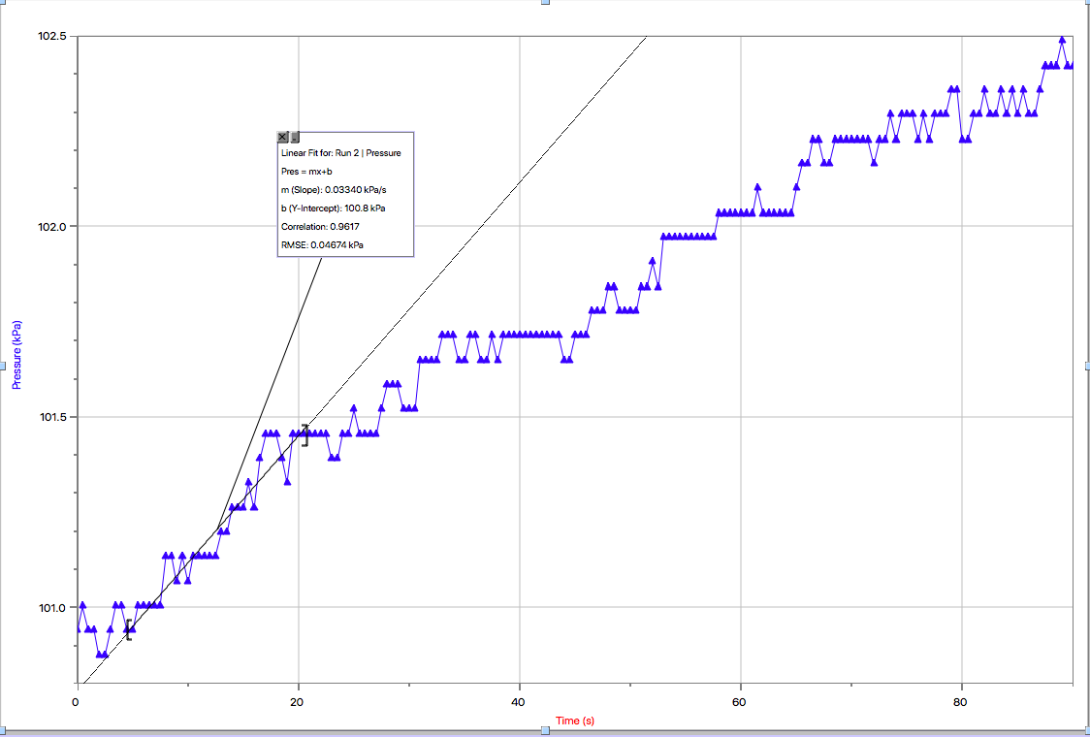

Graph 3.1: Part D Temperature Variation with KI Catalyzed Reaction: Trial 2 (40ºC)
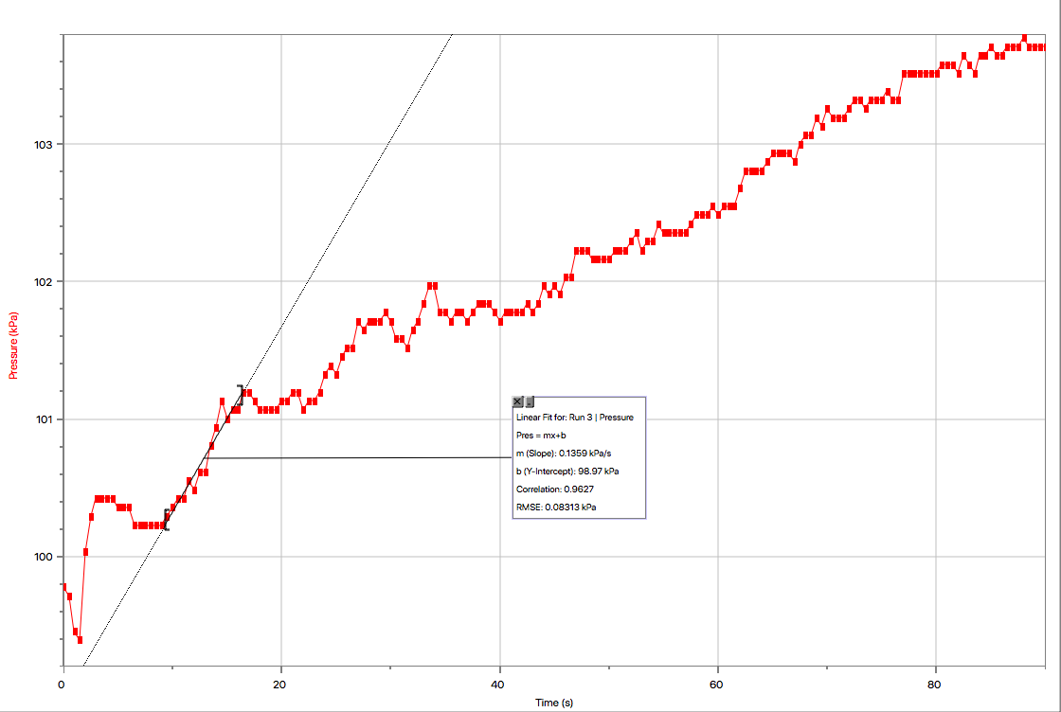

Graph 3.2: Part D Temperature Variation with KI Catalyzed Reaction: Trial 3 (40ºC)
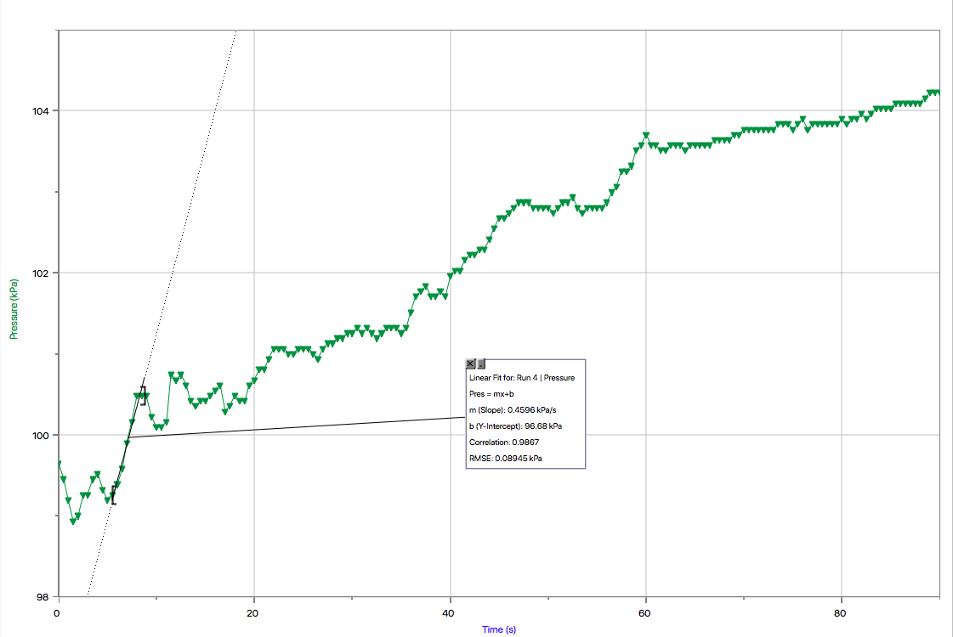
Graph 3.3: Part D Temperature Variation with KI Catalyzed Reaction: Trial 1 (55ºC)
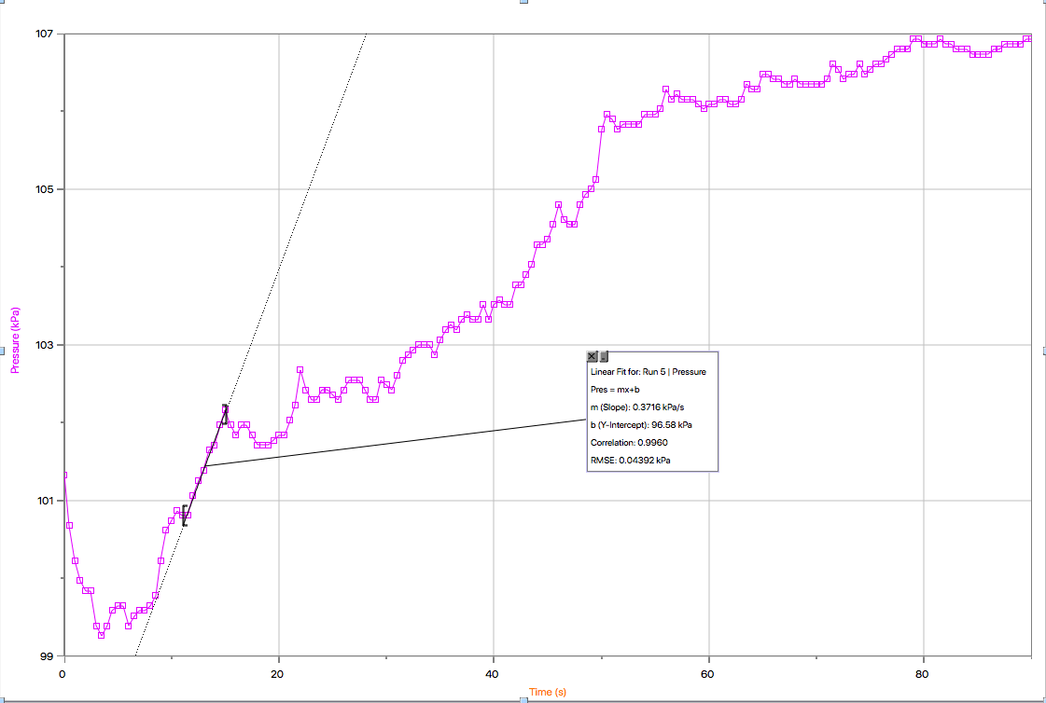

Graph 3.4: Part D Temperature Variation with KI Catalyzed Reaction: Trial 2 (55ºC)
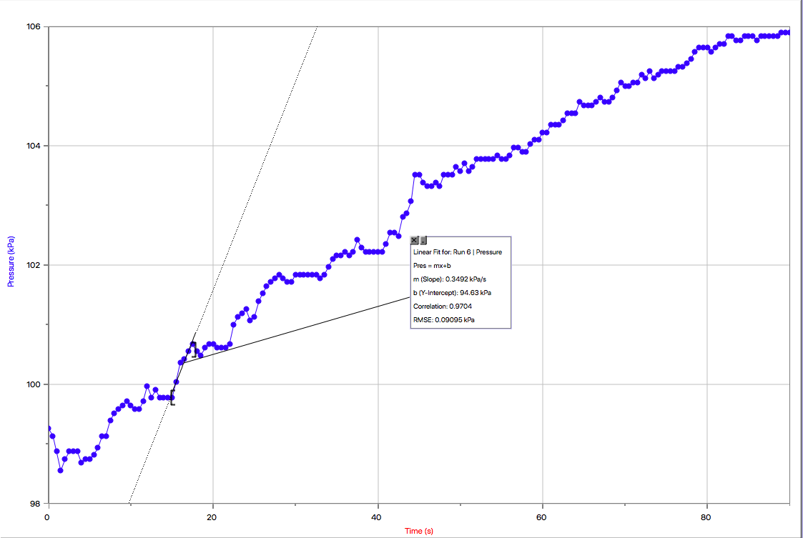

Graph 3.5: Part D Temperature Variation with KI Catalyzed Reaction: Trial 3 (55ºC)
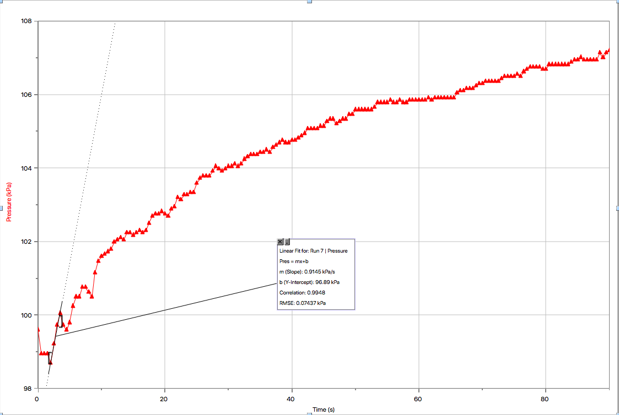

Graph 3.6: Part D Temperature Variation with KI Catalyzed Reaction: Trial 1 (70ºC)
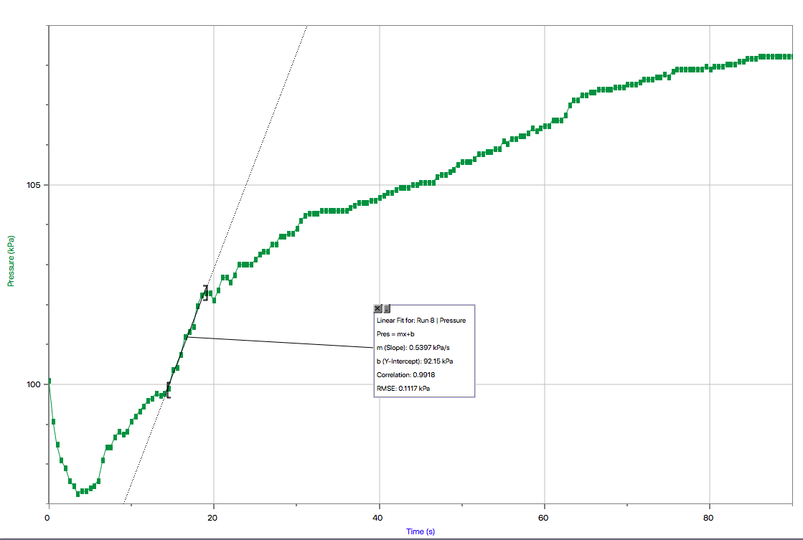
Graph 3.7: Part D Temperature Variation with KI Catalyzed Reaction: Trial 2 (70ºC)
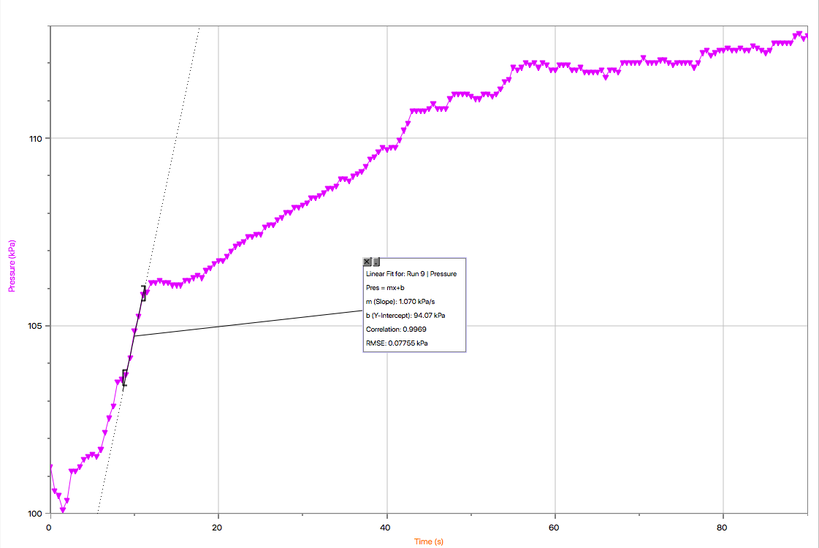

Graph 3.8: Part D Temperature Variation with KI Catalyzed Reaction: Trial 3 (70ºC)
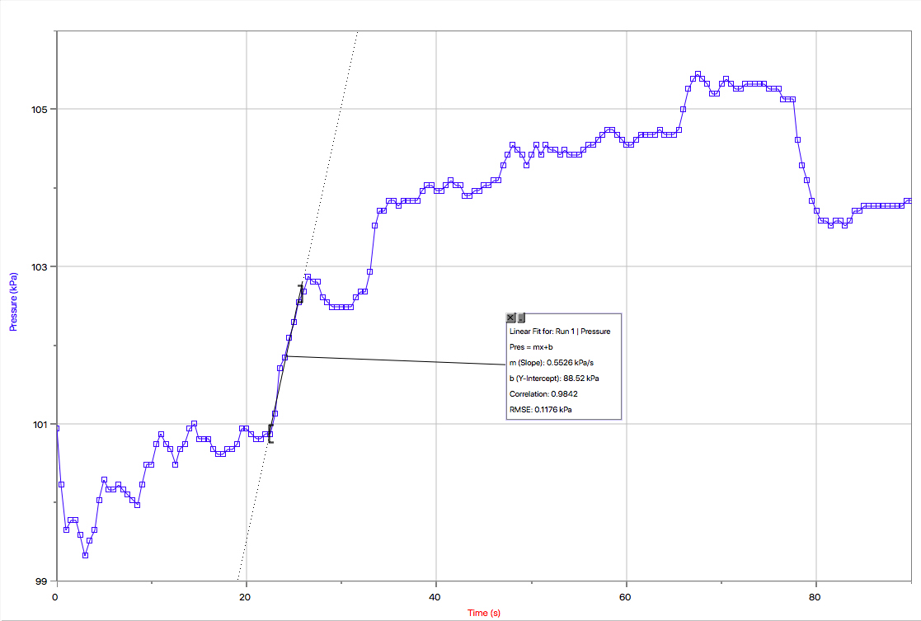

Calculations

Partial Order for H₂O₂
Rate=k[H₂O₂]^{x}[catalase]^{y}
Concentration of catalase is constant, thus Rate=k[H₂O₂]^{x}

Rate 2/Rate 1= k[H₂O₂]₂^{x}[catalase]^{y} / k[H₂O₂]₁^{x}[catalase]^{y}
Rate 2/Rate 1= k[H₂O₂]/k[H₂O₂]
Rate=[H₂O₂]^{x}[catalase]^{y}
Rate=k’[H₂O₂]^{x} which is a pseudo first order reaction
lnRate=lnk’+xln[H₂O₂]

y= b + mx

Solution A
H₂O₂ concentration-4mL
0.75% H₂O₂ = 0.75 g per 100 mL
0.75g/100mL= x/4mL
3.00g/mL=100x g/mL
(3.00g/mL)/100mL=x
0.0300 g = x

Number of moles
n=0.0300g/34.015g/mol
n=8.82 x 10^-4 mol

C=n/v
C= 8.82 x 10^-4 mol/ 0.004L
C=0.221 mol/L ln[H₂O₂]=ln(0.221M)= -1.51

Solution B
H₂O₂ concentration- 3mL
0.75% H₂O₂ = 0.75 g per 100 mL
0.75g/100mL= x/3mL
2.25g/mL=100x g/mL
(2.25g/mL)/100mL=x
0.0225 g = x

Number of moles
n=0.0225g/34.015g/mol
n=0.00066147 mol

C=n/v
C= 0.00066147 mol/0.004L
C=0.165 mol/L ln[H₂O₂]=ln(0.165M)= -1.80

Solution C
H₂O₂ concentration- 2mL
0.75% H₂O₂ = 0.75 g per 100 mL
0.75g/100mL= x/2mL
1.5g/mL=100x g/mL
(1.5g/mL)/100mL=x
0.0150 g = x

Number of moles
n=0.0150g/34.015g/mol
n=0.00044098 mol

C=n/v
C=0.00044098 mol/0.004L
C=0.110 mol/L ln[H₂O₂]=ln(0.110M)= -2.21

The ln(rate) value is obtained through the slopes of the graphs for all three trials. The values obtained are as follows. Note: for Solution C, the best three trials were included.
Thus for Solution A (4mL H₂O₂)
TRIAL 1: ln(rate)= ln(0.5926)= -0.523
TRIAL 2: ln(rate)= ln(0.8490)= -0.164
TRIAL 3: ln(rate)= ln(1.133)= 0.125 (THIS VALUE WAS NOT INCLUDED IN THE GRAPH)

Thus for Solution B (3mL H₂O₂)
TRIAL 1: ln(rate)= ln(0.8632)= -0.147 (THIS VALUE WAS NOT INCLUDED IN THE GRAPH)
TRIAL 2: ln(rate)= ln(0.6052)= -0.502
TRIAL 3: ln(rate)= ln(0.7078)= -0.346

Thus for Solution C (2mL H₂O₂) (excludes trial 2 and 3 due to error)
TRIAL 1: ln(rate)= ln(0.4754)= -0.744
TRIAL 4: ln(rate)= ln(0.2992)= -1.21 (THIS VALUE WAS NOT INCLUDED IN THE GRAPH)
TRIAL 5: ln(rate)= ln(0.4401)= -0.821

Now through inputting ln[H₂O₂] versus ln(rate) into logger pro, the slope of the graph will give us the order for the hydrogen peroxide.

Graph of ln[H₂O₂] versus ln(rate)
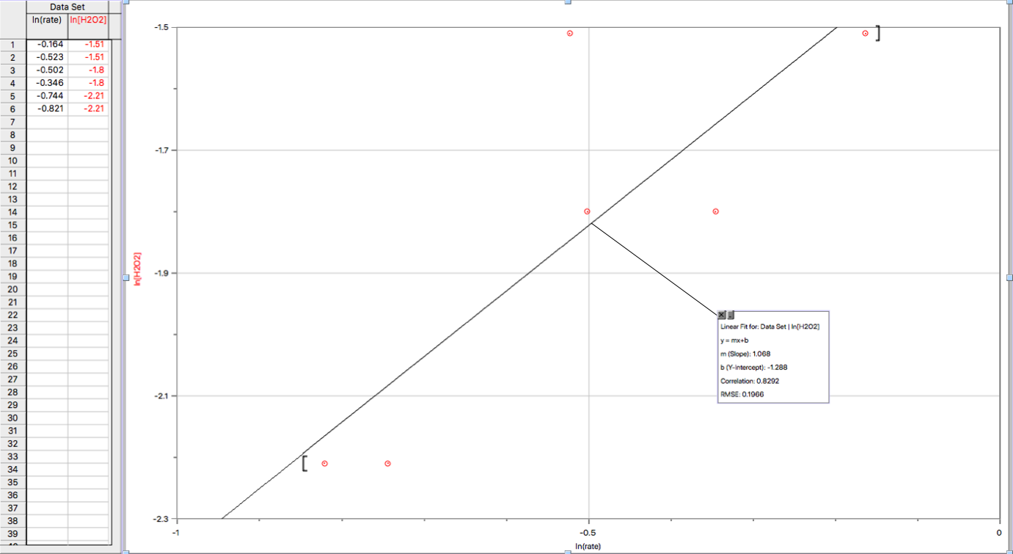
From this graph, one can see that the slope of the variables approximates to a value of 1.068, which is approximately 1.1. Thus since the slope of this graph represents the partial order of hydrogen peroxide (slop=x value), the partial order of H₂O₂ is approximately 1.1. Thus the rate equation can be represented as Rate=k[H₂O₂]^{1.1}.
Activation energy for Catalase Catalyzed Reaction of Peroxide Decomposition

Note: Averages of the temperatures were taken, thus trial 1 was 23°C, trial 2 was 10.0°C and trial 3 was 35°C.

k=Ae^{-EA/RT}
lnk=lnA - E_{A}/RT

H₂O₂ Concentration
H₂O₂ concentration- 2mL
0.75% H₂O₂ = 0.75 g per 100 mL
0.75g/100mL= x/2mL
1.5g/mL=100x g/mL
(1.5g/mL)/100mL=x
0.0150 g = x

Number of moles
n=0.0150g/34.015g/mol
n=0.00044098 mol

C=n/v
C=0.00044098 mol/0.004L
C=0.110 mol/L

23°C
Trial 1
Rate=k[H₂O₂]^{1.1}
0.4395 kPa/s= k(0.110)^{1.1}
ln(k)=ln(4.98)
ln(k)=1.61

Trial 2
Rate=k[H₂O₂]^{1.1}
0.4647 kPa/s= k(0.110)^{1.1}
ln(k)= ln(5.27)
ln(k)= 1.66

Trial 3
Rate=k[H₂O₂]^{1.1}
0.4261 kPa/s= k(0.110)^{1.1}
ln(k)= ln(4.83)
ln(k)= 1.57

10°C
Trial 1
Rate=k[H₂O₂]^{1.1}
0.2328 kPa/s= k(0.110)^{1.1}
ln(k)=ln(2.64)
ln(k)=0.971 (NOT INCLUDED IN GRAPH DUE TO ERROR)

Trial 2
Rate=k[H₂O₂]^{1.1}
0.4900 kPa/s= k(0.110)^{1.1}
ln(k)= ln(5.55)
ln(k)= 1.71

Trial 3
Rate=k[H₂O₂]^{1.1}
0.3353 kPa/s= k(0.110)^{1.1}
ln(k)= ln(3.80)
ln(k)= 1.34

35°C
Trial 1
Rate=k[H₂O₂]^{1.1}
0.4900 kPa/s= k(0.110)^{1.1}
ln(k)=ln(5.55)
ln(k)=1.71

Trial 2
Rate=k[H₂O₂]^{1.1}
0.1933 kPa/s= k(0.110)^{1.1}
ln(k)= ln(2.19)
ln(k)= 0.784 (NOT INCLUDED IN GRAPH DUE TO ERROR)

Trial 3
Rate=k[H₂O₂]^{1.1}
0.5673 kPa/s= k(0.110)^{1.1}
ln(k)= ln(6.43)
ln(k)= 1.86

ln(k) versus 1/T of a Catalase Catalyzed Reaction of H₂O₂
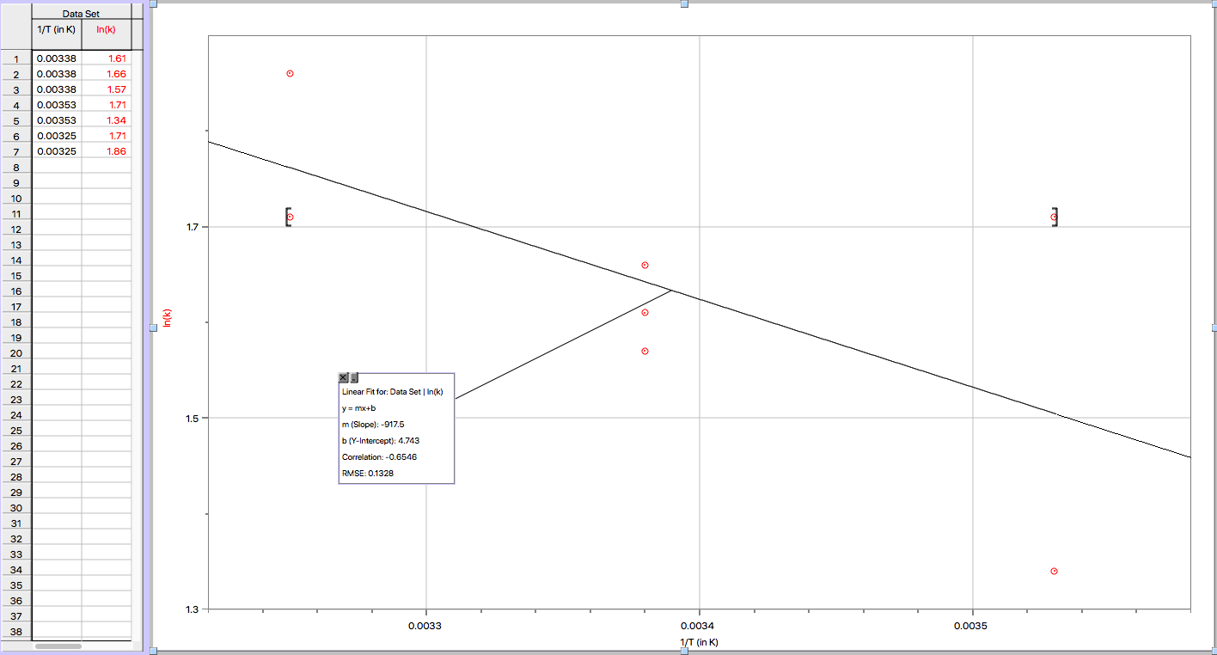

-917.5=-Ea/R
-917.5*(8.314J/K*mol)=-Ea
7628.095 J = Ea
7.63 x 10³ J= Ea

Thus, the activation energy of a catalase catalyzed reaction of H₂O₂ for the experiment at hand was approximately 7.63x10³ J, however there is quite some source of error associated with this value.

Activation Energy for the KI Catalyzed Reaction of Peroxide Decomposition

k=Ae^{-EA/RT}
lnk=lnA - E_{A}/RT

KI Concentration
KI concentration- 4mL
Concentration of KI= 0.1mol/L
0.1mol/L= x/0.002L
0.0002 mol=x

C=n/v
C=0.0002 mol/0.004L
C=0.05 mol/L
40°C
Trial 1
Rate=k[KI]^{1.1}
0.03340 kPa/s= k(0.05)^{1.1}
ln(k)=ln(0.901)
ln(k)= -0.104 (NOT INCLUDED IN THE GRAPH DUE TO ERROR)

Trial 2
Rate=k[KI]^{1.1}
0.1359 kPa/s= k(0.05)^{1.1}
ln(k)= ln(3.67)
ln(k)= 1.30

Trial 3
Rate=k[KI]^{1.1}
0.4596 kPa/s= k(0.05)^{1.1}
ln(k)= ln(12.4)
ln(k)= 2.52

55°C
Trial 1
Rate=k[KI]^{1.1}
0.3716 kPa/s= k(0.05)^{1.1}
ln(k)=ln(10.03)
ln(k)= 2.31

Trial 2
Rate=k[KI]^{1.1}
0.3492 kPa/s= k(0.05)^{1.1}
ln(k)= ln(9.42)
ln(k)= 2.24

Trial 3
Rate=k[KI]^{1.1}
0.9145 kPa/s= k(0.05)^{1.1}
ln(k)= ln(24.7)
ln(k)= 3.21

70°C
Trial 1
Rate=k[KI]^{1.1}
0.5397 kPa/s= k(0.05)^{1.1}
ln(k)=ln(14.6)
ln(k)= 2.68

Trial 2
Rate=k[KI]^{1.1}
1.070 kPa/s= k(0.05)^{1.1}
ln(k)= ln(28.9)
ln(k)= 3.36

Trial 3
Rate=k[KI]^{1.1}
0.5526 kPa/s= k(0.05)^{1.1}
ln(k)= ln(14.9)
ln(k)= 2.70

ln(k) versus 1/T (in K) for the KI Catalyzed Reaction of H₂O₂
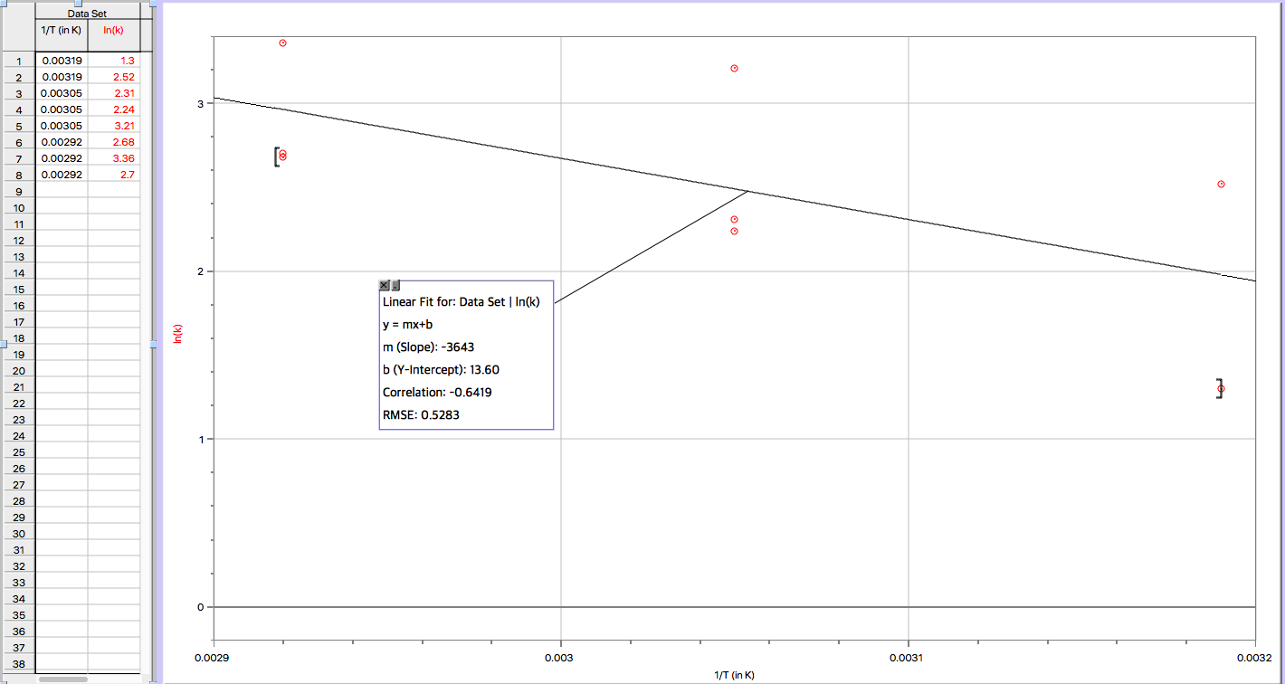
-3643=-Ea/R
-3643*(8.314J/K*mol)=-Ea
30,287.9 J = Ea
3.02 x 10⁴ J= Ea

Thus, the activation energy of a KI catalyzed reaction of H₂O₂ for the experiment at hand was approximately 3.02x10⁴ J.

Discussion:
Extracted from lettuce, catalase is an enzyme naturally found in the vegetable. Enzymes are biological catalysts, working to speed up rates of reactions by lowering the amount of activation energy required for the reaction to take place. In the case of the experiment at hand, the activation energy barrier was the one that existed for the decomposition of hydrogen peroxide.

PART B
For part B of the experiment, varying concentrations of hydrogen peroxide were used by diluting it with distilled water to give a total final volume each time. Each concentration was then tested through three separate trials, for improved accuracy of results. The objective of this experiment was to use the data that was obtained along with the calculations and theoretical portion of the lab learned in class to calculate the order of the reaction as well as define the overall rate. The rate is defined as Rate = k$[H2O2]^{x}[catalyst]^{y}$. The amount of catalase was kept constant at 10.0mL each time. A source of error that could have existed in the lab was related to the equipment that was used. Since a 10mL graduated cylinder was used to measure out the catalase for each trial, it was not accurate to two decimal places and could have easily changed slightly with each trial due to the apparatus. Another limitation during the lab was the amount of catalase provided. It was only sufficient for 10 trials since only 100 mL was provided and 10 mL was required for each. During the lab, it was noticed that since there was a minimal amount of hydrogen peroxide, and the amount of distilled water was not limited, the substance in which there was not have enough of was the catalase. The experiment was completed approximately two hours into the lab meaning there was a full hour in which there could have been additional trials to improve the accuracy of the results. In theory, it was possible to reproduce the data but sufficient materials were required. Another error was that the pressure was constantly fluctuating while attempting to measure the initial pressure. It would remain steady around a certain volume, accurate to two decimal places, however within a few seconds it would change again, increasing the difficulty of obtaining a precise and concrete observation, subsequently altering the resulting calculations. It was then decided to wait for a value that lasted about five seconds and record that, but it may have been inaccurate in the hundredth decimal place. One of the factors that affect rate of reaction are collision of the particles with sufficient activation energy and collisions in the correct orientation. The geometry of these collisions were greatly affected by the shaking of the erlenmeyer flask manually. Through the shaking of the flask by human hands, this would result in shaking/stirring at an inconsistent rate due to inevitable human error. This would cause constant variation throughout the experiment leading to changes in the amount of time that it takes for the reaction to come to an end. This could affect properties related to the enzyme and catalase, which was the catalyst in the experiment. A way to avoid this issue in the future is to use a machine to stir it rather than a human, so that there is no human error which could alter the results.
In the experiment, the predicted partial order with respect to hydrogen peroxide was determined to be approximately 1.1 through the graph obtained through calculated values. Since this was experimentally found, our overall rate order is 1.1, the sum of all the orders should equal 1.1. However, like all lab experiments, there is a certain degree of error associated with this value.

PART C
The third part of this experiment involved varying temperatures using a hot plate and an ice water bath. As well, this experiment illustrated how to determine the minimal activation energy needed for H2O2 to decompose in the presence of the catalase. To attain this value, the experiment was performed at different temperatures while the concentration of the substances remained the same. Initially, due to the Arrhenius equation, it was thought that with a catalyst, and a temperature increase, the rate would also increase. This was proven in this part of the experiment as with each temperature increase, the rate increased. Using this rate calculated found on the graph as the slope, the equation allows for the activation energy to be calculated. Assuming that the data and procedure were correct, the calculated activation energy on a catalase catalyzed reaction was approximately 3.02x10⁴ J. As this experiment required temperature changes, the time frame and the temperature are two variables that require extra care as the temperature of the solution needed to be at a certain temperature. A possible source of error could be that the temperature was not exactly precise and that there may have been measurement errors, like measuring out the catalase from the beaker.

PART D
The last part of the experiment involved potassium iodide as well as the hot plate and cold bath again. Similar to catalase, when KI was added to H2O2, the activation energy of the decomposition reaction is lowered. Because of this, while the rate of the decomposition reaction is lowered, the rate of the decomposition of H2O2 increases. Assuming the data was collected properly with little error in the procedure and method, the activation energy would be easily obtained. Being that once again, using the principle of the Arrhenius equation, the rate is determined at different temperatures and is found to increase as the temperature increases. This is also known as the slope of the graph. With that, the activation energy can be calculated by taking the ln of both sides. Through the data and calculations, it was found that the activation energy for a KI catalyzed reaction of H₂O₂ was 3.02x10⁴ Joules. The source of error for this portion of the experiment is similar to Part C as they both require temperature changes, which causes the experiment to be temperature sensitive. As well, there could have been measurement errors, when measuring out the H2O2 and the KI.

Conclusion:
In Part A, lettuce was blended to extract catalase. In Part B, the partial order was found to be a first order reaction for a catalase catalyzed reaction of H₂O₂. In Part C, for the catalase catalyzed reaction of H₂O₂, the activation energy was calculated to be 7.63x10³ Joules per mole. Finally, in Part D, the activation energy for the KI catalyzed reaction of H₂O₂ was 3.02x10⁴ Joules per mole.

References

Chieh, C. (n.d.). Chemical kinetics. Retrieved November 25, 2018, from http://www.science.uwaterloo.ca/~cchieh/cact/c123/chmkntcs.html
Laidler, K. J. (2013, May 16). Chemical kinetics. Retrieved November 25, 2018, from https://www.britannica.com/science/chemical-kinetics
Libretexts. (2016, July 21). Reaction Rate. Retrieved November 25, 2018, from https://chem.libretexts.org/Textbook_Maps/Physical_and_Theoretical_Chemistry_Textbook_Maps/Supplemental_Modules_(Physical_and_Theoretical_Chemistry)/Kinetics/Reaction_Rates/Reaction_Rate
Libretexts. (2017, June 05). Arrhenius Equation. Retrieved November 25, 2018, from https://chem.libretexts.org/Textbook_Maps/Physical_and_Theoretical_Chemistry_Textbook_Maps/Supplemental_Modules_(Physical_and_Theoretical_Chemistry)/Kinetics/Modeling_Reaction_Kinetics/Temperature_Dependence_of_Reaction_Rates/The_Arrhenius_Law/Arrhenius_Equation
Sciencing. (2018, April 28). What Is the Role of Catalase? Retrieved November 25, 2018, from https://sciencing.com/role-catalase-5521462.html
UCSB scienceline. (2002, September 26). How does catalase break down hydrogen peroxide? Retrieved November 25, 2018, from http://scienceline.ucsb.edu/getkey.php?key=166.
Raw Data:
(put pics in)

