“DO I DARE DISTURB THE UNIVERSE?”
(T.S. Eliot)
VERIFICATION OF GAS LAWS
Written by:
Author A Author B
Subomi Leke Akinrowo, 300051293 Veronica Cameron, 300066663

Supervisor
Chris Bamforth

Date: 18th September, 2018

Introduction:
Gas: A gas is one of the 4 known fundamental states of matter which is made of atoms. It is also known to have a volume and shape that varies, based on changes in pressure, temperature and volume.
Ideal gas: An ideal gas is a gas whose molecules have no interactions with each other, they occupy minimal space and exactly obey the gas laws.
In this experiment, different methods were used to validate the gas laws: Charles’ Law and Boyle’s law, to determine whether in real life, gas is ideal (perfect).
Charles’ Law: Charles’ law is one of the gas laws that shows the relationship between volume and temperature. This law states that the volume of a gas is directly proportional to the temperature at a constant pressure [linear relationship].
V ∝ T
Boyle's Law: Boyle’s law is the second gas law that shows the relationship between the volume of a gas and the pressure being applied. This law states that the volume is inversely proportional to the pressure at a constant temperature.
P ∝$\frac{1}{V}$

Procedure
Verification of Charles’ Law
- Obtain a 125 mL Erlenmeyer flask and ensure that it is clean and dry. If it is not, rinse it with 2-3 mL of acetone (dispose of the waste in the organic waste container) and place the flask in the oven for 5 min.
- Place a rubber stopper (with a hole in it) in the Erlenmeyer flask and mark the position of the bottom of the stopper with a marker.
- Fill a large beaker (600 ml or 1 L) to two-thirds with tap water.
- Place the beaker on a hot plate.
- Clamp the Erlenmeyer with an extension clamp and place it in the beaker of water. The Erlenmeyer should be as fully submerged as possible; water should not spill over the edge of the beaker onto the hotplate (if needed, water can be added to the large beaker once the Erlenmeyer is in place). Ensure that water does not enter the Erlenmeyer flask!
- Turn on the hotplate and heat the water to boiling. Monitor the temperature of the air inside the Erlenmeyer. Once the water is boiling, allow the Erlenmeyer to remain in the boiling water for 6 - 7 minutes.
- During this time, prepare a large ice bath (the temperature should be below 6 °C).
- Using a digital thermometer, determine the temperature of the air in the Erlenmeyer flask. Place a finger over the hole on the stopper and remove the Erlenmeyer from the hot water by disconnecting the extension clamp from the clamp holder. Do not touch the Erlenmeyer flask directly as it is hot.
- Keeping your finger on the hole in the stopper, lower the Erlenmeyer flask into the ice bath (stopper facing downwards). Once the mouth is submerged, you can remove your finger. Water will enter the Erlenmeyer. If you see air bubbles escaping the Erlenmeyer flask, you must restart the experiment.
- The Erlenmeyer flask should be submerged for 5 to 6 minutes until the temperature of the air inside the Erlenmeyer has time to equilibrate to the temperature of the water.
- Record the temperature of the ice bath.
- Raise or lower the flask so that the level of the water in the flask matches the level of water in the bath (with the stopper pointing down).
- When the two levels are matched, place your finger over the hole again and remove the flask from the water bath.
- Transfer the water that is in the Erlenmeyer to a graduated cylinder and note its volume.
- Fill the Erlenmeyer flask to the mark you had drawn indicating the bottom of the stopper. Transfer this volume of water to a graduated cylinder and note the volume.
- Repeat the experiment at least once (twice, time allowing).

Verification of Boyle’s Law
- Prepare the Gas Pressure Sensor and an air sample.
- Connect the Gas Pressure Sensor to your LabQuest 2. Turn on the LabQuest 2 and choose New from the File menu. (You are using a gas pressure sensor and a syringe. What are the two variables you will be using? What units do you think will be used to measure these variables?)
- Move the plunger of a plastic 20 mL syringe to your chosen volume (you and your partner should have decided this volume beforehand). Decide which part of the tip of the plunger you will line up on the volume mark, and line up your subsequent volumes the same way throughout the experiment.
- Attach the 20mL syringe to the valve of the Gas Pressure Sensor.
2. Set up the LabQuest 2 data-collection mode
- On the Meter screen, tap Mode. Change the mode to Events with Entry.
- Enter the Name (your variable) and Units (for your variable). Select OK. Make sure to add 0.8 to each of your volume readings.
3. Collect and plot measurements.
- Start data collection.
- Hold the plunger at your initial volume mark.
- After the pressure reading stabilizes,tap Keep and enter your volume+0.8,the gas volume in mL. Select OK to proceed.
- Move the plunger to change the volume of air in the syringe and hold the plunger in place. After the pressure reading stabilizes, tap Keep and enter the volume (plus 0.8, remember). Select OK to proceed.
- Continue in this manner until you have measured the pressure in the syringe at 6-8 different volumes. For your final volume measurement, move the plunger back to the original volume mark (there is a reason why you are measuring the same volume twice). Stop data collection.
4. Decide which measurement at the original volume to keep.
- Examine the plotted points carefully and decide which of the two points at the same volume is better.
- Tap the table icon (top of the screen). Choose the original data point for volume that you wish to remove from the graph by tapping on it.
- Open the table menu by tapping on the word Table.On the menu that appears, choose Strike Through Data. Lines passing through the data indicate its removal from the graph.
5. Analyze the graph of your variables to determine the mathematical relationship. To test various mathematical functions:
- Tap Analyze and choose Curve Fit ► (your variable) from the Analyze menu.
- Open the menu below Fit Equation and choose a function to perform on your data.
- Select OK to return to the graph screen,where the function you chose will be plotted along with your data.
- Repeat Steps a-c if you wish to try another function.

Data Tables & Raw Data.
 | Independent Variable: Volume (mL) | Dependent Variable: Pressure (kPa)
Initial Chosen Volume (+0.8) | 10.8 | 99.89 [98.30]
 | 12.8 | 84.5
 | 14.8 | 71.27
 | 16.8 | 62.93
 | 18.8 | 56.61
 | 20.8 | 51.32

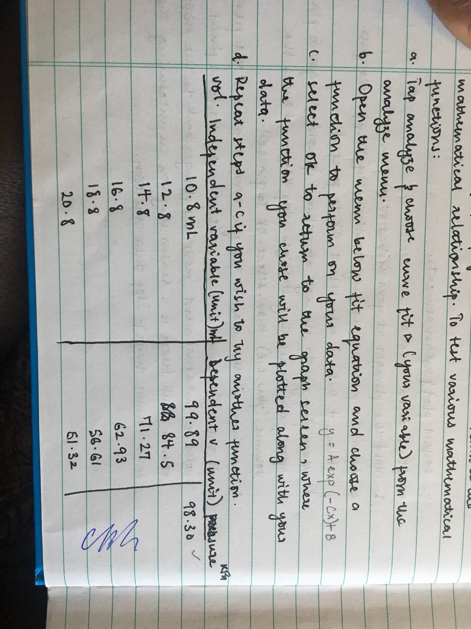
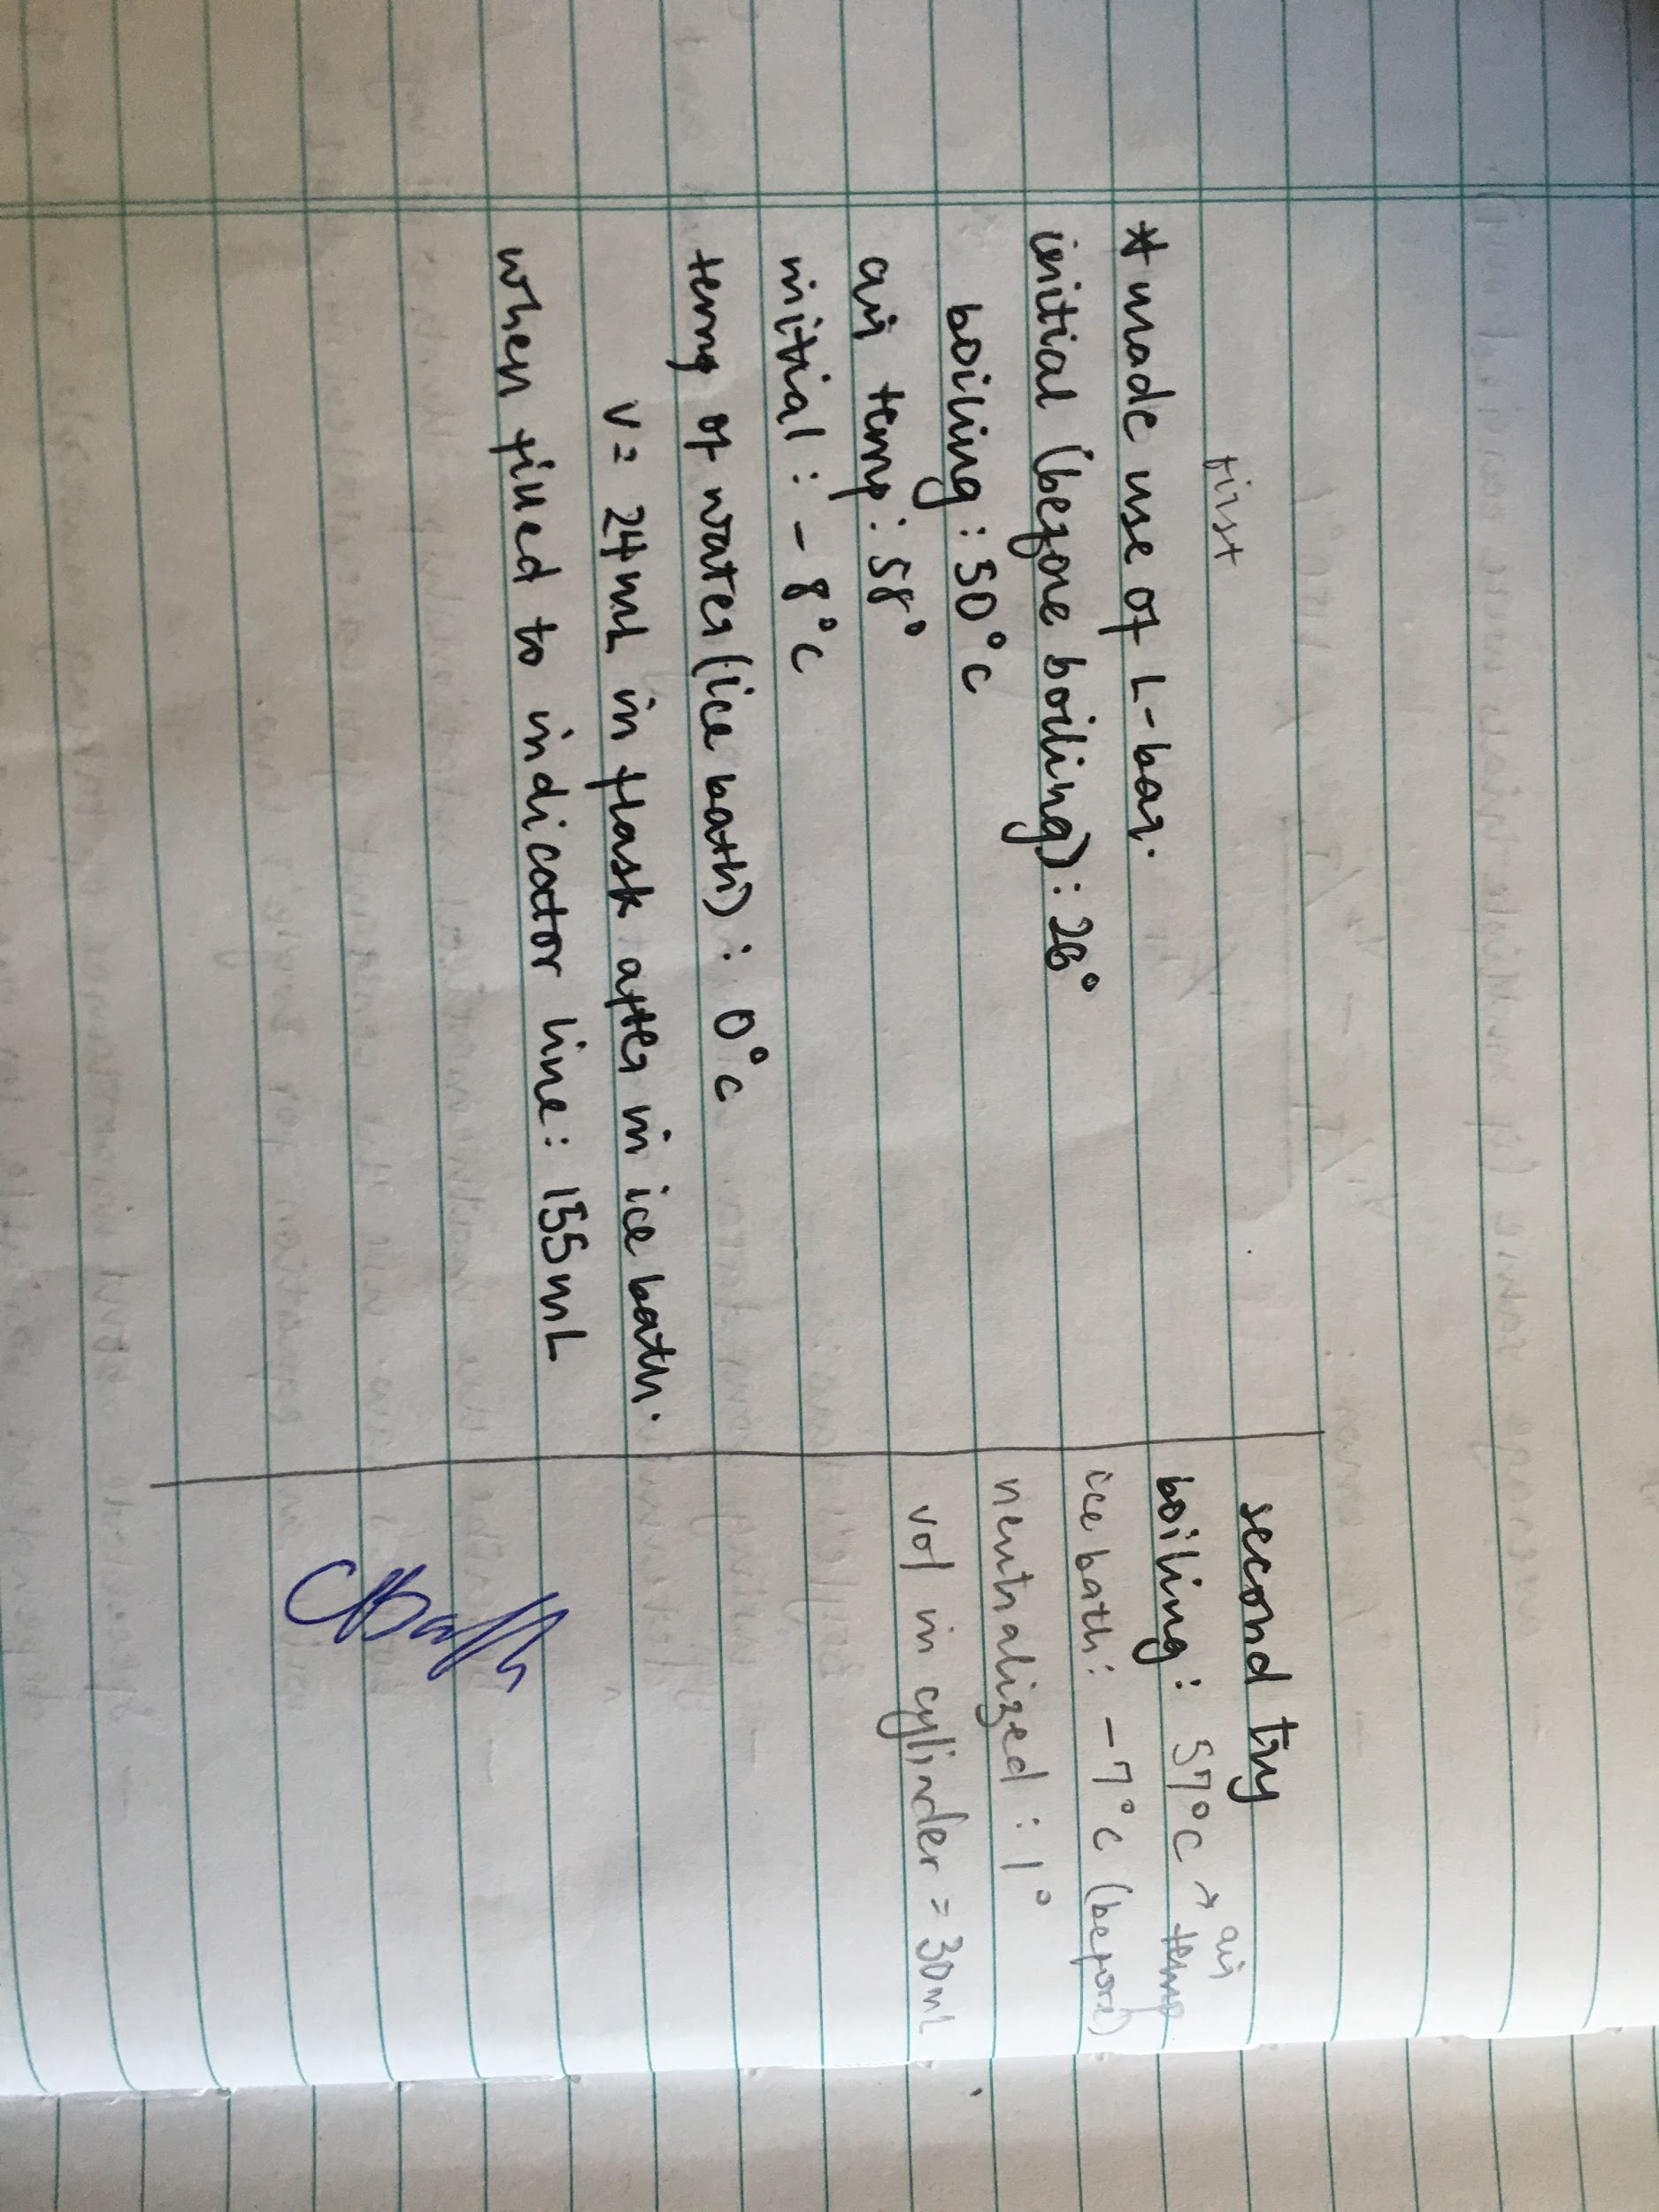
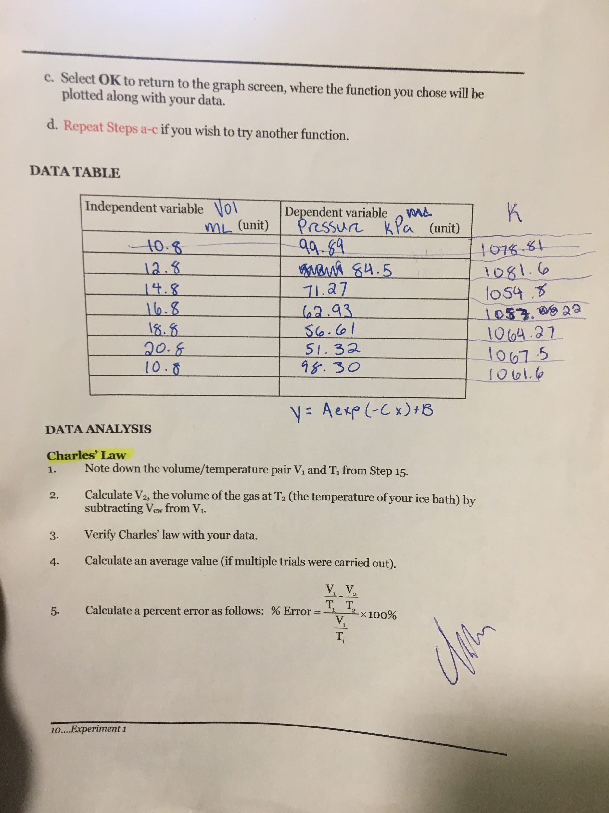
Graph
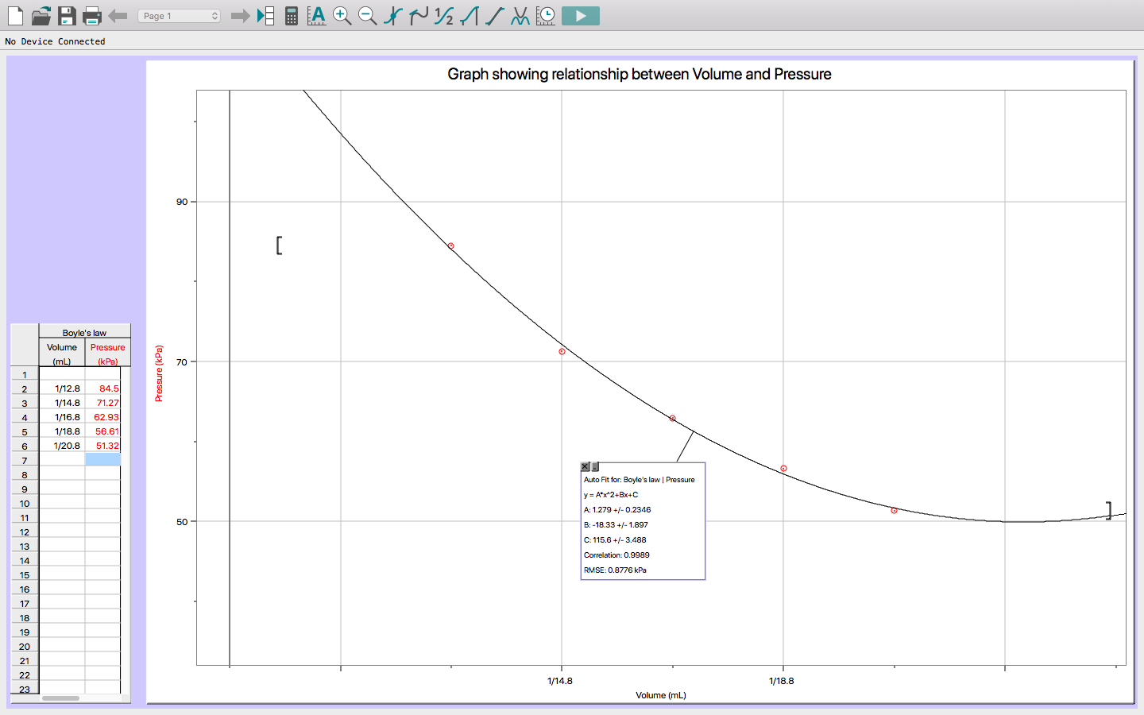

Data Analysis & Discussion
Boyle’s Law:
- Boyle’s law constant: K=PV
K= 10.8mL x 98.30 kPa
K= 1061.6 kPa*mL
- The mathematical relationship illustrated by boyle’s law is an inversely proportional relationship: if a fixed amount of gas is kept at a constant temperature, the volume and pressure are inversely proportional. This means that when one variable increases [the independent variable], the other variable [the dependent variable] will decrease.
Equation: P ∝ $\frac{1061.6 kPa*mL}{V}$
- It is important to take multiple readings of a dependent variable for the same independent variable because it helps in getting a good [average] value for the dependent variable. Doing this multiple times is crucial, so you can get the best average possible and a smaller percentage error.
- The variables for Boyle’s law that require certain conditions are the temperature, volume and pressure. We took these variables into consideration [as seen in the table above]. To ensure they remained constant, we did not put the syringe near hot or cold items and tried to touch it as little times as possible to avoid changing the temperature. For the volume, we made sure to move the plunger as close to 2mL as we could every time, so the volume increases at a constant rate. The pressure was dependent on the volume so to get an accurate constant decrease in pressure, we had to make sure the volume increased at a constant rate. This affected ou results in a good way. If we were unable to keep the variables from increasing/decreasing at a constant rate, the volume and pressure would not be inversely proportional. This means our answers would not be constant.
Charles's Law:
- V1= 155mL T1=100 degrees celsius
- V2=V1-Vcw =155-24 = 131 mL
- Charles's law states that a gas will tend to expand when heated and contract when cold. Our data verifies this theory. When the gas was placed on the hot plate for 6-7 minutes in the boiling water, (temperature of 100 degrees celsius), the volume of the gas in the erlenmeyer flask was measured at 155mL. When the flask was removed from the hot plate and placed in the ice bath (-8 degrees celsius), left for 5 minutes decreased the volume decreased to 131 mL.
- Average calculations: V1= 155 mL
V2= 131 mL
T1= 100 degrees celsius
T2= -8 degrees celsius
5. % error = ( ( V₁/T₁ ) - ( V₂/T₂ ) ) / (V₁/T₁ ) ) x 100%
= ((155/100)- (131/-8)) / (155/100)) x 100%
= 17.93%

Conclusion
In conclusion from the experiment performed with Boyle’s law, it is evident that realistically, that there is no such thing as the ideal gas. If gases were ideal, the k value would have been the same [for each pressure and volume multiplied: k=PV] , therefore, giving us a linear graph. However, in this case, the result of the graph was exponential.
Boyle’s law is also accurate in the sense that volume is inversely proportional to pressure.
For Charles’ law, we can also say it is valid because the results of the experiment have shown that the volume of a gas is directly proportional to the temperature [i.e any increase in temperature leads to an increase in volume and vice versa].

Works Cited
“Boyle’s Law”, National Aeronautics and Space Administration, 2015.
“DO I DARE DISTURB THE UNIVERSE?”, General Chemistry Laboratory Manual, Dr. Rashmi Venkateswaran, 2018.

