MOS 1023A Lecture 6 Introduction to finance Nov 7th, 2018
CONTENTS OF LECTURE:
- Define finance and explain what is involved in finance.
- Describe the six principles of Finance.
- Explain how money is transferred from lenders to borrowers.
- Explain the role played by the market and financial intermediaries.
- Identify the basic types of financial instruments that are available and how they are traded.
What is finance?
- Art of managing funds
- Science/study of managing funds
Goal of the firm:
- Create value for the firm’s shareholders
- Shareholders get wealthier through maximization of existing common stock
Role of management:
- Serves as an arbitrator (negotiator) and moderator between conflicting interest groups or stakeholders
- Stakeholder – Someone who has a stake in a firm’s financial well-being (Shareholders, customers, creditors, employees, community)
- Creditors, managers, employees and customers have contractual claims against the company (Company by law owes you money)
- Shareholders have residual claims against the company - what’s left after all the liabilities have been satisfied
Role of finance in the business:
- What long term investments should the firm undertake (Capital budgeting decision)
- How should they raise money? – Loans etc. (Capital structure decision)
- How to manage cash flows arising from day-to-day operations (Operating Decision)
Function of the financial manager:
- Getting the money, putting it out there
- Responsible to the investors
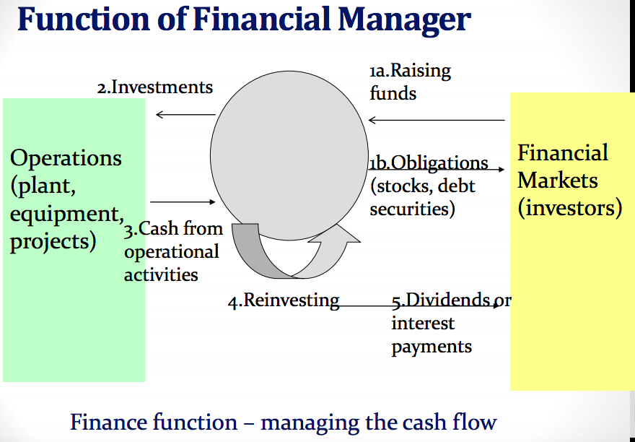
- Pay dividends/redeem the shares
- Take any surplus cash and invest it in short/long term investments to INCREASE THE VALUE of a company

The 6 Principles of finance:
- Cash flow is what matters
- Money has a time value
- Risk Requires a Reward
- Market Prices are generally right
- Conflicts of interest cause principle agent problems
- Ethics & Trust in Business

- Cash Flow is what matters: Bring Money in
- Accounting profits are not equal to cash flows – make a big profit and still have your cash go down – if you have to pay debts or invest in long term assets
- We record revenue when we earn them
- How much money did I spend, and how much did I make – cash flow determines profit of business
- Cash flow and not profits drive the value of a business
- We must determine cash flows when making financial decisions
- Money has a time value:
- Dollar received today is worth more than a dollar received in the future
- Since we can earn interest on money received today, it is better to receive money sooner rather than later
Computation of present value:
- An investment can be viewed in two ways: Future OR Present Value
  - Interest added over time
Present value – an example
If a bond will pay $100 in 2 years what is the present value of the $100 if an investor can earn a return of 12% on investments?
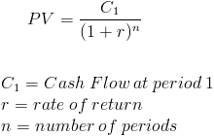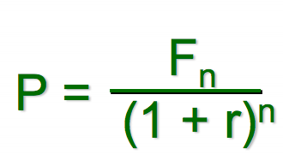

P=100/ (1+0.12) ^2 = 79.72
- This process is called discounting. We have discounted the $100 to its present value of $79.72.
- The interest rate of 12% used to find the present value, is called the discount rate.
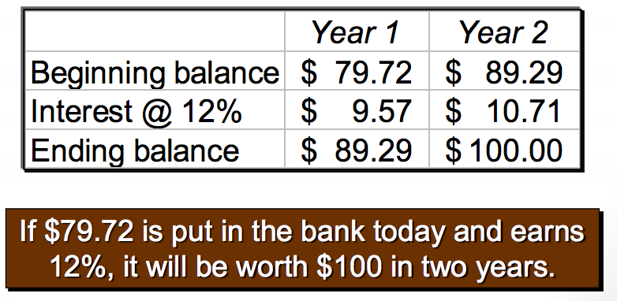
- Compound interest – earn interest on the interest
- Compounding and discounting are opposites

To Determine Net Present Value, WE:
- Calculate present value of cash inflows (take all inflows and discount them back to today)
- Calculate present value of cash outflows (take all outflows – when they are going to happen and discount them back to today)
- Subtract the present value of outflows from the present value of the inflows
If value is:
- Positive – acceptable since it promises a return greater than the required rate of return
- Zero – Acceptable, since it promises a return equal to the required rate of return
- Negative – NOT acceptable - return is less than required rate of return

Examples of cash outflows and inflows:
Outflows:
- Initial Investment (cash need to purchase asset)
- Incremental operating costs
- Repairs and Maintenance of new equipment
- Additional investment in inventory
Inflows:
- Incremental revenues
- Reduction of operating costs
- Salvage value
Choosing a DISCOUNT RATE:
- Firms COST of CAPITAL - minimum required rate of return
- Cost of capital = average rate of return that a company must pay to its long-term creditors and stockholders for the use of their funds
NET PRESENT VALUE EXAMPLE:
Craver Tech is considering the purchase of an attachment for its x-ray machine
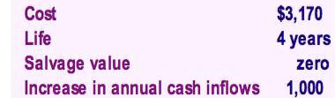

No investments are to be made unless they have an annual return of at least 10% -- 10% or lower passes the test
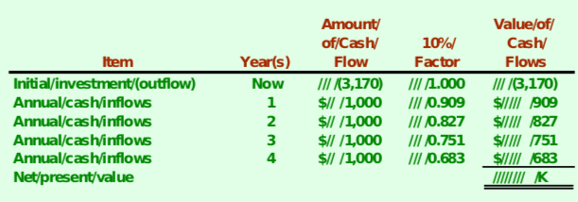

Principle # 3: Risk Requires a Reward:
- Risk is the uncertainty about the outcome or payoff of an investment in the future
- Rational investors would only choose a riskier investment if they expect to get a larger return on it.
Diversification of Investments:
- Investment risk varies
- Diversify risk by investing in several different securities
- Spread risk among different industries and stocks

Principle # 4: Market Prices are generally Right:
Financial Market is INFORMATION EFFICIENT:
- Prices of securities reflect all available information to the public
- When new information is available, prices quickly change to reflect info.
- Information efficient markets provide liquidity and FAIR prices
INEFFICIENCIES caused by:
- Behavioural biases
- May distort the market prices from the value of assets
- All based on expectations

Principle # 5: Conflicts of interest cause agency problems:
Principle Agent Problem: Occurs when one person or entity (the "agent") is able to make decisions and/or take actions on behalf of, or that impact, another person or entity: the "principal"
- Separation of management and the ownership of the firm creates an agency problem
- Shareholders are not always around
- Owners/Equity investors want to maximize returns on their investments
Goals are not aligned: MANAGERS VS OWNERS OBJECTIVES:
- Objectives often differ in nature
- Principle agent problem dictates that managers may not always make decisions in the best interest of shareholders
- Managers often seek to emphasize the size of firms’ sales, assets or other perks
- Dispersed ownership – if many people own small shares then ownership is spread out
- AGENCY PROBLEM MIMIMIZED – through monitoring (annual reports), and compensation plans (stock options)

Corporate Governance:
- It is essentially the system of rules, practices and processes by which a company is directed and controlled.
- It involves balancing the interests of a company's many stakeholders, such as shareholders, management, customers, suppliers, financiers, government and the community.”
Functions of Corporate Governance:
- OVERSIGHT – Board of directors have to oversee management
- MANAGERIAL – Run company – in best interest of shareholders
- COMPLIANCE – Laws, regulations & standards (protecting & reporting)
- INTERNAL AUDIT – Assuring & consulting activity (adding value)
- LEGAL AND ADVISORY – advice
- EXTERNAL AUDIT – Provides credibility
- MONITORING – Elect/Remove managers and directors
NOTE: Shareholders choose the board, board chooses management
PROXIES – Someone acting on your behalf. If you sign a proxy, they can vote on your behalf, allowing more control.
Principle # 6: Ethics & Trust in business
- Ethical behaviour involves ‘doing the right thing’
- Ethical standards are important for personal and business success
- Unethical decisions can harm shareholders’ wealth

Real Versus Financial assets:
Real assets are TANGIBLE THINGS owned by persons and businesses: Examples
- Residential structures and property (personal assets)
- Major appliances and automobiles (personal assets)
- Office towers, factories, mines (business assets)
- Machinery and equipment (business assets)

Financial Assets are what one individual has loaned to another: Claim that one individual/institution has on another: Examples
- Consumer Credit
- Loans
- Mortgages

FUNCTIONS OF MONEY:
- Means/medium of exchange:
  - How transactions are conducted:
  - Something acceptable in exchange for goods and services.
  - In this function, money removes the need for double coincidence of wants, by separating sellers from buyers
- Standard of value:
  - How the value of goods & services are denominated:
  - Something that circulates and provides a standardized means of evaluating the relative price of goods & services
- Store of Value:
  - How the value of goods and services are maintained in monetary terms:
  - The ability of money to command purchasing power in the future

The financial system:
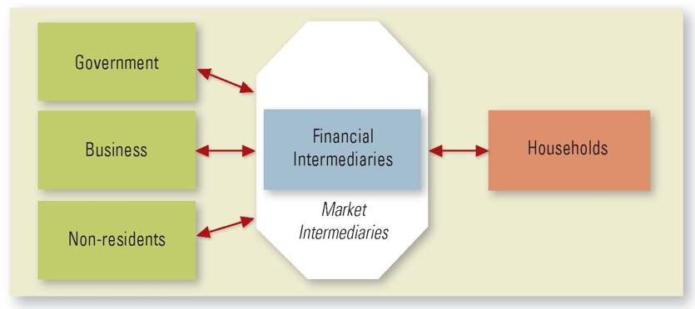

Financial Intermediaries: Examples:
- Financial intermediary - An institution/individual that serves as a middleman among different parties in order to facilitate financial transactions.
- Banks & other deposit taking institutions (most common)
- Insurance Companies
- Pension Funds
- MUTUAL FUNDS: Doesn’t fit the definition of a financial intermediary but is often placed in this category
  - Mutual Fund Managers – Pool money from people together
  - Allows a small investor access to market and EXPERTISE
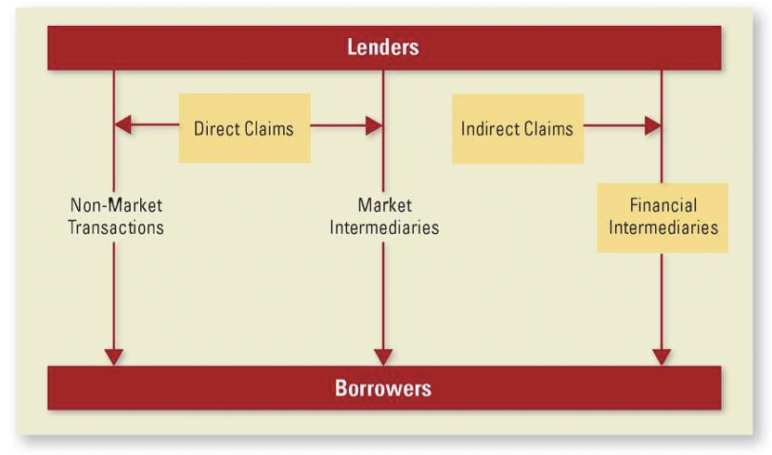
- Market intermediary is a broker
- Indirect Claim – If you put money in bank – It is then loaned to someone else, the bank still owes you money.

QUICK CHECK 1 – C
Which of the following is true about finance?
- Finance is different from economics because economics does not study how resources are allocated.
- Business finance is the only important part of finance.
- Finance is the study of how and under what terms savings (money) is allocated between lenders and borrowers.

QUICK CHECK 2 – B
Which of the following is not a real asset?
- Social Science building
- Paper certificate showing you own shares in Google
- Tables at Tim Hortons D. City of London transit buses
QUICK CHECK 3 – B
You have hired someone to buy 100 shares of a technology firm for your investment portfolio. The person you hired is acting as a
- Financial intermediary
- Market intermediary
- Principal
- Agent

QUICK CHECK 4 – C
Which of the following financial intermediaries does not transform the nature of the underlying financial securities?
- Banks
- Insurance Firms
- Mutual Funds
- Pension Funds

Financial Instruments & Markets:
Financial Markets

Organized Exchanges – (TSE, NYSE (large stock exchanges))
Over the Counter – Network of dealers - small companies who can’t get on big exchanges
Money Market – Short term stuff that has to be paid in the year
Capital Market – Longer than a year (shares – they never expire)
Primary Markets – First time a security is issued
Secondary Markets – Transaction between investors (critical market)

Debt Instruments Issued by Corporations:
- Commercial Paper:
  - Money needed in short-term (Short-term debt 1-270 days)
  - Normally for working capital financing
  - Unsecured (no specific collateral)
  - Can only be issued by companies with good credit rating (well-known ones)
- Bankers’ Acceptance:
  - More secure way of issuing short term debt
  - Bank steps in and guarantees debt on small companies’ behalf.
- CORPORATE BONDS:
  - Listed on the money market
  - Can be long term or short term
  - Will finance a big project
  - The reason we issue bonds is because the money that companies need is too much for the bank to back – profile diversity
CORPORATE BOND TERMINOLOGY:
Debentures:
- Unsecured debt
- Backed only by the general assets of the issuing corporation – no secure collateral

Secured debt:
- AKA mortgage debt
- Secured by specific assets

Senior debt:
- In default holders get payment before other debt-holders get.
- Ranked first if a company is liquidated you need to rank the debt (taxes go first, then secured debt, then senior debt, then subordinated)
- Protects older investors

Subordinated debt:
- In default, holders get payments only after other debt-holders get their full payment

Zero Coupon:
- Pay face value at maturity only
- Sold at discount (100$ at 8% -- 8% is the coupon rate) lend me 800$ today, ill give you 1000$ in 5 years

Junk (HIGH YIELD) bonds:
- Bonds with below investment grade rating
- Issued by really risky companies

Bond Features:
Issuer – the company (the borrower)
Holder – buyer or lender
- Retractable – gives holder the right to retract their loan (I want my money now)
  - Pro of this feature – you can force someone to pay you back and invest in something with a higher interest rate
- Convertible – Ability to convert bond into a different security (i.e. turn them into shares)
- Extendable – gives one side or the other - right to extend the life of the bond
- Callable (Redeemable) – you can reissue the bonds at a lower rate

Equity Instruments Issued by Corporations:
- Common Stocks:
- The common stockholders are the owners of the corporation’s equity
- They have voting rights
- No specified maturity date and the firm is not obliged to pay dividends to shareholders – get their money last
- Returns come from dividends and capital gains
- Preferred Stocks:
- Between equity and debt -- they are equity, but they have similar characteristics of debt
- Come before the common but don’t get to vote
- Have face value, predetermined periodical (dividend) payments with priority over common stockholders
  - Cumulative (Don’t pay in 2012, but pay me in 2013, for both)
  - Non-cumulative (non-cumulative – you will either get it that year or never)
  - Participating (participating – you get extra if there is extra)
  - Non-participating
  - Participatory Cumulative is the most secure
If dividend payment is not paid, preferred stockholders may get voting rights

Derivative Securities
- Securities whose value is derived from the value of some underlying asset
- Most important derivatives are options and futures

Stock options – not a tool of fundraising, it is a method of compensation – not a derivative

Conclusion
- Prices of financial instruments are determined in equilibrium by demand and supply forces
- They reflect market expectations regarding the future as inferred from currently available information

