Introduction to microeconomics
Ch. 14
Tue Nov
A monopoly refers to a firm that is the only producer of a good or service with no close substitutes.
– A firm is a perfect monopoly if it controls the entire market.
– A firm has monopoly power if it can manipulate the price.
Why do monopolies exist?
Monopolies exist because of barriers to entry that prevent other firms from entering the market:
– Scarce Resources
– Economies of Scale
– Governmental intervention – Aggressive business tactics

Barriers of Entry

Monopoly: scarce resources
• Not possible to enter the market because there is scarcity resources or input of the production process
Monopoly: economies of scale
• High fixed costs, better to produce at larger scale to take advantage of economies of scale
• New firms are prevented to enter the market because of this
• E.g.: railway, water-supply, fix phone lines, electricity
• A natural monopoly refers to a market where a single firm can produce the entire market quantity demanded at a lower cost than multiple firms.
Monopoly: government intervention
• Monopoly created or sustained by governments where they would not otherwise exist:
– To protect consumers
– For state-owned firms
– To protect intellectual property rights (patents, copyrights, trademarks, ...)
Monopoly: Aggressive business tactics
• Incumbent firm prevent new entries: – Acquiring competitors
– Predatory Pricing
– Threatening them

Monopoly Characteristics
Monopolies are also rational economic agents: maximize their profits
• But they have different characteristics than perfect competition firms:
– Monopoly is not price taker!!!
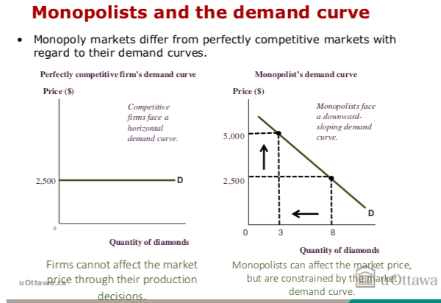
Monopoly revenue
• When a monopolist produces more of a good, the market price is driven down.
• Therefore, producing an additional unit of output has two effects on total revenue:
- Quantity effect: Total revenue increases.
- Price effect: Total revenue decreases.
• Total revenue might increase or decrease, depending on which effect is larger.
• In perfectly competitive markets, a firm can sell as much as it wants
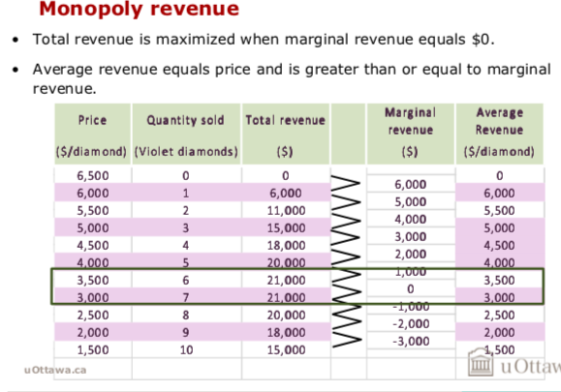
at the market price.
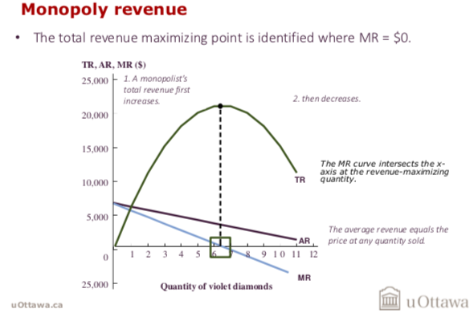
Monopoly profit-maximizing quantity
• While revenue is important, firms maximize profits.
• The profit-maximizing quantity of output for a monopoly is found where marginal revenue equals marginal cost.
– This is the same marginal decision-making analysis used in perfectly competitive markets.
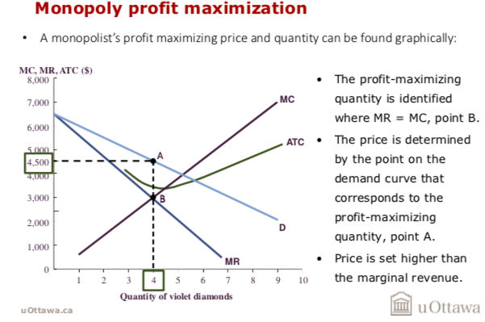
**MR=MC
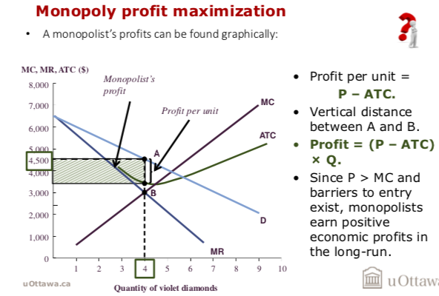

Problems with monopoly
• Monopoly power benefits monopolists but causes social welfare losses.
• In a competitive market, the equilibrium price and quantity maximize total surplus.
• Monopolists produce at a lower quantity than the efficient level.
- – Total surplus is not maximized.
- – Producer surplus (monopolist profit) increases.
- – Consumer surplus decreases.
– The loss of total surplus is a deadweight loss equal to the total surplus under perfect competition minus the total surplus under a monopoly.
The welfare costs of monopoly
• The welfare costs associated with monopolies is a positive statement.
• Many voters and policy-makers make normative statements concerning monopolies:
– Extra profits to monopolies.
– Benefits of maintaining a particular monopoly outweigh the social welfare costs.

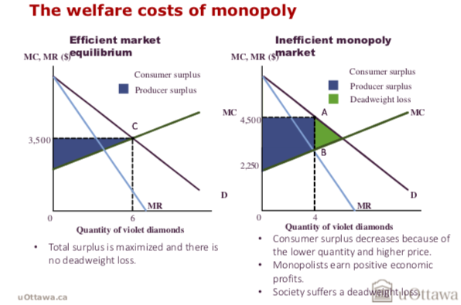

Public policy responses
• Pressure from both the government and consumers can lead to a decrease in monopoly power.
• Policy responses are often imperfect and controversial.
• The goals of policy responses are typically:
– Break up existing monopolies.
– Prevent new monopolies from forming.
– Ease the effect of monopoly power on consumers.
- How?
– Antitrust laws
– Public Ownership
– Regulation
– Vertical Splits
– No response
Public policy responses: Antitrust laws
• One public policy response is to enact antitrust laws that investigate and prosecute corporations that engage in anti-competitive practices.
– Competition Act.
– Administered by the Competition Bureau.
• Critics of antitrust laws argue that they:
- – Are typically politically motivated.
- – Cause more inefficiency than they create.
Public policy responses: Public ownership
- A public policy response to natural monopolies is to allow the government to run them.
- Natural monopolies occur when one firm can achieve lower costs of production than multiple firms.
Benefits
- Set prices lower than unregulated monopolies.
- Provide broader services.
Costs
- Loss of profit incentive potentially leading to inefficiencies.
- Political Pressure
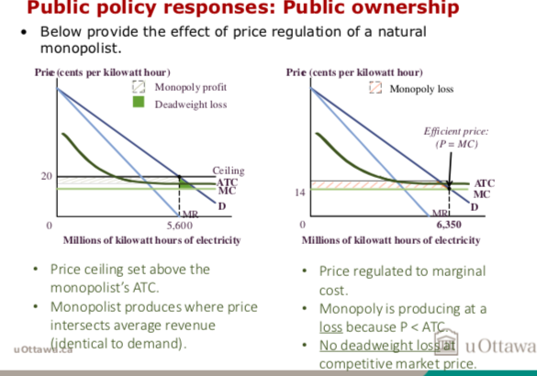
Public policy responses: Regulation
• If policymakers do not want public ownership, one common intermediate step is to regulate the behavior of natural monopolies.
– Takes the form of price controls.
• Firms have an incentive to avoid releasing information about their true production costs.
– This makes it difficult for regulators to determine the appropriate price.

Public policy responses: Vertical splits
• Another policy response is to vertically split an industry to introduce competition.
– Different firms now operate at different points in the production process.
• In a horizontal split, a monopolist is separated into several firms that compete with each other to sell the same product.

Public policy responses: No response
• Cost-benefit analysis might suggest that the best response is to do nothing.
• This might be preferable if regulation is difficult and/or ineffective to establish and manage.
• Common when government interventions are subject to corruption or political mishandling.

Market power and price discrimination
• Some consumers are willing to pay more for a good than the prevailing market price.
• Price discrimination is the practice of charging customers different prices for the same good (to increase monopoly profits)
– Firms with monopoly power can charge higher prices to consumers with a higher willingness to pay.
– The more monopoly power a firm has, the more it is able to price discriminate.
– E.g.: by age (students, elderly, children), be the first of doing something (choosing a plane sit, or ticket), different quality (the first edition or the pocket format)...Assuming different willingness to pay among these different groups
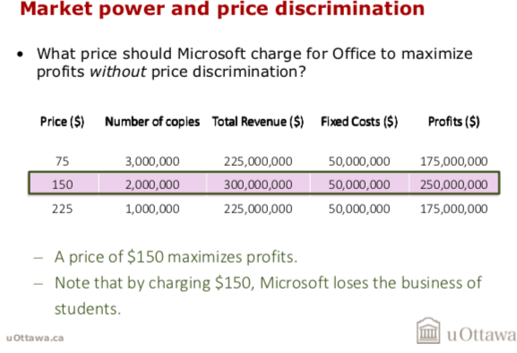

- Suppose Microsoft has the following potential customers for MS Office:
  - 1 million ‘business owner’ customers willing to pay $225.
  - 1 million ‘standard user’ customers willing to pay $150.
  - 1 million ‘student’ customers willing to pay $75.
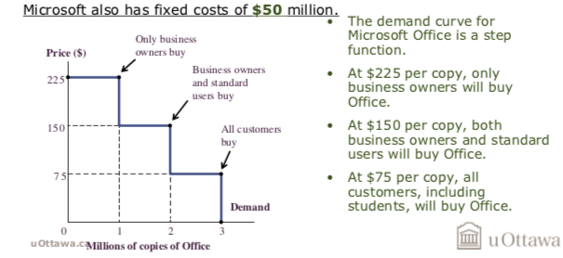

Price discrimination
• Price discrimination requires firms to accurately know how much each customer (or group of customers) are willing to pay.
– Requires some sort of verification.
• The ability to resell products creates problems for firms trying to price discriminate.



