Introduction to microeconomics
Ch. 17
Tue Nov
Outline
• Why trade? A review
• Who gains and who loses? From autarky to free trade
• Restrictions on trade: – Tariffs
– Quotas
• Trade Agreements
• Omit section: Big Economy and Small Economy
Why trade? A review
- Recall that voluntary exchanges generate surplus, leaving both participants better off than they were before (gains of trade).
- A country is said to have an absolute advantage if it can produce more of a good or service than other countries, given similar resources.
- A country is said to have a comparative advantage if it can produce a good or service at a lower opportunity cost than other countries.

  - Each country produces the goods in which it has a comparative advantage.
  - Both countries can have gains from trade when they specialize in producing the goods and services for which they have
comparative advantages, respectively, and engage in trade
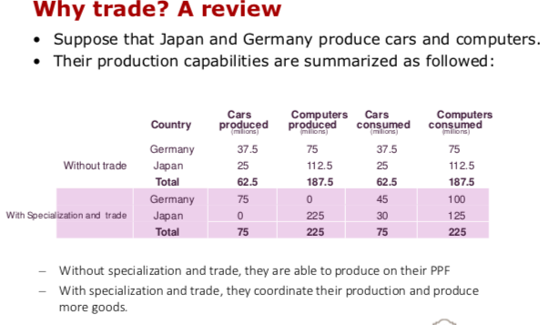

The roots of comparative advantage
• Given that the business of trade is conducted almost entirely by firms and individuals, not by governments, how do firms in one country know their comparative advantage relative to firms in another country?
• Firms produce the goods and services in which they have a comparative advantage by responding to input and output prices and choosing to produce the good that earns the highest profits.
- The characteristics that affect the costs of production are:
  - Technology
  - Factors endowment
  - Natural resources and climate

- Countries do not fully specialize because of:
  - Trade agreements between countries that may stymie specialization. There is no perfect free trade
  - Differences in the natural resources, climate, and relative factor endowment of different areas.

17.2 Who gains, who loses?
From autarky to free trade
- To understand the effects of trade (who really gains)
- Economic model: from autarky to free[ trade
  - Autarky: an economy does not export or import any goods or services.
- Imports are goods and services that are produced in other countries and consumed domestically.
- Exports are goods and services that are produced domestically and consumed in other countries.
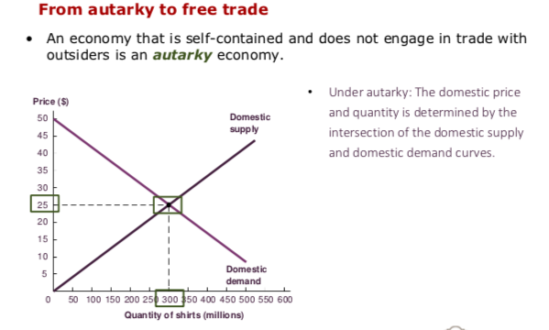
  - Free trade: no restrictions to imports and exports
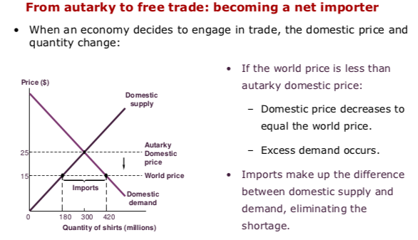

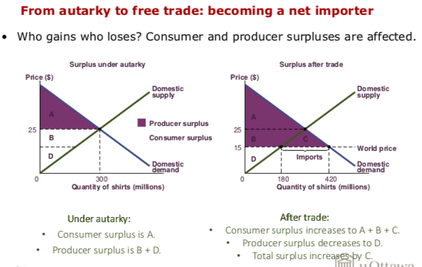

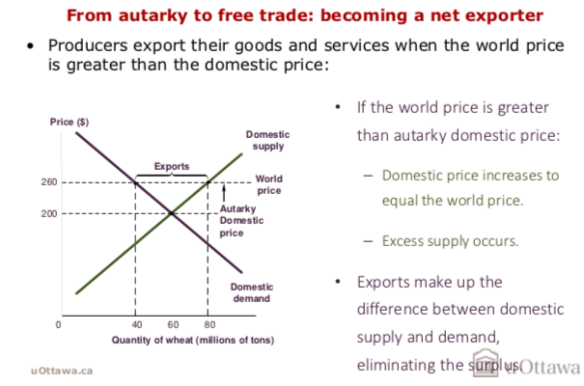

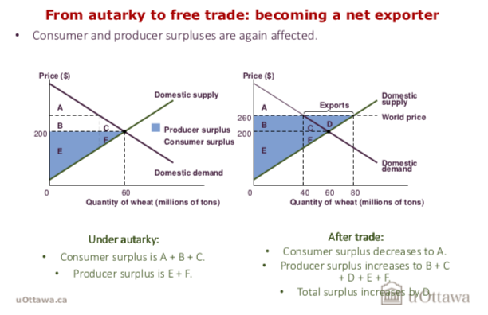

Restrictions on Trade
• The previous analysis indicates that imposing or lifting restrictions on trade can have different impacts on different groups of people.
• Laws limiting trade are referred to as trade protection.
– Protectionism is a preference for policies that limit trade.
– Trade liberalization is policies and actions that reduce trade restrictions
Tariffs
• A tariff is a tax targeted at certain imports.
• The purpose is to reduce the quantity of imports to protect domestic
Producers.

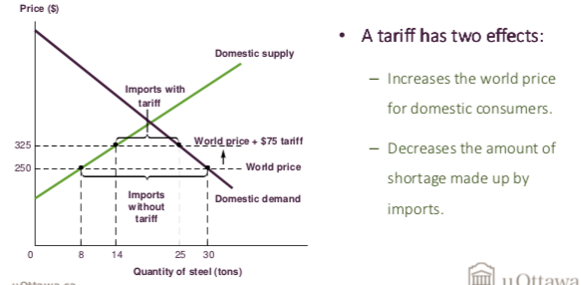
• A tariff redistributes surplus between consumers and producers
- A tariff creates deadweight loss
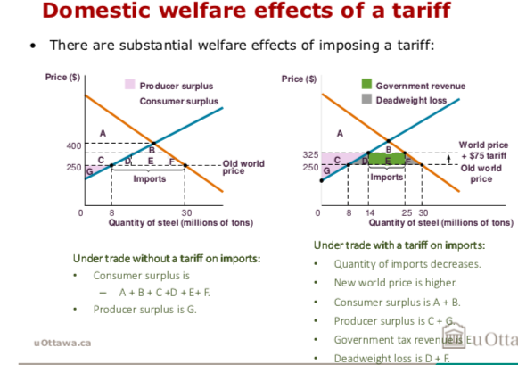
- A tariff raises public funds

Quotas
A quota is a limit on the amount of a particular good that can be imported.
Quota rents are profits earned by foreign firms or governments under a quota.

17.4 Trade Agreements

International labour and capital
- Although countries gain from trade liberalization, certain segments of the population lose out.
- As a rule of thumb, free trade increases demand for factors of production that are domestically abundant, and it increases the supply of factors that are domestically scarce.
  - Causes factor prices to converge across countries.
  - Owners of domestically scarce factors of production lose due to increased competition, and owners of domestically abundant factors gain from increased demand.
The WTO, trade mediation, and import standards
- Each country has its own set of laws and policies governing the economy.
  - Safety policies, labour standards, environmental regulations, taxes, laws about corporate finance, and governance.
  - Source of friction in international trade.
- The World Trade Organization (WTO) is an international organization designed to monitor and enforce trade agreements while also promoting free trade.
Import standards and the fair trade movement are ways in which countries try to deal with variations in cross- country standards.
• Similarly, the fair trade movement attempts to inform and influence consumers’ choices by certifying and labeling goods whose production meets certain conditions.

Embargoes: Trade as foreign policy
- Countries may use trade as a tool for foreign policy.
- An embargo is a restriction or prohibition of trade in order to put political pressure on a country.
- Examples include:
  - The 2009 United Nations Security Council international weapon trading ban with North Korea as a response to nuclear testing.
  - Cuba Embargo
  - Sanctions to Venezuela or Nicaragua to protect human rights.

Summary
- Comparative advantage is the ability to produce a good or service at a lower opportunity cost than others can.
- Characteristics such as climate, natural resources, factor endowment, and technology determine which goods and services a country will have a comparative advantage at producing.
- When countries moves from autarky (no trade) to trade:
  - If the world price < domestic price, then the country will be a net-importer of that good or service.
  - If the world price > domestic price, then the country will be a net-exporter of that good or service.
When markets function well, total surplus increases if a country opens trade.
– Net-importer: Consumers gain surplus from buying larger quantities at lower prices; producers lose surplus from selling less at lower prices.
– Net-exporter: Consumers lose surplus from buying smaller quantities at higher prices; producers gain surplus from selling more at higher prices.
- A tariff is a tax on imports, and it causes inefficiency and deadweight loss.
  - Raises domestic price of a good, reduces quantity
demanded, increases quantity supplied domestically, and
reduces quantity imported.
- Import quotas limit the amount of a particular good that can be imported.
  - Effect of the quota on domestic price and quantity is similar to the effect of a tariff. It differs on who captures the rent.
- In general, trade increases demand for factors domestically abundant, and increases the supply of factors that are domestically scarce.
- Each country has its own set of laws and policies governing the economy.
  - Policy-makers and consumers may apply explicit laws about imports and voluntary purchasing decisions in order to deal with the inconveniences.

