Introduction to microeconomics
Ch. 13
Tue Nov 6
Competitive Market Characteristics
This chapter analyzes how firms make production decisions in a competitive market
- The characteristics of a competitive market are:
- Full Information exists
  - Everyone knows what they are trading and at what price
  - No info asymmetries (One party has more info than another)
- Buyers and sellers are price takers
  - Comp markets have so much competition that no one has the ability to affect market prices. Thus, all are price takers
  - If a buyer or seller has the ability to noticeably affect market prices , that person/firm has market power (and its not a comp. market)
  - Participation in a competitive market places very specific constraints on a firms ability to maximize profits
- The good or service is standardized
  - Goods and services have the same characterisitics and are interchangeable
  - In real life , goods are differentiated by quality, brand , or characteristics that appeal to different tastes
  - Commodities (e.g.: gold, crude oil)under certain defined characteristics are considered standardized goods
- Firms freely enter and exit the market
  - Free entry and exit is not an essential condition for a competitive market, but when it does not hold, there are incentives to collude , breaking the price-taking requirement
  - Market entry is not easy in all markets
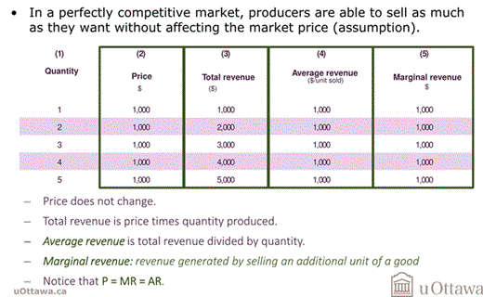
- Revenues in a perfectly competitive market

- In a competitive market : Price = average revenue= marginal revenue
- Profit and production decisions
  - Firms seek to maximize profits
  - In a competitive market, the only choice that a price-taking firm can make to affect profits is the quantity of output to produce
  - The profit-maximizing quantity corresponds to the quantity at which marginal revenue is equal to the marginal cost
- Profit maximization occurs when MR=MC for a perfectly competitive firm

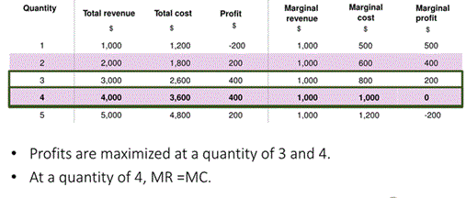

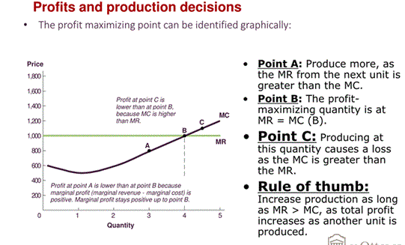

- Deciding when to operate

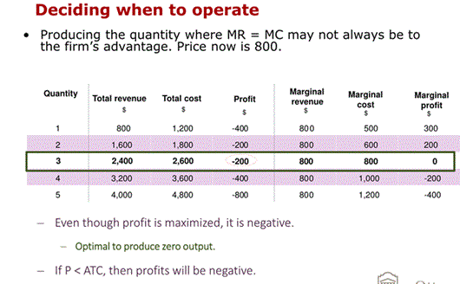
- When deciding the quantity to produce, a firm additionally must decide whether to:
  - Produce
    - When a firm shuts down production, it avoids incurring variable costs
    - Fixed costs remain and are sunk in the short run
    - Because fixed costs are sunk, they are irrelevant in deciding whether to shut down in the short-run
  - Shut-down in the short-run
    - The short-run decision to produce depends on the variable costs, not fixed costs
      - Shut down if P < min(AVC)
  - Exit the market in the long-run
    - The long run decision to produce depends on the total cost, since all costs are variable in the long-run
      - Exit if P < min (ATC)
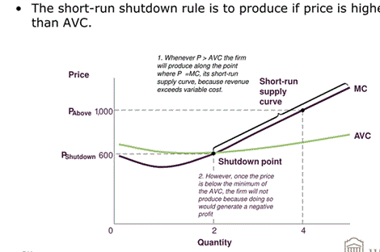
- The short run supply curve and the shutdown rule
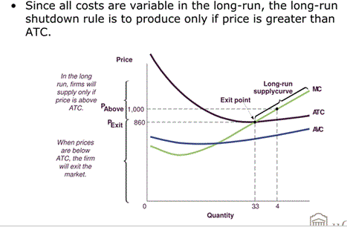
- The long-run supply curve and the shutdown rule

Supply Curve
- Short run supply curve
  - The number of firms in the market is fixed in the short run (assumption)
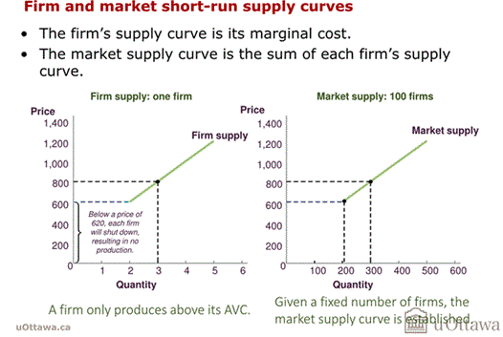
  - The total quantity supplied of a good at a given price is the sum of quantities that each individual producer is willing to supply
- Long run Supply
  - The key difference between short-run and long-run supply is that firms are able to enter and exit the market in the long run
  - The process of market entry and exit causes firms in the long run in a perfectly competitive market:
    - To earn zero economic profits (accounting profits are positive in the long run)
    - Firms operate at an efficient scale
    - Supply is perfectly elastic
  - Long run Supply: 0 economic profits
  - If positive economic profits exist:
    - P>ATC
    - New firms enter to gain profits
    - The market supply curve shifts outward until P= ATC
    - Economic profits go to zero for all firms (still have accounting profits
  - If negative economic profits exist
    - P < ATC
    - Some firms exit the market
    - The market supply curve shifts inward until P=ATC
    - Economic profits go to zero for all firms (still have acc profits)

- Economic profits and Accounting profits are not the same
- Economic profits include all the opportunity costs
- Accounting profits do not take into account the forgone profits
- When economic profits are negative (P<ATC), accounting profits may still be positive, but the firm could be making more money pursuing other opportunities, therefore firms exit the market to invest its resources in other projects

- Long run Supply: efficient scale
  - Efficient Scale: quantity that minimizes average total cost
  - Firm’s optimal production: P = MR= MC
  - MC intersects the average total cost curve at its lowest point: MC = min (ATC)
  - In the long run, economic profits are 0: P = ATC
So,
  - In the long-run, price = min(ATC) = MR = MC (firm producing at its efficient scale)

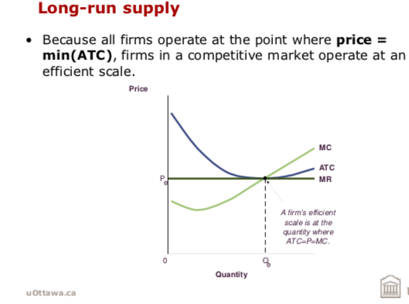
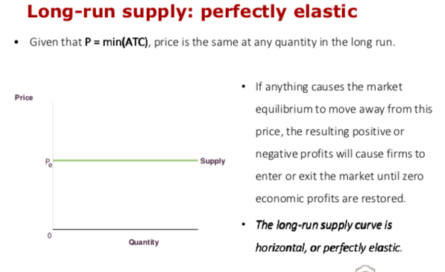

- Why long run supply doesn't slope upward but should
  - The competitive market theory suggests that the market supply curve should always be perfectly elastic.
  - Most long-run market supply curves are upward sloping.
    - This is due to the assumption that all firms have the same cost structure.
    - This assumption not always apply: not all firms have the same cost structure
    - This causes the long-run supply curve to be upward sloping.

- If new entrants have a higher cost than existing firms, price must rise sufficiently to entice new firms to enter the market.
  - Causes the long-run supply curve to be upward sloping.

- Long Run Economic Profits
  - The competitive market theory suggests that all firms should earn zero economic profit in the long-run.
  - In reality, price = min(ATC) for only the least-efficient firms in the market.
    - Typically, this is the last firm to enter the market.
    - More efficient firms with lower ATC earn positive economic profit in the long-run.
- Market entry due to changing production costs

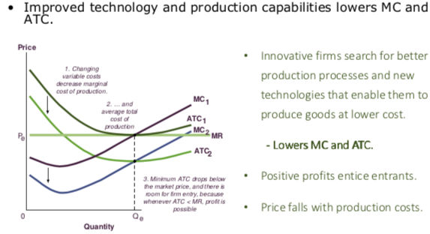

- Responding to Shifts in Demand
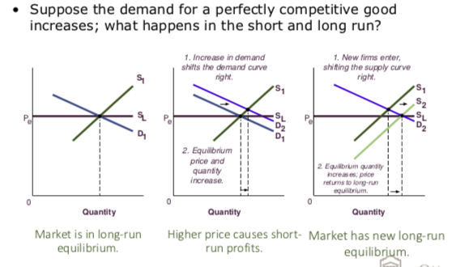

Summary
- Perfectly competitive markets are defined by:
  - There is a large number of buyers and sellers.
  - No one buyer or seller can affect the market price.
  - There is a standardized good or service.
  - No barriers to entry exist.
- Firms maximize profit by producing at the point where MR = MC.
- Firms are able to enter and exit the market.
  - If economic profits are positive, firms enter the market and the supply shifts outward until profits are zero.
  - If economic profits are negative, firms exit the market and the supply shifts outward until profits are zero.
- In the long-run:
  - Firms earn zero economic profits.
  - Firms operate at their efficient scale.
  - Supply is perfectly elastic.

