Introduction to Microeconomics
Ch. 12
Thu Nov 1
Revenues, costs ,and profits
- A firm’s goal is to maximize profits:
  - Profits = Total Revenue - Total cost
- The pursuit of profits drives every firm’s decision making process, including how much to produce and whether to stay in business
- Total Revenue is the amount that a firm receives from the sale of the goods and services and is calculated as quantity sold times price paid/unit
  - TR= (Q1 x P1) + (Q2 + P2)...
- Total cost is the amount that a firm pays for inputs used to produce goods or services (one-time expense and ongoing expenses)
  - Costs are more complex and harder to calculate than revenue
Total costs
- A firm’s total cost is defined as:
  - Total costs = fixed costs + variable costs
- Fixed costs are costs that do not depend on the quantity of output produced
  - One-time upfront payments before production begins, like buying equipment
  - Ongoing payments like monthly rents
  - Fixed constants are constant as quantity increases
  - Even if a firm produces nothing, it still incurs a fixed cost
- Variable costs are those that depend on the quantity of output produced
  - Includes raw as well as many types of labour costs
  - Total variable costs increase with each additional unit produced
  - If a firm produces nothing, variable costs are zero
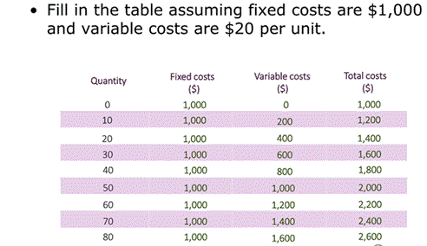

- Explicit and implicit costs
  - A firms opportunity cost of operation has two components
    - The first is composed of the fixed and variable costs
      - These are the explicit costs that require a firm to spend money
    - The second is composed of foregone opportunities
      - These are the implicit costs that represent opportunities that could have generated revenue if the firm had invested its resources in another way
    - To properly account for the total costs incurred by a firm , total cost includes both type of costs

- Economic and Accounting profit
  - When companies report their profits, they provide accounting profits:
    - Accounting profit = total revenue - explicit costs
  - Accounting profits may be a misleading indicator of how well a business is really doing
  - To account for implicit costs , economic profit further subtracts implicit costs:
    - Economic profit = Accounting profit - Implicit costs

Total Production
- Total production, marginal product, and average product
- Firms create value by bringing together different ingredients to create a good or service that consumers want
- A production function is the relationship between the quantity of inputs and the resulting quantity of outputs
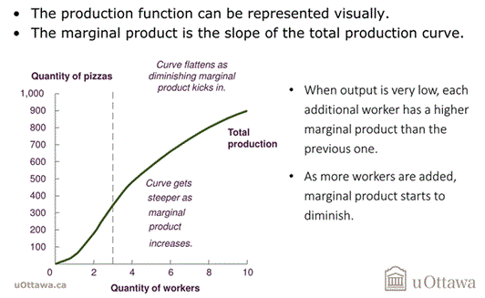
  - Q= Inputs
- The increase in output that is generated by an additional unit of input is the marginal product

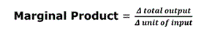
  - The principle of diminishing marginal product states that the marginal product of an input decreases as the quantity of the input decreases
  - The average product is the total production divided by the number of workers

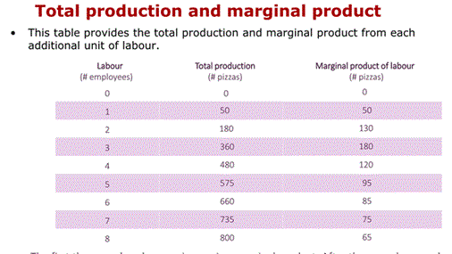

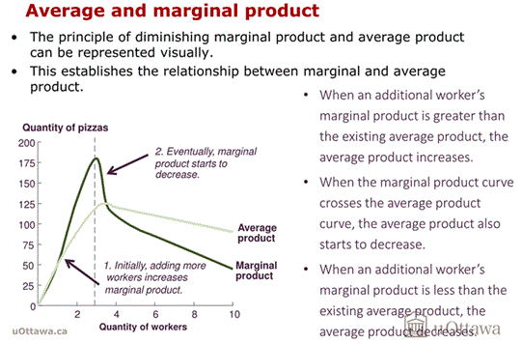
Costs of production
- When a firm increases its output by adjusting its use of inputs, it incurs the costs associated with that decision
- The relationship between output and costs are:
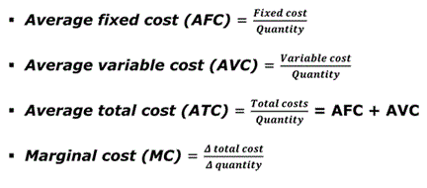
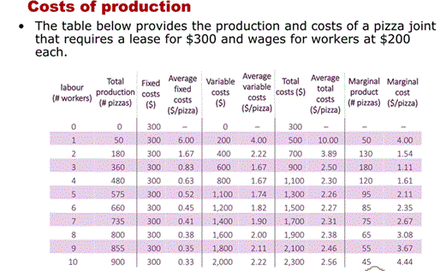
- Cost Curves
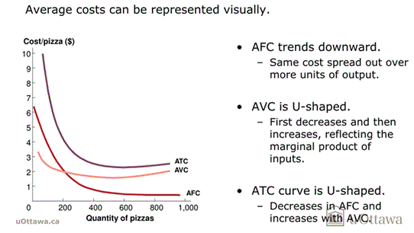
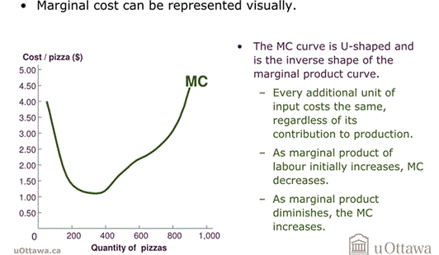
- 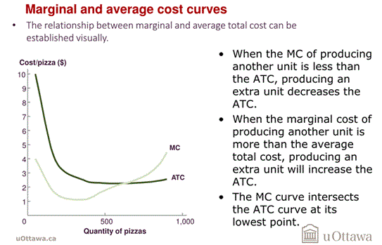
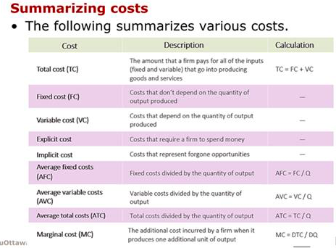

Long-run vs Short-run

