Equilibria

Written by:

Isabelle Quejada-Page, 300053286
and
Kelvin Stidwill, 300067467

TA: Matt Elsby

Date: October 30th,2018

Introduction
Equilibrium is the point at which there is no net change in the concentration of reactants and products over time because the rates of the forward and reverse reactions occur at constant equal rates. At the state of dynamic equilibrium, there are no changes in colour, volume, pH, concentration or mass. Equilibrium only occurs under the conditions of a constant temperature, as well as constant pressure, within a closed system. If any of these conditions suddenly change, the system will not return to its original state, it will attempt to adjust in order to reach a new equilibrium. This is the basis of Le Chatelier’s Principle.
The electromagnetic spectrum is a continuum of all electromagnetic radiation and their respective wavelengths and photon energies (Figure 1).
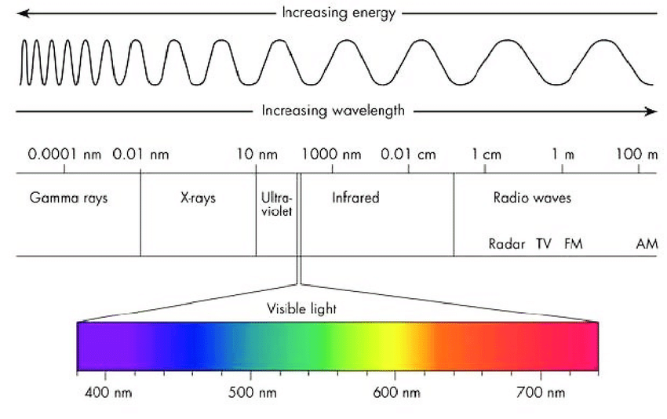

Figure 1: Electromagnetic Spectrum

When an electron in an atom absorbs energy, it is considered to be in an excited state, which makes the electron unstable, resulting in the electron returning back to its ground state. This results in the electron emitting all of its lost energy in the form of light.
The equilibrium constant (Keq) can be described as the value of the ratio of equilibrium concentrations of products to equilibrium concentrations of reactants, each being raised to the power equal to its stoichiometric coefficient. In the following general equation, where:
aA+bB ⇌ cC + dD
The equation for equilibrium constant Keq can be expressed as the following:
Keq= [C]^{c}[D]^{d} ÷ [A]ª[B]^{b}
This formula is used to determine whether the reaction tends to have a higher concentration of products or reactants at dynamic equilibrium.
pH is a logarithmic scale used to measure the acidity or alkalinity of a solution, based on hydronium ion concentration. The pH of a solution can be determined by taking the logarithm of the hydronium ion concentration, and changing the sign; the equation can be expressed as such:
pH = -log[H₃O⁺]
The pH scale values ranges from 0-14. The pH of pure water is 7.00, and is considered to be neutral on the pH scale. A solution with a pH of less than 7.00 is considered acidic, while a solution with a pH of more than 7.00 is considered basic. A solution containing both a weak acid and a conjugate base; or vice versa, is called a buffer solution, and resists variations in pH level. A buffer works by reacting with and neutralizing any added acid or base in order to control pH.
The purpose of this experiment is to observe shifts in equilibrium of different solutions by adding various stresses, as well as to observe the effects of acids and bases on a buffer system.

Procedure
As written in the lab manual (Equilibria, Dr. Rashmi Venkateswaran, 2018, Exp. 3, p. 9-12).
Materials and Apparatus
- Copper Sulfate, CuSO₄
- Test tubes
- Spatula
- Scale
- pH probe
- Stir magnet
- Test tube rack
- 150mL beaker
- Ammonia, NH₃
- Hydrochloric Acid, HCl
- Nitric Acid, HNO₃
- Potassium Iodide, KI
- Sodium Sulfide, Na₂S
- Silver Nitrate, AgNO₃
- Sodium Bicarbonate, NaHCO₃
- Lactic Acid, C₃H₆O₃
- Dry Ice, CO₂ (s)
- Ammonium Chloride, NH₄Cl
Observations
Part 1
- The physical properties observed of the Copper(Ⅱ) Sulfate added to the test tube were that was a light pale blue colour and it was transparent. This is a result of the Cu²⁺ ions because this is a d-block metal ion which means that the electrons transfer between different energy states causing light to be absorbed and giving off the colour blue. The colour can also be affected by the ligand attached to the Cu²⁺ ion and in this case, the polyatomic sulfate ion causes it to appear blue.

- When 2 drops of ammonia were added, the substance changed to a very dark blue and it became opaquer. There was also a very strong odour because of the ammonia.

[Cu(H₂O)₄]²⁺ (aq) + 4NH₃ (aq) ⇌ [Cu(NH₃)₄]²⁺ (aq) + 4H2O.

When the ammonia was added to the solution, it caused the equilibrium to shift to the right and create more products. The product, [Cu(NH₃)₄]²⁺, that was formed is a dark blue colour because a stronger ligand (NH₃) is connected compared to H₂O which results in a greater splitting in the d-orbitals of the Cu²⁺ ion. [Cu(NH₃)₄]²⁺ absorbs yellow light which means that its complimentary colour is a darker blue. According to Figure 1, yellow light requires higher energy compared to red light (which [Cu(H₂O)₄]²⁺ needed to emit its light blue colour). Because ammonia is a stronger ligand, it provides the higher energy needed to emit this dark blue colour.

- When HCl was added, the solution turned from a dark blue back to its original pale blue colour. This is because the H⁺ ions react with the NH₃ in the reactant to create NH₄⁺ ions. This means that the Cu²⁺ ions are rehydrated, reverting it back to its light blue colour.

- There were no changes when both solutions were added. Although there should have been because when a reactant is added, the equilibrium should shift towards the right in attempt to consume it. There could have been a human error in not the right amount of drops added.
Part 2
- Sodium carbonate was added to the test tube and it is clear and colourless.

- When the clear Silver nitrate was added to the sodium carbonate, the solution turned yellow-brown and cloudy. This is due to the precipitate, Ag₂CO₃ that was formed (the Ag⁺ and CO₃²⁻ ions).

- When one drop of HNO₃ was added, the bottom of the solution was transparent and clear while the top was still the same colour as in the previous step. After the second drop was added, the rest of the solution became a clear liquid.

2H⁺+ CO₃²⁻ ⇌ H₂CO₃ → H₂O (aq) + CO₂ (g)

The solution is not reversible because the test tube was not sealed making this an open solution which means the carbon dioxide escaped.

- After 2 drops of HCl were added, the solution became cloudy again because of the dissociated H⁺ and Cl⁻ ions reacting with the Ag⁺ ions from the previous reactions. The silver and chlorine ions formed silver chloride.

- 3 drops of NH₃ were added to the solution to create [Ag(NH₃)₂]⁺ (aq). The solution became clear again and the reaction shifted towards the right.

- 4 drops of HNO₃ turned the solution cloudy again and it created smoke in the test tube. When 1 drop of ammonia was added after, it turned clear again. This was expected because the reaction shifts towards creating products when a reactant is added and all the same ions were present to create the same effects as before.

- Potassium iodide was added and the solution became a pale yellow solution that was opaque. The I⁻ ions combined with the silver ions to create AgI (s) which is a yellow-gray colour.

- Na₂S was added and the solution became a dark brown/black and had a foul odour. The reaction is a double displacement reaction.

2AgI (s) + Na₂S (aq) ⇌ Ag₂S (s) + 2NaI (aq)

Silver sulfide is a grayish-black crystal which is why the solution became the dark colour.

Part 3
- The pH of the distilled water was 7.02 which is around the expected pH water should be although it is slightly more alkaline than it should be.

- 2.50g of NaHCO₃ was added to the water and the pH increased to 8.35.

NaHCO₃ (s) + H₂O (aq) → H₂CO₃ + (OH⁻) + (Na⁺).

The hydroxide ions resulted in the pH spike and created the solution to become very basic. This can also be seen as the bicarbonate buffer system that is present in the human body to maintain pH balance and homeostasis.

2H₂O (l) + CO₂ (g) ⇌ H₂CO₃ (aq) + H₂O (l) ⇌ HCO₃⁻ (aq) + H₃O⁺ (aq)

- 30mL of HCl was added to the solution which resulted in a decrease of pH to 7.22. This reaction creates NaCl, CO₂ and H₂O. The carbon dioxide mixes with H₂O to produce carbonic acid from the reaction in the previous step which decreases the pH. Hydrochloric acid also reacts with the water to produce hydronium ions and chlorine ions. The hydronium ions are acidic.

Na₂CO₃ (aq) + 2HCl (aq) → 2NaCl (aq) + CO₂ (g) + H₂O (aq)

- When lactic acid was added, the pH decreased again to 7.12 because it reacts with H₂O to produce H₃O⁺ ions. This pH is slightly more alkaline than the original pH of the distilled water and is more acidic compared to the pH of the blood which should be 7.4.

- Once the stir speed was increased to the maximum amount, the pH increased slightly to 7.16. This was done to expel more CO₂ from the solution to create a more basic condition. This mimics the body’s condition during exercise and anaerobic conditions where lactic acid is produced. This is why our respiration increases; to decrease the amount of carbon dioxide in our blood and maintain a healthy pH level.

2H₂O (l) + CO₂ (g) ⇌ H₂CO₃ (aq) + H₂O (l) ⇌ HCO₃⁻ (aq) + H₃O⁺ (aq)

As CO₂ is being removed from the system, the equilibrium will shift towards the left in order to replenish it, diminishing the amount of H₃O⁺ ions being created which raises the pH.

- 0.50g of NaHCO₃ was added in attempt to raise the pH. The pH was raised slightly to 7.19 and more bubbles were created. This aligned well with the information from the lab manual. Relating back to the second step, the solution is dissolved to create NaOH⁻ which raises the pH.

- Another 0.50g of NaHCO₃ was added and the pH rised to 7.44 and the body is currently in alkalosis.

NaHCO₃ (s) + H₂O (aq) → H₂CO₃ + (OH⁻) + (Na⁺)

- A pellet of dry ice (CO₂) was added to the solution which had no impact on the pH. This could have been due to human error. Adding the carbon dioxide theoretically should have decreased the pH, mimicking the body’s attempt to slow down breathing during alkalosis, increasing the amount of CO₂ in the body. According to the bicarbonate buffer system, carbon dioxide in the body would react with water to create carbonic acid which lowers the blood pH.

- Finally, 0.40g of NH₄Cl was added to the system in order to further decrease the pH to 7.42. The solution dissociated into ammonium and chloride ions, decreasing the pH.

Discussion
1.a) The ammonium ion is used as the acid source instead of HCl because it is used as a buffer by dissociating into its ions: NH4+ and Cl-. NH4Cl is a safer choice to use because HCl would begin destroying blood cells.
b) NH₄Cl is used as opposed to other ammonium compounds because when it dissociates, its Cl⁻ ions will have no effect on pH, meaning that the ammonium ions will be the only weak acid factor in the system. NH₄I was not an appropriate choice because when added to a solution, it is known to cause a cooling effect which would affect the equilibrium. NH₄NO₃ was also an inappropriate choice because as learned in the previous lab, it is a dangerous alternative because it is explosively reactive.

2. Each time an acid was added to a solution, it was observed that the acid would dissociate and would cause the pH to decrease. An example of this is when hydrochloric acid was added to the solution.
HCl (aq) + H₂O (l) ➝ H₃O⁺ (aq) + Cl⁻ (aq)
The pH decreased from 8.35 to 7.22 which is a noticeable difference.

3. Acidosis would negatively affect the amount of O₂ in the body because according to the equation given;
HbH⁺ + O₂ ⇌ HbO₂ + H⁺
if the amount of H⁺ were to increase, the equilibrium would shift towards the reactants meaning that there would be less hemoglobin and oxygen molecules and the O₂ molecules would be forced out of the body.

4. The test tube on the right is darker in colour in comparison to the test tube on the left because it is deoxygenated due to the HCl in the blood. According to the equation from the previous question, if hydrochloric acid was added, the equilibrium would shift towards the left, causing there to be less oxyhemoglobin present which results deoxyhemoglobin which is black colour in the blood.

5. If a magnetic stirrer was placed in soda and it was made flat, the pH would be expected to increase, causing it to become less acidic. This is due to the fact that the stir magnet would force CO₂ bubbles to rise and be released from the system which results in the equilibrium shifting towards the left and decreasing the amount of carbonic acid produced and in turn, increasing the pH.
CO₂ (g) + H₂O (l) ⇌ H₂CO₃ (aq)

6. When chickens are panting in hot weather, this causes CO₂ to be released from the body and can have negative effects on the strength of their eggshells produced.
2H₂O + CO₂ ⇌ H₂CO₃ + H₂O ⇌ H₃O⁺ + HCO₃⁻ ⇌ CO₃²⁻ + H₃O⁺
With a decrease in carbon dioxide, the equilibrium will shift towards the left in attempt to replace the amount lost which results in less acidic compounds being formed and alkalosis will occur. Also, with less CO₃²⁻ being produced, the calcium would not be able to react with it to produce calcium carbonate which is needed for the strength of the shells.

Conclusion
In conclusion, Le Chatelier’s Principle regarding the effect of changing concentration of reactants in equilibrium was successfully observed in part 1. Part 2 demonstrated the relationship between multiple equilibrium reactions while changing concentration of reactants and products. A buffer system resisting change to its equilibrium was observed in part 3, through a simulation of the human blood buffer system.

References
https://www.chemguide.co.uk/inorganic/complexions/colour.html, Jim Clark, The Colours of Complex Metal Ions

Silberberg, M. S.; Venkateswaran, R.; Lavieri, S.; Amateis, P. CHEMISTRY, 2nd Canadian ed: the molecular nature of matter and change; McGraw-Hill Ryerson: Toronto, 2013

OpenStax. Chemistry - Buffer Solutions https://opentextbc.ca/chemistry/chapter/14-6-buffers/ (accessed Oct 15, 2018).



