Experiment 1: Verification of Gas Laws

Written by:
RG

Partner: MT

TA: LEM

Date: September 17, 2018

Introduction:
The volume of gases can vary depending on 3 variables: its quantity, its temperature, and its pressure. These variables can be used to determine the behavior of gases through the Ideal Gas Law equation PV=nRT. Theoretically, ideal gases “do not have volume and they do not have any attraction to one another” (Dr. Rashmi Venkateswaran, p2). However, in reality, extreme changes in temperature or pressure will cause ideal gases to deviate from being an ideal gas, and gases in reality does take up volume and will interact with one another due to intermolecular forces. Therefore, the gas used in this experiment (air) is assumed to be an ideal gas. This lab will verify the mathematical relationship for Charles’ Law and will determine the mathematical relationship for Boyle’s Law.

Charles’ Law states that “the volume occupied by any sample of gas at a constant pressure is directly proportional to the temperature in Kelvin” (Dr. Rashmi Venkateswaran, P5), given by the equation V=mT_{k}. A brief example can be demonstrated by the gas present inside a water bottle. According to an article written by Dean J. Campbell, “An unfilled (capped) bottle will also contract when immersed into liquid nitrogen” (cold temperature, volume of gas shrinks), and “it will return back to its normal volume and shape upon removal from the liquid nitrogen” (warm temperature, volume of gas expands). In this experiment, the constant of Charles’ Law will be determined at different temperatures. If both constants are equal or fairly close to each other, this mathematical relationship proposed by Charles’ Law will be successfully verified.

Boyle’s Law can only be performed at a fixed temperature, and it suggests that a relationship is present between the volume and the pressure of the gas, this means the change in volume of pressure of the gas will cause the other variable to change. This experiment will determine the mathematical relationship of Boyle’s Law, as well as determine a Boyle’s Law constant through the mathematical relationship.

Procedure:
As described in the lab manual (DO I DARE DISTURB THE UNIVERSE? Dr. Rashmi Venkateswaran, 2018, Exp. 1, p. 7-10).

For Boyle's’ Law:
- Set the volume of the gas as the independent variable, measured in mL, and set the pressure of the gas as the dependent variable, measured in kPa.
- Set the initial volume of the syringe to 10.0 mL, and take measurements by increasing or decreasing 1.0 mL at a time. Since there is only 0.8 mL of gas within the Gas Pressure Sensor, it would be impossible to take measurements of drastic changes in volume such as 10 mL from the previous measurement.

Data table and results:
Table 1: Data and Results to Verify Charles’ Law:
Variable | Trial 1
V₁ (mL) | 150.6
T₁ (K) | 348.2
V_{cw}(mL) | 71.9
T₂(K) | 279.45
V₂(mL) | 78.7

Table 2: Data and Results to Determine Boyle’s Law
Volume of gas (mL) | Pressure of gas (kPa)
14.8 | 76.25
13.8 | 81.81
12.8 | 86.64
11.8 | 93.79
10.8 (initial volume kept) | 101.91
10.8 (final volume, not kept) | 105.41
9.8 | 112.37
8.8 | 128.38
7.8 | 144.34
6.8 | 167.19

Data analysis:
Charles Law:
- V₁ = 150.6 mL , T₁ = 348.2 K

- V₂ = V₁ - V_{cw}
V₂= 150.6 mL - 71.9 mL
V₂= 78.7 mL

- V = mT_{k}
V₂= m₂T₂
m₂= V₂/T₂
m₂= 78.7 mL/279.45 K
m₂= 2.82 x 10^-1 mL/K

V = mT_{k}
V₁= m₁T₁
m₁= V₁/T₁
m₁= 150.6 mL/348.20 K
m₁= 4.325 x 10^-1 mL/K

m₂ ≠ m₁, therefore Charles’ Law is not verified

- Not available, only one trial was performed

- % Error = (V₁/T₁ - V₂/T₂) / (V₁/T₁) x 100%
% Error = (150.6 mL/348.20 K - 78.7 mL/279.45 K) / (150.6 mL/348.20 K) x 100%
% Error = 34.8 %

For Boyle’s Law:
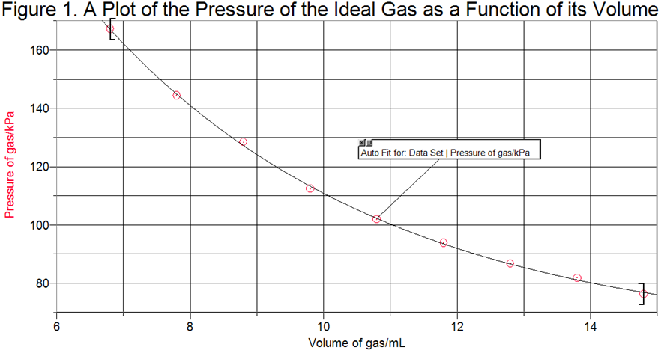
- By interpreting Figure. 1, an increase in the volume of the gas has caused a decrease in its pressure at constant temperature. More specifically, Figure. 1 shows that the pressure of the gas is the inverse function of its volume at a fixed temperature, meaning the pressure of the gas is inversely proportional to its volume, P ∝ (1/V). This is verified through Figure. 2, which is a plot of the pressure of the gas as a function of its inverse volume. Since Figure. 2 is linear, the slope of Figure. 2 will represent the value of Boyle’s Law Constant (m), which is determined to be 1118 ml/kPa by Logger Pro. (values of inverse volume is shown in Table 3 below)
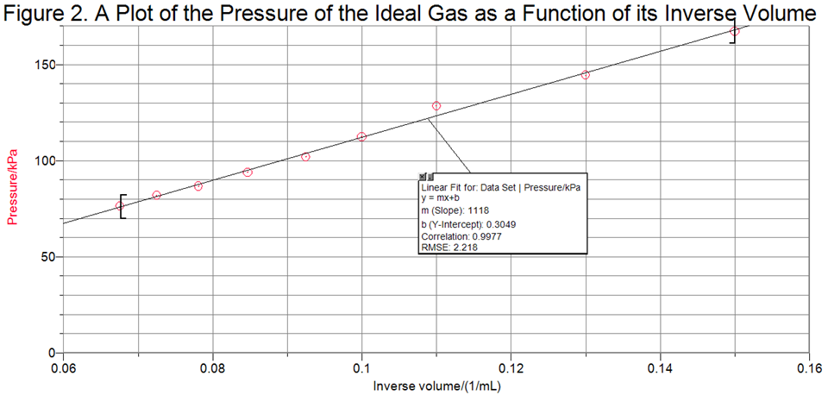
Table 3: Determination of inverse volume of the ideal gas used in the experiment (mL):
Volume of gas (mL) | Inverse volume (1/mL) | Pressure of gas (kPa) | Boyle’s Law Constant (ml*kPa)
14.8 | 6.76 x 10^-2 | 76.25 | 1.13 x 10^3
13.8 | 7.25 x 10^-2 | 81.81 | 1.13 x 10^3
12.8 | 7.81 x 10^-2 | 86.64 | 1.11 x 10^3
11.8 | 8.47 x 10^-2 | 93.79 | 1.11 x 10^3
10.8 (initial volume kept) | 9.25 x 10^-2 | 101.91 | 1.10 x 10^3
10.8 (final volume, not kept) | 9.25 x 10^-2 | 105.41 | 1.14 x 10^3
9.8 | 0.10 | 112.37 | 1.1 x 10^3
8.8 | 0.11 | 128.38 | 1.1 x 10^3
7.8 | 0.13 | 144.34 | 1.1 x 10^3
6.8 | 0.15 | 167.19 | 1.1 x 10^3
Sample calculations:
- Determining inverse volume:
1/V = 1/14.8
1/V = 6.76 x 10^-2 (1/mL)

- Calculating constant m:
P=m(1/V)
m= PV
m=(76.25kPa) (14.8 mL)
m= 1.13 x 10^3 kPa*mL

- Calculating the average constant (m_{av}):
m_{av}= [2(1.13 x 10^3) + 2(1.11 x 10^3) + 4(1.1 x 10^3) + 1.10x 10^3 + 1.14 x 10^3]/10
m_{av}= 1.112 x 10^3 kPa*mL (all significant figures are kept)
m_{av}= 1.1 x 10^3 kPa*mL (final answer with 2 significant figures)

- Percent error between average constant and constant derived from Figure 2:
% Error = (m-m_{av})/m x 100%
% Error = (1118 - 1.1 x 10^3) / (1118) x 100%
% Error = 1.6 %

- The mathematical relationship illustrated by Boyle’s Law is that: at a fixed temperature, the pressure of the ideal gas is inversely proportional to its volume, with a constant of 1118 mL/kPa determined empirically from Figure. 2. This means the equation for Boyle’s Law can be derived as P=m(1/V), where P represents the pressure of the ideal gas in kilopascals, V represents the volume of the gas, in milliliters, and m represents the Boyle’s Law Constant. To verify this, calculations of m are performed and displayed in Table 3. Although the average value of m is only in 2 significant digits, there is only a percent error of 1.6%, which means the constant calculated in Figure. 2 is correct.

- The same volume of syringe must be measured twice to ensure that the syringe as well as the tip of the Gas Pressure Sensor is well sealed. By measuring the pressure of the same volume of gas twice can also determine if a change in temperature is present. In this case, the final pressure reading has increased compared to its initial measurement. Typically, a decrease in temperature would reduce the volume of the gas. However, according to the Ideal Gas Law PV=nRT, if the volume of the gas is fixed, the increase in temperature will result in an increase in pressure of the gas, considering that the amount of gas remains constant. This means there must be an increase in temperature when the last measurement is being performed, which has resulted in the pressure of the gas to increase.

- Boyle’s Law requires the “temperature and the amount of gas are constant" (Chemistry 301 p1). Since the tip of the syringe connected to the Gas Pressure Sensor and the tip of the plunger are well sealed, air is prevented from leaking out or getting into the syringe. Therefore the amount of gas within the syringe has stayed fairly constant in this experiment. However, it is impossible to monitor whether the temperature within the laboratory has maintained constant throughout the experiment.
Discussion:
In this experiment, the constants of Charles Law are calculated at different temperatures. The constant calculated at high temperature (348.2 K) is 4.325 x 10^-1 mL/K, while the constant calculated at low temperature (279.45 K) is 2.82 x 10^-1 mL/K. Theoretically, both constants should be equal because the gas used is the same in the experiment (air), and the pressure of the gas was assumed to be constant during the experiment. However, both constants are not the same with a percent error of 34.8%, meaning at higher temperatures, the increase or decrease in temperature will have a more significant increase or decrease in volume (steeper slope), and at lower temperatures, the increase or decrease in temperature will not have a very significant increase or decrease in volume (slope is less steep). Yet, an increase in temperature of the gas has still caused its volume to increase linearly. Therefore, the results has somewhat verified the equation (V=mTk) provided by the experiment.

In terms of Boyle’s Law, pressure is set as the dependent variable with the unit kilopascals (kPa) which is the unit given by the Gas Pressure Sensor. Pressure changes depending on the independent variable, volume, which is measured in milliliters (mL) since that is the measurement of volume provided on the syringe. From the result, the mathematical relationship determined from this experiment is that the pressure of a gas is inversely proportional to its volume at a fixed temperature, and the constant for this mathematical relationship is calculated to be 1.1 x 10^3 mL*kPa. This means, as the volume within the container increases, the pressure within the container will decrease in proportion to the increase in its volume. This is because gas molecules will be provided with more space for movement inside the syringe before a collision with the side of the syringe or into another molecule will occur. On the contrary, as the volume within the syringe decreases, gas molecules have less space to move around inside the syringe and it will collide into the sides of the syringe or into another gas molecule a lot more frequently. Therefore, more pressure will be exerted by the gas onto the sides of the container or on each other, and the pressure within the container will increase proportionally to the decrease in its volume. Since the constant determined only has a percent error of 1.6%, the mathematical relationship of Boyle’s Law has been successfully verified by the results determined in this experiment.

The measurements are chosen to be increasing or decreasing by 1.0 mL from its previous measurement because there is only 0.8 mL of gas within the Gas Pressure Sensor, and it would be impossible to measure the change in pressure when there is a drastic change in the volume within the syringe, such as increasing or decreasing 10.0 mL from the previous measurement. Furthermore, If the initial measurement begins at 0.0 mL, it will be extremely hard to acquire enough volume of gas to take 8 measurements that are 1.0 mL apart. The same thing can be said if the initial volume is set to be at 20.0 mL. Since the Gas Pressure Sensor connected to the syringe is completely sealed, by taking 8 measurements of pressure at volumes of 1.0 mL apart will drastically increase the pressure within the Gas Pressure Sensor, which can exert a force on the tip of the syringe connected to the Gas Pressure Sensor significant enough to cause the tip of the syringe to become disconnected from the Gas Pressure Sensor. Therefore, the initial volume is set to be 10.8 mL, and measurements after the previous measurement is set to be increasing or decreasing by 1.0 mL.

There were a few sources of errors that have occurred during the experiment. Firstly, it is impossible to monitor air pressure within the laboratory throughout the experiment. Although the gas used in this experiment is assumed as an ideal gas, the pressure within the laboratory may change and cause slight deviations to the measurements that were used to verify Charles’ Law (since the pressure of the gas is inversely proportional to its volume). This might be the reason that has resulted in a percent error of 34.8% when the constants for Charles’ Law are calculated at different temperature. Another source of error is caused by the precision of the syringe when the experiment for Boyle’s Law is being performed. Any measurements that are below 10.0 mL will only have two significant digits (example: 9.8 mL only has 2 significant figures). This is why the calculations of the inverse volume with the original volume below 10.0 mL only has two significant digits. As a result, this may have caused the point (0.11, 128.38) not to be located perfectly on the line for Figure. 2 (see in Figure. 3 below). This has also caused a deviation of 1.6% in calculations of the Boyle’s Law Constant. Lastly, the experiment for Boyle’s law was conducted right after the first trial has been conducted for Charles’ Law. Since there are no words labelled under certain applications for LabQuest 2 (device used for measurements for Boyle’s Law), it was difficult for students to understand how to correctly manipulate its functions even with the proper understanding of the procedures. This prevented a second trial from being conducted for Charles’ Law, and less data have been provided to verify the linear relationship between the volume of a gas and its temperature at a fixed pressure for Charles’ Law.

Figure. 3: location of point (0.11, 128.38) on Figure 2.
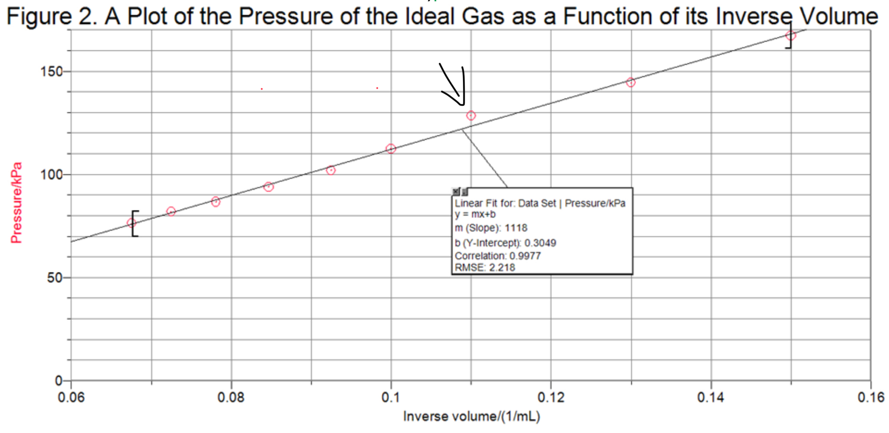

Conclusion:
The constant for Charles’ Law is determined to be m₁= 4.325 x 10^-1 mL/K and m₂= 2.82 x 10^-1 mL/K, with a percent error of 34.8%, which somewhat verifies the mathematical relationship for Charles’ Law. The constant for Boyle’s Law is 1.1 x 10^3 ml*kPa, with a percent error of 1.6%, and the mathematical relationship for Boyle’s Law is determined: the pressure of a gas at a fixed temperature is inversely proportional to its pressure [P=m(1/V)].

Works cited:
- “Thermal expansion of solids, liquids and gases”. BBC. Accessed September 15, 2018. https://www.bbc.com/bitesize/guides/zgr2pv4/revision/2

“Boyle's Law”. Chemistry 301. Accessed September 15, 2018. https://ch301.cm.utexas.edu/section2.php?target=gases/gas-laws/boyles-law.html
- D. J. Campbell, et all. “Gas Property Demonstrations Using Plastic Water Bottles”. ACS Publications. Accessed September 16, 2018. https://pubs-acs-org.proxy.bib.uottawa.ca/doi/pdf/10.1021/ed100745c

Pictures of raw data: (see next page)
Screenshots of electronic data and raw data collected during the experiment:
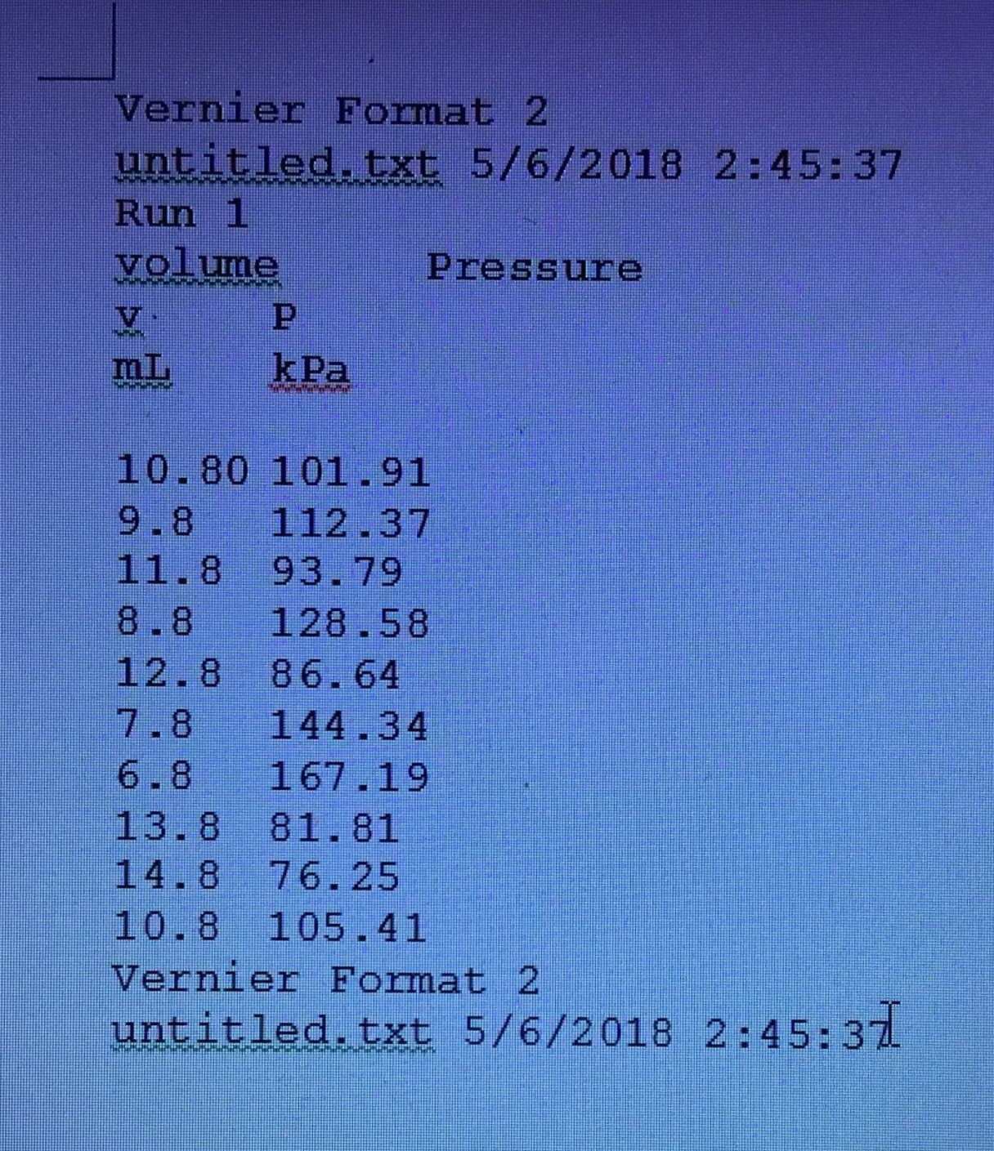
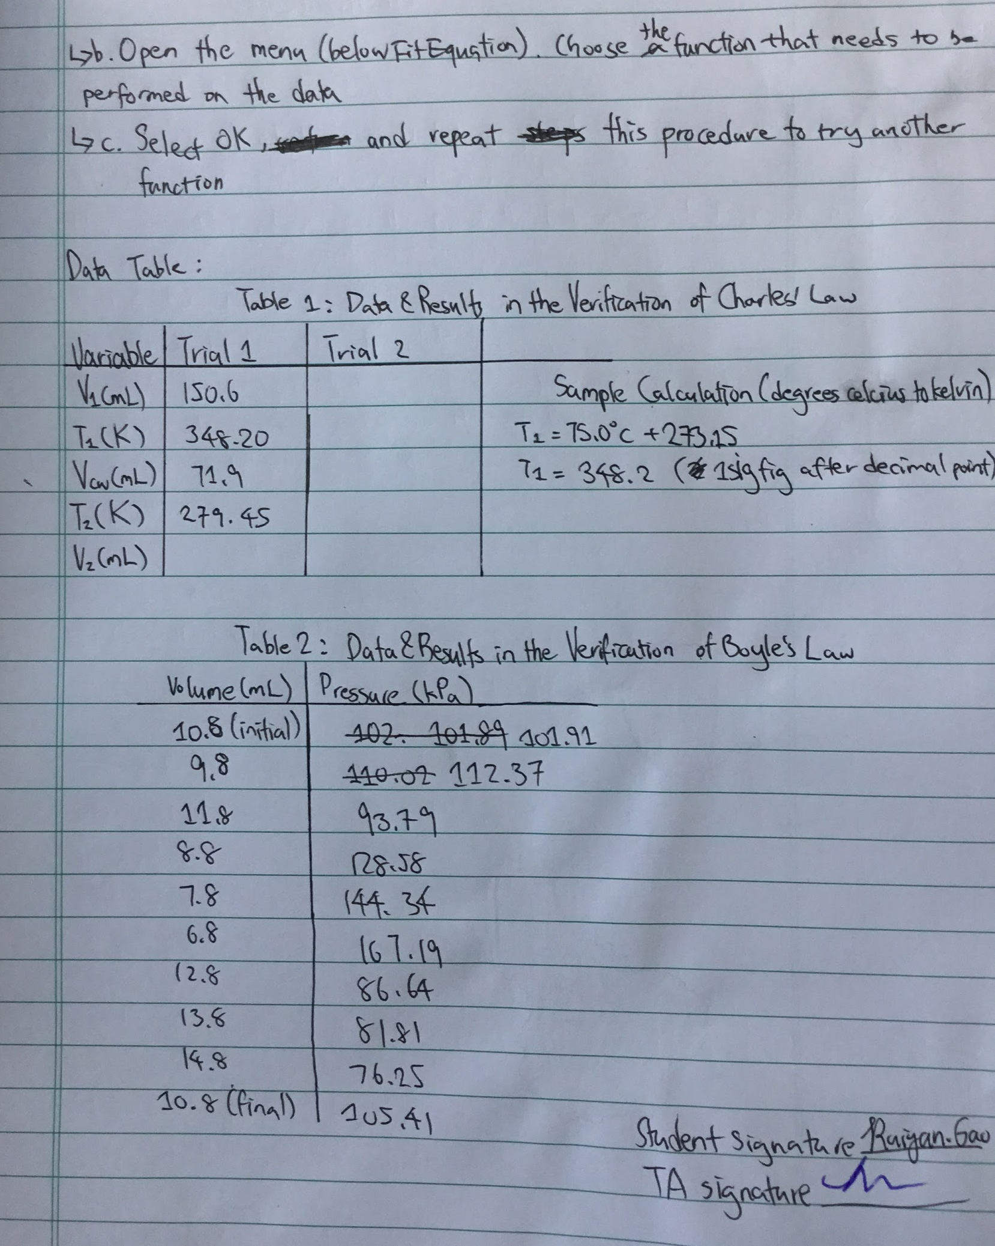
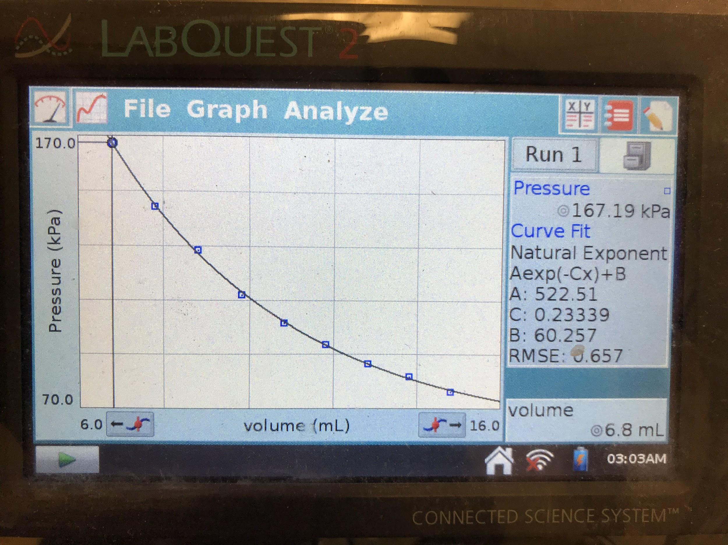

Screenshots of graphs made by Logger Pro:
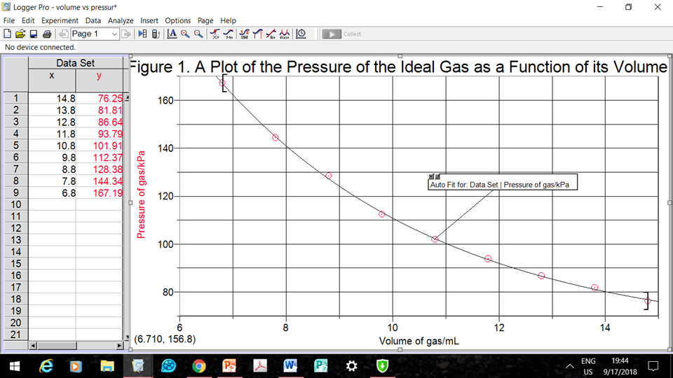
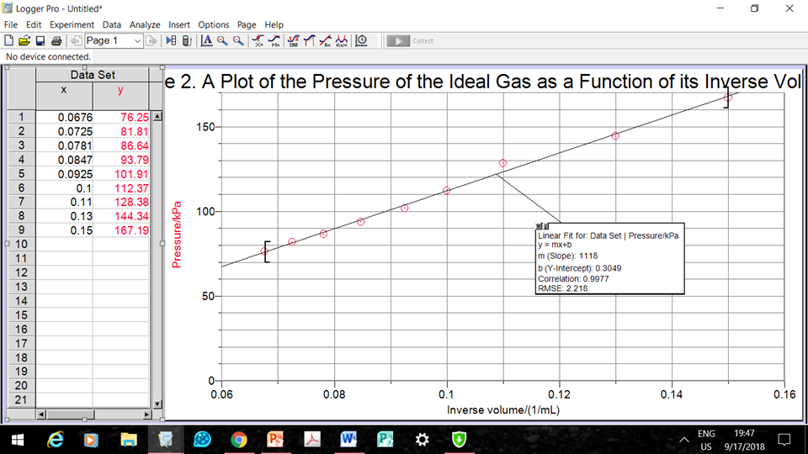

Screenshot of written procedure:

