Chapter 2: Transformism in antiquity:
2.1.1 Anaximander:
- First philosopher
- “Animals are born from the sea by solar heat on water. They were wrapped in spiny bark. As they aged, they migrated to the mainland. When the bark burst, they survived briefly in their new lifestyle.”
- Water is the central element of this universe (source of all life)
- Humans are born inside a fish,

2.1.2 Empedocles (p423-483)
- 4 elements make up the world:
  - Earth, water, air, fire (simple, eternal and unalterable)
- Assemble things into an organism
- 2 forces interact constantly on these elements: love (attraction/harmony) and hate (repulsion/discord)
- The balance between both created a species that survived nature and reproduced

2.1.3 Democritus:
- Most scientific Greek philosopher
- 2 realities: atoms (deduction of paper) and emptiness
- Matter: group of atoms in movement
- Atoms are indivisible (cannot be created or destroyed)
- Intrinsic property, a force within atoms that creates organisms (life, humans)
- Humans and animals born from dirt (spontaneous generation)

Conclusion:
- Acts of creation aren’t due to Gods, but the innovative power of matter (forces within it)
- Origin is not teleological (no ultimate goal), rather a result of chance/an irrational need

2.2.1 Classical thinkers (Socrates to Plato)
Socrates:
- Abstract view of life through soul contemplation (finding answers within self)
- Questions linked to a search for beauty, kindness, justice and sanity (not material).
- Arguments about logical, ethical and political questions (not the truth)
Plato:
- Theories of Forms (Essentialism): visible, imperfect & changing is a poor imitation of an Ideal World
- Modified concept of spontaneous generation by adding God as the creative force
- We are born with the notion of ideal shape and form (we need to get to this ideal shape)
- Nature is full of imperfections, because it obscures all forms
- Example: there are many chairs, but they all aren’t a perfect imitation of an ideal chair
- The world of forms is innate (we are born within it)

2.2.2 Aristotle:
- Meticulous observer. Did not believe in the innate nature of ideal forms
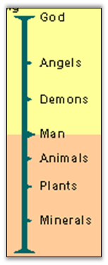
- Essense of things must be observed and defined in nature
- Created scala naturae, depicts species in a static & unchangeable hierarchy
- Morphological variability is viewed as confusion, imperfection. Instead, we need to define the essence of a species
- Father of comparative method
- Vitalist, perceives multiple levels of souls with cumulative effects
  - Vegetal soul (bottom): grow and reproduce (animal)
  - Animated soul (middle): able to move plus abilities in vegetal soul
  - Rational soul (top): able to think rationally
- Cannot switch levels (fixed world, no evolutionary thought)
- Darwin:
  - Variability is not imperfection, it’s the key to evolution

2.3 christianism:
- Christianity institutionalized the ideology of western society
- Dark age for transformism (no ideas of evolution are accepted)
- God becomes the measure of all things,
- The concept of scala naturae is metaphysical, proclaiming the perfection

2.4. From fixity of species to transformism
- Renaissance in Europe: (14-17 century)
  - Back to nature, challenges religious powers
- French revolution: (18th century)
  - Challenged ordered systems (monarchy) for active pursuit of progress
  - Open minded to science
- People can begin thinking of how nature works
- During & immediately after the Renaissance, things returned to experimentation and the observation of nature.
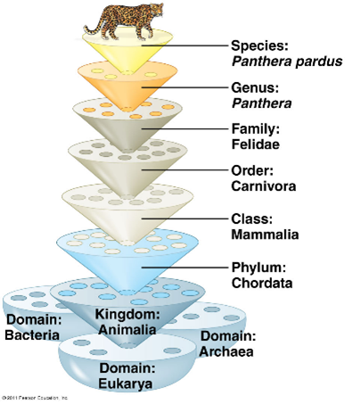
- Attempt of classifying of living organisms were done within the Great Chain of Being

2.4.1: Linnaeus:
- Swedish scientist, Father of modern taxonomy (Systema Naturae, 1758, ideas still valid today)
  - Hierarchical classification (linnaean system)
  - Binomial system of nomenclature (genus and species)
- Every species was static and created by God
- Wrote the Plan of Creation.
- Recognized different phyla (animal, plant, mineral) and divided them into classes
- Masterpiece of essentialism

2.4.2 Buffon
- Objective: describe nature (44 volumes Histoire)
- He wrote (1740s): every family, animal to plant, has a common origin, all animals derive from one animal, which produced all animal species today”. (similar to Darwin’s theory)
- His theory established the age of Earth to be around 75,000 years.
- The initial temperature of Earth was very high. Since then climate has mellowed out.
- The faculty of Theology of Sorbonne censored many of Buffon’s theories due to religious views. Causing him to focus on observing nature, and tone down evolutionary thinking
- Classification was different than Linneus, therefore not accepted
- Evolutionary ideas, but too revolutionary and controversial
- Strategic, works at museum and regained views of nature

2.4.3. Lamarck:
- First evolutionist (species morphology modified through time).
- Uses the environment as a factor of change (environmental determinism)
- 2 principles (affects individuals):
  - Principle of usage and non-usage. If you don’t use it it will disappear (giraffe, tennis player: your service side is stronger than the other)
  - Principle of inheritance of acquired characteristics (characteristics acquired during the life of an individual are transmitted to the next generation)
  - Not proved, but if you modify your morphology, you may not pass it along
  - We wear genetic material, we do not change them
- Gradual mechanism, adaptive (provoked by environment) and involves an organism’s innate ability (internal force) of to be more complex.
- Spontaneous generation explains the simple organisms, (more complex today)
- Theory not well received by his peers. Contradicted religious view of the creation
- Problem: acquired traits cannot be inherited
- Environment dictates change in species (factor of change)

2.4.4 Cuvier:
- French scientist who’s into mammal fossils, Father of paleontology
  - The older the stratum, the more dissimilar its fossils were to current species
  - From one layer to the next, species appear and disappear.
- Theory of correlation of parts (organs). Extrapolate info from bones/morphology to identify the animal
- God created several communities, and several layers of fossils.
- Believed in the fixity of species and catastrophism
- Modified the Great Chain of Being: God created 4 types of animals, (Radiata, jellyfish; Mollusca, molluscs; Articulata, insects; Vertebrata, vertebrates).
- Catastrophism: Natural catastrophes created periodical annihilation of all animals in a specific era, and are followed by the creation of species.
- Progressionism: God improved the quality, complexity and perfection of his creations after each cataclysm or catastrophe.
Example of theory of correlation of parts: carnivore vs herbivore jaws:
- Carnivore jaw:
  - Scissor movement, teeth cuts meat and swallow it.
  - Jaw joint is round to lock to choke prey to death
  - Teeth leveled with jaw, round jaw joint
- Herbivores jaw:
  - Way higher jaw joint, no scissor movement
  - Molar teeth crushes vegetables to obtain nutrients.
  - Flat jaw surface to move the jaw around to cut properly
  - Humans have typical herbivore jaws

2.4.5. Hutton and Lyell (geologists)
- A slow, gradual & continuous process cause geological changes.
- This world has no beginning or end
- Lyell :
  - Rejected Progressionism: no obvious progress according to the principle of uniformity. All life forms can be found in all geological layers.
  - Rejected Lamarck’s ideas on evolution. Individuals that deviate from the ideal individual shape were more susceptible to disappear than individual close to the ideal form or the essence of a species.
- Hutton:
  - Our world needed more than 6k years to get to where we are right now
  - Creating force that counterbalances this progressive degradation is the Earth’s heat, volcanos and the pressure of the crust.
  - Principle of uniformity(uniformitarianism):
    - Laws of nature aren’t affected by time passage, meaning we can interpret past geological events from current events or processes
- Example: himalayas hoodoos (tent rock): big rocks sitting on towers of sand

