ECON*3730 – The Origins of International Inequality
Final Exam Review

Why Nations Fail

Chapter 2
Geography Hypothesis:
- Jared Diamond; geography hypothesis argues that the origins of intercontinental inequality at the start of the modern period, 500 years ago, rested in different historical endowments of plant and animal species, which subsequently influenced agricultural productivity.
- Being able to domesticate more animals is attractive for societies to switch form hunter-gatherer to farming
- Farming developed earlier in the Fertile Crescent than it did in Americas for these reasons
- This thesis then says that the differential availability of plant and animal species created differential intensities of farming, which led to differential paths of technological change and prosperity across different continents.
- This does not explain modern world inequality
- Diamond explains that the Spanish were able to dominate the civilizations of the Americas due to their longer history of farming and thus superior technology
- Diamonds theory implies that once the Incas were exposed to the Spanish’s species and technology, they should attain the same living standards, this did not happen.
- Instead the gap in standard of living between the Spanish and Incas grew because gaps in income are closely connected to the uneven dissemination of modern industrial technologies, and not so much with the potential for animal and plant domestication or the intrinsic agricultural productivity differences between the countries
- Diamond’s theory does not tell us why these crucial technologies are not diffusing and equalizing incomes across the world, especially in the case of Nogales, Arizona and Mexico.
- We see problems in adapting Diamond’s thesis through the example of the Inca and Aztec empires in Peru and Mexico being undoubtedly more prosperous than the United States and Canada in 1532.
- North America became more prosperous precisely because it enthusiastically adopted the technologies and advances of the industrial revolution.
- North Americans became educated and benefited from railways, in contrast, South Americans did not adopt technologies and did not progress because of this.
- Diamond’s argument about continental inequality does not explain variation within continents, which is an essential part of modern world inequality.
- While the geography of the Americas stayed the same, the institutions imposed by European colonists created a “reversal of fortune”
- It was not the geography that made the Middle East poor, instead it was the expansion and consolidation of the Ottoman Empire, and it is the institutional legacy of this empire that keeps the Middle East poor today.

Culture Hypothesis:
- Can sometimes be useful for understanding world inequality, in the sense that social norms, which are related to culture, matter and can be hard to change, and they also sometimes support institutional differences, this book’s explanation for world inequality.
- But is mostly not useful because understanding culture is just not important for understanding how we got here and why the inequalities in the world persist, most of these cultural outcomes are simply an outcome of institutions, not an independent cause.
- Nogales have a similar culture North and South of the boarder, but the Mexican side trust others less than the US side trusts others according to surveys. This does not come from a cultural aspect but from the fact that the Mexican government cannot eliminate drug cartels or provide a functioning unbiased legal system
- While North Korea and South Korea have different cultures today, culture played no role in causing the diverging economic fortunes between the two
- Similar to Nogales, what matters is the border, each side having different regimes, different institutions, and creating different incentives.
- Thus we can say that any cultural difference between Nogales and N or S Korea is not a cause of the difference in prosperity, but a consequence.
- The Portuguese and Kongolese contact encouraged modern technological adoption in Africa, in West Africa there was rapid economic development based on the export of agricultural goods, in Southern Africa exports of industrial and mining goods rapidly expanded.
- Yet these promising economic experiments were obliterated not by African culture or the inability of Africans to act in their own self-interest, but first by European colonialism and then by post-independence African governments.
- The Kongolese did not adopt superior technology because there was no incentive to do so, they faced his risk of expropriation and unfair taxes by their King. There was also a high risk of being captured and sold as a slave, hardly an environment for investments in long term productivity.
- The Kongo king also had no incentive to adopt technologies on a large scale or to increase agricultural productivity as a major priority, selling slaves was so much more profitable
- Similar to Nogales, Mexico, surveys show that Africans do not trust others, much less so than the rest of the world, and this is the outcome of a long history of institutions that have undermined human and property rights in Africa.
- The English culture is not the reason for the United States, Canada, or Australia’s success, keeping in mind that Sierra Leone and Nigeria were also English colonies but are now two of the poorest countries

Ignorance Hypothesis:
- Asserts that world inequality exists because our rulers do not know how to make poor countries rich
- A leader’s apparent economic mismanagement can never be simply blamed on ignorance, if ignorance were the problem, well-meaning leaders would learn from these mistakes and correct them through policies that would increase citizens’ incomes and welfare.
- Differences in knowledge or intentions between John Smith and Cortes were not the cause for the divergence during the colonial period between the USA and Mexico. Just as it wasn’t the knowledge between US presidents Teddy Roosevelt or Woodrow Wilson, and Mexican President Porfirio Diaz that made Mexico choose economic institutions that enriched elites at the expense of the rest of society, while the US presidents did the opposite.
- It was the differences in the institutional constraints the countries’ presidents and elites were facing.
- Similarly to Africa nations having insecure property rights and economic institutions, it is not done because the leaders thought it was good economics, it was done because they could get away with it and enrich themselves at the expense of the rest, or good politics, a way of keeping themselves in power by buying the support of crucial groups and elites.
- The ignorance hypothesis differs from the geography and culture hypotheses in that it comes readily with a suggestion about how to solve the problem of poverty: if ignorance got us here, enlightened and informed rulers and policy makers can get us out.
- Yet the example of Ghana’s prime minister in 1971 Kofi Busia shows that the main obstacle to the adoption of policies that would reduce market failures and encourage market growth is not the ignorance of politicians but the incentives and constraints they face from the political and economic institutions in their societies.
- Ignorance hypothesis explains neither the origins of prosperity around the world nor the lay of the land around us, therefore it does not work.
- The example of China’s switch from the Chinese Communist Party to Deng Xiaoping’s leadership which implemented economic reforms is an example of how politics determined the switch from communism and toward market incentives in China, not better advice or a better understanding of how the economy worked.

Chapter 3
- After WWII, South and North Korea adopted very different ways of organizing their economies
- South Korea was led by Syngman Rhee, an anticommunist supported by the USA
- Rhee and his successor General Park Chung-Hee governed a market economy where private property was recognized, and used the states weight to channel credit and subsidies to firms that were successful, creating rapid economic growth.
- In North Korea, Kim Il-Sung, leader of anti-Japanese communist partisans during WWII, established himself as a dictator with help from the Soviet Union
- Kim introduced a rigid form of centrally planned economy called the Juche system, private property was outlawed and markets were banned. Freedoms were curtailed for all North Koreans other than the elite.
- North and South Korea’s economic fortunes diverged because of this, notably North Korea experienced a collapse in agricultural productivity due to a lack of private property that meant that few people had incentives to invest or to exert effort to increase or even maintain productivity.
- Neither culture nor geography no ignorance can explain the divergent paths of North Korea and South Korea, we have to look at institutions for an answer.
- Differences in N and S Korea, and the US and Latin America illustrate a general picture: inclusive economic institutions foster economic activity, productivity growth, and economic prosperity
- Inclusive economic institutions require secure property rights and economic opportunities not just for the elite but for a broad cross-section of society (unlike 1680 Barbados in which 2/3 of the population were slaves)
- Extractive economic institutions extract incomes and wealth from one subset of society to benefit a different subset
- Inclusive economic institutions pave the way for technology and education
- Political institutions that are sufficiently centralized and pluralistic are inclusive political institutions
- Nations fail because they have extractive economic institutions supported by extractive political institutions that impede and block economic growth
- Creative destruction (Schumpeter) is the reasoning behind most of the opposition to technological change
- Creative destruction is also why those oppose inclusive economic and political institutions
- The industrial revolution had clear losers, politically and economically, and these losers were the elites and aristocrats
- Luddites were those against technological change, such as the Artisans during the Industrial Revolution
- The Industrial Revolution marched on in England because Aristocrats, Elites, and Artisans could not stop it, but in Austro-Hungarian and Russian Empires, where the absolutist monarchs and Aristocrats had far more to lose, industrialization was blocked.
- A major dividing line between extractive political institutions is their degree of political centralization, those without it, such as many in sub-Saharan Africa, will find it difficult to achieve even limited growth.

Chapter 4
- The Bubonic Plague’s effect on England resulted in a more inclusive labour market where wages rose, due to scarce labour and those who survived demanding more freedoms.
- This did not occur in Eastern Europe because these towns were weaker and less populous than those of England’s. The Eastern landlords were able to expand their holdings by claiming more land after the plague, and used this power to further encroach on freedoms. (Second Serfdom)
- Eastern and Western were originally similar before the Bubonic Plague, there were only slight differences; such as in the East, Lords had slightly more rights and their peasants were weaker, smaller, and less organized. Yet these small differences made a huge difference for their future paths of institutional development once feudal order was shaken up by the Black Death
- England’s political revolution in the seventeenth century decided who would reap the benefits of prosperity, this was decided as different groups competed for power, contesting the authority of others and attempting to structure institutions in their own favour.
- The Glorious Revolution was the foundation for creating England’s pluralistic society, building on political centralization, thus creating the first set of inclusive political institutions.
- The Glorious Revolution enforced property rights, including patents, creating stimulus for innovation. Monopolies were abolished, law and order was protected, arbitrary taxation ceased, mercantile activities were promoted and given protection by the navy, and construction of infrastructure was crucial for later industrial growth.
- The full force of this revolution came from the market that created profitable opportunities for technologies to be developed and applied. Education and entrepreneurs thrived.
- England, Spain, and France diverged in terms of political institution’s pluralism because of small differences in 1588. All three were absolutist monarchs, but Elizabeth I was far less financially independent than the others as she had to beg Parliament for more taxes.
- Cortes in Spain had power over taxation but it didn’t matter because the Spanish monarchy had a vast American empire that benefited from the gold and silver found there, and the French monarchy had full control over taxation whereas the Estates-General did not. (Parliament = Cortes = Estates-General, these are assemblies of citizens in England, Spain, and France)
- The difference created by institutional drift determine how a society reacts to changes in economic or political circumstances during critical junctures

Chapter 5
- Stalin’s style of economic growth involved developing industry by government command and obtaining resources needed by taxing agriculture at very high rates
- This process abolished private property rights and herding the population into giant collective farms run by the Communist party, Stalin would take the agricultural output and use it to feed the factory builders and workers
- This created a lack of incentive and production fell sharply, there was not enough to eat and six million died due to starvation while hundreds of thousands were murdered or banished to Siberia during this forcible collectivization
- The Soviet Union grew rapidly during this time because the productivity of labour and capital in its heavy industry was so high, that even a top-down process under extractive institutions that allocates resources toward that sector can generate growth.
- This is a similar situation to those in Barbados and other Caribbean countries which allocated resources to the production of sugar, and was based on slavery which is certainly not “efficient”, and there was no technological change or creative destruction.
- Extractive institutions cannot generate sustained technological change for two reasons: the lack of economic incentives and resistance by elites.
- Growth under extractive institutions is limited not only due to a lack of technological progress but also because it will encourage infighting from rival groups wishing to take control of the state and the extraction it generates.
- Infighting and instability are inherent features of extractive institutions as explained in the case of the Maya city-states in the Classical-Era, they create further inefficiencies and reverse any political centralization.

Chapter 6
- Venice’s economic expansion was caused by a series of contractual innovations making economic institutions more inclusive; the commenda was one of these innovations
- The commenda was a rudimentary type of joint stock company formed for the duration of a single trading mission.
- A commenda involved two partners, the sedentary stayed in Venice, and the other traveled. The sedentary put capital into the venture, and the other accompanied the cargo.
- Those that did not have money to become the sedentary could get into the trading business by being the one that travels with the cargo, therefore allowing a key channel of upward social mobility.
- This economic inclusiveness and the new wealthy families created by the commenda forced the political system to become even more open.
- Venice now had many restrictions on those in power, and councils were frequently changed via fairly open voting systems.
- These inclusive Venetian institutions were accompanied by creative destruction, and the elite families experienced less profits and in the end forced the Great Council into closing down this system to anyone new.
- These restrictions obviously made Venice less friendly to entrepreneurs, the common folk fought back, but the elite and the Great Council responded by introducing a police force for the first time.
- This new political order was a switch to a extractive political institutions, which was followed by a switch to an extractive economic institution.
- The switch to an extractive economic institution is most obvious through the banning of the commenda contracts, because they benefited new merchants and the elite were trying to exclude them.
- Roman Republic transitioning into the Roman Empire is an example of inclusive qualities in an economy and politics can change into an extractive case.
- There is evidence of economic growth under the Roman Republic, and this level of growth was never achieved under the Roman Empire.
- Roman land ownership was as unequal as the plebeians were forced to fight as soldiers for the state and would be away from their land in Rome for so long that they would accumulate too much debt from unoccupied. They would end up selling their land to the senators who already owned most of Rome’s land, making them even more wealthy and influential.
- The Roman Empire’s Emperors made Rome’s institutions extractive by removing secession and therefore not allowing representation for common romans, abolishing the Plebeian Assembly by giving these powers to the Senate, creating the Praetorian Guard which were professional soldiers and removing the citizen soldiers (giving these soldiers a lot of influence in who becomes emperor).
- This accumulation of power at the center made property rights insecure, and all political rights of citizens declined while the state controlled all technological innovation implementations (unbreakable glass example, Roman Emperor killed the inventor because of the fear of creative destruction), no wonder economic growth declined.
- After the Western Roman Empire fell, Western Europe became mostly feudal, feudal society was decentralized and relied on unfree labor, but feudal institutions were consequential for the reduction of the rural population to the status of serfs, reducing slavery in Europe.
- In England the profits of the slave trade helped to enrich those who opposed absolutism, in Africa they helped to create and strengthen absolutism. (Case of England and Ethiopia diverging after the fall of the Western Roman Empire and the Kingdom of Aksum)

Chapter 7
- The fear of creative destruction is the main reason why there was no sustained increase in living standards between the Neolithic and Industrial Revolutions.
- England experienced increasing political centralization after the War of Roses. King Henry VII expanded the power of the central state by demilitarizing the aristocracy. His son and the chief minister revolutionized the government by introducing a bureaucratic state and removing the power of the church by expropriating all the Church lands.
- This made inclusive political systems possible, but was only a foundation for pluralistic political institutions as many successors to the throne did not continue this progress.
- James I and his son Charles I made efforts to build a more absolutist regime instead, and created extractive policies which brought resentment and resistance throughout England. A Civil war between Charles I and Parliament happened in 1642, Parliament won but this did not result in inclusive institutions.
- The Monarchy that was defeated was overthrown by a dictatorship under Oliver Cromwell, and once Cromwell died the Monarchy was re-established by Charles II who followed the same absolutism as his father. After Charles II died, his brother James II went even further with absolutism, starting another civil war called the Glorious Revolution.
- The Parliament was more organized during the Glorious Revolution, they won and replaced James II with William of Orange who would lead as a constitutional monarchy forged by Parliament.
- A new constitution was negotiated and the Parliament constructed a Declaration of Rights, this established some central constitutional principles. William gave up a lot of the previous kings’ practices and Parliament was firmly in control of state policy.
- Parliament was more pluralistic so the English people had access to Parliament, and the policy and economic institutions made in Parliament. Petitioning was a way to influence Parliament at this time. This influence in the way the state worked helped abolish monopolies like the Royal African Company and strengthen property rights.
- This paved the way for the Industrial Revolution as economic institutions were reformed to promote manufacturing, rather than taxing and impeding it.
- The Industrial Revolution was the result of the fundamental reorganization of economic institutions in favor of innovators and entrepreneurs, based on the emergence of more secure and efficient property rights.
- A combination of improved and new property rights, improved infrastructure, a changed fiscal regime, greater access to finance, and aggressive protection of traders and manufacturers influenced a jump in the number of patented innovations, this was the heart of the Industrial Revolution.
- The Industrial Revolution started and made its biggest strides in England because of unique inclusive economic institutions which were built on foundations laid by inclusive political institutions brought by the Glorious Revolution.
- The mass entry of English merchants into Atlantic trade and the economic development of the colonies, and the fortunes they made in the process, tipped the balance of power in the struggle between the monarchy and those who opposed absolutism.
- Pitting one group with the same interests against another group of a narrow set of interests would ultimately replace and re-create the same or different form of extractive institution. This did not happen in England as there was a broad coalition which created a greater demand for the creation of pluralistic political institutions.

Week 7: #2
“The Long-Term Effects of Africa’s Slave Trades” – Nathan Nunn (2008)

“Africa’s Power Reshuffle is a Renewal, not a Revolution” – Financial Times
- It is tempting to call it an "African Spring"
  - African Spring: dictatorial regimes topple in Africa
- In a matter of months, entrenched leaders have been dropping like flies
  - In Angola, Zimbabwe, South Africa, and Ethiopia
- Ethiopian prime minister quit a day after Jacob Zuma of South Africa resigned
  - Quit after public protest against the regime
- Africa is not a country, it is a complex continent of diverse nations whose histories, languages and political cultures make them hard to meaningfully compare
  - There is no reason to believe that events in one have any connection to happenings in another
  - Yet that doesn’t mean there are no common themes
- One thing they all have in common is they are run by liberation parties that have solidified in power for 1/4 - 1/2 a century
  - Angola: liberation after the Portuguese left in 1975
  - Zimbabwe: liberated 1980
  - Ethiopia: liberated 1991
  - South Africa: liberated 1994
- These countries were run in a way that destroyed the economy for many, at the expense of making a few elite richer
- Change is now partly driven by the pent-up frustration of the millions left out of prosperity
  - The public has found its voice
  - They are pushing the elite to shuffle leaders in the cause of survival
- Will new leaders bring change?
  - Unknown…
  - Resignation of the Ethiopian president was followed by the imposition of a state of emergency, hardly a sign of democratic opening…
  - New South African president is seeking more than cosmetic changes in the interests of restoring both the ANC's moral and electoral standing
  - Angola and Zimbabwe make it seem like they are going in a new direction… but don’t know if this will translate into more inclusive policies
- Still, in each country the ruling elite has engineered a personnel change in the interest of self-preservation
  - More than revolutions from below, they are party reorganisations from above.
  - But “African spring” does not capture what is going on - You could call it instead the season of the palace coup
The Logic of Effective Altruism - Peter Singer

- Peter Singer met Matt Wage in 2009 when he was taking his Practical Ethics class at Princeton
- In the readings relating to global poverty and what we ought to be doing about it, he found an estimate of how much it costs to save the life of one of the millions of children who die each year from diseases (that we can prevent or cure)
  - This led him to calculate how many lives he could save, over his lifetime, assuming he earned an average income and donated 10% of it to a highly effective organization, such as one providing families with bed nets to prevent malaria, a major killer of children
  - He discovered that he could save about 100 lives
- Wage was accepted by Oxford University for postgrad (which is many peoples dream)
- He turned this down to take a job on Wall Street, which earned a higher income (so he would be able to give much more)
- 1 year after graduating he was donating a 6 figure sum (1/2 his annual earnings)
  - He was on the way to saving hundreds of lives within the first year or two

- Wage is part of an exciting new movement: effective altruism
  - Altruism: selfless concern for the well-being of others
- Philosophy (more specifically practical ethics) has played an important role in effective altruism's development
  - And altruism shows that philosophy is returning to its Socratic role of challenging our ideas about what it is to live an ethical live
  - Socratic: cooperative arguments to stimulate critical thinking
- Effective altruism is based on a very simple idea: we should do the most good we can
  - Obeying usual rules (don’t steal, cheat, kill etc.) is not enough for those of us living fortunate lives (can support ourselves and have money to spare)
- Minimally Acceptable Ethical Life: using a substantial part of our spare resources to make the world a better place
- Fully Ethical Life: doing the most good we can
- Millennials - most effective altruist's
  - Realists (not saints) so do not claim to live a fully ethical life
  - Most lie on the spectrum between a minimally and fully ethical life
  - Don’t feel guilty about not being morally perfect, instead focus on the good they are doing

Effective Altruism is Notable from Several Perspectives:
- It is making a difference to the world
  - $200B go to charities every year in the US
  - Most of that money is given on the basis of emotional response to images of the people, animals and plants the charity is helping
  - Effective altruism seeks to change that
    - By providing incentives for charities to demonstrate their effectiveness
- It is a way of giving meaning to your own life
  - Directly benefit others; indirectly benefit themselves
- Sheds new light on an old philosophical and psychological question: Are we fundamentally driven by our innate needs and emotional responses? Or can reason play a crucial role in determining how we live? What is it that drives some of us to look beyond our own interests to the interests of others?
- Emergence of effective altruism and the evident enthusiasm and intelligence surrounding it from Millennials offers grounds for optimism about our future

Effective Altruists do things like:
- Live modestly and donate a large part of their income to the most effective charities
  - Often much more than the traditional 10%
- Researching and discussing with others which charities are the most effective
- Choosing a career in which they can earn most, not in order to live affluently, but to do the most good
- Talking to others about giving, so the idea of effective altruism is spread
- Giving part of their body to a stranger
  - Blood, bone marrow, kidney

- Effective altruism doesn’t require self-sacrifice
  - If you’re doing the most you can while also flourishing, then that’s the best possible outcome for everyone

Warm Glow Givers
- Some people give substantial amounts to 1 or 2 charities, while others give small amounts to many charities
- Those who donate to 1 or 2 charities seek evidence about what the charity is doing and whether it really has an impact
- Those who give small amounts are not so interested in whether what they are doing helps others (Warm Glow Givers)
- Ex. Make-A-Wish granted a 5-year-old his dream to be the "Batkid"
  - This gives me a warm glow!
  - The average cost per wish is $7500
  - Effective altruists would (like anyone else) be drawn to making the wishes of sick children come true… but they would know that $7500 could save the lives of at least 3 children (and maybe many more)
  - Part of the reason people donate to Make-A-Wish is because they know they are helping this child, rather than the unknowable children who would have died from malaria
- Thus, effective altruists don’t donate to what tugs at their heartstrings

Random Points
- They agree that the suffering of animals counts too and agree that we should not give less consideration to suffering just because the victim is not a member of our species
  - They may differ, however, on how to weigh the type of suffering animals can experience against the type of suffering humans can experience
- Effective altruists can accept that one’s own children are a special responsibility, ahead of the children of strangers
  - BUT don’t feel the need to spoil their children immensely, and upon death leave virtually everything they own to their children (rather than donating a substantial part of their wealth to those who can benefit much more from it)
- Promoting the arts is still a worthy goal, but donating to opera houses and museums isn't likely to do the most good
- It is possible for everyone who has some spare time or money to practice effective altruism
  - Unfortunately, most people who give to charity do not compare the effectiveness of the various charities to which they might donate
- They do not believe that we should violate basic human rights today for the sake of some distant future good
- Availability of research on the effectiveness of charities has risen dramatically over the past few years
  - Largely due to GiveWell, a research organization set up in 2007 to fill the void

Q: Suppose I set up a factory in a developing country, paying wages that are better than local workers would otherwise earn and enough to lift them out of extreme poverty. Does that make me an effective altruist, even if I make a profit?
- What are you going to do with your profits?
- If you decided to manufacture in the developing country in order to make it possible for people to escape extreme poverty, you will reinvest a substantial part of your profits in ways that help more people escape extreme poverty
  - Then you are an effective altruist
- If, on the other hand, you use your profits to live as luxuriously as you can, the fact that you have benefited some of the poor is not sufficient to make you an effective altruist
- There are all kinds of intermediate positions between these 2 extremes (of minimally acceptable ethical life + a fully ethical life)

Daron Acemoglu Response
- What's not to like about charitable given based on quantitative evidence and aimed at maximum impact?
  - Well… this dude has some SHIT TO SAY
- Individuals and Institutions
  - Assigning to individuals the roles typically reserved for societal institutions poses some dangers
  - Ex. We expect local and national law enforcement to fight crime
    - We may at first welcome vigilantes but soon discover their actions are fueled by bias, group psychology, and unchecked power
    - Even worse, they may start eroding society’s trust in public institutions. Why should we pay for police when others protect us?
  - Why is this bad given the track record of some states?
    - Consider the long-term consequences
    - When key services we expect from states are taken over by other entities, building trust in the state and developing state capacity in other crucial areas may become harder
- Effective Measurement
  - We cannot accurately measure which organizations use resources most effectively
  - More evidence is always preferred, but precise measurement of the social value of a donated dollar may be impossible
    - Every measurement has judgements
  - ALSO, a large body of research shows economic development is the best way to lift millions out of poverty
    - So, one has to take into account how charities activities affect economic development - essentially impossible
    - IF, as some suggest, changes in political and economic institutions are critical for LR economic growth, then watchdog organizations like Amnesty International may be essential
    - But effective altruists don’t (yet?) see the importance of these more political organizations
- What we Value as a Society
  - Their imperative to maximize their earnings so they can give more might influence what society views as a meaningful life
  - Many of us would consider the life of a young person who foregoes the comforts of a well-paying job to work as a community activist or a doctor in a war zone not just meaningful but also highly valuable for society
    - But effective altruism may slowly chip away at this conception
  - Or suppose a Wall Street trader had become an innovator, earning less and giving less but creating tools that millions find valuable. Would hers be a less meaningful life?

- None of these objections will have much force if effective altruists remain a small, marginal tribe
- But we may yet see the best and brightest in our colleges and high-prestige professions join them
- If that happens, the unforeseen consequences of this powerful but flawed idea could be stark.

Angus Deaton Response
- Why do the world’s poor have such a passive role in all of this happiness creation?
  - Why are they not asked to participate, if they too feel the warm glow?
- Singer does nothing to persuade us that they have volunteered to be the objects of "effective altruism"
  - Polls show that Africans own priorities lie elsewhere
- Instead, the evidence for effectiveness (which the recipients might have their own views) is outsourced to technical outfits (like GiveWell)

- It is an illusion that lives can be bought like cars
  - For a start, the evidence is nearly always in dispute
- The alleged effectiveness of the Deworm the World Initiative (which at the time of this writing ranked 4th in GiveWell’s list of top charities) runs contrary to the latest extensive review of the evidence by the Cochrane Collaboration (an organization that compiles medical research data)
  - Maybe Cochrane is wrong, but it is more likely that the effectiveness of deworming varies from place to place (depending on climate and on local arrangements for disposing of human waste etc.)

- However counterintuitive it may seem, children are not dying for the lack of a few thousand dollars to keep them alive
  - If it were so simple, the world would already be a much better place
  - Development is neither a financial nor a technical problem but a political problem, and the aid industry often makes the politics worse
- Lack of money did not lead to the recent Ebola epidemic
  - The true villains are the chronically disorganized and underfunded health care systems which governments care little
  - along with well-founded distrust of those governments and foreigners, even when their advice is correct

The current president of Rwanda has discovered how to use Singer’s utilitarian calculus against his own people:
- By providing health care for Rwandan mothers and children, he has become one of the darlings of the industry and a favorite recipient of aid
- Essentially, he is “farming” Rwandan children
  - allowing more of them to live in exchange for support for his undemocratic and oppressive rule
- Large aid flows to Africa sometimes help the intended beneficiaries, but they also help create dictators and provide them with the means to insulate themselves from the needs and wishes of their people

- I too see students who want to relieve suffering in the world. Should they go to Dhaka or Dakar? Focus on bed nets or worms?
- I tell them to go to Washington or London and to work to stop the harm that rich countries do; to oppose the arms trade, the trade deals that benefit only the pharmaceutical companies, the protectionist tariffs that undermine the livelihoods of African farmers; and to support more funding to study tropical disease and health care
- Or they could go to Africa, become citizens, and cast their lot with those they want to help. That is how they can save the lives of African kids.

Chapter 8: Not on Our Turf: Barriers to Development
No Printing Allowed:
- In 1445, in Germany, Johannes Gutenberg invented a printing press based on movable type, which drastically changed things.
- Without the invention, mass literacy and education would have been impossible.
- 1460: printing press now in France.
- Late 1460s: spread through Italy (Rome, Venice), then Florence, Milan, and Turin.
- By 1476: printing press in London 2 years later in Oxford, Spain, Eastern Europe.
- Muslims did not like the Western innovation, and were forbidden from printing in Arabic.
- However, a decree was issued granting a Muslim dude – Ibrahim Muteferrika - (respected Muslim religious scholar) permission to set up a press that would be closely monitored. They allowed this to ensure the printed books would be free from printing mistakes.
- Whatever the dude printed had to be reviewed by a panel of 3 religious and legal scholars – the Kadis.
- The dude only printed a few books in the end (17).
- Printing was lacking across the world and well into the 2nd half of the 19th century, book production in the Ottoman Empire was still primarily undertaken by scribes hand-copying existing books.
- This opposition to the printing press had obvious consequences for literacy, education, and economic success.
- In 1800, only 2-3% of the citizens of the Ottoman Empire were illiterate whereas, 60% of adult males and 40% of adult females were literate. ????????
- The Ottoman institutions were highly absolutist and extractive which lead to their hostility of the press.
- books would spread ideas and make the population harder to control, challenge the existing political and social status quo, undermine the power of those who control oral knowledge (i.e. the elites).
- Since the Ottoman Empire feared the creative destruction that would result, they forbid printing.
- The IR created a critical juncture that affected almost every country.
- England grew rapidly because they allowed and actively encouraged commerce, industrialization, and entrepreneurship.
- However, the Ottoman Empire, China and other absolutist regimes lagged behind because they blocked out/did nothing to encourage the spread of industry.
- The Ottoman Empire remained absolutist until it collapsed at the end of WW1 which saved many from what would have happened if the Empire continued.
- Economic changes took place in England and not in the Ottoman Empire because of the natural connection between extractive absolutist political institutions and extractive economic institutions.
- Absolutists rule with the support of SMALL groups or elite (not the majority).
- The basis of many extractive economic systems was a mass system of labor coercion and control.
- Example: 19th century Russia:
- Tsrars = absolutist rulers supported by only 1% of the pop.
- Many regimes besides just absolutists feared creative destruction, and at states that were centralized enough to impose bans on innovations (ex: Afghanistan, Haiti, Nepal).
- Without a centralized state to provide order and enforce rules and property rights, inclusive institutions could not emerge.
- Absolutism and a lack/weak political centralization are different barriers to the spread of industry however, they are connected in the sense that they are both kept in place by fear of creative destruction and because the process of political centralization often creates a tendency toward absolutism.
- Resistance to political centralization is due to fear of losing political power.
- In some cases, the process of political centralization ushers in an era of greater absolutism (ex: origins of Russian absolutism: swap of absolutist power – taking power away from others and redirecting it toward himself).

Main Points:
- Without a centralized state to provide order and enforce rules and property rights, inclusive institutions could not emerge.
- Absolutism and a lack/weak political centralization are both kept in place by fear of creative destruction and the process of political centralization which creates a tendency towards absolutism. ???????
- England grew rapidly because they encourage innovation and education whereas absolutist economies such as the Ottoman Empire, and Spain lagged behind because they did not encourage such things.

A Small Difference that Mattered:
- 17th century: absolutism crumbled in England but got stronger in Spain.
- The merger of the crowns of Castile and Aragon (formed Spain) and subsequent dynastic marriages and inheritances created a European super state. lead to a multicontinental empire (absolutist state).
- The effort to build and consolidate absolutism in Spain was massively aided by the discovery of metals in the Americas.
- At the time of the merger of Castile and Aragon, Spain was among the most economically successful parts of Europe.
- After its absolutist political system solidified went relative lead to an absolute economic decline.
- The super state expropriated 200,000 Jews as one of their first acts.
- Instability of property rights in absolutist Spain was crucial.
- The impact of absolutism on the economic institutions of trade and the development of the Spanish colonial empire was crucial as well.
- The processes in England that led to economic progress and institutional change did not take place in Spain.
- Spain’s rulers organized trade of the Americas between their new colonies and Spain via some merchants that made sure the monarchy got its share of the wealth of the Americas.
- no free trade – narrow, monopolized base thus, no broad class of merchants could emerge via trading opportunities with the colonies.
- The restrictions on trade within the Spanish Empire reduced its economic prosperity and indirectly reduced the potential benefits that Spain could have gained by trading with another, more prosperous Empire.
- However, they remained attractive because they guaranteed that the silver and gold would keep coming into Spain.
- The extractive economic institutions of Spain (Cortes = Kingdom of Castile and Kingdom of Aragon) were a direct result of construction of absolutism and the different path, compared to England, taken by political institutions.
- Urban elites tried to call for change from the Cortes and its powers which turned violent and lead to the Comunero Rebellion. Cortes won however, there was a continuous battle as the Crown tried to wrest away from the Cortes and was ultimately won by the monarchy.
- The defeat of absolutism in England led to pluralistic political institutions and to the further development of a much more effective centralized state.
- The exact opposite happened in Spain: it became increasingly difficult to raise taxes, even when attempted by direct negotiations with individual cities.
- England created a modern, efficient tax bureaucracy while Spain did not.
- During the 17th century, England was moving toward commercial growth and rapid industrialization, while Spain was tail spinning toward widespread economic decline.
- Spanish incomes fell, while England grew rich.
- The persistence and strengthening of absolutism in Spain = example of small differences mattering during critical junctures. England and Spain went in completely opposite directions.
- the small differences being the strengths and nature of representative institutions.
- the critical juncture being the discovery of Americas.

Main Points:
- England grew rich, while Spanish incomes fell.
- England created a modern, efficient tax bureaucracy, while Spain did not.
- No free trade in Spain thus, merchants did not have any opportunity to find work in trading. No free trade also reduced Spain’s economic prosperity.
- There were unstable property rights (i.e. fear of expropriation) in Spain, which gave people no incentive to work hard because they knew their things could be seized by the State at any time.

Fear of Industry:
- Without the changes in political institutions and political power similar to those that emerged in England after 1688, there was little chance for absolutist countries to benefit from the innovations and new technologies of the Industrial Revolution.
- Ex: the lack of secure property rights and the widespread economic decline meant that people simply did not have the incentive to make the necessary investments and sacrifices.
- At the center of Habsburg economic institutions stood the feudal order and serfdom.
- Feudal Order: a peasant or worker known as a vassal received a piece of land in return for serving a lord or king, especially during times of war. Vassals were expected to perform various duties in exchange for their own fiefs, or areas of land.
- Serfdom: the state of being a serf or feudal laborer. This completely blocked the emergence of a labor market and removed the economic incentives or initiative from the mass of the rural population.
- The suppression of markets and the creation of extractive institutions are quite characteristic of absolutism.
- Example: The problem in Kongo was that people understood that whatever they produced could be confiscated by an absolutist monarch and therefore they had no incentive to invest or use better technology removed the incentive to innovate or adopt new technology.
- Opposition to innovation was manifested in 2 ways:
1. Francis I was opposed to the development of industry. Industry led to factories, and factories would concentrate poor workers in cities. Those workers might then become supporters for opponents of absolutism. He aimed to lock into place the traditional elites and the political and economic status quo. Thus, he banned the creation of new factories and he banned the importation and adoption of new machinery (the basis of industrialization) until 1811.
2. He opposed the construction of railways, one of the key new technologies that came with the IR. This stemmed from Francis’s concern about the creative destruction that accompanied the development of a modern economy.
- Not only did he believe there was little to gain from industrialization, which would undermine the feudal order by attracting labor from the all over, but he also recognized the threat that major economic changes would pose to this political power.
- Thus, he blocked industry and economic progress (went backwards).
- Russia was similar and also feared industry. Their economic institutions were highly extractive
- Absolutism didn’t just create a set of economic institutions that impeded the prosperity of a society. There was a similar fear of creative destruction and a fear of industry and railways.
- Egor Kankrin: served as a finance minister between 1823 and 1844, and played a key role in opposing the changes in society necessary for promoting economic prosperity.
- his policies were aimed at strengthening the traditional political pillars of the regime.
- he quickly opposed, and reversed a proposal by the previous finance minister to develop a government-owned Commercial Bank to lend to industry.
- instead he reopened the State Loan Bank and applicants had to put up serfs as “security” so that only feudal landowners could get loans.
- to finance the state bank, he transferred assets from the Commercial bank so there would now be little money left for industry.
- he turned down numerous bids to build railways. The policy against railways was only reversed after Russia’s conclusive defeat by British, French, and Ottoman forces in the Crimean War when the backwardness of its transportation network was understood to be a serious liability for Russian security.

Main Points:
- Many absolutists blocked the industry and economic progress.
- Francis I banned the creation of new factories and banned the importation and adoption of new machinery because he feared the industry. He also opposed the construction of railways. HE WENT BACKWARDS.
- Apparent back in Kongo and Russia.

No Shipping Allowed:
- Absolutism also impacted Asia and prevented industrialization during the critical juncture created by the IR.
- China was absolutist and the growth under the Song dynasty was under extractive institutions.
- No political representation for groups other than the monarchy.
- At the root of all this was the usual logic of extractive institutions.
- The absolutist emperors of China opposed change, sought stability, and feared creative destruction.
- Best illustrated by the history of international trade:
- in China, while private merchants were commonly involved in trade within the country, the state monopolized overseas trade.
- Emperor Hongwu was concerned that overseas trade would be politically and socially destabilizing and he allowed international trade to take place ONLY if it were organized by the government and only if it involved tribute giving, and not commercial activity.
- 1402: Emperor Yongle came to throne and initiated one of the most famous periods of Chinese history by restarting government-sponsored foreign trade on a big scale.
- After Yongle’s reign, all overseas trade was eventually banned, the construction of seagoing ships was made illegal. The ban on overseas trade wasn’t lifted until 1567.
- These events were to have a fundamental impact on Chinese economic development.
- When international trade and the discovery of the Americas were fundamentally transforming the institutions of England, China was cutting itself off from this critical juncture and turning inward and this did not end until 1567.
- Although some overseas trade did develop, few were willing to invest when the emperor could suddenly change his mind and ban trade, making investments in ships, equipment and trading relations worthless or even worse.
- Reasoning for opposing international trade = fear of creative destruction!
- China traded the development of mercantile or industry prosperity for political stability,
- Consequence of the absolutist control in China = the Chinese economy was stagnant throughout the 19th and early 20th centuries, while other economies were industrializing.
- By 1949, China had become one of the poorest countries in the world.

Main Points:
- China went backwards as well by banning international trade and stunting their growth, while England continued to prosper.
- When overseas trade did develop, not many people wanted to invest because they knew the emperor could change his mind whenever he wanted to and it would be a waste of investment.

The Absolutism of Prester John:
- Absolutism was present in Africa (Abyssinia).
- Abyssinia Absolutism was even more long-lived than its European counterparts because it was faced with very different challenges and critical junctures.
- Prester John was a Christian King who had been cut off from Europe by the rise of Islam in the Middle East.
- Ethiopia had no pluralistic institutions of any kind, nor any checks and constraints on the power of the emperor who claimed the right to rule on the bases of supposed descent from the legendary King Solomon and the Queen of Sheba.
- Consequence of absolutism = great insecurity of property rights driven by the political strategy of the emperor.
- International trade in Ethiopia, including the lucrative slave trade, was controlled by the monarch.
- - the basic extractive economic institutions of the absolutist Ethiopian empire and the feudalism created after the decline of Aksum lasted until they were abolished after the 1974 revolution.
- Today, Ethiopia is one of the poorest countries in the world.
- This is due to the fact that absolutism in Ethiopia persisted until the recent past. With absolutism came extractive economic institutions and poverty for the mass of Ethiopians, though of course the emperors and nobility benefited hugely.
- The most enduring implication was that Ethiopian society failed to take advantage of industrialization opportunities during the 19th and early 20th centuries, underpinning the abject poverty of its citizens today.

Main Points:
- Ethiopia stunted its growth too due to absolutism.
- There was a lot of insecurity over property rights because of the emperor.

Children of Somali:
- The case of Somali shows the consequences of the lack of political centralization for economic growth.
- To politically centralize would have meant that some clans would have been subject to the control of others, but they rejected such dominance and the surrender of their power that this would have entailed.
- The balance of military power in the society would also have made it difficult to create such centralized institutions.
- As a consequence of this lack of political centralization and the implied absence of even the most basic security of property rights, Somali society never generated incentives to invest in productivity-enhancing technologies.
- Economically BACKWARDS.

Enduring Backwardness:
- The IR created a transformative critical juncture for the whole world during the 19th century and beyond.
- those societies that allowed and incentivized their citizens to invest in new technologies could grow rapidly.
- but many around the world failed to do so (aka nations under the grip of extractive political and economic institutions).
- Spain & Ethiopia = examples where the absolutist control of political institutions and the implied extractive economic institutions choked economic incentives long before the 19th century.
- Austria-Hungary, Russia, the Ottoman Empire, and China = similar examples but, it was due to their fear of creative destruction.
- Political centralization is resisted for the same reason that absolutist regimes resist change: the often-well-placed fear that change will reallocate political power from those that dominate today to new individuals and groups.

Chapter 9:
Spice and Genocide
- Moluccan Archipelago in modern Indonesia used to be the only islands that sold valuable spices like cloves & nutmeg (Ambon island, Banda islands to the south)
  - Thus, central to world trade
- Portuguese wanted to control the trade in spices, and captured Melaka in 1511 (an important port on the Malaysian Peninsula)
  - With Melaka in their hands they tried to gain a monopoly of the spice trade
  - They failed!
- Great deal of economic development in Southeast Asia between the 14th-16th centuries led to city-states popping up like: Aceh, Banten, Melaka, Makassar, Pegu and Brunei
  - These states had absolutist forms of government (similar to those in Europe during the same time period)
  - State institutions became more centralized (a king with absolute power)
  - As in Europe, the kings relied heavily on revenues from trade
  - As in absolutist Europe, this generated some economic growth but was far away from the ideal set of economic institutions for prosperity
    - There were significant entry barriers and insecure property rights
  - But the process of commercialization was under way
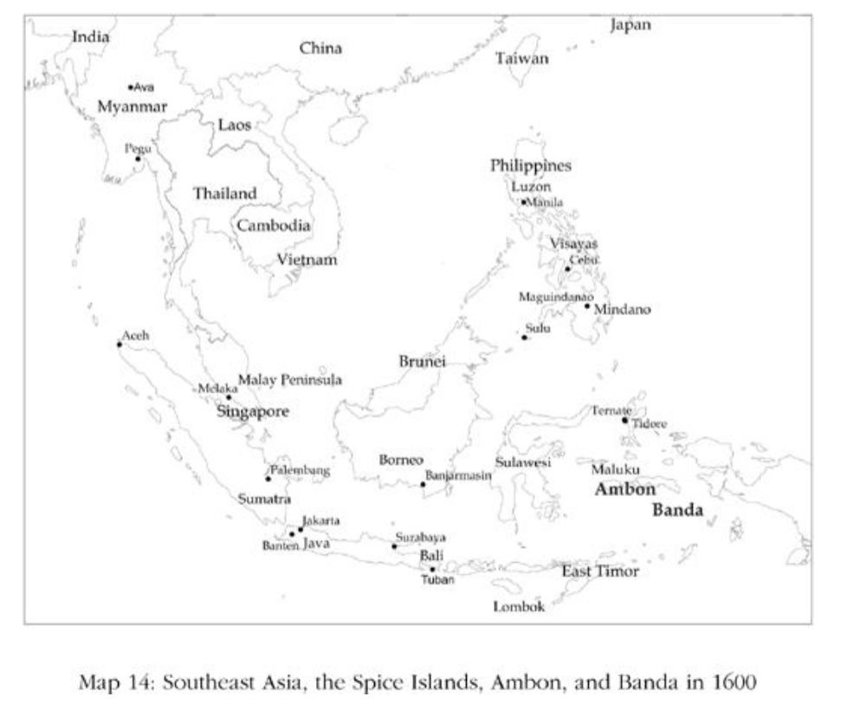

- The arrival of the Dutch really changed things…
  - They realized it was more profitable to monopolize the Moluccas spices rather than compete against local or other European traders
  - In 1600 they got the ruler of Ambon to grant them a monopoly on clove trade
    - Dutch East India Company founded in 1602
- The Dutch East India Company was the second European joint stock company, following the English East India Company
  - These are both major landmarks in the development of the modern corporation
  - Which would play a role in European industrial growth
- The company also had the ability to wage war and colonize foreign lands
- Ambon was ruled in a way similar to much of Europe (citizens owed payment to the ruler and were subject to forced labor)
  - When the Dutch took over they intensified these systems
- The Dutch also wanted to take over the Banda islands (to monopolize mace and nutmeg)
  - But these islands were organized differently than Ambon…
  - The islands were made up of many small autonomous city-states, with no hierarchical social or political order
    - The small states were fun by village meetings of citizens
  - There was no central authority whom the Dutch could coerce into signing a monopoly treating
- SO the Dutch governor of Batavia (on the island of Java) massacred the entire population of the islands in 1621 (around 15,000 people)
  - They then were able to create the political and economic structure necessary for his plan: a plantation society
- The extractive institutions created by the Dutch worked though, by the end of the 17th century world supply of these spices was down 60% and the price of nutmeg doubled

- The Dutch spread the strategy they perfected in the Moluccas to the entire region
- To avoid the threat of the Dutch East India Company, several states abandoned producing crops for export and ceased commercial activity
  - Autarky was safer than facing the Dutch
  - Ex. In Banten they cut down their pepper trees in hope this would induce the Dutch to leave
- Dutch colonialism fundamentally changed Southeast Asia's economic and political development
  - They stopped trading, turned inward, and became more absolutist
- Ultimately, their retreat from trade would not save them from the Europeans
  - By the end of the 18th century nearly all were part of European colonial empires

- We saw in Chapter 7 how European expansion into the Atlantic fueled the rise of inclusive institutions in Britain
  - But as illustrated by the Moluccas under the Dutch, this expansion sowed the seeds of underdevelopment in many diverse corners of the world by imposing (or further strengthening existing) extractive institutions
    - This destroyed nascent commercial and industrial activity throughout the globe, or perpetuated institutions that stopped industrialization
    - Nascent: new; emerging; young; developing

Dutch Disease: negative impact to an economy of anything that gives rise to a sharp inflow of foreign currency (spices)
The All-Too-Usual Institution
- During the same time period the Dutch East India Company was expanding, and a different sort of trade was intensifying in Africa: the slave trade
- In the Roman period slaves came from around Western and Eastern Europe
  - By 1400 Europeans stopped enslaving each other
- As we saw in chapter 6, Africa didn’t undergo the transition from slavery to serfdom as did Medieval Europe
  - Before the early modern period, there was a vibrant slave trade in East Africa
- The development of the sugar plantation colonies of the Caribbean beginning in the 17th century that led to a dramatic escalation of the international save trade
  - And an unprecedented increase in the importance of slavery within Africa itself
- In the 16th century 300,000 slaves were traded in the Atlantic (mostly coming from Africa)
  - Trans-Saharan slave trade was larger, with 550,000 Africans moving north as slaves
- By the 17th century, 1,350,000 Africans were sold as slaves in the Atlantic (mainly to America)
  - Trans-Saharan number was relatively unchanged
- By 18th century 6,000,000 slaves being shipped across the Atlantic
  - Maybe 700,000 across the Sahara
- Adding the figures up over periods and parts of Africa, over 10M Africans were shipped out as slaves
- There was an increase in warfare in Africa, as the Europeans were buying slaves with guns and ammunition
  - Many of the slaves shipped to the Americas were war captives

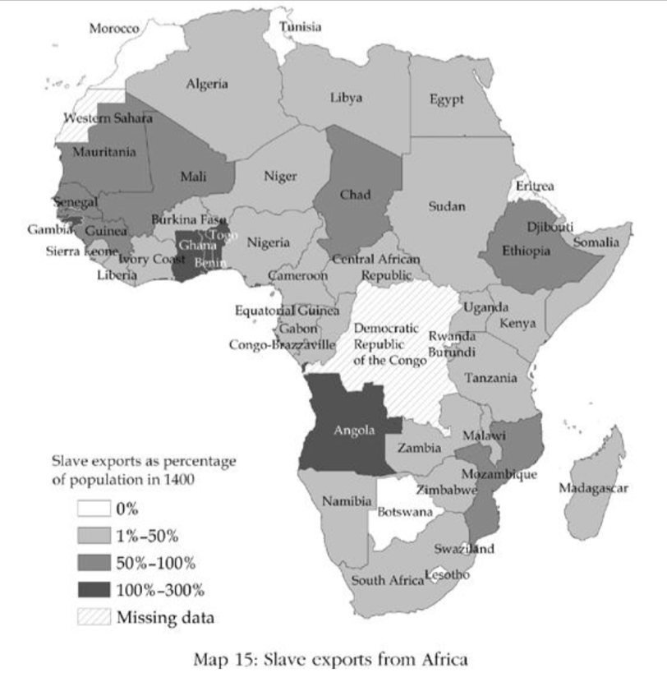

- All the warfare and conflict put into motion a particular path of institutional development in Africa
- Before the early modern era, African societies were less centralized and small scale (with tribal chiefs)
  - Many had no structure of hierarchical political authority at all
- The slave trade initiated 2 adverse political processes:
  - Many societies initially became more absolutist, organized around a single objective: to enslave and sell others to European slavers
  - As a consequence (but paradoxically in opposition to the 1st process), warring and slaving ultimately destroyed whatever order and legitimate state authority existed in sub-Saharan Africa
  - The law also became a tool of enslavement: slavery was the punishment for every crime

- Religious institutions even became perverted by their desire to capture and sell slaves…
  - Oracle at Atochukwa in Nigeria
  - People would travel to the oracle to settle disputes, with the decision typically being "swallowed" by the oracle (aka once you passed through the cave you were met by European ships)

- Most obvious impact of this massive extraction of human beings: demographic
  - In absence of slavery the population of Africa should have been 46-53M in 1850, when in fact it was HALF of this
  - Due to people being exported AND all the warfare and conflict
- 1807 = abolitionists persuaded the British Parliament to make slavery illegal
- 1834 = slavery itself was abolished in the British Empire
- In the place of slavery came "legitimate commerce" - exports from Africa that were not tied to the slave trade
  - Palm oil, kernels, peanuts, ivory, rubber, gum arabic
- However, many African states had become organized around slavery, and the British putting an end to the trade did not change this reality
  - So, the abolition of the slave trade (rather than making slavery in Africa wither away), simply led to a redeployment of the slaves, who were now used within Africa rather than in the Americas
  - Moreover, many political institutions of the slave trade were unaltered and the patterns of behavior persisted
- As a result, slavery expanded in Africa throughout the 19th century
  - Slavery wasn’t abolished until 1928 in Sierra Leone

Making a Dual Economy
- The "dual economy" paradigm still shapes the way most social scientists think about the economic problems of less-developed countries
  - Proposed in 1955 by Sir Arthur Lewis
- According to Lewis, many underdeveloped economies have a dual structure and are divided into: a modern sector and a traditional sector
- Modern Sector: which corresponds to the more developed part of the economy, is associated with urban life, modern industry, and the use of advanced technologies
- Traditional sector: is associated with rural life, agriculture, and “backward” institutions and technologies
  - Backward agricultural institutions include the communal ownership of land, which implies the absence of private property rights on land
- Labor was used inefficiently in the traditional sector
  - And Lewis believed it could be moved to the modern sector without reducing the amount the rural sector could produce
- The “problem of development” has come to mean moving people and resources out of the traditional sector, and into the modern sector, industry and cities.
  - In 1979 Lewis received the Nobel Prize for his work on economic development
- Even today, the dual economy is everywhere in South Africa
  - Dramatic Ex: the border between Natal and Transkei is the Great Kei River
    - Natal: wealthy beachfront properties, beautiful roads, lush green plantation properties (reeks of prosperity)
      - Have private property rights, legal systems, markets, industry, commercial agriculture
    - Transkei: land is brown and deforested, people live in huts not modern houses, cook on fires
      - Communal property in land, all-powerful chiefs
- But how did the dual economy come into existence…?
  - The dual economy between Transkei and Natal is recent, and is anything but natural
  - It was created by the South African white elites in order to produce a reservoir of cheap labor for their businesses, and to reduce competition from black Africans
- The dual economy is another example of underdevelopment created, not of underdevelopment as it naturally emerged and persisted over centuries

- Parts of South Africa and Botswana avoided most of the adverse effects of the slave trade
  - In the 17th century, the western part of South Africa was sparsely settled, and the South African coast was far removed from slave markets
- This changed in the 19th century…
  - Europeans found the climate and disease environment better than West Africa
    - South Africa didn’t have malaria or yellow fever, which turned much of Africa into the "white mans graveyard"
  - Began after the British took over Cape Town from the Dutch
- The next stage in the development of South Africa came with the discovery of vast diamond reserves and rich gold mines in the late 19th century
  - Led to the British wanted to extend their control over all of South Africa
  - The resistance by Africans led to the Boer Wars
- The development of the mining economy and the expansion of European settlement generated demand for food and other products, and created new economic opportunities for native Africans
  - Much of the land was cultivated - agricultural economy developed
  - As this economy developed, the rigid tribal institutions started to give way
    - Changes in property rights to land took place
    - Chiefs opposed this as it would destroy their influence among the other chiefs

- Thus, an African economic boom began, but was short lived
  - Between 1890-1913 it would come to an abrupt end and go into reverse
- During this period 2 forces worked to destroy the rural prosperity that Africans had created in the previous 50 years:
  - Antagonism by European farmers who were competing with Africans
    - Successful African farmers drove down the price of crops Europeans also produced, so the Europeans responded by driving Africans out of business
  - Europeans wanted a cheap labor force for the mines, which they could ensure by impoverishing the Africans, which they went about methodically over the next several decades
- Both of these goals were accomplished with the Natives Land Act of 1913
  - The act divided South Africa into 2 parts (a modern part and a traditional part) (anticipated Lewis's dual economy)
  - Except that prosperity and poverty were being created by the ACT ITSELF
    - 87% of land went to Europeans (20% of population)
    - 13% of land went to Africans
    - The effect of the act was to stop transactions involving partnership between Europeans and Africans
  - Crowded into the "Homelands", which was too small to earn an independent living from
    - Forced to work for a living in the white economy, supply cheap labor
  - As economic incentives collapsed, the advanced that had taken place in the past 50 years were all reversed
    - People gave up their plows and reverted to farming with hoes (or didn’t farm at all)
  - Political changes also went into reverse
    - The power of chiefs was strengthened

- Thus, evidence demonstrates the reversal in living standards in the Homelands after the Native Land Act of 1913
  - After the act, mining wages fell 30% by 1921
  - In 1961 (despite relatively steady growth) wages were STILL 12% lower than they had been in 1911
  - Europeans didn’t want Africans to educate themselves (as this would compete with white rather than supply cheap labor), so they removed the economic benefits of education + refused to invest in black schools
    - Africans were banned from occupying any skilled job
    - This was the 1st incarnation of the "color bar"
      - Non-whites are denied access to the same rights, opportunities and facilities as the whites
      - The color bar lasted until 1980s

- However, this type of dual economy is different than Lewis's…
  - In South Africa, the dual economy was not an "inevitable outcome of the process of development"
  - Instead, it was created by the state
- No movement of poor people to the modern sector as the economy developed
  - Instead, the success of the modern sector relied on the existence of the traditional sector
- In South Africa, the unskilled workers from the traditional sector would NOT become gradually more educated and skilled (as Lewis's approach envisioned)
  - And Africans were "trapped" here
- It is also no surprise that the economic development of the whites was limited, due to the extractive economic institutions the whites had built
  - Which were built on foundations laid out by extractive political institutions
    - Political system vested all power in whites
    - Structured under the military dominance of white settlers
- The dual economy came to an end in 1994
  - But not because of the reasons Lewis theorized about (natural course of economic development)
  - It ended because Blacks overthrew the Apartheid state

Development Reversed
- World inequality today exists because during the 19th and 20th centuries some nations were able to take advantage of the Industrial Revolution and the technologies that it brought, while others were unable to do so
- Technological change is only one of the engines of prosperity, but it is perhaps the most critical one
  - The countries that did not take advantage of new technologies did not benefit from the other engines of prosperity either
- This failure was due to their extractive institutions, either a consequence of the persistence of their absolutist regimes or because they lacked centralized states
- But this chapter has also shown that the extractive institutions that underpinned the poverty of these nations, were imposed (or strengthened) by the very same process that fueled European growth: European commercial and colonial expansion
- The Atlantic slave trade repeated the same pattern in Africa, even if starting from less developed conditions than in Southeast Asia and India
  - Many African states were turned into war machines intent on capturing and selling slaves to Europeans
  - As conflict grew into continuous warfare, state institutions (which had not yet achieved political centralization) crumbled in large parts of Africa, paving the way for persistent extractive institutions and the failed states of today that we will study later
- In parts of Africa that escaped the slave trade (South Africa) Europeans imposed a different set of institutions, this time designed to create a reservoir of cheap labor for their mines and farms
  - The South African state created a dual economy, preventing 80 percent of the population from taking part in skilled occupations, commercial farming, and entrepreneurship

Article: “The Long-Term Effects of Africa’s Slave Trades” – Nathan Nunn (2008):

Why Nations Fail & Current Affairs:
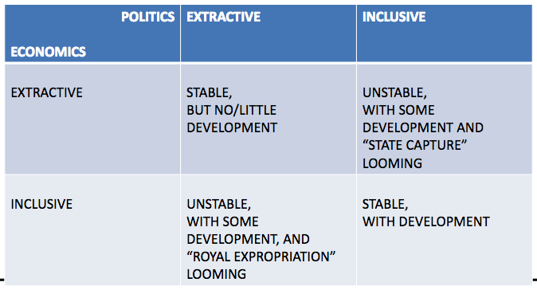

Colonialism & its Impact: The Beginning
- Latin America
- Juan Diaz de Solis explores Rio de la Plata (River of Silver) in 1516, and Pedro de Mendoza founded Buenos Aires in 1534.
- However, Solis and de Mendoza were unable to enslave and put to work the hunter and gatherer Indians of the area. Charruas and the Querandi Starving Spaniards soon left the area.
- In 1537, Juan de Ayolas found the sedentary and more densely settled Guarani up the Parana river in Paraguay. The Spaniards could now successfully take over the Guarani hierarchy, enslave them, and put them to work to produce food for them.
- This is a very similar pattern to the colonization of the Aztecs and the Incas.
- United States
- Colonization attempts of the Virginia Company in Jamestown in the early 17th century, which attempted to re-create an authoritarian, “extractive” regime.
- For example, “No man or woman shall run away from the colony to the Indians, upon pain of death”.
- However, the Company was unsuccessful, and couldn’t force the English settlers into gang labor and low wages.
- The Company switched to the headright system giving all settlers 50 acres of land and then shortly thereafter also political rights in the form of its General Assembly in 1619.
- Headright System: a grant of land (usually 50 acres) given to settlers in the 13 colonies.
- General Assembly: the main deliberative body of the United Nations, composed of delegations from member nations.
- Similarly…
- In the other Western Offshoots (i.e. Canada, Australia – originally also European colonies), the colonizers ultimately set up inclusive institutions, although they tried not to.
- In Africa and Asia, like in Latin America, the colonizers built on existing extractive institutions, or killed off any nascent moves towards more inclusive institutions (i.e. Asia).
- This is still related to the current lay of the land, with Western Europe and its Offshoots (US, Canada, Australia) being much more prosperous than Africa (decolonized LAST), Asia, and Latin America (decolonized FIRST).

Week 7: #3
Colonization Continued: Why the different impact in Africa, Asia, and Latin America compared to North American and Australia?
- Again, a story of extractive vs inclusive institutions.
- Pre-existing conditions:
- centralization of power (i.e. Aztecs; Incas)
- population density
- natural resources (i.e. gold)
- climate (i.e. disease, and its impact on the settler mortality, and this institutions).
- Role of slavery, particularly in Africa.

Labor Coercion: An Example:
- Even former slaves were enslaved, but the enormous increase in slavery was associated with the arrival of the Europeans.
- In West Africa, in 1820, the American Colonization Society (ACS) set-up a home for freed and repatriated African slaves in what is now Liberia.
- Their descendants formed the Americo-Liberians who dominated the country until 1980.
- About 3-5% of the population.
- Extractive economic institutions were set up to extract resources for the benefit of the Americo-Liberians and to consolidate their political control.
- In the 1960s, ‘tribal peoples’ were still subject to forced labor on public works and rubber plantations (a quarter of the labor force in the early 1960s).

Are wages a share of National Income?
Wages are 2/3 of National Income.

The Long-Term Effects of Africa’s Slave Trades: Nunn (QJE, 2008):
- Nunn compiled a new dataset on the country of origin of individuals sent to the New World in the Atlantic Ocean and Indian Ocean slave trades, using shipping records and slave ethnicity data.
- He assigns people shipped from a particular port as originally coming from that country or other countries using ethnicity data.

The African Slave Trade(s):
- There were 3 distinct, large-scale slave trading routes through the end of the 19th century:
- Atlantic Ocean Trade = 11-13 million people
- Sahara, Red Sea Trade = 5 million people
- Indian Ocean Trade = 2 million people
- For a total of 18-20 million people enslaved.

Why was Africa Targeted by Slave Traders?
- Location relatively close to the Americans, with its coming sugar plantations.
- Pre-existing internal slave networks.
- In the late 1800s, 18-44% of Africans were slaves of other Africans as domestic slaves, and in mines and plantations.

Ethnicity Level Slave Exports: Nunn (2008) Data:
- The ethnic groups in the historic documents are matched to a common classification scheme and linked to the map provided by Murdock in 1959.

Long-Run Impacts of Colonization/Slavery:
- Countries most exposed to European slave trading today look much worse off than other African countries.
- Several of Africa’s success stories (i.e. Botswana) were untouched by the trade.
- The regions/countries that were hardest hit by slaving appear to lag the MOST in modern development.
- The magnitude of these negative effects is quite large.
- A 1 standard deviation increase in slave exports decreases annual per capita economic growth during 1960-2000 by 1.25%.
- There were also adverse impacts on many other political institutional outcomes.
- Path Dependency: Example:
- “Le Wax Hollandais” (since 1846): a type of African wax fabric the path dependency of African institutions was negatively impacted by European colonization/slavery.

How did the Slave Trade Impact Society?
- Lower population density less urbanization
- Strategies to avoid capture lower output
- Shorter time horizons less investment
- Efforts diverted in slaving thus, away from productions.
- Changes in the nature of political power.
- Breakdown of social cooperation, and cultural changes.

Week 8: #1
Chapters 10,11

Chapter 10:
- The example of British convicts being sent to Australia to be out of site and out of mind turns into a case where Australia diverges from Britain in criminal and civil law as well as in a host of economic and political institutions.
- Convicts had to perform what was basically forced labour, while the guards/soldiers kept what they produced and only gave them food in return. But just like other cases read before, there was no incentives to work hard or do good work, making this system faulty.
- Due to this they had to give what they deemed “criminals” incentives, which would ultimately lead to institutions that were even more inclusive than those back in Britain. They could work for themselves and sell what they produced after completing their set of tasks assigned by the guards.
- Australia was more like Jamestown and Virginia as opposed to Austria-Hungary, Russia, Mexico and Peru because they incentivized their labour force by paying them wages and allowing them to become entrepreneurs and hire others. They were also given land after completing their criminal sentences and had their rights restored.
- The British and Australian elites did attempt to take back these rights given to convicts, but they fought this and demanded elections, participation, representation and ways to consolidate their economic and political rights fully.
- A Council was created and appointed by the British Government, and soon ex-convicts were sitting on juries. This ended the transportation of convicts from Britain to Australia as the Australian ex-convicts didn’t want any more transportation to lower wages.
- Similar to Jamestown, Australia did not have a dense enough population of indigenous people to exploit, ready access to precious metals, or soil and crops to make slave plantations viable.
- Australia and the US didn’t need the major revolutions that Britain experienced in order to achieve inclusive institutions because of the very different circumstances they were founded. In Britain, there was a deeply entrenched history of absolutism that required a revolution to remove it, not so in Australia and the US.
- The industrial revolution spread quickly in Australia and the US because of the inclusive institutions established, Canada and New Zealand followed this path too.
- Another path to inclusive institutions was Western Europe under the impetus of the French Revolution. This overthrew absolutism in France and generated conflicts that spread institutional reform across much of Western Europe. This caused the emergence of inclusive economic institutions, the industrial revolution and economic growth for these places.
- Before the revolutions there were three so-called estates, the aristocrats and the clergy were two estates that imposed major taxes on the third estate while paying none of their own. They also controlled manufacturing and blocked entrepreneurship and talented individuals from entering.
- The French Revolution abolished the feudal system and removed the tax exemptions of aristocrats and the clergy. Most importantly it created equality of law for all not only in business but in politics by removing occupational restrictions.
- After the French Revolution, the French also emancipated the Jews from Germany allowing them to pursue business opportunities. Napoleon and the rest of the leaders of the French Revolution were responsible for exporting the revolution to continental Europe through their invasions. This destroyed absolutism, feudalism, and guilds, also imposing equality before the law.
- Thus, France prepared much of Europe for inclusive institutions and economic growth.
- Code Napoleon was the legal system codified by Napoleon which outlined the ideas of equality before the law in which he imposed on every territory he controlled.
- The places France held experienced rapid industrialization in the 19th century unlike the places not held by France, including Russia and Austria-Hungary.
- Japan reacted the same way Western Europe reacted to the Industrial Revolution as a critical juncture through the Japanese lords forming a renegade that overthrew the Shogun, created the Meiji Restoration, and moved Japan onto the path of institutional reforms and economic growth. China reacted like Eastern Europe (Austria-Hungary, Russia and the Ottoman Empire) by allowing absolutism to remain resilient by building a stable agrarian society that was hostile to international trade.
- Mid 19th century China and Japan were poor under absolutist regimes, but they differed in these ways: China was a centralized bureaucratic empire ruled by and absolute emperor, Japan had a Shogun that sidelined the emperor and his power was not absolute due to other domains maintaining independence within the nation.
- The changes that led to the Meiji Restoration which overthrew the Shogun were needed for Japan’s economic survival and survival in general as they were experiencing economic backwardness that created military backwardness.
- Institutional reforms were required and although the Shogun obviously opposed this as he would lose his power, it was easier to overthrow the Shogun in Japan than it would have been for the Chinese to overthrow their Emperor.
- Instead of reforming institutions the Chinese imported weaponry to fight the British while the Japanese built their own after reform to fight the US, the critical juncture created by the industrial revolution is when Japan and China diverged.
- Japanese institutions transformed and the economy grew rapidly, while in China forces pushing for institutional change were not strong enough, so extractive institutions persisted leading to even worse absolutists such as Mao’s communist revolution.
- Overall, it is the rich countries of today that embarked on the process of industrialization and technological change starting in the 19th century, and the poor ones are those that did not.

Main Points:
- The French Revolution was a huge turning point during the IR as it led to inclusive institutions and economic growth.
- Japan reacted like the Western Europe world (positively).
- It was crucial that the Shogun in Japan was overthrown in terms of the survival of Japan’s economy because they were experiencing economic backwardness that created military backwardness.
- The rich countries today are the ones that followed the process of industrialization and technological change, and the poor countries are the ones that did not.

Chapter 11:
- The case of the “Blacks” in 1800 England that would hunt deer and collect firewood on politicians’ vast properties shows how England changed from having courts that would simply follow the wishes of the monarchs and act as an open tool of repression against their opponents, and where kings could remove judges whose decisions they did not like. Now they had to abide by the rule of law, laws were not applied selectively or arbitrarily and nobody was above the law.
- The virtuous circle is the powerful process of positive feedback that preserves these institutions in the face of attempts at undermining them and, in fact, sets in motion forces that lead to greater inclusiveness. The logic stems from the fact that inclusive institutions are based on constraints on the exercise of power and on a pluralistic distribution of power in society, enshrined in the rule of law.
- The virtuous circle is neither inevitable nor irreversible but it does preserve what has already been achieved and also opens the door to greater inclusiveness
- The first three decades of the 19th century witnessed increasing civil unrest, to avoid a revolution the elites knew that defusing the situation required them to meet the demand of the masses by undertaking parliamentary reform.
- The economic and political changes that had already taken place in Britain made using force to repress these demands both unattractive for the elite and increasingly infeasible.
- There is a dynamic positive feedback between inclusive economic and political institutions making such a course of action attractive. Inclusive economic institutions led to the development of inclusive markets, inducing a more efficient allocation of resources, greater encouragement to acquire education and skills, and further innovation in technology.
- Controlling power became less central under this positive feedback circle, British elites had less to lose because the position was less valuable now.
- Repression against an urban, concentrated, and partially organized and empowered group of people would be much harder than suppressing peasants and serfs.
- The Chartist movement and the People’s Charter of 1838 was important as it introduced the secret ballot and an end to open voting had helped buy votes and coerce voters.
- The Second and Third Reform Acts worked towards inclusive voting and outlawing any sort of vote buying. Along with many other laws that increased inclusivity, the tax systems also became more progressive so that wealthier people bore a heavier burden, and the education system became more accessible and expanded with the Education Act.
- Gradual reform like Britain’s was difficult to achieve for countries like Russia and France because they lacked pluralism and were highly extractive. It was pluralism during the GR and the rule of law that it introduced that made gradual change feasible and desirable in Britain.
- In the USA, the Populist and then subsequently the Progressive movements spurred from the monopolies and large companies using unfair and discriminatory business practices. It also fought the influence billionaires such as Rockefeller and Robber Barons were exerting over national politics.
- The virtuous circle can also be defined by inclusive economic institutions providing foundations upon which inclusive political institutions can flourish, while inclusive political institutions restrict deviations away from inclusive economic institutions.
- Free media is an important part of the virtuous circle because inclusive institutions allow it to flourish, and in turn free media makes it more likely that threats against inclusive economic and political institutions will be widely known and resisted.
- The virtuous circle works through several mechanisms.
1. First, the logic of pluralistic political institutions makes usurpation (taking power by force) of power more difficult. This would undermine the foundations of pluralistic political institutions, and the true measure of pluralism is precisely its ability to resist such attempts. Pluralism also enshrines the notion of the rule of law, the principle that laws should be applied equally to everybody. The rule of law, in turn, implies that laws cannot be used by one group to encroach upon the rights of another. This opens the door for greater inclusivity in the political system.
2. Second, inclusive political institutions support and are supported by inclusive economic institutions. Inclusive economic institutions remove bad extractive economic relations such as slavery and serfdom, and reduce the importance of monopolies to create a dynamic economy. This all reduces the benefits that one can secure by usurping political power.
3. Finally, inclusive political institutions allow free media to flourish. This mobilizes threats against inclusive institutions.

Tajikistan: On the Road to Failure
- Some 70% of the population lives in abject poverty in the countryside, and hunger is now spreading to the cities
- In the past few years increasing numbers of young Tajiks have left the country to work as seasonal laborers, primarily in Russia and Kazakhstan. In 2008 the number reached a new record, in all likelihood over one million, or at least half of the country’s labor force.
- Opposition parties have been sidelined or co-opted; potential rivals have been imprisoned or exiled.
- The median age is 21; around 35% of the population is under 14.
- A scandal at the National Bank of Tajikistan, where it was revealed in late 2007 that the authorities had failed to disclose that $310 million in reserves were used to guarantee a private financial institution financing cotton investors, mostly destroyed the Rahmon administration’s remaining credibility with donors.
- But the fragility of his country’s transport and energy infrastructure raises questions about Tajikistan’s ability to play a role in this planned logistical supply line (Central Asia transport line)
- Tajikistan’s 25 years as an independent state have been marred by poverty, endemic state corruption and the steady narrowing of political power to a single family.
- Other than the president and his family, there are no organized, functional political forces left.
- In 2016, the Tajik government declined an offer of up to $200 million in the form of grants and loans from the World Bank, because of the pre-conditions attached, which involved reform of the banking sector, currently largely controlled by Emomali Rahmon family members and associates.
- A third of Tajikistan’s population is undernourished and malnutrition is the underlying cause of about one third of child deaths, a higher proportion than in any of the other former Soviet republics.

Botswana’s Success: Good Governance, Good Policies and Good Luck
- In almost all developing countries, the government owns the mineral resources and is therefore the main recipient of the revenues from their extraction. This concentration of revenues with the government as the conduit of benefits to the rest of the economy can lead to a host of problems, including rent-seeking, corruption, and the efficiency losses that result from them.
- The government established respect for property rights and the rule of law. It maintained a high degree of transparency, which was reinforced by continuing the Tswana tribal tradition of consultation. These consultative institutions, known as kgotla, created a degree of trust in the government—the sense that government exists to serve the people and promote development and is not the instrument of one group or individuals for the purpose of getting hold of the wealth.
- Before independence, Botswana was a British protectorate, the colonial power having been “invited” in. Because Botswana was not colonized for economic or strategic advantage, the colonial rulers, it is argued, did not impose the extractive-type regime often found in other sparsely populated areas.
- Prevention of Dutch disease in Botswana consisted of three key components: fiscal saving, a surplus on the current account of the balance of payments, and heavy government investment in infrastructure and human capital. Together these policies limited the erosion of domestic productivity and competitiveness that can result from the appreciation of the real exchange rate
- Unlike many African countries, it did not adopt a policy of import substitution, and it did not expand the extent of state-owned productive entities, which employ only about 5 percent of the workforce in Botswana

Globalization:
- Economic “globalization” is a historical process, the result of human innovation and technological progress.
- It refers to the increasing integration of economies around the world, particularly through the movements of goods, services, and capital across borders.
- Sometimes also refers to the movement of people (labor) and knowledge (technology) across international borders.
- The term began to be used more commonly in the 1980s, reflecting technological advances that made it easier and quicker to complete international transactions – both trade and financial flows.
- It refers to an extension beyond national borders of the same market forces that have operated for centuries at all levels of human economic activity (i.e. village markets, urban industries, or financial centers).

International Movement of Capital: Interest Parity:
- The market will drive rates until there is no incentive for shifts in investments – when the expected differential in returns in different countries is 0, at least for the average investor.
- Thus, the expected rate of appreciation of the exchange rate of a currency should equal the difference in interest rates (interest parity).
- Interest Parity: lca – lus = Exchange Rate Expectation

Balance of Payments (BOP):
- A record of international transactions between residents of one country and the rest of the world.
- International transactions include exchanges of goods, services, and assets.

Double-Entry Accounting in the BOP:
- All transactions are either debit or credit transactions.
- Credit transactions result in receipt of payment from foreigners.
- merchandise exports
- transportation and travel receipts
- income received from investments abroad
- gifts received from foreign residents
- aid received from foreign governments.
- Debit transactions involve payments to foreigners.
- merchandise imports
- transportation and travel expenditures
- income paid on investments of foreigners
- gifts to foreign residents
- aid given by home government
- overseas investments by home country residents
- Each credit transaction has a balancing debit transaction, and vice versa. Thus, the overall balance payments are ALWAYS IN BALANCE.

Accounts Overview:
- Current Account: all real transfers
- merchandise trade
- service trade
- transfers
- Capital and Financial Account: transfers of ownership and financial assets and liabilities.
- changes in private assets
- changes in holdings of official international reserves
- statistical discrepancy

Capital Components of the BOP:
- The capital and financial account is the balance of payments account in which all cross-border transactions involving financial assets are listed.
- These include transactions between foreign and domestic residents, and foreign and domestic governments.
- All purchases or sales of assets, including:
- foreign direct investment (FDI)
- securities (debt)
- bank claims and liabilities
- official reserves transactions
- when CA citizens buy foreign securities, or when foreigners by CA securities, they are listed here as capital outflows and inflows, respectively.

International Capital Movements:
- FDI is the purchase of assets to establish financial control of a foreign entity.
- Generally, ownership of 10% or more of a company’s outstanding stock is considered FDI.
- Portfolio investment involves little management control or interest, and is solely for financial gain.

Official Reserve Assets:
- Historically, it was primarily GOLD.
- Now, it is primarily FINANCIAL ASSETS that denominate in a foreign currency that are widely accepted in international transactions.

Official Reserves Transactions:
- Governments can influence exchange rates by buying and selling official reserves (“interventions”).
- The buying and selling of official reserves is recorded in the official transactions account.
- Also referred to as “changes in holdings of official international reserves” or “official settlements balance”
- It is the part of the BOP accounts that records the amount of its own currency or foreign currencies that a nation buys or sells.

Statistical Discrepancy:
- It is the net result of errors and omissions on both the credit and debit sides.
- These errors mainly come from:
- misreporting merchandise imports
- misreporting investment incomes
- misreporting capital exports
- Basically, people succeed in hiding their incomes/wealth for tax and other purposes.

Capital Flight: AKA “Illicit Capital Flows”:
- Directly REDUCES the available resources to finance domestic investment and growth.
- Because governments have difficult taxing wealth held abroad as well as income generated from that wealth, the ability of the government to tax is REDUCED.
- As government revenues FALL with the erosion of the tax base, there is an INCREASED need to borrow from abroad, RAISING the foreign-debt burden, or greater recourse to domestic monetary financing, RAISING the inflation rate.
- Moreover, in the SR, capital flight can have potential destabilizing effects on domestic interest rates, the exchange rate, and international reserves.

Capital Flight in Practice #1: Transfer Pricing:
- Shift profits to low-tax jurisdictions.
- Tax havens
- Treasure islands

Capital Flight in Practice #2: Trade Misinvoicing:
- Import over-invoicing
- Export under-invoicing

Capital Liberalization: Good or Bad?
2 main lessons for countries to consider.
- The findings support the view that countries must carefully weigh the risks and benefits of unfettered capital flows.
- The evidence points largely to unambiguous gains from financial integration for advanced economies.
- In emerging and developing countries, certain factors are likely to influence the effect of financial globalization on economic volatility and growth:
- countries with well-developed financial sectors
- strong institutions
- sound macroeconomic policies
- substantial trade openness
- Countries with the above factors are more likely to gain from financial liberalization, while others need to be more careful.
- There are also costs associated with being overly cautious about opening to capital flows.
- These costs include:
- lower international trade
- higher investment costs for firms
- poorer economic incentives
- additional administrative/monitoring costs

Week 8: #2

Comparative Advantage: Example:

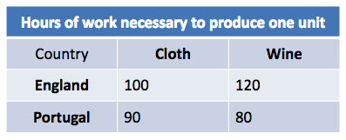

- To produce 1 unit of CLOTH:
- England gives up: cloth/wine = 5/6 units of wine
- Portugal gives up: cloth/wine = 9/8 units of wine
- Portugal has a higher OC to produce 1 unit of cloth thus, England has the comparative advantage in producing cloth at a lower relative price than Portugal

- To produce 1 unit of WINE:
- England gives up: wine/cloth = 120/100 = 12/10 units of cloth
- Portugal gives up: wine/cloth = 80/90 =8/9 units of cloth
- England has a higher OC to produce 1 unit of wine thus, Portugal has the comparative advantage in producing wine at a lower relative price.

- Number of hours in total for each country to produce both goods:
- England: 100 for cloth + 120 for wine = 220 hours
- Portugal: 90 for cloth + 80 for wine = 170 hours

- If both countries specialize:
- England on cloth: 220 hours in total/100 hours for 1 unit of cloth = 2.2 units of cloth
- Portugal on wine: 170 hours in total/80 hours for 1 unit of wine = 2.125 units of wine

- Production vs Consumption Possibilities Frontier:
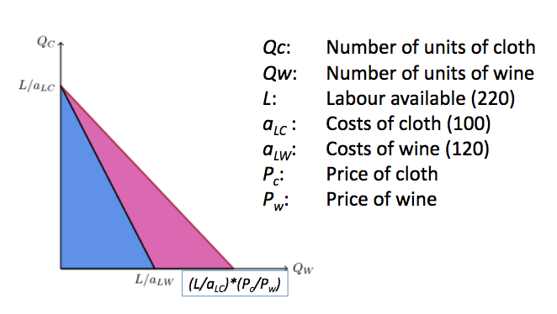
Inequality & Income Distribution in Global Value Chains (GVCs):
- Global Value Chain: includes all of the people and activities involved in the production of a good or service and its global level supply, distribution and post sales activities (also known as the supply chain).
- GVCs led by transnational corporations (TNCs) have reshaped the world division of labor over the past 2 decades.
- GVCs are pervasive in low technology manufacturing such as textile and apparel as well as in more advanced industries like automobiles, electronics, and machines.
- This hierarchical division of labor generates wild competition at the lower value-added stages of production, where low wages and low profit margins prevail for workers and contract manufacturers in developing countries. think outsourcing!
- At the top of the hierarchy, another kind of competition prevails, centered on the ability to monitor and control intellectual property rights related to innovation, finance, and marketing.
- Its argued that GVCs have had crucial effects on income inequality and the appropriation of rents in modern capitalism.
- Think of the ELEPHANT GRAPH!

Competitive Advantage is the key to….
- Access to:
- Natural resources:
- high-grade ores
- low-cost power source
- Highly skilled labor
- IT
- engineering
- New technology
- patents
- Geographic location
- High market entry barriers (ex: aerospace industry)
- Risks

Week 8: #3:
Philosophy: Milanovic (2008):
- Research shows that about 80% of the variability in people’s global income position (percentile in world income distribution) is determined by 2 variables:
- Mean country income – 60%
- Parental income – 20%
- Place of birth and parental income are random.

Stylized Facts:
- Late 19th century migration was MASSIVE.
- Migration was probably the primary cause of economic globalization in this period.
- As a flow, and unlike ALL other sources of economic globalization, migrations are considerably lower today than in the 19th century.
- Yet, it remains an important aspect of globalization.
- About 3% of world population lives in a different country from birth (very small %).
- Generally, as people get richer/less poor, emigration actually INCREASES, before it starts to decline beyond a certain income point.
- With ALL of the world population growth predicted to come from Africa shortly, emigration from Africa in particular stands to continue/increase more job-creation in Africa without slowing down.
- Emigration: leaving one’s own country to settle permanently in another.

Theory:
- Revealed preference: migrants move if they expect to be better off at the destination.
- Yet, migrants often suffer occupational downgrading, end up in poorly-paid informal jobs or remain unemployed.
- Harris-Todaro Model: Ex-Ante vs Ex-Post:
- migrants move until EXPECTED income/wages (MPL) in the country of destination and origin have been equalized.
- Ex-Ante: based on forecasts rather than actual results.
- Ex-Post: based on actual results rather than forecasts.

Harris-Todaro Model:
The model follows several features:
- First, real wages (adjusted for cost-of-living differences) are higher in urban formal-sector jobs than in rural traditional-sector jobs.
- Formal-Sector Jobs: Sector which encompasses all jobs with normal hours and regular wages, and are recognized as income sources on which income taxes must be paid. Produce goods using efficiency units of labor only.
- Traditional-Sector Jobs: produce the traditional good using raw labor only.
- Second, to be hired for a formal-sector job, one has to be physically present in the urban areas where the formal-sector jobs are located.
- Third, and as a consequence of the first two features, more workers search for formal-sector jobs than are hired, employers hire some of the job seekers but not all of them, and those not hired end up unemployed.
- Fourth, for equality to be maintained between the expected wage associated with searching for an urban job and the expected wage associated with taking up a lower-paying rural job, the equilibrium arising in such a setting is characterized by urban unemployment. less urban workers are hired so more traditional workers are hired
- Fifth, any temporary difference in the expected wages between one sector and another is eroded as workers migrate from the low-expected-wage labor market to the high-expected-wage labor market.

The model produced 2 powerful policy results:
- A policy of formal-sector job creation to employ the unemployed.
- This would increase the formal-sector LF by more than the # of jobs created, thereby raising the # of urban unemployed.
- Thus, the solution to urban unemployment is NOT to create urban employment.
- A policy of rural development.
- If such a program could increase the rural traditional-sector wage, unemployment would then fall.
- Thus, the solution to urban unemployment in this model is rural development.

Other Models of Migration:
- Beyond Income Differentials:
- Households vulnerable to idiosyncratic (unique) shocks that are region or sector-specific. floods
- Migration household members exposed to different regional shocks.
- Risk diversification through pooling of household members’ income remittances: action of sending money in payment.
- Migration optimal even without income differentials if individuals are risk averse consumption smoothing through risk sharing.
- Borjas Model:
- Consider 2 countries, A and B
- They have identical mean earnings
- They have different income distributions – returns to human capital are higher in country A.
- Individual returns to migration depend on one’s skill.
- Skilled workers perform better in A.
- Migration patterns:
- skilled migration to A
- unskilled migration to B
- Returns to human capital is important also when mean earnings are not identical.

Migration Impact:
- On Country of Destination:
- Popular view: immigrants displace native workers and drive DOWN wages.
- However, academic studies find no or only mildly negative impacts of migration on natives’ wages or employment (at the lower, unskilled part of the income distribution think Elephant Graph!).
- Empirical problem at the individual level: Selection bias, but strong evidence from studies controlling for other worker characteristics as well as from lotteries.
- A study shows that a typical person from an average developing country should expect to earn 2.5-3 times their income upon moving to the US.
- On Country of Origin:
- Wages: +/0, sometimes material for middle-income countries, but generally not for low-income countries.
- Remittances: +, for consumption/poverty reduction, but not for investment/growth.
- Brain drain: -/0, sometimes material for middle-income countries, but general not for low-income countries.
- Brain Drain: the emigration of highly trained or intelligent people from a particular country.
- These are all related to low institutional quality in the low-income country of origin.

Remittances & the Dutch Disease:
- Typically associated with revenue from export of natural resources.
- Origin: North-Sea natural gas exports in the Netherlands.
- Large receipts of foreign currency Exchange rate appreciates Loss of competitiveness other exports fall while imports rise.
- Can hamper the competitiveness of other sectors, and thus have negative export/growth prospects.

Ideas:
- The world can move around with capital/trade/people BUT clearly also without, certainly in the internet age.
- However, it is clear that the international mobility of ideas has increased (again, GLOBALIZATION).
- Impact: with INCLUSIVE INSTITUTIONS, low-income countries are able to catch up, but not without.

Week 9: #1

Chapter 12:
- Two harmful effects of European expansion and colonial rule in Africa: the introduction of the transatlantic slave trade encourages the development of African political and economic institutions in an extractive direction, and the use of colonial legislation and institutions to eliminate the development of African commercial agriculture that might have competed with Europeans.
- In Sierra Leone, they changed the existing politics by introducing a system of social stratification (ruling houses). What emerged was a rigid system with chiefs holding office for life and being far less accountable to the people they ruled.
- The marketing boards were used to tax farmers, and postcolonial governments did the extracting at even higher rates (around 90% of the crops value)
- The British set up an indirect rule through paramount chiefs, and governments that followed independence did not reject this colonial institution because it was lucrative.
- Sierra Leone’s lack of development is the outcome of the vicious circle. British colonial authorities built extractive institutions and the post-independence Africans were happy to take this for themselves.
- There are natural reasons for this vicious circle because extractive political institutions lead to extractive economic institutions. Also, extractive economic institutions create the platform for extractive political institutions.
- Extractive political institutions create a vicious circle because they provide no line of defense against those who want to further usurp and misuse the powers of the state.
- Extractive political institutions create a vicious circle because they create unconstrained power and great income inequality, this increases the stakes of the political game. Whoever wins gets the excessive power, therefore causing infighting.
- In Central America, the vicious circle was much simpler as those with economic and political power structured institutions to ensure the continuity of their power. This leads to the persistence of extractive institutions and the persistence of the same elites in power together with persistent underdevelopment.
- In the US, the reason that the economic and political trajectory of the South never changed, even though slavery was abolished and black men were given the right to vote, was because black’s political power and economic independence were weak.
- The extractive institutions in the southern US were based on the power of the landed elite, plantation agriculture, and low-wage, low-education labor. This vicious circle is based on extractive political institutions creating extractive political institutions because economic wealth and power buy political power.
- The iron law of oligarchy is the internal logic of oligarchies that reproduces themselves not only when the same group is in power, but even when an entirely new group takes control. This is the vicious circle depicted in Sierra Leone, Ethiopia, and other British colonial governed states. (History repeats itself – the first time as a tragedy, the second time as a farce – Karl Marx)
- Oligarchy: a small group of people having control of a country.
- Three factors greatly facilitated the emergence of more inclusive political institutions following the Glorious Revolution and the French Revolution.
1. The first was new merchants and businessmen wishing to benefit from creative destruction.
- These same people did not wish to see the development of another set of extractive institutions.
2. The second was the nature of the broad coalition that formed in both cases.
3. The third relates to the history of English and French political institutions
- they created a background against which new inclusive regimes could develop.
- Vicious circles are not unbreakable, but they are resilient in creating a powerful process of negative feedback, with extractive political institutions forging extractive economic institutions, which in turn creates the basis for persistence of extractive political institutions.
- When extractive institutions create huge inequalities in society and great wealth and unchecked power for those in control, there will be many wishing to fight to take control of the state and institutions. Extractive institutions then not only pave the way for the next regime, which will be even more extractive, but they also engender continuous infighting and civil wars.

Chapter 13:
- In the year 2000 Zimbabwe held a national lottery for everyone who had kept more than 5000 Zimbabwean dollars in their bank account (following a period of hyperinflation).
- The fact that it was Robert Mugabe, President of the partly state-owned bank, the Zimbabwe Banking Corporation or Zimbank, won this lottery and the bank was the one who organized the lottery
- It just goes to show the extent of his control over Zimbabwe’s institutions and just how extractive those institutions
- The most common reasons nations fail today is because they have extractive institutions – and Zimbabwe illustrates the economic and social consequences of these
- By 2008 its per capita income was half that when it gained its independence, and 2009 the unemployment rate stood at 94%.
- The roots of the political and economic institutions lie in the colonial period.
- Originally apartheid institutions were established for a white elite to extract wealth from the country, but when Zimbabwe gained its impendence, these institutions were simply maintained by Mugabe.
- Apartheid Institutions: a system of segregation or discrimination on grounds of race.
- Eventually (because of lack of inclusivity) his support waned until by the year 2000 he had to find further resources to buy political support – so he expropriated the farms owned by white people and when that wasn’t enough he printed money, which led to massive hyperinflation.
- Nations fail today because their extractive institutions do not create the incentives to save, invest and innovate. In many cases politicians stifle economic activity because this threatens their power base (the economic elite) – as in Argentina, Colombia and Egypt.
- In the cases of Zimbabwe and Sierra Leone this led to total state failure and economic stagnation. The countries in which this has happened include: Angola, Cameroon, Chad, DRC (Democratic Republic of Congo), Haiti, Liberia, Nepal, Sierra Leone, Sudan, Zimbabwe
- And the civil war, mass displacement, famines and epidemics that accompany them, in terms of development many of these countries are poorer today than they were in the 1960s.
A children’s crusade…
- This section outlines the causes of the civil war in Sierra Leone. The authors put this down to decades of extractive institutions by the tyrannical APC government (the economy was collapsing by 1985, and they use the example of the TV transmitter being sold by the minister of information in 1987 and in 1989 the country’s main radio antenna collapsed, ceasing radio transmissions.) By this point, the army had been disbanded because of the ruling elite feared it might overthrow them, which meant by the time Charles Taylor’s RPF crossed the border in 1991, there was no one there to stop them…. And then that brutal and chaotic civil war carried on for a decade – in which competing factions competed over resources in order to keep fighting each other – diamonds/ children (soldiers) and weapons.
- the historical precedent of the SL civil war is extractive institutions… the hollowing out the state to the point that was incapable of fending off rebels.
- The authors now go on to outline three other countries which have suffered from different types of extractive institutions – Colombia, Argentina and Egypt, and then Uzbekistan…. a country languishing under the absolutism of a single family and the cronies surrounding them, with an economy based on the forced labour of children
- Cotton accounts for 45% of the exports of Uzbekistan. When the country was created in 1991, its first and still only president Islam Karimov, divided up the land among farmers, but each was required to devote at least 35% of their land to cotton, a valuable export crop. However, because the farmers themselves receive only a fraction of the world market price of the crop, they had no incentive to maintain, let alone invest in, cotton harvesting machinery.
- No matter, however, because the country has turned to children to harvest the cotton, and every September-November the schools are emptied of approx. 2.7 million schoolchildren. Teachers, instead of being instructors, become labor recruiters.
- Each child is required to pick between 20-60KG a day, depending on age, and the lucky ones who live close to their allocated farms can walk or bus to work, but the unlucky ones have to sleep over in sheds, with no toilets or wash facilities. And it’s BYO food.
- While the market price for cotton was $1.40 in 2006, the children were paid somewhere in the region of $0.01 per kilo.
- All of this has come to pass because Karimov has established a regime where opposition is repressed and there is no free media or NGOs allowed.

Why do nations fail today?
- What all of the countries have in common is that they have an elite who have designed economic institutions in order to enrich themselves and perpetuate their power at the expense of the vast majority of people in society.
- Despite differences the bigger picture is that in each of these countries extractive political institutions that have created extractive economic institutions which transfer wealth and power toward the elite.
- The solution is to transform the extractive institutions into inclusive ones

International Movement of Capital:
- The market will drive up rates until there is no incentive for shifts in investments – when the expected differential in returns in different countries equals 0, at least for the average investor – interest parity.
- Thus, in theory, capital should flow from rich to poor countries, stimulating convergence.
- Convergence: the hypothesis that poorer economies’ per capita incomes will tend to grow at faster rates than richer economies. As a result, all economies should eventually converge in terms of per capita income.
- Evidence is that it only does so conditional on the quality of the institutional environment.
- Should, under competitive markets, also stimulate CONVERGENCE.

Bring International Movement of People (ideas), Capital, & Goods Conceptually Together:
- The Hecksher-Ohlin Model predicts patterns of commerce and production based on the production factor endowments of a trading region.
- The model essentially says that countries export products that use their abundant and cheap factors of production, and import products that use the countries’ scarce factors.

H-O Implication: Factor Price Equalization
- The main insight is that goods “embody” production factors.
- Therefore, free and competitive trade should make production factor prices converge along with traded goods prices.
- This factor-price equalization theorem is the most significant conclusion of the H-O model, which suggests that globalization should stimulate convergence between countries.
- Factor-Price Equalization Theorem: states that the prices of identical factors of production, such as the wage rate, or the rent of capital, will be equalized across countries as a result of international trade in commodities.

From Regionalization to Globalization: Wave I (1870-1913):
- Globalization = market integration on a world scale.
- Market Integration: markets effectively operate according to the law one (LOOP) price.
- LOOP: an identical good gets the same price in any market, apart from transaction costs, which can range from transport to institutional quality.

Regionalization:
- Evidence of some price convergence within Europe, dating from 1500.
- By the 1600s, there were distinct regional economies within Europe along major waterways such as: The Rhine River, and the North and Baltic Seas.

Globalization Wave I:
- Thus, there were some regionalization rather than globalization until transport costs distinctly fell (steamships now present) and the speed of information transmission increased (telephone now present) in the 19th century.
- Wave I: all markets were largely free from restrictions.
- The 2nd phase started after 1945, but international mass migration regulated, and capital and trade gradually liberalized.

Globalization Wave I: Mostly due to Migration:
- Would expect wage convergence if migration is not restricted because bargaining position of workers remaining in emigration-countries (old World) will increase, while bargaining strength of workers in immigration nations (New World) will fall.
- In the 1870-1913 period, migration was unrestricted in the Atlantic economy and there was clear wage convergence.
- World migration remained restricted after 1945 and migration has not anymore contributed strongly to wage convergence.

TO SUMMARIZE:
- Globalization Wave I was mainly driven by migration.

Week 9: #2
Globalization Wave II:
- From the start of WW1 (1914) to the end of WW2 (1945), globalization collapsed.
- After WW2, and particularly since the 1980s, Globalization Wave II started with financial innovations and trade liberalization, that led to increased international capital and trade flows being the main drivers of globalization in this period.

Broad Bottom Line on Impact of Globalization:
- In principle, just a continuation of specialization and trade (described by Adam Smith), but now on a global scale.
- Clear empirical evidence on the positive growth impact of all these flows, so should not throw away the baby with the bathwater. WHAT THE SHIT?!?!!?!?
- However, there is also evidence of negative impacts on some sectors/people in some countries, thus we need policies to address those nasty “side-effects”.
- The global system has also become more interdependent (and vulnerable), so we need multilateral cooperation.

Week 10: #1
Article – NGO (2009)
https://www.crisisgroup.org/europe-central-asia/central-asia/tajikistan/tajikistan-road-failure

Chapter 14:
Three African Chiefs:
- In 1885, 3 African chiefs docked in London, England and took a train to Paddington Station. The three chiefs had come to Britain on a mission: to save their and five other Tswana states from Cecil Rhodes.
- These states were known as Bechuanaland, former day Botswana
- In the 1840s, the famous Scottish missionary David Livingstone had traveled extensively in Bechuanaland and converted King Sechele of the Kwena to Christianity
- The British, on the other hand, wanted control of the area to block both further expansions by the Boers and possible expansions by Germans, who had annexed the area of southwest Africa corresponding to today’s Namibia
- The chiefs knew that only disaster and exploitation lay ahead for territories if they fell under the control of Rhodes, owner of the British South Africa Company
- The chiefs tried to persuade Queen Victoria and Joseph Chamberlain to take greater control of Bechuanaland and protect it from Rhodes which was granted
- The chiefs continued to travel through England giving speeches in order to drum up support but while this was happening, Rhodes was preparing for an armed assault on the Boer Republic (the Jameson Raid)
- By the 19th century, the Tswana states had developed a core set of political institutions. These involved both an unusual degree, by sub- Saharan African standards, of political centralization and collective decision-making procedures
- The political institutions of the Tswana, in particular the kgotla, also encouraged political participation and constrained chiefs.
- Tswana chieftaincy was not strictly hereditary but open to any man demonstrating significant talent and ability
- They just realized that railways, like the rest of the policies of the British, would not bring development to Bechuanaland as long as it was under colonial control.
- At its independence, Botswana was among the poorest countries in the world but today, it has the highest per capita income in sub-Saharan Africa
- How did Botswana break the mold? By quickly developing inclusive economic and political institutions after independence.
- Botswana exhibited many parallels to England on the verge of the Glorious Revolution.
- England had achieved rapid political centralization under the Tudors and had the Magna Carta and the tradition of Parliament that could at least aspire to constrain monarchs and ensure some degree of pluralism.
- Botswana also had some amount of state centralization and relatively pluralistic tribal institutions that survived colonialism
- The BDP set up its first marketing board, the Botswana Meat Commission in 1967 which played a central role in developing the cattle economy; it put up fences to control foot-and-mouth disease and promoted exports, which would both contribute to economic development and increase the support for inclusive economic institutions
- The first big diamond discovery was under Ngwato land, Seretse Khama’s traditional homeland. Before the discovery was announced, Khama instigated a change in the law so that all subsoil mineral rights were vested in the nation, not the tribe. This ensured that diamond wealth would not create great inequities in Botswana. It also gave further impetus to the process of state centralization as diamond revenues could now be used for building a state bureaucracy and infrastructure and for investing in education
- 2 crucial acts allowed for the continuation of the process of political centralization, enshrining the power of the state and the elected president by removing from chiefs the right to allocate land and enabling the president to remove a chief from office if necessary.
- When the diamonds came in stream in the 1970s, they did not lead to civil war, but provided a strong fiscal base for the government, which would use the revenues to invest in public services
- Botswana broke the mold because it was able to seize a critical juncture, postcolonial independence, and set up inclusive institutions

The End of the Southern Extraction:
- December 1, 1955 in Alabama... Rosa Parks would not move to the back of the bus
- She was already the secretary of the Montgomery chapter of the National Association for the Advancement of Colored People, the NAACP, which had long been struggling to change the institutions of the U.S. South. Her arrest triggered a mass movement, the Montgomery Bus Boycott, masterminded by Martin Luther King, Jr, where no colored people would ride on any busses in the city
- This was a huge critical juncture for change in the south
- Due to tech. innovations in agriculture and increasing number of blacks leaving the south, dependency on laborers was decreasing
- The civil rights movement in the south was heard on a federal level and ultimately reformed the nation as a whole
- 1954 Brown v. Board of Education: segregation of schools and other public sites was unconstitutional
- 1962 decision in the Baker v. Carr case, which introduced the “one-person, one-vote” standard
- after much negotiation between Barnett and President John Kennedy and Attorney General Robert Kennedy in Washington, the federal government intervened forcibly to implement this ruling. A day was set when U.S. marshals would bring James Meredith to Oxford.
- In anticipation, white supremacists began to organize. On September 30, the day before Meredith (a young black air force pilot looking to get into Ole Miss) was due to appear, U.S. marshals entered the university campus and surrounded the main administration building.
- A crowd of about 2,500 came to protest, and soon a riot broke out. The marshals used tear gas to disperse the rioters, but soon came under fire. By 10:00 p.m. that night, federal troops were moved into the city to restore order.
- Soon there were 20,000 troops and 11,000 National Guardsmen in Oxford. In total, 300 people would be arrested. Meredith decided to stay on campus, where, protected from death threats by U.S. marshals and 300 soldiers, he eventually graduated
- As in Botswana, the key in the U.S. South was the development of inclusive political and economic institutions. This came at the juxtaposition of the increasing discontent among blacks suffering under southern extractive institutions and the crumbling of the one-party rule of the Democratic Party in the South

Rebirth in China:

- The People’s Republic of China was proclaimed on October 1st 1949. The political and economic institutions created after 1949 were highly extractive. Politically, they featured the dictatorship of the Chinese Communist Party. No other political organization has been allowed in China since then.
- Accompanying these authoritarian, extractive political institutions were highly extractive economic institutions
- Mao Zedong immediately nationalized land and abolished all kinds of property rights in one full swoop.
- He had landlords, as well as other segments he deemed to be against the regime, executed.
- The market economy was essentially abolished.
- People in rural areas were gradually organized onto communal farms.
- Money and wages were replaced by “work points,” which could be traded for goods.
- Internal passports were introduced in 1956 forbidding travel without appropriate authorization, in order to increase political and economic control
- 1958 Great Leap Forward: plan to double steel output resulted in farmers burning their tools famine
- Soon the Cultural Revolution, just like the Great Leap Forward, would start wrecking both the economy and many human lives.
- Units of Red Guards were formed across the country: young, enthusiastic members of the Communist Party who were used to purge opponents of the regime.
- Many people were killed, arrested, or sent into internal exile
- They realized that economic growth would be possible only with significant moves toward inclusive economic institutions. They thus wished to reform the economy and bolster the role of market forces and incentives. They also wanted to expand the scope for private ownership and reduce the role of the Communist Party in society and the administration, getting rid of such concepts as class struggle
- In July of 1978, one of Deng’s supporters, Hu Qiaomu, presented some basic principles of economic reform. These included the notions that firms should be given greater initiative and authority to make their own production decisions. Prices should be allowed to bring supply and demand together, rather than just being set by the government, and the state regulation of the economy more generally ought to be reduced
- The rebirth of China came with a significant move away from one of the most extractive set of economic institutions and toward more inclusive ones. Market incentives in agriculture and industry, then followed by foreign investment and technology, would set China on a path to rapid economic growth
- If it weren’t for the Gang of Four losing power, China would not be the powerhouse that it is today

NOTE: Extractive authoritarian/absolutist political institutions go hand in hand with extractive economic institutions!
Argentina: A different case of “reversal fortune”:
- “The Paris of South Africa” (Argentina) went from being one of the richest to being averagely rich/poor.
- In the late 19th century it was among the top 5 countries in income per capita, richer than all European countries except Britain and on a par with other rich settler societies like the US, Canada, and Australia.
- Its status among the richest economies reached a peak around 1913 when income convergence stopped.
- Until 1929 it faced a slow and widening relative decline thereafter.
- Argentina is now close to the average country in the world given its level of income per capita, and its citizens enjoy only 40% of the average income per capita of the 12 core countries of Western Europe.
- Their early success was during part of Globalization Wave I, in particular migration.
- Between 1857 and 1930, Argentina received a net immigration of 3.5 million, meaning that about 60% of the total population increase would be attributed to immigration.
- Capital came from Europe (mostly Britain), who were investing in railroads, docks, and utilities.
- Argentina had a comparative advantage in producing meat and grain.

Argentina History & Politics: 1870-1929:
- Became a constitutional democracy and one of the world’s richest nations.
- Decades of foreign investment and massive immigration set the stage for economic revolution.
- Conservative forces dominate politics until 1916, when the Radicals win control.
- Emphasis on fair elections and democratic institutions lets the beginning middle class enter the political process.

Reversal of Fortune from 1930 (Great Depression):
- From a sudden seizure of power from a government (“coup”) by the military in 1930, Argentina descended into political instability and periodic economic crises that pushed it back to becoming an averagely rich/poor country, though it nevertheless remained among the richest countries until the mid-20th century (arguably because other also made bad policy choices until then).
- Several other coups until 1976, a US-backed coup occurred which forced Isabel Martinez de Person (3rd wife of Juan) from power and installed a right-wing military dictatorship under Jorge Rafael Videla known as the National Reorganization Process, which lasted until the transition to democracy in 1983.
- The military government persecuted and murdered numerous political critics, activists, and leftists in the Dirty War which lasted until the junta’s dissolution.
- Public dissent and anger over the dictatorship’s repressions led to a transition to democracy in 1983 when Raul Alfonsin was elected President.
- Several of the junta’s leaders were later convicted of their crimes and sentenced to imprisonment.

Since 1983:
- Argentina has functioned as a politically stable democracy, with perhaps the exception of the 2001-2002 period where political change was set off by widespread riots.
- Yet despite these significant political improvements, economic policies have continued to oscillate, with many reform reversals.
- While growth has picked up during parts of this period, the overall performance remains lackluster.

In essence, for most of the whole period since 1930…
- Military/landowners in effect were ruling the country.
- This blocked decentralization, furthered democratization, and lead to a diversification away from agriculture.
- Hardening conflict between military, landowners, and emerging urban classes.
- Inward-looking policies
- import-substitution, etc.
- Heavy borrowing, high inflation, banking/debt crises.
- Continued gradual relative deterioration of living standards.

“In all specification, we find that countries with higher population density in 1500 are substantially poorer today…a 10% higher population density in 1500 is associated with a 4% lower income per capita today”.

Institutions: Example of how population density affected European Colonization:
- The Spanish Conquest around the La Plata River (current day Argentina) during the early 16th century.
- This story is about how the interior provinces (i.e. La Rija) reached agreements with Buenos Aires.
- These agreements were a truce – the warlords of La Rioja agreed to leave Buenos Aires alone so that it could make money. In return, the Buenos Aires elites gave up reforming the institutions of “the interior”.
- So, Argentina at first appears a world apart from Peru or Bolivia, but it is really not so different when you leave Buenos Aires.

Week 10: #2:
More on History/Institutions:
- Tajikistan was the last to exit the Soviet Union, declaring independence on Sept. 9, 1991.
- Civil war from 1992-1997.
- UN-brokered peace deal on June 27, 1997.
- Political stabilization and economic reconstruction.
- Incumbent power consolidation.
- High corruption
- Bad governance
- No true level-playing field/competition
- Bad incentives
- Extractive institutions

Labor:
- Russians massively left Tajikistan.
- Tajik men massively left Tajikistan.
- Thus, a large outflow of labor, but no upward wage pressures from that in Tajikistan as there simply are no jobs, and remittances are the established social safety nets.
- No young men in the streets who could cause political trouble.

Week 10: #3
Botswana:
- Land locked country
- Drought prone; desert
- British colonization
- Extremely poor at independence (1966)
- rated among the poorest states in the world with a per capita GDP of only US$283.
- by 2010, it attained the status of an upper middle-income country.
- between 1966 and 2007, the country had the highest rate of economic growth in the world and way ahead of the rest of Africa.
- Initially little in terms of infrastructure and human capital
- Hostile “bad neighborhood”
- Producer of diamonds (since 1967)

Good Governance: Botswana
- Bostwana has had a good, earned and sustained record of good governance.
- A functioning constitutional multi-party democracy has existed since independence in 1966.
- All elections held have been conflict free and declared free and fair.
- Low levels of corruption – consistently the lowest in Africa, and amongst the lowest in the world according to Transparency International.
- Well-functioning state bureaucracy.
- Respect for the rule of law
- Constitution: protects property rights
- Enduring social and political stability.

History: Botswana:
- Early reasonable degree of centralization (government makes economic decisions).
- Late 19th century, the 3 main chiefs avoided extractive colonization by inviting Britain to make it its protectorate.
- Extractive Colonization: designed to extract incomes and wealth from one subset of society (i.e. population) to benefit a different subset (i.e. elite, colonizers).
- The British did not think full-scale colonization was worthwhile.
- Botswana had a low population density and no natural resources until they struck diamonds in 1967.

Inclusive Institutional Inheritance:
- Traditional Kgotla system: consultative assembly as well as a court through which decisions were made, justice was administered and tradition authorities were held accountable.
- Meritocracy of sorts that helped accountability and consensus; transparency and voice.
- Meritocracy: a ruling or influential class of educated or skilled people; government selected on the basis of their ability.
- Close similarity with post-independence parliament.
- The 1st president – Seretse Khama – enjoyed a legitimacy, drawn from his position as former chief of the dominant Tswana tribe.
- Legitimacy: conformity to the law or to rules.
- Khama’s charismatic style of leadership and his integrity, combined with his natural authority helped secure the Botswana Democratic Party’s (BDP’s) position and shaped the system of governance.
- The emergent elite were also conscious that its interests would be better served by private capitalist accumulation rather than state capitalism.
- At dependence, the state was in dire financial problems and could not be the means of accumulation consequently, the elites did not see the state as a source of self-enrichment.
- Instead, constructing a state to facilitate development and the accumulation of capital was the man vehicle advancing development.

Good Policies:
- Macroeconomic stability
- Avoiding boom-bust cycles
- Boom-Bust Cycles: a process of economic expansion and contraction that occurs repeatedly.
- Public investment in education, health, and transport infrastructure.
- Transparent budgeting with good accountability
- Avoiding the “natural resource curse”.
- Natural Resource Curse: refers to the paradox that countries with an abundance of natural resources (like fossil fuels and certain minerals), tend to have less economic growth, less democracy, and worse development outcomes than countries with fewer natural resources.
- FISCAL POLICY PLAYS A ROLE IN ALL OF THE ABOVE!
- No nationalizations (i.e. expropriations).
- Nationalization: the process of transforming private assets into public assets by bringing them under the public ownership of a national government or state
- Expropriation: the action by the state or an authority of taking property from its owner for public use or benefit.
- Relatively small role for State-Owned Enterprises
- Partnership with De Beers which was well-negotiated!
- De Beers (international corporation) Maximize profits
- Government Invest in infrastructure, health and education (i.e. build reserves).
- Exchange rate management
- Avoid Dutch Disease despite surpluses and growing diamond revenue.
- Dutch Disease: the negative impact on an economy of anything that gives rise to a sharp inflow of foreign currency, such as the discovery of large oil reserves. The currency inflows lead to currency appreciation, making the country's other products less price competitive on the export market.

Good Luck:
- Discovery of diamonds in 1967
- Thanks to pre-existing inclusive institutions and good leadership, in 1967, BEFORE mining commenced, parliament enacted the Mines & Minerals Act which secured all sub-soil resources in the state, not with a particular group. pre-empted future conflict over mineral wealth.

TO SUMMARIZE:
- Botswana’s success story is not primarily due to good luck.
- It was the result of effective management, thanks to relatively strong and competent state that operated under viable traditional and developed modern institutions of economic, political and legal restraint (i.e. inclusive political and economic institutions).

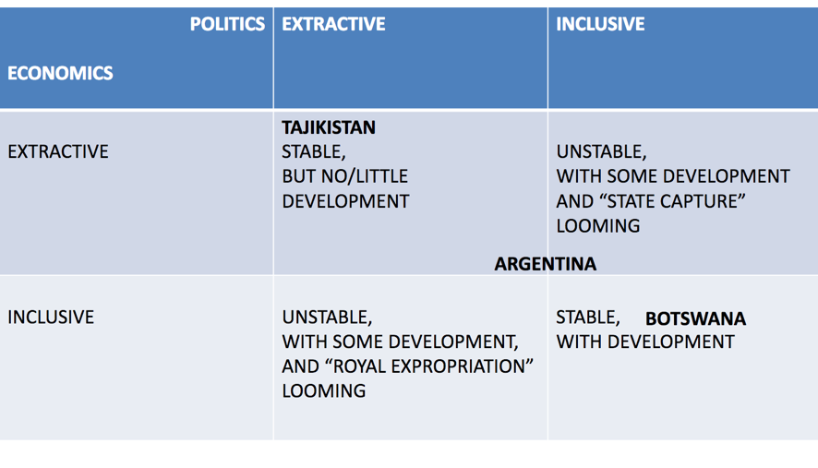

Week 11:
opening piece by Peter Singer, and replies by Angus Deaton
http://bostonreview.net/forum/peter-singer-logic-effective-altruism

Chapter 15
- Critical junctures are major events that disrupt the existing political and economic balance in one or many societies (Black Death, Atlantic trade and the Industrial Revolution)
- Institutional drift is important because it can create small differences that persist, they may disappear but can reappear once again during a critical juncture causing societies to diverge radically. (England, France and Spain institutional drift regarding their courts, with the critical juncture of Atlantic trade)
- Western powers surged ahead of others because of several historic turning points:
1. The path of feudalism, replacing slavery and weakening the power of monarchs on the way;
2. Europe witnessing the development of independent and commercially autonomous cities at the turn of the first millennium;
3. European monarchs were not as threatened by overseas trade so they did not discourage it; the arrival of the Black death shook the foundations of the feudal order.
- Growth under extractive institutions is easier when creative destruction is not a necessity, just as with the Soviet Union and catching up in industry.
- Modernization theory maintains that all societies, as they grow, are headed toward a more modern, developed, and civilized existence, and in particular toward democracy. It is also claimed that inclusive institutions will emerge as a by-product of the growth process. Different versions claim that an educated workforce will naturally lead to democracy and better institutions.
- Modernization theory is both incorrect and unhelpful for thinking about how to confront the major problems of extractive institutions in failing nations (ex: US invades Iraq to spread democracy and only started lengthy civil wars)
- Authoritarian regimes that have grown more rapidly over the past sixty or one hundred years, contrary to the modernization theory would claim, have not become more democratic.
- Conditional aid seems to have the same effects as unconditional aid, very little effect on a nation’s institutions because countries failing to meet these conditions typically receive just as much aid. Absolutists and elites will not be willing to give up power just for a little more aid.
- Ceasing foreign aid is impractical and would lead to more human suffering. It’s better than nothing
- Conditional aid should instead bring groups and leaders otherwise excluded from power into the decision-making process and empower the broad segment of the population

The Long-Term Effects of Africa’s Slave Trades
- Finds a robust negative relationship between the number of slaves exported from each country and subsequent economic performance. The African countries that are the poorest today are the ones from which the most slaves were taken.
- This finding cannot be taken as conclusive evidence that the slave trades caused differences in subsequent economic development. An alternative explanation that is just as plausible is that countries that were initially the most economically and socially underdeveloped selected into the slave trades, and these countries continue to be the most underdeveloped today
- Figure VI explores whether the data is consistent with this channel by examining the relationship between slave exports and a measure of current ethnic fractionalization from Alesina et al. (2003). As shown in Figure VI, there is a strong positive relationship between the two variables. This is consistent with the historic accounts of the slave trades impeding the formation of broader ethnic identities.
- This consequence of the slave trades is important because of the increasing evidence showing that ethnic fractionalization is an important determinant of a variety of factors necessary for economic development.
- Ethnic Fractionalization: deals with the number, sizes, socioeconomic distribution, and geographical location of distinct cultural groups.
- Studies find that ethnic diversity is important for social cohesion, domestic institutions, domestic polices, and the quality of government. Ethnic fractionalization reduces the provision of public goods, such as education, health facilities, access to water, and transportation infrastructure, all of which are important for economic development.
- A second, and closely related, consequence of the slave trades was the weakening and underdevelopment of states. The relationship between slave exports and nineteenth century state development is shown in Figure VII. The negative relationship between slave exports and state centralization shown in the figure is consistent with the historic accounts of the slave trades causing long-term political instability, which resulted in weakened and fragmented states.
- Africa’s post-independence leaders inherited nation states that did not have the infrastructure necessary to extend authority and control over the whole country. Many states were, and still are, unable to collect taxes from their citizens, and as a result they are also unable to provide a minimum level of public goods and services.
- Conclusion; slave trades affecting early state development, which may have mattered during colonial rule but mattered much more after independence. Because those parts of Africa that were most severely impacted by the slave trades tended to have the least developed political systems, after independence these countries continued to have weak and unstable states, as well as slower economic growth.

Africa’s Power Shuffle is a Renewal, not a Revolution
- One thing Angola, Ethiopia, South Africa and Zimbabwe have in common is they are run by liberation parties that have ossified in power for between a quarter and a half a century.
- In each country, the ruling elite has engineered a personnel change in the interest of self-preservation. More than revolutions from below, they are party reorganizations from above.

Tajikistan: On the Road to Failure
- Some 70 per cent of the population lives in abject poverty in the countryside, and hunger is now spreading to the cities
- In the past few years increasing numbers of young Tajiks have left the country to work as seasonal laborers, primarily in Russia and Kazakhstan. In 2008 the number reached a new record, in all likelihood over one million, or at least half of the country’s labor force.
- Opposition parties have been sidelined or co-opted; potential rivals have been imprisoned or exiled.
- The median age is 21; around 35 per cent of the population is under fourteen.
- A scandal at the National Bank of Tajikistan, where it was revealed in late 2007 that the authorities had failed to disclose that $310 million in reserves were used to guarantee a private financial institution financing cotton investors, mostly destroyed the Rahmon administration’s remaining credibility with donors.
- But the fragility of his country’s transport and energy infrastructure raises questions about Tajikistan’s ability to play a role in this planned logistical supply line (Central Asia transport line)
- Tajikistan’s 25 years as an independent state have been marred by poverty, endemic state corruption and the steady narrowing of political power to a single family
- Other than the president and his family, there are no organized, functional political forces left
- In 2016, the Tajik government declined an offer of up to $200 million in the form of grants and loans from the World Bank, because of the pre-conditions attached, which involved reform of the banking sector, currently largely controlled by Rahmon family members and associates.
- A third of Tajikistan’s population is undernourished and malnutrition is the underlying cause of about one third of child deaths, a higher proportion than in any of the other former Soviet republics.

Botswana’s Success: Good Governance, Good Policies and Good Luck
- In almost all developing countries, the government owns the mineral resources and is therefore the main recipient of the revenues from their extraction. This concentration of revenues with the government as the conduit of benefits to the rest of the economy can lead to a host of problems, including rent-seeking, corruption, and the efficiency losses that result from them.
- The government established respect for property rights and the rule of law. It maintained a high degree of transparency, which was reinforced by continuing the Tswana tribal tradition of consultation. These consultative institutions, known as kgotla, created a degree of trust in the government—the sense that government exists to serve the people and promote development and is not the instrument of one group or individuals for the purpose of getting hold of the wealth.
- Before independence, Botswana was a British protectorate, the colonial power having been “invited” in. Because Botswana was not colonized for economic or strategic advantage, the colonial rulers, it is argued, did not impose the extractive-type regime often found in other sparsely populated areas.
- Prevention of Dutch disease in Botswana consisted of three key components: fiscal saving, a surplus on the current account of the balance of payments, and heavy government investment in infrastructure and human capital. Together these policies limited the erosion of domestic productivity and competitiveness that can result from the appreciation of the real exchange rate
- Unlike many African countries, it did not adopt a policy of import substitution, and it did not expand the extent of state-owned productive entities, which employ only about 5 percent of the workforce in Botswana

The Logic of Effective Altruism
- Altruism: the belief or practice of disinterested selfless concern for the well-being of others.
- When key services we expect from states are taken over by other entities, building trust in the state and developing state capacity in other crucial areas may become harder
- Development is neither a financial nor a technical problem but a political problem, and the aid industry often makes the politics worse. The dedicated people who risked their lives to help in the recent Ebola epidemic discovered what had been long known: lack of money is not killing people. The true villains are the chronically disorganized and underfunded health care systems about which governments care little, along with well-founded distrust of those governments and foreigners, even when their advice is correct.
- Deaton states “I too see students who want to relieve suffering in the world. Should they go to Dhaka or Dakar? Focus on bed nets or worms? I tell them to go to Washington or London and to work to stop the harm that rich countries do; to oppose the arms trade, the trade deals that benefit only the pharmaceutical companies, the protectionist tariffs that undermine the livelihoods of African farmers; and to support more funding to study tropical disease and health care. Or they could go to Africa, become citizens, and cast their lot with those they want to help. That is how they can save the lives of African kids.”

Week 11 - #1

Back to Botswana quickly…
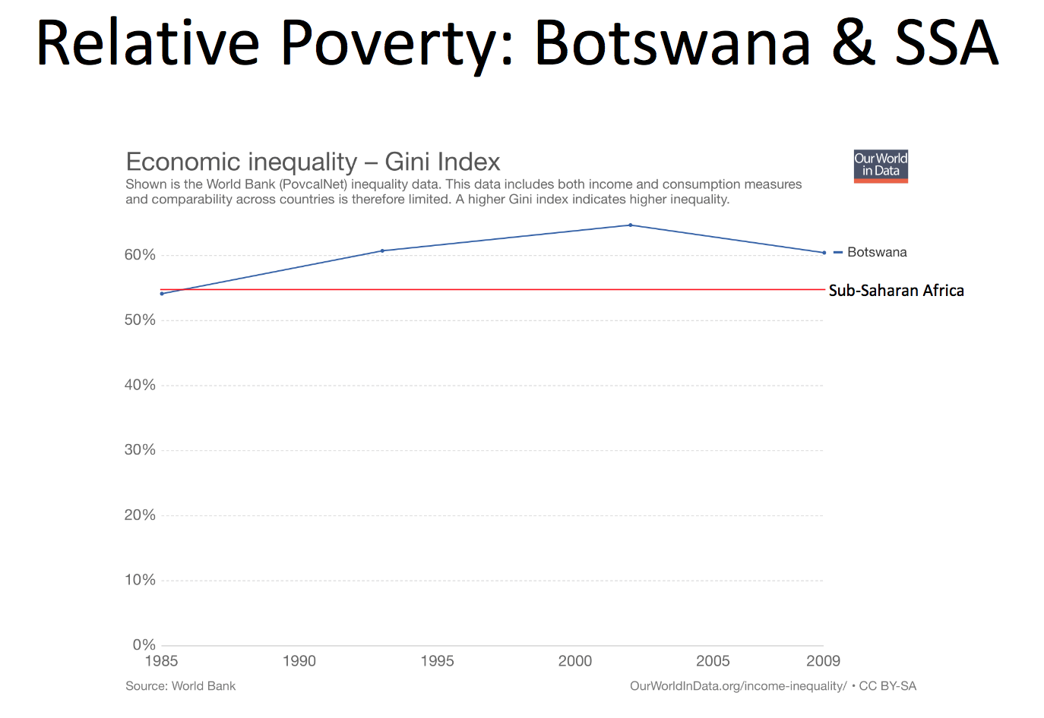
- Relative Poverty: lack the minimum amount of income needed in order to maintain the average standard of living in the society you live in
- Ex. Less than X% of average Canadian income

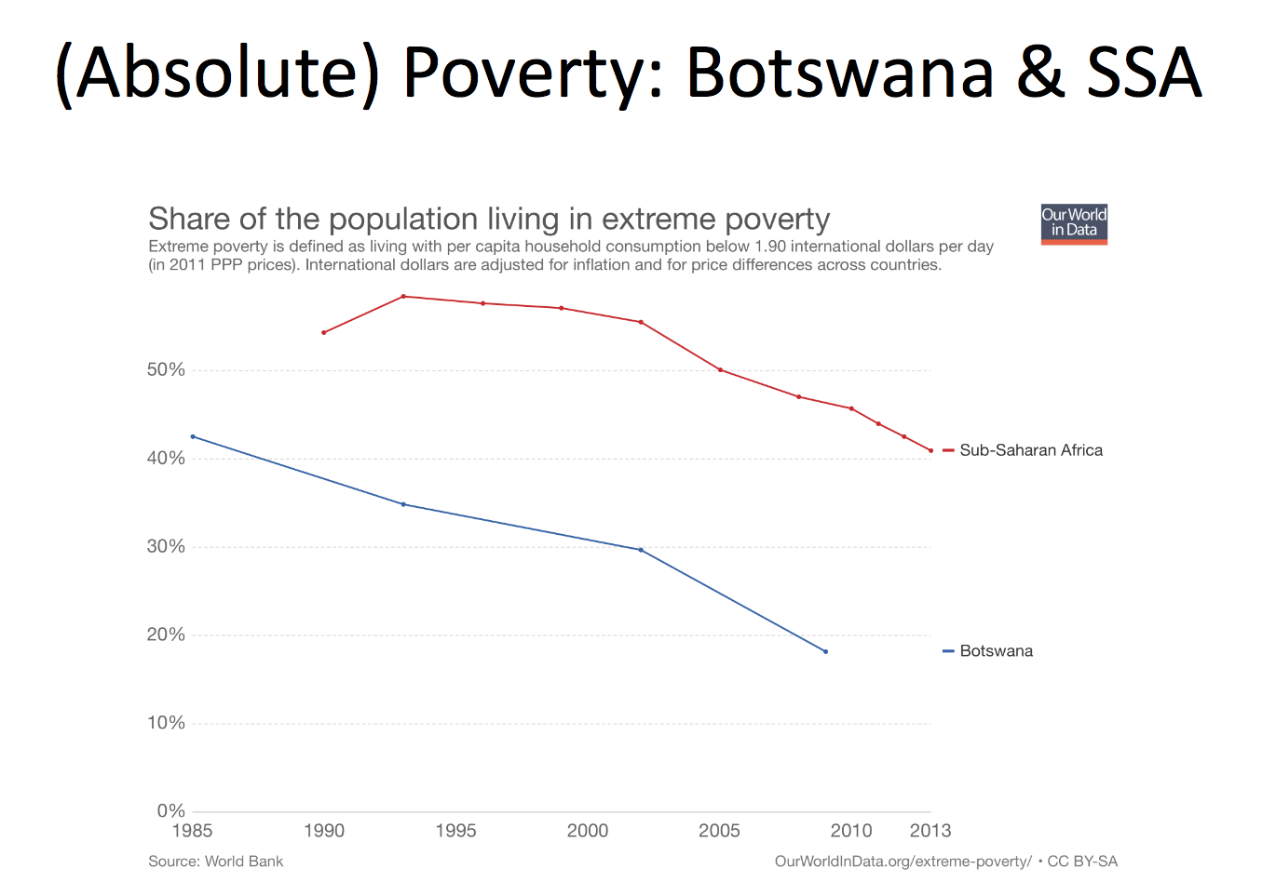
- Absolute Poverty: income is below a necessary level to maintain basic living standards in all countries, and doesn’t change over time
- Ex. Living on less than $X per day

Role of Policy in Development
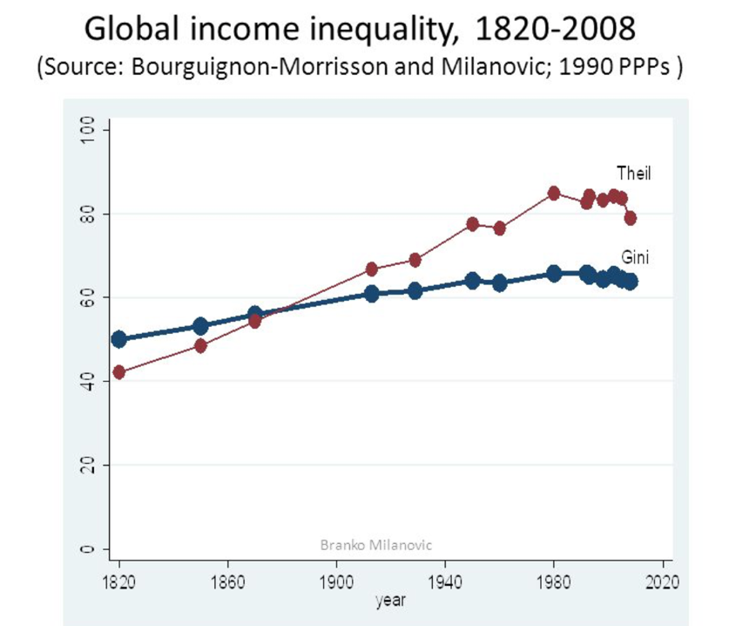

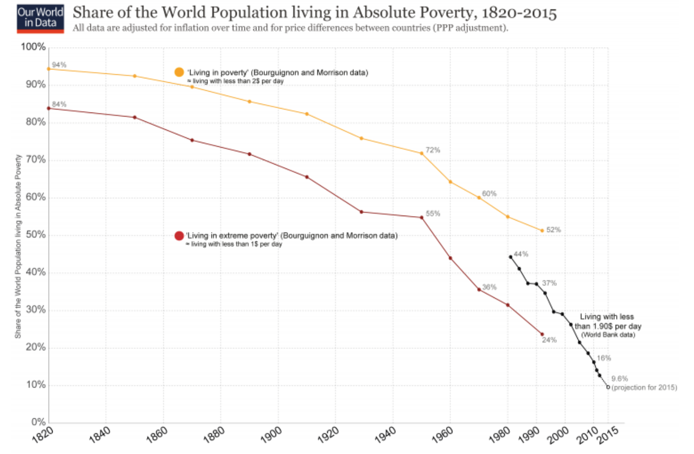

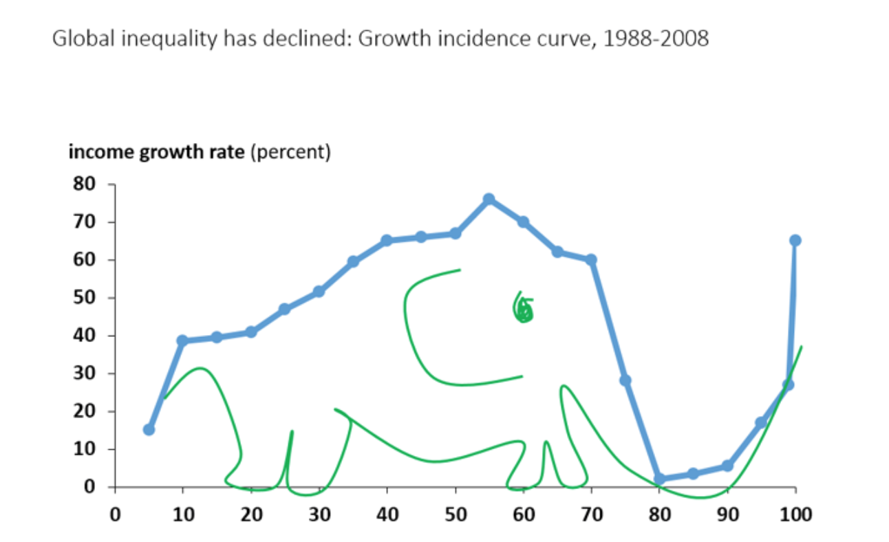

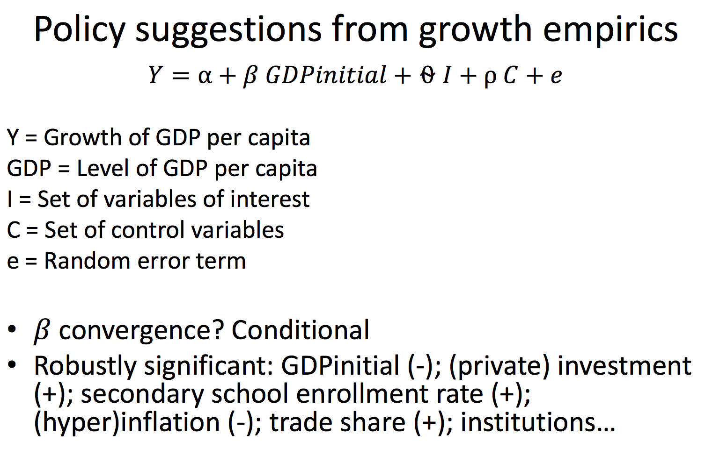

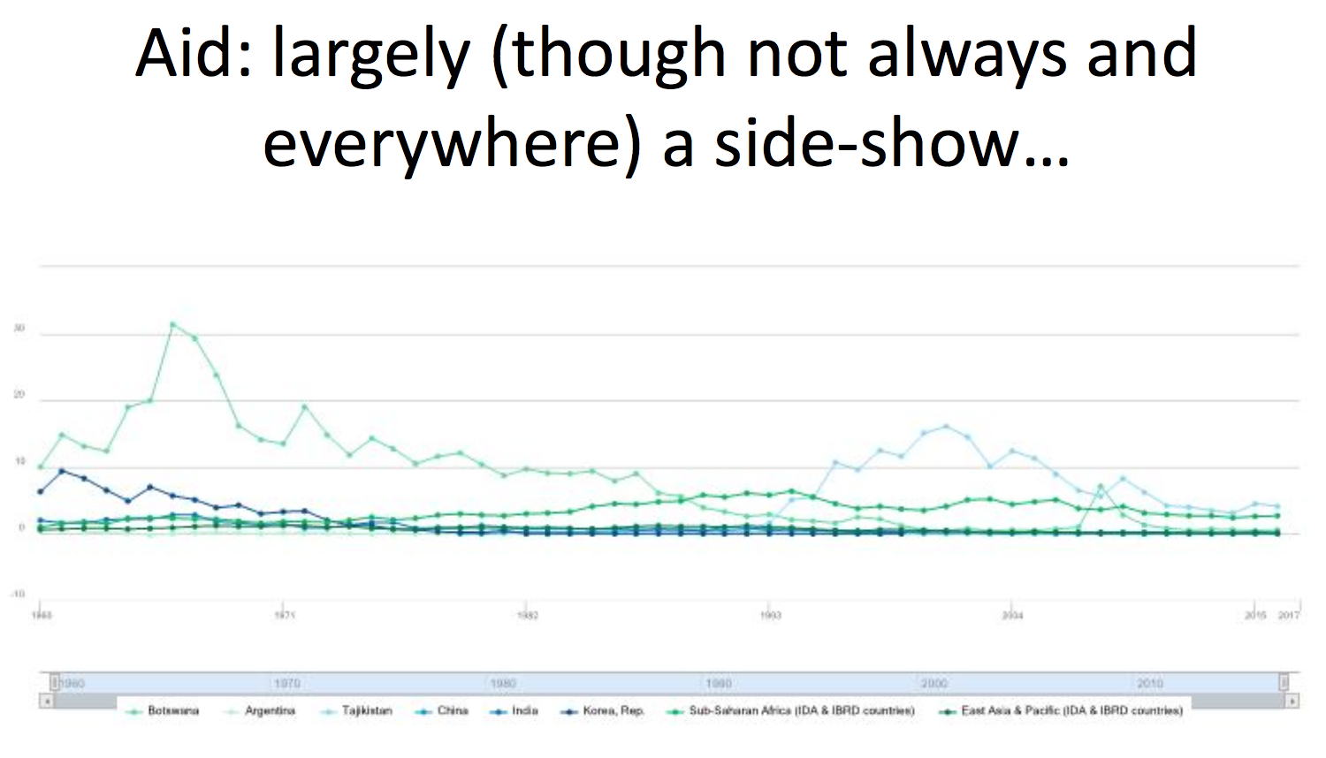

Aid: A Particular Type of Fiscal Transfer
- Replacing the role of the government of the aid-receiving country
- Undermining democratic accountability in aid-receiving country
  - Accountability lies in aid-giving country
- Often motivated by geopolitics, trade, FDI, bureaucracy status of the giving country instead of poverty reduction in the receiving country
- Input-focused
- Output measurement problem
- Money is fungible - able to replace or be replaced by another identical item
- Fragmented (badly or not coordinated; see next graph)

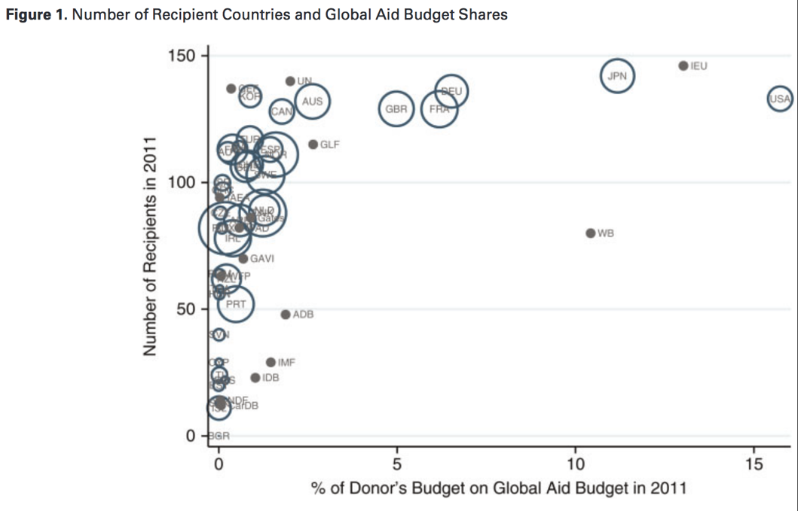

But Need to Treat causes, not Symptoms of sickness: How to Fight Extractive Institutions?
- “Conflict over income and power, and indirectly over institutions, is a constant in all societies”
- “Naturally, the predictive power of a theory where both small differences and contingency play key roles will be limited”
- “Nevertheless, our theory is still useful for policy analysis, as it enables us to recognize bad policy advice, based on either incorrect hypotheses or inadequate understanding of how institutions can change”
- In worst (extractive) cases: Can only focus on countervailing power from bottom up (improving checks & balances on state - "empowerment" - so no aid to the state if it is highly extractive) as a top-down approach will not work or even make matters worse
- The prof finds the authors view on "conditionality" (pg. 447) too negative
  - If only conditionality is implemented in a serious manner, it can make a difference!

Week 11 - #2
The "Washington Consensus"
- Fiscal policy discipline, with avoidance of large fiscal deficits relative to GDP
- Redirection of public spending from subsidies ("especially indiscriminate subsidies") toward broad-based provision of key pro-growth, pro-poor services like primary education, primary health care and infrastructure investment
- Tax reform, broadening the tax base and adopting moderate marginal tax rates
- Interest rates that are market determined and positive (but moderate) in real terms
- Equilibrium exchange rates
- Trade liberalization
- Liberalization of FDI
- Privatization of SOEs
- Deregulation
  - abolition of regulations that impede market entry or restrict competition
  - except for those justified on safety, environmental and consumer protection grounds, and prudential oversight of financial institutions
- Legal security for property rights

- But not "Market Fundamentalism"
  - Belief in the ability of laissez-faire or free market policies to solve most economic and social problems

- The Washington Consensus is a set of 10 economic policy prescriptions considered to constitute the "standard" reform package promoted for crisis-wracked developing countries by Washington, DC
- Based on institutions such as the IMF and World Bank
  - IMF = International Monetary Fund

Why was the Bretton Woods System, comprising IMF and World Bank, created?
- Avoid past mistakes: disastrous economic policies that contributed to the Great Depression of the 1930s and WWII
  - "Beggar-thy-neighbor-policies"
  - Protectionism and tariff wars
- Rebuild confidence in international cooperation and international financial system after failure of League of Nations and two World Wars

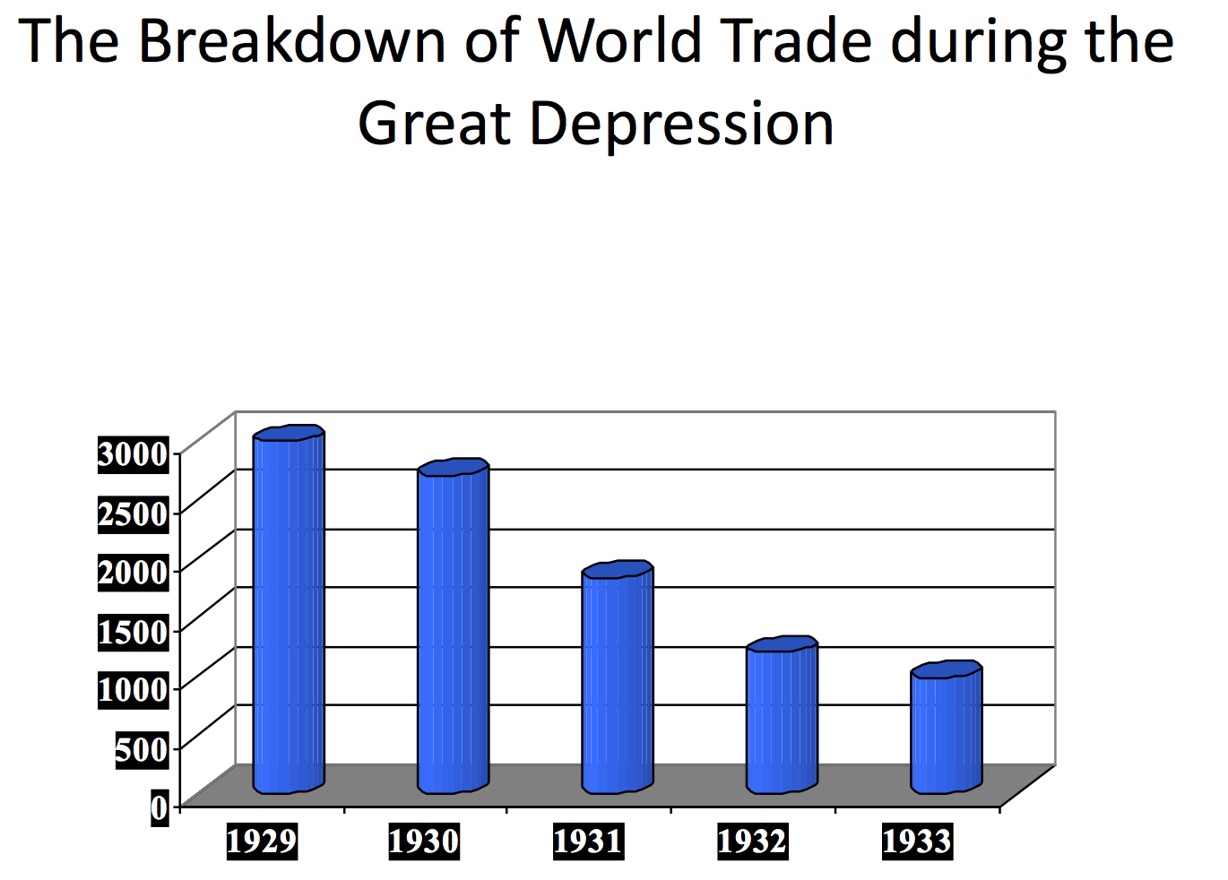

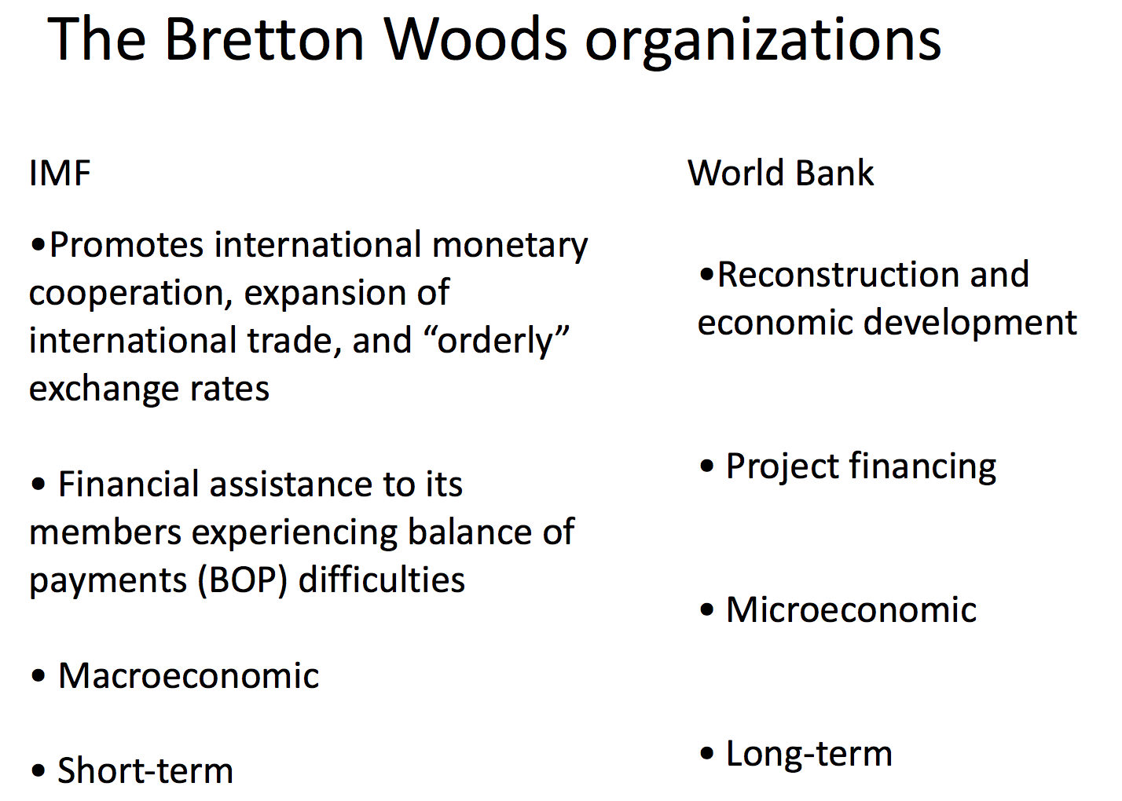

Structure of the IMF
- 184 member countries
- Governance Structure
  - Board of Governors
  - Executive Board
  - Management
  - Staff
- Working capital provided by member country's subscriptions or "quotas" in IMF speak (currently about US$700 billion, after 2010 quota reform that was approved in 2016…), determining voting power and access to financing

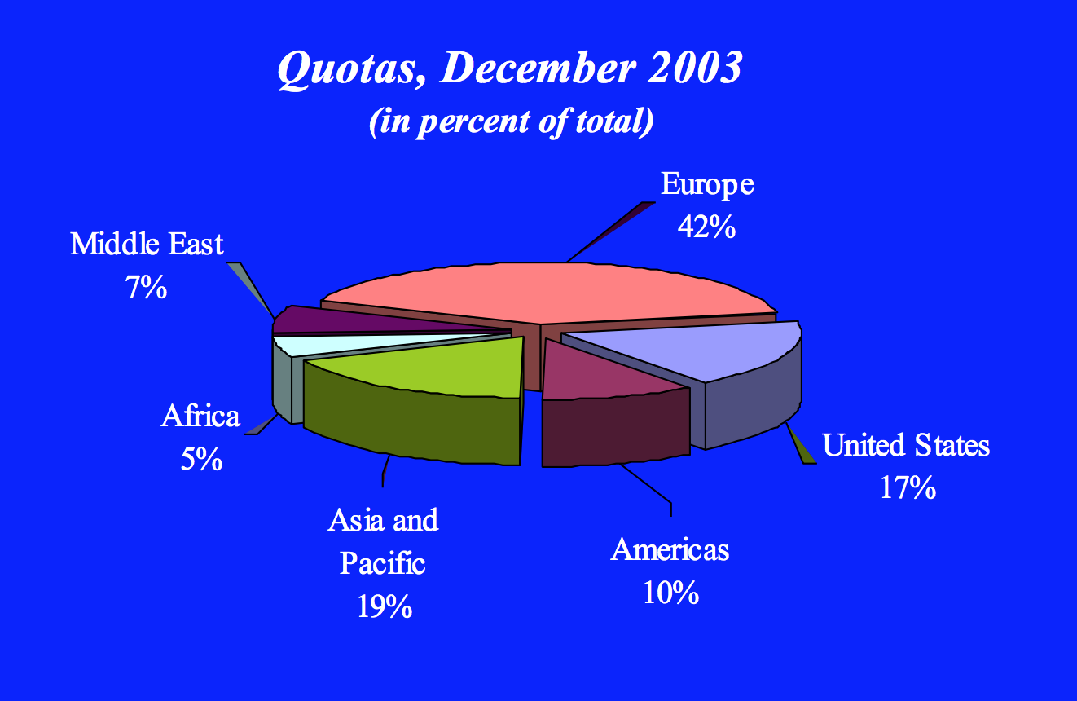

Operationalization of the IMF
Safeguard international trade and macroeconomic and financial stability through
- Lending: To support reforms to adjust to BOP problems, and reduce external vulnerability
- Financing provided as part of IMF “program”
- Financing is collateralized by program “conditionality” (quantitative and structural)
- Technical Assistance: Building institutional capacity
- Surveillance: Monitoring and policy advice
In the areas of
- Macroeconomic policies
- Financial sector policies
- Advise on other reforms that have a macroeconomic impact

What Does This Have to do with Economic Development?
- International trade and stable international financial system also important for Low-Income Countries (LICs)
- Macroeconomic stability is a prerequisite for sustained growth and poverty reduction
- So is sufficient/efficient tax capacity, and effective spending, to be able to build strong institutions and infrastructure.
- LICs’ (potential) BOP problems are structural
- Political economy – Reforms will not be sustained if they are not (perceived as) broadly equitable
- LICs are members of the Fund with the right to its lending, TA, and surveillance
- Growth for poverty reduction is at the center of LIC’s own policy agenda (though unfortunately not nearly always…)

But…
- The Fund is not a development institution, and does not give (direct) aid, unlike other donors
- Giving rise to sustained growth and poverty reduction is a medium to long-term challenge, dependent on a wide range of policies and actors…
- LICs do not pose a short-term threat to the international trade and/or financial system

Example -Tajikistan - Main conditionality, 2008 - 2010
- Quantitative
  - The “usual” conditions that essentially try to make sure that the government deficit can be financed from available sources without creating inflation/debt problems (safeguarding macroeconomic stability), while (re)building foreign exchange reserves (reducing external vulnerability), and paying all bills (no arrears)
  - Floor on social and poverty-related expenditure
- Structural
  - Cotton debt resolution; agricultural liberalization and financing
  - NBT: transparency; central bank law; recapitalization
    - National Bank of Tajikistan
  - SOE transparency: external audits (incl TALCO) ; MoF SOE supervision unit
    - Ministry of Finance State Owned Enterprise
- But: reform effort lapsed when (IMF) financing came in again, and conditions were waived

Some policy lessons from practice - Note the overlap with Acemoglu & Robinson (2012)
- Macroeconomic stability is a necessary, but not sufficient condition for sustainable economic growth and poverty reduction
- If the critical structure (political...) is not fixed, it will come back to haunt you in the macro at some point
- Underdevelopment is predominantly not about lack of financing, but about lack of/wrong incentives – Political economy dominates, on all sides – push to get institutions (and thereby incentives) right
- Be prepared to take conditionality to its logical conclusion or it will fail
- Development needs both bottom-up (people) and top-down (state), and the mix should be different depending on the institutional environment
- Ultimately, what is needed is (private sector) jobs and thus (private sector) investment

In Highly-Extractive Cases:
- Stick to conditionality: no official financing if conditions are not implemented.
- Pay more attention to bottom-up instead of top-down: “empowerment”, stimulating countervailing power on the extractive state, which is the source of the problem
- That is also where examples such as the solar-powered lamp and fair-trade fit in: market-based solutions that can help provide people with more independence
- For example: there is evidence that fair trade certification does help farmers to receive higher prices, have greater access to credit, and use more environment-friendly practices
  - However, in Tajikistan’s cotton sector it would not work because consumers don’t like to pay higher prices for everything, and under free-entry rents dissipate to only the cost of the fair-trade certification.
- Bottom-up, what we need most is informed citizens, who use that information to vote/act for good (collective action), fighting the con men.
- Ultimately, a reformed state (top-down) will have to be part of the solution as well, or “royal expropriation” and “state capture” will continue to block true development.
- If the critical structural, and political is not fixed, it will come back to haunt at some point.
- Underdevelopment is predominantly not about lack of financing, but about lack of/wrong incentive – political economy dominates, on all sides – push to get institutions and thereby incentives.

Week 12: #1: Presentation: Economic Growth & the Environment
The Energy Connection:
- Economic growth and air pollution are linked through the harnessing of energy.
- Energy requires a mechanism to turn it into usable power.
- Economic history closely follows development of mechanisms.

Power Mechanisms:
- Human
- Animal
- Wind
- Water
- Modern world arose from finding and learning to use fossil fuels (as well as hydro and nuclear energy).
- Concentrated energy and efficient mechanisms.
- Power output rose by spectacular amounts.

Combustion:
- Fuel-powered processes rely on combustion.
- Air pollution arises from by-products:
- use of air (rather than oxygen)
- impurities in the fuel
- incomplete combustion
- CO2

Air Pollution:
- Some result from emissions.
- Some formed by secondary processes
- However, these imply very different control problems.
- Offsetting effects:
- increased GDP means more combustion
- Increased income means better technology

Global Issues: Global Warming:
- Difficulty of reducing CO2 emissions:
- closely tied to combustion
- no scrubber, so reductions are very costly
- must be reduced at global level to make a difference

TO SUMMARIZE:
- Combustion of fossil fuels ties economic growth to air pollution.
- Most air pollutants do not necessarily increase with economic growth, many go down.
- Stratospheric ozone depletion due to CFC (hydrocarbon) use mainly occurred in polar regions and in the mid-latitudes during late winter and early spring.
- eliminating global CFC use was NOT very costly.
- Stratospheric ozone depletion: a steady decline of about four percent in the total amount of ozone in Earth's stratosphere (the ozone layer), and a much larger springtime decrease in stratospheric ozone around Earth's polar regions.
- CO2 emissions grow with fossil fuel use.
- CO2 is a greenhouse gas that is believed to have a warming effect on the climate.
- Eliminating or even reducing CO2 emissions is more costly than other types of emissions.

Week 12: #2
Operationalization of the International Monetary Fund (IMF):
- Safeguard international trade and macroeconomic and financial stability through:
- Lending: to support reforms to adjust to BOP problems, and reduce external vulnerability.
- Financing provided as part of IMF program.
- Financing is collateralized by program conditionality (quantitative and structural)
- Technical assistance: building institutional capacity.
- Surveillance: monitoring and policy advice.
- In the areas of:
- macroeconomics
- financial sector policies
- advise on other reforms that have a macroeconomic impact.

What does this have to do with economic development?
- International trade and stable international financial systems are also important for low-income countries (LICs).
- Macroeconomic stability is a prerequisite for sustained growth and poverty reduction.
- So is sufficient/efficient tax capacity, and effective spending, to be able to build strong institutions and infrastructure.
- LICs potential BOP problems are structural.
- Political economy – reforms will not be sustained if they are perceived as broadly equitable.
- LICs are members of the fund with the right to its lending, trade agreement, and surveillance.
- Growth for poverty reduction is at the center of LIC’s own policy agenda.

But…
- The Fund is not a development institution, and does not give direct aid, unlike other donors.
- Rising sustained growth and poverty reduction is a medium to long-term challenge, dependent on a wide range of policies and actors.
- LICs do not pose a ST threat to the international trade and/or financial system.

Example: Tajikistan – Main Conditionality (2008-2010):
- Quantitative:
- The “usual” conditions that essentially try to make sure that the government deficit can be financed from available sources without creating inflation/debt problems (safeguarding macroeconomic stability), while rebuilding foreign exchange reserves (reducing external vulnerability), and paying all bills (no arrears: money that is owed and should have been paid earlier).
- Floor on social and poverty-related expenditure.
- Structural:
- Cotton debt resolution, agricultural liberalization and financing
- NBT: transparency, central bank law, recapitalization.
- SOE transparency: external audits
- But reform effort lapsed when IMF financing came in again, and conditions were waived.

In Highly-Extractive Cases:
- Stick to conditionality: no official financing if conditions are not implemented.
- Pay more attention to bottom-up instead of top-down: “empowerment”, stimulating countervailing power on the extractive state, which is the source of the problem.
- That is also where examples such as the solar-powered lamp and fair-trade fit in: market-based solutions that can help provide people with more independence.
- For example: there is evidence that fair trade certification does help farmers to receive higher prices, have greater access to credit, and use more environment-friendly practices.
- However, in Tajikistan’s cotton sector it would not work because consumers don’t like to pay higher prices for everything, and under free-entry rents dissipate to only the cost of the fair-trade certification.
- Bottom-up, what we need most is informed citizens, who use that information to vote/act for good (collective action), fighting the con men.
- Ultimately, a reformed state (top-down) will have to be part of the solution as well, or “royal expropriation” and “state capture” will continue to block true development.
- If the critical structural, and political is not fixed, it will come back to haunt at some point.
- Underdevelopment is predominantly not about lack of financing, but about lack of/wrong incentive – political economy dominates, on all sides – push to get institutions and thereby incentives.

