“...BUT A HOT TEMPER LEAPS O’ER A COLD DECREE”
A Tall Cold Drink of Water: Enthalpy of Reactions

Introduction
Thermochemistry is the study of energy changes in physical and chemical processes. The study of energy change associated with the chemical reaction performed in this lab is called calorimetry. When chemicals react, heat is either absorbed or released to or from the surroundings of the reaction. A reaction in which heat is absorbed is called an endothermic reaction, and the release of heat is called an exothermic reaction. The energy that is being absorbed/released is thermal energy, a form of kinetic energy formed from the motion and vibration of atoms, and the rotation and translation of the molecules in the atoms. Since these qualities cannot be directly measured, chemists have found a method of measuring the change in the heat of a system, also known as the change in enthalpy (represented by 𝚫H). Standard state is the common condition in which the change in enthalpy is recorded, that is when pressure is equal to one bar and the temperature is equal to 25℃. The equation used to calculate change in enthalpy of the dissolution of a substance is:

𝚫_{s}H° = ( - heat loss of H₂O) + (- heat loss of salt)

Endothermic reactions are represented by a positive 𝚫H value, whereas an exothermic reaction is represented by a negative 𝚫H value. The specific heat capacity of a substance is important when measuring the thermal energy released or absorbed in a reaction, it is the amount of energy required to heat one gram of that substance by one degree celsius. In order to find the amount of energy absorbed or released by the reaction the formula:

q = mc𝚫T

is used where m represents mass, c represents the specific heat capacity of a substance, and 𝚫T is the change in temperature. When analyzing the energy released or absorbed, it is important to clearly identify the surroundings, which is the matter surrounding the reaction that is capable of releasing or absorbing energy, as well as the chemical system itself, which is the reactants and products experimented with.
For this experiment our group was asked to create a product for the UOttawa Gee Gee’s Sports and Health Drinks Association that can, whenever and wherever the consumer desired, cool down a beverage. The purpose of this experiment is to find a way to cool down 100cm³ of drinkable water by 5$℃$in no more than 5 minutes using either Ammonium Chloride (NH₄Cl) or Ammonium Nitrate (NH₄NO₃). This indicates that the dissolution of these salts must be an endothermic reaction. In order to do this we need to perform calorimetry, a method by which the change in thermal energy due to a chemical reaction can be measured. The equipment used will be a styrofoam cylinder with a lid and an opening at the top for the temperature probe. The styrofoam calorimeter can further be classified as a closed system. This means energy is able to move in and out of the system, since the isolation and equipment is not ideal, but matter has no way of entering or exiting the system. When performing calorimetry, a couple of assumptions must be made. First, no heat is transferred between the calorimeter and the outside environment, second, any heat absorbed or released by the styrofoam is negligible, and last, any dilute aqueous solutions will have the specific heat capacity and density equal to that of water, which is 1 g/mL, and 4.18 J/g°C.
In order to determine the enthalpy of dissolution of the salt, multiple separate values must be taken into account. Swiss Chemist G. H. Hess suggested that there is a mathematical relationship among a series of reactions leading from a set of reactants to a set of products. This became Hess’ Law, or the Law of Constant Heat Summation, stating that the enthalpy of a given chemical reaction is constant, regardless of the number of steps taken in the reaction. Hess’ Law is represented by the following equation:

𝜟H_{target} = 𝚺𝜟H_{known}

In this case, the lattice energy must be combined with the enthalpy of hydration of both of the ions in gaseous state. The lattice energy is the energy required to vaporize one mole of the salt to form their gaseous ions. The enthalpy of hydration is the energy released from one mole of gaseous ion dissolving into its aqueous in the presence of water. The numbers were provided in the Prelab Exercise (Experiment 2: A Tall Cold Drink of Water Prelab Exercise, Dr. Rashmi Venkateswaran, 2018). The lattice energy is 705 kJ/mol, the enthalpy of hydration of the ammonium ion is -307 kJ/mol, and the enthalpy of hydration of the chloride ion is -381 kJ/mol. The value of the following will be used in order to obtain the mass of the salt required for the increase in water.
Calculations must be made in order to adjust the mass of the salt required for the new volume of water in the calorimeter. The total energy of the system is the sum of the energies of the water in the can, the water in the calorimeter, and the energy of the can itself. The following equation will be used for each of the energies:

q = mc𝚫T

The c value is a constant known value, for water is 4.18 J/g°C, and for aluminum is 0.900 J/g°C. The volume of the water in the can does not change, therefore that equation will not be altered throughout the experiment. However, the volume changes in the equation for the contents of the calorimeter, therefore this equation has to be redone for each increase. Water will be measured with the graduated cylinder in mL, however a known conversion factor is 1 mL of water is equal to 1 g of water. The mass of the aluminum can will be taken at the beginning of the experiment, and will be the m value.
And has to be done for the water inside the aluminum can, the water in the styrofoam calorimeter, and the aluminum can itself.
Prior to performing this experiment, one law must be familiarized with, which is the law of conservation of energy, also known as the First Law of Thermodynamics. This law dictates that the energy before and after the reaction is the same, meaning it is not created or destroyed. This can be supported by the equation:

Qsystem = -Qsurroundings

stating that if systems release energy, surroundings absorb it, and vice versa.
From the two chemicals provided, ammonium chloride (NH₄Cl) and ammonium nitrate (NH₄NO₃), the one chosen for this task is ammonium chloride. Considering this will be used with drinkable water, it is important to follow the Health and Safety regulations imposed by Health Canada. Ammonium chloride is classified as a safer chemical compared to ammonium nitrate. Ammonium nitrate has a risk of fire and explosion associated with an increase in temperature. Additionally, the risks associated with ingestion of ammonium chloride are more subtle compared to those of ammonium nitrate. Another point which must be taken into account is the price of the chemicals, as ammonium chloride is the more affordable.

“Chapter 5.” Nelson Chemistry 12, by Frank Jenkins, Thomson Nelson, 2003, pp. 298–332.“Chapter 5.” Nelson Chemistry 12, by Frank Jenkins, Thomson Nelson, 2003, pp. 298–332.

National Institute for Occupational Health and Safety: Centers for Disease Control and Prevention, “Ammonium Nitrate”, 2015 https://www.cdc.gov/niosh/ipcsneng/neng0216.html

National Institute for Occupational Health and Safety: Concerns for Disease Control and Prevention,
“Ammonium Chloride”, 2015 https://www.cdc.gov/niosh/ipcsneng/neng1051.html

Materials and Equipment
- Styrofoam Calorimeter
- Temperature Probe
- NH₄Cl(s) (Ammonium Chloride)
- LabQuest 2
- Beaker (50 mL)
- Aluminium Can
- Graduated Cylinder (50 mL)
- Stirring Rod
- Scale
- Water

Apparatus
Figure 1: Diagram of the Setup
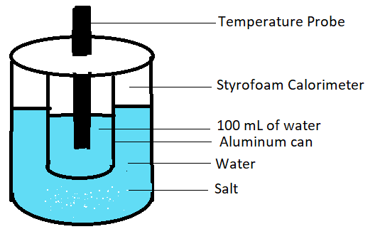

Procedure
- Gather materials and equipment
- Take mass of can.
- Plug temperature probe into LabQuest 2, in order for temperature change to be recorded.
- Measure 14.58g of ammonium chloride into a beaker and set aside for later use (this amount will change with each trial as the amount of water placed in calorimeter will be increasing as well. See calculations). Note: Remember to zero the scale after placing the beaker prior to adding the ammonium chloride.
- Fill aluminum can with 100mL of water, measured using graduated cylinder.
- Measure 120mL of water using graduated cylinder and pour into styrofoam calorimeter.
- Pour measured NH₄Cl into the styrofoam calorimeter, ensuring all of the salt makes it inside, and quickly stir with stirring rod to dissolve the salt in the water.
- Place aluminum can inside the calorimeter, cover with lid, and insert temperature probe through the opening at the top of the calorimeter making sure probe does not touch the bottom or the sides of the can. Note: This step has to be done quickly in order to make sure temperature reading is accurate and surrounding heat does not enter the can.
- Set LabQuest timer for 5 minutes, keeping an eye on temperature reading. Gently swirl the calorimeter until the time is up.
- Record final temperature in Table 1. Calculate temperature change.
- Empty out content of calorimeter as well as aluminum can into inorganic waste bin.
- Repeat steps 4-11, increasing the volume added into the calorimeter by 5mL, and thus altering the amount of NH₄Cl, for a total of 4 trials.

Observations/Data

Quantitative Results

Data Table 1: Change in Temperature of Water from Mass of Salt with Respected Trials.
Trial No. | Volume of Water (mL) | Mass of Salt (g) | Initial Temperature (°C) | Final Temperature (°C) | Temperature Change$ΔT$(°C)
1 | 120 | 14.58 | 23.3 | 19.0 | 4.3
2 | 125 | 14.91 | 23.3 | 19.3 | 4.0
3 | 130 | 15.24 | 23.6 | 19.3 | 4.3
4 | 135 | 15.90 | 25.4 | 20.7 | 4.7

Graph 1: Temperature (°C) vs Time (min) for Trial 3
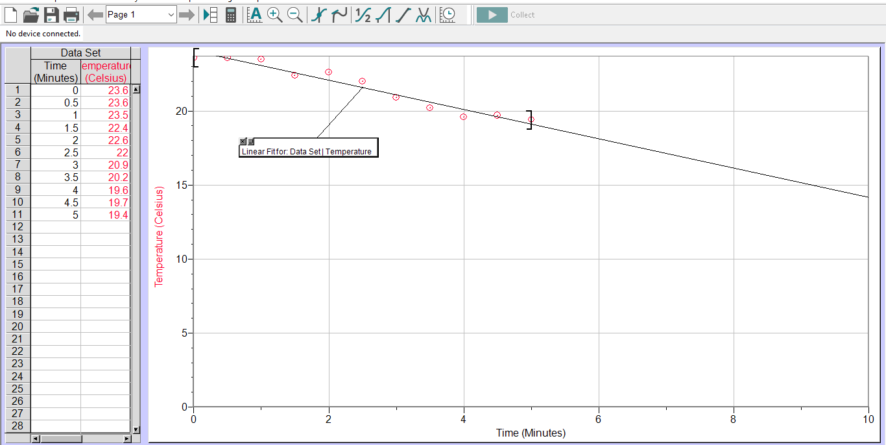
Note: LabQuest was started before the actual start of the experiment. This explains the discrepancy between the final temperature in Table 1, and the final temperature in Table 2.

Graph 2: Temperature (°C) vs Time (min) for Trial 4
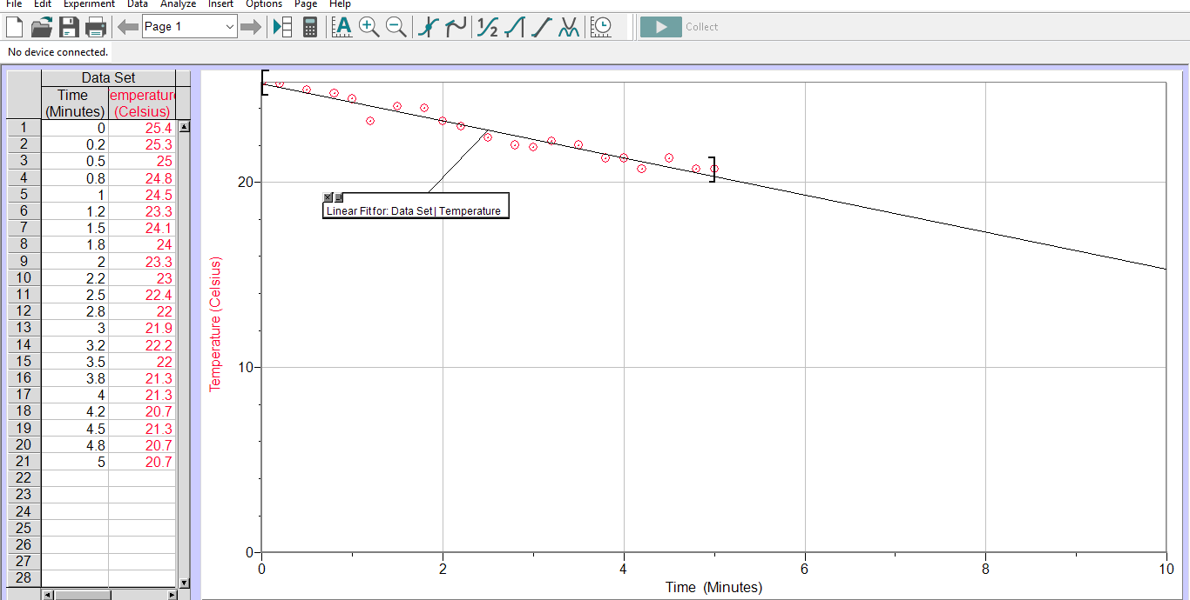

Figure 2: Potential Energy Diagram for NH₄Cl(aq)
NH4Cl (s)
NH4Cl (aq)
HNH4=17 KJ

Hlattice=705KJ
HhydNH4=-307 KJ

HhydCl=-381 KJ

Potential Energy (KJ)
Reaction Pathway

Sample Calculations
- Temperature Change
ΔT = |Tfinal - Tinitial|
=|23.3 - 19.0|
=|-4.3|
=4.3 degrees celsius

- ΔHsoln NH₄Cl(s)
=Lattice Energy of NH₄Cl(s) + Enthalpy of Hydration of NH4+(g) + Enthalpy of Hydration of Cl-(g)
=705+(-307)+(-381)
=705-307-381
=17kJ/mol

- Qsystem
Qsystem=Qwater + Qcalorimeter + Qcan
=((100)(4.18)(5))+((120)(4.18)(5))+((8.07)(0.90)(5))
=(2090)+(2508)+(36.32)
=4634.32 J
=4634.32 J (1 kJ/1000 J)
=4.63 kJ

- Finding Mass of Salt
Qsystem=4.63 kJ (from c)
=4.63 kJ/17kJ/mol
=0.273 mol NH₄Cl (s) x (53.497g/mol)
=14.58g NH₄Cl (s)

Qualitative Results
Ammonium chloride is a white, highly soluble powder. When it was added into the calorimeter with the water, the water rapidly became colder.

Discussion
Based on the data collected above, the experiment was not conducted successfully in terms of being able to cool the water in the can by 5°C in under 5 minutes.
The design of the calorimeter was successful considering it cooled the water in the can. As seen in Table 1, the change in temperature of the last trial was only slightly off from the change in temperature required. A distinct observation can be made that with each trial, besides trial 2, the temperature change approaches 5°C. This indicates that a few more trials would have most likely resulted in the desired temperature change of the water.
Various factors affected the results in this experiment. Firstly, when emptying out the salt from the beaker into the styrofoam calorimeter, the stirring rod was used in order to get as much of the salt as possible into the calorimeter. The beaker was not completely emptied out, leaving some of the mass inside, therefore slight discrepancy between theoretical mass calculated and actual mass added. The assumption that no heat is transferred must be made, however there is a degree of error in this assumption as likely some heat was able to enter the calorimeter and impact results. Next, during the first two trials, the calorimeter was not swirled. Lastly, some of the salt grouped together in solid chunks and not in a loose powder form. The powdered form enables a faster dissolution in the water since there is an increase in surface area. Having the salt in a solid chunk results in slower reaction time with the water in the calorimeter, meaning that the maximum time of 5 minutes would not be enough for the reaction to finish.
When measuring the salt for each trial, it was measured out into a beaker. The measurement would have been more accurate if the paper was used to weigh it. This would have reduced the error from ensuring all the content was emptied out into the calorimeter. It was time consuming to use the stirring rod in order to get all the remainder of the salt from the bottom of the beaker. Moreover, once the salt combines with the water, the reaction begins. This means the longer it takes to empty out the beaker and stir the content, the more of the cold given off is lost to the system instead of into the water. An improvement that can be made if this experiment were to be done again would be that, for all trials, to have set a specific and constant time frame for pouring the salt in the calorimeter and mixing it in the water with the stirring rod. This would reduce the discrepancy in results between trials as varying the time given for pouring and stirring the salt in the calorimeter for each trial impacts the final recorded temperature. Another improvement which can be made in the equipment is the calorimeter. Although with styrofoam calorimetry assumptions have to be made, it is not possible to track if that is true. Using bomb calorimeter would ensure that no heat or energy is lost. It would be an isolated system with the pressure staying constant, no matter or energy moving in or out.

Conclusion
Based on our data, calculations, and topics discussed we found that our hypothesis of using approximately 14.58 g - 15.90 g of ammonium chloride in 120 mL - 135 mL of water would make the water have a temperature difference of approximately 5°C in less than 5 minutes was initially proven wrong by the experimental data. However, the experiment was most successful in the fourth trial after the designated 5 minute interval, which indicates that with further experiments with the numerical values of trial four, eventually the hypothesis will be proven true. The results of the experimental data can be attributed to possible sources of error conducted throughout the experiment. These errors include varying the time between the pouring of aluminum chloride in the calorimeter and closing the system for each trial, the quality of the calorimeter, and the clumping of the salt thus increasing the time it takes for the salt to completely dissolve.

