Verification of Gas Laws

CHM 1311
Department of Chemistry

Introduction: Gas Laws
A gas is a state of matter that expands freely to fill any available space, thus the particles of a gas are much more widely spread out than in comparison to the particles of a liquid or a solid. The difference in the arrangement of particles of the three states is a result of the particles’ attraction to one other. Having low attraction, gas particles are able to constantly move freely in different directions and patterns, with elastic collisions, as stated by the kinetic molecular theory. This enables the gas to be able to take the shape of any container, regardless of its quantity. Another quality that must be taken into account when exploring the differences between gas and the other two states of matter is density. Gases are so much less dense that their density is measured in a different unit, as opposed to being measure in g/mL which is used for liquids and solids, gas density is measured in g/L. Temperature has an effect on density as well as pressure. When the temperature of the gas decreases, the pressure decreases, and the density increases.
Charles’ Law demonstrates that the volume of a gas is proportional to the temperature, V∝T, with pressure being constant. The formula which represents this is:

V₁ T₁ = V₂T₂
Or V/T=C, C being a constant.

Boyle’s Law on the other hand states that volume is inversely proportional to the pressure, V∝1/P, the temperature being constant. An equation to represent this is:

P₁V₁=P₂V₂
Or PV=C, C being a constant.

In both of these experiments, the gas used will be air.
To facilitate calculations, the Ideal Gas Law has been put together by combining the above laws, as well as Avogadro’s equation. This equation states that the volumes of different gases at the same temperature and pressure contain the same amount of particles, and the volume of the gas is equal to the amount of moles. The above relationships combined have formed the following equation:

PV=nRT, where R is the gas constant.

Although the Ideal Gas Law is still used to this day, further experiments have lead to deviations in this law. Firstly, the law states that gas particles have no intermolecular force. The gas particles are explained to be interacting through elastic collisions. In elastic collisions, the energy before and after the collision is not lost, meaning that potential energy is converted to kinetic energy and vice versa. This does not consider the intermolecular force that the particles have on each other, which in fact alters the way energy is distributed, and depends on the conditions of the gas. Second, the gas particles were said to not take up space, however they in fact do. The Ideal Gas Law however is more or less an approximation of how gases act only when they are in conditions of high temperature and low pressure. Van der Waals created a more accurate equation of the law which takes into account these exceptions.

“Chapter 9.” Nelson Chemistry 12, by Frank Jenkins, Thomson Nelson, 2003, pp. 418–444.“Chapter 9.” Nelson Chemistry 12, by Frank Jenkins, Thomson Nelson, 2003, pp. 418–444.
https://www.britannica.com/science/gas-state-of-matter/Behaviour-and-properties, Edward A. Mason, Encyclopædia Britannica

Procedure: Charles’ Law
Follow procedure as described in the lab manual (Verification of Gases, Dr. Rashmi Venkateswaran, 2018, Exp. 1 pp. 7-8).
Procedure: Boyle’s Law
Follow procedure in lab manual (Verification of Gases, Dr. Rashmi Venkateswaran, 2018, Exp. 1 pp. 8-10) for using the LabQuest and equipment.
- Set the 20 mL syringe at 10mL, the black strip closest to the tip of the plunger should be aligned with the 10 mL mark. Note that there is an extra 0.8 mL of gas volume inside the pressure sensor and it is important to take this into account when recording gas volume. Record the stabilized air pressure at 10.8 mL.
- Pull back the plunger 1.0mL to the 11 mL mark on the syringe. The volume is now 11.8 mL, record the stabilized air pressure at this volume.
- Repeat step 2 for a total of 8 readings, continuing to pull back the plunger 1 mL for each trial. Once finished, move the plunger back to original volume position of 10 mL and record the pressure value again.

Observations/Data/Results
Data Table 1: Effect of Temperature Change on Volume (Charles’ Law)
Temperature 1 (°C) | Temperature 1 (K) | Temperature 2 (°C) | Temperature 2 (K) | V_{cw} (mL) | V₁ (mL) | V₂ (mL)
86.4 | 359.55 | 5.9 | 279.05 | 33.5 | 154.5 | 121.0

Data Table 2: Effect of Volume Change on Pressure (Boyle’s Law)
Volume (mL) | Pressure (kPa)
10.8 | 107.07
11.8 | 99.21
12.8 | 91.25
13.8 | 85.92
14.8 | 80.53
15.8 | 75.46
16.8 | 70.62
17.8 | 66.73
10.8 | 110.79

Data Table 3: Volume vs 1/Pressure
Volume (mL) | 1/Pressure (kPa)
10.8 | 9.30 x 10e-3
11.8 | 1.00 x 10e-2
12.8 | 1.10 x 10e-2
13.8 | 1.16 x 10e-2
14.8 | 1.24 x 10e-2
15.8 | 1.33 x 10e-2
16.8 | 1.42 x 10e-2
17.8 | 1.50 x 10e-2

Graph 1: Volume(mL) vs Pressure(kPa) Quadratic. From Table 2
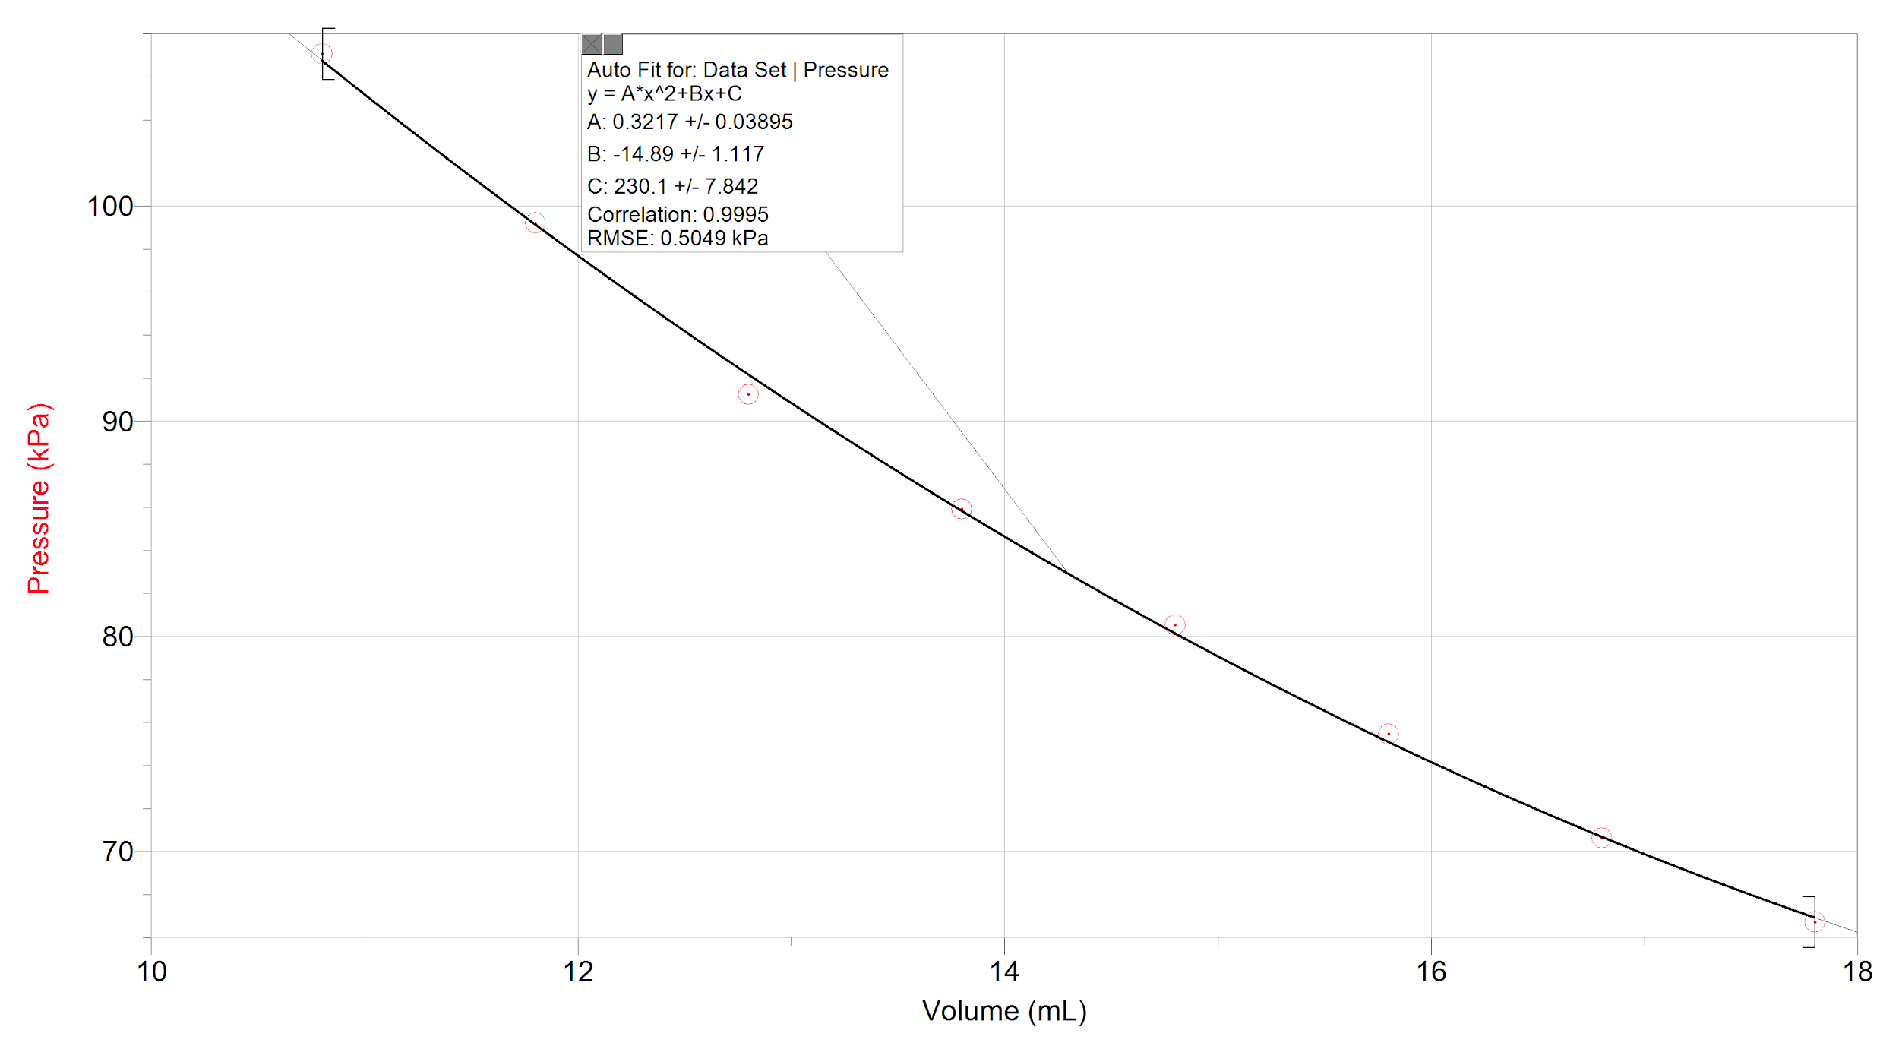

Graph 2: Volume(mL) vs 1/Pressure(kPa) Linear. Data from Table 3
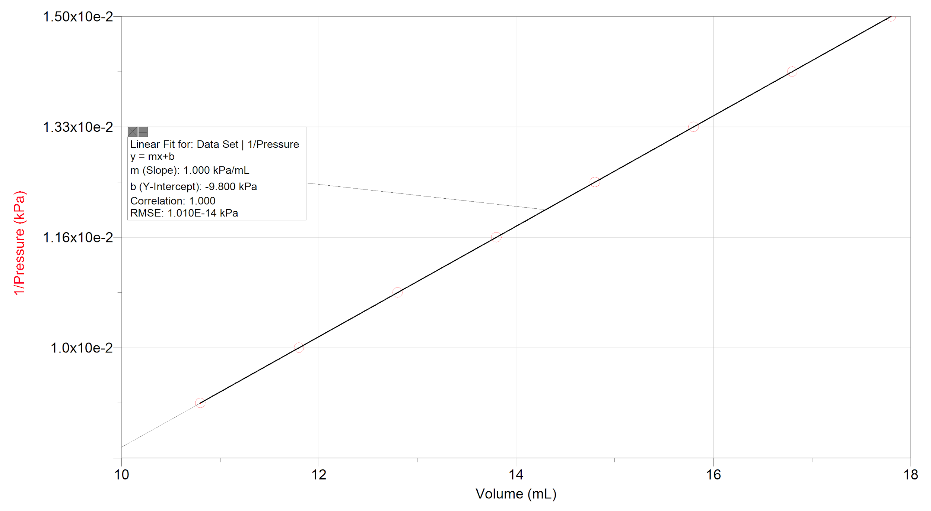

Sample Calculations
- Conversion from celsius to Kelvin
T_{k}= T_{c} + 273.15
= 86.4 + 273.14
= 359.54

b) Finding V₂
V₂=V₁-V_{cw}
=(154.5)-(33.5)
=121.0mL

c) Finding percent error for Charles’ Law Verification
V₁ - V₂ = (154.5) - (121.0) =0.429703796 - 0.433614047
T₁ - T₂ x100% 359.55 279.05 x100% 0.429703796 x100%
V₁ (154.5)
T₁ 359.55
= -0.902%
= -9.02 x${10}^{-1}$
= |9.02 x${10}^{-1}$| % error

d) Finding constant for Charles’ Law
V/T = C
(154.5)/(359.55) = 4.30 x ${10}^{-1}$ mL K

e)Average constant for Charles’ Law
=C1+C2 =(4.30 x ${10}^{-1}$)+(4.33 x ${10}^{-1}$)
2 2
=4.31 x${10}^{-1}$ mL K

f) Finding constant for Boyle’s Law
PV=C
(107.07 kPA)(10.8 mL)=1156.356 kPa mL
= 1.16 x${10}^{3}$kPa mL

g) Average constant for Boyle’s Law
=C1+C2+C3+C4+C5+C6+C7+C8+C9
9
=(1.16 x${10}^{3}$)+(1.17 x ${10}^{3}$)+(1.17 x${10}^{3}$)+(1.19 x${10}^{3}$)+(1.19 x${10}^{3}$)+(1.19 x${10}^{3}$)+(1.19 x${10}^{3}$)+(1.19 x${10}^{3}$)+(1.20 x${10}^{3}$) /9
=1.23 x${10}^{3}$kPa mL

Discussion
From the data collected above, with the decrease in pressure due to the decrease in temperature, as well as the increase in pressure from the decrease the volume, both of the laws were proven correct.
The pressure for the initial volume of 10.8mL was taken twice in Boyle’s Law. The two readings were different and demonstrates that there are inevitable sources of errors in the lab, even though the recorded temperature measured by the LabQuest was the same during the two trials. Out of the two readings, the outlier was removed, and the one that was closest to the rest of the data was kept and graphed. In order for Boyle’s Law to make sense, the temperature must remain constant while the volume and the pressure are the variables experimented with. The independent variable was chosen to be the volume because it was easier to manipulate with the equipment that was supplied, rather than the pressure, therefore the pressure is the dependent variable.
In order to improve accuracy of the experiment, the temperature was taken into consideration when performing Charles’ Law. To keep track of any fluctuations, the temperature probe was plugged into the LabQuest, recording any changes with each trial. Temperature affects the results because with an increase in temperature, the air molecules gain a higher kinetic energy, speed up, and collide with each other more frequently and at a faster rate. This collision results in an amount of energy given off causing in a build up of pressure when the container cannot be expanded. With a lower temperature, the kinetic energy decreases, the particles slow down, collide with each other less frequently and at a slower rate, decreasing the pressure in the syringe. As a result, when the temperature increased by 0.10 degrees Celsius in trial 6 and 7, the pressure shown by the monitor is most likely higher than it would have been if the temperature was 0.10 degrees lower.
Based on the relationship between volume and pressure, at infinite volume, the pressure should be 0. Looking at Graph 2 in the data section above, the y-intercept should be 0, which would then indicate that the gas dealt with in the experiment is in fact ideal and results in no pressure. The 0 pressure indicates a vacuum. The y-intercept according to the data is -9.800 kPa, from which we can conclude that the lab was not performed in ideal conditions, as the answer is not 0, and is negative. It is not possible to have a negative pressure; the lowest possible is 0.
During both parts of the lab, there were inevitable errors that could have had a significant effect on the results. When performing Charles’ Law, the temperature of the cold bath fluctuated since the ice melted and the water was adjusting to reach the temperature of the room, as well as the heat from the flask causing it to warm up. Moreover, one of the steps was to align the level of water in flask with the water level in the cold water bath. This was done to stabilize the pressure. If the pressure is not constant, the results of Charles’ Law become invalid.
On the other hand while performing Boyle’s Law, the temperature probe was used to ensure the temperature is kept constant, and recorded on the LabQuest for all trials. During two of the trials, it fluctuated 0.10 degrees Celsius. This has an effect on the pressure since an increase in temperature will result in an increase in kinetic energy and the way the particles collide with each other as well as the walls of the container. Additionally, when the volume on the syringe was set, the readings of the pressure fluctuated, resulting in less accuracy in the readings recorded. Adding on to measurement readings, there is some inaccuracy when marking where the stopper is in the flask, which would decrease or increase the volume readings of V₁. Lastly, when measuring the water using the graduated cylinder, the recorded amount was off by a couple of mL. There are multiple reasons for this. The first is due to the fact that the cylinder was not large enough for all the water to be poured in at once, meaning that multiple measurements had to be taken and added together. The second reason was because after pouring the water into the graduated cylinder, there will still be leftovers in the flask which are impossible to get out unless a pipette or such is used. The way that water molecules are structured and bonded to each other with the oxygen having the two exposed electrons cause it to have polar properties. The glass of Erlenmeyer flask is also polar. This explains that water molecules have a tendency to stick to the flask, and a certain volume of water would be left behind.
An improvement that could be made to the Charles’ Law experiment is to use a clamp to keep the flask leveled with the water, compared to holding it by hand resulting in constant motion. Another improvement is the use of a larger graduated cylinder that can entirely hold the volume of the Erlenmeyer flask, because using a smaller graduated cylinder (as was used in this experiment) and repeatedly filling it and emptying it to record the volume of air held in the flask will cause an inaccuracy, as some water is lost with each refill.
If Boyle’s Law were to be performed again, it would be useful to use a syringe that locks into place with more effectiveness. The syringe used in this experiment was difficult to lock into place at the wanted volume reading, causing very much inaccuracy as the pressure reading constantly changed and adjusted. In addition, to receive a more accurate temperature reading next time, the thermometer should not be touching any surfaces because it will cause a deviation in the temperature reading. Temperature should be taken into account when analyzing pressure changes in this experiment because temperature has an impact on volume and as result, pressure. During this experiment the thermometer was left on the countertop and may have cause an inaccuracy in the temperature due to the fact the countertop will not have the same temperature as air, as it absorbed the cold and the heat from the ice bath as well as the hot plate.

Conclusion
In conclusion, temperature is proportional to pressure with 9.02 x${10}^{-1}$% error, and volume is inversely proportional to pressure. Errors in the experiment may have been caused by the uncontrollable slight change in temperature of the room and the attraction between polar water and glass molecules causing an inaccurate water displacement volume reading.

