Midterm #2 ANP
Homeostasis (PPT)
Definition: To maintain relatively stable internal conditions even though there is continuous change in the outside world.
- Not unchanging but rather a dynamic state of equilibrium involving many systems
- Adequate blood levels of vital nutrients must continuously be present
- Heart activity/blood pressure monitored and adjusted as needed so blood reaches everywhere
- Wastes must not accumulate
- Core body temperature must remain within range
- 3 essential characteristics:
- Receptor:
- sensor monitoring the environment
- senses change (stimulus) and sends input (info) along afferent pathway to control center
- ex: its hot so temperature-sensitivity of cells in skin and brain feels that
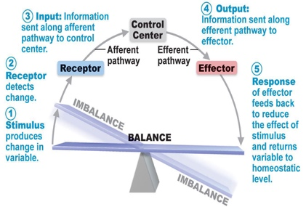
- Control center:
- determines set point that is the level at which variable is maintained
- analyzes information(input) and determines correct response
- goes from control center through efferent pathway to reach effector
- ex: control center wants to apply thermoregulatory center in brain in order to reduce the body temperature
- Effector:
- Carries control center’s response to stimulus
- provides means for response (output along efferent pathway) feedback (negative/positive) allows for regulation within a range/enhanced response such as reducing it in means of the control process to be shut off or enhancing it, so it will go as an even faster rate.
- Ex: in order for the body to reduce temperature, the control center activated sweaty glands (the effector)
- Negative feedback mechanisms;
- Mostly homeostatic are negative feedback
- Reduction in output shuts off original effect of stimulus thus reducing intensity; forcing the variable to change in an “opposite” direction of initial change
- output reduces or shuts off stimulus so you have two options
- hormone or neural pathway regulating a process: negative feedback decreases secretion
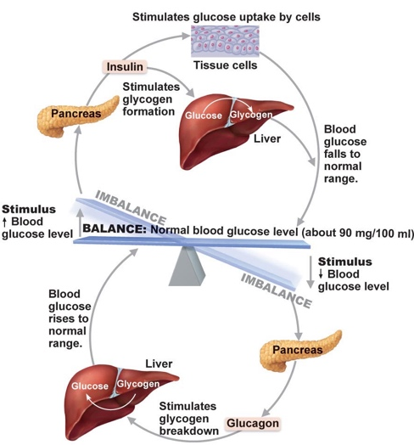
- Process regulated in opposite directions by 2 different hormones or neural pathways such as endocrine system and negative feedback
- Example: blood glucose control by insulin
Goal of negative feedback: prevents sudden, severe changes in
the body
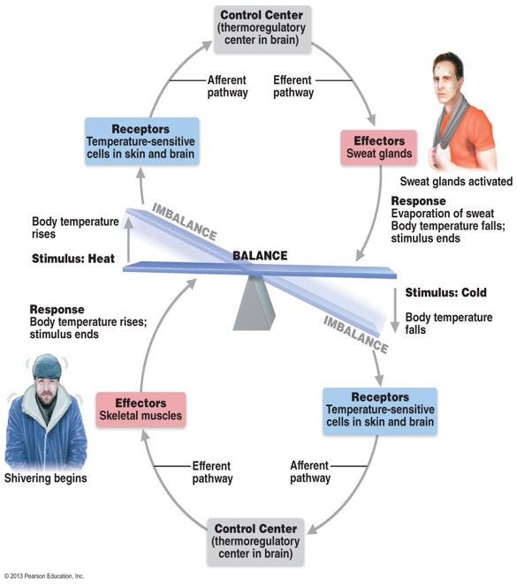
- Fig. 1.6: Regulation of Body Temperature by Negative Feedback

- Examples of negative feedbacks in our body: withdrawal reflex (pain and hand jerked once touched a broken glass), body temperature regulation, blood sugar regulation

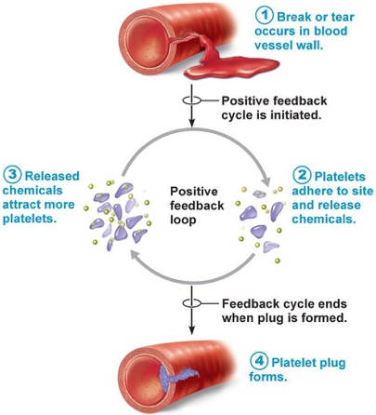
- Positive Feedback mechanism:
- Response of mechanism enhances original stimulus output is further stimulated
- Positive because change occurs in same direction as original response causing variable to deviate further
- Positive feedback occurs for situations that do not need constant adjustments
- There is a foal to be attained and has only local effects
- Example: contractions during birth and blood clotting; how is this still overall, maintaining homeostasis? Keeps stable the blood flow after one has been injured
- Known to run out of control that’s why happens less commonly than negative feedback
- Homeostatic imbalance
- Most disease seen as a disturbance in homeostasis which leads to a homeostatic imbalance
- Aging is associated with progressive decrease in our ability to maintain homeostasis tends for an individual to risk greater illness
- negative feedback is overwhelmed, and destructive positive feedback takes over (ex: heart failure)

Autonomic and Nervous system as a whole
- Auto=self and nom=govern therefore autonomy means self-govern
- Two subdivision: parasympathetc and sympethetic division (dual innervation meaning both are needed to balance the body
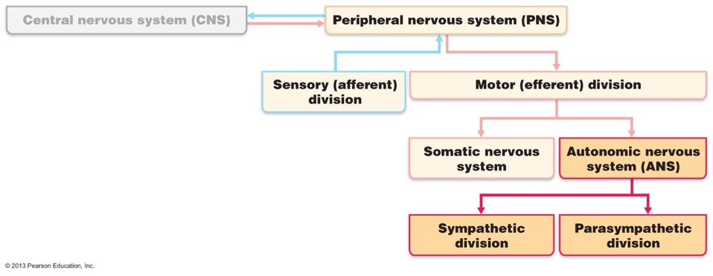
- Autonomic nervous system (ANS): system of motor neurons to smooth and cardiac muscle and glands to allow responses usually without our awareness
- Shunt blood to more needy areas
- Speed/slow heart and respiratory rates
- Adjust blood pressure and body temperature
Fig. 14.1
- Increase/decrease gastric secretions
Compare autonomic system to somatic nervous system

- Somatic(skeletal)
- Effectors: skeletal muscles
- Efferent pathways and ganglia:
- Motor fibers are thick, myelinated axon from spinal cord to skeletal muscle; rapid conduction of impulses (no ganglia)
- motor cell bodies are in CNS and axons are extend towards spinal and cranial nerves all the way to skeletal muscles which will be then be activated
- neurotransmitters effects:
- all somatic neurons release acetylcholine (ACh) at their synapses with skeletal muscle fibers
- giving the effect of always excit-atory
- ANS (visceral organs):
- Parasympathetic or sympathetic
- Effector: cardiac and smooth muscle and glands
- Two-neuron chain used to reach effectors:
- preganglionic neuron is originating in brain or spinal cord
- Preganglionic axon (which is preganglionic neuron’s axon) synapses with 2nd motor neuron (postganglionic)
- Postganglionic neuron has a cell body called autonomic ganglion which is find outside CNS. It’s axon, the postganglionic axon, extends to effector organ
- Autonomic ganglia are motor ganglia and are the sites at which synapse, and transfer of information occurs
- Conduction is slower compared to somatic;
- preganglionic axons are thin and lightly myelinated (in spinal or cranial nerves)
- postganglionic axons are thinner and unmyelinated (in spinal or cranial nerves)
- neurotransmitters: release two of them
- Norepinephrine (NE) by sympathetic
- Acetylcholine (ACh) by parasympathetic
- Autonomic and somatic can work together
- Example: Your skeletal muscle can be lacking oxygen to contract and need glucose therefore the autonomic control forces the heart to speed up its rate in order for homeostasis to be maintained.

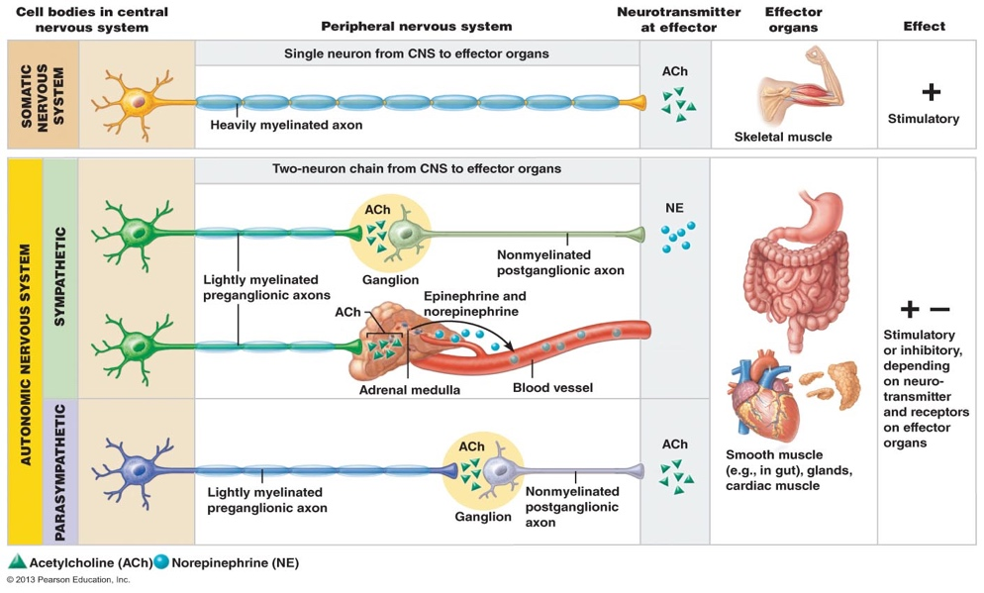

Distinguish between PNS and SNS in terms of the types of processes regulated
- Both serve the same visceral organs however have different effect
- Parasympathetic Division: maintains body energy and functions
- Active in non-stressful situations – also called “resting and digesting system”
- Keeps body’s energy use as low as possible while regulating “housekeeping” activities (like digestion, elimination of feces and urine)
- Why is it a good idea to relax after a meal: So that sympathetic activity does not interfere with digestion
- What are the predominate effects of the parasympathetic ns when reading a newspaper after a meal? Blood pressure and heart rate are regulated at low normal levels and GI tract is actively digesting food.
- “D” system: digestion, defecation, diuresis
- Exception: blood pressure at rest is not parasympathetic but sympathetic
- Sympathetic Division: mobilizes body during activity
- Also called “fight or flight” system:
- Response to excitement or emergency/threatening situations
- also important during exercise
- reactions are such as increased heart rate, rapid, deep breathing, cold sweaty skin, dilated eye pupils
- “E” system: exercise, excitement, emergency, embarrassment
Sympathetic tone and parasympathetic tone
- SNS and vascular tone:
- SNS dominates blood vessels
- Sympathetic fibers make blood vessels kept in a state of partial vasoconstriction called sympathetic/vasomotor tone; blood shunting possible via variations in sympathetic output to specific vessels
- Very low blood pressure, sympathetic fibers (vasomotor fibers) fire more rapidly; blood vessels will constrict and raises blood pressure
- Too high blood pressure, sympathetic vasomotor fibers fire less rapid and vessels dilates
- PNS and tone:
- PNS dominates heart and smooth muscle of digestive and urinary tract
- Organs mentioned exhibit parasympathetic tone
- PNS slows heart and dictates normal activity of digestive/urinary tracts
- PNS activates most glands except; adrenal glands and sweat glands of skin
- Tonic slowing effect on heart, regulation of contractile activity of smooth muscle of GI and urinary tracts – can be overridden by SNS
Systems regulated in opposite directions by the SNS and PNS
- Interactions of the autonomic divisions
- Most visceral organs receive dual innervation
- Antagonistic Interactions
- Mostly present for the activity of the heart, respiratory system and GI organs
 | PNS | SNS
Heart | Decreases rate (slows heart) | Increases rate and force of heartbeat
GI System | Digestion and wastes; Increases motility and amount of secretion, relaxes sphincters to allow foodstuff to travel in body easier | Inhibits digestion generally and elimination; decreases activity of glands and muscles of digestive system, constraints sphincters
Resp. System | Constricts bronchioles (bigger airway diameter) | Dilates airways (bronchioles)

- Cooperative Effects:
- Examples: regulation of external genitalia during intercourse
- PNS: dilation of blood vessels in penis
- SNS: ejaculation, reflex peristalsis of female’s vagina

Unique roles of sympathetic NS:
- SNS regulation only: adrenal medulla, sweat glands, arrector pili muscles of skin, kidneys, most blood vessels; trick to remember this most of us sweat under stress
- Thermoregulatory responses to heat; regulation of body temperature in term of constrict/dilate of blood vessels in response to heat
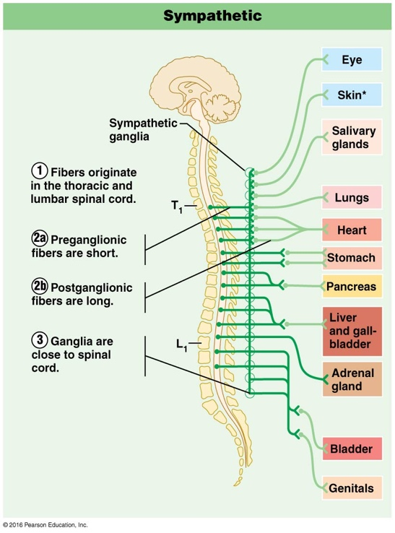
- Renin release from kidneys – result will be increased blood pressure
- Metabolic effects:
- Increases metabolic rate of body cells
- Raises blood glucose levels
- Stimulates mobilization of fats
- Increases mental alertness
- Increases speed/strength of muscle contraction
The PNS and SNS differs as to:
- Sites where nerves originate
- PNS fibers are craniosacral meaning they originate in the brain (cranium) and sacral spinal cord
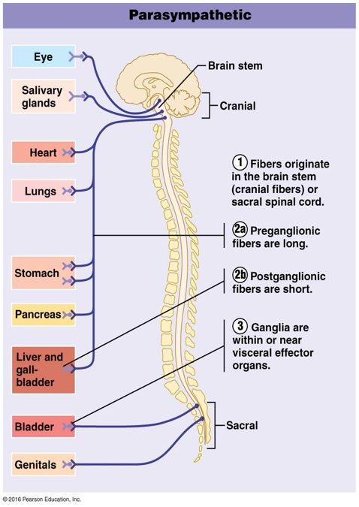
- SNS fibers are thoracolumbar meaning they originate in thoracic and lumbar regions of spinal cord
- Relative lengths of pre and post-ganglionic fibers
- PNS has long preganglionic and short postganglionic fibers
- SNS has short preganglionic fibers and long postganglionic
- Locations of ganglia
- PNS ganglia located in/near visceral effector organs
- SNS ganglia lie close to spinal cord
The 3 levels of regulation of autonomic function with examples
- ANS activity is regulated by CNS controls in the spinal cord, brain stem, hypothalamus, and cerebral cortex
- Brain stem and spinal cord controls
- Hypothalamus is the “boss”, but it seems brain stem and spinal cord exert a direct influence over ANS
- Significant direct effects on ANS-regulated activities
- Motor centres in ventrolateral medulla (ex: cardiac and vasomotor centers) regulates heart rate, blood vessels, GI, respiratory centres
- hypothalamic (integration centre of ANS) controls; stands on top of control hierarchy
- main integration center of the ANS
- Anterior regions are direct parasympathetic functions
- Posterior areas are direct sympathetic functions
- Hypothalamic centers exert their effects both directly which influences preganglionic motor neurons in the brain stem and spinal cord
- Hypothalamus contains centres to coordinate heart activity, blood pressure, body temp, water balance, endocrine activity; also centres that help mediate emotions and biological drives
- cortical controls aka cerebral cortex
- it was thought that ANS could not be voluntary, be in some cases it is possible
- Ex: meditation and biofeedback allow some conscious control over visceral activities
- Ex: during meditation, can lower heart and breathing rates, oxygen use, metabolic rate
- Biofeedback to improve management of migraine headaches, stress and cardiac function
Homeostatic imbalances of ANS
- Ex: hypertension
Two situations
- After surgery, patients are often unable to urine and bowel sounds are absent. What division of the ANS is affected by anaesthetic? Parasympathetic
- A risk factor for ulcers can be stress and the associated excess activity of the sympathetic nervous system. For example, one contributing factor to ulcers is a severe reduction in blood flow to the stomach wall. How is this related to sympathetic function? Blood vessels are controlled by sympathetic function
The endocrine (ductless-poured in bloodstream) system: influences metabolic activity via hormones
- (not neuro or synaptic communication but molecules being released such as hormones, tissues/glands into the blood stream and reached through diffusion which will take more time than neuro activity.
- Takes more time for a hormone to reach the location then the neurone but hormone is more effective as how long it will last than neuro messenger, hormones act over long distance and neuro via short distances
What is hormone?
- Chemical substance released into the ECF that regulates the metabolic function of other cells in the body
- They control reproduction, growth and development, maintenance of electrolyte and water and nutrient balance in blood, regulation of cellular metabolism and energy balance, mobilization of body defences
- Study of hormones: endocrinology
Remember
- Hormones: chemical substances released into the extracellular fluid into the blood stream and travels through blood or lymph to arrive to its particular location
- Hormones must bind to specific receptors to influence target cell function
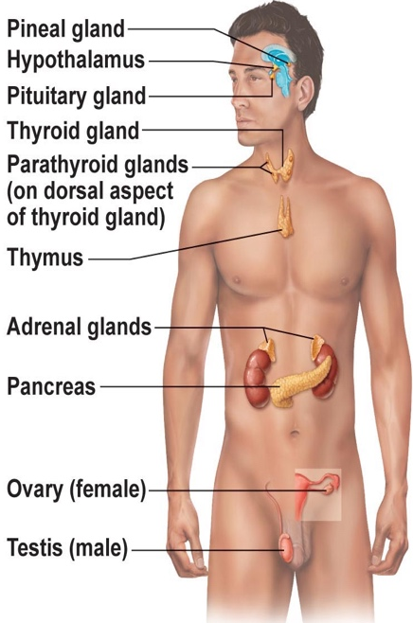
- Hormones are specific; level of target cell activation depends on
- Hormone concentration: how much of the hormone is coming in that target
- Target cell receptor content
- Affinity of hormone for receptor: how strongly is the receptor bind or attracted to the hormone to activate an appropriate reaction

*you should know the glands

A hormone produces one/more of the following changes:
- Hormones alter levels of cell activity (responses that could be regulated by hormones)
- Membrane permeability/potential by opening/closing channels
- Synthesis of enzymes within cells (regulating the rate of cell activity)
- Enzyme activation/deactivation (regulating the rate of cell activity)
- Induction of secretory activity
- Stimulation of mitosis (growth hormone; increase in size)
- structural groups of hormones
- Amino acids, peptides, proteins
- they all are water soluble and not lipid soluble, so need to bind on the surface of the cell) because they could not pass the plasma membrane
- source: all endocrine glands excepts from those of steroid hormones
- steroid hormones (derivatives of cholesterol)
- endocrine hormones that are steroid: gonadal and adrenocortical
- go right into the nucleus and regulate the rate of gene protection meaning are lipid soluble, could pass easily
- source: adrenal cortex, gonads, and thyroid gland
- eicosanoids
- not true hormones due to not influencing in long distant targets
- derivative from arachidonic acid
- include leukotrienes and prostaglandins
- leukotriene: signals for inflammation and allergic reaction
- prostaglandins: multiple effect like raising blood pressure and birth contractions, blood clotting…
Degree of target cell activation depends on 3 factors:
- Blood levels of hormone
- Relative numbers of receptors for that hormones on or in target cell
- Affinity or strength of the binding between the hormone and the receptor
2 main mechanisms of action
- peptide/protein hormones (water soluble hormones):
- act on receptors found on the surface of PM couple with second messengers by G-protein
- 3 components: hormone receptor, G protein and enzyme effector
- Hormone binds to its receptor in plasma membrane
- Known as the first messenger
- receptor will change shape once bind to hormone
- Receptor activates G protein
- Change in shape allows receptor to bind to G protein
- Binding of G protein to receptor causes G protein to activate
- How is G protein activated? GDP (guanosine diphosphate) is release from G protein and replaced by GTP (guanosine triphosphate)
- Note: GDP turns off G protein and GTP turns it on
- Activated G protein causes the activation of adenylate cyclase
- How? G protein moves along PM and binds to effector enzyme adenylate cyclase.
- Two types of G protein: “Gs” and “Gi”
- Gs activates adenylate cyclase and Gi inhibits it
- Once adenylate cyclase is activated, G protein is inactivated once GTP is hydrolyzed to GDP
- Adenylate cyclase converts ATP to cyclic AMP
- As long as Gs is bound to it, adenylate cyclase by converting ATP generates second messenger called cyclic AMP (cAMP aka calcium)
- cAMP activates protein kinases enzyme
- cAMP can diffuse freely in cell
- increase concentration of cAMP activates enzyme (protein) kinases
- activated protein kinases: phosphorylates (add phosphate group) a variety of proteins inside cell
- protein will therefore change activity which will generate cell’s response to hormone
- phosphorylation activates some proteins and inhibits others
- Steroid hormones (lipid soluble hormones like thyroid)
- Act on receptors inside cell which activates gene
- they diffuse through PM and then bind & activate intracellular receptors
- activated receptor hormone will make its way to nuclear chromatin to bind to a specific region of DNA
- exception: thyroid hormone receptors are already bind to DNA even if thyroid hormone is not existing
- binding of receptor hormone to specific region of DNA it activates a gene and initiates transcription of that gene (DNA) to produce mRNA
- mRNA translated in ribosomes which will generate specific protein and that will be synthesized so they could be exported from target cell
- It will take 6-12 hours in order to see an increase in protein production
Half-life, onset and duration of hormone activity
- Hormones are potent (big influencers even at low concentration)
- Hormones travel in blood freely (water-soluble hormones) or bind to plasma proteins for (steroid/thyroid hormones)
- Blood level of hormone depends on the (amount):
- Rate of synthesis at which it will be released
- Rate of degradation/clearance from blood (can be done by kidney/liver)
- Half-life: persistence of a hormone in the blood, usually more than a minute to a week
- Meaning the length of time for a hormone’s blood level to decrease by half varies from a fraction of a minute to a week
- Time to onset of hormone action variable:
- enzyme activation – rapid (minutes); some hormones provoke rapidly target cell
- enzyme synthesis – it takes hours to days for some hormones to provoke their target cell like steroid hormones particularly
- Some hormones secreted as prohormones (initial form of the produced hormone); are inactive but activated (binds more regularly to its receptor) once reach target cell
- Duration of hormone action also variable (hours to days)
- Limited: range from 10 sec to several hours
- Blood level drops, effect may disappear more rapidly
- All these 3 factors depend mostly on if the hormone is water soluble or lipid soluble.
Control of hormone release
- Synthesis and release of most hormones are regulated usually by negative feedback (setpoint);
- Stimulus triggers hormone secretion, level of hormone rises, effects target organ, then feedbacks to inhibit further hormone release. (hormone levels thus always vary)
- sometimes positive feedback (the goal)
- 3 types of stimuli: humoral, neural and hormonal (to know how)
- Humoral stimuli:
- Simplest endocrine control
- Hormone secretion in direct response to change in blood level of a nutrient, ion (ex: parathyroid hormone (PTH) and. Blood calcium; insulin and blood glucose
- Blood calcium hormone: monitored by parathyroid glands; as concentration of calcium lowers, they secrete PTH which will increase blood calcium
- Insulin hormone: released in response to high level of blood glucose
- Aldosterone hormone: released in response to low Na+ or high K+ blood levels

- Neural stimuli:
- Not as common, ex: sympathetic ns and epinephrine release by adrenal medulla, hypothalamic neurons and oxytocin release
- Nerve fibers stimulate hormone release
- Response to stress where SNS stimulates adrenal medulla to release norepinephrine & epinephrine
- Hormonal stimuli:
- Release of hormone in response to hormones produced by other endocrine organs
- Hypothalamus secretes hormones that stimulate the anterior pituitary gland to secrete hormones that stimulate other endocrine gland to secrete hormones
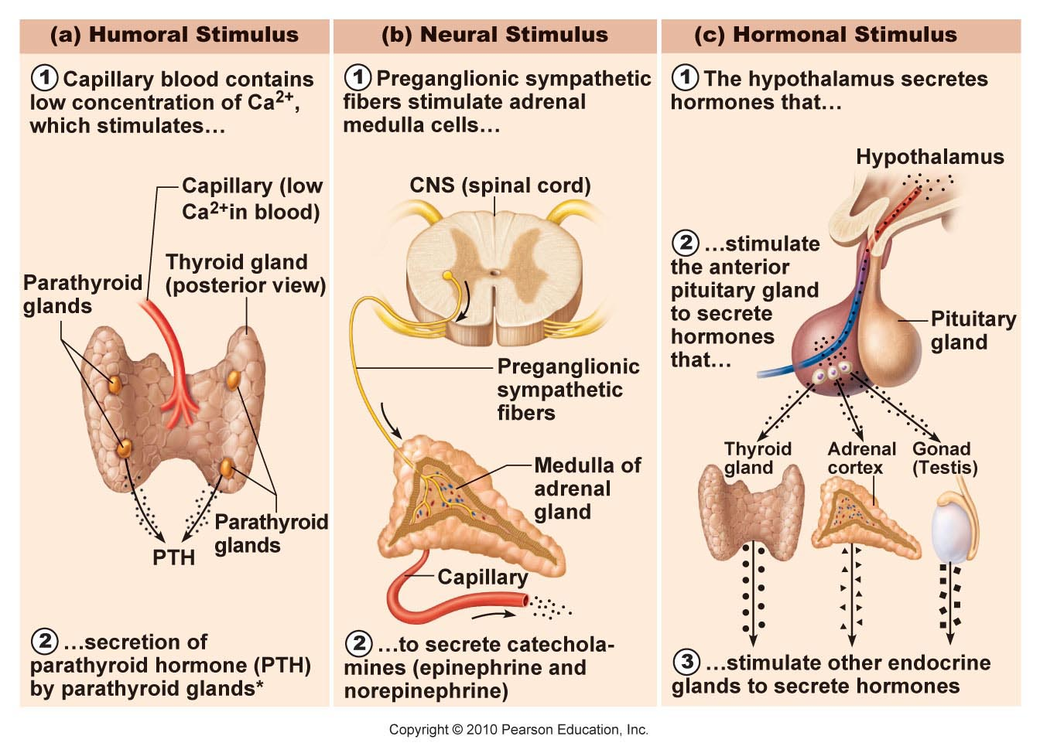
- 3-tiered system involving hypothalamus (1), pituitary (2) and target endocrine gland (3) – concept of hypothalamic pituitary axis

Hormonal Stimulus (continuity)
- Hypothalamus secretes neurone hormone Thyroid-releasing hormone (TRH)
- Then, TRH stimulates the anterior pituitary gland to secrete hormone called thyroid-stimulating hormone (TSH)
- TSH stimulate thyroid gland to secrete hormone such as Thyroid hormones (T3 and T4)
- Hypothalamus is neural; produces a number of releasing factors (hormones) which travel to anterior pituitary via hypophyseal portal system
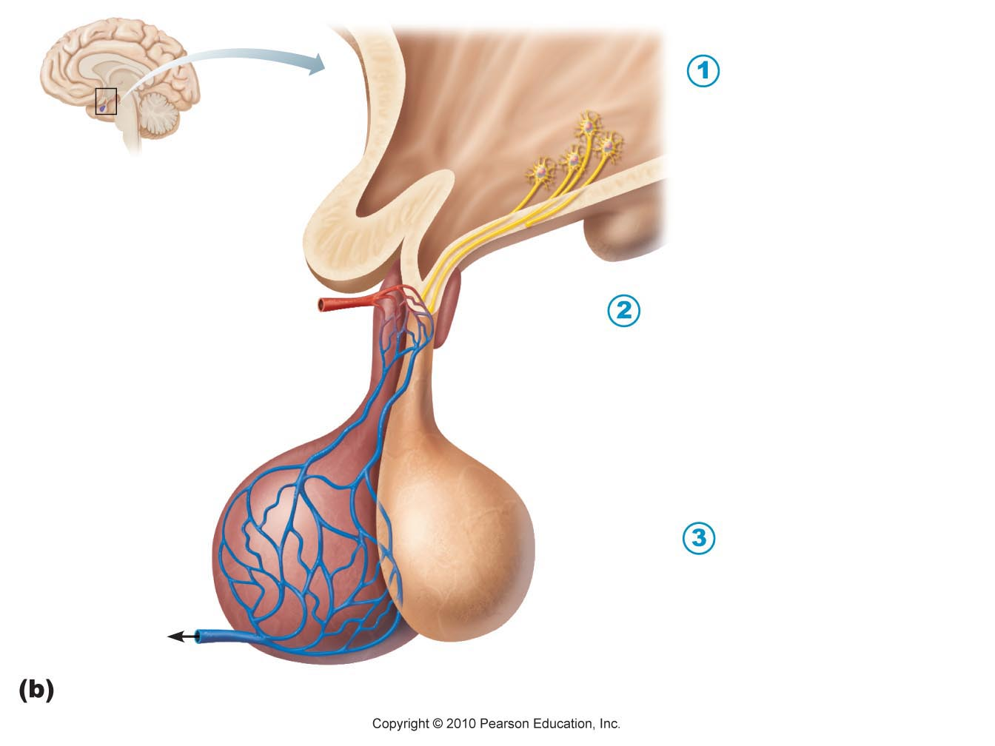
- What is a portal system? 2 capillary bed joined together; the hypothalamus and anterior pituitary in order to exchange hormones

Related to the figure
- hypothalamus: is the w form; it is formed of neuro tissue, it is a
infundibulum
neuro hormone but not a neuro transmitter
- Anterior lobe: the one with blood vessels
- Posterior lobe: the one with continuing neurons
- If there is an excess of thyroid hormones; negative feedback by toning down the rate of production
Pituitary gland:
- Secretes at least 8 hormones
- Size and shape of a pea
- Infundibulum connects pituitary to hypothalamus
Posterior lobe:
- Composed generally of neural tissue (pituicytes) and nerve fibers with axon terminals
- Releases neurohormones received from hypothalamus
- Hormone storage area and not a true endocrine glans that manufactures hormones
- Neurohypophysis: region covering infundibulum and posterior lobe
- Antidiuretic hormone (ADH – peptide from neurons in supraoptic nucleus of hypothalamus)
- Nuclei in hypothalamus
- Structurally similar, both are nonapeptides (composed of 9 protein); but very different in terms of functions
- Stimulate by impulses from hypothalamus in response to increased blood solute concentration or decreased blood volume, pain, drugs and low blood pressure
- Inhabited by adequate hydration of body and by alcohol
- Kidneys; this hormone makes kidneys absorb more water and return it to bloodstream giving a result to less urine therefore solute concentration of blood declines
- Hormone Oxytocin (PVN – peptide from neurons in paraventricular nucleus of hypothalamus), released during child birth mostly and triggers milk ejection form breast:
- Nuclei in hypothalamus
- Structurally similar, both are nonapeptides (composed of 9 protein); but very different in terms of functions
- Inhibited by lack of neural stimuli
- Stimulate by impulses from hypothalamus in response to stretching of uterine cervix or breast so therefore for muscle contractions
- Can be given in form of drug during child birth to stop post-bleeding
- Also acts as neurotransmitter involved in sexual and affectionate behaviour (known as cuddle hormone)
Anterior lobe
- Composed of glandular tissue
- Manufactures and releases a bunch of hormones
- Growth hormone (protein, somatotropin cells)
- To know the first row

To Summarize:
2 key homeostatic regulatory systems:

- Autonomic nervous system
- Sympathetic versus parasympathetic
- Sensory and motor neural pathways
- Fast response
- Endocrine system
- Hormones released into extracellular fluid and often travel to target organs via bloodstream
- Slower response time but response can be long-lived
- Different chemical classes of hormones with associated mechanisms of action
Blood (PPT2)
Blood Components:
- Only FLUID CT tissue in body (formed elements suspended in plasma aka nonliving fluid matrix)
- Connective tissue but lacks collagen & fiber
- Fibrin: Dissolved fibrous protein
- Formed elements:
- Erythrocytes or RBCs; no nuclei/organelles therefore not a true cell
- Leucocytes or WBCs: complete and true cells
- Platelets: cell fragments so not a true cell
- They mostly survive in bloodstream for a few days
- The cells do not divide, stem cells divide in red bone marrow to replace them
Physical Characteristics
- Colour is scarlet (O2-rich) to dark red where O2 is poor (what does make it more purple?)
- Denser and 5x more viscous than H2O; protein aka formed elements mostly erythrocytes in blood makes it viscous and not just plain water
- Slightly alkaline with a pH= 7.35 to 7.45;
- if it drops less than 7.35, blood thins and flows more rapidly
- you have an alkaline blood if your blood pH is higher than 7.45 meaning it will become more viscous and therefore low blood flow
- you have to keep it exactly in this range; no more no less
- 8% body weight (5-6 L for men and 4-5 L for women)
Functions
- Distribution aka transport
- Oxygen and nutrients: delivering oxygen from lungs and nutrients obtained from digestive tract to all cells
- Metabolic wastes: from cells like CO2 gases, have to get rid of it, and then kidneys to dispose wastes in urine
- Hormones: use bloodstream to get from endocrine organs to target organ
- Regulation
- Body temperature:
- distribution, conservation, dissipation (conserve or unloading heat by controlling where the blood is going into the body)
- maintain appropriate body temperature by absorbing and distribution heat to whole body
- central of our body will always be monitored but not in finger tips nor toes
- pH in body tissues (plasma proteins, bicarbonate reserve)
- 7.35 to 7.45
- Adequate fluid volume
- Protection
- Preventing blood loss; Platelets, plasma proteins (extra hydrogen ions to be dealt with) help to make blood clotting (bruising, bleeding in the brain or within a tissue
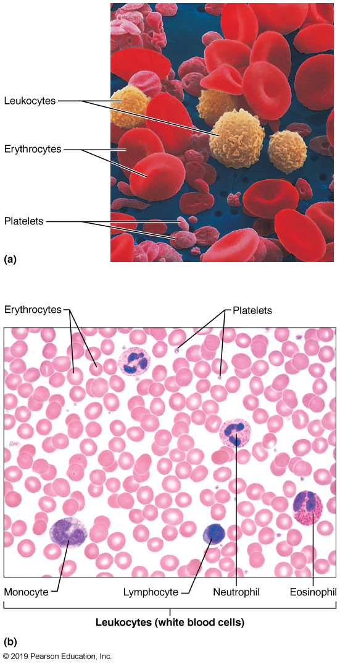
- Preventing infection; Antibodies, complement protein, WBCs (leukocytes)
Blood Plasma has
- Straw coloured; 90% water + many solutes
- Electrolytes; to maintain plasma osmotic pressure (pressure keeping
water in bloodstream), pH
- Plasma proteins (8%): albumin, globulin & fibrinogen
- Most plasma proteins are made by liver except for gamma globulins (antibodies) and hormones
- Albumin: 60% of all plasma proteins, carrier to shuttle certain molecules through circulation, major contributor to plasma osmotic pressure
- Urine: nonprotein nitrogenous substances
- Nutrients aka organic
- Gases and hormones
- Non-specific transporter, bound to a plasma protein such as albumin carrier of various molecules, important blood buffer, major osmotic protein
- What is the major osmotic ion? Na+
- Blood constantly adjusted by homeostatic mechanisms to keep its composition, pH within normal range and to keep enough water in our body
- Ex: drop in blood protein level, liver will then make more proteins
- Ex: acidic blood (Acidosis), both lungs and kidneys will restore slightly alkaline pH
- Erythrocytes (45%);
- red blood cells carrying oxygen
- hematocrit: percentage of blood fraction aka 45%
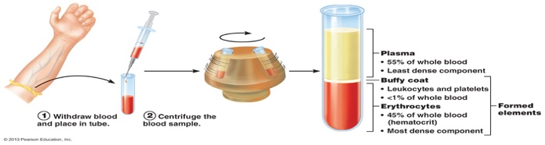
- Leukocytes & platelets (less than 1%): in centrifuge, it’s found between plasma and erythrocytes, a thin layer called buffy coat
Functional anatomy of an erythrocyte

- Erythrocytes:
- small cells, 7.5 um diameter; biconcave discs (no nucleus)
- have plasma membrane but no nucleus/organelles
- “bags of hemoglobin”; hemoglobin is RBC protein that functions in gas transport
- other proteins maintain PM, regulate cell shape, antioxidant getting rid of oxygen radicals
- Ex: spectrin – what is the function of this protein?
- To keep the shape (biconcave) of red blood cells; Once travelling through capillaries, they have to squeeze because it is passing through diameter smaller then theirs, so spectrin helps getting their shape back once rebounding
- Shape and reshapes RBC and twist and turns it if necessary
- Spectrin will break down once there would be so many breaking and rebounding
- Carries oxygen: picks oxygen in capillaries of the lungs and release it into cell tissues
- Transports 20% of CO2 released by cell tissues back to lungs
First image shows how the formed element was formed with hemoglobin, nucleus is no more needed and thus leaves in second diagram
- RBC transports O2 (First job) from lungs to tissues, transports 20% of CO2 back to lungs
- Co2 does not bound in the same bounding site as o2
Specialized characteristics that optimize function of erythrocytes
- Small size and biconcave shape make a large Surface area to Volume ratio compared to spherical shape
- Suitable for gas exchange because cytoplasm is close to surface
- More than 97% non-water composition is hemoglobin (to transport oxygen)
- They have no mitochondria; generate ATP anaerobically (it does not use oxygen just carry oxygen is not for the blood it’s for the body)
- Major factor contributing to blood viscosity; women have lower RBC count than men
- rate of blood flow inversely affected by RBC count
- hemoglobin = protein globin bound to red heme pigment (what makes RBC red) and which binds to oxygen
Structural organization of hemoglobin
- hemoglobin is made of red heme bound to globin:
- consists of 4 polypeptide chains (2 alpha & 2 beta) each binding to a red ring-like heme group; 4 different Fe in centre surrounded by a heme group
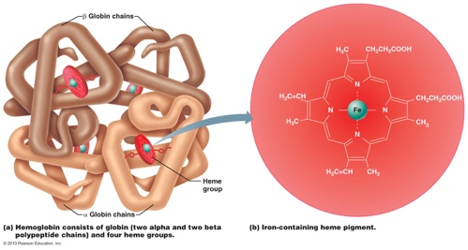
- Each Fe can reversibly bind one molecule of oxygen (so 4 per Hb molecule; a single RBC contains 250 million Hb molecules!!)
- Hb contained in erythrocytes
- Keeps it from fragmenting and being lost; to leak out of bloodstream
- Keeps it from contributing directly to osmotic pressure (draw water from tissue to bloodstream) and blood viscosity that’s why it is not in plasma
- oxyHb (oxyhemoglobin):
- once a blood not having oxygen reaches the lungs, oxygen diffuses from air saces of the lungs into that no oxy blood to reach a RBC and binds to iron in hemoglobin, once this happens the protein hemoglobin is called oxyhemoglobin
- it has a different shape (3-dimensional shape) and colour (ruby red) than deoxyHb
- deoxyHb (deoxyhemoglobin aka reduced hemoglobin):
- detachment of oxygen from iron in hemoglobin to reach tissues
- takes original shape of no oxy blood
- become darker red
- globin’s amino acid:
- 20% CO2 transported in blood combining to hemoglobin by globin amino acid and not to the heme like O2
- Carbaminohemoglobin: occurs when hemoglobin is in reduce state (dissociated from oxygen)
- Co2: travels from tissue to lungs and then eliminated from body
Production of Erythrocytes
- Hematopoiesis: production of blood cells
- Hema = blood & poiesis= to make
- occurring in red bone marrow
- That has a soft network of reticular CT
- Immature RBCs made of macrophages, fat cells, and reticular cells
- As blood cells mature, migrate through porous walls of sinusoid to enter blood
- Hematopoietic stem cell (hemocytoblast):
- Reside in red bone marrow
- stem cell for all formed elements, therefore cells become committed to a particular pathway (RBW, WBC or platelet) and cannot change afterwards
STAGES of Erythropoiesis: PRODUCTION OF RBCs (takes about 15 days)
- erythropoiesis: production of erythrocytes
- myeloid stem cell is derived from hematopoietic stem cell and will be transformed into a Proerythroblast that will be developed
- During two first phases: cells divides
- Phase 1: ribosome synthesis
- Phase 2: Hemoglobin accumulation
- From blue color of ribosomes to red color of hemoglobin transformation
- Phase 3: ejection of nucleus
- loss of most organelles and nucleus degenerates giving it the biconcave shape
- New and young erythrocyte is called reticulocyte due to still containing a bit of clumped ribosomes, becomes erythrocyte after 2 days of being called reticulocyte
- What is the difference between a reticulocyte and RBC? Reticulocyte will still have ribosome, but RBC won’t, but both of them lost their nuclei
- What would a reticulocyte count tell you? usually 1-2% of erythrocytes
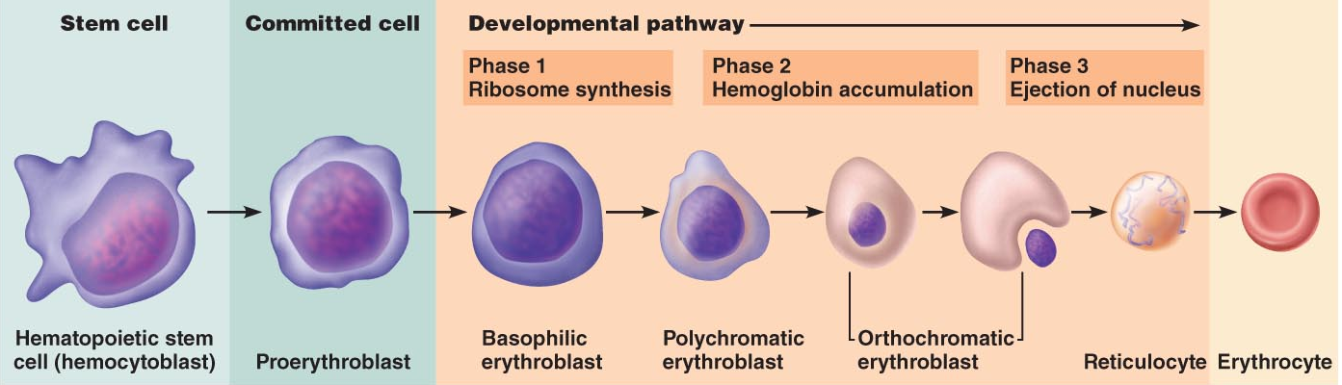

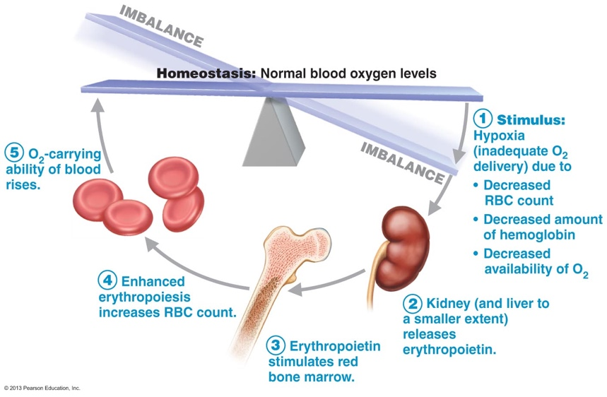
Regulation of Erythropoiesis:
- Balance between RBC production & destruction
- Too few RBC: leads to tissue hypoxia
- Which is oxygen deprivation (can be anemic)
- Decrease in RBC count
- Decrease hemoglobin & O2 availability
- Too many: makes blood undesirably viscous
- Ensuring number of erythrocytes in blood within homeostatic range
- Production rate: more than 2 million/sec if healthy (sufficient iron and B vitamins)
- Process controlled hormonally; adequate supply of Fe, amino acids and vitamin B
Hormonal Controls:
- Erythropoietin (EPO): regulates Erythropoiesis
- Drop in normal blood oxygen trigger EPO
- Due to bleeding (hemorrhage) or excessive RBC destruction, insufficient hemoglobin per RBC (iron deficiency) or reduced availability of oxygen (high altitude or pneumonia)
- Too many erythrocyte/oxygen in blood depresses EPO
- Erythropoiesis rate depends on their ability to transport enough oxygen to tissue
- EPO, Glycoprotein are produced in kidney as it is the major site of production and not liver
- Always some EPO in blood: additional release by kidney of hypoxia due to: Reduced RBC due to donating blood or major accident making you lose a lot of blood cell, if you don’t have the amount of oxygen necessary for that hemoglobin makes the problem or training program ask for major oxygen, your tissue will need more oxygen
- Hypoxia does not activate bone marrow directly; stimulates kidney that will provide hormonal stimulus (EPO) which he will activate bone marrow
- What is monitored and acts as a signal: the level of oxygen transport
- Erythropoietin: enhances maturation rate of committed RBC precursors (1-2 days to see results)
- Route of stimulation: hypoxia -> kidneys-> erythropoietin -> activation of bone marrow->more mature RBCs
Homeostatic Imbalance
- Renal failure patients: additional problem is lack of EPO (RBC counts can be 50% of normal); helped by recombinant EPO
- Athletes and EPO abuse: by injecting EPO to increase performance that rises hematocrit from 45% to 65%; but an increase in viscosity plus dehydration during race can -> clotting, stroke, heart failure
- What is the effect of testosterone on renal EPO production?
- Testosterone has a boosting on kidney’s Erythropoietin production than those of women.
- Could explain the reason why there’s more RBC count for men
- Therefore, an abuse of erythropoietin (making it higher); blood would be more viscous; so, you can have stroke, clotting, blood is concentrated and makes overall a dangerous situation for concerned individual
Dietary requirement (iron, B-vit)
- Material required for erythropoiesis:
- Nutrients such as amino acids, lipids and carbohydrates for synthesis of all cells
- Two B-complex vitamins; B12 and folic acid are also necessary for normal DNA synthesis.
- Deficiency in these leads to a malfunctioning in term of dividing cell and developing erythrocytes
- Iron: essential for hemoglobin synthesis
- Absorption of dietary iron controlled by body’s storage levels
- More than 65% of iron supply is already in Hb
- Rest is stored in liver, spleen, bone marrow (ferritin, hemosiderin)
- Free iron such as Fe2+ and Fe3+ are toxic
- Solution: iron ions stored inside cells as protein-iron complexes such as ferritin and hemosiderin
- Iron transported in blood loosely bound to transport protein transferrin
- Loss of iron: feces, urine, sweat for an average of daily loss of 1.7 mg (due to menstruation) for female and 0.9 mg for male
Fate/Destruction of Erythrocytes: Life cycle of red blood cells
- Mature erythrocytes become rigid, fragile with time; why? As they become old and not flexible, Hb begins to degenerate
- Useful lifespan: 100-120 days
- Spleen: “RBC graveyard” get trapped and fragment in smaller circulatory channels mostly those of spleen
- RBC are anucleate; cannot synthesize new proteins, grow or divide
- Macrophages destroy dying erythrocytes
- heme of that erythrocytes is split off from globin
- iron would be bound to protein ferritin or hemosiderin for re-usage
- heme group is degraded to bilirubin (yellow pigment) then release to blood while being bound to albumin for transport. Liver secretes it out
- protein globin: metabolized or broken down to amino acids and released into circulation
- Iron stored & reused; rest of heme degraded to bilirubin (what happens to this?) – eventually becomes stercobilin (caca) or urobilinogen (bilirubin secreted out by liver)
- Amino acids of globin party recycled; recycling of the iron but not of the ring
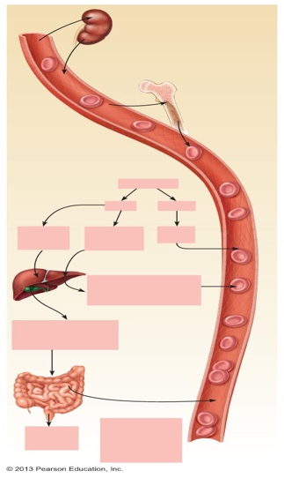
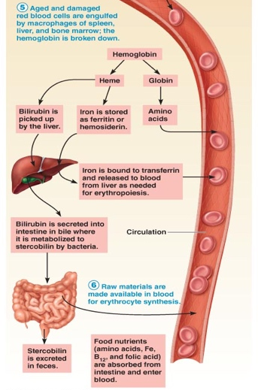
- To get rid of heme; happens firstly in liver, then GI tract, fiscis brown color because it is getting rid of the heme where iron is reused but not the ring

Anemia: disorder not a disease
- Condition in which blood’s oxygen-carrying capacity is too low to support normal metabolism
- Difference in normal RBC value; if you have less than require you have anemia, if the volume of plasma changes it does not matter, you do not have anemia
- Normal blood volume (plasma) & normal RBC volume: you are normal
- Low blood volume & low RBC volume: you have anemia
- A bit more than usual blood volume and low RBC volume: you have iron deficiency anemia
- High blood volume and normal RBC volume= non-anemic only volume is overloaded
- Tired, pale, short of breath, chilly
- causes:
- not enough normal RBCs produced
- deficiency in iron to complete red bone marrow (iron-deficiency anemia)
- formed literally complete erythrocytes which are paler colour called macrocytes, due to not being able to synthesis hemoglobin
- treat it by taking more iron intake diets
- pernicious anemia; old people where immune system destroys self-cell, have also microcytes and treated with vitamin B12
- renal anemia: caused by lack of EPO, inject EPO for treatment
- aplastic anemia: destruction/inhibition of red marrow by certain drugs/chemicals
- significant blood loss:
- hemorrhagic anemia where blood loss is rapid.
- Once problem fixed, erythrocytes go back to normal mechanisms
- RBCs too quickly destroyed
- hemolytic anemia: erythrocytes rupture/lyse prematurely because of mismatched transfusion or infection or hemoglobin abnormality due to genetics
- Thalassemias: sea blood people of Mediterranean ancestry
Sickle Cell Anemia
- Change in one of the 146 amino acids in a beta chain of globin molecule that causes abnormalities to heme then called hemoglobin S (HbS)
- Genetic disease where there was a mistake in translating the 6th coding position causing a dramatic shape of the blood
- Sickled erythrocyte results from a single amino acid change in beta chain of hemoglobin
- Sickle shape that looks like a “c” and is in a concave shape will get stuck in blood capillary and vessels which can lead to a stroke (recessive disease)
- Looks like this when they unload oxygen or when oxygen content of the blood is low ex: exercise can cause this or any high metabolic rate
- Treatment: blood transfusion, HbF, HYDROXYUREA
- Consequences: patient seeks for air (Africans)
- Malaria could not resist this type of blood
- It’s alright if you are a carrier, but if your partner is also one, this can cause your child to have sickle cell anemia
Polycythemia:
- Excess in erythrocytes that increases Blood viscosity
- Danger is blood volume is too viscous, so you could have heart problem or clotting because of having a high number of red blood cells
- Treatment: to remove some blood by “therapeutic phlebotomy)
- Polycythemia vera: bone marrow cancer (high RBC and dizziness)
- Secondary polycythemia: as a result of less oxygen available or EPO increase production (for people living in high altitudes)
- Artificial polycythemia: blood doping (creating polycythemia by removing blood that triggers EPO and infusing blood back in your body
Platelets
- Cytoplasmic fragments of large cells called megakaryocytes meaning “big nucleus cell” that produces platelets
- Blue staining outer region and inner contains purple-staining granules that contain clotting factors and enzymes such as serotonin, Ca2+, ADP and platelet-derived growth factor (PDGF)
- Responsible for clotting process in plasma when blood vessel is ruptured
- Anucleate:
- Lifespan of approximately 10 days due to not having a nucleus
- Platelet formation regulated by hormone thrombopoietin
- Hormone to regulate process, from the liver and starts from stem cell and causes to go through the blood pathway
- 150,000-400,000 platelets/μl blood
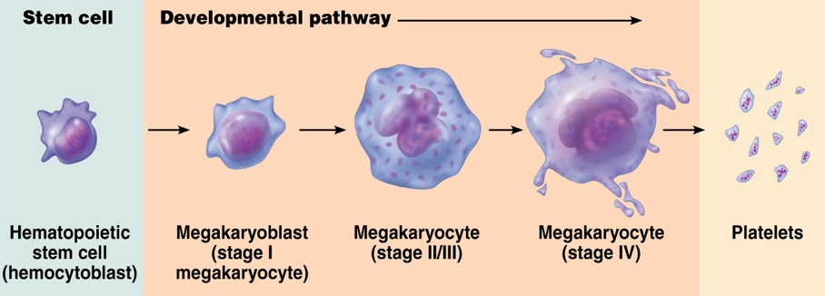
- cells we don’t want them to do anything, but we need them to activate quickly whenever we injure ourselves
- Stage 1: megakaryoblast mitosis
- Stage 4: large cell with huge nucleus

- After developmental pathway, megakaryocyte presses against a sinusoid and sends cytoplasmic throught hat sinusoid into bloodstream where it will release patelets
Hemostasis: formation of blood clot where stasis means halting
- Formation in 3 phases
- Vascular spasms:
- vasoconstriction of vessel in response to damage
- slows down blood flow in response to the area of damage, pathways towards pain in attempt to decreases the amount of blood released from body during injury
- triggers vascular spasm: damage, chemicals from endothelial cells & platelets, pain reflexes
- Purpose? Damage itself triggers chemicals to signals these to go slow down the blood flow
- formation of platelet plug:
- cells loosely sticking to each other but not as strong
- usually platelets do not stick to each other or to endothelial linings
- NO & PGI2 (prostacyclin):
- Produced by endothelial cells where they make hormones to stop activation of blood clotting which will inhibit platelet aggregation
- Why is this important? Chemicals that interfere in order that they don’t stick to one another in order for blood to be free to flow in undamaged tissue
- Exposure of collagen activates platelets to swell, become spiky & sticky -> adhere to exposed collagen (a large plasma protein called von Willebrand factor) bounds a bridge between collagen and platelets-> degranulation where platelets once activated release by vesicles ADP & SERETONIN…
- Release of chemicals once platelets are activated:
- ADP: enhances aggregation (vascular spasms) and degranulation (helps to make platelets sticky and release of granules – positive feedback)
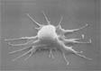
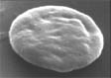
- Serotonin & thromboxane A2 (proxty gladend) positive feedback – enhance vascular spasm & platelet aggregation

- coagulation:
- formation of thin fiber (FIBRIN THREAD=MOLECULAR GLUE)
Resting platelet
Activated platelet
- attach everything to one another
- seen on surface of your body and inside blood vessel
- involves clotting factors or procoagulants

Differentiate between the intrinsic and extrinsic pathways for formation of prothrombin activator (conditions and relative speed of each pathway)
- Two pathways in making fibrine; know the enzyme
- No need to know all the details but rather why we have two pathways and in which situation one is more useful than the other
- Both have the goals to get to prothrombin activator but once got there, catalyzing phase 2-3 where clot forms are done in 10-15 sec
- Calcium is important in formation of clotting
- Intrinsic pathway: called intrinsic because factors needed for clot are present within blood
- Triggered by negative charge
- Someone with high blood pressure, little damage on vessel wall but with time it be fixed;
- blood sample taken from a patient because the plastic tube will slow down the rate of prothrombin activator for blood clot formation
- Clotting of blood outside body (in a tube for example) or in slightly damaged vessel – slower pathway to factor X and PA
- You don’t need anything from outside of vessel, reaction is so much slower
- Extrinsic pathway
- Faster pathway to factor X (10) and PA (prothrombin activator)
- For serious trauma where right into the vessel there is damage
- Triggered by exposed blood to factor TF/3 found on cell in tissues surrounded by blood vessel
- Clotting of blood associated with body & blood vessel damage that causes release of tissue factor which leads to bypassing many steps of intrinsic pathway
- You need tissue factor (TF or FACTOR 3)/damaged tissue, so you will need stuff from the outside
- Phase 1 finishes with formation of prothrombin activator
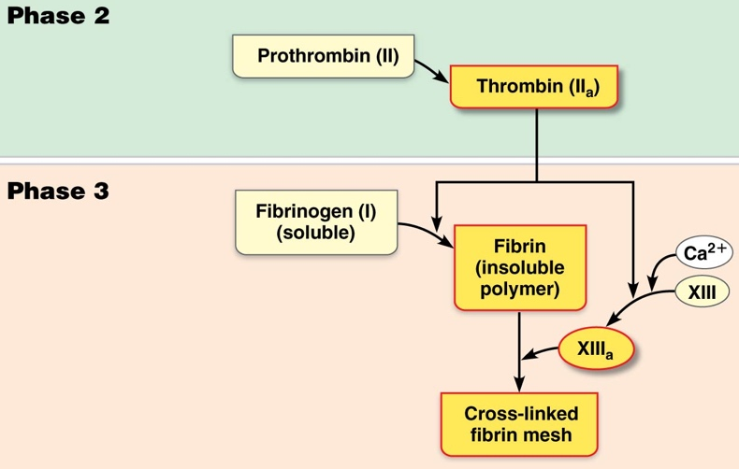
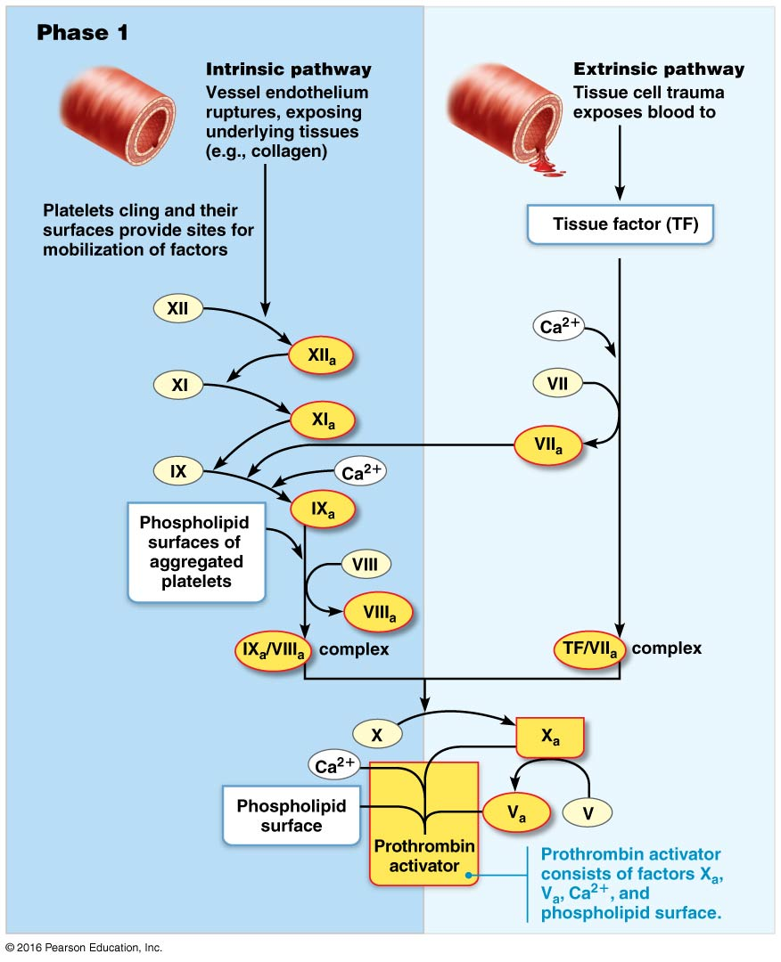
- Phase 2: prothrombin activator makes plasma prothrombin into active enzyme thrombin

Coagulation
- Blood transformed from a liquid to a gel because of fibrin
- Fibrin is the main base of clot and traps formed elements that try to get out
- Creation of fibrin mesh once phase 3 is getting done, which traps blood cells so it could get repaired the blood vessel
- 3 phases
- Prothrombin activator formed (end of phase one- enzyme activation)
- Prothrombin activator makes Prothrombin to thrombin (enzyme activation) phase 2 called common pathway to thrombin
- Thrombin transforms fibrinogen to fibrin; Fibrinogen molecules -> fibrin mesh (we get the clot)
- Also, there are many procoagulants (factors that make formation) & anticoagulants (stops formation for not useful blood clot); the latter predominate in an intact vessel
- Phase-3: common pathway to fibrin mesh
- Calcium ions activates factor 13 which binds fibrin mesh tight to each other
Clot retraction and repair
- Occurs within 30-60min; platelets contract (contain actin and myosin) & exerting pull-on surrounding fibrin strands which leads to next point
- Serum squeezed from clot and ruptured edges of blood vessels closer to each other
- PDGF (platelet derived grow factor) released during degranulation by platelets stimulates smooth muscle cells & fibroblasts to divide & rebuild vessel wall
- (VEGF = vascular endothelial growth factor): endothelial cells multiply to fill gap in lining
- Serums and plasmas are different
- Plasma sits on top
- Serum is the plasma minus the clotting factors
Fibrinolysis (lysis of fibrine threads): know the steps
- Removal of clot when no longer needed
- Key fibrin digestive-enzyme is plasmin produced when plasminogen (plasma protein) is activated– plasminogen is activated by tPA (tissue plasminogen activator] released by endothelial cells (x 12 and thrombin could also)
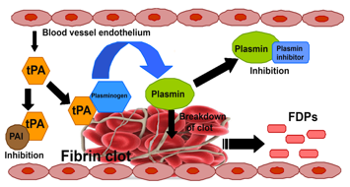
- Begins within 2 days and continues until clot is dissolved
Factors Limiting Clot Growth/Formation
- 2 homeostatic mechanisms prevent huge unnecessarily clot
- Swift removal of coagulation factors
- Inhibition of activated clotting factors
- Clot formation requires concentration of [pro-coagulation factors] to be higher than anticoagulation factors
- What limits concentration of where clotting is not necessary
- Normally flowing blood washes away procoagulants
- As thrombin forms, it is absorbed onto fibrine threads (which limits clot size) – fibrin acts like an anticoagulant and therefore clot would not be expand
- Protein Antithrombin III (in plasma) inactivates any escaping thrombin that did not bound to fibrin
- Antithrombin III & protein C (liver cells) inactivate many intrinsic pathway procoagulants if they are getting in area that clotting is not necessary
- Inhibits intrinsic pathway
- Heparin (anticoagulant in basophils & mast cells) – inhibits thrombin by enhancing activity of antithrombin III (which keeps unnecessary clotting from forming)
- Inhibits intrinsic pathway
- Smooth endothelial lining of undamaged blood vessels (also endothelial-derived heparin & prostacyclin)
- Platelets are prevented from clinging and piling up
- Secretion of antithrombin substances from endothelial cell prevent platelet adhesion
- To keep the victim unaware of its presence, these leeches secrete an anesthetic (painkiller) to numb the skin while biting. H. medicinalis also produce a potent anticoagulant, Hirudin, to keep blood fluid during feeding.
- Eating only twice a year, these leeches will ingest 10 to 15 mL of blood causing them to bloat to as much as 11 times their original body size.
- Clotting is dangerous for old people and people who do not have healthy vessels or do none or less physical activity
Thromboembolytic conditions: undesirable intravascular clotting (aka clotting happening when where you don’t have injury which the clot will be dissolve by tissue plasmin)
- Thrombus: clot that develops and persists in an unbroken blood vessel – can block critical blood circulation to those tissues
- Embolus: a thrombus which has broken free from vessel and floats in bloodstream can get stuck in a vessel of small diameter (ex: pulmonary or cerebral emboli)
- Embolism: obstructing the vessel
- Can cause stroke
- Anticoagulant drugs such as tPA, streptokinase to dissolve clot
- Aspirin (inhibits thromboxane A2 formation), heparin (injected), Warfarin & direct oral anticoagulant to reduce risk of stroke
- What might promote thrombus formation in an unbroken blood vessel? Status of blood flow so blood stays there for a long time, hypertension
- Why is aspirin a good preventative therapy in heart attack risk patients?
- Makes blood thinner, dilutes blood making it more watery than high viscous
- If you have low aspirin it will interfere with blood clot which inhibits thromboxyn A2, that had to keep unnecessary blood clot from forming
Bleeding disorders:
- Interference with normal clotting: thrombocytopenia, liver disorders, hemophilia
- Thrombocytopenia
- -penia means less than normal, lower of normal number concentration of platelet;
- happens for people going through chemo): they will have a massive bruise for just a small damage because it will take more time for them to create clot
- any condition harmful to red bone marrow (malignancy, radiation, drugs)
- any movement leads to bruising (internal hemorrhage)
- platelet count is less than 50,000/ul
- whole blood transfusions provide temporary relief
- Impaired liver function
- Liver unable to synthesize usual supply of clotting factors
- Severe bleeding occurs due to vitamin K deficiency that was the way clotting factors would be synthesize
- Liver could not produce bile to absorb fat & vitamin K
- hepatitis, cirrhosis (liver is source of procoagulants which could not be produced)
- Liver disease also associated with reduction in bile production; bile needed to absorb vitamin k, why?
- Hemophilia:
- Men have the disease, but woman are carrier
- Hereditary bleeding disorders;
- hemophilia A (83% of cases); deficiency in factor VIII (8)
- hemophilia B; deficiency in factor IX (9)
- hemophilia C; less severe and lack of factor XI (11)
- both sex-linked conditions
- requires transfusions/injections of fresh plasma purified of clotting factors; can kill because they can’t blood clot at all
Components of ABO and Rh blood group systems
- body compensates for some blood loss by:
- vasoconstriction to decrease blood vessel volume
- increased rate of erythropoiesis
- loss of 15-30% -> weakness, pallor; loss more than 30% can induce shock (so more adequate blood goes to the brain)
- whole blood transfusion: substantial blood loss or thrombocytopenia; packed red cells for anemia
- donor blood mixed with heparin (Ca2+ chelator which is needed for clot to not form once your blood is out of your vessel, anticoagulant)
- can be stored several weeks at 4 degree Celsius
Human Blood Groups
- transfusion of incompatible blood can be fatal
- RBC antigens (glycoproteins) promote agglutination (clumped together or destroys)
- Only the ABO and Rh antigens cause serious agglutination problems during transfusion
- Performed antibodies called agglutinins; newborn blood has no agglutinins (begin to appear within 2 months; peat at 8-10 years, slowly decline with age
ABO blood groups
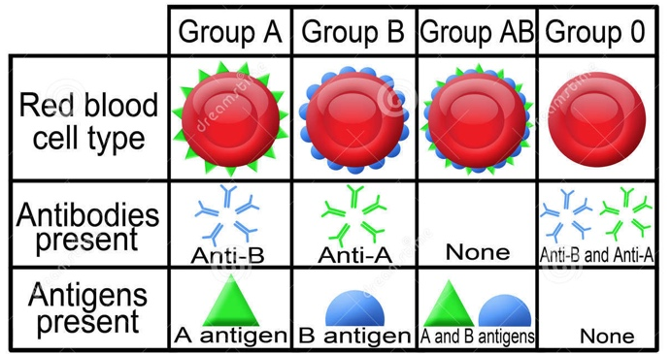
- Why is type O the universal donor?
- No antigens so no antibodies will be created
- Why is type AB the universal recipient?
- Which blood type is most common? Type O
- Least common blood type? Type AB
- Best to get blood from the same category as yours
Rh Blood groups:
- At least 8 different types of Rh factors (only C, D & E are fairly common)
- Rh D first identified in Rhesus monkeys, then in humans (85% north Americans Rh+)
- Means Rh factor on their blood cell, would therefore not have antibodies to Rh factor
- Rh antibodies NOT spontaneously formed in blood of Rh- individuals
- They become sensitized upon first exposure to Rh antigens (transfusion, Rh+ fetus) it will lead antibodies attack donor RBCs in response to second & subsequent exposures
- Rh- mothers carrying second Rh+ fetus treated with RhoGAM (anti-Rh serum) to prevent erythroblastosis fetalis
- Rh- woman carry first child with rh+ = healthy deliver; mother will create rh antibodies meanwhile
- Second baby dies
- Rhogam: serum containing anti-rh antibodies
Transfusion Reactions: Agglutination & Hemolysis
- Problem is recipient’s agglutinins (antibodies), not donors. Because recipients plasma antibodies attack the donor’s red blood
- Agglutination: clogs small blood vessel
- Clumped RBCs rupture or are destroyed (lysed) by phagocytes & Hb released
- Overall result:
- Blocked flow to tissues
- Reduced O2- carrying ability of blood
- Hb precipitates/clogs kidney tubules which can lead to possible kidney failure
- Also: fever, chills, nausea, vomiting, general toxicity – critical to prevent kidney failure by administering alkaline fluids to dilute and dissolve Hb; also, diuretics
- Treatment: to prevent kidney damage by administering fuif and diuretics to increase urine output and washing out Hb
- Autologous: transfusion (ex: 1 unit/4 days up to 3 days before surgery)
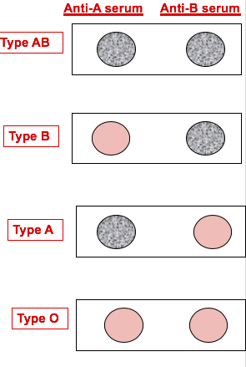
- Saving up your blood before surgery to use the same blood for transfusion after surgery (use your own blood)
Blood typing
- Use serum containing anti-A or anti-B agglutinins
- Similar procedure for Rh factor typing (precipitation forming is Rh+)

