What is Prejudice?
- Canadians showed the least prejudice towards Muslims, 75% of Canadians found they make a POSITIVE contribution to Canada
- Canada came across as the least prejudiced towards 15 different groups when compared to US, Britain, Germany
- Prejudice: A hostile or negative attitude toward people in a distinguishable group, based solely on their membership in that group
- Prejudice: is an attitude - affective, cognitive, behavioural component (attitudes)
  - Affective Component
    - Can involve either +/- affect
    - We will define prejudice as a hostile or negative attitude toward people in a distinguishable group, based SOLELY on their membership in that group
    - Racial and ethnic identity is a major focal point for prejudiced attitudes
    - Evidence that prejudice toward Canada's aboriginal people is on the rise
    - Even prejudice against subgroup of white ppl is on the rise - Newfie jokes
    - Canadians are more prejudiced toward homosexuals than Muslims
    - Research has shown people recommended harsher punishments for murder if the perpetrator was a 40-year-old man rather than a 20-/60- year old man
    - Prejudice/discrimination against overweight/obese is on the rise in many countries including Canada
      - Stereotyped as lazy, unhealthy, unattractive
      - Weight bias is so blatant that it is referred to as the "last acceptable form of discrimination"
    - Researchers found that immigrant youth in country fare best when they retain a sense of their own cultural identity as well as develop an identity as Canadians
      - Other studies found multiculturalism is beneficial for people who come to this country
      - Study:
        - Students were high and low in prejudice exposed to info on the merits of multiculturalism (i.e. Each ethnic group within Canada can contribute in its own unique way)
        - Other students did not receive pro-multiculturalism info
        - All participants sent and received written msgs from aboriginal student whom they expected to meet (none of participants were aboriginal)
        - Low prejudice students contemplated benefits created more warmth in messages than low-prejudice who did NOT receive this msg
        - Promoting multiculturalism seems to backfire for HIGH-PREJUDICE participants - communicated less warmth compared to those who did not receive message
        - Found that participants exposed to merits of multiculturalism felt that there were greater differences b/w themselves and Canadians who are of a different colour than did participants in control condition
        - Might be more effective to promote similarities between groups than to highlight differences
        - Recent research found that it can be positive for groups to be able to retain their own identity as long as they can also see themselves as part of a larger inclusive group
  - Stereotypes: Cognitive Component
    - Stereotype: a generalization about a group of people in which identical characteristics are assigned to virtually all members of the group, regardless of actual variation among the members. Resistant towards change once formed.
      - Most likely to be held for social groups (i.e. racial/ethnic) rather than other groups such as jury members or cast of play
    - Walter Lippman (first to intro stereotype) described the distinction b/w the world out there and stereotypes as "the little pictures we carry around inside our heads"
    - Researchers show Americans and Canadians have similar personalities
    - Stereotypes associated with different ways of addressing people (i.e. Ms. = more competitive/independent/less warm & nurturing than those titled Miss or Mrs.)
    - Stereotype does not always lead to negative or harmful behaviours - just to simply the world
      - "The law of least effort"
      - Allport said it was too complicated for us to have a highly differentiated attitude about everything. Instead, we maximize our cognitive time and energy by developing elegant, accurate attitudes about some topics, while relying on simple sketchy beliefs for others"
    - Stereotypes of gender: Stereotypes exaggerate differences b/w sexes, ignore differences in personality traits and ability WITHIN each gender and oversimplify
      - "Women are more talkative study"
        - Wired up a sample of men and women w/ voice recorders to track convo during daily life. Was no significant difference in # of words spoken. Large individual differences among the participants
    - Researchers found that around the world, sexism against females takes two basic forms: hostile and benevolent
      - Hostile sexists: hold negative stereotypes of women: Women are inferior to men b/c inherently less intelligent, etc.
      - Benevolent sexists: hold positive stereotypes of women - women are kinder, more empathetic
        - Tend to idealize women romantically, may admire them as wonderful cooks, mothers. Etc. Patronizing. Doesn't seem like prejudice to many people, but it is.
      - Both are apparently demeaning to women, b/c benevolent assume women are weaker sex
      - Found that for men, people find them more hostile and predatory than women, but reflects gender inequality and prejudice against women by characterizing men as being naturally designed for leadership dominance
      - Study found that male-dominated jobs contain more stereotypically masculine words than advertisements for female-dominated areas
        - Presence of stereotypically feminine words did not differ for male- and female-dominated occupations
        - Ppl perceived that there were more men in occupations which were advertise using masculine wording
        - High degree of agreement on the gender associated with various jobs
          - 100% of male participants indicated that a crystal/china clerk would be female
          - 94% perceived that an automotive magazine editor to be male; 100% of female participants perceive da home economics teacher to be female
          - Participants also assigned higher salary to male jobs than female jobs
          - Found that when jobs were advertised using masculine wording, women were reluctant to apply - not because they felt they did not have the requisite skills for the job but because they felt that they would not belong in the work environment
          - Conclusion: wording of job ads in terms of gender steroetypes has the subversive effect of maintaining gender inequality in our society
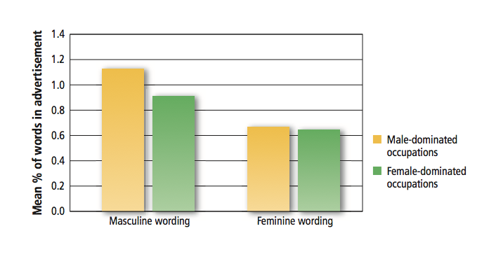
- Second study found young children associate dolls and doll houses with girls, and trucks, cars and tools with boys
  - Children aged 5-11 played a computer game in which they pretended to be Santa giving toys such as dolls/trucks to others
  - When told that Sarah wanted a doll and Marc wanted a truck, they were much faster at "delivering" the toys than when they were told that Pierre wanted a doll and Isabelle wanted a truck
  - Research has also shown that children face ostracism and ridicule for behaving in counter-stereotypic ways - especially boys
- Discrimination: The Behavioural Component
  - Unjustified negative or harmful action toward a member of a group simply b/c of his or her membership in that group
  - Landlords were more likely to claim that the accommodation was unavailable when they believed the caller was gay or lesbian
    - Landlords were 5x more likely to say unavailable when mentioned that he/she had aids
    - If mentioned living in a women's shelter, landlord was 10x more likely to say not available
    - Aboriginals face it too show up for showing then landlord says not available after all
      - White friend went and it was shown to her
      - If Abs find a place to live, they were more likely to exp unfair evictions & demands for sexual favours from landlord
  - School setting discrimination
    - Asked teachers of elementary school to place students in remedial to advanced program
    - The same academic record received a lower placement recommendation when it contained info that the student was of Aboriginal ancestry
    - Those who were homophobic also expressed less commitment and willingness to help students who were non-heterosexual
  - Found that in US, UK, Canada there were more photographs of male players than female players
  - Fat people are often targets of jokes, harassment and humiliation
    - People want to interact less with fat people
    - People high in anti-fat prejudice were more likely to support a policy denying medically necessary surgeries to overweight people
  - In Canadian courts, black defendants still receive harsher sentences than white defendants
  - Aboriginals make up only 4% of Canada population but represent 22% of inmates
  - In Prairies, 46% of prison is aboriginal

Modern Racism and Other Implicit Prejudices
- Modern racism: outwardly acting unprejudiced while inwardly maintaining prejudiced attitudes
  - Includes more than specifically racial prejudices
  - Implicit prejudice revealed if alone or drunk, etc.
  - Study
    - Showed that participants rated ethnic groups much more positively when experimenter was in room than alone or internet
    - When experimenter present, participants rated various out-groups even MORE positively than their own group to show how unprejudice they were
  - Study
    - Showed white students videotape of a black person and white person making speeches
    - When performance was poor, participants attributed more negative characteristics to the black speaker than to the white speaker
    - When the speakers performed well, participants bent over backward to show that they were not prejudiced and rated the black speaker even more positively than the white speaker
- Measuring Implicit Prejudices
  - Implicit Association Test: measures speed of people's positive and negative associations to a target group
    - i.e. if whites take longer to respond to black faces associated with positive words than to black faces associated with negative words, it must mean that whites have an unconscious prejudice towards blacks
    - Millions of people of all ages and walks of life have taken the test
    - The implicit bias it uncovers is related to how people actually behave in various situations - i.e. whether they find whites or black trustworthy - willing to invest money with them in a project or nah
    - Ther'es controversy - some people concluded that IAT does not measure emotional evaluations of the target, but rather the SALIENCE of the word associated with it - how much stands out
      - Negative words attract more attention in general)
    - Some argue IAT isn't assessing true prejudice but rather picking up a familiarity effect - we are more familiar with faces of people from our own race than other races
    - Another down side of using IAT to measure prejudice
      - Had white participants categorize pictures of white and aboriginal people
        - Control: either put pictures of insects and flowers into categories or did not complete an IAT
        - Later, all participants engaged in some interaction with an aboriginal person
        - Convo partners (aborg.) felt that they were viewed LEAST positively by white who had completely racial IAT
        - Follow-up study showed white participants who completed racial IAT self-disclosed less than participants in control conditions
        - Concludes that racial IAT may actually make people aware o f their prejudices, causing them to be more uncomfortable and less friendly when engaging with a member of the other race
    - People have found ways to combat some criticisms
      - Methodology in which images (black/white faces) are presented for brief duration
      - Rate pleasantness of of a neutral stimulus that appears on the next screen
      - People who are prejudiced rate the neutral stimulus as less pleasant when it is preceded by black face than white
    - Another study to access prejudice
      - Told to study memory associations
      - Homosexual and heterosexual words were displayed on a computer screen - either pull he word toward them with mouse - making words larger or push them away (making them shrink/disappear)
        - High in prejudice towards homo were likely to push away than low prejudice
        - People are required to respond EXTREMELY quickly; because there isn't time to control their responses, people's true attitudes come through
      - Nearly 2/3 of participants endorsed the modern SUBTLE prejudiced item "Aboriginals people should not have reserved placements in university"
        - But less supported a more BLATANTLY prejudiced item
        - Members of the general public expressed more prejudice than uni students
    - Neosexism Scale - assess sexist attitudes in a subtler manner
      - Asks respondents to indicate how much they agree with statements such as "Women will make more progress by being patient and not pushing too hard for change"
        - High on scale pro-male bias
        - Researchers found that male managers who score high on this scale are less willing to support women in the workplace
      - Neosexism also associated w/ negative attitudes towards feminist movement and towards gay/lesbians
    - Modern Homonegativity Scale - subtler way of measuring prejudice towards gay/lesbian. Those who are willing to agree with statements like "If gay men want to be treated like everyone else, they need to stop making such a fuss about their sexuality/culture." researchers found that American university students expressed more negative attitudes toward gays and lesbians than Canadian

What Causes Prejudice?
Social Categorization
- First step in prejudice: creation of groups based on different characteristics
- In-group Bias: The tendency to evaluate in-group members more positively than out-group members
- Out-group members often seen as possessing negative traits and are often disliked
- Found hockey students of opposing teams disliked each other more
- Even a smile is perceived my negatively when it comes from an out-group than an in-group member
- Minimal groups: Tendency to favour the in-group while denigrating the out-group that people show this bias even under the most minimal conditions
- In these experiments, complete strangers are formed into groups by using the most trivial criteria imaginable
  - i.e. one experiment, participants watched a coin toss that randomly assigned them to either group X or group W
  - Another experiment asked to express opinion about artists they had NEVER heard before and when then randomly assigned to a group that appreciated either the Klee style or Kandinky style, based off of picture preference
  - Although participants were strangers before the experiment and didn’t interact with one another during it, they behaved as if those who shared the same meaningless label were their dear friends or close kin
  - Like members of their own group better; rated the members of their in-group as more likely than out-group
  - Participants allocated more money and reward to those who shared their label and did so in a rather hostile, cutthroat manner - when given choice, preferred to give themselves 2$ if it meant outgroup gets 1$, rather than give themselves 3$ if outgroup got 4$.
- Different study found that people photographed together were more likely to use terms such as "we" / "us"
- Tendency to discriminate against outgroup is EVEN stronger when people have chosen their group than randomly assigned to it
- Why show in-group bias?
  - Belonging to a group gives us a social identity
  - If belonging to a group provides us with a social identity, then we would expect the people who strongly identify with a group would be more likely to favour their group than people whose identification with a group is weaker
    - Study on native children
      - More these children identified with being Native, the more positive their attitudes toward Native Canadians
      - Adults show these effects too
    - Canadian students were induced to feel either high or low identification with Canada
      - Asked to recall negative acts that Canadians have committed toward other groups as well as positive acts
      - Participants in the high-identification group were more likely to recall good deeds done by Canadians and less likely to recall bad deeds than those in the low-identification group
  - Immigrants to Canada who adopted a Canadian identity were less likely to feel that Canada discriminated against immigrants compared to those who did NOT identify as strongly with Canada
    - These findings are striking given that the participants in this research were professionals who were frustrated and angry b/c of difficulties w/ getting their credentials recognized in this country
  - Evidence that threats to identity cause people to "circle their wagons" and becom eeven more protective of the in-group
    - Study conducted w/ french canadian living in quebec, participants in threat condition were given information that in the future, French Canadian cultur emight merge with anglophone culture
    - Those who had a strong French Canadian identity subsequently expressed greater support for Quebec sovereignty than those who did not identify as storngly with being French Canadian
  - Another study
    - Those who had strong Canadian identity were more likely to endorse actions to protect Canada's sovereignty when told that there's risk of absorption by an out-group (US)
  - Evidence that when people's canadian identity is threatened, people try to restore it
  - Evidence that more strongly one identifies with one's own group and the more likely one is to discriminate against an out-group
    - Study - French Canadian uni student told that they were in group K or group W based on coin toss and would be deciding how to allocate 5% to other participants' psychology grades
    - As predicted, those who identified most strongly with theig roup discriminated most against the other group when awarding grade points
    - The more these participants discriminated, the more they liked being a member of their group
    - Those who identified most storngly w/ their group discriminated more agaisnt the other group when awarding grade points
    - Moreover, the more these participants discriminated, the more they liked being apart of the group
  - Study
    - Students at UOS cared who cared about either " women's issue" or a men's issue" discussed these topics in same-sex groups
    - They were told that later they would exchange ideas with an oppsoite sex group
    - Before doing so, those in high-threat conditions were informed that the opposite-sex group couldn't care less about their issue and didn't see a need for change
    - Participant in low-threat condition --> told that other grouup thought issue was important and had come up with strategies for change
    - Participants in whose identities were threatened (told didn't care) rated other gorup more negatively

- Having social identity contributes to feelings of self-esteem
- Self-esteem boost if we think that our group is superior and other groups are inferior
  - Study
    - Students told that they were either in red or blue group. Some participants were then given an opportunity to discriminate against the out-group, whereas others were not
    - Those who discriminated against the out-group showed higher self-esteem than did those who were NOT given the chance to discriminate
    - Researchers included condition in which participants were not assigned to any group but were allowed to discriminate against one of the groups
    - These participants did NOT show an increase in self-esteem
    - This result suggests that discriminating against others improves our self-esteem, but only when our social identity is involved
- Recent research confirms identification with one’s group is associated with self-esteem and well-being
  - Found among native children living in remote Northern areas
  - When self-esteem is threatened, we are likely to denigrate the out-group to restore feelings of self-worth
    - Study threatened self-esteem by making them feel responsible for an accident in laboratory
      - Participant in control not made responsible
      - Feeling of group identification were manipulated by asking participants to rate various issues relating to Quebec either from the perspective of a member of the English speaking majority or as an individual
      - Threat to self esteem group rated FC more negatively than those whose self-esteem had not been threatened especially if their identity as an English-speaking Canadian had been made salient
    - Similar findings as above study
      - Looked at discrimination towards Native people
      - Feeling defensive + threatened, we are more likely to engage in discrimination than if our self-esteem is in good shape
- Implications of Social Categorization for Reducing Prejudice:
  - People gain social identity benefits from dividing the world into “us” and “them”
  - Can boost self-esteem by discriminating against “them”
  - We need to blur lines between us and them
  - Speaking same language can help blur
  - Study
    - Found that competence in other group’s language promoted feelings of identity with that group (Anglophone and Francophone)
    - Researchers suggest that at a very basic level, speaking same language can help blur the distinction between us and them
  - Researchers have tried to reduce prejudice by making salient superordinate group to which members of both groups belong
    - Asked members of the Jewish students’ Association at two Canadian universities questions such as should Germans be forgiven for the Holocaust?
    - Social identity condition – holocaust was described as an event in which Germans behaved aggressively towards Jew
    - Human identity condition – Holocaust = an event in which humans behaved aggressively towards other humans
    - Participants in human identity condition were more willing to forgive and assigned less guilt to Germans today than social identity condition
    - Suggest that prejudice and discrimination can be reduced when people’s focus SHIFTS from membership in their specific in-group to a broader group hat includes members of the out-group
  - Another approach is to provide alternative route to self-esteem
    - Self-affirmation theory predicted that if people were affirmed in some way, they would be less likely to need to boost self-esteem by derogating out-group members
    - Study
      - Self-affirmation condition asked to write WHY certain values were important to them
      - Control not engaged in this exercise
      - All participants saw a video of a woman who was portrayed as Jewish, a group negatively stereotyped by these participants
      - Those affirmed provided less negative ratings of the woman than control
      - People are less likely to respond defensively when confronted with their discriminatory actions if they are affirmed by writing about an important value
  - People who are especially likely to derogate out-groups may need a double-dose of affirmation in order to reduce discrimination
  - Conclusion: if you want to reduce prejudice against stigmatized groups, remind in-group member of our common identity as human beings and give them a self-esteem boost should reduce their need to put other people down

Can social categorization affect reaction to terrorism?
- Reactions to terrorist diff depending on whether participants were induced to regard Americans as in group or own group
  - When Americans were made to be part of the in group (i.e. “Westerner” group made salient, greater fear was reported)

What We Believe:
- Relationship between stereotyping and prejudice is highly complex
  - Why complex?
    - Stereotypes are not activated in every situation
    - Our attitude towards members of another group are determined by stereotype and perception of that groups stereotype of us
Activating Stereotypes
- Beliefs that pertain to a particular group
- Play role in prejudice and discrimination when negative stereotypes are activated
- They are actually a weak predictor of prejudice or discrimination
- Study
  - Look at black or white people photograph and identify objects
    - People misidentified tool as a gun for black people more than white people
    - Converse is true – crime object is displayed on computer screen, white and officers identify black faces faster than white faces
- Another Study
  - People perform task that mirrors the kind of dilemma that police officers encounter in real life
  - White participants play video game in which they saw photographs of young men in realistic settings – park, train, etc.
  - Half men were black, half white
  - Half men in each group holding a hand gun, half holding nonthreatening object – cell phone, camera, wallet
  - Instructed to press button labelled SHOOT if holding gun or DON’T SHOOT if he did not
  - Very little time to make decision <1 second
  - Won 5 points for not shooting someone who did not have a gun and 10 points for shooting someone who did have a gun
  - Lost 20 points if they shot someone who was not holding a gun and 40 points if they failed to shoot someone who has holding gun
  - Result: especially likely to pull trigger if black, whether holding gun or not
    - Shooter bias – people made relatively few errors when black person was holding gun, but made most errors when black person was NOT holding a gun
    - Officers showed SAME bias…
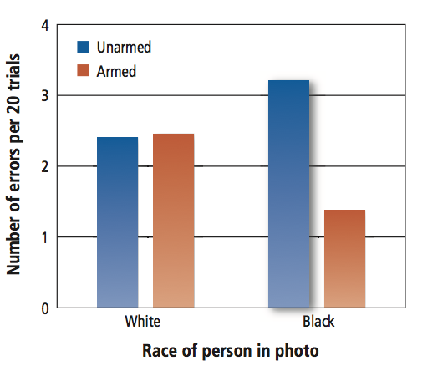
- Physical environment can trigger automatic thinking about race/crime
  - Dark room people can come up with negative stereotypes about balck people faster than if in brightly lit room
  - Especially prominent if they viewed world as a dangerous place
  - Closed booth vs. open field (participants associated black men w danger)
    - Closed fight/aggression responses
    - Open flight/escape responses
Automatic VS Controlled Processing of Stereotypes
- People who are not just prejudiced can be influenced by cultural stereotypes
- Even if score low on prejudice scale, you are certainly familiar with certain stereotypes
  - Triggered under certain conditions – automatic
- Devine’s 2 step model of stereotyping
  - Automatic process triggers activation of stereotypes under certain conditions; no intentionality, control or awareness involved
  - Controlled processes most often involve a conscious and deliberate decision to suppress the stereotype(s) being activated
    - Controlled can refute or ignore it
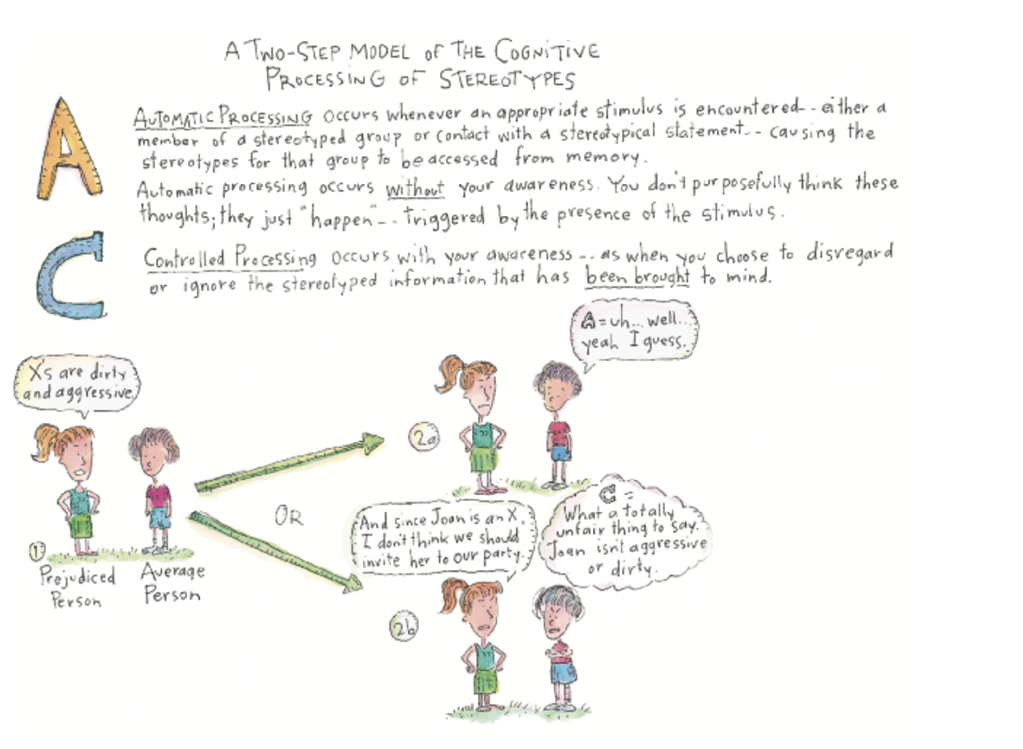
- Motivation to control prejudice
  - Those who are motivated to control prejudice are less likely to show prejudice
    - These researchers found that people who are high in motivation to control prejudice inhibited the application of stereotypes
    - These people were less likely to read hostility into ambiguous behaviours performed by a black man than were people who are lower in motivation to control prejudice
  - the need to feel good about ourselves (sinclaire & Kunda, 1999)
    - Study demonstrated that we not only selectively activate stereotypes, but also inhibit stereotypes in the service of self-enhancement
    - Non-black males asked to participant in research on managers’ evaluations of employees’ interpersonal skill
    - Participant answer Q assessed their interpersonal skills then received evaluation from either a white or black manager (both confederates)
    - Half of the participants received a positive evaluation, whereas other half received a negative evaluation
    - Participants who received negative feedback from black manager would activate stereotype of black people hypothesis
    - Praised by black manager would inhibit second hypothesis
    - Next phase of experiment, participant given a word completion task “unrelated study – that’s what they told them”
      - _ _ ACK could be BLACK or SNACK
      - CR _ _ _ could be CREEK or CRIME , etc.
    - Participants who activated stereotype more racial word completions
    - White manager ratings = control (graph below)
    - Negative feedback + black maanger = stereotype activation
    - Hypotheses were CORRECT
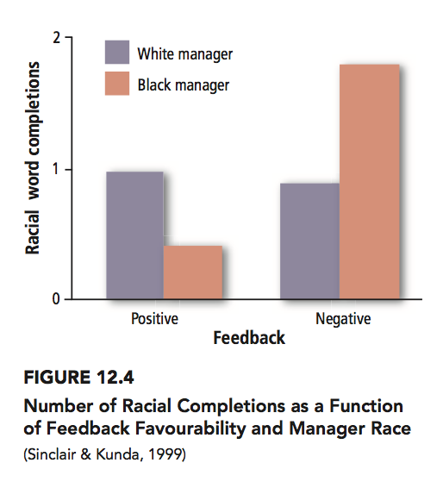
- Other studies found similar results with women
  - Female profs rated as less competent if student got a bad grade vs male profs
- Another study
  - Looked at reaction to Natives and whites after delivering a threatening message to university – implementing exit exam to graduate
    - Speakers portrayed as administrators
  - Native rated more negatively, less professional, less competent even though both had SAME arguments
  - Non-prejudice students were just as likely to show these effects as those who were high in prejudice towards Aboriginals
  - Conclusion: regardless of degree of prejudice, people may derogate stigmatized individuals and their messages when it suits their purposes
- Multiple stereotypes can apply to the same person
  - We pick and choose which stereotypes to activate or inhibit depending on what will produce the greatest self-enhancement
  - Participants either received positive or negative evaluation from either black or white doctor
    - Researcher predicted that when the black doctor delivered praise, doctor stereotype would be activated to bolster their desired positive impression of him and the black stereotype would be inhibited
    - Criticism vice versa; black stereotype would be brought to mind
    - Shows we can salvage our self-esteem by activating negative stereotypes

Meta-stereotypes
- Is a person’s belief regarding the stereotype that out-group members hold about their own group
- White Canadians believe Natives perceive them as prejudiced, unfair, selfish, arrogant, wealthy and phony
- Study
  - Found whites expected to have an interaction with aboriginal person, those who thought that they personally would be perceived in terms of meta-stereotype anticipated that the interaction would be unpleasant
    - These participants showed most amount of prejudice
  - Belief about whether aboriginal would stereotype them predicted attitudes and reactions more strongly than did their own stereotypes of aboriginals
  - The way in which participants expect to be perceived by an out-group member was the most important determinant oft heir reactions – even more so than their own evaluation of that group
- People are more likely to be prejudice when asked to take that person’s perspective than if they are not asked to do so makes meta-stereotype of one’s in group salient
- Study
  - Looked at convo between white and native
  - Each person rated their convo partner and how they believed their convo partner perceived them
  - White high in prejudice felt that they were stereotyped by aboriginal partner when in reality they were not
  - Low prejudice white did not feel as if they were stereotyped by aboriginal and they were right
  - Interestingly: Neither high or low prejudice people stereotyped their aboriginal partner & Aboriginal partners did not feel victim of prejudice
    - BUT Aboriginal paired with high prejudice white felt ashamed, angry with themselves – attributed negativity they experienced with themselves rather than prejudice
- Found that concerns confirming meta-stereotypes can be reduced if interaction partners are encouraged to take an other-focus rather than a self-focus
- Study with white-Asian pairs and white-Native pairs
  - Some participants who were told that the goal of interaction was to learn as much as possible about other person
  - Others told that participatns were asked to focus on how much they thought the other person was evaluating them
  - Inter-racial interactions were much more positive and warm in the condition in which focus was on other person, rather than worries about how the self was being evaluated by him or her
- We project our own prejudice onto other groups and therefore assume that they also dislike us
- 2 studies found that white participants tended to believe that Black people see them as prejudiced
  - These perceptions contribute to negative meta-stereotypes
Can prejudice be reduce by revising stereotypical beliefs?
- We hang onto our stereotypes even in the face of contradictory evidence
  - Study
    - Anglophone student listen to tape recording in which French Canadian speaker described himself in ways that were either consistent or inconsistent with English Canadians’ stereotypes of French Canadians as religious, emotional, talkative, sensitive and proud
    - Even if speaker completely contradicted stereotype, he was still perceived in stereotypical terms
  - Sometimes ppl are so contradictory to our stereotype that it is impossible to interpret the person’s behaviour in stereotype-consistent terms
    - We retain our stereotype but create a small category of “exceptions” – tendency can place target of stereotype in a no-win situation

The way we feel: affect and mood
- Prejudice is also a product of our symbolic beliefs (i.e. perception that a group promotes or hinders values that we cherish) and a product of behavioural experiences with members of the group
- Study Tried to find best predictor of attitude (prejudice)
  - Attitude toward 4 ethnic groups + gay and lesbians
  - To find out what best predicted attitudes, the researchers asked the participants to describe:
    - the emotions they experienced when thinking about members of each group
    - their stereotypic beliefs (i.e. characteristics you would use to describe the outgroup)
    - symbolic beliefs (values you believe member of the outgroup promote/hinder)
  - Behaviour assessed by asking participants to describe frequency of contact/quality of most recent experience with members of these groups
  - All these variables related to prejudice
  - Strongest effects emotion
    - Variable though depending on group towards which participants were least prejudiced
    - Emotion was best predictor of attitude for the group toward which participants were least prejudiced
  - Symbolic belief best predicted attitude for groups toward which participants were most prejudiced
  - Stereotypes did not predict attitude towards groups when behaviour, symbolic beliefs and emotions were taken into account
    - Symbolic beliefs predict attitudes towards gays and lesbians
- Study (Another lol shocker)
  - Emotion is strong predictor of prejudice that minority groups feel toward majority groups
  - Asked whites about emotion (i.e. anxiety), symbolic beliefs and stereotypes they felt when interacting with out-groups
    - All variables predict level of prejudice but emotion is best
  - Same is true for native’ prejudice of white ppl
    - Conclusion: the more negative emotion people expect to feel white interacting with members of another group, the greater their prejudice towards that group REGARDLESS of if they’re the majority or minority group
  - Important to point out that research we’ve been discussing is correlational, no causational! Does not actually prove that negative emotions cause people to be prejudiced. It might be the other way around
- Study: Does prejudice produce nasty feelings in ppl?
  - Research induced 3 moods – positive, negative or neutral
  - Participant in bad mood described various ethnicities as more negative
- Conclusion: not saying that stereotyping does not produce prejudice (it does). This research simply suggests that an even stronger determinant of prejudice is emotion!
Reducing Prejudice by Changing People’s Emotions
- Study
  - White participants shown videotape of blacks man experiencing discrimination in situations
  - Some instructed to pay attention to feelings; other told to pay attention to thoughts
  - Focused on feeling group more willingness to engage in future contact with black ppl
    - Affected emotions BUT not symbolic beliefs or stereotypes
    - Now they felt more + towards black people
Attributions and Prejudice
- Ultimate attribution error – the tendency to make dispositional attributions about an entire group of people
- Additionally, for out groups, poor outcomes are seen as dispositionally caused and good outcomes are situationally caused
- Study
  - If man was successful on task – observer attributed success to ability
  - Woman successful then attribute success to hard-work
  - Occurs with white and native too
    - When white kid did good, both white and native made dispositional attributions (i.e. smart)
    - When the native kid did good both white and native made situational attributions (luck)

Prejudice and Economic Competition: Realistic Conflict Theory
- Realistic Conflict Theory – proposes that limited resources lead to conflict between groups, resulting in increased prejudice and discrimination
- Study
  - Tracked attitudes toward immigration along with unemployment rates in Canada
  - When unemployment rate increased and so did negative attitudes about immigration
  - When unemployment rate dropped and so did opposition to immigration
- Economic recession in country increase prejudice towards immigration
- Study test whether perceived competition for resources causes unfavourable attitudes towards immigrants
  - Test whether perceived competition for resources actually causes unfavourable attitudes towards immigrants
    - Participants in them read 1-2 editorials on immigration to Canada
    - In competition condition, editorial focused on the scarcity of jobs in Canada and the high rate of participation of skilled immigrants in the job market; in the no-competition condition, the job market was not mentioned
    - Participants told that b/c of natural disaster in country of Sandir, a new group of immigrations Sandirians would be arriving in Canada
      - Described in positive terms by researchers
      - Competition group construed traits more negatively than no-competition condition
Reducing Prejudice by Fostering Common Goals
- Study: Test of realistic conflict theory
  - Groups kept in isolation form each other – randomly assigned to Eagles or Rattlers – each group had enjoyable activities to increase cohesiveness
  - Additionally, for out groups, poor outcomes are seen as dispositionally caused and good outcomes are situationally caused
  - Got 2 groups to compete with each other increase tension
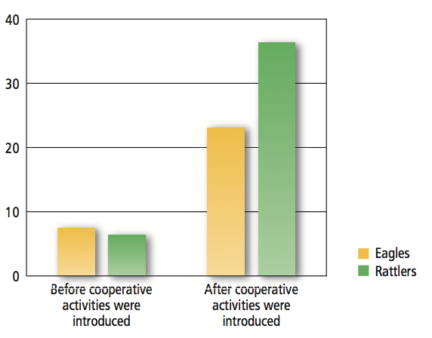
- Futher intensify tension:
  - Arranged dinner other group were intentionally late
  - All of the good food got eaten, other group shows up and chaos ensues including a food fight

- What happens when we remove competition?
  - Removed competition, but that didn’t get rid of hostility…things continued to escalate.
  - Researchers succeeded in getting rid of hostility by having the boys experience mutualistic interdependence
  - Mutual interdependence: situation in which 2+ groups need each other and must depend on each other to accomplish goal important to both groups
    - E.g. bus broke down work together to pull bus up a hill
    - Start to reduce prejudice and discrimination
Pressure to Conform: Normative Rules
- Injunctification – a motivated tendency to see the status quo (the way things are) as the most desirable state of affairs (the way things should be)
  - Effect occurs when people are motivated to justify current system
  - Study
    - Students either reminded impact that Canada and their university has had on them (two groups)
    - Then given info that system distributed its funds unequally (for provinces or academic departments depending on which group)
    - When reminded about how much impact country had regard government distribution as fair and the unequal fund distribution in uni as unfair
  - Injunctification occurs for people in committed relationships such as marriage – superior to being single (despite research debunking myth that single miserable)
  - Men are likely to show effects under conditions of threats ex. More critical of article arguing that people in committed relationships are no different than people who are single
  - Research suggests institutions such as marriage are set up in favour of men – more motivated to justify system now
- Study found hat when people are highly motivated to justify their systems, they are more likely to endorse stereotypes
  - Study of gender roles found men who were given info that threatened faith in federal government system more attracted to a woman who was described using terms an phrases that reinforce gender inequality (i.e. vulnerable) than a woman who was described in non-stereotypical terms (athletic)
- Evidence that when people are motivated to believe that status quo reflects how things should be, they react negatively to someone who does not conform to prevailing social norms
  - i.e. female participants who read article about social/economic downturn of Canada – given info about few women in CEO position rated female biz student as less likable and competent than participants who were told Canada has many women in CEO positions
- When women exposed to benevolent sexism (women r wonderful but childlike n needy), less likely to take actions to improve rights of women compared to hostile – causes women to justify benevolent sexism
Individual Differences in Prejudice
- Research suggests that people who score higher on the following dimensions are more likely to hold –ve attitudes toward out-groups
Right wing authoritarianism
- Defined with 3 attitude clusters
  - Authoritarian submission high degree of submission to authority figures
  - Conventionalism high degree of conformity to rules established by authority figures
  - Authoritarian Aggression Aggression towards groups that are seen as legitimate targets by authority figures
    - Think: People being attacked in trump rallies
- High RWAs are more prejudice against ethnic minorities, immigrants, women and sexual minorities
- When RWA shown attitudes are more negative than others – they tend to match them because conforming to social norms is important to them
- Can reduce prejudice by encouraging interaction with members of outgroups
  - Or showing them that attitudes towards gays have become more positive
  - Attitudes also change if they personally knew a gay person, the prof said he was gay and the RWA became more positive in their attitude towards gays
Religious Fundamentalism
- Characterized by
  - Belief that the absolute and literal truth of one’s religious tenets
  - Belief that one’s religion is “right” and forces of evil are threatening to undermined its truth
- Not the same as being religious or having religiosity
  - E.g. Religious quest –vely related to prejudice more open to idea of interpretation
  - Less prejudiced
- Study: Religious fundamentalism is correlated with prejudice towards racial prejudice, single mothers, and sexual minorities. Greater the fundamentalism = greater the hostility
  - Sexual out-groups targeted for discrimination in western societies

Social Dominance Orientation (SDO)
- High in SDO ppl Belief that groups of people are inherently unequal
  - Acceptable that some groups benefit at the expense of the other group
  - They prefer to be in advantaged group
  - “To get ahead in life, sometimes you need to step on others”
- Associated with racism, sexism, homophobia, opposition of interracial dating, & transracial adoptions
- Leaders high in SDO do not consider it important to relate to subordinates
- Prefer jokes targeting lower groups and not higher or in group
- Perceive immigrants as a threat, lack of empathy for them, and dehumanization of immigrants. Refugees seen seen as immoral & just trying to sneak in
- Organization leaders that are high in SDO more unethical decisions
- Law students score higher on SDO than psych students

- Diff groups of people and resources are scarce natural tendency for people high in SDOs one of us has to come out on top okay
- People not high in SDO fit very nicely with conflicts leading to prejudice, competition of resources leading to prejudice
- If there were 2 factors that stand out SDO and Right wing authoritarianism strongest correlates of prejudice and discrimination

- Opposed to inter-racial dating/transracial adoptions
- Prefer jokes directed at low-status out-groups and hold negative attitudes towards immigrants
- Organizational leaders high in this unethical decisions
- Law students score higher on SDO than psychology students – higher up year law students score higher than first year and opposite is true for psychology
- Reduce SDO via
  - Persuasion didn’t work; made things worse
  - Feelings of shared identity w ppl in high SDO and immigrants
    - worked in Canada but not Germany
    - People with high SDO do not see a need for prejudice to be reduced

Effects of Stereotyping, Prejudice and Discrimination
- Study showing black baby prefer white dolls
  - Occurs with native and white dolls in Canada
  - Leads to self-fulfilling prophecy
- Self fulfilling prophecy
  - Study
    - African interviews vs white interviews
    - White ppl had better interview cause interviewer conducted themselves such that the black person was at a disadvantage
  - Found similar idea with male vs female engineers and with women + math
    - The confederate’s sexist behaviour activated the sterotype that women are not good at math/engineering BUT NOT ENGLISH anxiety about confirming his negative stereotype interfered with the women’s performance on only the math test not English test
      - Study: less women in math/engineering, the less likely they are to buy into these stereotypes
  - Sexist male female engineers more attracted to them, but performed shittier on test

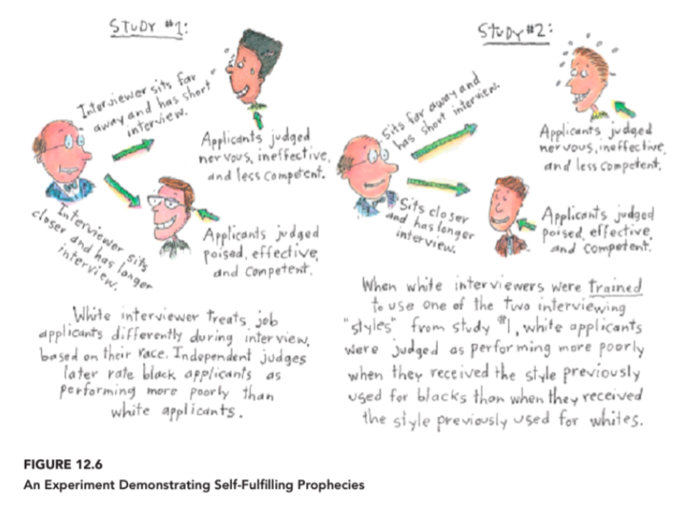

- Stereotype Threat: the apprehension experienced by members of minority group that they might behave in a manner that confirms existing cultural stereotypes
  - black people writing exam
    - Will think: If I perform poorly, then it will reflect poorly on me and my race nervous actually perform badly
    - Study: GRE for white and black, but half told that it was non-diagnostic and other half told they were measuring intellectual ability
      - White ppl performed the same in either condition
      - Black ppl performed much worse in diagnostic conditions
    - When race is made more salient, the decrement in performance among African American students is even more pronounced
  - Math test designed to show gender differences vs. just normal math test
    - Former: women do worse than men
    - Latter: women do just as well as men
  - Asian girls math test: Those who were reminded of their gender (women are bad at math) did worse than those reminded of cultural identity (Asians are good at math)
  - F women indicate gender + name do worse on math test than if giving fake name
  - Stereotype threat can lead women (even if good at math) to avoid math related careers
- Can stereotype threat be overcome?
  - No. But you can reduce it.
  - Change mindset during a test, etc.
  - Get a reminder that you’re good student before test or that it’s normal for stereotyped groups to experience anxiety
  - Women do better on math tests when told that stereotype threat is why there is a gender disparity in math ability, not genetics OR if told there r no gender differences
    - Cognitive reappraisal (think of math test n objective manner) also improves performance on math test relative to stereotype threat condition
  - Self affirmation before do better on test
  - Reminded that traits are improvable not unchangeable

Interventions for Reducing Prejudice and Discrimination
The contact hypothesis – repeated contact with members of an out-group can have + effect on stereotypes and prejudice
- Barrier = difficult to get contact started because interacting with an out group can be scary and they might be hostile/unfriendly, we also come across as less warm bc nervous
- Cycle: we think it’s obvi that we’re trying to be friendly but it’s not that obvi to out-group
- Reducing prejudice via bringing members of different groups into contact might be counterintuitive
- If Israelis and Palestinians spend more time together, they will get along not true
- Sherif identified idea of Mutual Interdependence helpful if people work towards a common gaol and not competing against one another for the same things
- Two key factors in success of contact = MI + having a common goal. Additional factors listed below:
  - Both groups have an equal status
  - The setting is friendly and informal
  - Individual learns settings are typical of their group
  - There is contact with multiple group members
  - There are social norms that promote equality and egalitarianism among groups
    - Goal is to promote exposure to multiple people so your mind is confronted with multiple situations
- Low-prejudice people are more likely to overestimate friendliness they’ve shown, leading to counterintuitive results that their interaction with out-group members can actually be actually more negative than those of high prejudice

Six Conditions when contact reduces prejudice
- Mutual interdependence
- Having common goal
  - Recall: boys camp study
- Equal status – unequal statues will shape interactions between groups (not the point)
- Informal, interpersonal contact – members need to actually interact one on one
- Multiple contacts – multiple members of group present so that out group cannot think one person is exception
- Social norms of equality among groups – e.g. of boss creates a norm of acceptance, group members will conform
Even hostile groups will reduce their stereotyping, prejudice and discriminatory behaviour when these 6 conditions are met

Cooperation and Interdependence: Jigsaw Classrooms
- A class room setting designed to reduce prejudice b/w children by placing them in small desegregated groups and making each child dependent on other children in group to learn the course material and do well in the class
- Underprivileged kids Don’t have resources to prepare them
- Forced in school attended by middle class white kids, they think white ppl are arrogant & white ppl think they’re stupic (but actually just overwhelmed)
- How to change atmosphere in classroom so that the contact hypothesis actually works

Setting up jigsaw classrooms
- Jigsaw classroom – Creates interdependent classroom atmosphere designed to place the students of various racial and ethnic groups in pursuit of common goals
- Divided classes into mixed race groups ~ 6 people/group
- Split lesson into diff/ components
- E.g. learning about a historical figure each child would be given a diff/ component of his background, his history forced kids to pay attention to each other and show that they are knowledgeable and competent
- Increase academic content of minorities and to decrease prejudice
- Widely used and successful

Extended Contact Hypothesis
- Mere knowledge that a member of one’s own group has a close relationship with a member of another group can reduce one’s prejudice towards that group
- Study
  - Made summer camp – blue or green group
    - Made them get to know each other’s group members very well but isolated from each other
  - Made them do activities supposedly leading to conflict and hostility
  - One member of each group was selected to participate in an unrelated experiment friendship building exercise
  - Later, participants asked to describe the experience to their group
  - Discovery that one of members was now friends with enemy caused remaining group to adopt more positive attitudes towards out-group as a whole

