Micronutrients Part I – bind to Type II Steroid Hormone Receptors and have Global Health Implications

Vitamins & Minerals: The Basics
- Characteristics for classification as a vitamin:
- Exogenous supply is required – can’t be produce but some bacteria and plants can produce them
- Needed in small amounts
- Distinct from sugars, fats and proteins in regard to structure and function
- Performs at least one essential biochemical function in the body
- When lacking in the diet, a characteristic deficiency develops
- Vitamins are organic
  - Primary distinction from minerals (which are inorganic)
Way to discuss micronutrients?
Functional Groupings/Practical Importance Discussion
- Group I – micronutrients that control type II steroid hormone receptors and have major global health implications
- Iodine, vit A, vit D, Calcium, vit K, Phosphorous and Fluoride
- Group II – micronutrients that work together in oxidant defense
- Vit E, selenium Vit C, Niacin, Riboflavin, Copper, Zinc, Manganese
- Group II – micronutrients that act as enzyme cofactors
- Thiamin, niacin, riboflavin, vit B6, folate vit B12, biotin, pantothenic acid
- Group IV – iron, copper and zinc-related divalent cations
- 1 out of 3 people in developing countries are affected by vitamin and mineral deficiencies -WHO

Group I
- These micronutrients control cellular function through a certain type of process (type II steroid receptors)
- Not all act directly on steroid hormone receptors (only if vit A, vit D, and iodine)
- But you can’t talk about vit D without talking about calcium, phosphorous and vit K (*** which are all involved in bone metabolism)
- Vit A consumed as retinol (animal based) or beta carotene (plant- based), which is eventually converted into retinoic acid (which goes an activate)
- Vit D precursors converted to calcitriol, which regulates calcium levels in the body
- Iodine used to make T3 hormone, which regulates synthesis of proteins that control basal metabolic rate

Steroid hormone receptors (SHRs)
- SHRs are intracellular protein receptors that bind ligands and become active transcription factors
- Two ‘types’
- Type 1 receptors -> cytosolic
  - Respond to steroid hormones like estrogen, testosterone, progesterone, glucocorticoids and mineralcorticoids
- Type 2 receptors -> nuclear
  - Respond to steroid and non-steroid ligands, like thyroid hormone, retinoic acid and calcitriol
- /difference is where they are located in the cell
Iodine
Iodine in the diet
- Iodine (inorganic mineral) content of most food is low
- Iodine found in higher concentrations in coastal populations compared to mountainous regions
- Seafood has high concentrations (especially sea greens) since iodine is very water soluble so it permeates on sea greens
- Iodine washed away to coastal areas
- In NA, most of the iodine consumed comes through ‘salt fortified with potassium iodine’
- Iodized salt contains 0.03mg iodine per g of salt
- As of 2007, 29% of the world population live in areas of iodine deficiency
- Developing countries have iodine deficiency since they don’t have ion fortified salt

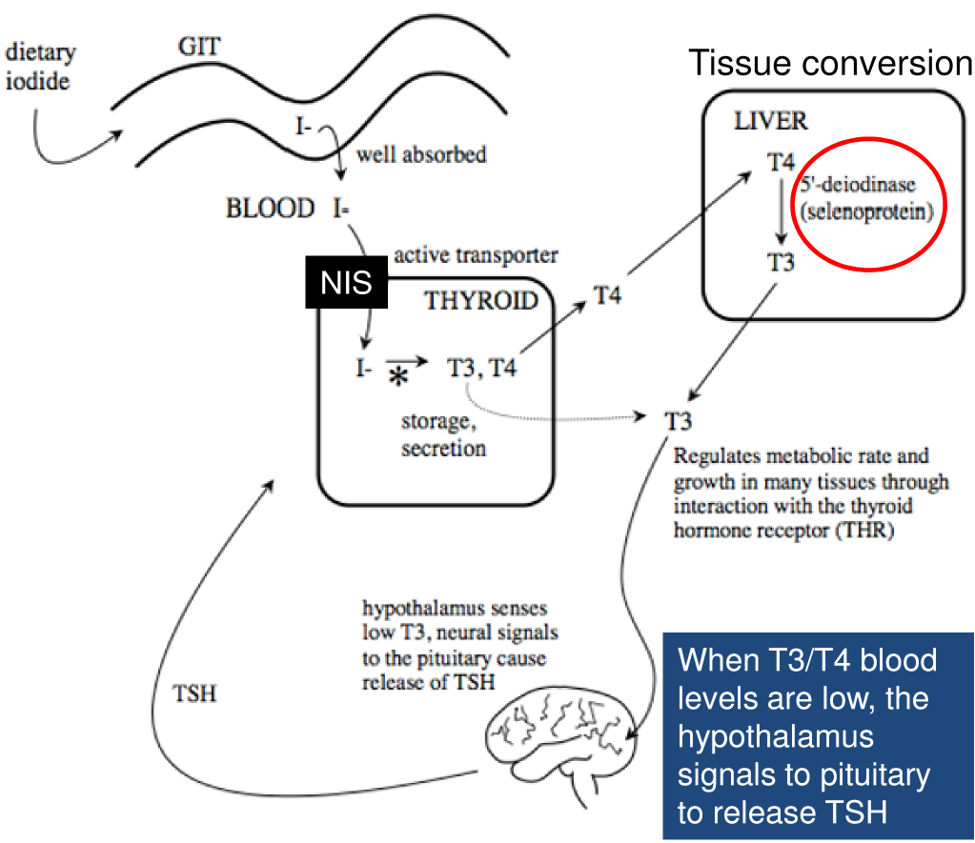
Iodine absorption
- Iodine (I) is typically found in body in its ionic form iodide I⁻
- Dietary I can be bound to amino acids or found free
- Rapidly converted to I⁻ and absorbed
- Most absorbed in the stomach, a bit in small intestine
- In the blood, free I⁻ is found and can enter all tissues (however, most accumulates in the thyroid gland)
- Uptake in thyroid mediated by an active transport system known as the (Na⁺/I⁻) symporter (NIS)

Iodide transport and functions
- All tissues depend on thyroid hormones (T3 and T4) rather than iodide
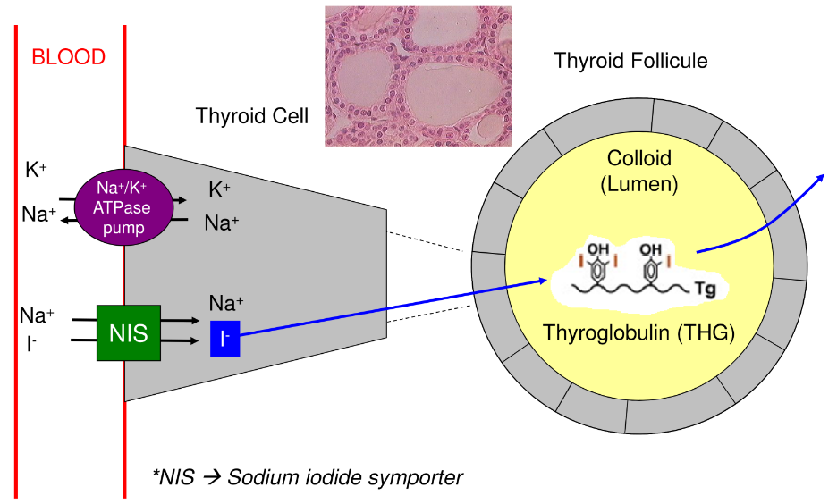
- Once T3 and T4 made, they are secreted into blood and transported by specific carrier proteins (albumin, transthyretin, etc.)
- 50x more T4 in plasma compared to T3 BUT T3 is 100x more potent
- T3 half-life < T4
- T3 interacts with thyroid hormone receptor (THR)
- T3 and T4 production regulated by TSH (thyroid stimulating hormone) – for thyroid gland
Iodide Uptake in Thyroid Gland
- /NIS transports both Na and I
- /Na and I – happens due to favourable Na concentration gradient produced by NA/K pump
- /Iodine enters the lumen
- /Thyroglobulin is enriched with thyroid which is an important feature and will interact with iodine
- /Thg secreted into the lumen
How does iodide make thyroid hormones?
- In the colloid, iodide is oxidized to form a free radical
- Thyroglobulin (THG) protein is produced in thyroid gland
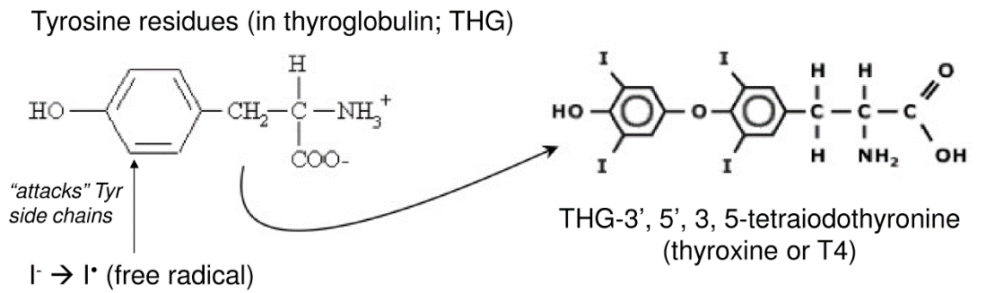
- This is a tyrosine-rich (Tyr) protein
- Iodide radical ‘attacks’ the Tyr residues in THG, eventually leading to crosslinking between tyrosine residues
- Thyroid cell proteases hydrolyze THG, releasing (mostly) T4 and T3
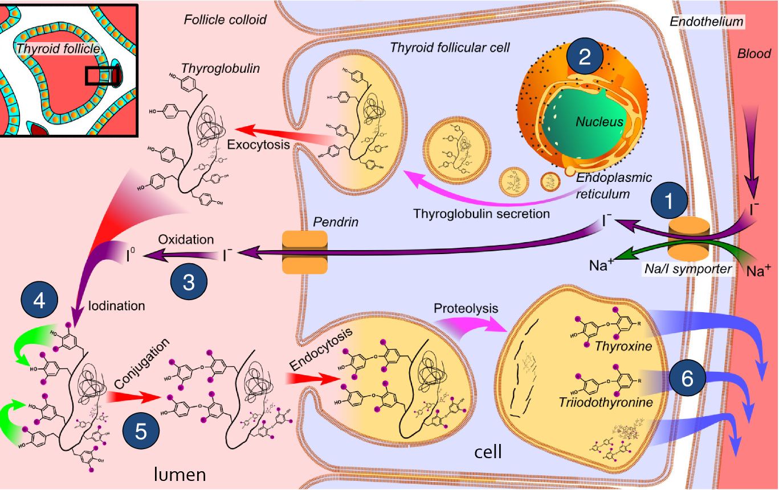
- /radical important to produce T3 or T4
- /iodide into the cell and sodium – iodide goes thru the cell into the lumen
- /Thg is produced in nucleus and incorporated in a vessel and secreted into the lumen
- /iodide becomes a free radical
- /will attack the residues (purple circles which represent iodide and is not attached to tyrosine residues)
- /will crosslink with tyrosine residues
- / will clip off amino acids and just tyrosine residues crosslink still intact
Thyroid Hormone Signalling
- T3 and T4 are lipophilic (can cross plasma membrane easily)
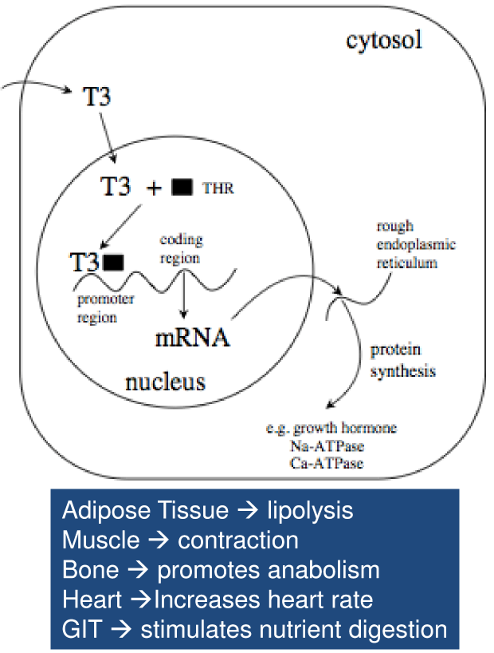
- T4 converted to T3 in various tissues (in particular the liver)
- In tissues, T3 binds to THR, which then binds to response elements in promoter regions of DNA to activate gene expression (mRNA)
- The induced proteins have wide ranging effects, leading to increased metabolic rate and playing a key role in fetal development. Examples of genes activated by T3:
- ATPases (pumps Na⁺ and Ca²⁺ out of cells), which increases metabolic rate
  - Na⁺ (muscle contraction, neuron firing)
  - Ca²⁺ (signaling events)
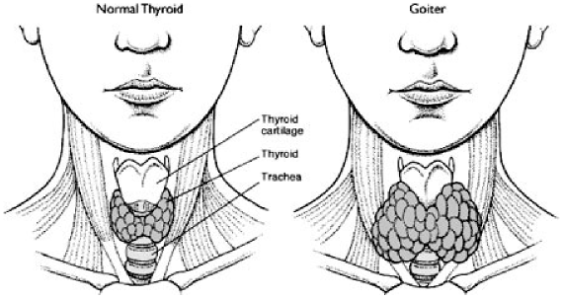
- Growth hormone (anabolic events)
- /can get into cells easily, T3 affects gene expression
- /T4 needs to be converted to T3
- /T3 more bioactive will bind to its receptor THR (thyroid hormone receptor)
- /transcription factor that once bound to T3 is active
- /THR located within the nucleus, T3 goes into the cell to bind with it
Iodine deficiency
- When T3 levels are low, the pituitary gland releases TSH (thyroid stimulating hormone)
- When iodine deficient, thyroid still being stimulated by TSH to produce hormones, but it can’t. leads to:
- Hyperplasia (increases cell number)
- Hypertrophy (increases cell size)
- The result
- Goiter -> thyroid enlargement
  - If left untreated, becomes thyroid cancer
- Cretinism -> when iodine levels are low in mother, the fetus doesn’t develop properly
  - Irreversible
  - 50 million people have some degree of mental impairment caused by IDD (WHO)
  - Mild retardation
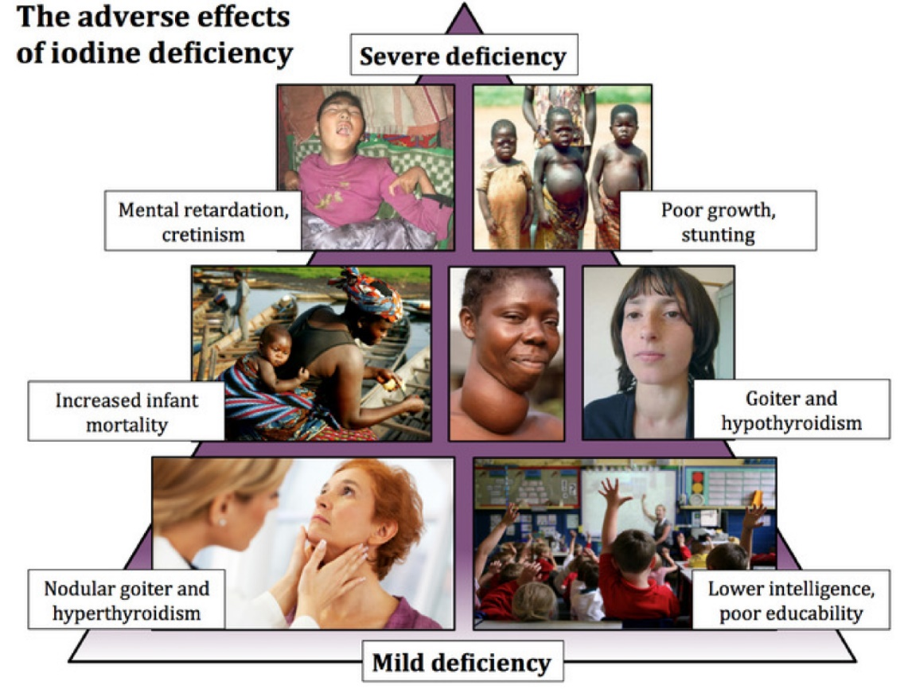
- Growth and developmental abnormalities
- /there is no iodine if there’s no crosslink
- /disease affected by age
- /hypothalamus signals the pituitary to send TSH for production of T3, even though there isn’t any iodine to produce T3
- /increase in cell numbers and size to adapt to chronic and consistent TSH signalling
- /mild goiter is reversible by adding iodine in the diet but if left to grow bigger is can lead to tissue enlargement and thus, fibrosis leads to thyroid cancer which isn’t reversible and can’t be fixed by adding iodine
- /hyperthyroidism – mild deficiency, takes iodine excessively in the system which is overloading the thyroid gland which leads to proliferation of the cell
- /happens when people overcompensate for mild deficiency
- /iodine measure thru urine = UIC

Vitamin A
- Night blindness was a recognized disease before 1500 BC
- Ancient Egyptians recorded that juice squeezed from cooked liver onto the eyes cured night blindness (Greeks realized you could also just eat liver)
- In the late 19th century, purified diets were examined and specific dietary factors were identified
- Egg yolk contains a fat soluble material necessary for life, which was originally named fat soluble A or vit A
- Vit A is a general term used to refer to a group of compounds (termed retinoids)
- Major forms of vit A in the body are: retinol, retinal, retinoic acid, & retinyl ester
- /Retinoic acid – ligand, interact with retinal which allows us to see in low levels of light
- /Retinol – intermediate, interconversion of these vitamin A,
  - /retinol is the form you would find in blood levels
- The alcohol form (retinol) was identified and then carotenes were recognized as the plant form of vit A
- IMPORTANT: a plant provitamin is the form of a vitamin produced by plants that when consumed by animals is converted in vivo into the bioactive vitamin
- /alcohol is a detergent that would break down the cell thus retinol needs to be bound to a protein
- Carotenes (provitamin A) are precursors for vit A
- Carotenes are a type of carotenoid, which are pigments produced in plants (e.g. β-carotene, α-carotene, etc.)
- /carotene is needed to change to a bioactive molecule vit A we need
Vit A digestion and absorption
- Retinyl esters (milk and eggs)
- Retinol + saturated fatty acid
  - /can be bound to palmitate since most abundant saturated fatty acid or something you ate
  - /retinol + sfa = ritnol ester = safe since alcohol won’t be able to act as a detergent
  - /retinyl esters must be changed into retinol in order to enter the cell
- Retinyl esterase (produced in pancreas and secreted from small intestine) cleaves fatty acid from retinol
- β -carotene (plants)
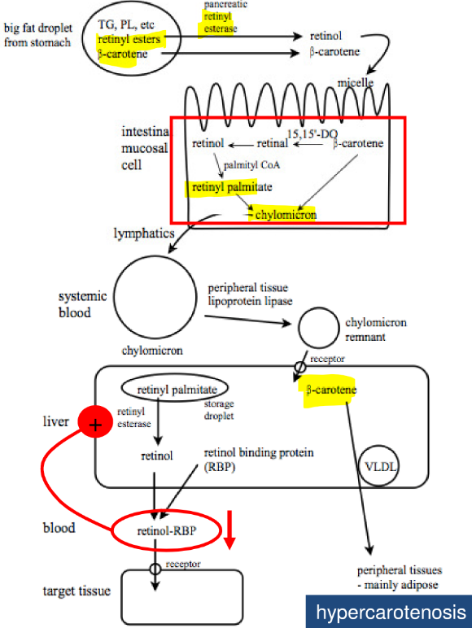
- Lipophilic compounds, therefore incorporated into mixed micelles – /fat soluble vitamin
- Both absorbed by passive diffusion
- Depending on the vit A status of a person, β-carotene has 2 fates:
1. converted into a retinyl ester – /if there is low vit A status
2. incorporated ‘as is’ into chylomicron – /doesn’t get converted and is sent to adipose tissue
- Everything ends up at the liver in a chylomicron remnant
- β-carotene can be packaged into VLDL and stored in adipose tissue
- retinyl esters are stored in liver (usually as refinyl palmitate) in stellate cells
- retinol-RBP (retinol binding protein) levels are key!!! – /are used to measure vit A levels
- /no matter the form it will be handled the same way as lipids – are incorporated into chylomicrons
steps from the diagram
- Retinyl esters changed by pancreatic retinyl esterase to retinol & β-carotene stays the same
- Retinol and β-carotene enter the cell and are converted to retinyl palmitate and packaged in a chylomicron
- CR then goes to tissues to deposit sfa and becomes a CR remnant that still has β-carotene attached to it
- β-carotene can then be sent to adipose tissue or converted to a retinyl ester (aka retinyl palmitate) which is then sent to the target tissue
- hypercarotenosis - β-carotene accumulation in subcutaneous adipose tissue
- If vit A low it will create RBP to create vit A
KEY POINTS
- Vit A and β-carotene are lipophilic
- Therefore, these compounds are handled like dietary fats
- Depending on the vit A status of a person (which is very stable in normal situations), β-carotene will be either:
1. incorporated into cr directly
2. converted to retinyl palmitate and then incorporated into cr
- Taken up predominantly by liver where
- β-carotene is packaged into VLDL and sent to adipose tissue for storage
- Retinyl pamitate is stored in hepatic stellate cells until needed
  - When needed, liver retinyl esterase cleaves the FA, releasing retinol which binds to retinol binding protein (RBP) and secreted into blood
  - RBP synthesis depends on vit A status, but also zinc and protein.
Vitamin A – Important molecules
In the intestine:
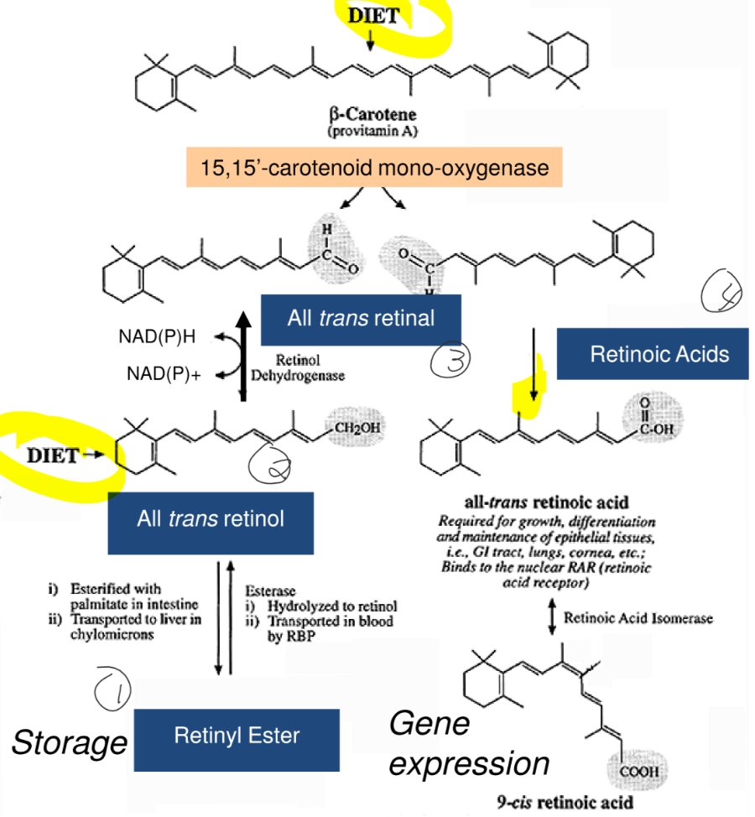
- β-carotene can be broken down and converted into retinyl ester
- enzyme responsible or this is 15,15’-carotenoid mono-oxygenase
- located in duodenal mucosa
- retinal (aldehyde)
- retinol (alcohol)
- acts as a detergent, which is why it is converted into an ester (retinyl ester)
- no function per se.
- /very top of diagram has two β-carotene (2 retinals bound together)
- /point of the diagram is to show the relationship between the retinoids
- All retinoids can be interconverted
- /animal based food produces retinol
- /retinol can be changed to retinal using the retinol dehydrogenase
- /retinal can be converted to retinoic acids which are ligands that affect gene expression
Vitamin A and night vision
- Rods use rhodopsin to absorb light (greyish purple colour)
- This is thanks to Vit A
- /Retinol-RBP will be sent to the eyes, once retinol is brought to the epithelium cells of the rods, that retinol is quickly converted to retinal using retinol dehyrodgenase since we don’t want the detergent (retinol)
- /all-trans-retinal gets changed to 11-cis retinal using an isomerase and introduces kinks in the structure
- Opsin + 11 cis-retinal join to become rhodopsin, which is light-sensitive
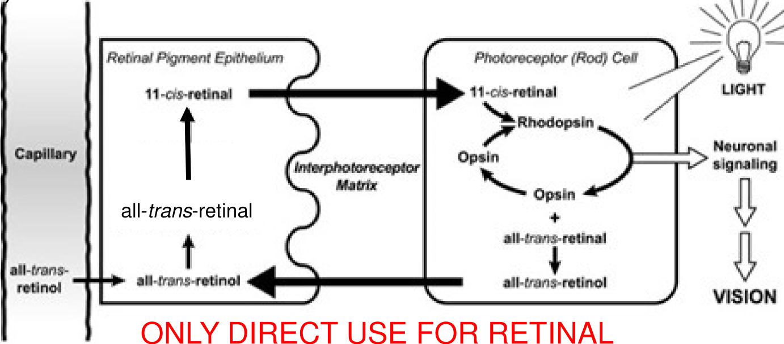
- When light hits rhodopsin, it reforms all-trans retinol
- /rhodopsin needs to be made once the process is started
- Once we see in this greyish blue because of rhodopsin,
- /Rhodopsin is the only place that uses the retinal molecule
- /retinal is mostly a transition state, but will be used in rod cells of our eyes
Retinoic Acid (RA) Signaing
- Retinol-RBP brings retinol to a cell, which is then converted to RA
- RA goes to nucleus where it binds and activates both the retinoic acid receptor (RAR) and the retinoid X receptor (RXR) transcription factors
- These complexes homo- and hetero- dimerize with other nuclear hormone receptors (NHR), creating a huge number of possible combination of transcription factors, which allows specific regulation of gene expression
- Ex. Growth hormone -> important for growing and differentiating tissues (e.g. bones)
- /RA used in every cell in our body
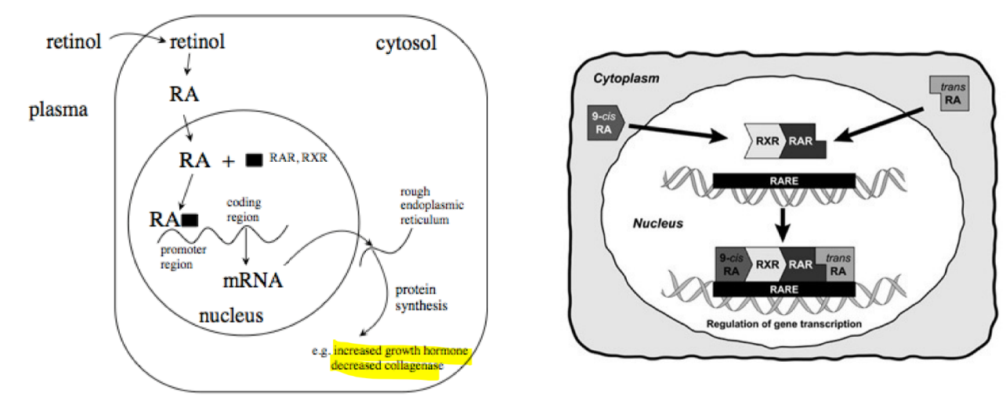
- /RAR and RXR are both binding RA receptors (type 2 hormones located within the nucleus)
- /RAR and RXR need to be together to form an active transcription pattern
- /the more combinations of receptors the more gens can be read

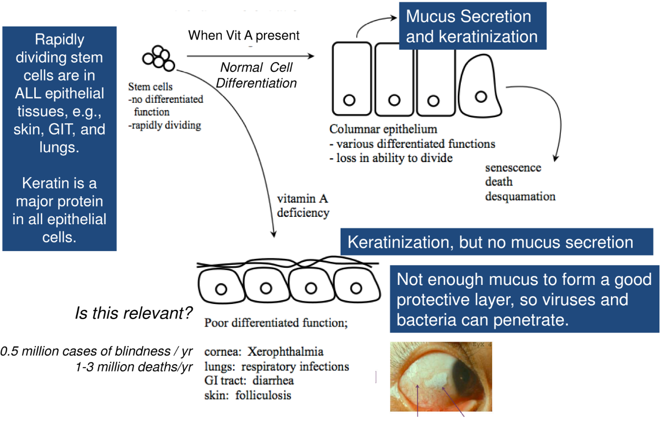
Vit A Deficiency and Epithelial differentiations
- /RA incredible important for the epithelial cells that are constantly regenerating, like the gut, skin, lungs where epithelial cells have a very high turnover rate
- /Differentiation directed by vit A which ends up creating barrier cells and very commonly produce keratin, mucosal keratin mix required for normal differentiation cell

- /with deficiency there is an imbalance on what is made in the epithelial cells but you don’t have a protective barrier
- /absence of protective barrier can lead to viruses and bacteria
- /white debris is keratin debris which can lead to permanent blindness

Vit A deficiency worldwide
- Between 100 and 140 million children are vit A deficient. An estimated 250,000-500,000 vit A deficient children become blind every year, half of them dying within 12 months of losing their sight (WHO)
Consequences of Vit A deficiency
- Night blindness (rhodopsin)
- Reversible, one of the first signs of Vit A deficiency
- Associated with Bitot’s spots, a buildup of keratin debris in the conjunctiva of the eye (chronic vit A deficiency)
2. impaired epithelial cell differentiation
- Can cause permanent blindness and life threatening infections
3. impaired growth (growth hormone not produced)
- Relevant for bones, tooth decay
4. impaired fertility
- Decreased sperm formation, fetal resorption (early death of embryo)
5. fetal development defects
- Birth defects due to loss of control of differentiation
- Can occur with too little or too much vit A
- Deficiency is mostly found in underdeveloped countries (Asia, Central America, Africa)

Vit A dietary requirements
- Retinol activity equivalent (RAE) -> 1 RAE = 1 μg dietary retinol = 12 μg dietary β-carotene = 24 μg other carotene
- /Since we don’t absorb β-carotene as well we need more to equal dietary retinol
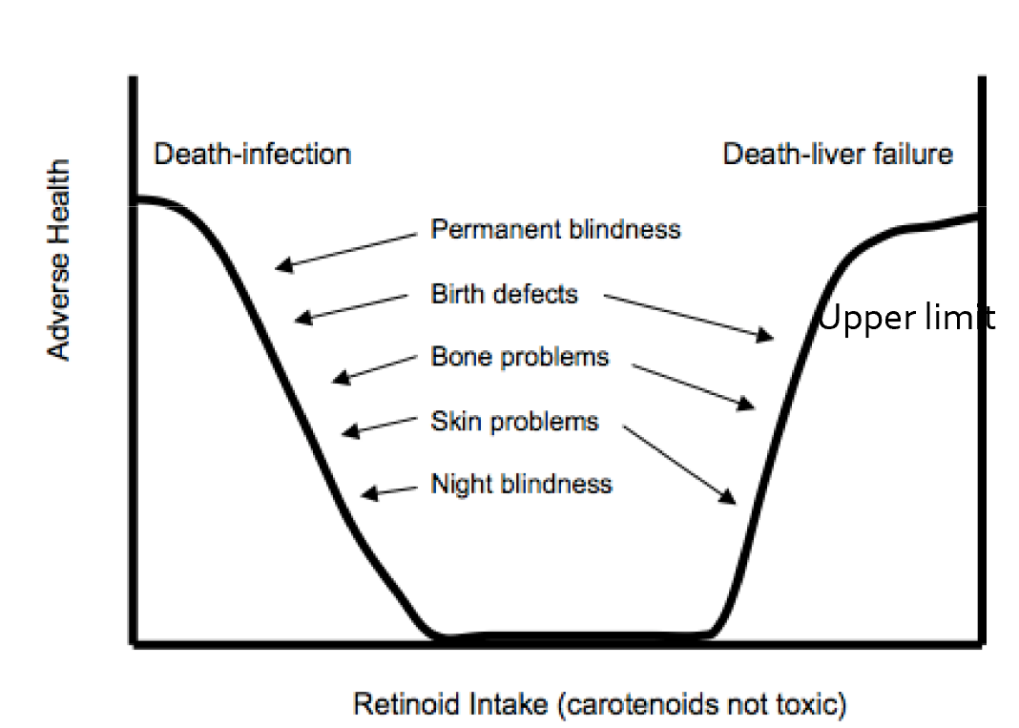
- RAE accounts for differences in biological activity of carotenoids
- RDA for adults
- Men -> 900 μg RAE
- Women -> 700 μg RAE
- UL = 3000 μg/d retinol
- There is NO UPPPER LIMIT for β-carotene
- Carotenoids prevent deficiency, but don’t cause toxicity
- 15-15’-carotenoid mono-oxygenase regulated by Vit A status
- If you have enough Vit A, carotenoids aren’t converted to retinol but are stored ‘as is’
- /body doesn’t use β-carotene until it is low in Vit A, it is just used as a pigment in the adipose tissue

Vit A dietary toxicity
- Most severe consequence is liver cell death
- Retinyl palmitate is stored in the stellate cells of the liver and with excess Vit A intake, the cells get full to capacity
- Raw Vit A spills out and the local hepatocytes become damaged and die
- Death from liver failure can result
- Excessive intake of β-carotene is not toxic, but can cause hypercarotenosis (skins turns yellow-orange)
- Acutane, an acne drug that contains 13-cis retinoic acid (a derivative of vit A which is bioactive), can cause birth defects in women in the early months of pregnancy
- Taken off the market due to lawsuits

Vitamin D
- While Vit A and iodine are deficiencies of the developing world, Vit D is the most prevalent micronutrient deficiency in the developed world
- Vit D acts as a hormone (‘true’ steroid hormone)
- /since it is a derivative of cholesterol (so it’s a sterol)
- Made in one tissue (kidney), and acts on other tissues
- Works with other hormones such as parathyroid and calcitonin
- Evidence of rickets (i.e. Vit D deficiency) in skeletons from over 50,000 years ago
- Medically described in 1695
- 1919 – rickets was in dogs, and treated with cod liver oil
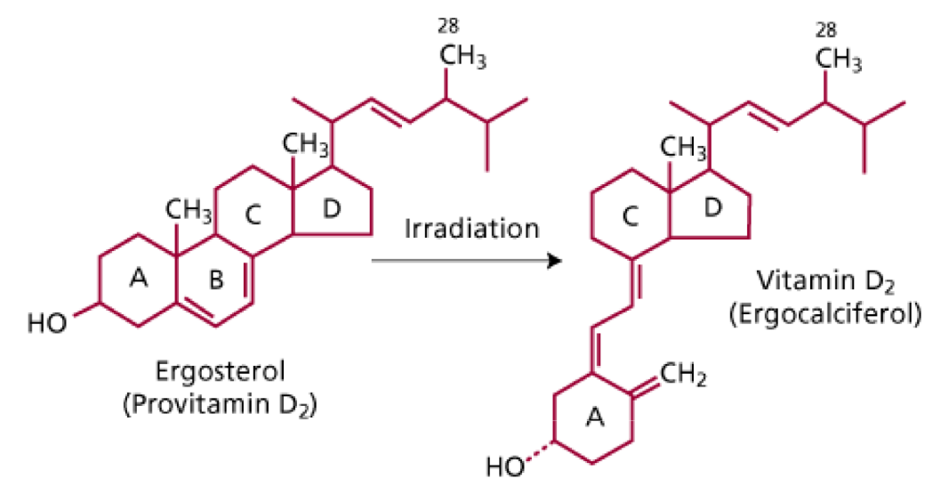
- Rediscovered the use of cod liver oil to prevent bone disease
- Sunlight also used to cure rickets, which indicated that fat soluble vit D could also be synthesized in the body
Vitamin D sources
1. Natural Plant Sources (Provitamin D2)
- Shitake mushrooms
- Not very active in plants, so not a great source of vit D
- Ergocaliferol less bipotent than cholecalciferol
2. Natural Animal Sources (Provitamin D3)
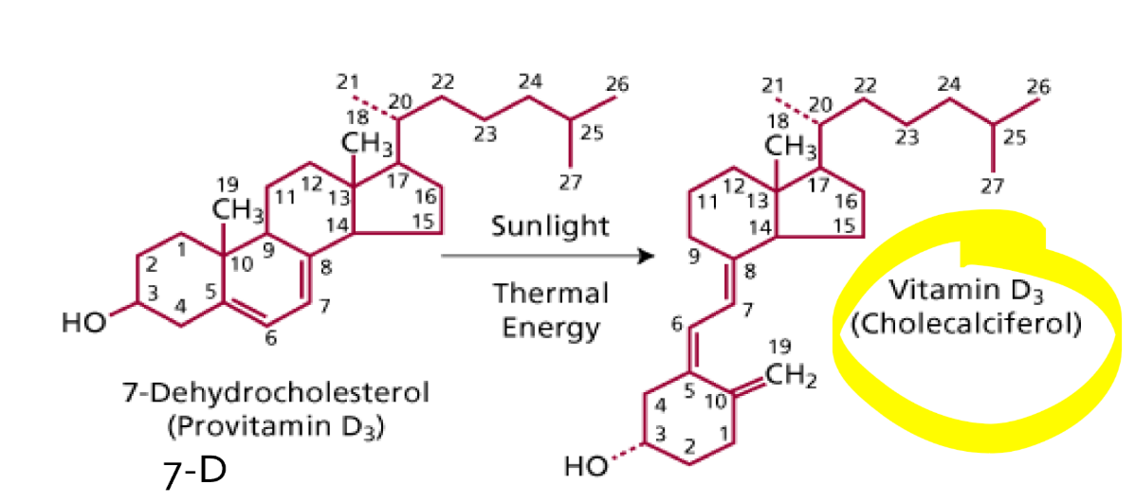
- Not many (fish, fish liver oils)
- 7-dehydrocholesterol (7-D) converted to cholecalciferol by sunlight (UVB and infrared)
- In sebaceous glands of skin
- Animals with fur produce 7-D in sebaceous glands which can migrate in the fur
- 7-D changes to vit D3 once UV hits it and animals ingest vit D3 when they lick themselves
- ***however, you can’t achieve good vit D statutus by consuming animals or plants
3. sunlight
- Vit D3 made in skin, binds Vit D binding protein (DPB and circulates around the body)
- Lumisterol and tachysterol are also produced (inactive products) that are eventually lost as we shed skin cells
- Or converted back to Provitamin D3 (7-dehydro-cholesterol)
- /7D can also be converted to other compounds
- /Lumisterol and tachysetorl limit how much 7D gets converted to D3
- Melanin in the epidermis absorbs UV rays which can limit vit D3 production
- Part of the problem for population deficiencies over time (migrating population)
  - due to amounts of pigmentations in the skin
4. supplementation
- should use vit D3
- (cholecalciferol)
- Especially important when someone spends lots of time indoors
5. fortification
- Government initiative
- Milk and margarine
- Insufficient for health if this is the only source of Vit D3
- /fortified foods don’t have enough vit D3
- /animal based food, sunlight and supplement are the three ways you can consume enough
Vit D3 from Diet & Sun
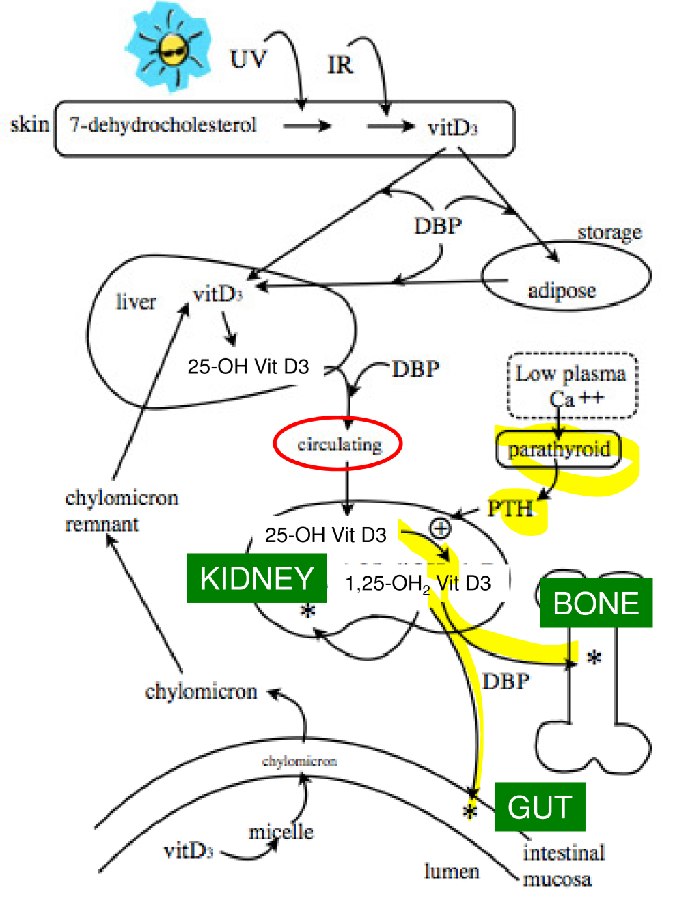
skin/sun
- 7-D rapidly converted to vit D3 (10 min)
- No risk of vit D toxicity from sun
- Vit D3 enters blood bound to DBP and can go to:
- Liver (conversion)
- Adipose (storage)
  - /body doesn’t store vit D, small levels would be in adipose tissue/skin but not a depot
  - /vit D just happens to be there because of its fat solubility and adipose tissue is fat
Diet
- Absorbed passively in ileum, but this is not efficient
- Incorporated into chylomicrons
- Taken up by liver in remnants
- / vit D3has to be bound to DBP to move
- /there are no differences between sun-derived and diet derived vit D3
Vit D3 conversion in the Liver
- In the liver, the 25th carbon on vit D3 is hydroxylated to form 25-OH D3 by the enzyme 250hydroxylase (a cytochrome p450 enzyme)
- Once produced, 25-OH D3 is secreted into blood bound to DBP
- This corresponds to the largest pool of 25-OH D3 in body
- /25-OH D3 will travel around the tissues unactivated
- If 25-OH D3 levels in the blood are low, this is the sign of Vit D deficiency (THIS IS KEY!)
- When calcium levels are low in the body, the inactive 25-OH D3 will be converted into its active from
Active Vitamin D3
- High gradient of blood to intracellular Ca²⁺ is essential
- /need high gradient in the outside for signalling
- /low levels undesirable since no signalling will be done
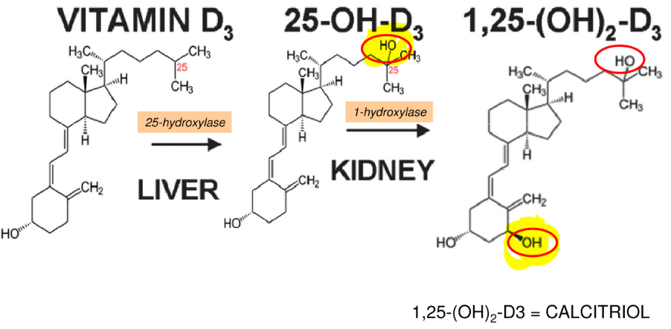
- Low blood Ca²⁺ is sensed by the parathyroid gland
- Releases PTH (parathyroid hormone)
- Promotes uptake of 25-OH D3/ DBP complex in kidney via endocytosis
- 1-hydroxylase activates Vit D3
- 1,25-(OH)2 D3 = calcitriol
- /1-hydroxylase hydrolyses 1-25OH D3 by adding an extra OH
- 25-OH D3 -> 1,25 (OH)2 D3
- /calcitriol bound to DBP to different parts of the body
Calcitriol Signalling
- Vit D3 activated in kidney and then sent out into the body
- /calcitriol will regulate and low levels of Ca
- /helps adapt to low levels and builds a response to low levels of Ca
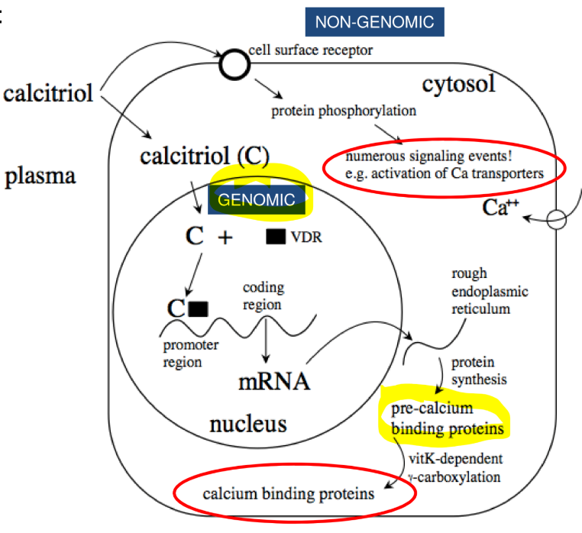
- Two intracellular signalling pathways:
1. genomic
- Vit D receptor (VDR)
- VDR = nuclear hormone receptor
- Transcription factor promoting calcium binding protein synthesis
- Activated by PTM
  - Vit K -> co factor
  - γ-carboxylation
- /calcitriol (C) and VDR affect gene expression
- /longer process takes some time
2. non-genomic
- also binds, cell surface receptors, like MARRS (membrane-associated rapid response steroid-binding protein)
  - /remember MARRS which triggers signalling pathways
- trigger intracellular signalling cascades
- very fast, no dependence on Vit K
- /leads to modifications on existing protein
- bone uses both pathways
- /precalcium binding proteins are to ensure that Ca is only high in the blood
- /need to make sure calcium binding proteins move out of the cells
- /proteins that are generated can’t bind until there is an interaction with vit K
- /γ-carboxylation is due to vit K
- / can’t have calcium binding proteins without K
Outcomes of Calcitriol Signalling
Responses to low blood calcium?
In bone:
- Elevated calcitriol and PTH work together to stimulate resorption of Ca²⁺ and P from bone
- Calcitriol causes an increase in the expression of RANK ligand (RANKL), a cytokine
- RANKL activates osteoclasts to increase their activity
- Osteoclasts secrete factors that degrade the bone matrix, releasing Ca²⁺ and P into blood
- /osteoclasts degrades the bone, Ca and minerals released from bone
- /99% of Ca is locked in bone for structure
- /if you body becomes deficient it sacrifices the mineralization of the bones and the bones become weak
In intestine:
- Primary function is to increase absorption and reabsorption of Ca²⁺
- Genomic and non-genomic effects:
- Calcium binding proteins are synthesized and require vitamin K dependent γ-carboxylation
- Membrane transporters
- MARRS activation
- /in intestine, if we eat food that has Ca we need calcium binding protein to move it around
- /favours absorption of Ca
Organs relevant for Vit D/Ca²⁺ story
- Absorption (small intestine)
- Minerals need transporters to get through the membrane into the mucosal cells and more transporters to pass into portal circulation
- Proper absorption of Ca²⁺ depends on the expression of Ca²⁺ binding proteins in epithelial cells
- Reabsorption (kidney)
- Small molecules like Ca²⁺ circulate in blood and eventually reach the kidney, where they pass through the filter and can end up in the urine (unless reabsorbed). Reabsorption removes the molecules from the filtrate and gets them back into the blood
- Resorption (bone)
- Dissolving bone structure to release Ca²⁺ into the blood
  - Osteoclasts resorb, osteoblasts build
  - Balance between break-down and synthesis allows for bone maintenance, remodeling and repair
Ca²⁺ hormonal control system
- Key point -> maintaining blood Ca²⁺ more important than maintaining Ca²⁺ reserves in bone (as seen with pregnancy and lactation)
- Vitamin D (calcitriol)
- Serves to increase blood calcium
  - Stimulates Ca²⁺ resorption from bone
  - Facilitates absorption of Ca²⁺ from intestine
  - Maximizes tubular reabsorption of Ca²⁺ in kidney
- PTH (parathyroid hormone)
- Secreted by the parathyroid glands
- Serves to INCREASE blood calcium (1st response)
  - Promotes the production of calcitriol in kidney by activating 1-hydroxylase
  - Stimulates resorption of bone (activation of osteoclasts)
  - Maximizes tubular reabsorption of calcium in kidney
  - No direct effect on small intestinal absorption
- /activates and allows calcitriol to be made
- /plays a role in different tissues
- Calcitonin
- Secreted by parafollicular cells in the thyroid
- Served to DECREASE blood Ca²⁺(e.g. in response to Ca²⁺ rebound)
  - Suppresses tubular reabsorption of Ca²⁺ in kidney
  - Inhibits bone resorption and facilitate remineralization
- /used to maintain calcium levels in the bloods and decreases level if too high
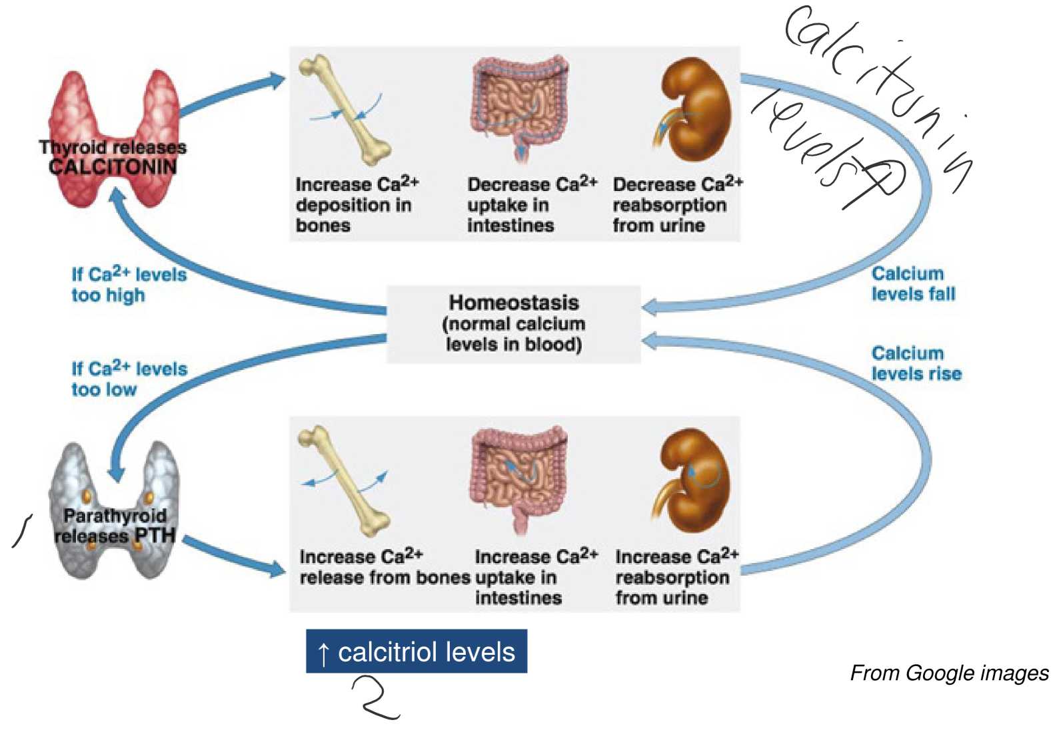
- /calcitonin doesn’t work in the level of the intestine

Vitamin D deficiency
- Consequence of Vit D deficiency varies across the lifespan
- Composition of normal bone?
- Mixture of soli (outer) and spongy (inner) parts
- What is mineral and what is organic?
  - Solid part -> 60% mineral (Ca²⁺, P) and 40% organic (collagen)
  - In babies, bones starts as collagen and gradually become infused with mineral /with diet
  - Deficiency concerns solid bone only, which changes the ratio of mineral to collagen in the bone matrix
- Vit D deficiency in infants -> rickets (p0or mineralization)
- Bones don’t mineralize properly and can’t support the body’s weight when they start walking (permanent)
- Was seen in Britain during the industrial revolution where UV lights were used because of fog, cod oil used too
- /if there is not vit D, kids can’t produce Ca and legs can’t sustain BW so they curve
- / this can only be reversed with surgery
- Vit D deficiency in adolescents to adult -> osteomalacia
- Bones become demineralized (can be reversed with supplementation)
- Bone fractures can occur more easily
- /can be reverse since bones are already developed and the only thing affected is the mineral content
- /reversed with diet
- Vit D deficiency in Middle-aged to elderly -> osteoporosis
- Normal part of aging (loss of both mineral and organic parts of bone)
- Diagnosed with bone density scans
- Difficult to reverse due to erosion of bone (holes in bone form)
- /supplementation can prolong osteoporosis but can’t reverse or fix it
- Best supplementation method? Take both Vit D3 and Ca²⁺

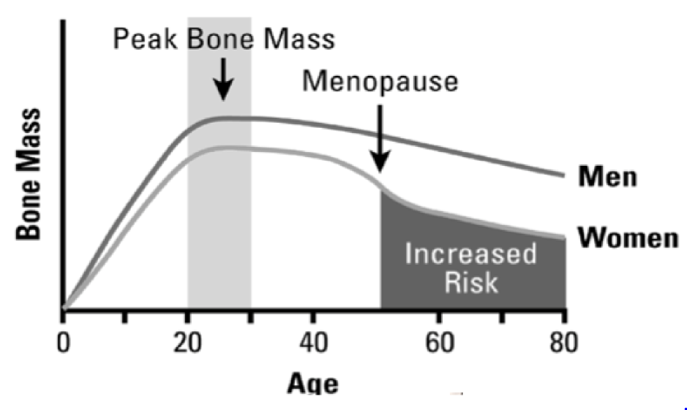
Osteoporosis
- Bone loss associated with aging, /will occur in everybody
- Worsened by chronic low Ca²⁺, vit d and/or vit K intake
- Fractures (e.g. hip) often lead to mortality in the elderly
- Men have higher peak bone mass between 20-30 years and lower bone loss
- Treatments include supplementation or drugs that affect bone formation/resorption
- /after 30 years, bone density is gradually lost
- /can’t prevent it but can push it off in the long run
- /women lose more bone density due to menopause

Seasonal Variation and Supplements
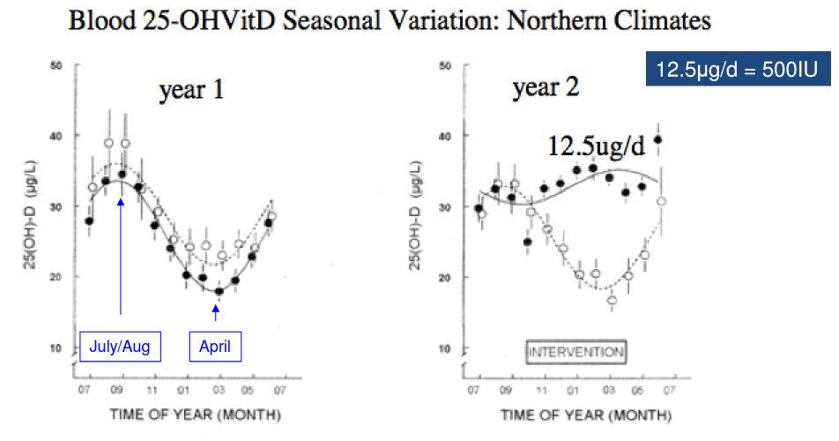
- Vit D surveys and human intervention studies suggest that increasing Vit D3 improves bone mass; decreases colon, prostrate and breast cancers; diminishes MS, psoriasis, rheumatoid arthritis; decreases hypertension and CVD; decreases diabetes; improves muscle strength and motor nerve function in elderly
- /in a group study one untreated group was affected by the season and the supplementation group was unaffected
- /RDA was increased for Vit D to promote that supplementation is the only way to prevent deficiency

Recent changes to the RDI for vit D
- RDA fro vit D intake for adults = 600 IU (international units)
- 1 ug vit D = 40 IU so this means 15ug of vit D/day
- In 2010, the RDA was 200 IU. Health Canada tripled the RDA based on overwhelming evidences
- Used input from research, stakeholders and scientists
- Pregnancy doesn’t need an increase of vit D because women naturally increase their ability to absorb calcium and reduce excretion, so body has adapted to prevent a deficiency
- /as you get older RDA increase, infants have lower RDA values than children
Vitamin D toxicity
- No risk of vit D toxicity from sun exposure
- Production of vit D3 is limited by amounts of 7-D present in skin
- Also produces the inactive lumisterol and tachysterol metabolites with prolonged sun exposure
- /no risk if only source of vit D is sunlight
- Can get much higher levels of circulating 25-OH D3 from dietary intake
- Vit D3 is absorbed and incorporated into cr and eventually end up in the liver where it is hydroxylated at position 25 and returned to circulation as 25-OH D3 bound to DBP
- Very high dietary levels can cause hypercalcemia, with possible calcification of soft tissues
- People with vit D intake greater than 10,000 IU (or more)/day for several months experience toxicity (hypercalcemia)
- This can happen because food are fortified with vit D now, people take dietary supplements, spend time in the sun etc., /but not common since people aren’t commonly getting all sources of vit D
- /toxicity can happen due to changes in our diet

Vitamin K
- Vitamin K named after the Danish word koagulation which means coagulation (so vit K important for bone formation and blood coagulation)
- Chicks fed a low-fat and cholesterol-free diet bleed excessively and their blood took a long time to clot. When vit K was added to their diet, the problems were reversed
- Dam and Doisy won the Nobel prize in Medicine in 1941 for this discovery
- Provided by green leafy plants (as phylloquinone)
- Sensitive to light and heat
- Babies are born with poor vit K status because:
- No vit K in mother’s milk and not eating leafy plants
- Haven’t developed their colonic microflora, which can produce vit K and gut bacteria isn’t passed on thru milk
- /will get a heel prick to prevent deficiency while they start to eat food and produce gut bacteria
- Vit K is also made by gut bacteria, in the form of menaquinone
- Deficiency rare in adults due to colonic synthesis
- /vit K can be absorbed thru raw vegetables or gut bacteria
Vitamin K – digestion and absorption
- Phylloquinone requires no digestion
- Incorporated into micelles and absorbed in the small intestine (jejunum)
- Apical active transporter remains unidentified
- Menaquinones synthesized by bacteria in the intestine
- Passive absorption
- Using menaquinones varies from person-to-person (genetics)
- Both incorporated into chylomicrons and delivered to various tissues
- Vit K stored in cell membranes in lungs, kidneys, adrenal glands, bone, etc…
- /only difference between menaquinone and phylloquinone is the side chain
Vitamin K Cycle
- /3 step cycle to transfer electrons for γ-carboxylation
1. vit K quinone (mena or phylloquinone) will be reduced by quinone reductase to its active form Vit K hydroquinone
2. Vit K hydroquinone is then used as a substrate by γ-glutamyl carboxylase in the conversion of glutamic acid to γ-carboxyglutamic acid.
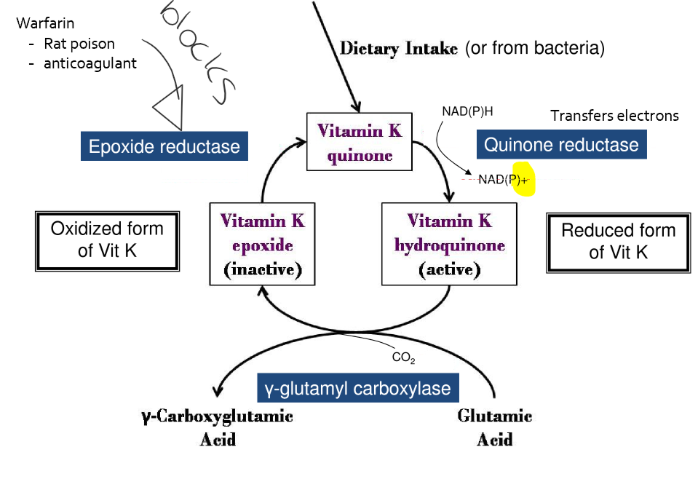
- during step 2 vit K hydroquinone is then turned into is inactive and oxidized form vit K epoxide
3. Vitamin K epoxide is then converted back to vitamin k quinone by epoxide reductase
- this is a PTM on several proteins that need Ca²⁺ to allow for coagulation
- /warfarin which is a rat poison and anticoagulant blocks epoxide reductase from converting epoxide into quinone
- /γ-carboxylation helps with Ca binding
- Is important for coagulation,
- Vast majority of proteins (?) are dependent on their ability to bind and hold on to calcium
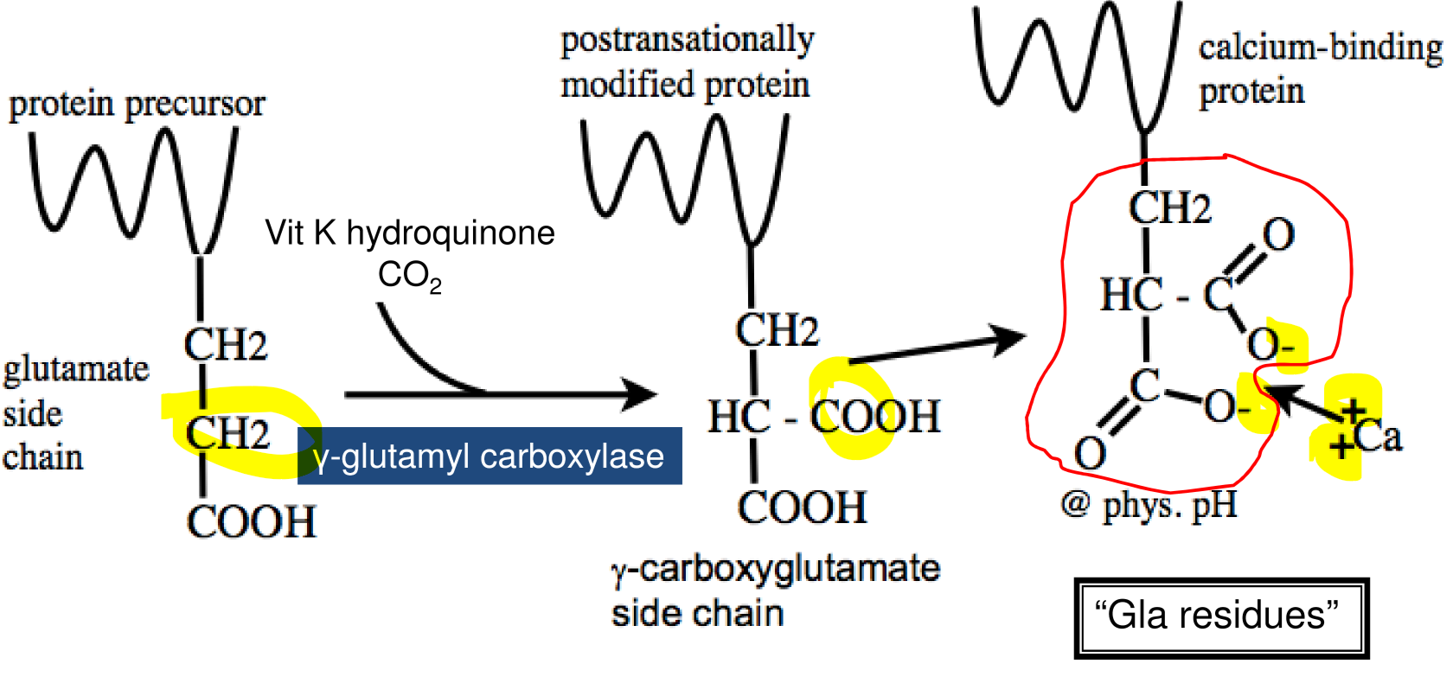
Vitamin K and γ-carboxylation
- Gla residues on blood clotting proteins bind Ca²⁺.
- Ca²⁺ mediates binding of Gla-containing proteins to phospholipids on membranes of blood platelets and endothelial cells
Vitamin K Deficiency and Toxicity
- Virtually no instances of toxicity in adults
- Susceptible populations?
- Newborns (injected with phylloquinone after birth)
  - No vit K in breast milk
  - Little vit K can cross the placenta
  - Gut bacterial population not established
- People consuming antibiotics chronically
  - Antibiotics destroys the gut bacterial community
- People with malabsorptive illnesses (IBD, Crohn’s, pancreatitis)
- Deficiency symptoms related to role in γ-carboxylation
- Impaired blood clotting
  - Possible hemorrhagic syndrome (mostly newborns)
- Impaired activation of calcium binding proteins
  - Osteoporosis
Calcium
- Represents ~40% of the body’s mineral mass
- 1,000-1,400 mg in human body
- Bones and teeth contain about 99% of the calcium
- The remaining 1% is critically important for signalling pathways
  - /if there is a problem with the 1%, bone wil be sacrificed for signalling pathways
- Predominantly obtained from dairy products, but also high in sardines, salmon and some green leafy vegetables
- Present as an insoluble salt
- Stomach acidity creates soluble Ca²⁺
- Absorption (25-30% of dietary calcium absorbed)
- /low absorption percentage since other dietary intakes can inhibit Ca absorption
- /very sensible to food matrix
- Saturable, carrier-mediated, active transport
  - In duodenum and jejenum (regulated by calcitriol)
  - Most calcium absorbed this way
- Diffusion via paracellular route is a secondary pathway for uptake
- Transport in body
- 40% bound to albumin /(common protein in blood)
- Up to 10% found complexed with sulfate, phosphate, etc.
- 50% found in free (ionized) form /important for 1% Ca used in signalling pathways
Calcium – functions
- Bone (99%)
- Minerals (calcium, phosphorous, fluoride, magnesium, potassium, etc) make up hydroxyapatite (a crystal like structure)
  - This is ~60% solid bone mass
- Intra an extracellular (1%)
- Ionized calcium is active and used for:
  - Blood clotting (via ‘Gla’ residues)
  - Skeletal muscle contraction (release of calcium stores)
  - Nerve potential (via ion channels)
  - Intracellular signalling pathways
    - For example, Ca²⁺ activates PLA2 which cleave AA from PL to produce eicosanoids (ex of premidterm kind of question)
- If intra- and extracellular levels of Ca²⁺ drop, bone will be sacrificed otherwise death occurs.

Calcium in the small intestine
- /diagram shows how calcium is being absorbed from intestinal lumen into the blood
- /its more important to have calcium ions in blood so that when channels open calcium ions can rush in
- /need to make sure there isn’t an accumulation of calcium in the intestinal cells
- /in the intestinal cell there are many proteins that are involved in the transport of calcium
- /calcitriol is important to work in our genomic expression
- /for calbindin-D to bind to calcium it needs γ-carboxylation
- Calbindin-D is important because the intracellular levels of calcium would be a lot and the concentration gradient would be equal and it would stop working
- /calcium has different transport mechanism in order to get to blood
- /concentration of calcium is greater in the blood then lumen and then in the intestinal cells
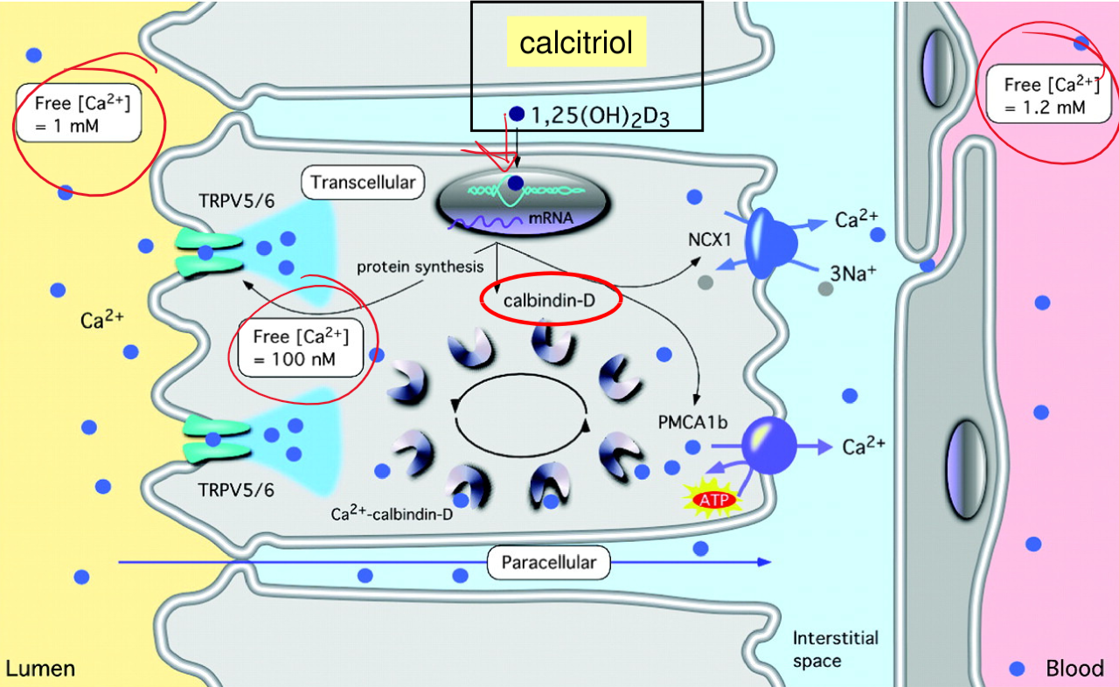
- /TRP5/6 and calbindin-D expression decreases with age
Body distribution of Calcium
- Intracellular calcium
- Mostly stored in mitochondria and ER
- Released from stores in response to an extracellular signal (e.g. receptor binding)
- Transduces signal into an intracellular response (gene expression, neurotransmission, etc.)
- /can get a very rapid response
- Blood calcium
- Approximately ½ is bound to proteins
- Maintained at a very constant level; 10,000x the concentration of intracellular calcium***
- Nearly identical to the concentration of phosphorous
- Bone calcium
- The majority (around 99%) of calcium in the body is in the bone and teeth
- In bone, 99% is in mineral phase (hydroxyapatite, with phosphorous), and 1% is in a pool that can exchange with extracellular calcium
Recent changes to Ca²⁺ DRI
- /changes in levels due to consequences of high intake
- Recent changes related to UL?
- Increase of UL in children
- Decrease of UL in adults (51-70 years)
- Decrease in older than 70 years to prevent developing kidney stones
- Factors affecting calcium absorption
- Caffeine decrease absorption
- Fibres decrease absorption
- Magnesium and zinc decrease absorption
- PTH (vit D) increase absorption
- Pregnancy and lactation increase absorption
Ca²⁺ deficiency and toxicity
- Deficiency
- Profoundly affects bone and muscle
- Bone:
  - Inadequate mineralization in bone
    - Rickets in children (commonly associated with vit D deficiency)
    - Osteoporosis in adults, sometimes osteomalacia
- Muscle:
  - Tetany
    - A condition characterized by involuntary muscle contractions
- Evidence for association with hypertension
- Evidence for association with colon cancer (current research supports association in high risk populations)
- Toxicity
- Constipation, bloating and/or gas
- Hypercalcemia
  - Kidney stones
Phosphorous
- Widely distributed in food, so deficiency and toxicity are very rare;
- however, very important in physiology (2nd most abundant mineral in body)
- Found in both animal products (as phosphorous) and in grains (as phytic acid)
- Most phosphorous absorbed in the small intestine as an inorganic ion
  - Passive diffusion (primary method)
  - Saturable, carrier-mediated, active transport (NaPi cotransporter)
- 50-70% of the phosphorous in foods is absorbed
- Absorption is inhibited by magnesium, aluminum and calcium (-> phosphate binders)
- Primarily transported in the blood as organic phosphate (e.g. in phospholipids)
- Found largely in bone (hydroxyapatite), but also central to metabolism (ATP, DNA, RNA, cAMP, etc)
- Plays a key role in protein phosphorylation (common PTM in proteins)
Fluoride (F⁻)
- Fluoride present in the body in trace amounts; not essential
- Community water fluoridated (with ~1ppm or ~1mg/L) for the past 60 year due to the inverse relationship between fluoride intake and dental caries – (water not fluoridated in Guelph)
- Absorption in stomach by passive diffusion (nearly 100% efficiency)
- Transported in the body as ionic fluoride or bound to plasma proteins
- Major function related to effects on mineralization of teeth and bones
- Increases resistance of enamel to acid demineralization by forming fluoroapatite (protective layer)
- Deficiency -> increased incidence of tooth decay
- Toxicity -> fluorosis (molting of teeth)
- Tolerable UL in adults is 10 mg/day

