Anatomy Study – Chapter 20 – Lymphatic System
• 2 parts: lymphatic vessels & lymphatic tissues/organs
- lymphatic vessels: system of drainage vessels that collect excess protein-containing interstitial fluid and return it to the bloodstream. carries up to 3 L of “leaked” fluid plus plasma proteins to be returned to the circulatory system. Once interstitial fluid enters the lymphatics it = lymph

- lymphatic tissues/organs: essential in body defense/resistance to disease
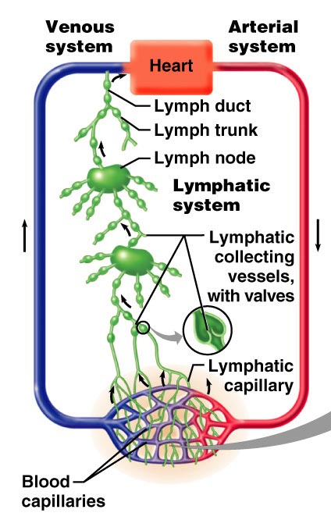
Lymphatic Vessels
- begins with microscopic blind-ended lymphatic capillaries (lacteals)
- lacteals = more permeable than reg capillaries
- everywhere in the body except bones, teeth, bone marrow, CNS
- lymph capillaries = so permeable because of two structural modifications:
- flap-like minivalves – endothelial cells forming lymph capillaries are not tightly formed. The edges of adjacent cells overlap forming flap-like valves
- collagen filaments – anchor the endothelial cells to surrounding structures so that any increase in IF volume opens the valves rather than causing lymphatic capillaries to collapse

What happens when fluid pressure builds up in tissues? – when its greater than pressure in the lymphatic capillary, the flaps open making it easier for it to flow into the capillary

When pressure = greater inside capillary, forces flaps closed, preventing lymph from leaking back out
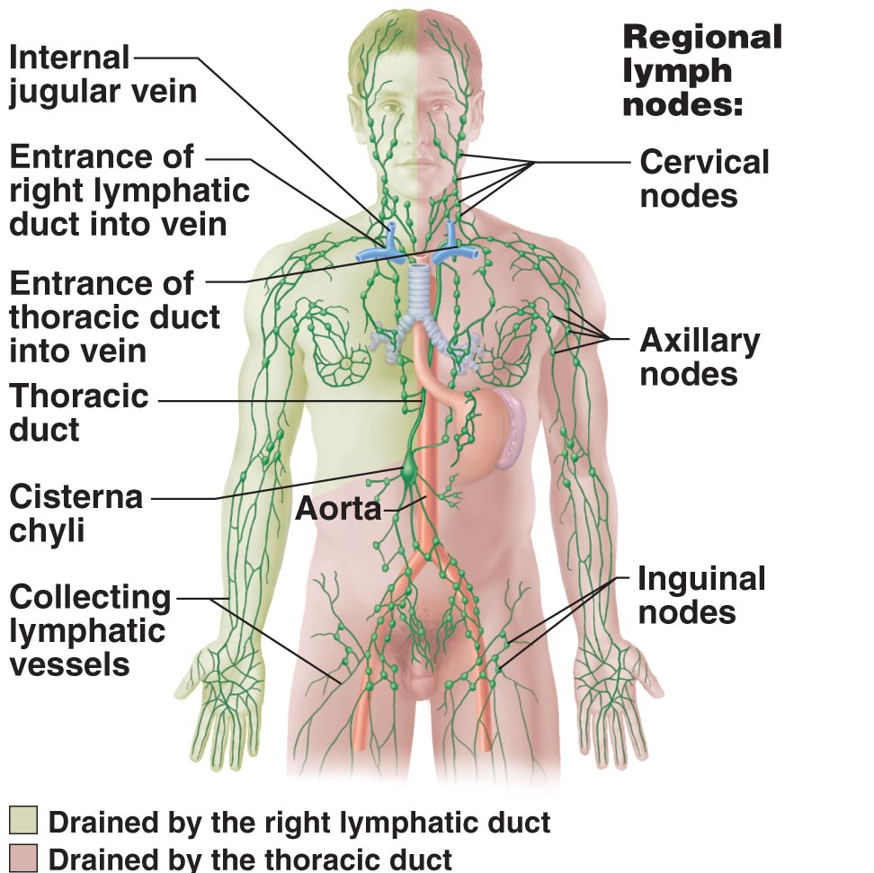

Right Lymphatic Duct drains lymph from: right upper limb, right side of head & thorax

(Much Larger) Thoracic Duct drains lymph from: the rest of the body

* this division is very unequal, bumps represent lymph nodes, where a lot of these lymphatic veins are joining there are clusters of lymph nodes locally distributed

Lymph Nodes
- principle lymphoid organs in the body
- clustered along lymphatic vessels of the body
- larger clusters where lymphatic vessels converge to form trunks (inguinal, axillary, cervical regions)

Two Basic Functions:
- filter lymph (macrophages in the nodes remove & destroy microorganisms and other debris that enter the lymph, preventing them from being delivered to the blood and spreading to other parts of the body)
- activate immune system (lymph nodes are strategically placed where lymphocytes encounter antigens and are activated to mount attack on them)

1. Lymphoid Cells
- fight infectious microorganisms that have penetrated epithelial layer & are starting to proliferate in underlying loose CT

Fought Off By:
Lymphocytes: main warriors of the immune system. Arise in red bone marrow.
Two Types: T-cells (manage immune response; some are soldiers which directly attack and destroy infected cell) & B-cells (protect the body by producing plasma cells – what are these? Daughter cells that secrete antibodies into the blood, antibodies mark antigens for destruction)

Macrophages: phagocytize foreign substances and activate T-cells (as they are digesting the foreign things they will advertise these disgusting things on their surface to try to rid of any other things that might be present) – “garbage collectors” which go around cleaning up all debris to keep our fluid as clean as possible

2. Lymphoid Tissue
Functions:
- houses and provides proliferation sites for lymphocytes – to increase the size of the army that can go out and fight these foreign substances
- makes ideal surveillance vantage point for lymphocytes & macrophages

Largely made up of reticular CT: in all lymphoid organs except thymus; also in lamina propria of mucous membranes; macrophages live in the fibers of the network; lymphocytes make temporary stopovers (occupy spaces in the network) in between patrolling the body – this cycling of lymphocytes ensures that they can reach infected or damaged sites quickly
- Makes up a finer network (meshwork)
- All lymph organs except the thymus

- Lymph Nodes
- Lymphoid organs
- discrete, encapsulated collections of diffuse lymphoid tissue + follicles
- ~2.5 cm long
- divided into compartments by trabeculae (ct strands which extend inward to divide node)
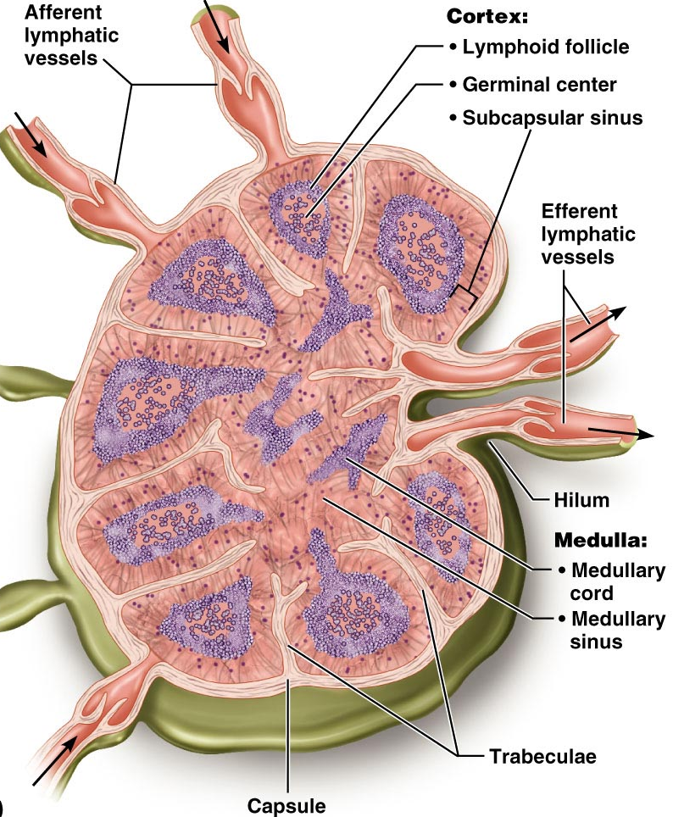
Two Distinct Regions:
Cortex:
- follicles with germinal centres – what happens here? Heavy with dividing B cells *******
Medulla:
- medullary cords & large lymph sinuses
- lymph sinuses = large lymph capillaries spanned by crisscrossing reticular fibers. Many macrophages live in these fibers and phagotize foreign matter as it flows by sinuses

Circulation in Lymph Nodes:
- lymph enters the convex side of a lymph node through afferent lymphatic vessels
- then moves through subcapsular sinus, into many smaller sinuses that cut through the cortex and enter the medulla
- exits through the hilum (the indented region on the concave side) via efferent lymphatic vessels
- lymph passes through several nodes before it is cleansed
- there’s no pump in the node we just move fluid through vessel with valves

- Note the one-way flow of traffic through each lymph node
- fewer efferent vessels draining node than afferent ones feeding it. Significance = flow of lymph through the node is stagnated allowing time for the lymphocytes to carry out their protective functions
- gives time to take a good look at the fluid, held in the lymph node for a short period of time to hopefully recognize anything that’s foreign and present in it

Other Lymphoid Organs:
- except for the thymus, all lymphoid organs are made of reticular ct
- but only lymph nodes filter lymph
- other organs have only efferent lymphatics draining them but no afferent lymphatics
- other organs include: spleen, thymus, tonsils, Peyer’s Patches of the intestine

1. SPLEEN
- largest lymphoid organ
- not essential for life but very important
- located in the left side of the abdomen just below diaphragm
1) site for lymphocyte proliferation, immune surveillance & response
2) blood cleaning (by removing aged and defective blood cells and platelets from blood, macrophages remove debris and foreign substance flowing through its sinuses)
3) stores some RBC products (iron) for recycling
4) RBC production in fetal development (ONLY)
5) stores blood platelets
- spleen is composed largely of erythrocytes:
- areas that are mostly WBCs suspended in reticular fibers = white pulp (involved in immune functions of spleen)
- surrounding clusters of white pulp = red pulp (disposing of worn-out rbcs and bloodborne pathogens)
- spleen’s capsule is very thin, meaning that a direct blow or severe infection may cause it to rupture, spilling blood into the peritoneal cavity so may need to be removed. If removed, the liver and bone marrow take over much of its function
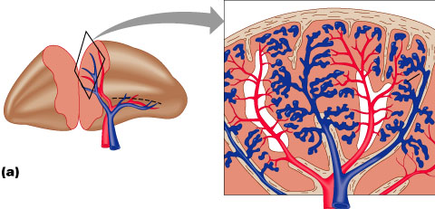
2. Thymus
- important functions primarily during early years of life
- site where T lymphocyte precursors become immunocompetent lymphocytes (where they become able to defend us against specific pathogens in the immune response)
- prominent in newborns
- increases in size throughout childhood; then starts to atrophy after puberty and by old age has been replaced by fibrous and fatty tissue

- lymphocyte maturation - only lymphoid organ that does not directly fight antigens or police since it functions strictly to in maturation of T lymphocyte precursors (Wbcs and rbcs go here to be tested for how well they are able to distinguish antigens and if they fail the test they are destroyed)
- stroma consists of star-shaped thymocytes that secrete thymosin & thymopoietin

3. Tonsils
- ring of lymphatic tissue at entrance to pharynx
- Located in areas where they are policing the air but also fluids and foods that travel through the oral cavity
- named according to location:

1) palatine tonsils: right side of picture, largest of the tonsils and most often infected
2) lingual tonsil: a lumpy collection of lymphoid follicles at the base of the tongue, only one that’s not paired
3) pharyngeal tonsils (adenoids): located in the posterior wall of the nasopharynx. These constantly sweep materials out of the throat to catch possible infectious agents (policing)
4) tubal tonsils: tiny tonsils surrounding the auditory tubes into the pharynx. These gather and remove many of the pathogens entering the pharynx in food or in inhaled air.
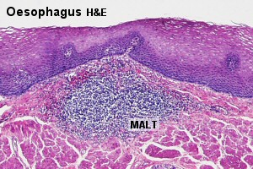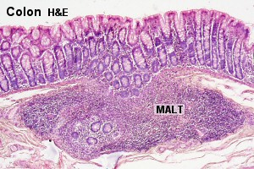

- Aggregates of Lymphoid Nodules

1) Peyer’s patches: large clusters of lymphoid follicles, structurally similar to the tonsils. Located in the wall of small intestine
2) Appendix: lymph nodules forming offshoot of cecum first part it the large intestine
• BOTH: 1) destroy bacteria; 2) generate memory lymphocytes for long-term immunity

MALT = Mucous Associated Lymphatic Tissue = Peyer’s patches + appendix + tonsils + nodules in walls of bronchi and areas of GI tract & genitourinary system

5.2 Explain the origin of lymph as well as its transport
- lymphatic capillaries in inflamed tissues??
- lymph detours through lymph nodes before entering blood
- lacteals in intestinal villi??
- lymphatic collecting vessels have same 3 tunics as veins, but are thinner-walled,more valves, more anastomoses
- lymphatic trunks: paired lumbar, bronchomediastinal, subclavian & jugular trunks; single intestinal trunk

1. Right lymphatic duct: lymph from rt upper arm, head, thorax
2. Thoracic duct: from lower limbs, intestinal trunk, lt thorax, upper limb/head



