Anatomy Study – Chapter 19 – Blood Vessels

General Blood Vessel Structure and Function:
Compare & Contrast Structure of Capillaries, Arteries and Veins
- three major types of blood vessels are arteries, capillaries, veins
Passage of Blood = Arteries > Arterioles > Capillaries > Venules > Veins

Arteries – blood vessels that carry blood away from the heart and into the circulation
Arterioles – smallest branches of arteries (“little arteries”)
Capillaries – the smallest of blood vessels and sites of exchange between the blood and blood tissues, only capillaries directly serve cells
Venules – a small vein
Veins – blood vessels that carry blood toward the heart from the circulation

Structure of Blood Vessel Walls
3 Layers Surrounding the Lumen:
Tunica Intima
- innermost layer (think intimate with blood)
- single layer of endothelial cells (simple squamous epithelium)

Tunica Media
- middle layer
- primarily smooth muscle but also elastic tissue, because arteries and arterials are capable of regulating their diameter to reduce how much blood is going somewhere if it is more needed elsewhere
- either vasoconstriction (reduction in lumen diameter) or vasodilation (increase in lumen diameter as smooth muscle) – mostly performed by elastic fiber
- this is regulated by vasomotor nerve fibers of ANS
- critical in regulating circulatory dynamics because small changes in vessel diameter greatly influence blood flow and blood pressure
- bulkiest layer in arteries

Tunica Adventitia (Externa)
- external layer
- mostly collagen fibers that protect vessel, reinforce vessel and anchor it to surrounding structures
- “coming from outside”

- the three vessel types vary in diameter, length, wall thickness, tissue makeup

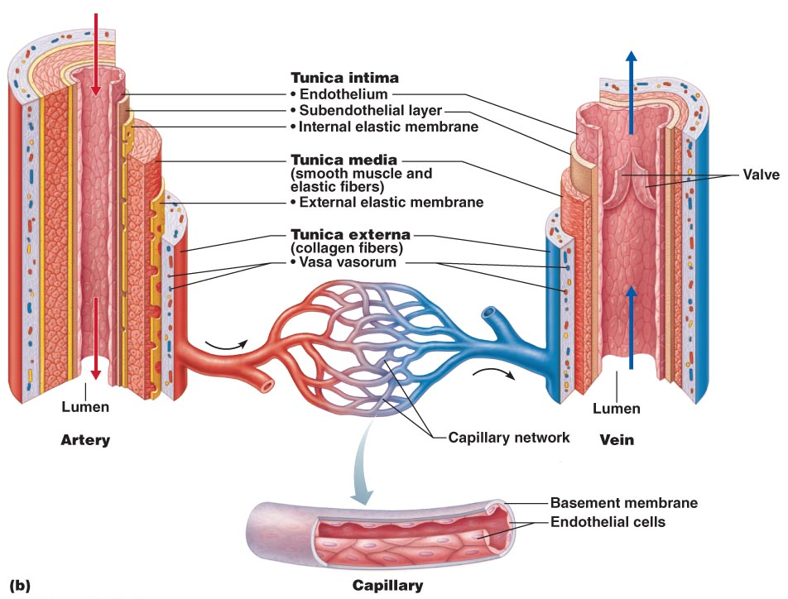

Arterial System
Compare and Contrast the Structure and Function of The Three Types of Arteries:
- arteries are at the beginning of the pathway so they have to be able to stretch to accommodate 70 ml of blood in resting conditions and even more in working conditions
- much thicker wall in artery than in a vein

Three Types:
Elastic (Conducting) Arteries
- thick-walled, large diameter arteries (large lumens)
- near the heart
- highest proportion of elastin (most elastic of the three)
- Conducting since they are low-resistance pathways that conduct blood from the heart to medium-sized arteries
- recoil help maintain pressure & flow of blood
- smooth our pressure fluctuations (keep blood flowing fairly smoothly rather than starting and stopping or having a jerky discharge from the heart)
- without pressure smoothing effect of elastic arteries, walls would experience higher blood pressures, weaken and balloon or even burst
- have to be able to change diameter since they are at the beginning of the pathway and deal with systolic and diastolic pressure

Muscular (Distributing) Arteries
- deliver blood to specific organs
- (0.3 mm – 1 cm diameter)
- have the thickest tunica media of all vessels:
- more smooth muscle vs. elastin (consequences of this are: they are more active in
vasoconstriction and less distensible [less capable of being stretched under
pressure])

Arterioles
- smallest of the arteries (10 um to 0.3mm diameter)
- tunica media primarily smooth muscle, in smallest arterioles there is only a single layer of smooth muscle
- arteriole diameter determines which capillary beds flushed, minute-to-minute:
- when arterioles constrict, the tissues served are largely bypassed, when arterioles dilate, blood flow into the local capillaries increases dramatically
- less elastic since they are farther away from the heart so see less change in pressure

Capillaries
- smallest blood vessels
- thin walls of only tunica intima
- length = ~1 mm; lumen diameter = 8-10 um
- function = exchange
- pericytes – smooth muscle-like cells on the outer surface of some capillaries, stabilize capillaries and help control capillary permeability

3 Types of Capillaries:
* from least leaky to most leaky

- Continuous Capillaries:
- abundant in skin & muscle
- most common
- continuous = their endothelial cells provide uninterrupted lining, adjacent cells joined by tight junctions
- but spaces between these cells exist as intercellular clefts - allow limited passage of fluids and small solutes
- either in places we want to protect a lot (ex. CNS) or skin and muscle
- in the brain the tight junctions of complete continuous capillaries which extend around the entire perimeter of endothelial cell – Blood-brain barrier

- Fenestrated Capillaries:
- similar but endothelial cells are riddled with pores (fenestrations) = increased permeability to fluids/small solutes
- located in small intestine (receive nutrients from digested food), endocrine organs (allow hormones entry into the blood), kidney (filtering the blood)
- areas where the functions of these cells and tissues is transportation

- Sinusoidal Capillaries:
- highly modified, leaky capillaries
- found only in liver, bone marrow, lymphoid tissues, endocrine organs
- have large, irregularly shaped lumens & are usually fenestrated
- have fewer tight junctions & larger intercellular clefts for passage of proteins and RBCs
- located where you need o get in and out of the circulatory system ex. bone marrow, liver
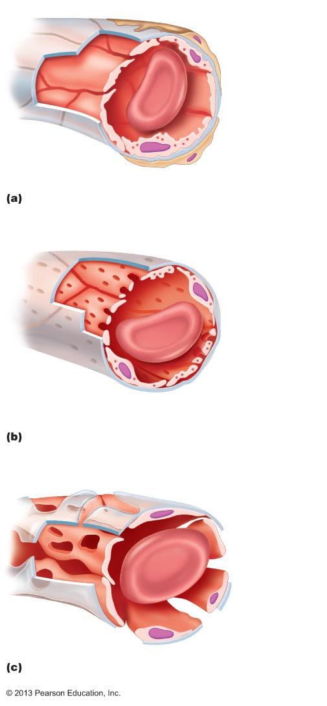

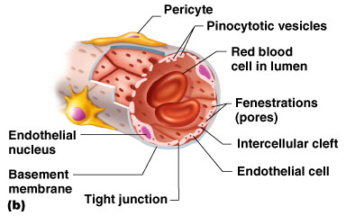
Capillary Beds
- Capillaries do not function independently, they form interconnected networks called capillary beds
Microcirculation = flow of blood from an arteriole to a venule through a capillary bed

Two Types of Vessels in Capillary Beds:
- vascular shunt = (metarteriole + thoroughfare channel) – short vessel that directly connects the arteriole and venule at opposite ends of the bed
- true capillaries = actual exchange vessels (10-100 per bed), branch off the metarteriole
- precapillary sphincter surrounds root of each true capillary – acts as a valve to regulate blood flow into the capillary

Metarteriole = central larger communicating channel, continuous with the thoroughfare channel (they’re one), blood can just be sent through the this if it doesn’t need to be transported everywhere – controlled by precapillary sphincters

Thoroughfare Channel = (intermediate between a capillary and a venule), joins the postcapillary venule – venule which drains the bed

- Blood flowing through a terminal arteriole may go through either the true capillaries or through the shunt.

sphincters = relaxed (open) blood flows through the true capillaries and takes part in exchange with tissue cells

sphincters = contracted (closed) blood flows through the shunts and bypasses the tissue cells

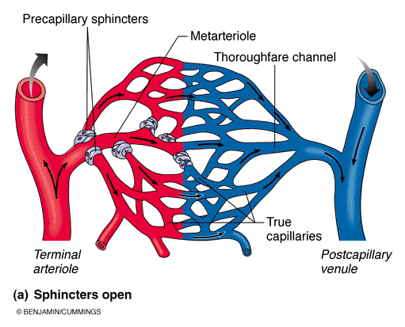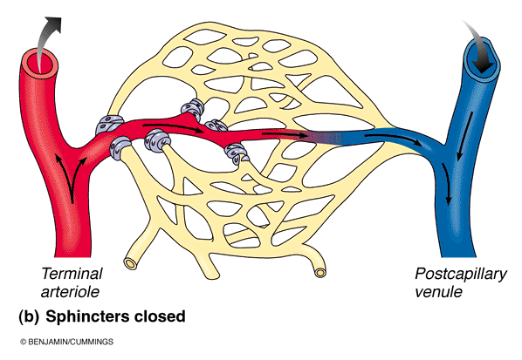
Venous System
- Venules:
- 8 – 100 un diameter
- smallest venules, postcapillary venules consist entirely of endothelium + few fibroblasts
- larger venules have sparse tunica media (one or two layers of smooth muscle cells) & thin tunica adventitia (externa)

- Veins:
- 3 tunics but walls are thinner & lumens larger
- relatively little elastin/smooth muscle in tunica media
- tunica adventitia is the heaviest layer (made of thick bundles of collagen fibers and elastic networks)
- thin tunica media even in the largest veins
- can accommodate a fairly large blood volume (since they have large lumens and thin walls), up to 65% of body’s blood volume is found in veins at any time = called capacitance vessels or blood resevoirs

Two Structural Adaptations of Veins that Promote Blood Return: 1) venous valves – similar to semilunar of the heart, prevent blood from flowing backward, most common in limbs where the flow is opposite of gravity, 2) Large Diameter Lumens – offer little resistance to blood flow so can return to heart at same rate it is pumped into circulation
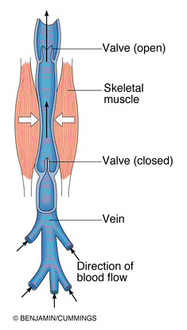
Blood Flow, Blood Pressure and Resistance

Blood Flow – movement of blood per unit/time
- can be regulated independently for various tissues & organs

Blood Pressure – the force per unit area exerted on a vessel wall by its contained blood (mm Hg)
- Refers to systemic arterial blood pressure in the largest arteries near the heart
(eg: average aortic BP = 90 mm Hg [millimeters of mercury])
- For example, a BP of 120 mm Hg is equal to pressure exerted by a column of mercury 120 millimeters high
- the pressure gradient – the difference in blood pressure within the vascular system, – is what provides the force that keeps blood moving (always area of high to low)
- If we do not have a pressure gradient (difference from beginning to end) there will be nothing to encourage its movement (ex. 90 – 90 = no flow, 90 – 30 = flow)
- Blood is being confined and pushing against the walls of vessels and arteries
- How well do they adapt to stress and recoil ??

Resistance –measures total of frictional forces that impede flow
- flow and resistance are inversely related
- Is the major determinant of blood flow because a change in blood vessel radius increases resistance to the 4th power (resistance varies inversely with the fourth power of the vessel radius [(radius)⁴]) – (ex. if the radius of a vessel is doubled, the resistance drops to one sixteenth of it original value)
- Most resistance occurs away from the heart, in the peripheral (systemic) circulation because arteries close to the heart do not change dramatically in diameter

Three Sources of Resistance:
- Blood Viscosity – caused by formed elements and plasma proteins (most important one and one we can control)
- Total Blood Vessel Length – more length = more resistance (eg. Extra adipose tissue, gaining a lot of weight)
- Blood Vessel Diameter – changes in diameter are frequent while viscosity and vessel length remain relatively unchanging (constant in healthy people), fluid close to the wall of a channel is slowed by friction while fluid in the centre flows freely (faster)

Relationship Between Flow, Pressure and Resistance
F = P₁- P₂
R

Blood Flow = Difference in Blood Pressure
Peripheral Resistance

Velocity of Blood Flow
Velocity = ~ 1/total cross-sectional area
• aorta: (2.5 cm²): 40-50 cm/sec
• capillaries: (4500 cm²): ~0.03 cm/sec
• vena cava: (8 cm²): 10-30 cm/sec (sees more open pathways ahead of it and you are pooling blood so picks up speed as it goes ahead, moves to areas of increased diameter)
* Total cross sectional area influences what happens with resistance

Systemic Blood Pressure
- any fluid driven by a pump through closed channels operates under pressure
- the nearer the fluid is to the pump, the greater the pressure exerted on the fluid
- blood flows through blood vessels along a pressure gradient from higher- to lower pressure areas
- the pumping action of the heart is what generates blood flow
- pressure results when flow is opposed by resistance
- Systemic Blood Pressure = highest in Aorta and lowest (0mm Hg) in Right Atrium
- steepest drop in blood pressure = arterioles which have greatest resistance to flow

Arterial Blood Pressure
Reflects two factors: 1) how much elastic arteries close to heart can be stretched (compliance or distensibilty) 2) volume of blood forced into them at any time

- if the amount of blood entering and leaving the heart elastic arteries in a given period were equal, arterial pressure would be constant – but it rises and falls in a regular way

Systolic Pressure – pressure exerted by blood on the blood vessel walls during ventricular contractions (av. 120 mm Hg)

Diastolic Pressure – arterial blood pressure reached or as a result of diastole, lowest level of any given cardiac cycle

- Pulse Pressure = systolic blood pressure – diastolic blood pressure
- indicates vigor of contraction of ventricle
- provides info on elasticity of aorta at the beginning of circulatory pathway & major arteries
- increases in SV and contractibility cause temporary increases in PP
- chromically increased by arteriosclerosis (elastic arteries = less stretchy)

- Mean Arterial Pressure (MAP) = diastolic pressure +1/3rd pulse pressure
- MAP is the pressure that propels blood to tissues during the cardiac cycle
- not mean of systolic & diastolic pressures since diastole is longer than systole which is why its diastolic + 1/3rd of pulse pressure
- MAP & Pulse Pressure decrease with distance from heart; by end of arterial tree, blood flow is steady & pulse pressure has disappeared

Sample Calculation: BP = 120/80 mm Hg: MAP = 80 + 40/3 = 93 mm Hg
* know how to do this calculation
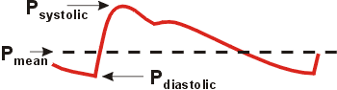

Capillary Blood Pressure
- low blood pressure once we reach the capillaries
- 35 mm Hg at entry and 15 mm Hg by the end of the capillary beds
- low pressure is desirable since:
1) capillaries are fragile and high pressures would rupture them
2) most capillaries are extremely permeable, even the low capillary pressure forces solute-containing fluids out of bloodstream into interstitial space (lots of exchange occurs at low blood pressure)

Venous Blood Pressure
- steady, changes very little during cardiac cycle (pressure gradient = ~20 mm Hg)
- by the time we get to the heart we’re just about at 0
- venous pressure is normally too long to promote adequate venous return

Three Functional Adaptations Aiding Venous Return:
- Respiratory Pump – pressure changes in the thoraxic cavity during breathing help to pull the blood up toward the heart.
- as we inhale, abdominal pressure increases, squeezing the local veins to expand and speed blood entry into right atrium

- Muscular Pump – skeletal muscle activity. As skeletal muscle surrounding deep veins contract and relax, they “milk” blood toward the heart and once blood passes each valve it cannot flow back
Ex. people in standing jobs often have swollen ankles because blood pools in feet and legs after prolonged muscle inactivity

Maintaining Blood Pressure
- homeostatic mechanisms in place to maintain adequate flow to tissues under a variety of circumstances (ex. standing up in the morning and not keeling over)
- main factors influencing blood pressure are:

Cardiac Output – how big of a push behind blood as you send it out, the bigger the push the higher blood pressure is.

Peripheral Resistance – how much resistance surrounding the flow of blood, tissue diameter etc.

Blood Volume – ex. after eating a high sodium meal, can go down if we’re dehydrated and up if we’ve consumed so much water to try to dilute the salt we just ate

Blood Pressure = Cardiac Output x Peripheral Resistance

What Determines Cardiac Output?
It is the product of:
HR (neural and hormonal factors associated with influencing heart rate)
SV (venous return, neural & hormonal factors associated with influencing heart rate)

What about Peripheral Resistance & Blood Volume??

What is Pulse? How do you take a Pulse?
Pulse = pressure wave due to alternating expansion & recoil of elastic arteries

- can feel pulse in any artery that lies close to the body surface by compressing the artery against firm tissue
ex. radial pulse (wrist) is routinely used

- also called pressure points (why? Because they are compressed to stop blood flow into distal tissues during hemorrhage
ex. if you deeply cut your hand you can slow or stop bleeding by compressing radial artery

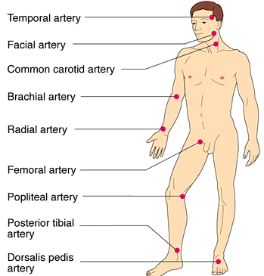

*

Measuring Blood Pressure
Auscultatory Method: measuring blood pressure in the brachial artery of the arm by use of sphygmomanometer (blood pressure cuff)

- Cuff Fully Inflated - until cuff pressure exceeds systolic pressure
(artery fully collapsed >> no blood flow, no brachial pulse)

- Cuff Pressure Lowered to < Peak Systolic Pressure
(momentary high velocity spurt through the constricted artery, when first sounds are heard) >> record cuff pressure as systolic bp

- Cuff Pressure lowered to < diastolic pressure
(continuous flow, sounds disappear) >> record cuff pressure as diastolic bp

Sounds of Korotkoff – arterial sounds heard through a stethoscope applied to the brachial artery distal to the cuff of a sphygmomanometer that change with varying cuff pressure and that are used to determine systolic and diastolic blood pressure.

Average Blood Pressures:
Normal Adults at Rest: Systolic Pressure = 110-140; Diastolic Pressure = 75-80
Above 80 = concern because it tells you that blood vessels are not as elastic as we thought
Influenced by age, gender, weight, race, stress, nutrition, mood, posture, fitness
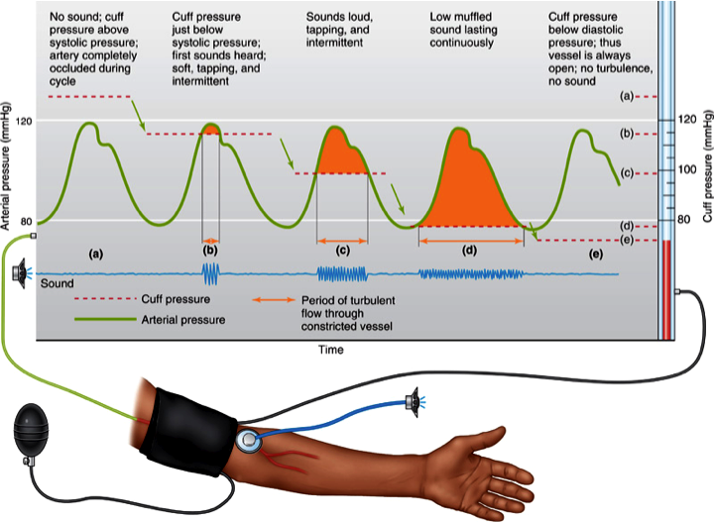
Short-Term Neural and Chemical Mechanisms for the Regulation of Blood Pressure
Short-Term Regulation of Blood Pressure
- mediated by the nervous system and blood chemicals
- counteract moment-to-moment fluctuations in blood pressure by altering peripheral resistance and cardiac output

- Two Main Goals:
- Alter blood distribution to respond to specific demands
Ex. during exercise blood is shunted temporarily from GI to skeletal muscles
- Maintain adequate MAP by altering blood vessel diameter
(very small changes in blood vessel diameter cause substantial changes in peripheral resistance and therefore in systemic blood pressure)

Most neural controls operate via reflex arcs involving Baroreceptors : a type of stretch receptor in the walls of blood vessels, can give info on blood pressure in that vessel at a given time

Vascular Smooth Muscle – output comes here, because that’s how you regulate blood vessel diameter

Parasympathetic DOES NOT regulate blood vessel diameter, only Sympathetic 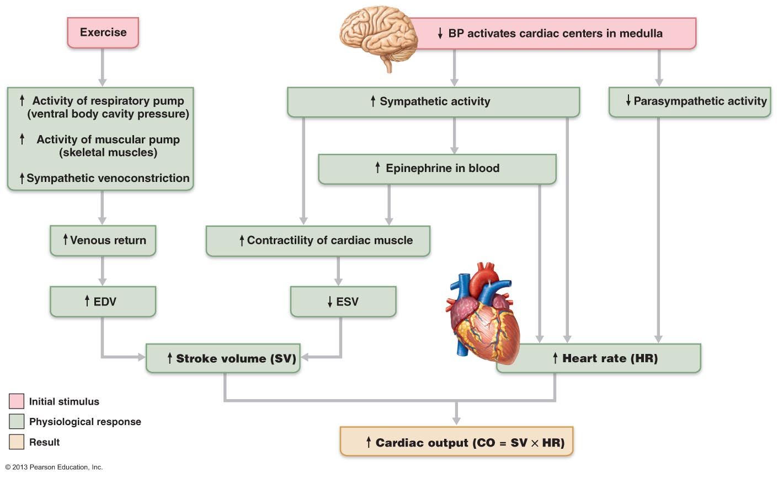
Realize that an increase in CO will lead to an increase in MAP.

Short-Term Mechanisms: Neural Controls:
Vasomotor Tone & the Vasomotor Centre
Vasomotor Centre - cluster of sympathetic neurons in medulla: part of cardiovascular centre, transmits impulses at steady rate along sympathetic efferents called vasomotor fibers, arterioles always in state of partial constriction (vasomotor tone)

vasomotor tone: constant input, especially to arterioles which tend to be more strongly constricted (NE)
- any increase in sympathetic ns activity = is going to overall induce vasoconstriction in the blood vessels & increase bp
- any decrease will decrease vasoconstriction in blood vessels & decrease bp
- This sympathetic ns activity could be a response to stress

• vasomotor centre is located in the medulla and responds to input from:
(i) Baroreceptors (monitor changes in arterial pressure and stretch)
(ii) Chemoreceptors (monitor levels of CO₂, O₂, H⁺ in bloodstream)
- if these levels are climbing they can be helped by circulating blood more quickly and bringing it back to the heart
(iii) Higher brain centres or hormones

Vasomotor Centre Responds to Input From:

- Baroceptor-Initiated Reflexes:
- baroreceptors in carotid sinuses, aortic arch (where the aorta is coming out of the heart and curving around) & other large arteries of neck & thorax

- Increasing MAP stretches receptors which send a rapid stream of impulses to the vasomotor centre, causing:
(i) dilation of arterioles (to deal with fluctuations)
(ii) venodilation to shift blood to venous reservoirs (causing decline in venous return and CO)
(iii) afferents also to cardiac centres to stimulate parasympathetic ns activity & inhibit sympathetic ns activity, thereby decreasing heart rate & contractile force

- These act to bring bp down or put a cap on the bp to keep it from getting so high that it is damaging to the walls of the vessels
- This is not redirecting blood flow – because this is in the blood vessels at the beginning of the circulatory system
- decreasing MAP initiates reflex vasoconstriction and increases CO, causing blood pressure to rise

GOAL: is to protect against short-term changes in bp (ex. changing position like standing, bending = increase in MAP, there will be adaptations to accommodate this); ineffective in sustaining pressure changes chronically (body adapts)

Baroreceptors:
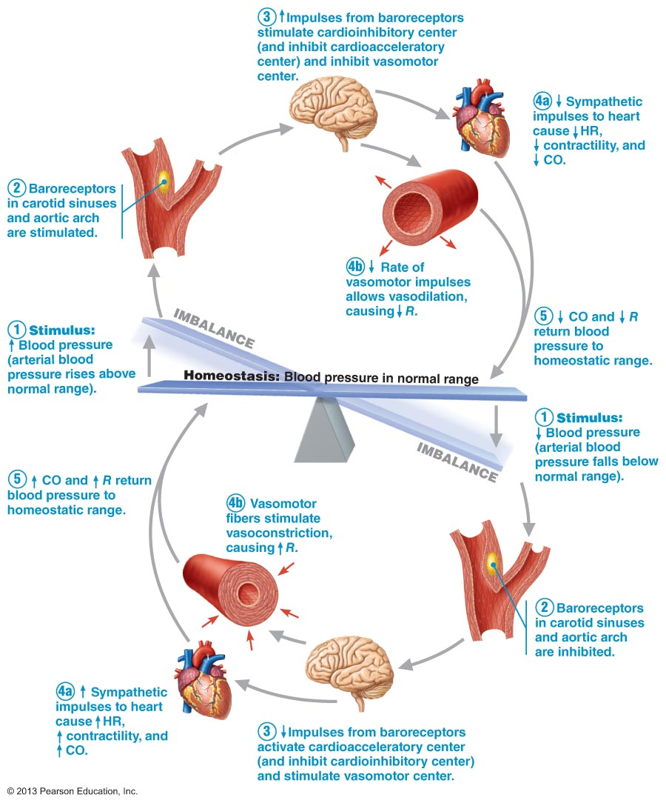

2. Chemoreceptor-Initiated Reflexes:
- monitoring what’s going on in terms of o2 or co2 levels or pH
- drop in O₂, pH or rise in CO₂: chemoreceptors in aortic arch & large arteries of neck transmit impulses to cardioacceleratory centre (causes increased cardiac output) & vasomotor centre (causes reflex vasoconstriction to try to move blood around faster, get it to the lungs more quickly etc.)
- result is a rise in bp that speeds return of blood to heart & lungs

3. Influence of Higher Brain Centres:
• “fight-or-flight”, stress, exercise, . . »» cerebral cortex & hypothalamus get involved

Short-Term Mechanisms: Hormonal Controls
- just like changing levels of carbon dioxide and oxygen can help regulate blood pressure via chemoreceptors, hormones can help regulate blood pressure both short-term and long
- Short-Term – changes blood vessel diameter

- Adrenal medulla hormones: under conditions of short-term stress not long-term, there is a release of NE and EP to blood which enhances fight-or-flight response
ex. mad for 30 mins
- vasoconstriction (going to redirect blood flow to heart so this is except skeletal/cardiac muscle »» vasodilation)
- increases CO
- nicotine mimics effects of catecholamines (mimics effects of NE or Epinephrine, tend to have a higher blood pressure all the time due to intense vasoconstriction)

- Atrial natriuretic peptide (ANP): hormone produced by atria of heart, natriuretic = encouraging the body to unload sodium at the level of the kidneys and water from the body:
a) causes blood volume & blood pressure to decrease
b) generalized vasodilation

- Antidiuretic Hormone (ADH): produced by hypothalamus/posterior pituitary, not usually important in short-term bp regulation but when bp falls dangerously low
- stimulates kidneys to conserve water (eg: severe hemorrhage) – long term effect
- if levels high, can potentially cause vasoconstriction

- Angiotensin II: release of renin when blood pressure or blood volume is low, renin acts as an enzyme generating angiotensin II, which stimulates:
a) intense vasoconstriction to increase systemic bp
b) release of aldosterone and ADH which act by enhancing blood volume

- Endothelium-derived factors:
a) endothelin is a potent vasoconstrictor
b) platelet-derived growth factor vasoconstrictor
c) nitric oxide (NO) induces brief vasodilation to improve the profusion of

- Inflammatory chemicals:
eg: histamine, prostacyclin - released during inflammatory response; potent vasodilators

- Alcohol: inhibits ADH release, depresses vasomotor centre, promotes vasodilation (especially in skin)

Long-Term Mechanisms: Renal Regulation
- Long-term – does things with altering blood volume
- although blood volume varies with age, body size and sex, it’s usually maintained @ ~5L]
- as noted earlier, blood volume is a major determinant of CO (via it’s influence on EDV, stroke volume and venous return)
• baroreceptors adapt to prolonged or chronic high/low blood pressure
• kidneys step in to restore blood pressure by adjusting blood volume
• anything that changes blood volume will change blood pressure (^ will ^, v will v)
• if blood volume increased, kidneys excrete more salt & water:

Kidneys
- Direct Action: increased blood volume/pressure = increased rate of filtrate formation → insufficient time to reclaim water → increased volume of urine

Explained: when either blood volume or blood pressure rises, the rate at which fluid filters from the bloodstream into the kidney tubules is sped up. The kidneys cannot process the filtrate rapidly enough to reclaim the water, so more of it leaves the body in urine. Results: blood pressure and volume fall

When bp is low, water is conserved and returned to the bloodstream to ^ bp & ^bv

- Indirect Action: renin-angiotensin system - MAP decreases → kidney cells release renin → cascade of reactions to yield angiotensin II (potent vasoconstrictor) → increased rate of renal perfusion
angiotensin II stimulates secretion of aldosterone (adrenal cortex) → increases renal absorption of Na⁺ & water
also increased secretion of ADH (post pituitary) promotes water reabsorption

Explained: when map v the kidneys release the enzymatic hormone renin into the blood. Renin triggers a series of reactions that produce angiotensin II. As mentioned, angiotensin II increase bp in three ways:
I) potent vasoconstrictor – increasing bp by increasing peripheral resistence

II) stimulates the adrenal cortex to secrete aldosterone a hormone that enhances renal reabsorption of sodium. As sodium enters bloodstream, water follows and blood volume is therefore conserved

III) prods the posterior pituitary to release ADH which promotes water reabsorption

* increases in blood volume that cause a rise in blood pressure also stimulate the kidneys to eliminate water, which reduces blood volume and consequently blood pressure

* falling blood volume triggers renal mechanisms that increase blood volume and blood pressure

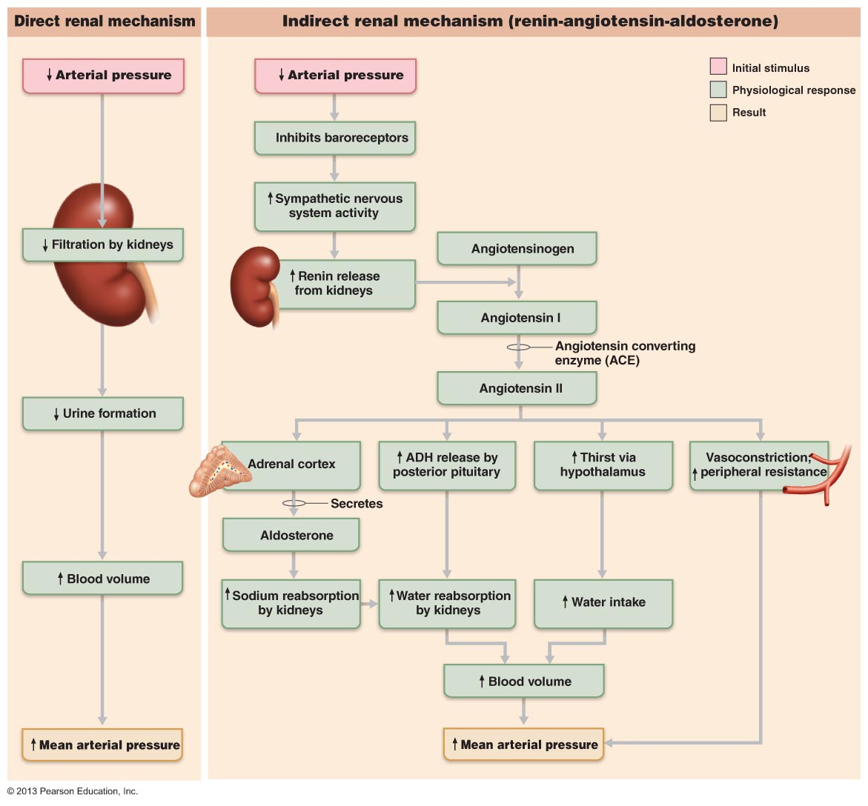
Therefore, blood pressure can only be stabilized and maintained when blood volume is stable

- Kidneys responsible for filtering the blood and if blood is pushed through there less forcefully then it wont be filtered as much and you will be keeping more salt and water in the bloodstream. These both kick in at the same time since the stimulus is the same for both (arterial pressure)
2) Leads to the baroeceptors being stretched less
3) Release of renin from the kidneys
4) End up with the activated hormone angiotensin 2
5) It targets adrenal cortex and this increases sodium reabsorption
6) ADH opens water channels increasing the its reabsorption by the kidneys
7) When both of these occurs at the same time, then blood volume can be increased as the sodium follows the water
8) Also you will feel thirsty and drink, move this from gi tract to plasma
9) Vasoconstriction helps to bring blood pressure back up and
* Need to understand these steps and what they accomplish

Autoregulation: Local Blood Flow
* Explain the mechanisms of autoregulation with regards to local blood flow

- blood flow to each organ regulated to meet needs of the tissue at any instant
- changes in blood flow through indiv organs are controlled intrinsically by modifying the diameter of local arterioles feeding the capillaries

resting vascular tone: in resting state, smooth muscles in walls of arterioles somewhat contracted (symp ns) »» can increase flow by vasodilation

Immediate Adjustments to Changes in Local Conditions:
R varies 1/r⁴ - The resistance to blood flow varies to 1/radius to the 4th power
• organs regulate individual blood flow by varying resistance of arterioles
- the blood pressure in the arterioles remains relatively constant but the local demand will regulate diameter of arterioles to regulate amount of blood directed to different local organs

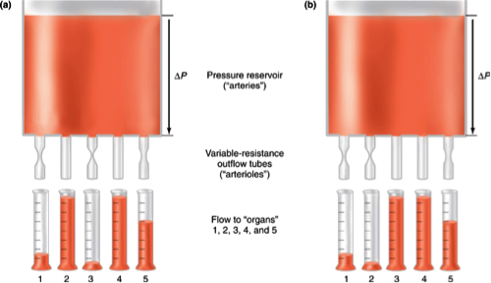

Metabolic Controls (Local!)
- Declining levels of oxygen and
- Increased levels of CO2, adenosine, H+, K+, heat, inflammatory chemicals released by metabolically active tissues serve as autoregulation stimuli
- some act by relaxing vascular smooth muscle and others by causing release of NO (vasodilator)
- End result: immediate increased perfusion of blood to “needy tissues”

Active vs. Reactive Hyperemia
Active Hyperemia – due to increased metabolic activity of the cells (exercise). When muscles become active, blood flow increases (hyperemia) in direct proportion to their greater metabolic activity

Reactive Hyperemia – refers to the dramatically increased blood flow into a tissue that occurs after the blood supply to that area has been temporarily blocked. Results from myogenic response and from accumulation of metabolic wastes in the area during occlusion. (ex. sitting or having a bp cuff on)

Myogenic Controls (Local!)
- (myo = muscle, gen = origin)
- vascular smooth muscle responds to increased stretch with increased tone which resists the stretch and causes vasoconstriction
- vascular smooth muscle responds to increased stretch with increased tone >> stretch is resisted >> vasoconstriction
- decreased stretch results in vasodilation
- Result: tissue perfusion homeostasis (maintained constant) so cells not deprived/capillaries not damaged
- homeostatic mechanism that kicks in fairly quickly to maintain non-dramatic changes in blood flow to the area
- this is what happens when we change body position (ex. headstand)
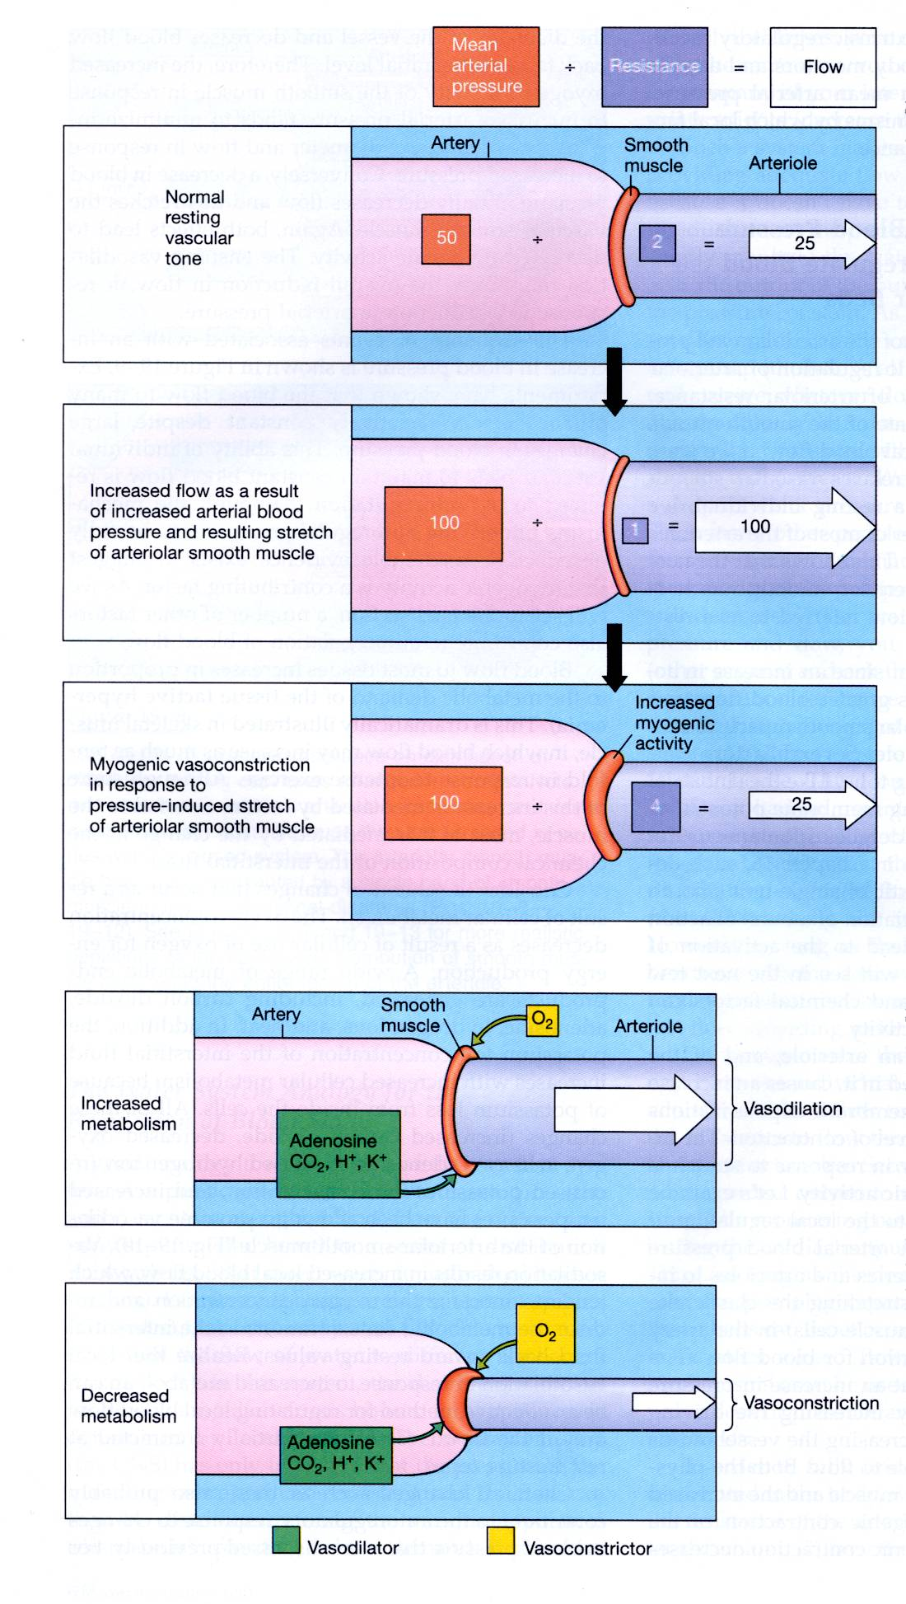
Myogenic Autoregulation:
- Normal situation – artery feeding into arterial
- Bent over or changed position – stretched small arteries to a greater extent, pass on to increased flow going there, vasoconstriction, resistance has gone up to 4

Active Hyperemia:
- Accumulation of waste priduct, o2 in larger green box
- Don’t need to continue with increased blood flow
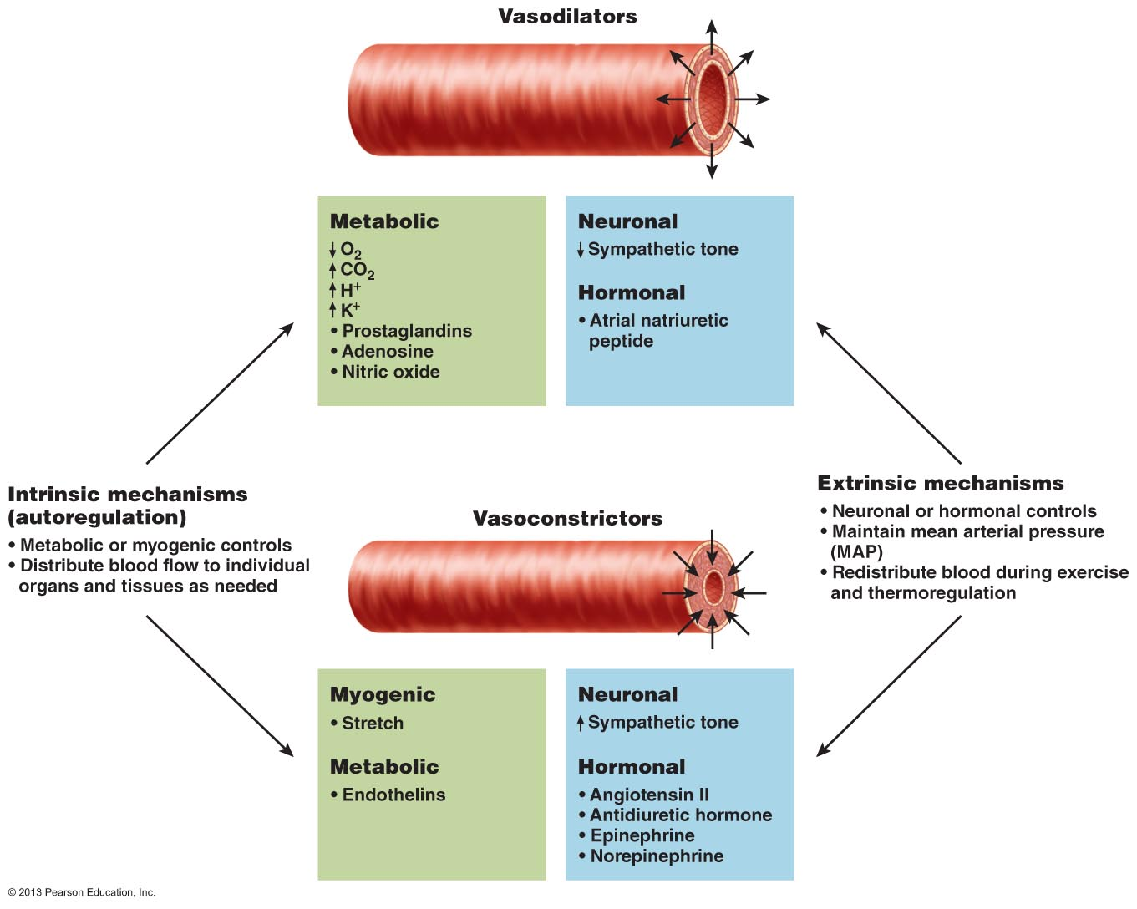
* know what’s going on in this

Blood Flow Through Capillaries and Capillary Dynamics
Capillaries – major point of communication between interstitial fluid & blood

- most cells in body within 0.02 mm of a capillary >> diffusion works
- capillary walls only 1 cell thick: mix of diffusional, osmotic & hydrostatic forces

Precapillary Sphincter – cuff of smooth muscle at beginning of capillary; capillary walls themselves have no smooth muscle

Vasomotion – intermittent contraction and relaxation of precapillary sphincters -> sporadic flow through each capillary when tissue needs are not extreme

* diffusion is always from an area f higher concentration of the substance to an area of its lower concentration

Capillary Exchange Mechanisms
1. Vesicle Transport:
• for relatively large, lipid-insoluble molecules (eg: insulin)
• shuttling via endocytosis, then exocytosis
• also antibody molecules from maternal to fetal circulation

2. Diffusion:
• primary mechanism for dissolved solutes & gases - eg: O₂, CO₂, glucose
• follow gradients
• heat moves via convection down a thermal gradient
• water-filled pores (Na+. K+, Cl-, glucose) or through bilayer (O₂, CO₂, urea)
• pores <1% capillary SA; lipid-soluble substances have 100X more SA

3. Bulk Flow:
- important in determining the relative fluid volumes in the bloodstream and the interstitial space

Three Types:
HP = hydrostatic pressure – force exerted by a fluid pressing against a wall. In capillaries, this is the same as capillary blood pressure–the pressure exerted by blood on capillary walls. HPc is higher at the at the arterial end (35 mm Hg) of the bed than at the venous end (17 mm Hg). Net hp at any point is the difference between HPc and HPif since blood pressure is opposed by interstitial fluid HPacting outside the capillaries and pushing fluid in.

OP = colloid osmotic pressure – the force opposing hydrostatic pressure, is created by the presence in a fluid of large nondiffusible molecules, such as plasma protein, that are unable to cross the capillary wall. (about 26 mm Hg)

NFP = Net Filtration Pressure – determines whether there is a net gain or net loss of fluid from the blood. Considers all the forces acting on the capillary bed

- fluids will leave the capillary if net HP > net OP
- fluids will enter the capillary is net OP > net HP
- c = capillary hydrostatic pressure, if = interstitial fluid hydrostatic pressure

Calculation: NFP = (HP_{c} - HP_{if}) – (OP_{c} – OP_{if})
= (35 – 0) – (26 – 1)
= (35 – 25)
= 10 mm Hg

overall deficit of 1-2 mm Hg some fluid (3-4 ml/min) lost from the circulation. This fluid and any leaked proteins are picked up by lymphatic vessels and returned to the vascular system
- increased arteriole pressure means increased filtration pressure = more fluid loss to tissues (edema); liver disease also > edema (why? – they are not making enough plasma proteins to hold water in the bloodstream and therefore in the tissues )
- hemmorhage favours reabsorption – they’re going to pull back more fluid


