MCQ (Chapter#3)

1) Which market is an example of a market for goods? 1) _______
A) haircut market
B) manufactured input market
C) labour market
D) energy market
E) apple market

2) The opportunity cost of a hot dog in terms of hamburgers is 2) _______
A) the money price of a hot dog minus the money price of a hamburger.
B) smaller in the winter than in the summer.
C) the ratio of the slope of the supply curve of hot dogs to the slope of the supply curve of hamburgers.
D) the ratio of the money price of a hot dog to the money price of a hamburger.
E) the ratio of the slope of the demand curve for hot dogs to the slope of the demand curve for hamburgers.

3) Which one of the following events shifts the demand curve for grape jelly to the right? 3) _______
A) an increase in income if grape jelly is a normal good
B) an increase in the price of peanut butter, a complement of grape jelly
C) a decrease in the price of grape jelly
D) a decrease in the population
E) a decrease in the price of strawberry preserves, a substitute for grape jelly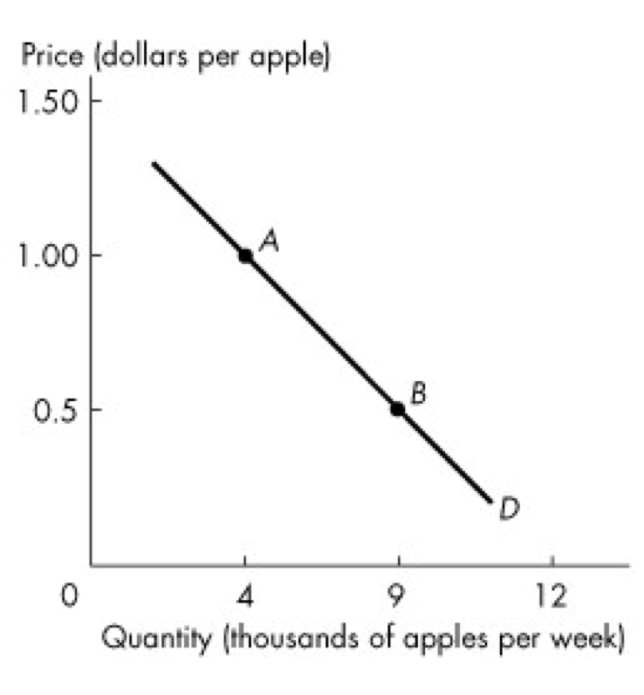

Figure 3.2.1

4) Which one of the following would result in a movement from point A to point B in Figure 3.2.1? 4) _______
A) a rise in the price of oranges
B) an increase in population size
C) a rise in the price of bananas
D) public concern about chemicals sprayed on apples
E) a fall in the price of apples
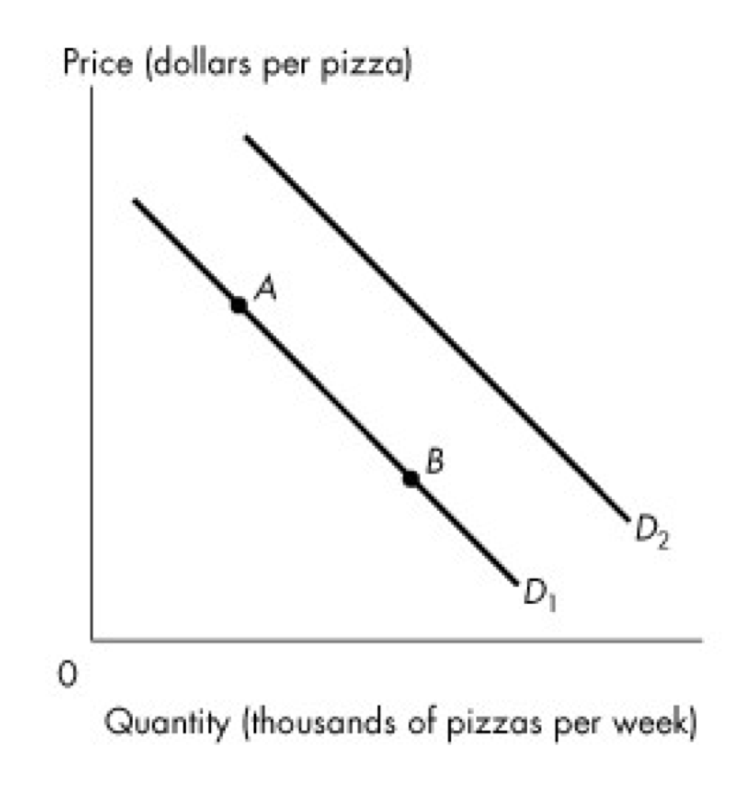

Figure 3.2.2

5) Which one of the following would result in the demand curve shifting from D1 to D2 in Figure 3.2.2? 5) _______

A) a rise in the price of pizza
B) a fall in the price of pizza
C) a rise in the price of hamburgers, a substitute for pizza
D) an increase in the supply of pizza
E) a rise in the price of Coke, a complement of pizza

6) The price of good X falls and the demand for good Y decreases. We can conclude that 6) _______
A) X and Y are independent of each other.
B) X and Y are substitutes.
C) X and Y are complements.
D) X is an inferior good.
E) X is a normal good.

7) Some sales managers are talking shop. Which one of the following quotations does not refer to a rightward shift of the demand curve? 7) _______

A) "It has been an unusually harsh winter; our sales of wool scarves are up from last year."
B) "We decided to cut our prices, and the increase in our sales has been remarkable."
C) "People are expecting a harsh winter next year, so the sales of our winter coats have increased."
D) "The Green movement has sparked an increase in our sales of biodegradable products."
E) "Since our competitors raised their prices, our sales have doubled."

8) An increase in supply is shown by 8) _______
A) a movement down along the supply curve.
B) a leftward shift of the supply curve.
C) a rightward shift of the supply curve.
D) a movement up along the supply curve.
E) an initial movement up and then down along the same supply curve.

9) If goods X and Y are substitutes in production, then a rise in the price of good X 9) _______
A) decreases the demand for good Y.
B) decreases the supply of good Y.
C) increases the supply of good Y.
D) increases the demand for good Y.
E) might change the supply of Y; it depends on whether X and Y are also substitutes.

10) A shift of the supply curve for rutabagas occurs if there is 10) ______
A) a change in preferences for rutabagas.
B) a change in income.
C) a change in the price of a related good that is a substitute for rutabagas.
D) a change in the price of rutabagas.
E) none of the above

11) Which of the following shifts the supply curve for good X leftward? 11) ______
A) a decrease in the wages of workers employed to produce X
B) a situation in which the quantity demanded of X exceeds the quantity supplied of X
C) a situation in which the quantity supplied of X exceeds the quantity demanded of X
D) an increase in the cost of the machinery used to produce X
E) a technological advance in the production of X

12) Which one of the following would not shift the supply curve of good X to the right? 12) ______
A) an increase in the price of Y, a complement in production of X
B) a fall in the price of Y, a substitute in production of X
C) an improvement in technology used in the production of X
D) a fall in the price of the factors of production used in producing X
E) a rise in the price of X

13) If the price is above the equilibrium price, then 13) ______
A) none of the good will be sold.
B) a shortage exists.
C) the price must rise further to reach the new market equilibrium.
D) a surplus exists.
E) price will not change; producers will cut back production until the market is in equilibrium.

14) Since 1980, there has been a dramatic increase in the number of working mothers. Based on this information alone, we can predict that the market for child care services has experienced 14) ______

A) a decrease in demand.
B) an increase in supply.
C) a decrease in quantity supplied.
D) an increase in quantity demanded.
E) an increase in demand.

15) The price of a good will fall if 15) ______
A) demand for the good remains constant.
B) demand for the good increases.
C) supply of the good remains constant.
D) supply of the good decreases.
E) supply of the good increases.

16) If A is an inferior good and consumer income rises, the demand for A 16) ______
A) increases and the equilibrium price rises, but the equilibrium quantity decreases.
B) decreases and the equilibrium price falls, but the equilibrium quantity increases. (?)
C) increases, and the equilibrium price and the equilibrium quantity increase.
D) decreases, the equilibrium price rises, and the equilibrium quantity decreases.
E) decreases, and the equilibrium price and the equilibrium quantity decrease.

17) Crude oil is a very important factor of production used in the production of gasoline. If the price of crude oil rises, we would expect the 17) ______

A) price of gasoline to rise due to an increase in demand.
B) equilibrium quantity of gasoline to rise due to an increase in demand.
C) price of gasoline to rise due to a decrease in supply.
D) equilibrium quantity of gasoline to fall due to an increase in supply.
E) price of gasoline to fall due to an increase in demand.

18) The fish stocks in the Atlantic fishing industry have decreased. As a result, we would expect 18) ______
A) a fall in the price of fish, leading to a decrease in the demand for meat, because meat and fish are substitutes.
B) a fall in the price of fish, leading to an increase in the demand for meat, because meat and fish are substitutes.
C) an increase in the demand for meat because meat is a substitute for fish.
D) an increase in the demand for meat (e.g., beef) because meat is a complement of fish.
E) a rise in the price of fish, leading to a decrease in the demand for meat, because meat and fish are complements.

Tim Hortons' Risks
Tim Hortons has exploded to become a dominant player among quick-serve restaurants. In 2001, it took the risk by switching to centralized production of baked goods, which lowered its labour costs and increased its sales volume.
Source: Financial Post, August 12, 2010

19) Lower labour costs 19) ______
A) increase the quantity supplied of Tim's baked goods.
B) lower the equilibrium price of Tim's baked goods but do not change the equilibrium quantity.
C) increase the supply of Tim's baked goods, increase the demand for Tim's baked goods and increase the equilibrium quantity.
D) increase the demand for Tim's baked goods and raise the price.
E) increase the supply of Tim's baked goods and lower the equilibrium price.

Use the figure below to answer the following questions.

Figure 3.5.1

20) If the demand curve is D2 in Figure 3.5.1, 20) ______
A) the equilibrium price is P2 and the equilibrium quantity is Q0.
B) the equilibrium price is P2 and the equilibrium quantity is Q2.
C) there is a shortage in the amount of Q2 - Q0.
D) the price will rise.
E) a rise in price will shift the demand curve to D3.

MCQ 4

MULTIPLE CHOICE. Choose the one alternative that best completes the statement or answers the question.
1) A price elasticity of demand of 2 means that a 10 percent increase in price will result in a 1) _______
A) 20 percent increase in quantity demanded.
B) 20 percent decrease in quantity demanded.
C) 5 percent decrease in quantity demanded.
D) 2 percent increase in quantity demanded.
E) 2 percent decrease in quantity demanded.

2) If a large percentage drop in the price level results in a small percentage increase in the quantity demanded, 2) _______

A) the price elasticity of demand is zero.
B) demand is inelastic.
C) the price elasticity of demand is close to infinity.
D) demand is unit elastic.
E) demand is elastic.

3) If a 10 percent rise in the price of goods leads to a 10 percent decrease in quantity demanded, the demand curve for this good 3) _______
A) has slope equal to 1.
B) is horizontal.
C) is vertical.
D) is a straight line with slope equal to 10.
E) none of the above

4) A fall in the price of a good from $11.50 to $8.50 results in an increase in the quantity demanded from 19,200 to 20,800 units. The price elasticity of demand is 4) _______

A) 8.0. B) 0.27. C) 3.75. D) 0.08. E) 30.

5) Suppose the government of Nova Scotia wants to reduce the consumption of electricity by 5 percent. The price elasticity of demand for electricity is 0.40. You advise the Nova Scotia government to 5) _______ (just divide the two)

A) stay away from the market for electricity and let the market mechanism fix the problem.
B) raise the price of electricity by 2 percent.
C) raise the price of electricity by 12.5 percent.
D) lower the price of electricity by 12.5 percent.
E) lower the price of electricity by 2 percent.,

6) Factors that influence the price elasticity of demand include 6) _______
A) the closeness of substitutes.
B) preferences.
C) the price of complements but not the price of substitutes.
D) income.
E) the price of substitutes and complements.

7) The demand for a good will be more price inelastic, 7) _______
A) the fewer substitutes are available for the good.
B) the higher is its price.
C) the longer is the passage of time since a price change.
D) the larger is the percentage of income spent on it.
E) the smaller the supply of the good.

8) Total revenue is more likely to rise when the price rises if 8) _______
A) some extended period of time passes.
B) there are few substitutes for the good.
C) a high proportion of income is spent on the good.
D) all of the above
E) none of the above

9) The income elasticity of demand equals the percentage change in ________, other things remaining the same. 9) _______

A) quantity demanded divided by the percentage change in income
B) quantity demanded divided by the percentage change in price
C) price divided by the percentage change in quantity demanded
D) income divided by the percentage change in quantity demanded
E) price divided by the percentage change in income

10) Fred's income increases from $1,950 per week to $2,050 per week. As a result, he decides to increase the number of movies he attends each month by 10 percent. Fred's demand for movies is 10) ______

A) income inelastic.
B) price elastic.
C) price inelastic.
D) income elastic.
E) income inferior.

11) If a 10 percent increase in income results in a 5 percent increase in quantity demanded, what is the income elasticity of demand? 11) ______

A) -0.5 B) 0.5 C) -2.0 D) 2.0 E) 1.5

12) An economic measure that indicates when the demands for two or more goods are related is 12) ______
A) the price elasticity of demand.
B) the normal elasticity of demand.
C) the substitute elasticity of demand.
D) the cross elasticity of demand.
E) the income elasticity of demand.

13) If a rise in the price of good B increases the demand for good A, then 13) ______
A) A and B are substitutes.
B) A and B are complements.
C) the demand for A is price elastic.
D) the cross elasticity of demand between A and B is negative.
E) A is a resource used in the production of B.

14) When Erika's income increases by 6 percent, her demand for tickets to professional hockey games increases by 3 percent. Erika's demand for tickets is income ________. For Erika, hockey tickets are ________ good. 14) ______
A) elastic; an inferior
B) elastic; a normal
C) inelastic; a normative
D) inelastic; a normal
E) inelastic; an inferior

15) If a large percentage fall in the price of good A results in a small percentage decrease in the quantity supplied, then 15) ______
A) demand is elastic.
B) supply is elastic.
C) demand is income inelastic.
D) supply is inelastic.
E) demand is inelastic.

16) A vertical supply curve 16) ______
A) is impossible except in the long run.
B) indicates a shortage of the good.
C) implies an elasticity of supply equal to zero.
D) implies an elasticity of supply equal to infinity.
E) indicates that suppliers are unwilling to produce the good.

17) Preferences for brussels sprouts increase. The price of brussels sprouts will not change if the price elasticity of 17) ______
A) supply is 0.
B) supply is infinity.
C) supply is 1.
D) demand is 1.
E) demand is 0.

18) In the market for farm crops momentary supply is ________. In the market for farm crops, short-run supply is ________. 18) ______
A) positive; negative
B) more elastic than short-run supply; more elastic than long-run supply
C) less elastic than short-run supply; less elastic than long-run supply
D) perfectly elastic; perfectly inelastic
E) negative; positive

19) At a price of $15, Jack's quantity demanded of good A is the same as when the price rises to $16. Jack's demand for good A is 19) _______
A) unit elastic.
B) perfectly inelastic.
C) elastic.
D) inelastic.
E) perfectly elastic.

Use the table below to answer the following questions.

Table 4.1.1
Demand schedule for good A.

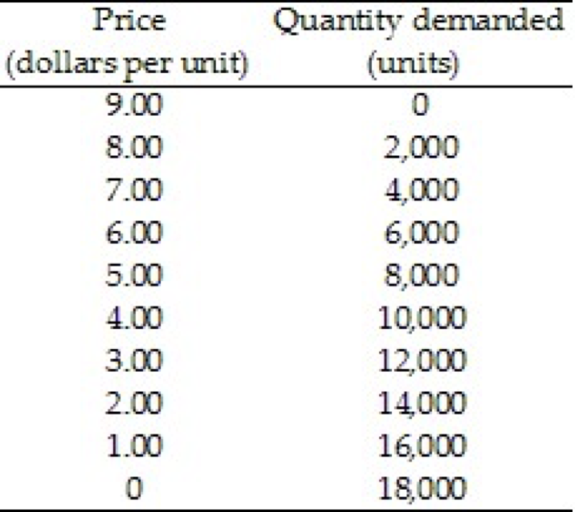

20) Refer to Table 4.1.1. The price elasticity of demand when the price rises from $6 a unit to $7 a unit is 20) _______
A) 2.0. B) 1.3. C) 0.5. D) 1.0. E) 2.6.

MCQ 5

MULTIPLE CHOICE. Choose the one alternative that best completes the statement or answers the question.
1) When a market price allocates a scarce resource, 1) _______
A) ability to pay for the resource is less important than willingness-to-pay.
B) only those who show interest can use the resource.
C) only those who are willing and able to pay get the resource.
D) everyone in the economy can use the resource.
E) willingness-to-pay is not an issue.

2) In the Canadian economy, the command system 2) _______
A) is used extensively in place of markets.
B) is used only by private companies.
C) is used extensively inside firms and government departments.
D) is not used at all.
E) is used occasionally inside firms and government departments.

3) Choose the statement or statements that are correct.
I. The value of one more unit of a good or service is its marginal benefit.
II. Marginal benefit equals the total amount we spend on a good or service.
III. Marginal benefit is the maximum amount willingly paid for another unit of a good or service. 3) _______

A) I only
B) II only
C) I and III
D) III only
E) I, II, and III

4) A new car has a sticker price of $35,000. Fred decided that he would pay no more than $32,000 for this car. He bought the car for $31,000. Fred obtained a consumer surplus of 4) _______

A) $4,000. B) $1,000. C) $32,000. D) $3,000. E) $35,000.

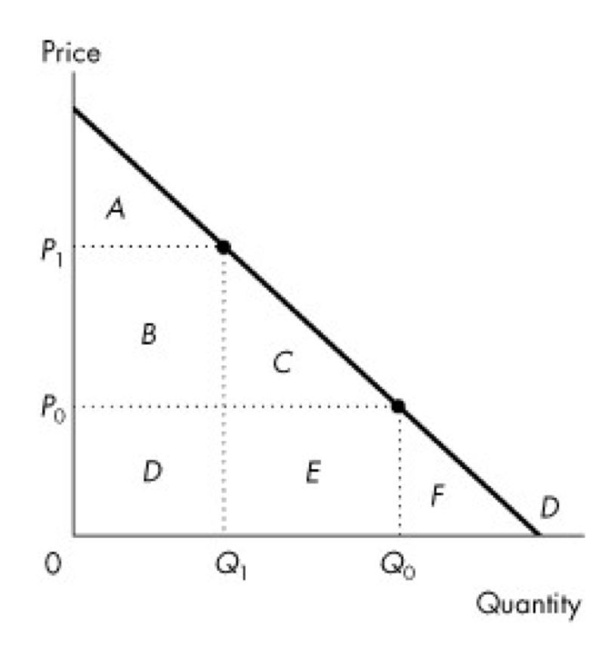

Use the figure below to answer the following questions.

Figure 5.2.2

5) Refer to Figure 5.2.2. If the price is P0, consumer surplus is 5) _______
A) A.
B) B plus C.
C) D plus E.
D) A plus B plus C.
E) A plus B plus C plus D plus E.

6) The marginal cost of producing an additional basket of tomatoes is $5.00. The consumer is willing to pay a maximum of $9.00 for an additional basket. A farmer sells a basket of tomatoes for $6.00 each. The farmer receives a producer surplus from selling an additional basket of tomatoes equal to 6) _______

A) $4.00. B) $5.00. C) $3.00. D) $1.00. E) $9.00.

Use the figure below to answer the following questions.
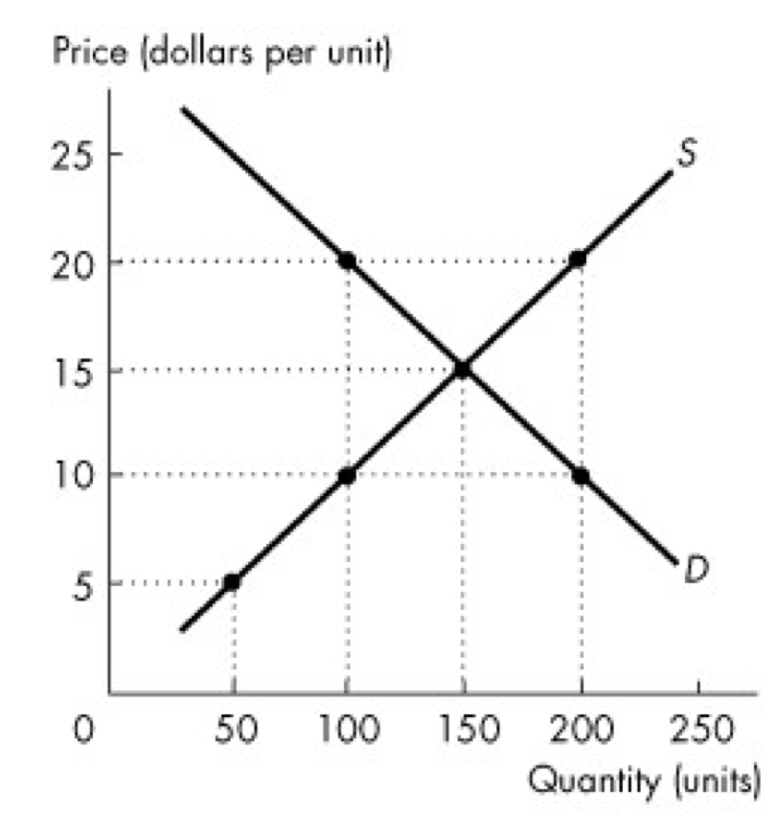

Figure 5.3.1

7) Refer to Figure 5.3.1. The efficient quantity is 7) _______
A) 200 units. B) 50 units. C) 250 units. D) 150 units. E) 100 units.

8) Consider the market for hot dogs. If this market becomes a monopoly, then there will be 8) _______
A) underproduction of hot dogs.
B) overproduction of hot dogs.
C) a deadweight loss in the market for hot dogs.
D) an efficient quantity of hot dogs.
E) both A and C are correct.

Use the figure below to answer the following questions.
Figure 5.3.2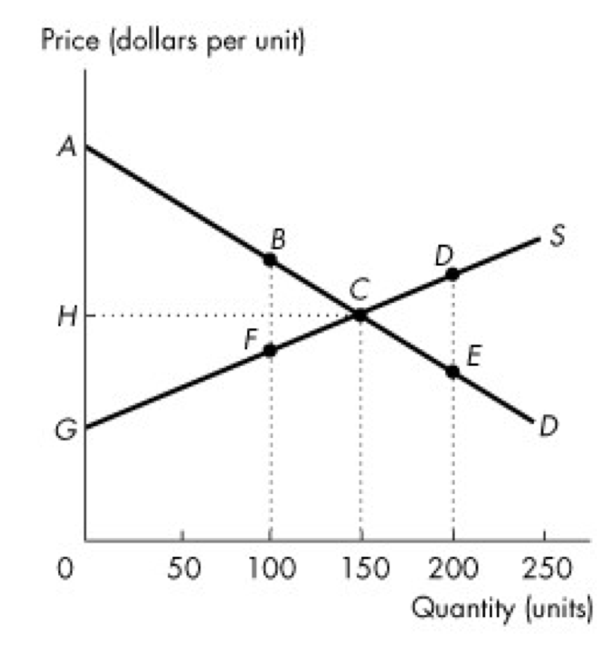

9) Refer to Figure 5.3.2. If the level of output is 100 units, the deadweight loss is area 9) _______
A) BCF. B) ACG. C) DCE. D) ACH. E) HCG.

10) Markets may not achieve an efficient allocation of resources when there are 10) ______
A) monopolies.
B) external benefits.
C) subsidies.
D) public goods.
E) all of the above

Use the table below to answer the following questions.

Table 5.2.1
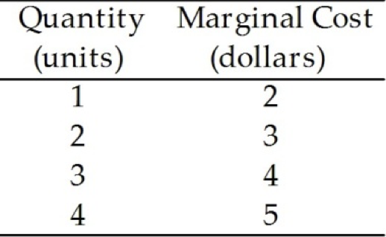

11) Table 5.2.1 gives information on marginal cost for the XYZ firm. If XYZ sells the first unit at a price of $6, what is the producer surplus on that unit? 11) ______

A) $4 B) $12 C) $9 D) $6 E) $7

Use the figure below to answer the following questions.

Figure 5.2.2

12) Refer to Figure 5.2.2 If the price falls from P1 to P0, then the change in consumer surplus is 12) ______
A) A + B. B) A + B + D. C) B + C. D) A + B + C. E) A.

13) A contest allocates resources to 13) ______
A) a winner or a group of winners.
B) a gambler.
C) private firms.
D) an athlete.
E) the government.

14) Lotteries work best 14) ______
A) when potential users of scarce resources are unknown.
B) under any circumstances.
C) under a command system.
D) under the first-come, first served allocation method.
E) when there is no effective way to distinguish among potential users of a scarce resource.

15) Deadweight loss is 15) ______
A) not a problem with overproduction.
B) eliminated by a monopoly.
C) gained by producers.
D) borne entirely by consumers.
E) the social loss from inefficiency.

MULTIPLE CHOICE. Choose the one alternative that best completes the statement or answers the question.
Use the figure below to answer the following questions.

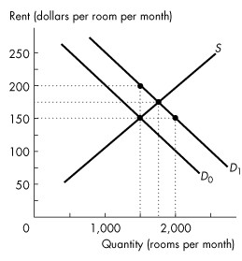
Figure 6.1.1

1) Refer to Figure 6.1.1. If the demand for rental housing increases and the demand curve shifts rightward from D0 to D1, and there is a strictly enforced rent ceiling of $150 per room, 1) _______

A) the number of rooms rented will increase to 2,000.
B) the number of rooms rented is 1,500.
C) there is a housing shortage of 500 rooms.
D) the number of rooms rented decreases to 1,000.
E) both B and C

2) If the government imposes a maximum rent for housing that is above the equilibrium price, then you predict that 2) _______

A) the demand curve for housing shifts rightward.
B) the law will generate a shortage of housing.
C) the supply curve of housing shifts leftward.
D) the law will create a surplus of housing.
E) the law will have no effect in the market for housing.

Chapter 6

Use the figure below to answer the following questions.

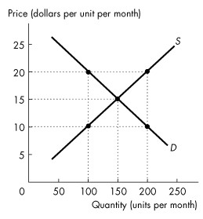
Figure 6.1.2

3) Refer to Figure 6.1.2. If a rigorously enforced price ceiling is set at $10, then 3) _______
A) 150 units will be sold at a price of $15 each.
B) 200 units will be sold at a price of $10 each.
C) 100 units will be sold at a price of $15 each.
D) 100 units will be sold at a price of $20 each.
E) 100 units will be sold at a price of $10 each.

4) An effective rent ceiling 4) _______
A) increases producer surplus.
B) increases the supply of housing.
C) increases consumer surplus.
D) creates a deadweight loss.
E) decreases the supply of housing.

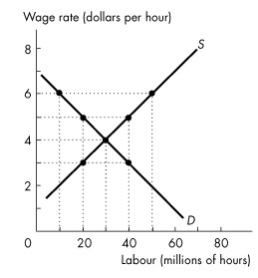
Figure 6.2.1

5) Refer to Figure 6.2.1. Suppose a $5 per hour minimum wage is in force. What is the lowest wage per hour an unemployed person would be willing to accept? 5) _______

A) $3 B) $4 C) $5 D) $2 E) $1

Use the table below to answer the following questions.

Table 6.2.2

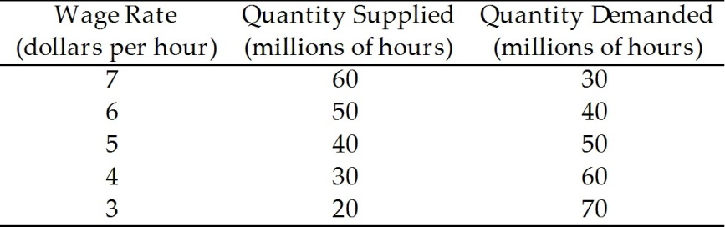

6) Refer to Table 6.2.2. What is the level of unemployment in millions of hours if the minimum wage is set at $3 per hour? 6) _______

A) 70 B) 20 C) 30 D) 40 E) zero

7) Suppose the equilibrium wage is $10 an hour. A minimum wage is a price ________ that will change the quantity of employment if it is set at ________ an hour. 7) _______

A) ceiling; $12
B) floor; $10
C) ceiling; $8
D) floor; $8
E) floor; $12

8) Suppose the demand for gasoline is inelastic, but not perfectly inelastic, and the supply is elastic, but not perfectly elastic. A tax on gasoline is paid 8) _______

A) mostly by buyers.
B) equally by buyers and sellers.
C) totally by sellers.
D) mostly by sellers.
E) totally by buyers.

Use the figure below to answer the following questions.

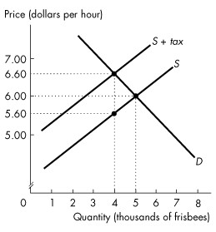
Figure 6.3.1

9) Refer to Figure 6.3.1 showing the market for frisbees before and after a tax is imposed. The tax on each frisbee is 9) _______

A) $5.60. B) $0.40. C) $6.60. D) $0.60. E) $1.00.

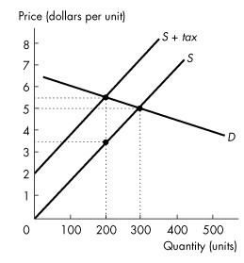
Figure 6.3.2

10) Refer to Figure 6.3.2. The deadweight loss from the sales tax is 10) ______
A) $1,000. B) $150. C) $100. D) $50. E) $200.

11) The buyer pays most of a tax if demand is relatively inelastic because 11) ______
A) the buyer cannot easily substitute to other markets.
B) the seller cannot easily substitute to other goods.
C) there is a black market for this good.
D) the buyer can easily substitute to other markets.
E) the government forces the seller to bear the burden of the tax.

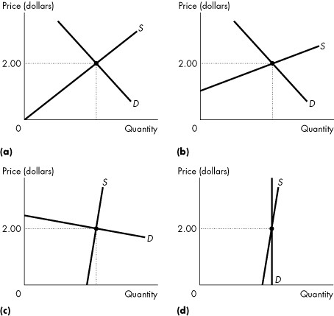

Figure 6.3.3

12) Refer to Figure 6.3.3. Suppose a tax of $1 is imposed. In which market would the seller pay the highest portion of the tax? 12) ______

A) (a)
B) (b)
C) (c)
D) (d)
E) all markets equally

13) A subsidy is a 13) ______
A) payment made by the government to a producer.
B) payment made by foreign governments to domestic farmers.
C) payment made by a consumer to a producer.
D) tax imposed by the government on a producer.
E) tax imposed by the government on imported goods.

14) An effective production quota 14) ______
A) is inefficient because it results in overproduction.
B) is efficient because it results in overproduction.
C) is efficient because it results in underproduction.
D) is inefficient because it results in underproduction.
E) is efficient for quantities below the equilibrium quantity and is inefficient for quantities above the equilibrium quantity.

15) Suppose the Canadian Dairy Commission sets a production quota for dairy production above the equilibrium quantity. Then, 15) ______

A) the policy will raise the price of milk in the international market.
B) the policy will increase revenue received by dairy producers.
C) the policy will increase the quantity of milk produced in Canada.
D) the policy will decrease revenue received by dairy producers.
E) the policy will have no impact on the dairy industry.

Chapter 11
MULTIPLE CHOICE. Choose the one alternative that best completes the statement or answers the question.
1) The short run is a time frame in which 1) _______
A) the firm is not able to hire more workers.
B) the amount of output produced is fixed.
C) at least one factor of production is fixed.
D) there is not enough time to make all of the decisions necessary to maximize profit.
E) there is a shortage of most factors of production.

2) The long run refers to a time period 2) _______
A) in which labour is variable, but plant is fixed.
B) when there is at least one variable factor of production.
C) in which all factors of production are variable.
D) of one year or less.
E) of at least 5 years.

3) The total product curve is a graph that shows the 3) _______
A) maximum output that can be produced as technology advances.
B) minimum cost of producing a given amount of output using a given technology.
C) change in total product for a given change in marginal product.
D) maximum profit from each unit of output sold.
E) maximum output that a given quantity of labour can produce.

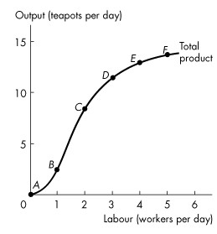
Figure 11.2.1

4) Refer to Figure 11.2.1 which illustrates Tania's total product curve. Which one of the following statements is false? 4) _______

A) All the points below the curve are attainable.
B) All the points on the curve are attainable.
C) The cost of producing at point B equals the cost of producing at point C.
D) All the points below the curve are inefficient.
E) All the points above the curve are unattainable.

5) Refer to Figure 11.2.1 which illustrates Tania's total product curve. Which one of the following statements is true? 5) _______

A) The points below the curve are attainable and inefficient.
B) The points below the curve are inefficient and unattainable.
C) The points above the curve are attainable and inefficient.
D) The points on the curve are efficient and unattainable.
E) Marginal product is equal at every point on the total product curve.

6) Refer to Figure 11.2.1 which illustrates Tania's total product curve. Marginal product of labour reaches its maximum when the number of workers increases from 6) _______

A) zero to 1. B) 1 to 2. C) 2 to 3. D) 3 to 4. E) 4 to 5.

Refer to the table below to answer the following questions.

Table 11.2.1

Labour  (workers per day) | Output  (teapots per day)
0  1  2  3  4  5 | 0  3  12  19  23  25

7) Refer to Table 11.2.1 which gives Tania's total product schedule. The average product when the firm hires two workers is 7) _______

A) 9 teapots per worker.
B) 3 teapots per worker.
C) 6 teapots per worker.
D) 7 teapots per worker.
E) 12 teapots per worker.

8) Which of the following are correct? According to the law of diminishing returns,
(1) marginal product eventually rises.
(2) marginal product eventually falls.
(3) marginal cost eventually rises.
(4) marginal cost eventually falls. 8) _______

A) (1) and (3) B) (1) and (4) C) (2) and (3) D) (2) and (4) E) (4)

Use the figure below to answer the following questions.

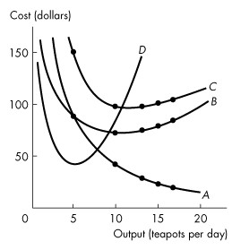
Figure 11.3.2

9) Refer to Figure 11.3.2, which illustrates short-run average and marginal cost curves. Which one of the following statements is false? 9) _______

A) The vertical gap between curves B and C is equal to average fixed cost.
B) The vertical gap between curves B and C is equal to average variable cost.
C) Line B comes closer to line C as output increases because of a decrease in average fixed cost.
D) Curve D is the marginal cost curve.
E) Average fixed cost decreases with output.

10) Marginal cost equals 10) ______
A) (TC - TVC)/Q.
B) ΔTC/ΔQ.
C) ΔQ/ΔTVC.
D) ΔTFC/ΔTC.
E) Q/TVC.

11) A firm's total fixed cost is $100. If total cost is $200 for one unit of output and $310 for two units, what is the marginal cost of the second unit? 11) ______

A) $200 B) $310 C) $110 D) $100 E) $210

12) A technological advance will shift
(1) TP, AP, and MP curves up.
(2) TP, AP, and MP down.
(3) TC, ATC, and MC curves up.
(4) TC, ATC, and MC curves down. 12) ______

A) (1) and (3)
B) (1) and (4)
C) (2) and (3)
D) (2) and (4)
E) none of the above

Use the figure below to answer the following questions.

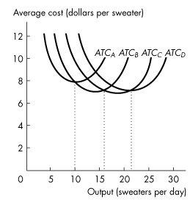
Figure 11.4.2

13) Refer to Figure 11.4.2, which illustrates the short-run average total cost curves for four different plant sizes. Which plant has the lowest average total cost for an output rate of 5 sweaters a day? 13) ______

A) Plant A
B) Plant B
C) Plant C
D) Plant D
E) none of the above

Use the figure below to answer the following questions.

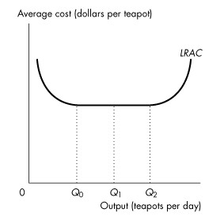
Figure 11.4.4

14) Refer to Figure 11.4.4, which illustrates the long-run average total cost curve. Which one of the following statements is false? 14) ______

A) Diseconomies of scale exist at quantities greater than Q2 units of output.
B) Constant returns to scale exist between Q0 and Q1 units of output.
C) Economies of scale exist between 0 and Q0 units of output.
D) Diseconomies of scale exist between 0 and Q1 units of output.
E) Constant returns to scale exist between Q1 and Q2 units of output.

Labor (workers) | Total product (units) | Marginal product | Average product
0 | 0
1 |  | 3
2 |  |  | 4.5
3 | 14
4 |  | 3
5 | 19
6 |  | 1

15) The above (incomplete) table provides information about the relationships between labor and various product measures. The total product that can be produced with 6 units of labor is 7) _______
A) 19.
B) 20.
C) 22
D) More information is needed to answer the question.
E) None of the above answers is correct.
Chapter 12
MULTIPLE CHOICE. Choose the one alternative that best completes the statement or answers the question.
1) Which one of the following does not occur in perfect competition? 1) _______
A) Sellers and buyers are well informed about prices.
B) There are many buyers.
C) Established firms have no advantage over new ones.
D) There are significant restrictions on entry into the market.
E) No single firm can exert a significant influence on the market price of the good.

2) A price taker is a firm that 2) _______
A) cannot influence the market price.
B) is incurring an economic loss.
C) sets the market price.
D) must lower its price if it wants to sell more output.
E) can raise its price if it lowers output.

Use the table below to answer the following questions.

Table 12.2.1

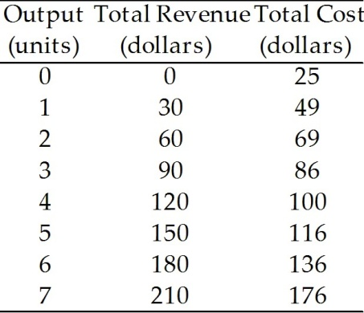

3) Refer to Table 12.2.1, which gives the total revenue schedule and total cost schedule of a perfectly competitive firm. If the firm produces 3 units of output, it will 3) _______

A) make an economic profit of $90.
B) incur an economic loss of $86.
C) make an economic profit of $4.
D) incur an economic loss of $4.
E) break even.

4) A firm shuts down if price is 4) _______
A) below minimum average variable cost.
B) above minimum average fixed cost.
C) below average total cost.
D) less than marginal cost.
E) above minimum average variable cost.

5) A firm that temporarily shuts down and produces no output incurs a loss equal to its 5) _______
A) total fixed cost.
B) average fixed cost.
C) marginal cost.
D) total variable cost.
E) average total cost.

Use the figure below to answer the following questions.

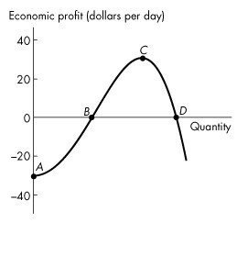
Figure 12.2.2

6) Refer to Figure 12.2.2, which shows a perfectly competitive firm's economic profit and loss. The firm is breaking even at points 6) _______

A) A and C. B) A and D. C) B and C. D) B and D. E) C and D.

7) A firm is producing the profit-maximizing amount of output when it is producing where its ________ curve intersects its ________ curve. 7) _______

A) marginal cost; average variable cost
B) total cost; total revenue
C) average total cost; average variable cost
D) marginal cost; marginal revenue
E) marginal cost; average total cost

8) In which one of the following situations will a perfectly competitive firm make an economic profit? 8) _______
A) MR > AVC B) ATC > MC C) MC > AVC D) MR > ATC E) ATC > MR

Use the figure below to answer the following questions.

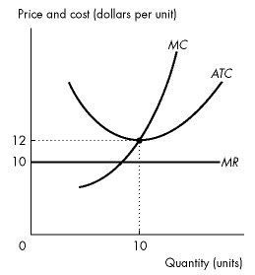
Figure 12.3.1

9) Refer to Figure 12.3.1, which shows the cost curves and marginal revenue curve of a firm in a perfectly competitive industry. In the short run, the firm will 9) _______

A) incur an economic loss.
B) exit from the industry.
C) close down.
D) break even.
E) make an economic profit.

Use the figure below to answer the following question.

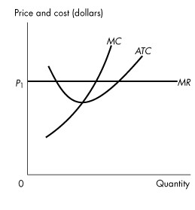
Figure 12.3.2

10) Refer to Figure 12.3.2, which shows the cost curves and marginal revenue curve of a firm in a perfectly competitive industry, The firm is 10) ______

A) not maximizing economic profit.
B) going to close down temporarily.
C) incurring an economic loss.
D) making an economic profit.
E) breaking even.

Use the figure below to answer the following questions.

Figure 12.4.1

11) Refer to Figure 12.4.1, which shows the cost curves and marginal revenue curve of a firm in a perfectly competitive market. In the long run, market 11) ______

A) demand will increase.
B) supply and market demand will decrease.
C) supply will decrease.
D) demand will decrease.
E) supply will increase.

12) When a perfectly competitive market is in long-run equilibrium, 12) ______
A) all firms make zero economic profit.
B) marginal revenue equals minimum average variable cost.
C) firms exit the market if other firms are incurring an economic loss.
D) firms enter the market if other firms are making an economic profit.
E) at least one firm makes an economic profit.

13) If firms in a perfectly competitive market are incurring an economic loss, some firms will exit. This exit shifts the market 13) ______

A) supply curve rightward, and the market price falls.
B) demand curve leftward, and the market price falls.
C) supply curve leftward and the market demand curve rightward.
D) demand curve rightward, and the market price rises.
E) supply curve leftward, and the market price rises.

14) The market for maple syrup is perfectly competitive. Suppose that the market is in long-run equilibrium when the market demand for maple syrup increases. All of the following occur except 14) ______

A) the price rises in the short run.
B) in the short run, existing firms make an economic profit.
C) in the long run, firms make an economic profit.
D) the number of firms in the long run is greater than the number of firms in the short run.
E) the equilibrium quantity increases.

15) In a perfectly competitive market, a technological advance brings ________ economic profit for producers and ________ lower prices for consumers. 15) ______

A) temporary; temporary
B) negative; permanent
C) permanent; temporary
D) temporary; permanent
E) permanent; permanent

Chapter 13
MULTIPLE CHOICE. Choose the one alternative that best completes the statement or answers the question.
1) In a natural monopoly, the long-run average cost curve 1) _______
A) may be either upward sloping or downward sloping in the relevant range of output levels.
B) is downward sloping in the relevant range of output levels.
C) is horizontal in the relevant range of output levels.
D) is upward sloping in the relevant range of output levels.
E) lies below the marginal cost curve.

2) Which of the following is least likely to be a natural monopoly? 2) _______
A) electric utilities
B) taxicab service
C) subway services
D) cable television services
E) water and sewer services

3) A monopoly arises for two key reasons, which are 3) _______
A) barriers to entry and close substitutes.
B) close substitutes and no barriers to entry.
C) franchises and barriers to entry.
D) barriers to entry and no close substitutes.
E) natural and legal

Use the figure below to answer the following question.

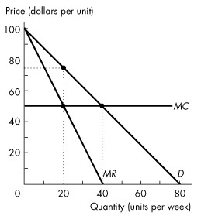
Figure 13.2.1

4) Refer to Figure 13.2.1. This single-price monopoly produces ________ units per day and charges a price of $________ per unit. 4) _______

A) 20; 50 B) zero; 0 C) 20; 20 D) 20; 75 E) 40; 50

Use the figure below to answer the following questions.

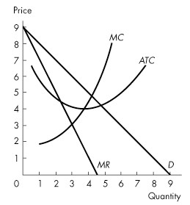
Figure 13.2.2

5) Refer to Figure 13.2.2. If the single-price monopoly shown in Figure 13.2.2 is maximizing profit, what is total economic profit? 5) _______

A) $4 B) $7 C) $9 D) $6 E) $3

6) The pursuit of wealth by capturing economic rent 6) _______
A) is illegal in Canada.
B) is price discrimination.
C) is rent seeking.
D) creates a legal monopoly.
E) creates a natural monopoly.

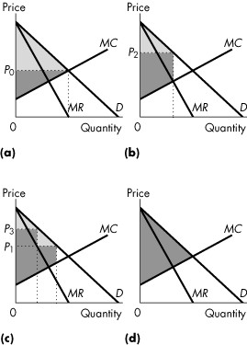

Figure 13.3.2

7) Consider Figure 13.3.2. Consider a perfectly competitive market. If the light grey area shows the consumer surplus, and the dark grey area shows the producer surplus, which graph correctly represents this market? 7) _______

A) (a) B) (b) C) (c) D) (d) E) (b) and (d)

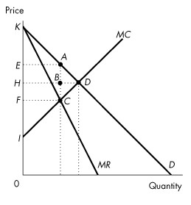
Figure 13.3.3

8) Consider the revenue and cost curves in Figure 13.3.3. If this is a single-price monopoly, what is consumer surplus? 8) _______

A) ACD B) EADH C) EABH D) ABD E) KEA

9) Which of the following markets will have the largest deadweight loss? 9) _______
A) a perfectly competitive market
B) a single-price monopoly
C) a perfectly price discriminating monopoly
D) both B and C
E) both A and C

10) A monopoly can practise price discrimination when it 10) ______
A) produces a good with close substitutes.
B) has different marginal costs of production for different output levels.
C) has decreasing average variables cost.
D) is a price taker.
E) can segment the market according to the different prices the consumers are willing to pay.

Use the figure below to answer the following questions.

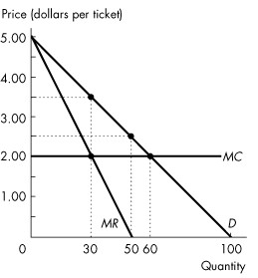

Figure 13.4.2

11) Refer to Figure 13.4.2. Assume this monopolist practises perfect price discrimination. How many tickets are sold? 11) ______

A) 40 tickets B) 80 tickets C) 60 tickets D) 20 tickets E) 100 tickets

Use the figure below to answer the following questions.

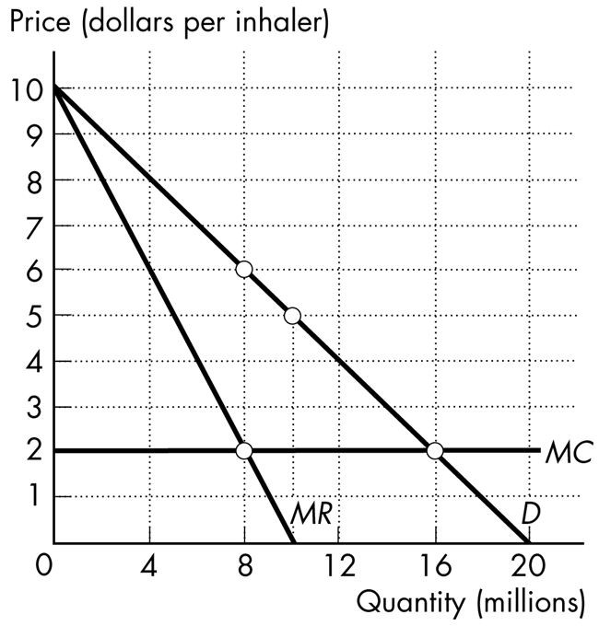

Figure 13.4.6

12) Prime Pharmaceuticals has developed a new asthma medicine, for which it has a patent. An inhaler can be produced at a constant marginal cost of $2 per inhaler. The demand curve, marginal revenue curve, and marginal cost curve for this new asthma inhaler are shown in Figure 13.4.6. The patent gives Prime Pharmaceuticals a monopoly for its new inhaler. If Prime Pharmaceuticals can perfectly price discriminate, then it 12) ______

A) sells 16 million inhalers.
B) charges a price of $2 for each inhaler it sells.
C) makes zero economic profit.
D) sells inhalers for $6 each.
E) Both A and B are correct.

Use the figure below to answer the following questions.

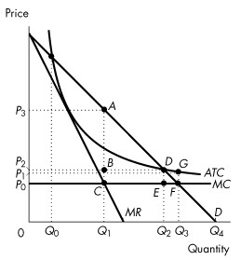
Figure 13.5.2

13) Consider the natural monopoly depicted in Figure 13.5.2. If a regulator uses a marginal cost pricing rule to set price, what is the quantity produced? 13) ______

A) 0 B) Q2 C) Q1 D) Q3 E) Q0

14) Consider the natural monopoly depicted in Figure 13.5.2. If a regulatory agency sets a price just sufficient for the firm to make zero economic profit, what output will it produce? 14) ______

A) Q0 B) Q1 C) Q3 D) Q2 E) Q4

15) Consider the natural monopoly depicted in Figure 13.5.2. What area in the graph represents the deadweight loss arising from an average cost pricing rule? 15) ______
A) DEF B) ACF C) DGF D) ABD E) CBDE

Chapter 15 MCQ

1) A game includes 1) _______
A) rules. B) a strategy.
C) payoffs. D) All of the above.

2) In a static game, firms 2) _______
A) compete only once.
B) compete multiple times until there is a winner.
C) act sequentially.
D) must have complete information.

3) A strategy is dominant if 3) _______
A) it yields a payoff at least as large as that from any other strategy, regardless of the actions of other players.
B) it yields a greater payoff than any other player receives.
C) the player cannot gain by changing strategy, assuming that no other player changes strategy
D) it is part of a Nash equilibrium.

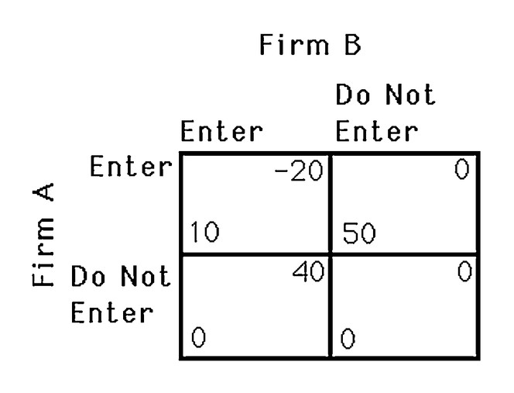
4) The above figure shows the payoff to two airlines, A and B, of serving a particular route. If the two airlines must decide simultaneously, which one of the following statements is TRUE? 4) _______

A) Firm A does not have a dominant strategy.
B) Neither firm entering is a Nash equilibrium.
C) Firm B does not have a dominant strategy.
D) The outcome of the game is unpredictable.

5) The above figure shows the payoff to two airlines, A and B, of serving a particular route. If the two airlines must decide simultaneously, which one of the following statements is TRUE? 5) _______
A) The outcome of the game is unpredictable.
B) Only firm A will enter the market.
C) Only firm B will enter the market.
D) Neither firm entering is a Nash equilibrium.

6) Suppose that industry A consists of four firms who collectively control 96 percent of total sales in the market. We can conclude that industry A is 6) _______

A) monopolistically competitive.
B) perfectly competitive.
C) a monopoly.
D) an oligopoly.
E) a duopoly.

7) Which one the following industries is the best example of an oligopoly? 7) _______
A) the fast-food industry
B) the market for wheat
C) the automobile industry
D) the restaurant industry
E) the clothing industry

Use the figure below to answer the following question.

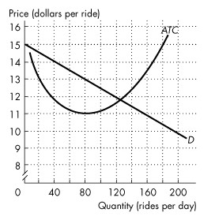
Figure 15.1.1

In the figure, D is the demand curve for taxi rides in a town, and ATC is the average total cost curve of a taxi company.

8) Refer to Figure 15.1.1. In the scenario above, the market is 8) _______
A) a natural monopoly.
B) perfectly competitive.
C) a natural duopoly.
D) monopolistically competitive.
E) a natural oligopoly with three firms.

Use the table below to answer the following questions.

Table 15.2.1

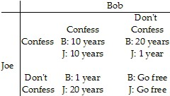

9) Refer to Table 15.2.1. This table includes the sentences that Bob and Joe will receive if convicted. They have been apprehended by the police under the suspicion of committing armed robbery. The two are immediately separated and questioned about the case. Which one of the following observations is correct? 9) _______

A) Both Bob and Joe have a dominant strategy of not confessing.
B) Both Bob and Joe would be better off not confessing if they both do not confess.
C) Both Bob and Joe would be better off "coming clean" and confessing to their crime.
D) Bob would be smart to confess no matter what Joe does.
E) Joe would be smart not to confess no matter what Bob does.

Refer to the table below to answer the following question.

Table 15.2.9

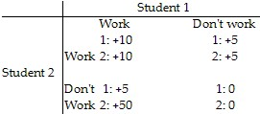

10) Refer to Table 15.2.9. Two students are assigned a group project. Each has the option to work or not work to achieve a high grade. The payoffs are shown in the above table. Student 1 10) _______

A) works only if student 2 works.
B) works only if student 2 does not work.
C) does not work if student 2 works.
D) does not work regardless of what student 2 decides.
E) works regardless of the decision made by student 2.

11) Two firms, Alpha and Beta, produce identical computer hard drives. They have identical costs, and the hard drives they produce are identical. The industry is a natural duopoly. Alpha and Beta enter into a collusive agreement, according to which they split the market equally. If both firms cheat on the agreement so the market is the same as a competitive market, 11) _______

A) each firm makes zero economic profit in the long run.
B) each firm incurs an economic loss and exits the market in the long run.
C) the oligopoly will produce the same number of hard drives as a profit-maximizing monopoly would produce.
D) each firm makes the monopoly profit.
E) the oligopoly will produce fewer hard drives than a profit-maximizing monopoly would produce.

Use the information below to answer the following questions.

Fact 15.2.1

Two firms, FastNet and SmartCast are the only Internet providers in a city. They have identical costs and one firm's service is a perfect substitute for the other firm's service. The industry is a natural duopoly. FastNet and SmartCast decide to collude and agree to share the market equally.

12) Refer to Fact 15.2.1. Which of the following actions maximizes the industry's economic profit? 12) _______
A) Both firms charge the price that would exist in a perfectly competitive market.
B) Both firms comply with the agreement.
C) One firm cheats and one firm complies.
D) New firms enter the market.
E) Both firms cheat on the agreement.

13) Anti-combine law attempts to 13) _______
A) establish fair trade laws.
B) support prices.
C) establish Crown corporations.
D) deregulate monopolies.
E) prevent monopoly behaviour.

14) Canada's anti-combine law dates from the 14) _______

A) 1930s. B) 1960s. C) 1980s. D) 1880s. E) 1910s.

15) A merger is unlikely to be approved if 15) ______
A) the good produced in the market has been deemed a necessity.
B) it prevents or substantially lessens competition.
C) the industry is government regulated.
D) there are fewer than 6 firms in a market.
E) all of the above

CHAPTER 16 MCQ

1) An externality is a cost or benefit arising from an economic activity that falls on 1) _______
A) someone other than consumers or producers.
B) consumers but not producers.
C) producers but not consumers.
D) consumers or producers.
E) foreigners.

2) Which of the following illustrates the concept of external cost? 2) _______
A) Smoking harms the health of the smoker.
B) Bad weather reduces the size of the wheat crop.
C) A reduction in the size of the wheat crop causes income of wheat farmers to fall.
D) Public health services reduce the transmission of disease.
E) Smoking harms the health of nearby nonsmokers.

3) A well-maintained waterfront property that is enjoyed by other property owners is an example of 3) _______
A) a negative consumption externality.
B) an inefficient allocation of resources.
C) a negative production externality.
D) a positive consumption externality.
E) a positive production externality.

4) If the marginal private cost of producing one kilowatt of power in British Columbia equals five cents and the marginal social cost of each kilowatt equals nine cents, then the marginal external cost equals ________ per kilowatt. 4) _______

A) nine cents
B) fourteen cents
C) five cents
D) forty-five cents
E) four cents

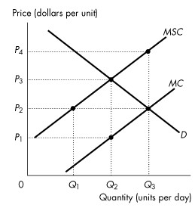
Figure 16.2.1

5) Refer to Figure 16.2.1. The figure shows the marginal private cost curve, the marginal social cost curve and the market demand curve. If the market is unregulated, then the quantity produced is 5) _______

A) zero. B) Q1. C) Q2. D) Q3. E) too low.

6) Refer to Figure 16.2.1. The figure shows the marginal private cost curve, the marginal social cost curve and the market demand curve. To promote an efficient allocation of resources, the government could impose a constant per unit tax equal to 6) _______

A) P3 - P1. B) P4 - P1. C) P1. D) zero. E) P3 - P2.

Table 16.2.1

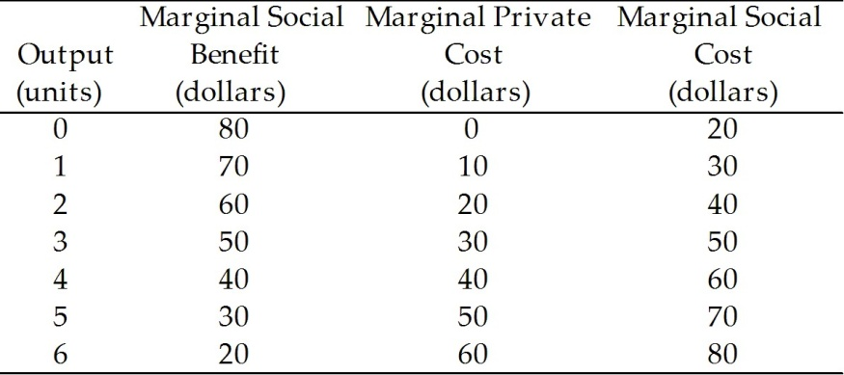

7) Refer to Table 16.2.1. Given in the table are the marginal private cost and the marginal social cost of the production of chemical fertilizer and the marginal social benefit from the consumption of fertilizer. Under these circumstances, 7) _______

A) not enough information is provided to determine whether or not there are externalities.
B) there are positive externalities in this market.
C) there are negative externalities in this market, equal to $20 per unit.
D) there are negative externalities in this market, equal to $10 per unit.
E) there are no externalities in this market.

8) Refer to Table 16.2.1. Given in the table are the marginal private cost and the marginal social cost of the production of chemical fertilizer and the marginal social benefit from the consumption of fertilizer. If the market is unregulated 8) _______

A) the quantity produced is greater than the efficient quantity.
B) production is technologically inefficient.
C) marginal external cost is maximized.
D) the quantity produced is less than the efficient quantity.
E) the quantity produced is the efficient quantity.

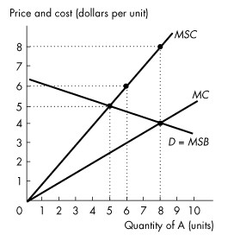
Figure 16.2.2

9) Refer to Figure 16.2.2. This figure shows the demand curve, the marginal private cost curve and the marginal social cost curve of good A. Production of the 6th unit of output generates a marginal external 9) _______

A) cost of $3.
B) cost of $6.
C) cost of $1.50.
D) benefit of $3.
E) benefit of $6.

Use the table below to answer the following questions.

Table 16.2.2
Chemical Fertilizer Market

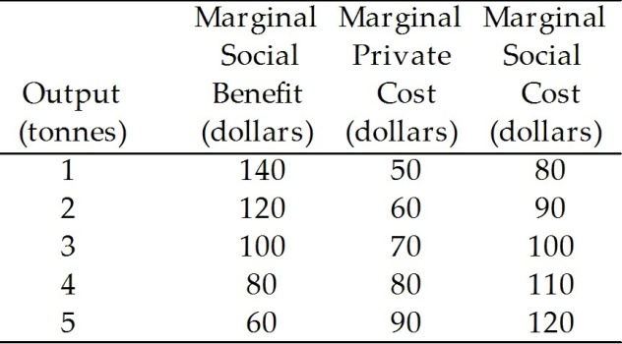

10) Refer to Table 16.2.2. If the fertilizer market is perfectly competitive and unregulated, output (in tonnes) is 10) ______

A) 1. B) 2. C) 3. D) 4. E) 5.

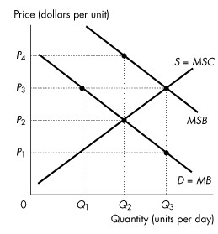
Figure 16.3.1

11) Refer to Figure 16.3.1. The figure shows the marginal private benefit curve, the marginal social benefit curve, and the market supply curve. If production is left to the private market, then the quantity produced is 11) ______

A) zero.
B) Q1.
C) Q2.
D) Q3.
E) between 0 and Q1.

12) Refer to Figure 16.3.1. The figure shows the marginal private benefit curve, the marginal social benefit curve, and the market supply curve. To promote an efficient quantity the government could grant a subsidy equal to 12) ______

A) P4 - P1. B) zero. C) P1. D) P3 - P1. E) P2 - P1.

Use the table below to answer the following questions.

Table 16.3.1

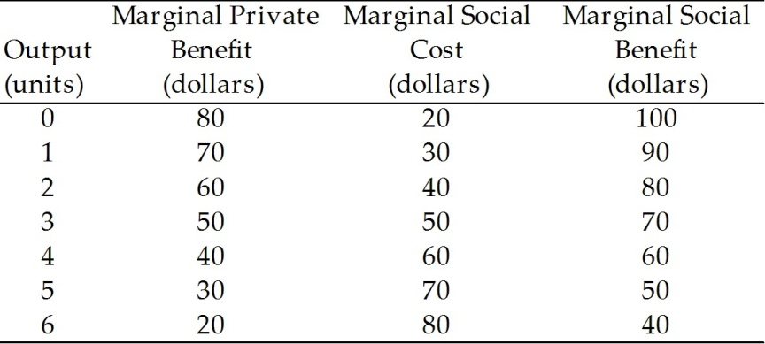

13) Refer to Table 16.3.1. The table shows marginal private benefit and the marginal social benefit from the consumption of chemical fertilizer and the marginal social cost of the production of fertilizer. If production is left to the private market, the quantity produced is 13) ______

A) 1 unit. B) 2 units. C) 3 units. D) 4 units. E) 5 units.

Use the figure below to answer the following questions.

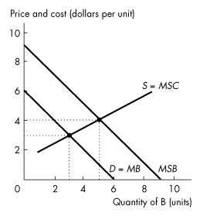
Figure 16.3.2

14) Refer to Figure 16.3.2. The figure shows the market for good B. How many units of good B are produced and consumed in an unregulated market? 14) ______

A) 9 units B) 3 units C) 5 units D) 6 units E) 0 units

15) In Figure 16.3.2. The figure shows the market for good B. Which of the following government policies creates an efficient outcome? 15) ______

A) Provide vouchers for consumption of B of $4 per unit.
B) Provide vouchers for consumption of B of $1 per unit.
C) Provide vouchers for consumption of B of $3 per unit.
D) Tax the production of B by $4 per unit.
E) Tax the production of B by $3 per unit.

Chapter 8
MULTIPLE CHOICE. Choose the one alternative that best completes the statement or answers the question.
1) Utility is 1) _______
A) equal to the price of a good.
B) the value of a good.
C) the additional satisfaction received from consuming another unit of a good.
D) the practical usefulness of a good.
E) the benefit or satisfaction from consuming goods and services.

2) The fact that your fourth slice of pizza does not generate as much satisfaction as your third slice is an example of 2) _______

A) diminishing total utility.
B) the law of demand.
C) the paradox of value.
D) consumer surplus.
E) diminishing marginal utility.

3) The first can of Coke gives 15 units of utility to Witney, while the second can of Coke increases her total utility to 23. What is the marginal utility of the second can of Coke? 3) _______

A) 11.5 units B) 38 units C) 8 units D) 24 units E) 7.5 units

Use the table below to answer the following questions.

Table 8.2.1

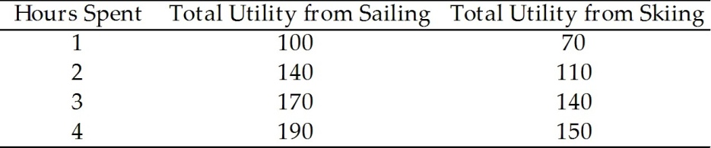

4) Refer to Table 8.2.1. Consider Sam's utility from sailing and skiing. The price of sailing is $10 per hour and the price of skiing is $20 per hour; Sam's income to spend on these activities is $80. In consumer equilibrium, Sam will sail for 4) _______

A) 4 hours and ski for 2 hours.
B) 3 hours and ski for 2 hours.
C) 2 hours and ski for 4 hours.
D) 4 hours.
E) 8 hours.

5) If a consumer spends all his income and his marginal utility per dollar is equal for all goods, then 5) _______
A) he cannot be better off even with more income.
B) marginal utility is maximized.
C) total utility is maximized.
D) the number of units bought of each good must be equal.
E) the proportion of income spent on each good must be equal.

6) Let MUA and MUB stand for the marginal utility of goods A and B, respectively. Let PA and PB stand for the price of goods A and B, respectively. Which statement must hold for consumer equilibrium? 6) _______

A) MUA = MUB and PA = PB
B) MUA = MUB
C) MUA/MUB = PA/PB
D) MUA/MUB = PB/PA
E) MUAPA = MUBPB

Use the table below to answer the following questions.

Table 8.2.2

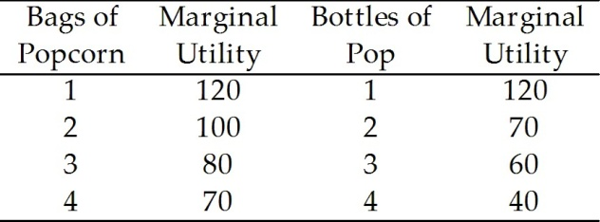

7) Refer to Table 8.2.2. What is the total utility if 3 bags of popcorn and 2 bottles of pop are consumed? 7) _______
A) 310 B) 660 C) 150 D) 100 E) 490

8) Samir consumes apples and bananas and is in consumer equilibrium. The marginal utility from his last apple is 10 and the marginal utility from his last banana is 5. If the price of an apple is $0.50, then what is the price of a banana? 8) _______

A) $0.25 B) $0.50 C) $0.10 D) $0.05 E) $1.00

Use the table below to answer the following questions.

Windsurfing equipment rents for $10 per hour and snorkeling equipment rents for $5 per hour.

Table 8.3.1

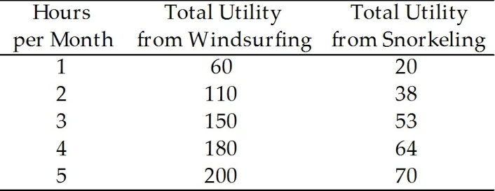

9) Devon enjoys windsurfing and snorkeling. His total utility from each activity is summarized in Table 8.2.1. Devon has $35 to spend. How long will Devon choose to windsurf and to snorkel? 9) _______

A) 4 hours windsurfing and no hours snorkeling
B) 1 hour windsurfing and 5 hours snorkeling
C) 2 hour windsurfing and 4 hours snorkeling
D) 2 hours windsurfing and 3 hours snorkeling
E) 3 hours windsurfing and 1 hour snorkeling

Use the table below to answer the following questions.

Table 8.2.3

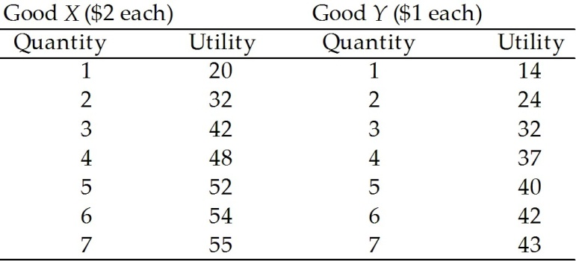

10) Refer to Table 8.2.3. If income is $13, then utility is maximized when consumption is 10) _______
A) 6 units of X and 1 unit of Y.
B) 2 units of X and 9 units of Y.
C) 4 units of X and 5 units of Y.
D) 3 units of X and 7 units of Y.
E) 5 units of X and 3 units of Y.

