Lecture 6 – Cardiovascular Disease
Review of RAAS (renin-angiotensin-aldosterone system)
- Juxtaglomerular release renin when BP, blood volume, Na+ [plasma] or renal perfusion is detected
- Renin converts angiotensinogen angiotensin I…ACE converts angiotensin I II
  - Angiotensin II acts on…
    - Adrenals (stimulates aldosterone, causing water/salt retention blood volume)
      - This takes days to months
    - Blood vessels (vasoconstriction – done by NE/N release – to BP
      - This takes minutes to hour from RAAS activation…QUICK!
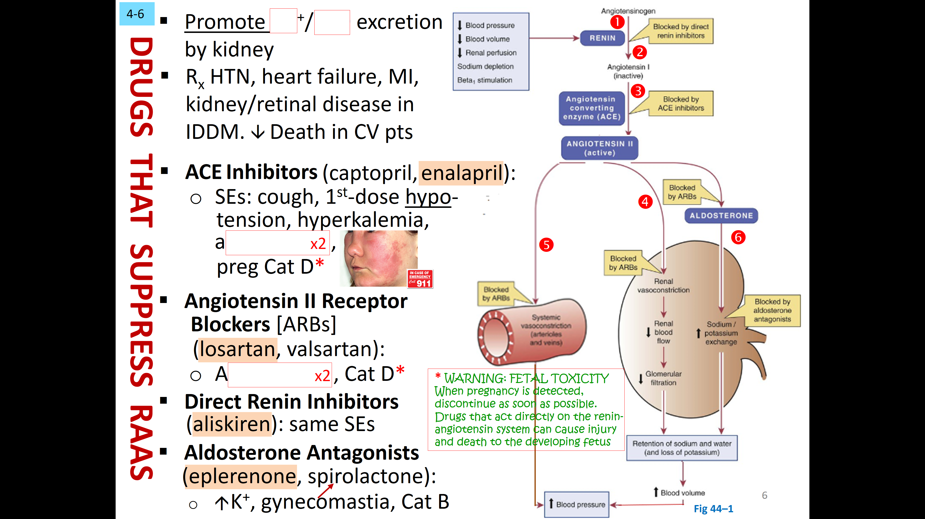

    - Drugs that suppress RAAS (this would promote water and salt excretion to treat HTN, heart failure, MI, kidney/retinal disease in IDDM)

Ace inhibitors (enalapril) – SE: 1st dose hypotension, hyperkalemia or angioedema (not in preg)
Angiotensin II Receptor Blocker (losartan) – SE: angioedema, not in pregnancy
Direct Renin Inhibitor (aliskiren) – same as above
Aldosterone Antagonists (eplerenone) – hyperkalemia, don’t use in pregnancy

Calcium Channel Blockers (or calcium antagonists)
- Work by prevent calcium from entering cells…blood vessels and heart affected while skeletal is not
  - Blood Vessels – vasodilation will occur (as Ca entering cells is blocked); CCB’s act selectively on peripheral and heart arterioles, NOT veins
  - Heart – contractile force , HR by slowing SA node pacemaker (regulated by Ca) and rate of AV node conduction
    - CCB’s are coupled with B1-adrengic receptors and both force of contraction/HR/AV
- 3 CCB drug families
  - I – verapamil II – diltiazem III – nifedipine
    - I/II work by blocking Ca channels in arterioles and heart; III only blocks arterioles
- Verapamil treats HTN, angina pectoris and cardiac dysrhythmias
  - Blocking peripheral arterioles leads to BP via dilation and blocking arteries of heart s coronary perfusion and suppressing AV node helps with dysrhythmias
  - ADR’s include dizziness, headache, edema, worsen function with cardiac dysrhythmias
- Nidedipine treats HTN and angina (NOT dysrhythmias); also helps suppress preterm labour
  - ADR’s include same as above; much safer with certain dysrhythmias; also reflex tachycardia (must coRx with beta blockers)

VASODILATORS
- CCB’s, hydralazine, minoxidil selectively dilate arterioles while organic nitrates selectively dilate veins
  - Dilating arterioles and veins can be done with ACE inhibitors, ARB’s, direct renin inhibitors, a-adrenergic blockers, nitroprusside
- Dilation in the…
  - Arterioles will cardiac afterload (force heart overcomes to pump blood) = cardiac work and output and perfusion
  - Veins will blood return to heart and ventricular filling = cardiac preload (stretch of ventricle before contraction)..will also cardiac work, output and perfusion
    - This has increased risk of orthostatic hypotension
- Vasodilation drugs are used for HTN, hypertensive crisis, angina pectoris, MI as wellas perpihral vascular disease, pheochromocytoma and controlled hypotension during surgery

- ADR’s of Vasodilators
  - Postural/orthostatic hypotension – relaxation of smooth muscle will cause blood to pool in veins and venous return and cardiac output/BP (leads to lightheadness and fainting)
  - Reflex tachycardia – baroreceptor in aortic arch/carotid detects drop of BP and signals medulla to HR to attempt to restore BP
    - Creates burden on heart and vasodilator is negated (esp for BP purposes)
    - Co-Rx with b-blocker
  - Expansion of blood volume – when BP remains low for long, blood volume will via kidneys (aldosterone release water/salt retention and low renal blood flow water salt reabsorption as well
    - Co-Rx with diuretics

- Specific vasodilators include..
  - Hydralazine – Rx for HTN, hypertensive crisis, heart failure; ADR’s are reflex tachycardia, systemic lupus eythematosus (rheumatoid like syndrome with pain, fever, pericarditis, antinuclear antibodies)
  - Minoxidil – Rx only severe HTN (b/c of ADR’s) and also topically for hair growth (rogaine); ADR’s are reflex tachycardia, water/salt retention, pericardial effusion, hypertrichosis (excess hair growth)
  - Sodium Nitroprusside – Rx for hypertensive crisis, heart failure and MI; ADR’s are hypotension and cyanide poisoning
HYPERTENSION
- Chronic elevated BP affecting 1 billion worldwide; lifelong Rx is needed to reduce symptoms (w/o heart/kidney disease and stroke)…only 70% diagnosed and 60% on Rx and 35% that Rx adequately
  - No consensus of when to Rx for HTN (140mmHg + above 60 yrs? Or 80?...now is 130/80)

- Primary/Essential HTN: Unknown cause in ~90%! Diagnose by ruling out other illnesses
  - Risk factors include age, menopause, African/Hispanic race
  - Drugs will not cure HTN, only treat
- Secondary HTN: identifiable cause in ~10% (usu secondary issue like renal/adrenal disease, thyroid/parathyroid disease, sleep apnea, pheochromocytoma
  - Possible to treat and cure! Or must manage with drugs used for primary HTN
- Chronic HTN can lead to morbidity and mortality risk – aka a ‘silent killer’ because its asymptomatic
  - Death from MI, renal/heart failure, brain hemorrhage
  - Systolic is more of an indictor of M&M than diastolic
  - Diagnose w/ several readings over several visits, confirm in opposite arm and avoid ‘white coat’

- Various ways to evaluate a pt…
  - Diagnose with tests (ECG, urinalysis, creatinine, electrolytes, glucose, hemoglobin/hematocrit, cholesterol/TG’s and uric acid)
  - Therapy needs to be aggressive if organ damage is present (heart disease, prior MI, angioplasty, stroke, chronic kidney issues, retinopathy, L-ventricular hypertrophy)
  - Consider CV risks as well… smoking, obesity, inadequate exercise, diabetes, age and family history
    - Interventions also include lifestyle changes (less salt, healthy diet, reduced alcohol, stop smoking, weight loss and aerobic exercise)

Blood Pressure Control
- Arterial pressure is calculated by CO x PR
- Some systems that regulate BP are baroreceptor reflex, RAAS and kidneys
- Chart of HTN drugs and their effects…
Beta blockers, Calcium-channel blockers | HR and force of contraction
Diuretics | Blood volume by urine output
Vasodilators | venous return
Calcium-channel blockers | peripheral vascular resistance

DIURETICS
- Thiazide diuretics = hydrochlorothiazide
  - Work by reducing blood volume and arterial resistance
  - SE is hypokalemia (low K) – fix with K rich foods/supplements or K-sparing diuretic (like spironolactone) *potential for hyperkalemia though
- Loop Diuretics = furosemide
  - More effective that above but too much for most ppl
  - SE’s are low K, dehydration, hyperglycemia, hearing loss
ADRENERGIC RECEPTOR BLOCKERS
- B-Adrenergic Blockers = propranolol, metaprolol
  - Work by blocking cardiac B1 receptors to HR/contractility; also reduces renin (blocks RASS)
  - SE’s are bradycardia, low contractility, asthma, hypoglycemia, depression
- A-Adrenergic Blockers = doxazosin, terazosin
  - Work by vasoconstriction of arterioles and veins to peripheral resistance and venous return
  - SE is orthstatic hypotension
    - Also are alpha and beta blockers!
- Centrally Acting A2 agonists – work pre-synpatically in brainstem to suppress sympathetic tone to heart/vesseals (vasodilation and CO)
  - SE is severe rebound HTN if abrupt stoppage of drug
- Adrenergic Neuron Blockers – work on post-gang terminals of sympathetic neurons
  - SE is orthostatic hypotension and depression
- In hypertensive emergencies = DIASTOLIC BP >120
  - Need rapid treatment if papilledema (swelling of optic disc), intracranial hemorrhage or MI/HF is present…MUST lower with 1 hour!
  - If these symptoms are not present, reduce over 24-48 hr; with rapid reductions, cerebral ischemia, MI or renal failure can occur
    - Rx with IV vasodilators! Sodium nitroprusside, labetolol, diazoxide etc
- In hypertensive pregnant emergencies…
  - Chronic HTN – 5% of pregnancies; can result in placental abruption, maternal heart decompensation, CNS bleed, premature birth
    - Rx if SBP over 180 and DBP 110 (methyldopa but not ARB/DRI)
  - Preeclampsia/Eclampsia – when BP is 140/90+ with proteinuria
    - Fetus – growth restriction, premature birth; mother – seizures, renal failure, pulmonary edema
    - Can treat if mild with best rest, anti-HTN drugs but if severe, must choose between fetus and mother
HEART FAILURE (‘CFA’ or congestive heart failure)
- Heart is unable to pump sufficient amount of blood to meet metabolic needs; this is due to HTN, MI, valvular heart disease, congenital heart or coronary artery disease or cardiac dysrhythmia
  - Heart will remodel itself to meet demands by 1) Dilating ventricles 2) Hypertrophy of cardiac walls and 3) Becoming more spherical in shape
  - The heart will also take on an increased sympathetic tone to compensate (if BP falls, baroreceptors activate sympathetic output to heart/vein/arterioles)
- There are both good results and bad results of this remodeling of heart
  - GOOD - HR/CO, vein narrowing/ventricular filling, arterial pressure and thus organ perfusion
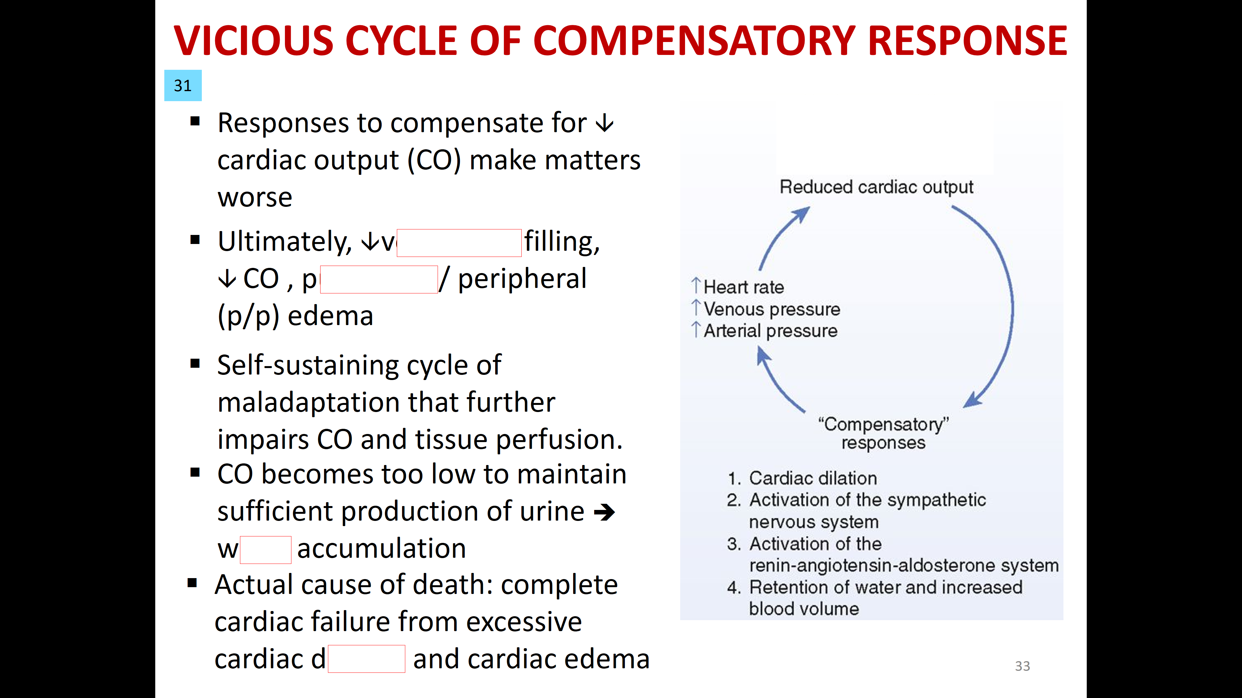
  - BAD – ventricles can’t fill in time, O2 demand by heart,
peripheral edema and hear workload
- As this continues, blood volume will increase due to the urine output
(from low blood flow to kidneys and activation of RAAS)…then heart
will dilate and stroke volume decreases
  - Becomes a vicious cycle of compensation; actual cause of death
with HF patients is excessive cardiac dilation and cardiac edema

- S/S of HF = SOB (crackles, wheezing, cough), pulmonary edema,
fatigue, cardiomegaly and enlarged spleen/liver, ascites (swollen
abdomen) and peripheral edema (swollen legs), low BP weak pulse
and urine output

- Diuretics for HF – will cause water exertion to blood volume (afterload, edema and cardiac dilation will also decrease); ONLY for symptoms (not a cure)
  - BP can also drop too low = BP and CO
  - Thiazide diuretics are oral agents for long term Rx of mild HF; loop diuretics are oral and IV for severe HF and K-sparing diuretics are weak and only use to counteract hypokalemia
    - ACE inhibitors, Angiotensin II receptor blockers, b-blockers and aldosterone antagonists can also be given for HF

- Digoxin – ‘last hope’ for HF; works by heart contractile force and cardiac output
  - Considered a wonder drug as it improves heart size, p/p edema, weight, fatigue BUT doesn’t prolong life
  - Problems with digoxin are…
    - Low therapeutic index (even slightly out of range will cause dysrhythmias)
    - Toxicity that is worsen by hypokalemia (blood levels of electrolytes and ECG needed to monitor and prescribe)
    - SE including anorexia, N/V, fatigue,
    - DDI’s with any heart drugs (diuretics, ACE inhibitors, ARB’s dopamine)

- Again, HF can only be ‘manage’
  - Drug therapy – diuretic + ACE inhibitors/ARB’s + B-blocker; also + 4th digoxin + 5th aldosterone antagonist; +6th/8th isosorbide dinitrate and hydralazine
  - Device therapy – Cardio-defibrillators or biventricular pacemakers (L/R out of sync); extra-aortic cuff
  - ‘Stage D’ marks advanced structural disease and symptoms appear at rest; hospitalization common – best long-term solution here is heart transplant or LVAD (left ventricular mechanical assist device to help pt make it to transplant (also end-of-life care)

ATHEROSCLEROTIC CV DISEASE – Prophylaxis/prevention
- Thickening of the coronary arteries = coronary artery arteriosclerosis or atherosclerotic cardiovascular disease (leading killer in Canada and globally)
  - Manifests as anginal pain and can lead to ACS (acute coronary syndrome) or MI
  - Treatment is to lower cholesterol and triglycerides by diet, exercise and last-resort drugs
- Atherosclerosis begins as fatty streaks in arterial walls progress to fibrous plaques (causing blocked blood flow and angina)
    - If plaque ruptures = thrombus (blood clot) that can entirely block flow, causing an MI
    - If it dislodges = embolus travels downstream and blocks smaller blood vessel
  - Inflammation plays a big role in the progression of this disease; LDL’s penetrate the arterial walls (atherogenesis) and our inflammatory system actually creates this plaque and can also rupture it
    - Can predict CV status with biomarkers from inflammation = C-reactive proteins (CRP)

- Cholesterol – critical to life! Needed for hormone synthesis and membrane structure
  - Sources come exogenously (diet) and endogenously (synthesized by liver)
  - HMG-CoA reductase is necessary to synthesis (this is where statins work)
    - Main culprit = dietary saturated fat! ‘lipoproteins’

- Lipoproteins classes…
  - HDL (High-Density Lipoproteins) ~30% of blood cholesterol; these carry back to liver
  - LDL (Low-Density Lipoproteins) ~70% of blood cholesterol; these carry lipoproteins to peripheral tissues (blood vessels)
    - LDL’s contribute greatly to ASCVD; any drugs that increase LDL uptake into the liver will lower LDL levels in blood and amount that deposit in blood vessels
  - VLDL (Very-Low-Density) are mostly all TG’s and move from stomach to liver

- Cholesterol screening can begin at age 9-11 and again at 18-21 (if family history than @ 2-8 years)
  - Goal is to see numbers that indicate more HDL and less LDL and TG’s
  - Can also take ‘ASCVD Risk Assessment Test’
  - Also consider positive risk factors (advancing age, African descent, HTN, smoker and low HDL) and negative risk factors (high HDL cholesterol levels)

- TLC (or therapeutic lifestyle changes) are possible!
  - Goals are to reduce LDLs and maintain healthy weight (keep cholesterol under 200mg/day and sat fats under 7% of total calories/day)
  - Exercise! This will lower LDL, raise HDL, lower BP and insulin resistance and CV
    - ~30-60 mins per day (time is more important than intensity)
  - Stop smoking! Cigarettes LDL and HDL
  - Loss weight! LDL and ASCVD risk

- Drugs therapy for ASCVD if TLC fails
  - Statins (HMG-CoA reductase inhibitors) and Bile-acid sequestrates or fibrates (not as effective)
  - Lifelong treatment; drugs will prevent ASCVD rather than regress established plaques; drugs also can raise HDL’s (these are the weaker agents)
- Treatment should also target..
  - Metabolic Syndrome – Risk factors are abdominal obesity, hyperglycemia, HTN, HDL/TG’s
    - Rx with weight reduction + exercise; BP and TG lowering drugs + low dose aspirin ‘
  - High Triglycerides – independent risk factor of ASCVD and associated with obesity, smoking, alcohol, high carb
    - Rx with diet, statin, TG meds
Statins (lovastatin)
- Most effective in lowering LDL/total cholesterol = improve outcomes ( risk of HF/death)
  - Main mechanism is blocking synthesis of cholesterol in liver cells…these levels activates LDL receptor on liver so more LDL bind (this draws cholesterol out of circulation and to be used in liver instead of being deposited in arterial walls)
  - Slows progression of ASCVD, stroke risk, hospitalization, peripheral vascular disease
    - Primary prevention is to reduce mortality with healthy individuals
    - Secondary prevention is to reduce mortality with pre-existing angina, previous MI, diabetes, stroke
      - Can also be used for Parkinson’s, Alzheimer’s, MS, kidney disease, macular degeneration disease
- SE’s are uncommon but…
  - Myopathy/Phabdomyolysis – mild muscle tissue resulting in aching, tenderness and weakness
    - Only in 1-5%; myositis (muscle inflammation) and can rarely progress into rhabdomyolysis (muscle disintegration)
  - Hepatotoxicity, Peripheral Neuropathy or potentially Type 2 Diabetes

- Other cholesterol-lowering agents
  - Nicotinic Acid (niacin) - LDL/TG’s and HDL
  - Colesevelam (Bile-acid sequestrants) - LDL and used primarily as adjuncts to
  - Fibrates – most effective to TG’s (but SE is risk of bleeding with warfarin and hepatotoxic
  - Ezetimibe – newer drug that blocks cholesterol absorption from SI; meant to be used in adjunct to diet and statin
- OTC agents
  - Fish oil – reduced risk of ASCVD and thrombotic stroke
  - Plant Stanol/Sterol Esters – analogs of cholesterol so they reduced actual absorption
  - Cholestin – dietary supplement but lacks evidence of clinical benefits

