Respiratory Disorders
ASTHMA
- Chronic disorder caused by an immune attack resulting in the inflammation of airways
  - Widespread – 1/11 children have it with 15% since 2000
  - Drug therapy is very effective = no limitations for pt who have asthma
- S/S include breathlessness, chest tightness/pain, wheeze/cough and dyspnea
- Pathophysiology –
  - Allergen binds to and activates a mast cell (via IgE) resulting in the release of inflammatory mediators (histamine, prostaglandins, interleukins etc)
    - This causes inflammation and bronchoconstriction
    - Inflammation edema, mucous plug, muscle hypertrophy, bronchial hyper reactivity to mild triggers (cold air, exercise, smoke)
  - Rx with bronchodilator and anti-inflammatory
COPD
- Chronic disorder of adults who smoke cigarettes; caused by inflammation and airflow restriction
  - 3rd leading cause of death
- S/S include wheezing/cough/dyspnea as well as chronic bronchitis (with excessive sputum) and poor exercise tolerance
- Similar to asthma – including drug therapy – except for…
  - COPD is a progressive and irreversible disease and drug therapy has minimal benefit
  - Preventable by smoking cessation
- Pathophysiology –
  - Exaggerates reaction to cig smoke leads to inflammation in airways causing…
    - Hypertrophy of mucous-secreting glands = mucous secretion and chronic bronchitis
    - Protective protease inhibitors (enzymes that break elastin down) are inhibited = alveolar wall destruction
    - Enlargement of alveoli/bronchioles from wall deterioration = emphysema
    - Bronchial edema from inflammatory mediators narrows airway = wheezing
  - Rx (same as asthma) with bronchodilator and anti-inflammatory

DRUGS
- Administration by inhalation is best because drug is delivered directly into lungs (ing therapeutic effects) and minimizing systemic effect as well as rapid relief
- Types include…
  - Metered-Dose Inhaler (MDI) – pressurized devices that user activates after inhaling
    - Difficult to use properly as only 10% reaches lungs and 80% is swallowed
  - Respimats – similar to MDI but dose is in a fine mist ( delivery to lungs)
  - Dry-Powder Inhalers – breathe activated but still only 20% enters lungs
  - Nebulizer – large machine that delivers drug in fine mist over minutes (not seconds)
    - “May be” more effective
- Can either be…
  - Taken daily as a prophylactic to attack frequency/severity and PRN need
  - PRN for quick relief of ongoing attack by revering bronchoconstriction/cough etc
    - Both anti-inflammatory and bronchodilators in short and long term control
Anti-inflammatory
- MOST effective as suppressing inflammation ( mediators, airway edema/mucous and bronchial hyperactivity)
  - Inhaled – 1st line of therapy for asthma; prophylaxis/daily use for relief 3-10 days after RX start
    - Steroid are NOT PRN
  - Systemic (PO/IV) – used for severe, persistent asthma or acute COPD if inhaled not effective
    - SE when use is prolonged

- Types…
  - Glucocorticoids – short term (~10days max) or inhaled PRN
    - SE is oral candidiasis, hoarseness, minimal adrenal suppression, CA growth slowed, potentially suppresses growth of brain/lungs?
    - Long-term systemic use has many severe SE
  - Leukotriene Modifiers – suppress inflammatory mediators (specifically by blocking leukotriene synthesis or its receptors) = in bronchoconstriction, mucous, airway edema
    - “2nd line agents” as they can’t be used PRN and not as effective as steroids AND they have adverse psychiatric SE
  - Omalizumab – monoclonal antibody; block allergens by antagonizing IgE
    - 2nd line agent; NOT PRN; only modest benefit with unknown long-term safety
    - SE anaphylaxis and CA
  - Cromolyn – suppresses bronchial inflammation
    - 2nd line agent/not PRN

Bronchodilators
- MOST effective at reliving acute bronchospasm and preventing exercise-induced bronchospasm
  - Have no anti-inflammatory properties
  - Mechanism via B2-adgrengic agonists decrease bronchospasm in lung SM
    - BUT can affect B1 in skeletal muscle (tremours) or B1 in heart (angina/arrhythmia)
- Types…
  - SABA (short-acting) – albuterol
    - Begin immediately = used to abort ongoing attack
    - Peak at 30-60 mins and last 3-5 hours = not used prophylactically (except with exercise-induced asthma)
    - With OD, heart will be affected as excess B2 will affect the B1 receptors on the heart
  - LABA (long-acting) – salmeterol (slower onset)
    - Used prophylactically (not PRN); even ones that have quick onset (formoterol)
    - MUST be combined with glucocorticoid (if LABA taken alone, results in severe asthma and death)
  - Methylxanthines – theophylline
    - Taken PO only; same chemical family as caffeine
    - Must measure theophylline blood levels periodically
      - <111umol/L = therapeutic
      - 111-140umol/L = N/V/D, insomnia, restlessness
      - >167 mcg/mL = severe dysrhythmia, Rx-resistant
        - Rx OD with charcoal, IV diazepam
    - Generally has been replaced by safer options
  - Anti-cholinergics – ipratropium
    - Mechanism via blocking muscarinic receptor in bronchi = bronchospasm
    - Inhaled drugs; used long-term or for PRN relief of COPD + off-label for asthma PRN
    - Can be used with B2-agnoists as mechanism is different

Managing Asthma
- Measuring kung function via spirometer is first step
  - FEV₁ (forced expiratory volume in 1 second), FVC (forced vital capacity – total volume exhaled), PEF (peak expiratory flow)
    - Normal FEV1/FVC = 80% (70% with age) but with asthma = less than 5%
- Classify severity based on two domains…
  - Impairment – impact of asthma of QOL and functional capacity
  - Risk – future adverse events of impairment and drug responses
    - Can have high risk but no impairment
  - This is put on the “asthma severity scale”
    - 1 – intermittent 2 – mild 3 – moderate 4 – severe
- Acute severe exacerbations…
  - Supplement O2, systematic glucocorticoids, nebulized high-dose SABA, nebulized ipratropium, IV magnesium sulfate (bronchodilator) and Heliox (mostly helium)
  - Post-crisis, oral + inhaled glucocorticoid for 5-10 days; may take weeks to recover function j
- Exercise-induced bronchospasm…
  - Caused by loss of water/heat from lungs; starts during or immediately after exercise
  - Rx prophylactically with SABA/cromolyn
Managing COPD
- Can be quantified via spirometer that measures airway obstruction; rate on an A-D scale
  - A – mild (few S, low risk)
  - B – moderate (some S, low risk)
  - C- severe (few S, high risk)
  - D – very severe (some S, high risk)
- Has “two” goals…
  - Reducing symptoms, improving health status/exercise tolerance
  - Reducing risks/mortality by preventing progression, stopping/preventing exacerbations
- Stable COPD is managed by bronchodilators, glucocorticoids, and PDE4
  - Phosphodiesterase type 4 inhibitors work by cAMP in lungs and inflammation, excessive mucous (**PDE 5 is for ED)
- Exacerbations are managed with the same drugs + supplemental O2 and antibiotics (bc of freq infection)

Gastrointestinal Disorders
PEPTIC ULCER DISEASE
- PUD is the wall erosion of the ‘gut’ (esophagus, stomach, SI/LI); can result in perf and hemorrhage
  - Most common cause is helicobacter pylori infection; by eradicating this bacteria, your ‘gut’ wall heals and there is a low reoccurrence rate (also gastric CA promotion as it’s a type 1 carcinogen)
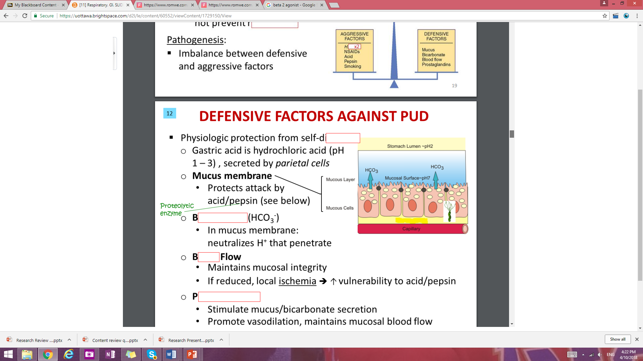
- Pathogenesis is an imbalance between defensive and aggressive factors
(Mucous membrane protects against self-digestion by HCl from parietal cells)
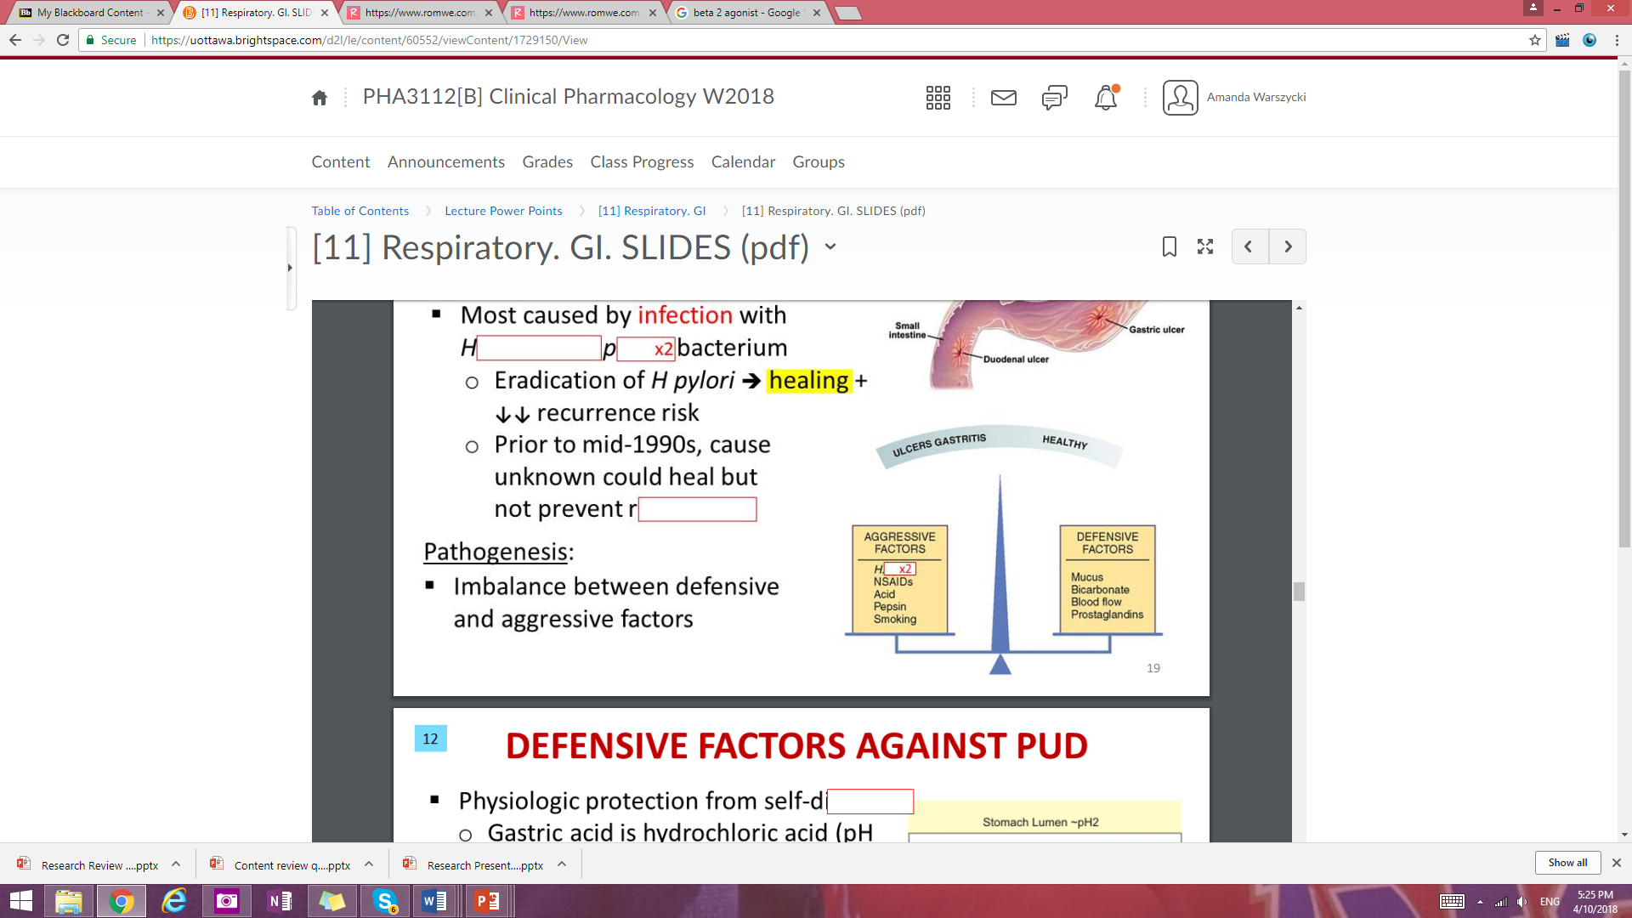H. pylori
Defensive factors
Mucous Membrane | Protection against acid/pepsin in stomach
Bicarbonate HCO₃⁻ | Neutralized H⁺ that get into the mucous membrane
Blood Flow | Maintains integrity of mucosa (if reduced, local  ischemia will create vulnerability to acid/pepsin
Prostaglandins | Stimulate mucous/bicarb secretion, promotes  vasodilation (maintaining blood flow) and  suppresses gastric acid secretion
Aggressive factors
Helicobacter pylori | Gram –ve bacillus that colonizes stomach but hides in epithelium/mucosa (is able to escape acidity of stomach); 50% of humans infected
NSAIDS | prostaglandins and directly irate mucosal lining
Gastric acid | HCl acid in stomach can injure mucosal directly and indirectly through pepsin activation (need additional factors as this is ‘normal’)
Smoking | Delays healing/ reoccurrence risk as it interferes with Rx, bicarb secretion and gastric emptying into duodenum

- PUD Drug Therapy
  - Goals is to alleviate symptoms, promote healing, prevent bleeding/perf and reoccurrence
  - Various anti-ulcer drugs including antibiotics, mucous protectorants, antacids, and anti-secretory agents (PPI, H2RAs and muscarinic anticholinergic)
  - Must evaluate with radiologic/endoscopic exams (pain can be alleviated before complete healing or can continue after exam is clear)

- Non-drug measures…
  - Diet plays no/minor role (ulcer diet of bland foods, no caffeine doesn’t affect ulcer or healing)
    - Eating patterns may benefit and recovery
  - Avoid cigarettes, ASA/NSAIDS, alcohol (esp if alcohol increases symptoms); stress has no role
- Drug measures…
  - 1st – test for H. pylori will endoscope biopsy (invasive) or other non-invasive tests like breath test (CO and ammonia) blood antibodies and stool antigens
  - Antibiotics (choice is amoxicillin, clarithromycin, tetracycline); usu will prescribe 2-3 antibiotics PPIs/H2RAs for 2 weeks!
  - Can also use Bismuth (hardly effective) and metronidazole (40% of h. pylori is resistant though)

- Histamine₂ Receptor Antagonists – cimetidine, ranitidine, famotidine, nizatidine
  - H₂ receptors in parietal cells are blocked (gastric acid secretion)
    - NOT H₁ – blocking these have an antihistamine effect for allergy symptoms
  - Low incidence of SE so they are 1st choice for gastric/duodenal ulcers
  - Used for…
    - Gastric/duodenal ulcers (acute or prophylactically)
    - GERD/reflux esophagitis
    - Zollinger-Ellison syndrome
    - Preventing aspiration pneumonia (in surgery as anesthesia glottal reflex)
    - Heartburn/sour stomach, indigestion
- Proton Pump Inhibitors – omeprazole, lansprazole, rabeprazole, pantoprazole
  - Suppressing gastric acids (betters than H₂RAs) by…
- Suppressing gastric acid formation (H₂RA suppress secretion)
- Inhibits H, K-ATPase and gastric acid generating enzymes
    - Also, these are prodrugs and are converted in parietal cells of the stomach
  - Used short-term (4-8wk) for ulcers/GERD or long-term for hypersecretory conditions (Z-E)
  - ADRs include headache, NVD, pneumonia (short-term) and gastric CA/ Ca absorption = osteoporosis (long-term)

- Review on GERD (gastro-esophageal reflux disease) – acid regurgitation from the stomach into the esophagus caused by inappropriate relaxation of the lower esophageal sphincter (LES)
  - Many contributing factors like obesity, hiatal hernia, delayed gastric emptying (NOT h. pylori)
  - Can be erosive esophagitis (GERD) or non-erosive esophagitis (NERD)
    - Rx with drugs (PPIs, H2RAs) or surgery and lifestyle changes (weight loss, sleep with head elevated, no alcohol/smoking)

Anti-ulcer drugs
- Sucralfate – creates additional protective barrier against acid/pepsin that compliments the natural mucosal layer (but does not neutralize acid or decrease acid secretion)
  - Rx for 4-8 weeks
- Misoprostol – used for NSAID induced ulcer by replacing endogenous prostaglandins (blocked by NSAIDS); Rx for 4-8 wk
- Antacids – neutralize gastric acid to gut wall destruction, pepsin activity and prostaglandins
  - Used for prevent aspiration pneumonitis pre-op, prophylaxis for stress-included ulcer, relief for GERD and acid indigestion
  - Sold as aluminum hydroxide (or magnesium/calcium)
    - SE include constipation from Al, diarrhea from Mg (must combo two to offset)
- Anti-cholinergics – inhibit gastric acid secretin but has very limited role today
  - Needed dose for therapeutic effect = dose producing SE (dry mouth, constipation, urinary retention, visual disturbances)

Other GI Disorders
- Emesis, CINV (chemo-induced nausea/vomiting), N/V during pregnancy, motion sickness, diarrhea, IBS, IBD, constipation, oral mucositis, pancreatic enzyme deficiency, gallstones, etc

EMESIS
- Occurs from a complex reflex from the direct/indirect activation of the vomiting center
  - This center acts on the diaphragm abdominal muscles they contracted and this forces the gastric contents out
- Activation in the medulla (brain stem) can be…
  - Direct-acting: stimulation from CNS (fear, pain) or the vestibular apparatus inner ear (motion)
  - Indirect-acting: stimulation from the CTZ (chemoreceptor trigger zone) in the medulla will also activate the vomiting center; caused by vagus nerve (from stomach/SI) or from emetogenic compounds (like chemo) in the blood
- 3 types of emesis…
  - Anticipatory – before drugs given/triggered by memory
  - Acute – within mins/hours but resolves in 24 hr
  - Delayed – develop after 1 day but persist 6-7 days
    - Negative consequences of CINV is dehydration, nutrient depletion, electrolyte imbalance, esophageal tears and as a result, pt refuses to continue treatment
Anti-emetic Drugs…
- Serotonin Receptor Antagonists – ondansetron¸ granisteron
  - ‘anti-emetic effect’; most effective for chemo, radiation, anesthesia
    - Also, does NOT block DA receptors (so no EPS – akathisia, acute dystonia)
- Glucocorticoids – methylprednisolone
  - Anti-inflammatory and anti-emetic effects for CINV
    - Unknown mechanism; no serious SE if used short-term
- Substance P/Neurokinin Antagonists – aprepitant (from pro-drug fosaprepitant)
  - Newer preventative drug for post-op N/V and CINV by blocking neurokinin receptors from substance P in the CTZ
- Benzodiazepine
  - Used in combo regimens to suppress CINV (but also sedates and causes anterograde amnesia)
- Dopamine Antagonists – haloperidol, metoclopramide
  - Block DA₂ receptors in CTZ for post-op N/V, CINV, RT, opioids and toxins (also antipsychotic)
    - SE = EPS (extrapyramidal syndrome), anticholinergic, hypotension and sedation
- Cannabinoids – dronabinol, nabilone for CINV
  - Activate cannabinoids receptors in vomiting; dronabinol also increase appetite in AIDS pt and THC + cannabinoids for CA/MS
    - SE = temporal disintergration, dissociation, dysphoria

*Anti-emetics are more effective at preventing rather than suppressing CINV
  - Low risk 1 drug; pt with mod/high risk aprepitant + dexamethasone + 5-HT₃ antagonist

Nausea/Vomiting in Pregnancy
- ‘Morning sickness’ can actually be anytime of the day; 25% just get nausea and 50% get N+V
  - Hyperemesis gravidarum (severe from causing dehydration, ketonuria, hypokalemia)
  - Does resolve but 60% by 13 wk and 90% by 20 weeks
- Rx by eating small portions, avoiding triggers, alternatives (like ginger/acupuncture)
  - 10% need drugs = diclectinloxylamine + vit B6 (1st line agents BUT preg risk “A” – not really)
Motion Sickness
- Rx with more effective at preventing symptoms, not stopping the symptoms (N/V, pallor, cold sweats)
- Scopolamine (acetylcholine muscarinic blocker)
  - Blocks inner ear vestibular apparatus so no connection to the vomiting center
  - Given PO, subQ, transdermal patch behind ear)
    - SE dry mouth, blurred vision (more severe is urinary retention, disorientation, constipation
- Anti-histamine₁ (meclizine, cyclizine)
  - Same mechanism as scopolamine (blocking acetylcholine) but less effective/more sedating
Diarrhea
- Excessive volume/fluidity of stools and frequency of defecation; not a disease but symptom of one
  - Many causes including infection, maldigestion, inflammation, functional bowel disorders
  - SE of diarrhea is dehydration and electrolyte loss
- Manage with…
  - Diagnosing underlying disease, replacing Na, K, Cl, relieving cramping
  - Rx with 2 major anti-diarrheals non-specific (symptom relief) and specific (underlying cause)
- Non-specific agents…
  - Opioids – most effective; activated opioid receptor in GI tract to motility and fluid/electrolyte reabsorption as well as stool fluidity/volume and lower frequency of defecation
    - No “dependence” with required dose
  - Bismuth Subsalicylate (Pepto) – works to prevent/treat mild diarrhea (also used against h. pylori)
  - Bulk-forming Laxatives – helps manage diarrhea as it makes stool more consistent, less watery

- For infectious diarrhea, Rx may add antibiotic to counter a variety of bacteria/protozoa
  - Usu self-limited and no antibiotic is needed; best to avoid prescribing due to resistance
    - Must use antibiotics if severe (Salmonella, shigella, campylobacter, clostridium)
  - E. Coli can cause traveller’s diarrhea
    - Rx is unnecessary and infection is self-limited; using non-specific agents can even prolong infection as it slows peristalsis and export of the bug
IBS (Irritable Bowl Syndrome)
- Most common GI disorder of abdominal pain for 12 week+ ; 20% of pop affected (more F than M)
  - 2 types: IBS-D (diarrhea) or IBS-C (constipation); both relieved by defecation
  - Triggered by stress, depression, diet but no known cause/mechanism so it’s considered as a functional (physiatric) disorder

- Rx for IBS…
  - Non-drug Rx measures = find triggers, small meals, more fluids for IBS-D
  - Non-specific Rx = anti-spasmodic, antidiarrheal, antibiotics, bulk-forming agents, antidepressants, acids suppressants
  - Specific Rx includes alosetron, lubiprostone and tegaserod
    - Either effective but serious SE or very modest effects

Inflammatory Bowel Disease
- S/S are abdominal cramps, diarrhea, rectal bleeding caused by an exaggerated immune response to normal flora or genetics
  - Either Crohn’s disease (ileum) or ulcerative colitis (colon/rectum)
- Drugs…
  - 5-aminosalicyaltes – sulfasalazine
    - Rx for mild/mod IBD + to maintain remission; metabolized by intestinal bacteria into 5-aminosalcyclic acid and sulfapydrine
  - Glucocorticoids (budesonide, dexamethasone) to relieve symptoms as an anti-inflammatory
  - Immunosuppressant (mercaptopurine from pro drug azathioprine)
    - Effects of disease delayed up to 6 months but more toxic that steroids/5-aminos
    - More effective (like cyclosporine) reversed by acute/severe Rx of resistant-IBD
    - Also, methotrexate can provide short-term relief for Crohn’s
  - Immuno-modulatory (infliximab, natalizumab for MS, adalimumab for RA)
    - Used early to induce and maintain remission
    - SE infections, thrombocytopenia/leukopenia, HF, anaphylaxis
  - Other agents – antibiotics for Crohn’s ONLY; nicotine for UC
*study on whipworm for Rx resistant UC; worms may have therapeutic in immune diseases*
Constipation
- Prokinetic agents work to tone and motility of GI tract
- Some drugs are..
  - Metoclopramide – suppresses emesis by blocking DA serotonin receptors in CTZ) “anti-cholinergic”; used for GERD, gastroparesis as well
  - Cisapride – enhances acetylcholine to Rx GERD, gastro-paresis, severe chronic constipation
    - Potentially dangerous
Oral Mucositis
- Painful complication of cancer chemo-radiotherapy
- Rx with palifermin synthetic form of KGF (keratinocyte growth factor) via recombinant DNA
  - Stimulates proliferation, differentiation of epithelial cells to thickness of the oral mucosa
    - Can induce cancer as it proliferation in CA cells too
Pancreatic Enzyme Deficiency– deficiency for 4 digestive enzymes (lipase, amylase, chymotrypsin and trypsin) causing fatty stools (as fat cannot be absorbed) Rx by replacement; pancreatectomy, pancreatitis, obstruction of pancreatic duct (CF patients needs a pancreas transplant eventually too)
Gallstone/ Cholelithiasis
- Bile from gallbladder digests fat and solubilizes cholesterol from removal from the body
- Can be present from years without symptoms (or just indigestion) once blocked, jaundice + pain
  - Rx with cholecystectomy (preferred) or drugs (chenodiol/ursodial) to gradually dissolve gallstones by hepatic cholesterol production and bile cholesterol content (Rx for 2 years)

