Lesson One
- Magnesium has 12 electrons

- Given that the half life of Carbon-14 is 5730, when it comes to dating bones that are over a million years old, the radioisotope would not be useful, because by that the time the level of carbon-14 will be too low.
3. There are four major types of biochemical reactions that exist. The first being, hydrolysis.
Hydrolysis's the chemical breakdown of molecules using water. As discussed in the lesson, the most common hydrolysis happens in the body every day, all the time. This frequently happens when water breaks down proteins to turn into amino acids. Also when enzymes aid digestion through hydrolysis is another important thing that hydrolysis aids to. Hydrolysis is biologically important because it is a key part of the breakdown and digestion system, helps turn proteins and carbohydrates in to important acids that our body needs.
Condensation is the reaction of two molecules that combine and form one molecule. An example of condensation is two amino acids transforming into a peptide. This is a great example of condensation because it is two specific molecules that are transforming into a single molecule, a peptide. Condensation is important in the biological world because it encompasses an important element in the environment. It is the key component to the creation of clouds, and the transformation of water vapour turning back into water in which supplies the environment.
Oxidation is the process of losing electrons, and reduction is the process of gaining electrons. When it comes to the electron transfer between two substances always involves a reduction of one and an oxidation of the other, this is called redox reaction. An example of redox reaction is the creation of table salt. Chlorine is the oxidizing agent, so as our sodium reacts with chlorine, sodium is our reducing agent, so chlorine gains electrons, and the sodium is reduced. Oxidation-reduction is an important biological process. It is important because these reactions are the main source of energy on the planet.
The final process is neutralization. Neutralization is the process of the reaction of an acid and a base to produce water and salt. These reactions are common throughout our bodies, happening within our stomach and our intestines. Acids play a key part on adding the concentration of hydrogen ions. Bases play a key part with the increasing levels of hydroxide. An example of neutralization reaction to form salts is HCl + NaOH --> NaCl + HOH. Neutralization is important because it helps return pH levels back to a more neutral level. It also is key in agriculture as it creates a more stable pH level in soil.
4. A) The substance is being oxidized

Lesson Two
5. Macromolecules:
a) Carbohydrates
i) Carbohydrates monomer is monosaccharides (ex, glucose),
ii) Carbohydrates functional groups include aldehyde and ketone
iii) glycosidic linkages
iv) The primary function of carbohydrates is to build materials for energy and for call identification and communication
b) Proteins
i) Proteins monomer is amino acids
ii) Proteins functional groups include an amino group and a carboxylic group
iii) peptide linkages
iv) Protein’s primary functions are to provide energy to the cell, the control chemical reactions and the build structures and communicate between cells.
. c) Lipids
i) Lipid’s monomer is fats
ii) Lipid’s functional groups include fats, phospholipids and steroids
iii) ester linages through esterification
iv) Lipids primary function is to store energy in plants and animals mostly
. d) Nucleic acids
i) Nucleic acids monomers are DNA, RNA , ATP and nucleonic coenzymes
ii) Nucleic acids functional group are adenine, guanine, cytosine, thymine and uracil
iii) covalent bonds
iv) Nucleic acids primary function is to make up the genetic information of living things.

6.
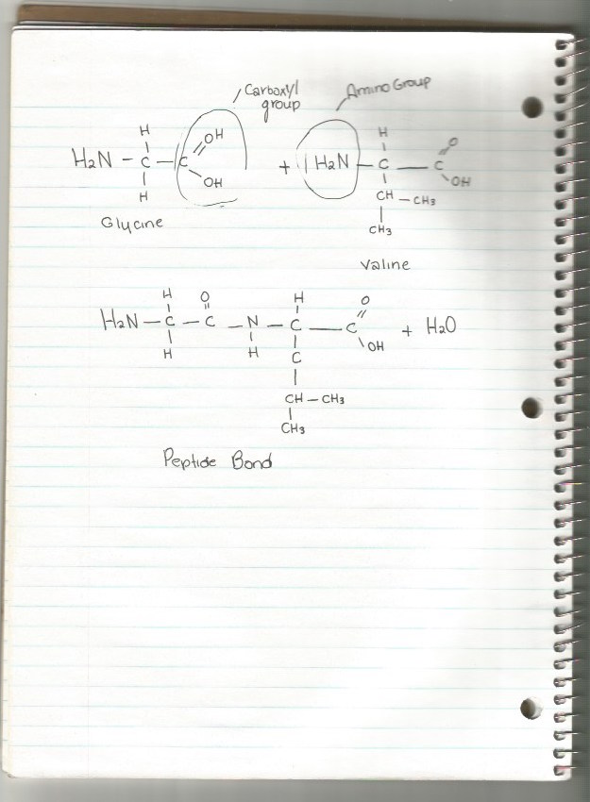

Lesson Three
7. A) In order to test for the source of protein, carbohydrates and lipids in chocolate milk, one would have to perform a Benedicts reagent test for simple sugar, and and Iodine test for polysaccharides. Then as well as Sudan IV test for lipids and Biuret’s protein test
B) From consulting a nutritional label, one can see that the results from the test would show for the Benedict’s Reagent test, a orange level for the amount of sugar that is in the liquid, as well as for the Sudan IV test, it would present that there were lipids in the sample. For the protein test the test would show deep purple because of the presence of protein in the liquid.
8. Enzyme catalyzes speed up the reaction, so when enzymes are breaking down, they will catalyst to speed up the reaction. In order for the reaction to work, the reactions have to overcome the activation energy barrier. As the enzymes work to lower the activation energy the substrate find their optimal position and they can bond to the large molecule.
9. a) pH can affect the shape of both the enzyme and the substrate. Enzymes has optimal pH, depending on the environment surrounding the substrate. Enzymes mostly work best at pH 7 and some also work at acidic enzyme levels.
b) When the concentration of a substrate or enzyme increase, the number of collisions between the both increases. This increases the enzyme activity. Once the amounts of successful collisions reach past the threshold point, a saturation appears where all the enzymes are occupied with substrates.
10. Enzyme A: pH 4
temperature: 37 ̊
Enzyme B: pH 7
temperature: 37 ̊
Enzyme C: pH 7
temperature : 20 ̊
11. Enzyme’s are very important to research in food technology. Firstly, Enzymes can change the aspects of food, improve their texture and appearance. They can help in nutritional value, and give off good flavours.
Secondly, enzymes can replace synthetic chemicals, which is not only the healthier benefit, but also can lower the amount of waste and energy that happen during production.
Thirdly, it allows very specialized food products to be produced efficiently. This happens because reactions are occurring that do not usually occur.

Lesson Four
12. Muscle cells would require more mitochondria than fat cells because it is in the mitochondria that the cells receive their energy. Without high levels of mitochondria the muscles would not be muscles, they would just be fat cells without any energy levels.

13. Diffusion is the movement of molecules, specifically their movement from places of higher concentration to places of lower concentration. It is important with diffusion that the molecules are moving along the concentration gradient, and as passing through a solution. In facilitated diffusion, no energy is needed.

Active transport is the movement of materials across the cell membrane. Energy is the key component in active transport because without it, the cell wouldn’t be able to pump the molecules through the membrane.

14. RME differs from phagocytosis because is its use of receptors. Where in phagocytosis, cells “eat” large solid particles to consume the cell, RME recognizes and binds to molecules before they are engulfed.
It also differs because where in phagocytosis trapped bacteria are digested, during RME it is all about the molecule binding to special receptor proteins in which doesn’t happen during phagocytosis. Instead of a engulfing or “eating: of the cell, RME is about pinching cell membrane pinching the molecules in.

15. Integral protein are embedded in the membrane and they act as channels for ions and other molecules that are necessary for cells to travel in and out of the cell.
Cholesterol is used as a type of doctor, to fix any breaks in the membrane. It rebuilds and fixes the faults in the cell.

16. A) Osmosis is being investigated
B) Beaker B contained distilled water because the carrot caused the osmometer fluid level to decrease. This would indicate that the fluid surrounding the carrot has a higher solute concentration than the cytoplasm of the cell. Whereas in Beaker A, the fluid level increased which shows that is contains the salt solution because a higher solute concentration causes the fluid levels to rise.

17. To start off, rinsing your mouth with salt water comes with a lot of reactions, one of which because the reduction of swelling in the gums. Salt water becomes hypertonic when in contact with the fluid inside the gums that are swollen. This is because the fluid surrounding the gums (the salt water), is greater in solute level than the cells in the gums. The two states, the salt water and the fluid in which is swelling the gums are separated by a selectively permeable membrane, being the gums themselves, this means that osmosis must happen, which difuses the water across the gums and balances the two. As the fluid comes out of the gums, it becomes isotonic, and the process of osmosis enforces the fluid in which is causing the gums to swell to come out and alas, decreasing the swelling.

