Assignment #5
The Tragedy of the Commons is when individuals try to get the greatest benefit over a limited resource, which causes problems for future generations. Unfortunately, this issue still exists today. The results of the tragedy of the commons can be seen through pollution, overpopulation, deforestation, overfishing and other social and environmental problems.

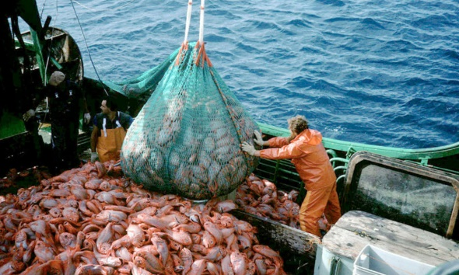
For example, Tragedy of the Commons exists today for overfishing. Often what occurs with overfishing is that people have a growing demand for fish, a limited resource. Fish, in this case, is consumed faster than it can reproduce which could lead to species being depleted or very underpopulated in a body of water in that area. This is a problem because not only are species being lost but ecosystems are being lost due to this. Because of overfishing, we are at risk for losing a valuable food source that many individuals rely on for proteins. In addition, overfishing affects the balance of life in the ocean since many marine animals rely on fish as a food source. According to World Wildlife, “more than 30 percent of the world's fisheries have been pushed beyond their biological limits and are in need of strict management plans to restore them”. Additionally, “production of farmed fish has increased from 24 million tons in the mid-1990s to 67 million tons in 2012, according to Seafarms”.

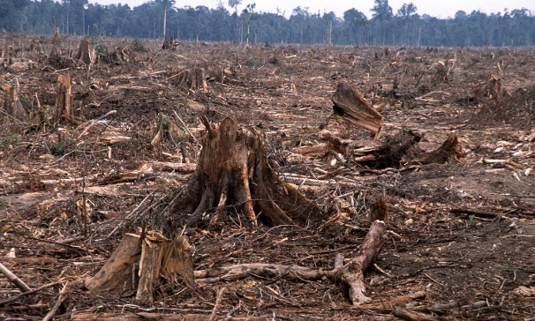
Another example in which Tragedy of the Commons exists today is in deforestation. Just as the last example, there is a growing demand for wood, a limited resource. The demand for these resources are high and keep growing which is a problem. This results in wood being consumed faster than it takes for a tree to replenish and grow since trees require approximately 10-30 years to grow to its full potential. This leads to the depletion of trees in an area, which causes numerous issues such as the loss of the endangered species, less oxygen in the atmosphere, loss of homes to wildlife. Additionally, according to World Wildlife, 1.6 billion people rely on benefits forests offer, including food, fresh water, clothing, traditional medicine and shelter.” Also, according to data from the University of Maryland, released on Global Forest Watch. “In total, the tropics experienced 15.8 million hectares (39.0 million acres) of tree cover loss in 2017, an area the size of Bangladesh” (World Resources Institute).
Bibliography
Deforestation. Retrieved from
https://www.worldwildlife.org/threats/deforestation

Overfishing. Retrieved from
https://www.worldwildlife.org/threats/overfishing

Overfishing Statistics Everyone Should Know (2015, February 13). Retrieved from
https://seafarms.com.au/overfishing-statistics-everyone-should-know/

Why is overfishing a problem. Retrieved from http://overfishing.org/pages/why_is_overfishing_a_problem.php

2017 Was the Second-Worst Year on Record for Tropical Tree Cover Loss. Retrieved
from
https://www.wri.org/blog/2018/06/2017-was-second-worst-year-record-tropical-tree-cover-loss

