Use Cases:  A use case should  Cover a sequence of steps  Describe the user’s interaction with the system ...  Not the computations the system performs.  Be as independent as possible from any particular user interface design.  Only include actions in which the actor interacts with the computer.  Not actions a user does manually  A. Name: Short and descriptive.  B. Actors: Types of users that will do this  C. Goals: What are the actors trying to achieve.  D. Preconditions: State of the system before the use case.  E. Summary: Short informal description.  F. Related use cases.  G. Steps: Describe each step using a 2-column format.  H. Postconditions: State of the system after completion.  A and G are the most important | Extensions:  Used to make optional interactions explicit or to handle exceptional cases.  Keep the description of the basic use case simple.  Generalization:  Much like superclasses in a class diagram.  A generalized use case represents several similar use cases.  One or more specializations provides details of the similar use cases.  Inclusions:  Allow one to express commonality between several different use cases.  Are included in other use cases  Even very different use cases can share sequence of actions.  Enable you to avoid repeating details in multiple use cases.  Represent the performing of a lower-level task with a lower-level goal. | Attributes:  Are simple data found in classes and their instances  Associations:  Represents the linkage between instances of classes  System model vs System domain model:  Reflexive association:  Possible for an association to connect a class to itself  Association vs Generalization:  Association - between instances at runtime  Generalizations - between classes in class diagram | Delegation:  Basically a “method” that connects classes in order to use one’s methods, instead of inheritance.  Observer:  If two classes are inseparable: to use one without using another, use observer. To maximise flexibility  Factory:  We want to have the framework create and work with application-specific classes that the framework does not yet know about.  Solution:  The framework delegates the creation of application-specific classes to a specialized class, the Factory.  The Factory is a generic interface defined in the framework.  The factory interface declares a method whose purpose is to create some subclass of a generic class.  Abstraction-occurrence:  Sometimes, domain models have related objects(occurrences). To represent them, without duplicat. Use Occur in diagram.
  Type | Contains elements that represents things in the domain | Models only things that will actually be implemented | Contains elements that instead needed to build a complete system
  Exploratory Dom | Y | N | N
  Sys Domain | Y | Y | N
  System | Y | Y | Y
The player-role:  To have object play different roles, make abstract role to which object inherits. And the abstract to inherit multiple roles.  Proxy: To reduce instances of heavy classes, add proxy by creating interface for heavy class.  Heavy-weight: a class that takes too long to make an instance cause too big.  General-hierarchy: to represent a hierarchy, create a central node for em, and organize it like a tree.  Singleton: use it to restrict the number of instances to 1.  Read-only Interface:  <<ReadOnlyInterface>> associated to <<UnprivilegedClass>> and have a <<Mutable>> generalization under, which is associated to a <<Mutator>> | Transitions:  Represents a change of state in response to an event. The label on each transition is the event that causes the change of state  Guard Condition:  Each operant in an alternative fragment has these., to prevent/allow transitions  State diagram: is a directed graph where the nodes are states and the arcs are transitions.  Interaction Diagrams: used to model the dynamic aspects of a software system. Helps to visualize, often built from a use case and a class diagram.  Elements found within: instances of classes - as boxes with object name underlined, Actors - stick symbols just like in use case, messages - shown as arrows between the other elements. | Fragments:  Allow multiple sequences to be represented in compact form (may involve all participants or just a subset).  alt, for alternatives with conditions  opt, for optional behavior  loop(lower bound, upper bound), for loops  par, for concurrent behavior, two or more operands that execute in parallel  ref, for referencing other sequence diagrams  Alt: multiple operands, separated by dashed lines  Each operand has guard condition  If more than one is true, one will be chosen nondeterministically. Special guard: else - true if no other guard is true  Opt: to specify a guarded behavior fragment with no alternative, special case for alt and equivalent to alt with two operands: the first is the same as the operand for the opt, the second is an empty operand with an else guard  Loop: loop fragment may execute multiple times, at least executed the minimum count, up to a maximum count as long as the guard condition is T | Design space:  The space of possible designs that could be achieved by choosing different sets of alternatives is often called the design space  System:  A logical entity, having a set of definable responsibilities or objectives, and consisting of hardware, software or both.  A system can have a specification which is then implemented by a collection of components.  A system continues to exist, even if its components are changed or replaced.  The goal of requirements analysis is to determine the responsibilities of a system.  Subsystem:  A system that is part of a larger system, and which has a definite interface
Component:  Any piece of software or hardware that has a clear role.  A component can be isolated, allowing you to replace it with a different component that has equivalent functionality. | Package Diagrams: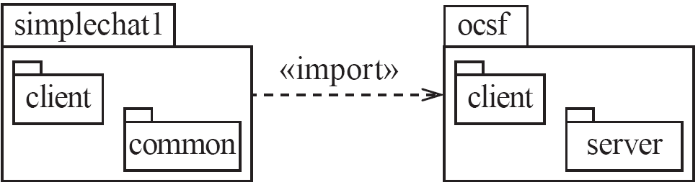 | Component diagrams:  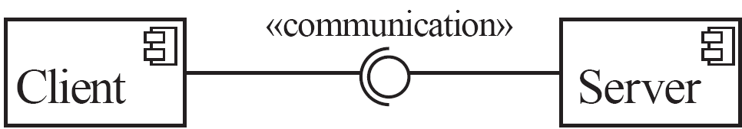 | Deployment diagrams:  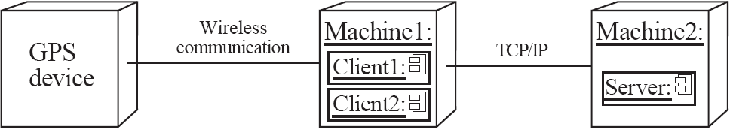
Layered architecture:  In a layered system, each layer communicates only with the layer immediately below it.  Each layer has a well-defined interface used by the layer immediately above.  The higher layer sees the lower layer as a set of services. | A complex system can be built by superposing layers at increasing levels of abstraction.  It is important to have a separate layer for the UI.  Layers immediately below the UI layer provide the application functions determined by the use-cases.  Bottom layers provide general serv.. | Principles:  1. Divide and conquer: The layers can be independently designed.  2. Increase cohesion: Well-designed layers have layer cohesion.  3. Reduce coupling: Well-designed lower layers do not know about the higher layers and the only connection between layers is through the API.  4. Increase abstraction: you do not need to know the details of how the lower layers are implemented. | 5. Increase reusability: The lower layers can often be designed generically.  6. Increase reuse: You can often reuse layers built by others that provide the services you need.  7. Increase flexibility: you can add new facilities built on lower-level services, or replace higher-level layers.
Abstraction – Occurrence  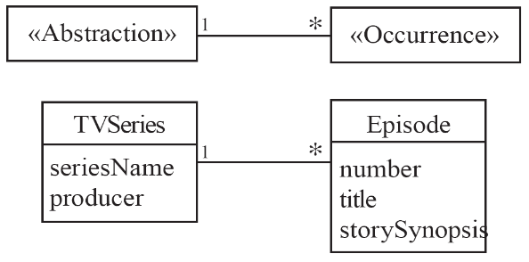  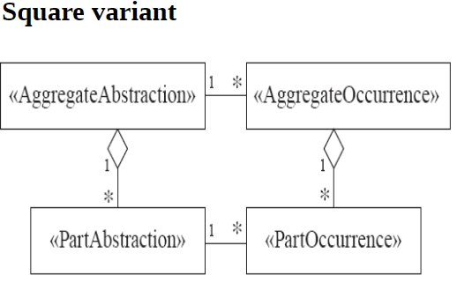 | General Hierarchy  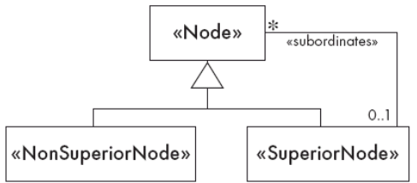  Delegation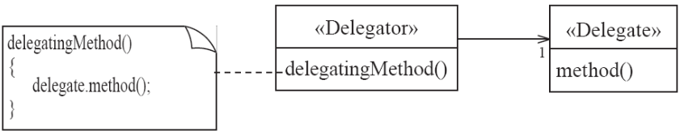  Read Only Interface  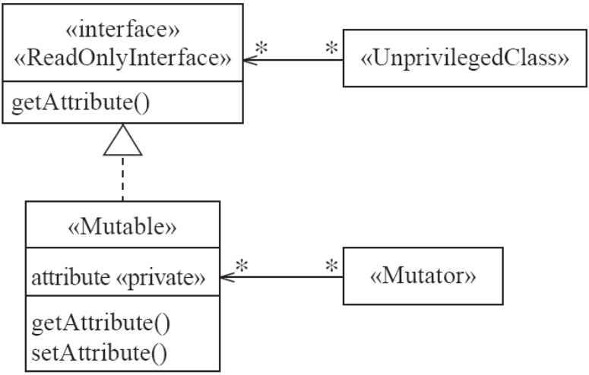 | Player Role  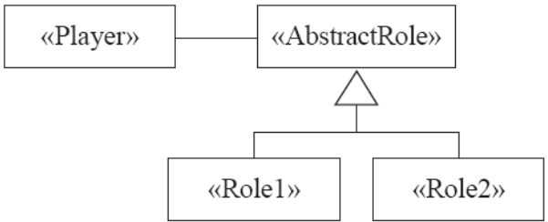  Adapter  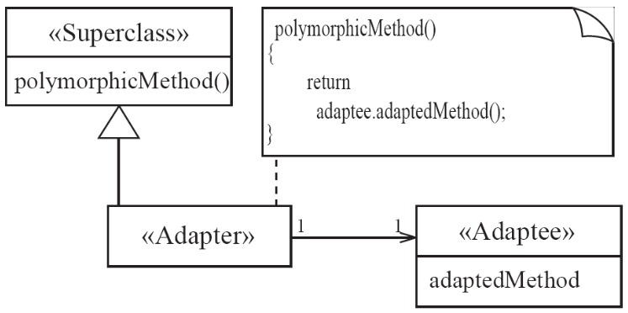 | Singleton  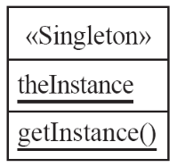  Façade  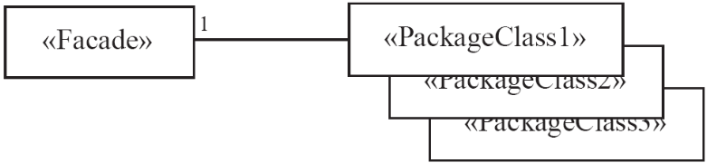  Proxy

8. Anticipate obsolescence: By isolating components in separate layers, the system becomes more resistant to obsolescence.  9. Design for portability: All the dependent facilities can be isolated in one of the lower layers.  10. Design for testability: Layers can be tested independently.  11. Design defensively: The APIs of layers are natural places to build in rigorous assertion-checking.  Broker Architecture:  Transparently distribute aspects of the software system to different nodes  An object can call methods of another object without knowing that this object is remotely located.  CORBA is a well-known open standard that allows you to build this kind of architecture.  Principles:  1. Divide and conquer: The remote objects can be independently designed.  5. Increase reusability: It is often possible to design the remote objects so that other systems can use them too.  6. Increase reuse: You may be able to reuse remote objects that others have created.  7. Design for flexibility: The brokers can be updated as required, or the proxy can communicate with a different remote object.  9. Design for portability: You can write clients for new platforms while still accessing brokers and remote objects on other platforms.  11. Design defensively: You can provide careful assertion checking in the remote objects.  Pipe-filter:  A stream of data, in a relatively simple format, is passed through a series of processes  Each of which transforms it in some way.  Data is constantly fed into the pipeline.  The processes work concurrently.  The architecture is very flexible.  Almost all the components could be removed.  Components could be replaced.  New components could be inserted.  Certain components could be reordered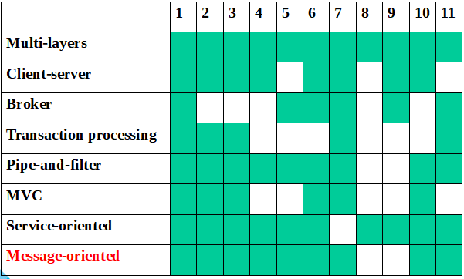 | Principles:  1. Divide and conquer: The separate processes can be independently designed.  2. Increase cohesion: The processes have functional cohesion.  3. Reduce coupling: The processes have only one input and one output.  4. Increase abstraction: The pipeline components are often good abstractions, hiding their internal details.  5. Increase reusability: The processes can often be used in many different contexts.  6. Increase reuse: It is often possible to find reusable components to insert into a pipeline.  7. Design for flexibility: There are several ways in which the system is flexible.  10. Design for testability: It is normally easy to test the individual processes.  11. Design defensively: You rigorously check the inputs of each component, or else you can use design by contract.  MVC:  An architectural pattern used to help separate the user interface layer from other parts of the system  The model contains the underlying classes whose instances are to be viewed and manipulated  The view contains objects used to render the appearance of the data from the model in the user interface  The controller contains the objects that control and handle the user’s interaction with the view and the model  The Observable design pattern is normally used to separate the model from the view  Service Oriented:  This architecture organizes an application as a collection of services that communicates using well-defined interfaces  In the context of the Internet, the services are called Web services  A web service is an application, accessible through the Internet, that can be integrated with other services to form a complete system  The different components generally communicate with each other using open standards such as XML.  Equival  COUPLING TYPES Coupling: Interdependencies between modules. Tightly coupled = Bad - Changes in one require changes elsewhere - Hard to see how components work Content (Always avoid): Modifies internal data of another component w/ no association. violates LOD. Common: (Restrict this) Using global var – all modules using it become coupled. Changes to var will affect all classes. Public static var is a global var. Common = Global var in Fortran Control: 1 cmpnt affects the sequence of execution in another using “command”. | Failure: an unacceptable behaviour exhibited by a system  The frequency of failures measures the reliability  An important design objective is to achieve a very low failure rate and hence high reliability.  A failure can result from a violation of an explicit or implicit requirement  Defect: a flaw in any aspect of the system that contributes, or may potentially contribute, to the occurrence of one or more failures  could be in the requirements, the design and the code  It might take several defects to cause a particular failure. Commonly called a bug  Error: (in this context) a slip-up or inappropriate decision by a software developer that leads to the introduction of a defect  Glass-box testing:  Statement Coverage - This technique is aimed at exercising all programming statements with minimal tests.  Branch Coverage - This technique is running a series of tests to ensure that all branches are tested at least once.  Path Coverage - This technique corresponds to testing all possible paths which means that each statement and branch is covered.  Black-box Testing  Equivalence classes + Boundary Testing  context Application inv atMostTwoLetters:  self.forScholarshipType = 'RegularScholarship'  implies self.numOfLetters <= 2  context User inv mustHaveName:  self.fName.size() > 0 and self.lName.size() > 0  context Student inv mustHaveUniqueID:  Student.allInstances->forAll(e1, e2 | e1.studentNum <> e2.studentNum)  context Application inv cannotBeTwoOrMore:  Application.allInstances->forAll(a1, a2 | a1.forScholarshipType = 'MutuallyExclusiveScholarship' and a2.mutuallyExclusiveScholarship = 'MutuallyExclusiveScholarship' implies a1.student <> a2.student)  Stamp: Using custom class as an mthd arg. Changes to the class may affect the functioning of the method. sendEmail has access to full Employee object, only needs email and name. Data: Method arguments are simple data Routine call: 1 method calls another Type use: Module uses data type defined in another module. Class declares instance or local variable with type of another class. Import/inclusion: import/include code of another module/pkg. External: dependencies on OS, shared libraries, HW, framework.
Proxy Observer Factory Pattern


