STUDENT NAME: ………….……………..…………..

STUDENT NUMBER: …………………………

University of Ottawa
ANP 1105C
Midterm #2

Date: November 13, 2018 Duration: 1 hr 20 min
Instructor: J. Copeland/W. Staines

INSTRUCTIONS:

- 45 multiple choice questions (1 mark/1 correct answer per question) plus 15 marks for fill-in-the-blank questions and diagram-labeling.

- Please answer the multiple choice questions on the computer sheet that is provided and answer the remaining questions right on the last pages of this exam.

- Please put your name and student number at the top of this page, on the top of the last page and on the computer sheet. Hand in the exam and your computer sheet when you have finished.

- Make sure this exam is complete. This exam contains 11 pages and is printed double-sided. The excuse of missing a page will not be accepted after the examination.

- Visceral reflex arcs differ from somatic in that ________.

- visceral arcs contain two sensory (afferent) neurons
- somatic arcs contain one additional component that visceral arcs do not possess
- visceral arcs involve two efferent neurons
- visceral arcs do not use integration centers

- Preparing the body for the "fight-or-flight" response is the role of the ________.

- sympathetic nervous system
- cerebrum
- parasympathetic nervous system
- somatic nervous system

- Which of the following is TRUE?

A. the sympathetic nervous system is excitatory
B. the parasympathetic nervous system is excitatory
C. the parasympathetic nervous system is excitatory in the gastrointestinal system
D. the parasympathetic nervous system is excitatory in the heart

- Cardiovascular effects of the sympathetic division include all except ________.

- constriction of most blood vessels
- dilation of the vessels serving the skeletal muscles
- increase of heart rate and force
- dilation of the blood vessels serving the skin and digestive viscera

- Sympathetic division stimulation causes ________.

- decreased blood glucose, increased GI peristalsis, and increased heart rate and blood pressure
- increased blood glucose, increased GI peristalsis, and decreased heart rate and blood pressure
- increased blood glucose, decreased GI peristalsis, and increased heart rate and blood pressure
- decreased blood glucose, increased GI peristalsis, and decreased heart rate and blood pressure

- Which of these effectors is not directly controlled by the autonomic nervous system?

- smooth muscle
- cardiac muscle
- skeletal muscle
- most glands

- The resting heart in a healthy person is primarily under the control of the .................. nervous system.
  - sympathetic
  - parasympathetic
  - somatic
  - spinal
- The Frank Starling Law of the Heart implies a direct relationship between stroke volume and:
  - end systolic volume
  - mean arterial pressure
  - afterload pressure
  - preload
  - pulse pressure
- The external boundary between the atria and ventricles is the:
  - anterior interventricular sulcus.
  - interventricular septum.
  - interatrial septum.
  - coronary sulcus.
  - posterior interventricular sulcus.
- To open the semilunar valve during the normal cardiac cycle, the pressure in the left ventricle has to be .......................................
  - greater than the pressure in the aorta
  - the same as the pressure in the aorta
  - the same as the pressure in the left atrium
  - less than the pressure in the left atrium
- The coronary arteries arise from:
  - inferior vena cava
  - aorta
  - superior vena cava
  - pulmonary trunk
  - right atrium
- The mitral valve prevents blood backflow from:
  - aorta to left ventricle
  - left ventricle to left atrium
  - right ventricle to right atrium
  - right atrium to inferior and superior vena cava
- Normal resting cardiac output for an average adult is approximately:
  - 70ml/min
  - 1 litre/min
  - 2 litres/min
  - 5 litres/min
  - 10 litres/min
- Platelets initially stick to the wall of a damaged blood vessel because:
  - exposed collagen fibers make a rough surface to which the platelets are attracted
  - histamine causes vasoconstriction so that platelets can't fit through the opening
  - fibrin threads act like glue t o hold them there
  - prothrombinase alters the electrical charge of the vessel wall
  - the intracellular fluid released by damaged cells in the blood vessel wall has a higher viscosity than plasma
- Blood enters which vessel(s) during ventricular systole?
  - aorta
  - pulmonary arteries
  - pulmonary veins
  - (a) and (b)
  - (a) and (c)
- Which of the following chemicals is an enzyme that converts fibrinogen to fibrin?
  - heparin
  - thrombin
  - prothrombin
  - coagulation factor VI
  - tissue factor
- Which of the following lists the electrical activity of the heart in the correct sequence?
  - Plateau, rapid depolarization, repolarization, refractory period.
  - Refractory period, repolarization, rapid depolarization, plateau.
  - Rapid depolarization, repolarization, plateau, refractory period.
  - Rapid depolarization, plateau, repolarization, refractory period.
- The extrinsic pathway of coagulation is activated by the:
  - sticking of platelets to roughened blood vessel walls
  - activation of a proenzyme exposed to collagen
  - release of heparin from the liver
  - the conversion of prothrombin to thrombin
  - the release of tissue factor by damaged tissue cells
- Damage to the ................................ is referred to as heart block.
  - SA node
  - AV valves
  - Purkinje fibers
  - AV node
  - Ventricular node
- The function of the chordae tendineae is to:
  - pull the walls of the ventricles inward during contraction
  - open the semilunar valves
  - open the AV valves
  - prevent eversion of the AV valves during ventricular systole
  - hold the heart in place within the mediastinum
- Which of the following would not increase stroke volume?
  - increased Ca2+ in the interstitial fluid
  - epinephrine
  - increased K+ in the interstitial fluid
  - increase in venous return
  - slow resting heart rate
- Each hemoglobin molecule consists of:
  - a single polypeptide chain plus 4 heme groups
  - 4 polypeptide chains plus a single central heme group
  - 4 polypeptide chains, each of which has a central heme group
  - a single polypeptide chain with a central heme group
  - none of the above
- When red blood cells transport respiratory gases:
  - both oxygen and carbon dioxide bind to the globin portion of hemoglobin
  - carbon dioxide binds to the heme portion and oxygen binds to the globin portion of hemoglobin
  - the main form of gas transport in the body is through the plasma
  - both oxygen and carbon dioxide bind to the heme portion of the hemoglobin
  - oxygen binds to the heme portion while carbon dioxide binds to the globin portion of hemoglobin
- Blood flows from the pulmonary veins into the:
  - right atrium
  - left atrium
  - lungs
  - left ventricle
- The space between the parietal and visceral layers of the pericardium is normally filled with:
  - air
  - blood
  - adipose tissue
  - serous fluid
  - serum
- The dicrotic notch occurs in response to:
  - closing of the pulmonary valve
  - atrial systole
  - opening of the AV valves
  - closing of the aortic valve
  - ventricular systole
- When ventricular pressure exceeds atrial pressure, what event occurs first?
  - AV valves open
  - AV valves close
  - Semilunar valves open
  - Semilunar valves close
- Together, leukocytes and platelets comprise approximately ........... percent of total blood volume.
  - 1
  - 10
  - 25
  - 45
  - 75
- Which of the following is TRUE about erythropoietin?
  - it is produced in red bone marrow in response to increased blood oxygen levels
  - it induces production of platelets
  - its production is usually higher in low altitudes
  - its production increases at higher altitudes
- The cells of the myocardium are joined by specialized junctions called:
  - desmosomes
  - gap junctions
  - intercalated discs
  - all of the above
  - none of the above
- Which of the following statements is TRUE?
  - Plasmin degrades insoluble fibrin.
  - Hemophilia is equally common in men and in women.
  - Lack of the coagulation factor VIII is the main cause of thalassemia.
  - Polycythemia vera is a hereditary disease characterized by a low number of RBCs.
- The father is Rh- and the mother is Rh+. They have had one child without a problem due to the Rh factor and now the mother is pregnant again. In terms of Rh factor, the risk to the fetus now within the uterus:
  - is less than before
  - is greater than before
  - never was a problem
  - is not the same and remains relatively moderate
  - is nonexistent because the mother was given RhoGAM when delivering the first infant.
- Which vessel of the heart receives blood during right ventricular systole?
  - superior and inferior venae cavae
  - pulmonary trunk
  - aorta
  - pulmonary veins
  - right atrium
- When the cardiac output = 15 L/min and the HR = 100 beats/min, the stroke volume equals ............
  - ~ 70 ml
  - 100 ml
  - 1500 ml
  - 150 ml
- A type of anemia that is due to a deficiency of intrinsic factor production is:
  - aplastic
  - sickle cell
  - hemolytic
  - pernicious
- P waves on an ECG represent:
  - depolarization of the ventricles
  - repolarization of the ventricles
  - depolarization of the atria
  - repolarization of the atria
  - ventricular systole
- Which of the following lists the elements of the heart's conduction system in the correct order?
  - SA node, AV bundle, bundle branches, AV node, Purkinje fibers
  - AV node, AV bundle, SA node, bundle branches, Purkinje fibers
  - Purkinje fibers, AV bundle, bundle branches, AV node, SA node
  - SA node, AV node, AV bundle, bundle branches, Purkinje fibers
  - None of the above
- Which sequence of events is correct in response to an injury that has penetrated through the skin and damaged an underlying blood vessel?
  - formation of tissue factor, prothrombin -> thrombin, fibrinogen -> fibrin, activation of plasmin
  - fibrinogen -> fibrin, activation of plasmin, formation of tissue factor, prothrombin -> thrombin
  - prothrombin -> thrombin, formation of tissue factor, fibrinogen -> fibrin, activation of plasmin
  - formation of tissue factor, activation of plasmin, fibrinogen -> fibrin, prothrombin -> thrombin

- Virtually all of the protein or amino acid-based hormones exert their effects through intracellular ________.

- calcium
- deactivating ions
- nucleotides
- second messengers

- Steroid hormones exert their action by ________.

- entering the nucleus of a cell and initiating or altering the expression of a gene
- binding cell receptors and initiating cAMP activity
- entering the cell and activating mitochondrial DNA
- activating the hypothalamic release of regulating hormones

- Which of the following is not a category of endocrine gland stimulus?

- enzyme
- humoral
- neural
- hormonal

- Several hormones are synthesized in the hypothalamus and transported to the anterior pituitary gland. The mechanism of transportation from hypothalamus to anterior pituitary gland is through the ________.

- hepatic portal system
- general circulatory system
- hypophyseal portal system
- feedback loop

- The second-messenger mechanism of hormone action operates by ________.
- synthesizing more than one hormone at a time
- increasing the basal metabolic rate in the target organ
- altering gene expression in the nuclear DNA
- binding to specific receptors and acting through G proteins and cAMP

Name: …………………………………………….. Student # ………………………
45) The postganglionic neurons of the parasympathetic division uses only __ACh______________ as a neurotransmitter
46) Diagram: What gland tissue is indicated by the pointer labeled (A) ? Adrenal medulla
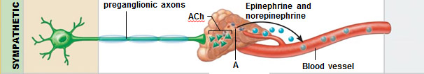
47) Which hormones are synthesized from cholesterol? ______Steroid__________________

48) Diagram: The principle of homeostasis is depicted. Fill in the labels listed as
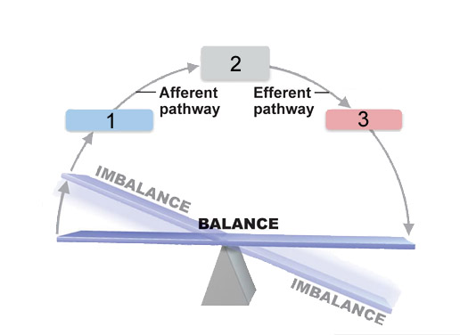
1 ___Receptor______________
2 ___Control center______________
3 ___Effector__________ _____

Name: …………………………………………….. Student # ………………………
49. Label the indicated structures (3 marks)
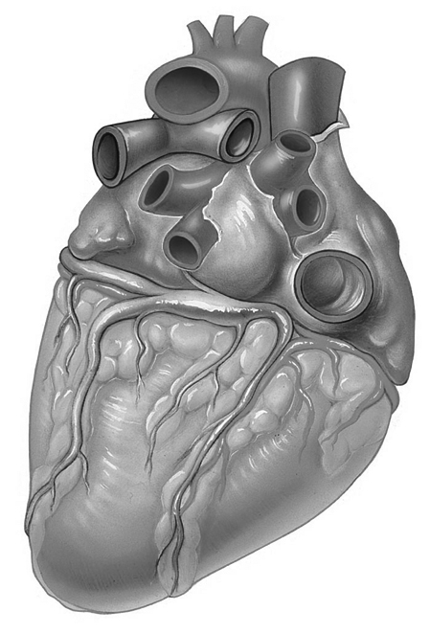
Left atrium or
auricle
Superior vena cava
(space) coronary sulcus or atrioventricular groove
(vessel) coronary sinus

50. Below is a normal ECG tracing. Indicate a) Atrial Depolarization; b) Ventricular Repolarization c)Are the semi lunar valves open or closed during the P wave? (3 Marks)
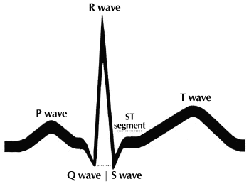
- P wave
- T wave
- closed

Name: …………………………………………….. Student # ………………………
51. Indicate which agglutinogens are present and the corresponding serum reactions (4 marks)

AB: A and B Agglutinogens, reacto both anti-A and Anti-B
B: B agglutinogen, reacts to anti-B
A: A agglutinogen, reacts to anti-A
O: no agglutinogen and no reaction.

