Managing Human Resources – Midterm Review

Midterm:
MNT 201/202
1:00-3:00
10MC per chapter
1 Short Answer per Chapter
Worth 30%

Chapter One: The World of HRM

Lecture Notes

Demographic Change
- More diverse workplace
- Aging Workforce
- More educated workforce

Managing Diversity
- By 2031, 30.6% of Canadian population will identify as visible minorities

Textbook notes

Intro:
- One of the main challenges of businesses in the next ten years will be obtaining human capital and optimizing human capital investment
- In order to forecast trends and support strategies HR managers will
  - Analyze the capabilities of different demographic groups
  - How they are represented in fast and slow growing occupations
- Creating a more diverse workforce will be important to:
  - Accommodate demographic shifts
  - Find qualified talent
  - Broaden customer basis

Demographic Changes
- Employee background
- Age
- Gender
- Education

The Diversity Immigration Challenge
- Minorities in Canada are increasing in numbers relative to the population
- Businesses recognize that they must increase their effort to recruit and train a more diverse workforce
- Immigrants are critical to the strength and survival of a company, and allow them to better attract and serve a larger consumer base

Age distribution of Employees
- The number of seniors in Canada is expected to double over the next ten years
- Echo boom generation of 9.1 million people (born 1972-1992 aka millennials) will be required to fill workforce demands of 9.6 million baby boomers
- Companies are finding large portions of their workforce are approaching retirement
- Management is concerned the expertise of these employees will be drained from the company faster than they can train and replace them
- Therefore, employees are retaining older workers foe longer to bridge this gap
- Older employees tend to stay longer, the turnover rate is 10 times less than 50 and under turnover rates
- There is concern the older population will lower the interest rates and affect the economy
- The number of business start-ups is declining due to the older population
- Millennials have good tech skills and initiative, especially when starting their own business or doing meaningful work
- Gen X (1964-1979) value job security but are more likely to switch jobs and employers
- Gen X is independent
- Managers find challenges working with all three generations as they all have different strengths and weaknesses
- There is often bad perceptions between generations so managers are devising programs to help the generations better understand each other

Gender Distribution of the Workforce
- Women make up almost half the workforce in Canada
- Educational attainment of women is also increasing relative to men
- 61% of university grads are women
- Employers trying to attract women focus on equality in terms of advancement options, compensation
- They are also being more accommodating with:
  - Parental leaves
  - Part time work
  - Flexible work schedules
  - Job sharing
  - Telecommuting
  - Child and Elder care

Conclusion
- Companies are having a hard time finding trained and certified workers
- They have to offer higher compensation package to attract workers
- They need to study minorities and women as their populations are increasing in the workforce
- It is important to be aware of COMMON characteristics but also treat employees as INDUVIDUALS

Chapter 2: Strategy and Human Resources Planning

Lecture Notes

Trend Analysis
- Quantitative
- Estimation of how many workers will be needed, considering a variety of factors such as technological increases

Markov Analysis
- % of people who remain, transfer, quit, or are promoted

Forecasting:
- Forecast the demand
- Forecast the supply
- Balance the supply and demand

Textbook Notes

Human Capital Readiness:
- The process of evaluating the availability of critical talent in a company and comparing it to the firm’s supply
- See gap analysis to calculate

Gap Analysis:
- Analyses the difference between quantity and quality of employees required vs the quantity and quality of employees available
- Determine company’s core capabilities and key people and processes that are critical to the capabilities organize into critical job families
- For each of the critical job families determine critical knowledge, skills, and behaviours to build core capabilities
- Determine the number of people need, and the number of people that are currently qualified
- Divide number of people qualified by number of people required to get the percentage of human capital readiness for reach job family
- See figure 2.7 for reference in TB

Forecasting Demand Considerations
- Product/service demand
- Economics
- Technology
- Financial Resources
- Absenteeism/Turnover
- Organizational Growth
- Management Philosophy
- Techniques
  - Trend analysis
  - Managerial Estimate
  - Delphi technique

Forecasting Supply Considerations
- Demographic changes
- Education of workforce
- Labour mobility
- Government policies
- Unemployment rate
- Techniques
  - Staffing tables
  - Markov analysis
  - Skills inventories
  - Management inventories
  - Replacement charts
  - Succession planning

Balancing Supply and Demand
- When there is a shortage or surplus, the number of employees must be increased or reduced to balance supply and demand

Shortage
- Utilize overtime
- Add full time workers
- Add part time workers
- Employ contract workers
- Outsource work
- Reduce employee turnover

Surplus

- Implement hiring freeze
- Lay off Strategy usually based on seniority or ability, can use work reduction strategies such as:
  - Reduced work week
  - Reduced shifts
  - Transfers to related companies
- Offer employees early retirement
- Attrition Strategy a natural departure of employees through quits, retirements, death
- Termination Strategy separate employee from organization permanently, give severance pay based on years of service and salary

Trend and Markov Analysis

 | Definition | Advantages | Disadvantages | When to use
Trend Analysis | A quantitative approach to forecasting labour demand based on an organizational index such as sales. | Relies on a single factor- allows to analyze a specific area of the business  Can be used for a what if analysis to determine how many new people to hire to ie) increase sales by 10% | Relies on a single factor – may miss other demand factors  Is difficult for smaller businesses to use | When you want to forecast demand based on a single index  Usually used by larger companies with analysts and statisticians
Markov Analysis | A method of tracking the pattern of employee movements through various jobs.  Shows percentage (and actual number) of employees who remain in each of a firms jobs, from one year to the next, as well as the proportions of those who are promoted, demoted, or transferred through the organization | Easy to apply  Can be used for longer ranged forecasts  Can identify regulations in the flow of employees  Can help to develop career patterns and planning and development | The analysis is not as reliable when the transition probabilities are not stable.  Too few employees will yield extreme results  Analysis assumes that probability of movement is determined by employees initial job state, and does not consider other factors. | Can use to forecast future demands for new employees, as it shows the projected number of employees still in the company.  Best to use with companies with over 50 employees

Chapter Three: Equity and Diversity in HRM

Lecture Notes:

Employment Equity Act:
- Federal employment equity act
- Applies to designated groups

Systemic vs Intentional:

Systemic Employment criteria that have the effect of discriminating on prohibited grounds but are not used with the intent to discriminate (e.g. height req.)

Intentional Deliberate use of race, religion, or prohibited criteria in employment decisions

Bona Fide Occupational Qualification
- A justified business reason for discriminating against a member of a protected class
- Customer preference is not valid

Textbook Notes:
Employment Equity the employment if individuals in a fair and nonbiased manner

Employment Equity Act:
- Provide employees a questionnaire to identify themselves as part of designated groups
- Identify jobs in which the percentage of members of designated groups falls below availability in the labour market
- Communicate info about equity employees
- Identify possible barriers in employment systems
- Develop employment equity plan and make an effort to implement the plan]
- Monitor, review, and revise plan when needed
- Prepare annual report on employment equity
- Applies to Employers and Crown corporations that have 100 employees or more and are regulated under the Canada Labour Code

Designated Groups:
- There are 4 groups covered under the federal employment equity act
  - Women
  - Visible minorities
  - Aboriginal people
  - Persons with disability

Systemic Discrimination:
- The exclusion of members of certain groups through the application of employment policies or practices based on criteria that are not job related

Reasonable Accommodation
- Attempts by employers to adjust the working conditions or schedules of employees with disabilities or religious preferences

Bona Fide Occupational Qualification:
- A justifiable reason for discrimination based on business reasons of safety or effectiveness

Disparate/Adverse Impact: Griggs vs Duke Power (1971)
- Willie Griggs, a black man, applied for the job of coal handler at Duke Power. The company, which required that all coal handlers have high school diplomas, rejected Griggs because he did not. Griggs filed a suit against the company claiming that the diploma requirement had nothing to do with a person’s ability to do the job and that it discriminated against blacks, since fewer blacks had high school diplomas than did whites.

Benefits of Employment Equity
- Contributes to the bottom line by broadening the base of qualified individuals for:
  - Employment
  - Training
  - Promotions
- By avoiding costly Human Rights Complaints
- Enhances an organizations ability to attract and keep the best qualified employees

Diversity Management The optimization of an organization’s multicultural workforce to reach business objectives
- Diversity management is voluntary, whereas employment equity is not
- Managing diversity is a broader more inclusive topic
  - Religion
  - Personality
  - Lifestyle
  - Education
- Allows companies to gain a strategic and competitive advantage by helping all employees perform to their full potential
- It is a necessity imposed by market laws, competition and the need to be the best to survive
- Benefits include:
  - Ethnic groups provide expertise in language skills, foreign cultures and business practices, and natural trade links with overseas markets
  - This helps to capture market share in new and emerging economies
  - Access to a new labour pool
  - Benefits related companies’ reputation
  - Commitment to equality and diversity as company values
  - Unlocking innovation and creativity
  - Enhanced customer satisfaction
  - Drives success in global markets

Chapter Four: Job Analysis and Work Design

Textbook Notes:

Job Description:
- A list of the tasks, duties, and responsibilities that a particular job entails
- Focuses on activities

Job Specification
- A list of competencies that an individual must have to perform a particular job
- Focuses on KSAOs required to do the job
- KSAO Knowledge, skills, abilities, other factors

Job Analysis:
- Procedure for determining tasks, duties and responsibilities of each job and the human attributes (knowledge, skills, abilities, other (KSAO) required to perform it

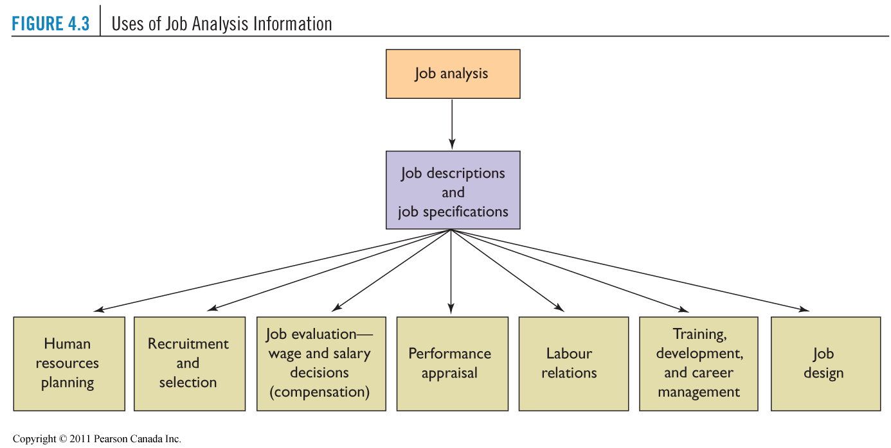

Position Analysis Questionnaire (PAQ):
- Very structured job analysis questionnaire which contains many items
- Provides quantitative job score on six dimensions of job requirements:
1. Information input
2. Mental processes
3. Work output (physical activities and tools)
4. Relationships with others
5. Job context (physical and social environment)
6. Other job characteristics (pace and structure)

Textbook Notes

The Process of Job Analysis:
- Sources of Data AND Methods of collecting Data Job Data Job Description AND job specification HR functions

Sources of Data
- Job analyst
- Employee
- Supervisor

Methods of collecting data
- Interviews
- Questionnaires
- Observations
- Records
- O*NET

Job Data
- Tasks
- Performance Standards
- Responsibilities
- Knowledge required
- Skills required
- Experience needed
- Job context
- Duties
- Equipment used

Job Description
- Tasks
- Duties
- Responsibilities

Job Specification
- Skill requirements
- Physical demands
- Knowledgeable requirements
- Abilities needed

HR Functions
- Recruitment
- Selection
- Training and development
- Performance appraisal
- Compensation management

 | Definition | Advantages | Disadvantages | When to use
PAQ  (Position Analysis Questionnaire) | A question covering 194 different tasks, that, by means of a five point scale, seeks to determine the degree to which different tasks are involved in performing a particular job | Permits the dimensions of behaviour to be compared across a number of jobs  Permits jobs to be grouped on the basis of common characteristics  Easy and quick assessment  Less complex than other methods  It is a standardized model so It is reliable | Is not possible to use one method to differentiate and classify equally all conceivable occupations  Question answers could be biased | A broader analysis  More tasks to analyze in more specific detail
Critical Incident Method | A job analysis method by which important job tasks are identified for job success  Employees/managers are asked to describe their job and critical job tasks are identified  They are then complied into a list of 5-10 concise duties | Teaches analysts to focus on employee job behaviours critical to job success  Does not force respondent into any given framework | Built in bias towards recent job duties as they are most memorable  Respondents could be biased  Relies on accurate and truthful reporting of employees | Specific analysis for one positon  More general job tasks

Chapter Five: Expanding the Talent Pool: Recruitment and Careers

Recruitment: The process of searching out and attractive qualified job applicants, which begins with the identification of a position that requires staffing, and is completed when applications are received from an adequate number of applicants.

Labour Markets / Recruitment Channels:
- Local: Area from which applicants are to be recruited
  - Tight market: High employment, few available workers
  - Loose Market: Low employment, many available workers
- Global:
  - To develop better products via a global workforce
  - To attract the best talent, wherever it may be

Realistic Job Previews: If you tell the recruit exactly what they’ll be doing, you’ll be more likely to attract a reasonable number of mutually interested recruits
**These are essentially so that upper management knows whether or not new recruits are having an effect on the bottom line**

External Recruitment Methods:“Go into book and make sure you know them, and which is best to apply”
- online recruiting
- social networking sites
- print advertising
- private employment agencies
- executive search firms
- walk-ins and write-ins
- employee referrals
- former employees
- educational institutions
- Human Resources and Skills Development Canada (HRSDC)
- professional and trade associations
- labour organizations
- military personnel
- open houses and job fairs

Recruiting Within the Organization Advantages:
- Employees see that competence is rewarded thus enhancing commitment, morale and performance
- Insiders are less likely to leave
- More accurate assessment of person’s skills and performance level
- Inside candidates require less orientation
Recruiting Within the Organization Disadvantages:
- Discontent of unsuccessful candidates
- Time consuming to post and interview all candidates if one is already preferred
- Employee dissatisfaction with insider as new boss
- Possibility of “inbreeding”

Recruiting Outside the Organization Advantages:
- Larger pool of qualified candidates
- More diverse applicant pool
- Acquisition of skills or knowledge not currently available within the organization
- Elimination of employee rivalry and competition
- Cost savings resulting from hiring individuals who already have the skills, rather than providing the training

Recruiting Outside the Organization Disadvantages
- Opposite of advantages of internal

Textbook Notes

Internal Recruitment:
- Advantages
  - Capitalize on investment in recruiting, selecting, training, and developing current employees
  - Promoting employees rewards them for past performance and encourages them to continue their efforts
  - Improves company morale
  - Eliminate orientation and training costs associated from hiring externally
  - Transferees performance record is likely a more accurate predictor of their success as opposed to data on outside applicant
- Disadvantages
  - Jobs that require specialized training and expertise are difficult to be filled internally
  - Small business with small talent pools may have a hard time recruiting internally
  - Inbreeding of ideas

External Recruitment
- Advantages
  - Source of creativity and innovation
  - May bring knowledge from previous employer
  - The bring revenue
  - Can help to meet employer’s diversity goals
- Disadvantages
  - Opposite of internal advantages

Recruitment Channels
- Internal recruitment Channels
  - Internal Job Postings
  - Identifying Talent through Performance Appraisals
  - Skill Inventories and Replacement Charts
- External Recruitment Channels – read textbook to find best methods
  - Advertisements
  - Walk-ins and Unsolicited Applications and Resumes
  - The internet, Social Networking, and Mobile Recruiting !!
  - Job Fairs
  - Employee Referrals
  - Re-Recruiting
  - Executive Search Firms
  - Educational Institutions
  - Professional Associations
  - Labour Unions
  - Public Employment Agencies

Recruitment Metrics:
- Yield Ratios
  - The percentage of applicants from a recruitment source that make it ot the next stage of the selection process
  - Number of people who make it to next stage divided by number of applicants at the previous stage
- Costs of Recruitment
  - SC/H=(AC+AF+RB+NC)/H
  - AC=advertising costs
  - AF = agency fees
  - RN = referral bonuses
  - NC= no cost hires ($0)
  - H= total hires
- Quality of Fill Statistics:
  - Quality of Hire = (PR + HP + HR) / N
  - PR = average job performance rating of new hires (%)
  - HP = % of new hires reaching acceptable productivity within an acceptable time frame
  - HR = % of new hires retained after one year
  - N = number of indicators
- Time to Fill Metric:
  - Number of days from when a job opening is approved to the date the candidate is selected. Lower time to fill is better, but a trade-off can be seen between time to fill and candidate quality

Recruiting Yield Pyramid

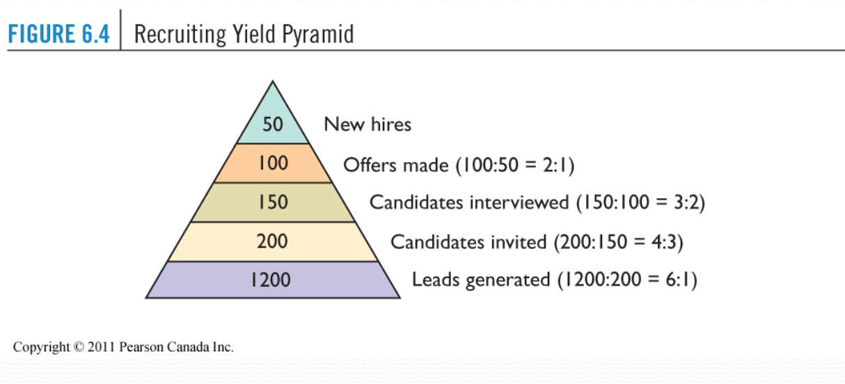

Realistic Job Preview
- Informing applicants about all aspects of the job including all its desirable and undesirable facts. Rather than just showing off positive elements of the job, an RJP shows both positive and negative aspects of the job. Ie) working condition
- Advantages
  - Reduced turnover as there are fewer surprises
  - Increased job satisfaction
- Disadvantages
  - Deterring potential employees
  - Uses more resources

Chapter 6: Employee Selection

Reliability:
- The degree to which interviews, tests, and other selection procedures yield comparable data over time.
Validity:
- The extent to which performance on a measure (e.g. test) is related to what the measure is designed to assess (such as job performance)
- Often use correlation coefficients
Determining the Validity of Tests:
- Criterion-Related Validity: The extent to which a selection tool predicts, or significantly correlates with important elements of work behaviour.
  - Concurrent: Test scores correlate with criterion data obtained from current employees at about the same time
  - Predictive: Test scores match criterion data obtained from applicants/employees after they have been on the job for an indefinite period
  - Content Validity: The extent to which a selection instrument adequately samples the knowledge and skills needed to perform a particular job
    - Ex: Typing test, driver’s license
  - Construct Validity: The extent to which a selection tool measures a theoretical construct or trait


- Employment Tests:
  - Cognitive Ability Tests General Mental Ability:
  - Physical Ability Tests
  - Job Knowledge Tests Asking how the job should be done
  - Work Sample Tests Asking candidate to do the job
  - Personality and Interest Inventories

Behavioural Description Interview (BDI):
- Applicant is asked questions about what he or she did in a given situation

Behaviour Based Interviewing:
- Looks for job related experiences of the past, to predict the future, helping eliminating errors made by interviewers relying on intuition.
- Evaluate someone’s ability to do a job, rather than their personality
- How a person handles a specific situation in the past is the best predictor of how they’ll do it in the future
- The job specifications and description are the basis for the questions being asked
  - Performance skills and technical skills can be a basis as well
- Example: In determining one’s willingness to break rules, ask for them to detail a time when it is justifiable to alter company policy. Open ended questions to get specific answers pertaining to job.
- *Interpret the answers in light of the behaviour it represents*

Textbook Notes

Reliability
- degree to which interviews tests and other selection procedures yield comparable data overtime

Validity
- the degree to which a test or selection procedure measures a person’s attributes

 | Definition | Advantages | Disadvantages
Job Knowledge Test | A type of achievement test designed to measure a person level of understanding about a particular job. | Eliminates under qualified applicants | May overlook good candidates as they have little experience or understanding in the particular job, but have a high potential to learn
Work Sample Test | Requires the applicant to perform tasks that are part of work required on the job | Cost effective  Reliable  Valid  Fair  Acceptable to all applicants | Time consuming  Ineffective use of resources
Assessment Centre Tests | Test used to evaluate candidates, often as a group, as they participate in simulations that resemble typical jobs tasks and duties | Professional standard  Good for hiring in teams/groups | Excessive costs  Time consuming
Cognitive Ability Tests | Measure mental capabilities using written tests such as the general aptitude test or SATS | Good predictors of performance for a wide variety of jobs | The validity of the tests reflects their connection to general intelligence, rather than job specifications
Biodata Tests | Collect biographical info about candidate, where candidates are asked questions about events and behaviours that reflect attitudes, experiences, interests, skills, abilities etc | Good predictor of future | Sophisticated and must be professionally developed and validated  Questions might not appear clearly related to the job so applicants question the validity of the test
Personality and Interest inventories | Measures disposition and temperament using the Big Five personality traits and other similar tests ie) Myers Briggs Indicator | Can predict job performance, however connection is known to be quite low | Inadvertently discriminate against individuals who would otherwise be effective  May not be extremely reliable due to poor connection
Polygraph Tests | Lie detector test, to meet standards of honesty and suitability | Difficult for applicants to lie or deceive | Illegal in some areas, check legislation
Honesty and Integrity Tests | Personality test designed to assess an applicant's tendency to be honest, trustworthy, and dependable. | Great at predicting job performance and a wide range of disruptive behaviors, such as theft, disciplinary problems, and absenteeism | The prospect may prepare for the test and cheat the test, which may not help choosing an honest candidate.
Physical Ability Tests | The test that physical characteristics such as strength, agility, height, and weight. | Able to show the physical abilities such as strengths and endurance needed for jobs | Could be disadvantages to females which may be considered as discrimination.
Medical Examinations | A test that the health and fitness of applicants are adequate to meet the job requirements. | Determining work-caused disabilities and determining the health level of the employee which would help to ensure that prospect won’t take too much time off. | Invasive to potential candidates
Drug Testing | To determine the presence or absence of specified parent drugs or their metabolites. | Provide an insight as to the dependency of the prospect to any abuse which may show in his/her work. | Doesn’t measure the actual impairment nor the likelihood of the person reporting to work under the influence of drugs, or alcohol.  Limited as many people are protected under the Canadian Human Rights Act if they’re drug users.

