Managing Legal Risk

Examples of business risks
Environmental – fines for improper disposal of hazardous waste
Human resources – loss from staffing and termination, workplace insurance premiums, human rights claims
Operational – use of equipment to prevent breakdown
Regulatory – international risks, competition law fines
Financial – fraud, enforcing contracts
Technological – protecting personal information, ensuring technology works
Risk Management
- Preventative
- Reactive
Steps to risk resolution
- Identify the Legal Risks
- Asses the organization’s functional areas
- Review the organization’s business decisions
- Examine the organization’s business relationships
- Analyze the organization’s operations and transactions
- Evaluate the risks
- Assess the probability of loss
- assess the severity of loss
- Devise the plan
- Avoid or eliminate: stop activities, eliminate products etc.
- Reduce: involves introducing policies, practices and procedures
- Transfer: to another by contract (insurance)
- Retain: absorbing the loss
  - Self-insurance (funded reserve)
  - Insurance policy deductibles
  - Noninsurance (charge as an expense item)
- Implement the plan
- Carry out the plan
- Monitor and revise

Lawyers
- Balancing legal costs with benefits of managing risk.
- Get advice on risk management strategy
- If there is litigation
  - Get advice on merits (objective/confidential)
  - Advocacy on your behalf (argues “one side”)

Dispute resolution
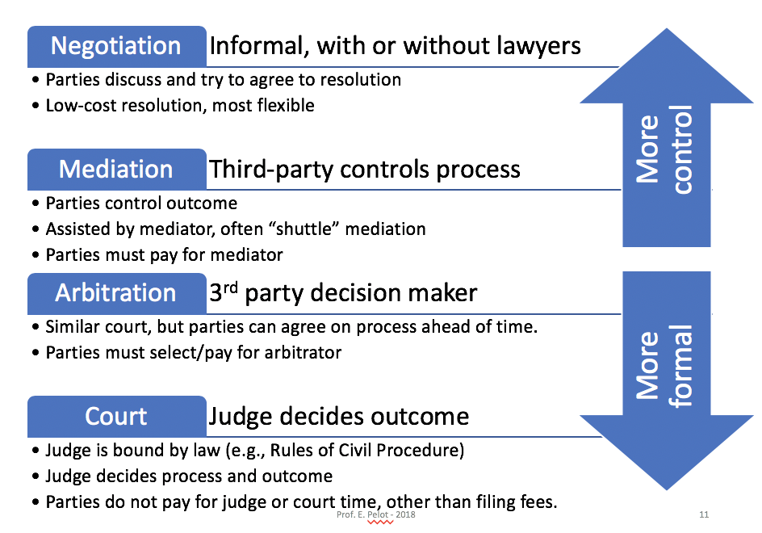
Superior court action
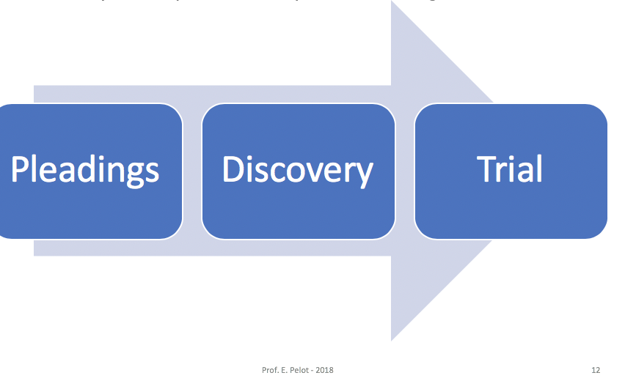
Pleadings – filing Statement of Claim and Statement of Defence with court, setting out alleged facts
Discovery – disclosure of all relevant documentation, and/or examination (recorded interviews) with witnesses and experts.
Trial:
- Opening statement (what facts will come out at trial)
- Evidence – documents and witnesses on the stand under oath
- Closing argument (fact and law)

Stages of A Small Claims Action
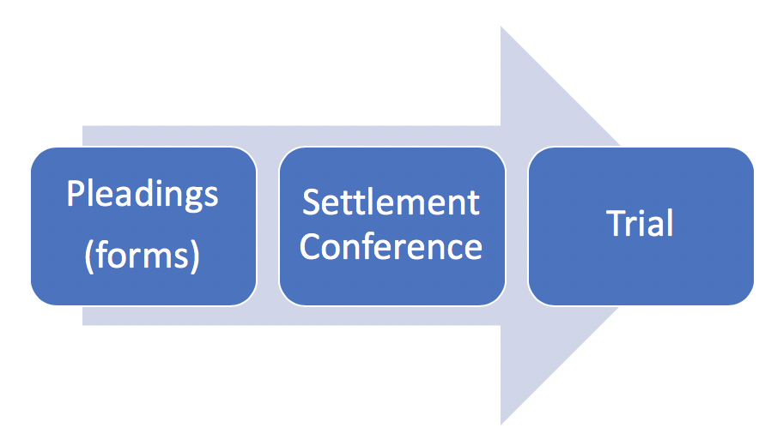
- Up to $25,000 – in money or personal property only (Courts of Justice Act, s 23)
- Simplified rules – “fill in the blank” court document forms, settlement conference, no discovery (Small Claims Court Rules)
- May be self-represented (still pay filing fees)
- Still need to prove your claim (documents, witnesses)

