Intro to Psychology: Foundations PSY 1101 F
Christophe Fortin, Fall 2018
Day 1: Tuesday 11:30 - 1
Day 2: Friday 1 - 2:30
CRX 240

Chapter 6 October 9 & 12/18

Sensations and Perception
What is the Difference Between Sensation and Perception?
- Sensation
  - The detection of environmental stimuli, such as sounds, objects and smells
- Perception
  - The experience of detecting those environmental stimuli - it refers to how our brains organize and interpret sounds, objects and smells

Bottom - up Processing
- Sensory receptors relay information to the brain
- The brain interprets this information

Top - Down Processing
- Previous experience and expectations affect the detection and analysis of information from the senses
- Explains visual illusions

Psychophysics
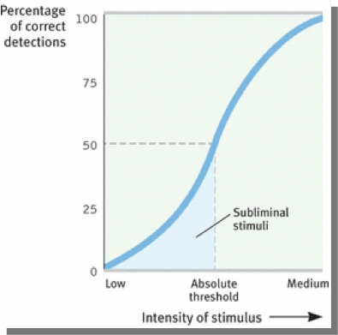
- Method that measures the strength of a stimulus and the observers sensitivity to the stimulus

Absolute Threshold
- Minimal stimulus necessary to detect a stimulus half of the time
Difference threshold (just noticeable difference or JND)
- Minimal changes in a stimulus that can just barely be detected
- Weber's law: for a difference to be perceptible two stimuli must differ by a constant proportion, rather than amount

Sensory Adaptation
- Diminishing sensitivity to an unchanging stimulus
  - Benefit - freedom to focus on informative changes without uninformative background stimulation
  - We perceive the world not as it actually is, but as it is useful for is to perceive it

Senses
Vision
- Transforms light energy into neural signals
- Represents objects in the environment in terms of shape, size, colour, and location

The Visual System The Electromagnetic Spectrum
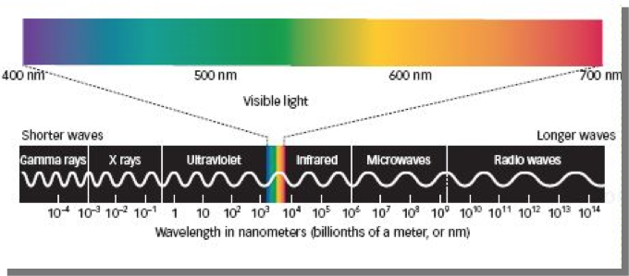
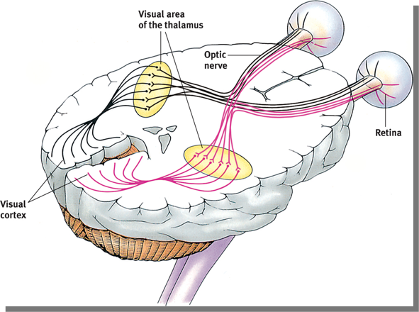
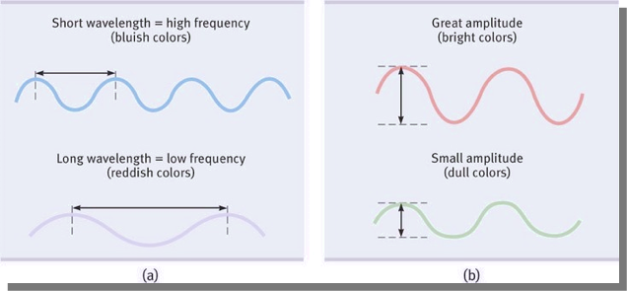
Light Energy
- Hue - the colour experienced
- Wavelength - distance from one peak to the other
- Intensity - determined by the waves amplitude

Visual Pathway
- Objects in right visual field stimulate left half of retinas
- Objects in left visual field stimulate right half of retinas
- Axons of ganglion cells form the optic nerve
- Retina route visual info over the optic chiasm to visual area in the thalamus
  - Info from the left visual field travels to the right visual cortex
  - Info from right visual field travels to the left visual cortex

Parallel Processing
- The brain processes colour movements, form and depth simultaneously in different areas
- The brian integrate the separate, parallel dimensions of visual info interpreted in different areas

Hearing
- Audition
  - The sense or act of hearing
    - What do we sense and perceive in the energy of a sound wave?
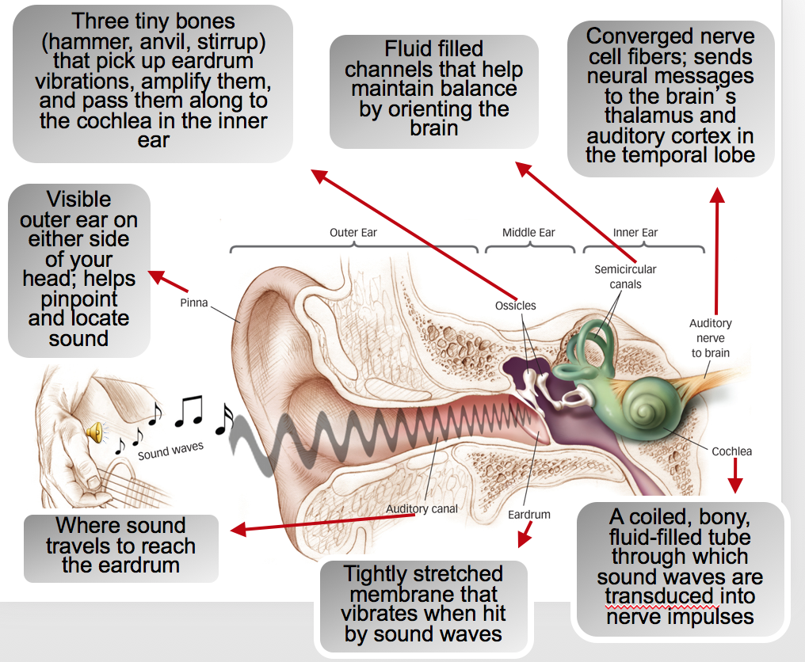
- The Ear
  - Outer ear—Sound waves are collected
  - Middle ear—Sound waves are amplified
  - Inner ear—Sound waves are transduced into coded neural messages

Properties of Sound Waves
- Frequency
  - Corresponds to our perception of pitch
  - Length of the sound wave; perceived as high and low sounds (pitch)
- Amplitude
  - Corresponds to our perception of loudness
  - High or intensity of sound wave; perceives as loud and soft (volume)
- Complexity
  - Corresponds to our perception of timbre
  - Perceives as sound quality or resonance

The Body Senses
- Touch
  - Pressure, warmth, cold and pain
- Proprioception
  - Information about body position
- Kinesthesis
  - Position and movement of the parts of your body
- Vestibular
  - Balance; sensing the orientation of your head/body in space
- Pain
  - C fibers - transit longer lasting, duller pain
  - A- delta fibers - fast acting, transit sharp pain
  - Nociceptors - pain receptors
- Can we block pain?
  - Gate Control Theory: The spinal cord contains a neurological gate that…
  - Blocks pain signals via larger fibers
  - Allows pain signals to pass to the brain through small nerve fibers

Biopsychosocial Approach to Pain
- Biological influences
  - Activity in spinal cords large and small fibers
  - Genetic differences in endorphin production
  - The brain's interpretation of CNS activity
- Social - cultural Influences
  - Presence of others
  - Empathy for others pain
  - Cultural expectations
- Psychological influences
  - Attention to pain
  - Learning based on experience
  - Expectations

Taste Sensations
- Sweet
  - Energy source
- Sour
  - Potentially toxic acid
- Umami (savoury)
  - Proteins to grow and repair tissue
- Bitter
  - Potential positions
- Salty
  - Sodium essential to physiological processes

The Taste System
- The human mouth contains about 5,000-10,000 taste buds evenly distributed over the mouth and tongue
- Each taste bud includes 50-100 taste receptor cells
- The old “tongue maps” are a myth: all five tastes can be sensed by receptors all over the tongue

Smell (Olfaction)
- Airborne odor molecules are inhaled through the nose
- Olfactory receptor cells in the nasal cavity are stimulated
- Receptor cells stimulation converted to neural signals to olfactory bulb
- Olfactory Neural Pathways
  - Olfactory neurons are the ONLY neurons that directly link the brain to the outside world
  - Connect to temporal lobe part of neural pathway involved in conscious recognition of smells
  - Structures in the limbic system that regulate emotional reactions to smells

Perception
Gestalt
- “Form” or “whole” in German
- Max Wertheimer was one of the founders of Gestalt Psychology.
- People organize sensations into a meaningful whole

Form Perception
- Part of seeing a Gestalt/whole is to view faces and other objects as distinct from their surroundings
- What do you see here? Reversible figure-and-ground illustrations show that the same stimulus can trigger more than one perception

Grouping
- The tendency to organize stimuli into coherent groups
  - Proximity, continuity, similarity, connectedness, closure

Perceptual Set
- The effect of prior knowledge and expectations on what you perceive
  - As your senses take in an ambiguous situations

Context Effects
- Prepositions is…
  - Innate and learned
  - Fed by sensations, cognition and emotion
  - Influenced by culture

Fact or Falsehood?
- Patients who have negative expectations about the outcome of a surgical procedure may experience increased postoperative pain
  - True
- Subliminal messages can raise our self-esteem and improve our memories
  - False
- Most people cannot quickly make sense of words on a page
  - True
- If we could stop our eyes from quivering as we stared at a stationary object, the object would probably vanish from sight
  - True
- If we stare at a green square for a while and then look at a white sheet of paper, we see red
  - True
- Most color-deficient people see the world in only black and white
  - False
- An 80-decibel sound is 100 times more intense than a 60-decibel sound
  - True
- Hard-of-hearing people are usually less sensitive to loud sounds than those with normal hearing
  - False
- Touching adjacent cold and pressure spots triggers a sense of wetness
  - True
- People who are born without the ability to feel pain my die by early adulthood
  - True
- Closing one’s eyes and thinking a happy thought is not a suitable means of pain control
  - False
- Without their smells, a cold cup of coffee may be hard to distinguish from a glass of red wine
  - True
- A drink’s strawberry odor enhances our perception of its sweetness
  - True
- Infants just learning to crawl do not perceive depth
  - False
- Persons who have sight in only one eye are totally unable to gauge distances
  - False
- Cars are more likely to be perceived as closer if they are higher in our field of vision
  - False
- A person who is born blind but gains sight as an adult cannot recognize objects that were familiar by touch
  - True
- If required to look through a pair of glasses that turns the world upside down, we soon adapt and coordinate our movements without difficulty
  - True

Localizing Sound Sources
- Ears on either side of the head gives us stereophonic hearing
- Timing method—noting direction of sound by which ear is stimulated first (best with low frequency sounds)
- Volume method—noting direction of sound by which ear is stimulated most vigorously (best with high frequency sounds)

Chapter 7 October 16 & 19/18

Learning
Classical Conditioning
- Leaning
  - Relatively permanent change in behaviour due to experience
- Associated learning
  - Linking two events that occur close together in time
- Conditioning is…
  - The process of learning associations between events and behavioural responses
    - Stimulus 1: see lightning
    - Stimulus 2: hear thunder
- Classic conditioning is…
  - A type of learning where we learn to associate two stimuli and anticipate events
    - After repetition - stimulus: see lightning, response: cover ears to avoid sound

Operant Conditioning
- Associate a response (behavior) and its consequences
- Learn to repeat behaviors followed by desirable results
- Learn to avoid behaviors followed by undesirable results

Behavioursism
- View that psychology should be an objective science
- Studies behaviours without taking mental processes into account
  - Pavlov, Watson, Skinner

Pavlov
- Studied the digestive system for two decades
- Won the Nobel Prize for Physiology in 1904
- Accidentally discovered classical conditioning through his work on salivation with dogs.
- Investigated this phenomenon further through experimentation
- Experimental investigation… should lay a solid foundation for a true science of psychology. (1927)
- Before conditioning
  - Neutral stimulus (bell) - no response
  - Unconditioned stimulus (food) - unconditioned response (dog salivates
- During conditioning
  - Neutral stimulus (bell) plus Unconditioned stimulus (food) - unconditioned response (dog salivates)
- After conditioning
  - Conditioned stimulus (bell) - conditioned response (dog salivates
- Acquisition
  - The initial learning of the stimulus-response (S-R) relationship
  - As the NS and US are paired more often, the CR becomes stronger
- Extinction
  - The diminished CR when an US no longer follows the CS
- Spontaneous Recovery
  - The reappearance of a weakened CR after a pause; this suggests that extinction suppresses the CR rather than extinguishes it

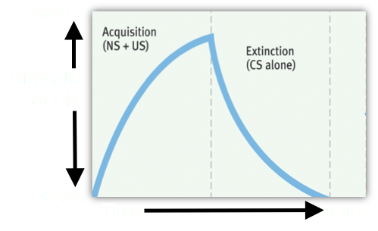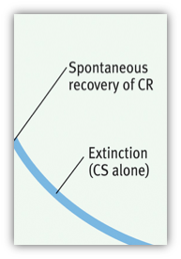

Higher-Order Conditioning (Second-Order Conditioning)
- A procedure in which the CS in one experience is paired with a different NS to create a second CS

Generalization
- Once a response has been conditioned, the tendency to respond in a similar way to stimuli similar to the CS
  - Infants can tell the difference between their mother’s voice and the voice of other women

Discrimination
- The learned ability to distinguish between a CS and other similar stimuli that do not signal a US
  - A dog that is conditioned to salivate at the sound of a dinner bell may also salivate at the sound of a doorbell

Little Albert Experiment
- John Watson applied the principles of classical conditioning to humans
- Watson believed that human emotions and behaviors are merely a bundle of conditioned responses (conditioned emotional reactions or CERs)
- Watson and a colleague, Rayner, conditioned a baby to associate white rats (CS) with a loud noise (US) and fear them (CR)
- Before conditioning
  - NS (rat) - no fear
  - UCS (hammer hit metal) - Natural reflex fear
- During conditioning
  - NS (rat) plus UCS (hammer) = natural reflect fear
- After conditioning
  - NS (rat) - conditioned response fear

Applications of Classical Conditioning
- Extinction processes or new conditioning can help change unwanted responses to stimuli
- Exposure therapy or systematic desensitization therapy combat psychological disorders using classical conditioning principles

Systematic Desensitization
- How to fix it?
  - Establish anxiety stimulus hierarchy
  - Learn the mechanism response
    - Relaxation training (e.g.: grounding, breathing)
  - Connect stimulus to the incompatible response or coping method by counter conditioning

Fact or Falsehood?
- Primitive animals, like sea slugs, behave by instinct and are incapable of learning
  - False
- The study of inner thoughts, feelings, and motives has always occupied a central place in psychology
  - False
- Ted is afraid of doctors because he doesn’t like receiving injections. This is a form of learning
  - True
- Ivan Pavlov was a psychologist who focused all his research on learning
  - False
- Biological preparedness helps explain why some associations are easier to acquire than others
  - True

The Cognitive Elements of Classical Conditioning
- Rescorla and Wagner expanded classical conditioning to include the role of cognition and the mind.
- Their research explained why an animal can learn the predictability of an event.
- They found that classical conditioning occurs when an animal has set up an expectancy or an awareness of an event
  - The conditioned stimulus and the unconditioned stimulus are simply two events and the organism can be seen as trying to determine the relationship between them.

Biological Predispositions
- John Garcia challenged the idea that all associations can be learned equally well.
- Humans (and nonhuman animals) are biologically predisposed to learn certain associations but not others

Pavlov's Legacy
- Classical conditioning is one way all species learn to adapt to their environment.
- Learning can be studied objectively.
- It provides a scientific model for psychological science

The Immune System Responds to Classical Conditioning
- Psychologist Robert Ader teamed with immunologist Nicholas Cohen and demonstrated that immune system responses could be classically conditioned
- When a certain taste accompanies a drug that triggers the immune response, the taste by itself (CS) may come to trigger the immune response
Operant Conditioning and Observational Learning
Classical Conditioning
- Organisms form associations between stimuli – CS and US
- It involves automatic reactions to stimuli (respondent behavior)
- Stimulus precedes the response and elicits it
  - If the organism is learning associations between events that it does not control, it is...
Operant Conditioning
- Organisms associate their own behavior with consequences
- Stimulus follows the response and strengthens it
- Actions followed by reinforcers increase
- Actions followed by punishers decrease
  - If the organism is learning associations between its behavior and the resulting events, it is...

Thorndike and the Law of Effect
- Placed cats in a puzzle box with a food reward outside the box
- Recorded the amount of time that it took them to figure out how to escape
- Concluded that rewarded behavior is likely to recur, which he called the law of effect

Operant Chamber (Skinner Box)
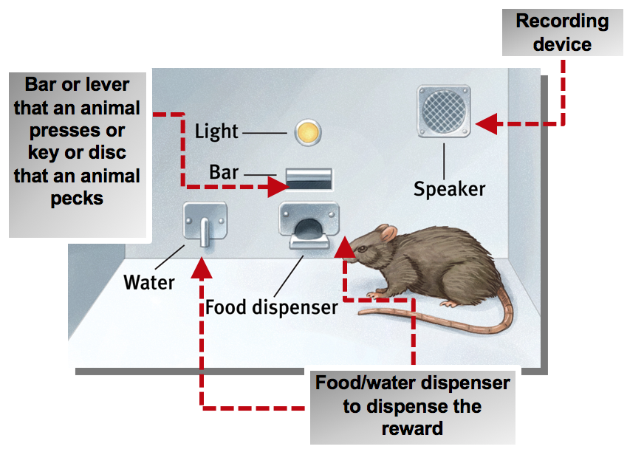

Reinforcer
- An event that increases the likelihood of a behavior being repeated
- Negative Reinforcement
  - Removing an unpleasant stimulus after a response (-)
- Positive Reinforcement
  - Presenting a rewarding stimulus after a response (+)
- Conditioned (secondary) reinforcers are effective through learned association with primary reinforcers.
- Positive Punishment
  - Administering an aversive stimulus
  - Receiving a parking ticket
  - Spanking
- Negative Punishment
  - Withdrawing a desirable stimulus
  - Revoked driver’s license
  - Time outs
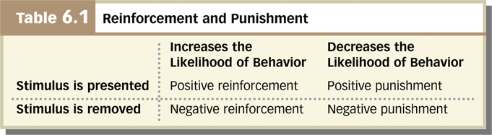
- Continuous reinforcement
  - The desired response is reinforced every time it occurs
- Partial (intermittent) reinforcement
  - Responses are sometimes reinforced and sometimes not

The Schedule of Reinforcement
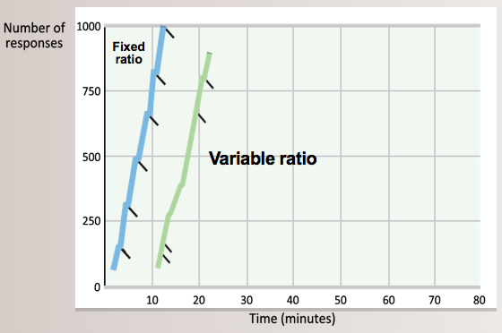
- Fixed-Ratio Schedules
  - Reinforce behavior after a set number of responses (every so many)
  - Produces high rates of responding
- Variable-Ratio Schedules
  - Reinforce behavior after an unpredictable number of responses (after an unpredictable number)
  - Produces high rates of responding
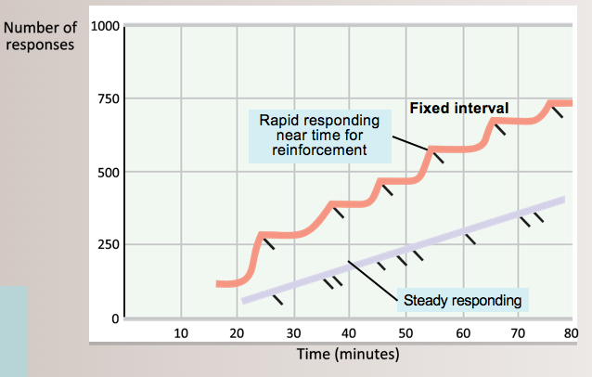
- Fixed-Interval Schedules
  - Reinforce first response after a fixed time period (every so often)
  - Produces a choppy stop-start pattern of responding
- Variable-Interval Schedules
  - Reinforce the first response after varying time intervals (unpredictably often)
  - Produces slow, steady responding

Shaping Behaviour
- Successive approximations
- Reward behavior that approaches the desired behavior
- Allows animal trainers to get animals to perform complex behaviors
- Observational Learning
  - Learning by observing others
  - Learning by imitating models
  - Learning without direct experience
- Modeling
  - Observing and imitating specific behaviours
- Latent Learning
  - Learning that becomes apparent only when there is an incentive to demonstrate it
- Cognitive map
  - A mental representation of the physical features in the environment

Classical vs. Operant Conditioning | Classical  Organism learns associations between events that it does not control. | Operant  Organism learns associations between its behavior and resulting events.
Response | Reflexive, involuntary behaviors | Non Reflexive, voluntary behaviors
Basis of learning | Associating two stimuli (CS + US) | Associating a response and the consequence
Extinction process | CR decreases when CS is repeatedly presented alone. | Responding decreases when reinforcement stops.
Cognitive processes | Organisms develop expectations that CS signals the arrival of US. | Organisms develop expectations that a response will be reinforced or punished.  Organisms exhibit latent learning without reinforcement
Biological predispositions | Natural predispositions constrain what stimuli and responses can easily be associated | Organisms best learn behaviors similar to their natural behaviors.  Unnatural behaviors instinctively drift back to natural ones

Fact or Falsehood?
- Humans are the only animals that can learn behaviors merely by observing others perform them
  - False
- Negative reinforcement is another term for punishment
  - False
- Psychologists agree that punishment, regardless of its form, has little effect on behavior
  - False
- Animals learn only when rewards are given
  - False
- Animals can learn to make virtually any response if consistently rewarded for it
  - False
- Research indicates that televised violence leads to aggressive behavior by children and teenagers who watch the programs
  - True

Albert Bandura
- In his classic Bobo Doll Experiment, Bandura explored observational learning in children
- The children in the film imitated the actions of the woman they watched abusing the Bobo doll. Would they have been as likely to imitate a male professor wearing a lab coat, if they had watched him instead? Why or why not?
- What are some children’s toys that support observational learning?

Applications of Observational Learning
- Models all around affect us both positively and negatively
- Prosocial influence
  - Organizations use behavior modeling to teach skills
  - Positive behaviors and messages can be modeled to children
- Antisocial Influence
  - Modeling can be antisocial
  - Abusive parents model aggression to their children and perpetuate a cycle of violence
  - The media can model violence as acceptable, or even “cool,” rather than harmful

Violence Viewing Effect
- Violence is committed by attractive perpetrators
- Most of the violence is “unpunished.”
- Victims’ pain is not portrayed
- Many of the incidents involve “justified” violence
- Through desensitization, children become indifferent to violence
- Even the very young imitate what they see on TV

Mirror Neurons
- Are neurons in the frontal lobe that fire when performing certain actions or observing others perform those actions
- Enable imitation and empathy
- Underlie humans’ social nature

Chapter 8 October 30 & November 2/18

Memory
- What is memory?
  - Learning that has persisted over time
  - Information that has been stored over time
  - Information that can be retrieved over time
Memory Processes
- Encoding
  - Getting information into memory
- Storage
  - Retaining information in memory
- Retrieval
  - Recalling or using previously encoded and store information

Three - Stage Model of Memory
- Sensory input from the environment is recorded as fleeting sensory memory.
- Information is processed in short-term memory.
- Information is encoded into long-term memory for later retrieval

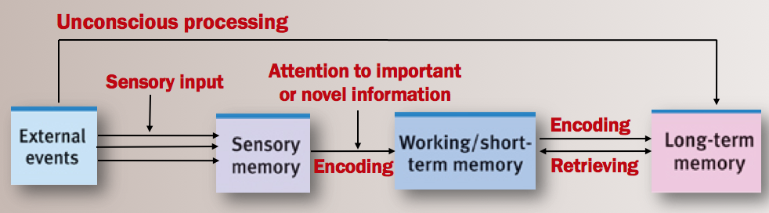

Sensory Memory
- The immediate, initial recording of sensory information in the memory system
- Visual - iconic memory
  - Duration - less than a second
- Auditory - echoic memory
  - Duration - a few seconds

Working Memory (Short-term Memory)
- Active processing of information
- Associates new and old information
- Solves problems
- Short - term memory
  - Limited in capacity – Seven bits of information can be stored +/- 2 (Miller, 1956). Recall is better for random digits (phone numbers) than for random letters
  - Recall is better for random digits (phone numbers) than for random letters
  - Recall is slightly better for what we hear than for what we see
  - Without rehearsal, most people can retain about 4 information chunks in their short term memory
- Long - term Memory
  - Unlimited capacity, but not as accurate as sensory memory or short-term memory
  - Organizes and stores information
  - Information not stored in precise locations
  - Duration of memory storage thought by some to be permanent

Encoding
- Visual encoding
  - Visual encoding stores new memories by converting them into mental pictures. We more easily remember words that are concrete nouns because they lend themselves to visual imagery giving us two codes for the word.
- Encoding failure
  - What letters accompany the number 5 on the telephone?
  - Where is the number 0 on your calculator?
  - Some memories cannot be encoded without effort

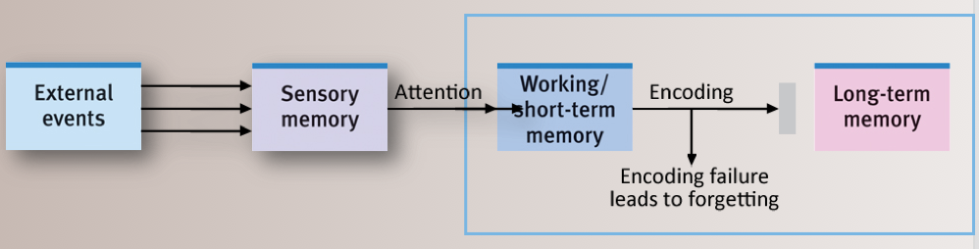

Strategy for successful encoding: Deep Processing
- Semantic judgment, or thinking about a word’s meaning, allows for deeper processing and best memory
- Rhyme judgment, or attending to the word’s sound, results in shallow processing
- Visual judgment, or attending to how the word looks (shallow processing), yields the lowest remembering

Processing
- How information gets encoded into memory
- Automatic processing is the unconscious encoding of information about space, time, frequency, and well-learned information
- Effortful processing is encoding that requires attention and conscious effort (i.e., rehearsal

Hermann Ebbinghaus and
The Retention (Forgetting) Curve
- Ebbinghaus studied his own verbal memory
- He tried to learn (memorize) a list of nonsense syllables
- The more times he rehearsed the list on day one, the less time it took to memorize the list on day two

Storage
What can we learn from Ebbinghaus’ experiment?
- We retain more when our learning involves more time and repetition
- This result applies to learning completely novel and meaningless information
- Would this result generalize to meaningful information? Ebbinghaus estimated that learning meaningful information would take 1/10th the effort

Spacing Effect
- Information is retained better when rehearsal is distributed over time
- Distributed study produces better long term recall
- Massed practice (doing your studying on one day) produces speedy short term-learning but poorer long-term recall

The Serial Position Effect
- The tendency to remember the first and the last items in a list

Types
Implicit (Nondeclarative) Memory
- Retention independent of conscious recollection
- Processed by cerebellum and other brain areas
- Motor and cognitive skills
- Amnesia patient H.M. retained implicit memory. He could learn new skills such as copying a picture using a mirror.

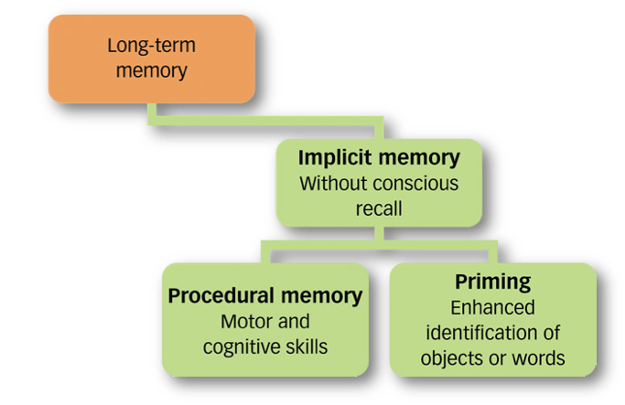
Explicit (Declarative) Memory
- Processed in hippocampus
- Memory of facts and general knowledge
- Memory of personally experienced events
- Memory that can be consciously recalled
- Amnesia patient H.M. was unable to form new explicit memories. He couldn’t recall new events or facts in his life such as spending time on lessons with researchers
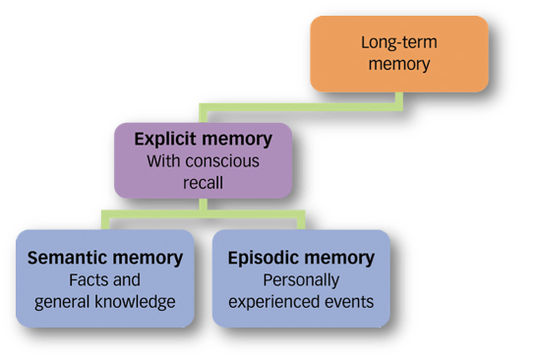

Hierarchies
- A few broad concepts divided into smaller concepts and facts
- Subdivided into even narrower concepts and facts
- Hierarchies can be used to learn concepts; this is called organizational encoding

Flashbulb Memories
- Flashbulb memories are clear, detailed memories of emotionally significant events
- However, as people relive the event and discuss it with others, these memories may become distorted

Emotional Memory
- Can be persistent
- Heightens the body’s stress response
- Spurs production of the stress hormones adrenaline and cortisol
- Can be a key symptom of Post-traumatic Stress Disorder (PTSD)
- Experimental treatments include drugs to block memory

Strategies
- Chunking
- Priming
  - Activation of an existing memory by a stimulus
  - The activation, often unconsciously, of particular associations in memory
- Emotion and Memory
  - Excitement, stress, or strong emotion can strengthen memories. Stronger memory in response to emotional situations is adaptive
  - Emotion-triggered stress hormones increase glucose production, which signals to the brain that something important has happened. The amygdala boosts activity and proteins in the brain’s memory areas

How to Improve Memory?
- Use distributed (spaced) practice
- Make the material meaningful
- Activate retrieval cues
- Use mnemonic devices
- Minimize interference
- Sleep more
- Test yourself

Physiology
Patient H. M. (Henry Molaison, 1926-2008)
- H.M. suffered from epileptic seizures
- At 27, he had parts of his temporal lobes removed to prevent seizures
- H.M. had explicit memories from before the surgery
- He could NOT remember what happened after the surgery
- H.M. could recognize himself at age 27 in pictures, but he could not recognize himself in the mirror as a much older man years later
- H.M. lost explicit memory for events that happened after the surgery
- H.M. retained his implicit memory: He performed normally on procedural memory and priming tasks
- This suggests that explicit memories are processed by the hippocampus
- Implicit memories are processed elsewhere in the brain

The Hippocampus
- Processes explicit memories for facts and episodes
- Feeds memories to other brain areas for storage
- Part of the limbic system
- Active during slow-wave sleep
- Hippocampus and cortex display simultaneous activity during sleep

The Cerebellum
- Crucial to the formation of implicit memories
- Plays key role in forming and storing memories created by classical conditioning
- Damage to cerebellum disrupts forming conditioned reflexes

Long Term Potentiation (LTP)
- A neural basis for learning and remembering associations
- Synapses become more efficient at transmitting messages, and…
- Increased efficiency in the synapse leads to more efficient neural circuits
- It is the physical bases of memory
  - LTP-blocking drugs interfere with memory.
  - Mice that lack an enzyme needed for LTP cannot navigate a maze.
  - Injecting rats with a chemical that blocks LTP erases recent learning.
  - Rats that ingest an LTP-enhancing drug learn a maze with half the number of usual mistakes

Retrieval
- Getting information out of memory
- Recall—bringing previously learned information into conscious awareness, as in a fill-in-the-blank question on a test
- Recognition—correctly identifying previously learned information when exposed to it again, as in a multiple-choice test

Context Effects
- Ability to recall is improved when in the same context as the initial experience
- State-Dependent Memory
  - Recall is improved when encoding and retrieval of a memory happen in the same emotional or biological state
  - It is difficult to remember happy times when depressed.
  - This may explain why after a happy experience, people view the world through rose-colored glasses

Forget It
- Forgetting
  - Encoding failure
  - Storage decay
  - Retrieval failure

Storage Decay
- Memories decay gradually if they are not used
- Information is at first rapidly forgotten
- After a certain period of time, the forgetting levels off

Retrieval Failure
- Tip-of-the-tongue phenomenon
- Interference
- Motivated forgetting

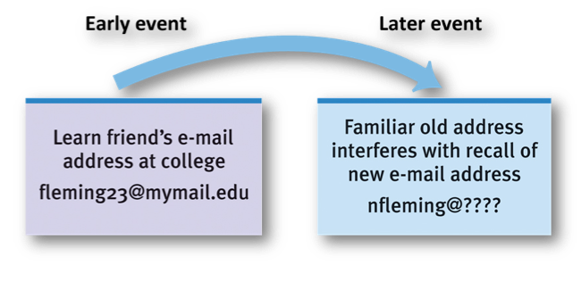
Proactive Interference
- Forward acting
- The disruptive effect of prior learning on the recall of new information
- A friend’s email address that was learned long ago may interfere with learning the new email address

Retroactive Interference
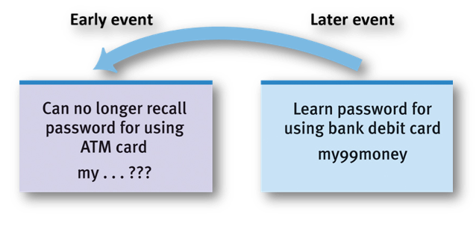
- Backward acting
- The disruptive effect of new learning on the recall of old information
- Learning a password for a new bank card can disrupt recall of the password for your existing ATM card

Amnesia
- Retrograde: Inability to access memory before a certain date
- Anterograde: Inability to form or consolidate new memories after a certain date

Motivated Forgetting
- Repression - Freudian defense mechanism that banishes an anxiety-producing memory from consciousness
- Preserves self-concept
- Memory may be retrieved through a cue or therapy
- Increasing number of memory researchers think repression rarely occurs

False Memory
- False memories can be “planted.”
- Imagining nonexistent events can create a memory
- Imagination inflation – Imagining something and really perceiving it activate similar brain areas
- People with vivid imaginations are more likely to have false memories
- Children are very susceptible to false memory

Fact or Falsehood?
- The persistence of learning over time most clearly depends on memory
  - True
- Memory storage is never automatic; it always takes effort
  - False
- Shortly after hearing a list of items, people tend to recall the first items in the list most quickly and accurately
  - False
- Children can better remember an ancient Latin verse if the definition of each unfamiliar Latin word is carefully explained to them
  - True
- We are more likely to remember the word “fire” than the word “process.”
- True

Memory in Everyday Life
- How do residents of an assisted living community describe finding another resident wandering the halls aimlessly, not recalling where they are or how they got there?
- What does a woman in the video recommend for keeping one’s mind alert in advancing age? Can you think of any other ideas for “exercising” an aging mind?
Recency Effect
- Immediately after a list of words is read or seen, people recall the last items in a list better
- Possible explanation: The last items may be held in short-term memory

Primacy Effect
- When exposure to a list is followed by a long delay, people recall the first items on a list better
- Possible explanation: The attention is on the first items, and short-term memory is not helping

Fact or Falsehood?
- Only a few people have any type of photographic memory
  - False
- Although our capacity for storing information is large, we are still limited in the number of permanent memories we can form
  - False
- We store information in memory as libraries store their books, that is, in discrete, precise locations
  - False
- Research on sea slugs indicates that memory formation is associated with the release of certain neurotransmitters
  - True
- Prolonged stress often inhibits the process of long-term memory formation
  - True

Iconic Memory
- A fleeting photographic memory
- Sperling’s Iconic Memory Experiment
  - Sperling flashed letters on a screen for 1/20th of a second
  - He asked people how many letters they recalled
  - Participants could recall only ½ of the letters
  - Next, Sperling flashed the letters on a screen for 1/20th of a second
  - Immediately after the screen went blank, he sounded a tone
  - A high, medium, or low pitch tone signaled the row that participants were to report
  - Recall for letters in a row was almost perfect
  - How can we explain this result?
  - What happens when the tone sounds?
  - When the tone sounds right after the picture is flashed, we have time to retrieve the letters from iconic memory

Fact or Falsehood?
- When people learn something while intoxicated, they recall it best when they are again intoxicated
  - True
- The hour before sleep is a good time to commit information to memory
  - True
- Learning a new ATM password will not block the recall of the old password
  - False
- Repeatedly imagining a nonexistent event can lead us to believe it actually happened
  - True
- Children typically will repress any memory of having seen one of their parents being murdered
  - False

