Class 10

Deffinitions
- Vulnerability Urbane
A system which is influenced by a variety of variables such as natural and human that can lead to dangerous situations within society
- Risk
Natural phenomenon or technological accident that is unable to be predicted (random).
Risk = Hazzard (Probability of the phenomenon) X Stake (people, material goods, natural areas which could be effected by the hazard)
Intensity of risqué can be considered élévé or faible
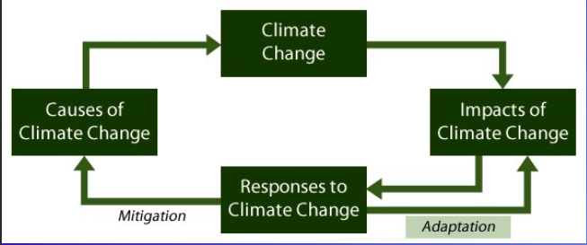

Types of Risks
Risques Exogènes: Linked to natural hazards happens outside of the city, often destructive
Ex: volcanic eruption, earthquake, flood, tsunami

Risques Endogènes: created by human activity associated with technological, health and social fields which often increases the amount of Exo- risks
Ex: High density, urbanization

Catastrophe vs. Risque ordinaire

Catastrophe: an event which causes damages to humans and our resources on a large scale. Quantify Catastophe: 20+ dead, 2000+ homeless& +35million in damages
Media coverage is based on death toll and insurance cost
Risque Ordinaire : common and minor importance. Effects are localised and on a small scale or there are no effects at all.
Ex: car accident, fire

Climate Change -> impacts of climate change -> Response to climate change -> cause of climate change

Résilience: Ability of the city to withstand a disturbance and recover

Résillience Réactive: Immediate (evacuation), Short Term (Networks/infrastructure), Mid-Term (return of population/Reconstruction) & Long Term: (recovering economically and culturally)

Résillience Proactive: prevent and better adapt to future disaster

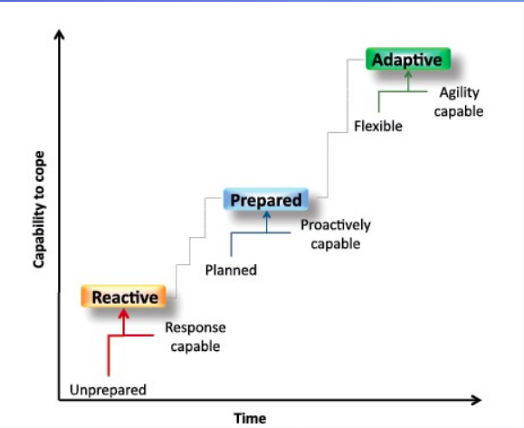
Video Summary: https://www.youtube.com/watch?v=SZJVUnFzI9c

Class 12

Risques Technologiques
Les risques technologiques sont liés à l’action humaine et plus précisément à la manipulation, au transport ou au stockage de substances dangereuses pour la santé et l’environnement (ex : risques industriel, nucléaire, biologique.)

Types of Dégâts (Damages)
- Fire
- Toxic waste
- Explosions
- Pollutions
- Irradiations
Causes of accidents
- Equipment malfunction
- Human errors
- Intentional Attack
- Natural
Types of Industrial Accidents
- Accidents
- Nuclear accidents
- Transporting Dangerous materials
- Mining accidents
- Breaks

Effects of Industrial Accidents
This impacts industrial establishments (chemically or petrochemically). It impacts staff, surrounding neighborhoods, animals and property and the environment

Thermal Effects – explosion or combustion caused by flammable products. Causes burns
Mechanical Effects – followed by explosion/shock causes tumor lung problems
Toxic/chemical – Leaking of substances can be inhaled, ingested or skin contact

Companies with Industrial accidents are divided in 2 groups:
- Chemical industries – supply basic chemicals for agriculture, Pharmaceuticals and consumer products. (plant production, fertilizer, bleach)
- Petrochemical – Develop petroleum products. (gas, petrol, tar)

Nuclear Accidents
Release radio active elements into the environment and strong radiation

Two types of Uses
Military: Passive deterrence
Civil: production of electricity

Damages
Sabotage (terrorism)
Accident
War

Effects
irradiation
Contamination (skin/ingestion)

Debate on Nuclear arms
Pro
- The destructive potential become a beneficial deterrent tool that reduces the risks instead of creating
- Has no intention of using it
- Used to avoid wars
Con
- Never a valid answer it is disproportionate
- Effects are felt over generations
- Capable of destroying the entire planet
- Undemocratic due to its secrecy

Transporting hazardous materials
- Fuel, gas, fertilizer
- Pose risk to people, property and environment
- High concentration

76% Road accidents
14% Trains
10% Boats

Dam Rapture
Pros
- Retain water
- Allows regulation of water bodies and flow
- Useful for crop irrigation
- electric power generation
- mining
- tourism
- fight against fires.
Cons
- destruction of structure
- large initial wave
- flooding downstream
Causes
- defective design, construction or materials
- Natural Aging
- Operation errors
- Earthquakes
- Flooding
- Landslides
Effects
- Living things drown or become buried
- Destruction/deterioration of buildings, bridges and roads
- Kills flaura and fauna
- Deteriorates soils
- Carries Pollution/mud and debris

Mining Accidents: Gold, coal, salt, uranium
- Large number of mining sites
- Resulting in several underground tunnels
Risks
- Land movement causing collapse, impacting buildings roads and access to gas and water
- Water pollution
- Flooding
- Explosions
- Toxic radioactivity (uranium)

Prevention:
Legislation made by the ministry of environment and urbanism
Creating a classification system that evaluates risk and danger as well as further studying accidents and seeking effective mitigation measures

Cours 14
- Face aux rique politique et sociaux
- 2-5 Violence urbain - Deffiition et cause
- 6 formes de violence
- 7 quelles son les ville le plus dangerouse aux monde?
- 9 why are they dangerous?
- 11 solution de violence urbaine
- 12-18 Insecurité urbain
- Whats the difference between insecurité urbain and violence urbain?
- Why are women more effected?
- 19-23 confli armmedifference entre le ville et guerre
- Models that we saw from conflict
- Make connections between slide 19 Bayroute, lapresguerre en eurpe (construction)

Violence Urbaine: Gangs lashing out at society that are lashing out against the system. “Poor organized actions resulting in a collective revolt against property and people, most often related to institution and disadvantaged territories

Territory or Space are often considered to created conflict and tension. This happens when space is claimed by a group which may share different religion, ethnicity, language or even socioeconomic status. This is when different groups clash.

Enjeu - Actively fighting over space (Sandly hill vs. Embassy)
Théatre de conflit - Random space but that’s where people are fighting (shopping mall parking lot)
Support d’exsperssion - This space is where people come together to protest (parliament hill)

Causes of Urban Violence
School, Economic, crime, racial, lack of authority, bad physical environment (transpo).
- Single parent
- Lack of parental authority
- School failure
- Unemployment
- Presence of Criminals (gangs, drugs, trafficking)
- Alcoholism and smoking
- Violence
- Poor quality of the physical environment
- Small housing
- Minimal public transport
- Lack of urban activities

Juvenile Delinquency
- Tries to attract attention (aggression phase)
- Depression
- Abandonment
They distrust adults, ignores the value of work and seek to rebel

Incivilité : disrespectful behaviour towards the community, Vandalism, Theft & Verbal assault
physical violence: Use of physical force against others trying to hurt or kill (murder, rape, riots)

Most dangerous Cities in the world (number of homoscides)
South America
Sao Paolo – 1621
Bogotà – 1281
Tégucigalpa – 1175
Mexico - 779

Why are they dangerous?
In Brazil violence in poor neighbourhoods is due to the abandonment of authorities, drug traffic and poor development

(Divide between rich and poor these differences are visible through gated communities ect.)

Solutions
Prevention
- Identify behavioral problems in school
- Deploy more support throughout the community with community workers, police ect.
- Employment assistance for youth
- Overall improvement of the living environment

Surveillance
- Use police only when necessary
- Fines
- Imprisonment
- Community service
- Electronic bracelet

Insecurity vs. Violence
Urban insecurities: Are different from physical violence. Insecurities are related to the consequence of violent acts. This changes the way people look at a place
Ex: being scared to walk in bad neighborhoods or even picking another country to visit when traveling in fear of security.

Violence is an actual act where as insecurities is how you feel towards the space

Who is impacted by insecurities?
Women, elderly, disabled. Those who have already experienced or know someone who has experienced violence.

Influences
- The media plays a huge role on the overall perception of a place or space. Impacting the way people see it and deter people from visiting or puts fear into those who live there.
- Prior knowledge and familiarity in a neighborhood you feel safer in a place that you know. Safety as well as Layout, type of people and public places
- Type of Traffic for example who hangs out there, who owns the space and urban planning
- The layout and Cleanliness if there is graffiti, vacant land, waste, gangs, homeless, minimal lighting

How to make a safe environment for women
- Know where you are and where you’re going
- Be aware of whos around you
- Listen to whats around you
- Able to access help if needed
- Live in a proper and lit up place
- Create connections within a community

Conflits armés
- DES – Marked in history between which city has the most wealth and power
- POUR – fighting for territory, preference of place, by having more space means more power
- PAR – destruction of the city to win the war ex: Natzi vs. soviets
- CONTRE – Urbanophobic ideologies, attempt to break free of “the system” capitalism
- DANS – city is the battle field

Class 15
Armed conflicts
- Lack of food & water
- No medical assistance
- Creates refugees
Eg: Syrian refuges that moved to Europe

New York : 9/11
Political (terrorism) and technological (using planes)
An attack contre le quadre bati
Proved resillient
Construction started 2006 -One World Trade Center was rebuilt and the memorial opened in 2011 and was a symbolic representation for the city.
Proactive résilience - Urban areas security initiative

Beirut, Liban : diversité religieuse, mix de socioeconomic. It was controlled by Christians but most of the population was Muslim. Assasinations and murdars in 1967. 150,000 people killed people displaces, and immigrated, cities destroyed, infrastructure destroyed 1975-1990
Mid-Term Reactive Resilliance: They were unsuccessful in rebuilding the city

Europe reconstruction after the second world war both became heritage sites
Harve France – Rebuilt in 10 years, first people didn’t want reconstruction to happen but then they decided that they would re build
Varsovie pologne Warsaw- Successful
Natzi wanted to erase memory, they blew everything up. City rebuilt and involved the whole city. Preserved as much as they could
des models de construction (before and after war)

Cours 17 - Patrimoine en péril
- Retenire les titre, confli armees, development urbain, degradation, separe de la ville, privativation de pattrimonie
- Reviser le video sure 22

Conflicts – When people attack the cities heritage
Development urban – Pollution, building too fast, forgetting about heritage Eg: pyramids heritage being overtaken by the city seen in ariel photo. Using old foundations and creating new building with no regarts for historical sites

Degredation – not taken care of their heritage, some times intentional so they just let it go and sometimes its unintentional
Medina – historical site Tunis decided to save the old part of their city

Insersion Moderne -
Reconversion et Privatization –

Class 18
- Gament powerpoint slide 3- proximité conceptuelle
- Difference entre patrimonie et résilience
- Slide 4 patrimonie et vulnérabilité 2 approaches, top half vs. bottom half of slide
- Tout les element qui menace le ppatrimonie : guerre, confli.
- Commaitre que le patrimoe et cible
- Aussi how tourism has negative impacts, and how success becomes difficult
- Slide 7-8 Patrimonie et resilliance: population qui trouve resilliance by taking care of the partimonie

Patrimoine et resilience
Theres a relationship between heritage and resilliance. Heritage looks at the past and resilliance looks at the future. Both are relevant for sustanible development

Connection between heritage and vualnerability
- Less vaulnerable Herirtage fights it, because its espabilishing identity and communal collective memory of the city.

- More vaulnerable, if you have a percious piece of historical land it can be targeted to obolish a cities identity

Climate change can effect heritage sites, its harder to move forward because theres rules on what you can and cant build.

Trying to determine weather to reconstruct, restore or preserve the ruins.

Heritage is symbolic for resilience

