What is a project?
A temporary endeavor undertaken to create a unique product, service or result
What is project Management?
The application of knowledge, skills, tools, and techniques to project management activities to meet project requirements.
PMI- Definition of Project
“A temporary endeavor undertaken to create a unique product, service or result. The temporary nature of projects indicates that a project has a definite beginning and end. The end is reached when the project’s objectives have been achieved or when the project is terminated because its objectives will not or cannot be met, or when the need for the project no longer exists”

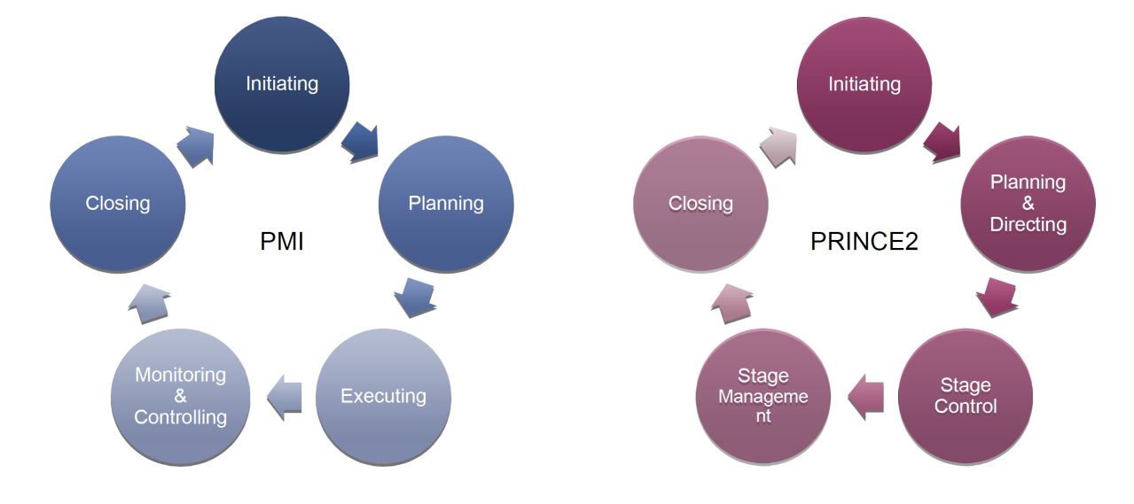

What is PMBOK Guide?
- Identifies that subset of the project management body of knowledge generally recognized as good practices
- Provides and promotes a common vocabulary within the project management profession for discussing, writing and applying project management concepts
- Establishes guidelines for project management processes, tools and techniques

PMBOK Knowledge Areas:

- Integration
- Scope
- Time
- Cost
- Quality
- Human Resource
- Communication
- Risk
- Procurement
- Stakeholder
PMI Knowledge Areas: (*Possible Short Answer)
- Project Integration management, Project Scope Management, Project Time Management, Project cost management, project quality management, project human resource management, project communication management, project risk management, project procurement management, project stakeholder management
What is Prince2?
- Is a book that describes a method for approaching, managing and closing down a project of any type or size
- Tells what should be done and why it should be done but does not say how it should be done
- Is not prescriptive, rather it is descriptive
- Is a structured management method
Prince 2 Principles:
- Business Justification
- Roles and responsibilities
- Learn from experience
- Manage by exceptions
- Manage by stages
- Tailor to suite the environment
- Focus on product
PMBOK VS PRINCE2
Comprehensive | Focus on key areas only (not complete)
Largely descriptive, prescriptive on high level | Highly prescriptive, especially on Process Structure, but adaptable to any size project
Core and facilitating processes; need to be scaled to needs of project | All processes should be considered; also need to be scaled
Customer requirements driven | Business case driven
Sponsor and stakeholders | Clear project ownership and direction by senior management

Scope Management
- Controlling the project objectives and goals
- Creating plans for the different set of activities
- Defining Product
- Establishing tasks

Six Main activities of Scope Management
- Conceptual development (what is the problem? - How can I solve it? - What do I want to achieve? -How can I get there?)
- The scope statement (KPI’s – Project Plans – WBS – RACI – Scope Baseline)
- Work authorization (The actual “go ahead”. Get the work going! – Execute Work Packages – Supplier Contracts – Hiring people – Organizing/assigning the work)
- Scope reporting (Communication* - Keep stakeholders informed – Format of communications – Frequency)
- Control systems (Making sure all is in the right place and time – Configuration Management – Documentation – Execution)
- Project closeout (Gathering information for the future – Historical records – Lessons learned)
Plan: Series of tasks and assignments needed to reach a goal
The Scope Statement: Document including more details than Project Statement of Work on the scope and deliverables of the project, major assumptions and constraints are also added if appropriate.
- Establishment of goals: Define KPIs and Define deliverables
- Management Plan
Work Breakdown Structure (WBS): “A deliverable-oriented grouping of project elements which organizes and defines the total scope of the project, each descending level represents an increasingly detailed definition of a project component.” (Task list, define relations and dependencies and create a baseline)
RACI Table: Responsible, Accountable, Consulted and Informed
Project Life Cycle
INITIATION:
Business case:
- Why are we doing this?
- What benefits do I want to get out of the Project?
- Who will benefit from it?
- How much resources will be needed?
- Is it feasible?
- Executive Summary
- Reasons
- Business Options
- Expected Benefits
- Expected Dis-Benefits
- Timescale
- Costs
- Investment Appraisal
- Major Risks
Goals and outcomes:
Goal (launch a product) – Outcome (save energy)
- S: specific, significant, stretching
- M: measurable, meaningful, motivational
- A: agreed upon, attainable, achievable, acceptable, action-oriented
- R: realistic, relevant, reasonable, rewarding, results-oriented
- T: time-based, time-bound timely, tangible, trackable
Stakeholders: an individual, group or organization who may affect, be affected by, or perceive itself to be affected by a decision, activity or outcome of the project.
Project Brief:
The Project Brief provides a way into the project and acts as a first step to producing a Project Initiation Document. This template can be used successfully as the basis of an initial brainstorming session with everyone involved or interested in the project.
- Outcomes, objectives, outline deliverables, scope approach, exclusions, constraints, outline business case, reason for selecting this solution, outline project plan/schedule, quality expectations, risk assessment
Project Charter/PID
- Defines the project & its scope
- Justifies the project
- Secures funding, if necessary
- Defines the roles & responsibilities
- Answers the questions: What, Why, Who, How, When
THE PID:
- Purpose
- Project scope statement
- Project background
- Assumptions, Dependencies, Constraints
- Organisation & Governance
- Communication plan
- Quality Plan
- Initial project plan
- Project controls
- Initial risks and issues log

THE PROJECT CHARTER (PMI)
- Executive summary, Project Purpose/Justification, Business Need/Case, Business Objectives, Project Description, Project Objectives and Success Criteria, Requirements, Constraints, Assumptions, Preliminary Scope Statement, risks, Project Deliverables, Summary Milestone Schedule, Summary Budget, Project Approval Requirements, Project Manager, Authorization

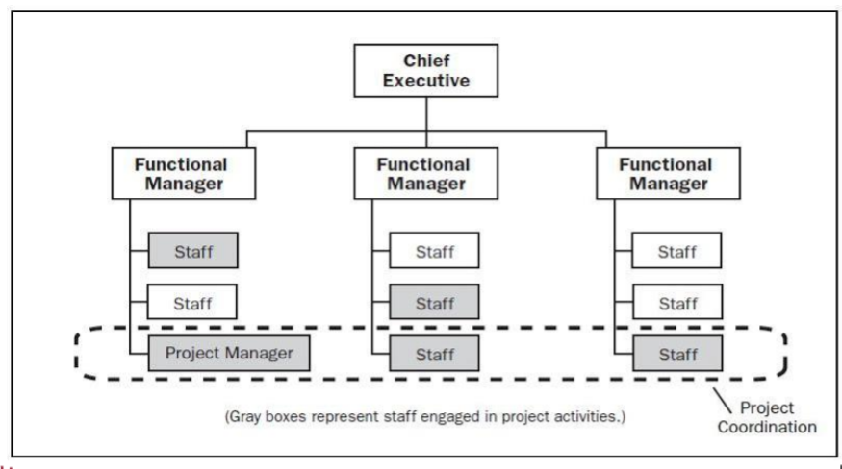
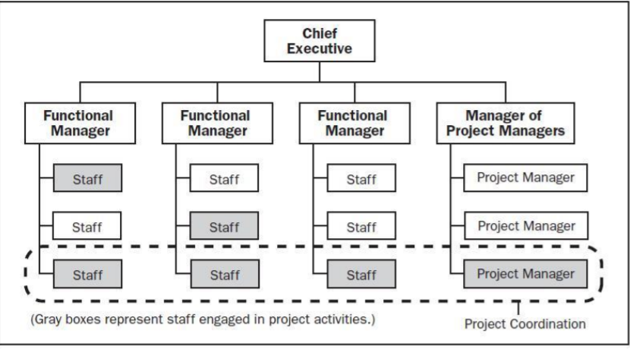
Establishing the team:

PLANNING:
- PMI 10 Management Areas: Integration, Scope, Time, Cost, Quality, Human Resource, Communication, Risk, Procurement, Stakeholder
- Project time management process:
  - Plan schedule management, define activities, sequence activities, estimate activity resources, estimate activity durations, develop schedule, control schedule
Risk management: the art and science of identifying, analyzing, and responding to risk factors throughout the life of a project and in the best interest of its objectives
Project Risk: An uncertain event or condition that, if it occurs has a positive or negative effect on one or more project objectives such as scope, schedule, cost, or quality.
- Risk = (probability of event) * (consequences of event)
Four stages of Risk Management:
- risk identification
- Analysis of probability & consequences
- Risk mitigation strategies
- Control and documentation (Change Management)

6 Step Project Risk Management (PMI):

- Plan risk management
- Identify risks
- Perform qualitative risk analysis
- Perform quantitative risk analysis
- Plan risk response
- Control risks

The Delphi Method: Is a forecasting method based on the results of questionnaires sent to a panel of experts.
Risk Score = Probability Score X Impact Score (Shows importance of risks)
Failure Mode and Effect Analysis (FMEA)
Probabilities/Impact Matrix: (Risk Impact Matrix)
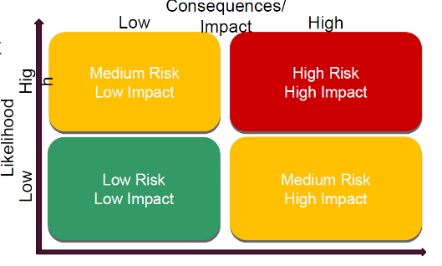

Mitigation strategies: **
- Avoid – Don’t do risky action
- Transfer – Somebody else (Insurance – Contracts)
- Mitigate/Reduce – Make changes to reduce probability
- Accept – Let it happen (Contingency reserve)
Other mitigation strategies:
- Mentoring
- Cross training
Plan Risk Response for Opportunities:
- Exploit
- Enhance
- Reject
Project Risk Analysis and Management (PRAM): Presents a generic methodology that can be applied to multiple project environments and encompasses the key components of project risk management.
- Risk management strategy changes over the project life cycle
- Synthesized, coherent approach

9 Phases of Risk Assessment:

- Define
- Focus
- Identify
- Structure
- Clarify ownership of risks
- Estimate
- Evaluate
- Plan
- Manage

Agile Project Management (Agile PM): Reflects a new era in project planning that places a premium on flexibility and evolving customer requirements throughout the development process.
- Planning the work and then working the plan
- Customer needs may evolve and change over course of project
- Importance of evolving customer needs leads to incremental, iterative planning process
Agile Concepts:
- Sprint: one iteration of the Agile planning & executing cycle
- Scrum: the development strategy agreed to by all key members of the project
- Time-box: the length of any particular sprint, fixed in advance, during the Scrum meeting
- User stories: short explanation of the end user that captures what they do or what they need from the project under development
- Scrum master: person on the project team responsible for moving the project forward between iterations, removing impediments, or resolving differences of opinions between major stakeholders
- Sprint backlog: the set of product backlog items selected for the Sprint, plus a plan for delivering the Sprint Goal
- Burndown chart: remaining work in the Sprint backlog
- Product owner: person representing the stakeholders and serving as the “voice of the customer”
- Development team: organizational unit responsible for delivering the product at the end of the iteration (sprint)
- Product backlog: a prioritized list of everything that might be needed in completed product and source of requirement for any changes
- Work backlog: evolving, prioritized queue of business and technical functionality that needs to be developed into a system
Steps in agile (Stages in a Sprint): Sprint Planning Daily Scrums Development work Sprint Review Sprint Retrospective
Waterfall Model for Project Development:
Gather requirements design system implement system test system Full deployment Maintenance

Waterfall project development process works well when:
- Requirements are very well understood and fixed at the outset of the project.
- Product definition is stable and not subject to changes
- Technology is understood
- Ample resources with required expertise are available freely
- The project is of short duration
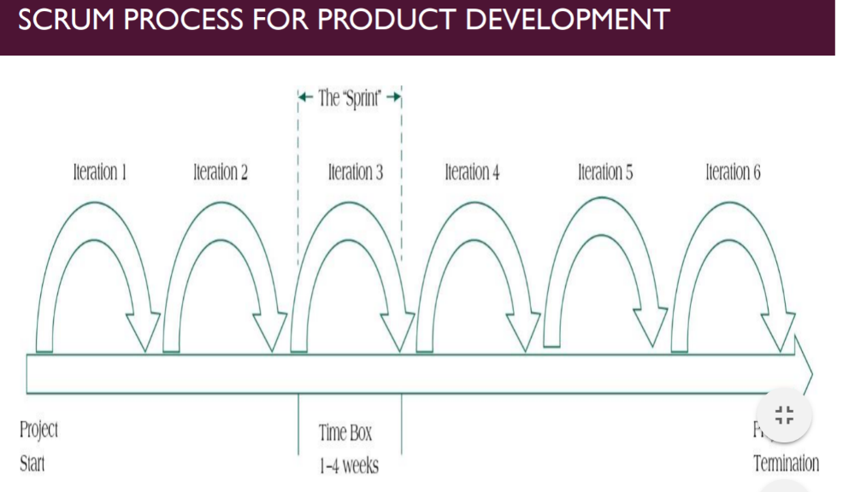

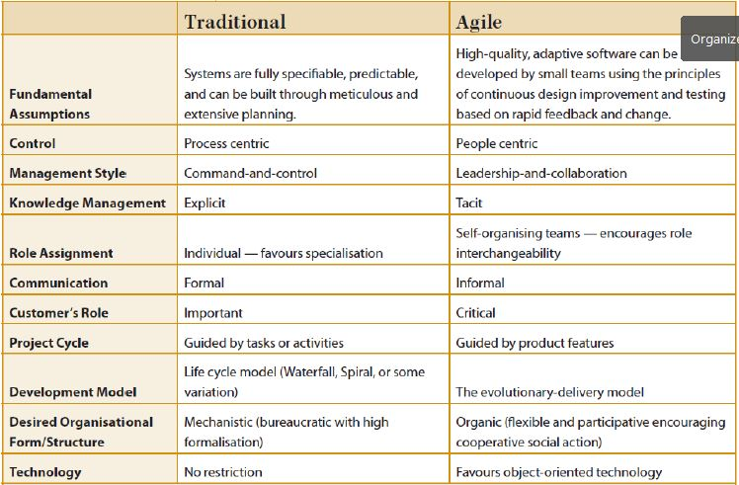
Traditional VS Agile Software Development:

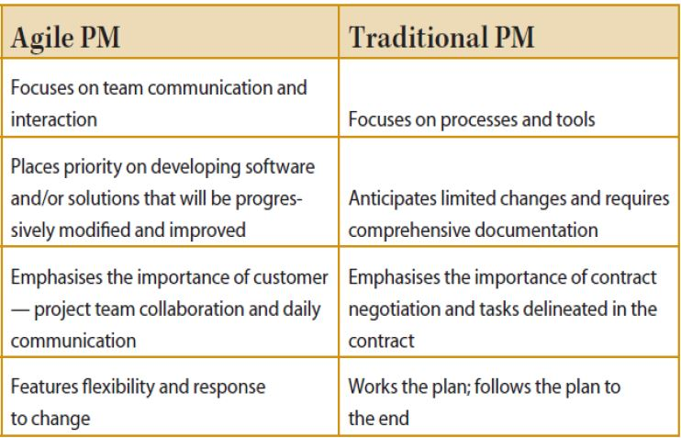

Problems with Agile:
- Active user involvement and close collaboration of the Scrum team are critical throughout the development cycle.
- Evolving requirements can lead to potential for scope creep.
- It is harder to predict at beginning what the end product will actually resemble.
- Requirements are kept to minimum, which can lead to confusion about final outcomes.
- Testing is integrated throughout lifecycle, which can add cost to project.
- Frequent delivery of project features puts a burden on product owners
- If it is misapplied to traditional projects, it can be an expensive approach without delivering benefits.
EXECUTION
Resource management:
- Plan human resource management: The process of identifying and documenting project roles, responsibilities, and required skills, reporting relationships and creating a staffing management plan.
- Acquire project team: The process of confirming human resource availability and obtain the team necessary to complete project assignments.
- Develop project team: The process of improving the competencies, team interaction, and the overall team environment to enhance project performance.
- Manage project team: The process of tracking team member performance, providing feedback, resolving issues, and managing changes to optimize project performance.
Reasons why teams fail:
- Poorly defined project team roles & interdependencies
- Lack of project team motivation
- Poor communication
- Poor Leadership
- Turnover among project team members
- Dysfunctional behavior
Stages in Group Development (The PMI Ladder):
- Forming – members become acquainted
- Storming – conflict begins
- Norming – members reach agreement
- Performing – members work together
- Adjourning – group disbands
Building high-Performing Teams:
- Make the project team tangible (Publicity – Terminology & Language)
- Reward good behavior (Flexibility – Creativity)
- Develop a personal touch (Lead by example – Positive feedback)
Resource Loading: Amount of work each individual in the project is scheduled to work.
Types of Constraints: Physical, Time, Resource and Mixed.
Resource Leveling: A process that address the complex challenges of project contraints.
- To determine the resource requirements so that they will be available at the right time
- To allow each activity to be scheduled with the smoothest possible transition across resource usage levels
Prioritization Rules for Leveling:
- Smallest amount of slack
- Smallest duration
- Lowest ID number (FCFS)
- Greatest number of successor tasks
- Requiring the most resources
KPI: key performance indication (used to measure performance across teams or projects or entire sectors and industries) For PMs, KPIs can be those specific measures for determining success on a project
MONITORING & CONTROLS
Project Scheduling: Requires us to follow some carefully laid-out steps, in order, for the schedule to take shape. “An output of a schedule model that presents linked activities with planned dates, durations, milestones and resources.”
Project Scheduling Terms:
Project Network Diagram: Any schematic display of the logical relationships of project activities.
Path: A sequence of activities defined by the project network logic.
Event: A point when an activity is either started or completed.
Node: One of the defining points of a network; a junction point joined to some or all of the other dependency lines (paths).
Critical Path: The path through project network with the longest duration
Critical Path Method: A network analysis technique used to determine the amount of schedule flexibility on logical network paths in project schedule network and to determine minimum project duration.
Forward Pass: Network Calculations to determine earliest start/earliest finish for an activity through working forward through each activity in network
Backward Pass: Network Calculations to determine late start/late finish…. network.
Predecessors: Those activities that must be completed prior to initiation of a later activity in network.
Successors: Activities that cannot be started until previous activities have been completed.
Early start (ES) date: The earliest date the uncompleted portions of an activity can start.
Late start (LS) date: The latest possible date that an activity may begin without delaying a specific milestone.
Float (Slack): The amount of time an activity may be delayed from its early start without delaying the finish of the project.
Resource-limited schedule: Start and finish dates reflect expected resource availability.
Burst Activity: An activity with two or more immediate successors.
Merge Activity: An activity with two or more immediate predecessors.
Concurrent Activities
PERT (Program Evaluation and Review Technique): Probability based and used in projects where task durations are hard to precise (Useful in R&D Projects)
CPM (Critical Path Method): Used to find how flexible is a project schedule, uses early and late start and finish dates.
- Used to plan very large projects
- Single time estimates for each activity
- Focus on longest sequence of activities
- Used to determine how to complete a project early
- Useful in construction industry
GANTT CHART: A Gantt chart is a type of bar chart that illustrates a project schedule. This chart lists the tasks to be performed on the vertical axis, and time intervals on the horizontal axis. The width of the horizontal bars in the graph shows the duration of each activity.
Benefits of GANTT Charts:

- Easy to comprehend
- Identify the schedule baseline network
- Allow for updating and control
- Identify resource needs
- Easy to create

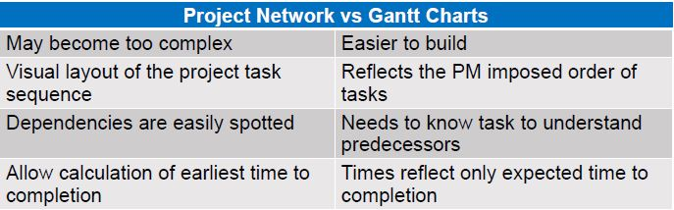

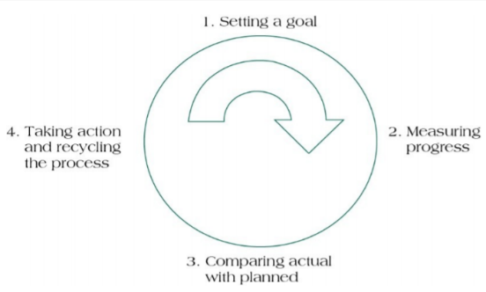
The project control cycle:

Milestones: are events or stages of the project that represent a significant accomplishment
- Signal completion of important steps
- Motivate team and suppliers
- Offer revelation points
- Help coordinate schedules
- Identify key review gates
- Signal other team members when their participation begins
- Delineate work packages
Earned Value Management (EVM): Recognizes that it is necessary to jointly consider the impact of time, cost, and project performance on any analysis of current project status.
Earned Value (EV): Directly links all three primary project success Metrics (cost, schedule, and performance)
CLOSING
Early Termination Decision Rules:
- Costs exceed business benefits
- Failure to meet strategic fit criteria
- Deadlines continue to be missed
- Technology evolves beyond the project’s scope

Project termination: 4 main reasons
- Extinction: the end of all activity on a project without extending it in some form
  - Project has successfully completed, or it has failed
- Addition: The project has been terminated, but its success has led to its addition to the organizational structure.
- Integration: The project’s resources, including the project team are reintegrated within the organization’s existing structure following the conclusion of the project
- Starvation: Can happen for various reasons, such as political, a placated sponsor or general budget cuts. (Decreasing the project budget to the point where the project cannot possibly remain viable.
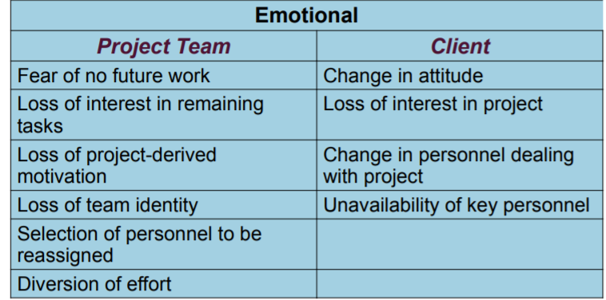

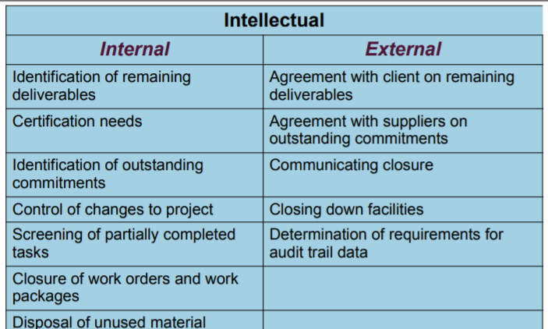

Lessons Learned:
Common errors:
- Misidentifying systematic errors
- Misapplying or misinterpreting lessons based on events
- Failure to pass along conclusions
Meeting guidelines:
- Establish clear rules of behaviour
- Describe objectively what occurred
- Fix the problem, not the blame
Benefit Analysis
Goals evaluation
TOP 10 SUCCESS FACTORS OF A PROJECT: *

- Project mission
- Top management and support
- Project plan and schedules
- Client consultation
- Personnel
- Technical tasks
- Client acceptance
- Monitoring and feedback
- Communicating channels
- Troubleshooting

Top 10 Signs of IT Project Failure:

- Best practices and lessons learned are ignored
- Project lacks people with appropriate skills
- Sponsorship is lost
- Users are resistant
- Deadlines are unrealistic
- Business needs change
- Chosen technology changes
- Project changes are poorly managed
- Scope is ill-defined
- Project managers don’t understand users’ needs

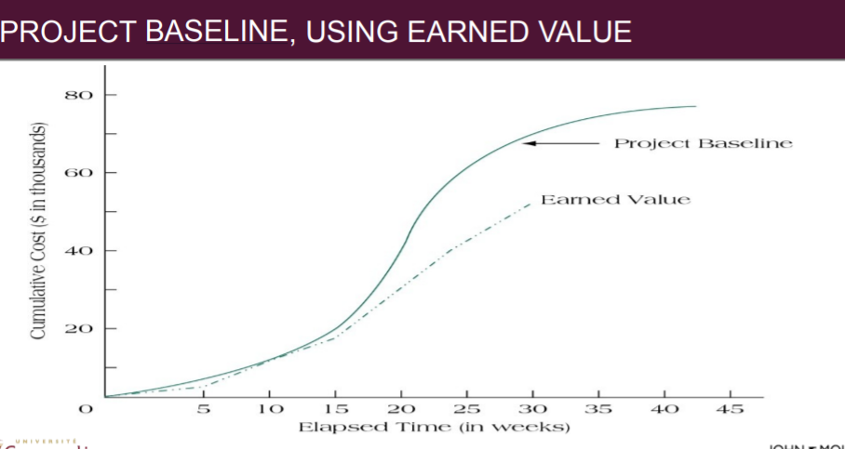

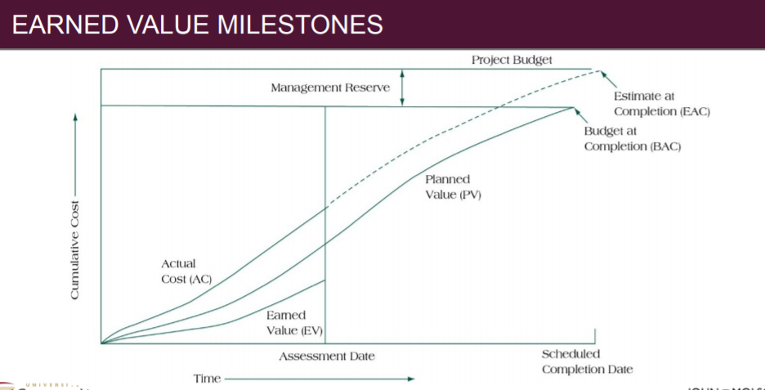

THE PMO
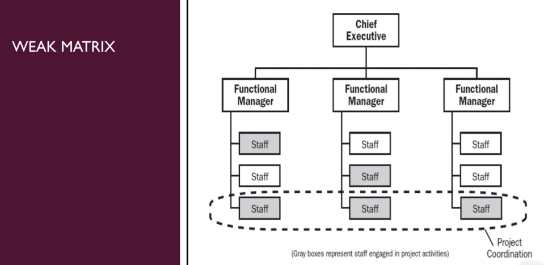
Organizational Matrix types:

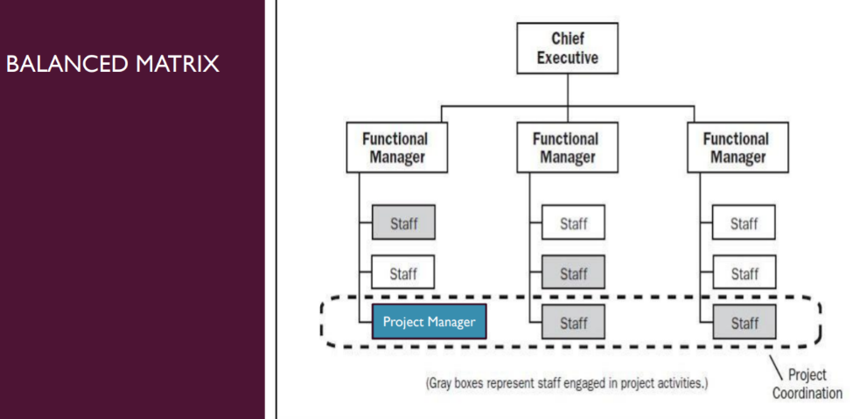

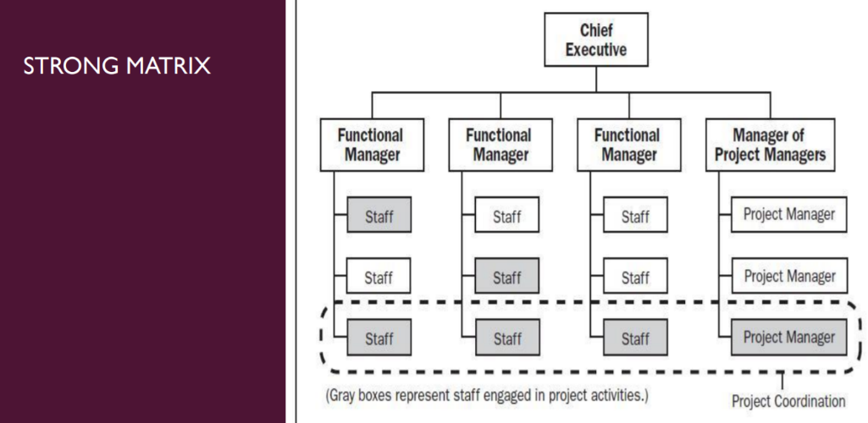

MAIN ROLE & RESPONSIBILITIES - the PMO
- Establishing project methodologies: Include providing a program baseline for implementation of a project. Including making an estimate of the size, time and recourses the project requires and lays down the project methodologies through many PMO tools and instruments.
- Project Charter: Provides an overall vision of the program goals and objectives.
- Work Plans: lay down detailed schedules of activities, milestones, and deliverables of the project team, and identifies the resources available.
- Governance Plan: Identifies the roles and responsibilities of each member of the project team.
- Work Breakdown Structure: Defines the specific deliverables due from each team member, at each stage of the project.
- Communication Plan: Establishes the protocol, procedure, and methods to communicate project information and issues among members of the team.
- Forms and Templates: Simplify Communication, record-keeping and reporting.
- Risk Analysis: Lists out potential problems and chances of deviance from the project methodology, the probability of such occurrences, the possible impact, and possible solutions.

- Project tracking:
- Auditing or Tracking ongoing projects at regular intervals
- Establishing a project management governance structure that includes KPIs and sets milestones
- Usually tracks projects in a three-step cycle
- Implementing corrective action
- Gather and archive project experience and reusable data to improve PM methods in the future

- Gathering of project data & production of information for management review
- Project support (Manage processes, negotiate & analyze, develop teams, provide training and in-house consultancy on project related issues)
- Resource management
- Manage and allocate accurately across projects.
- Train, mentor and coach employees in general and in particular project managers. (Regular Workshops and training programs)

- Managing and facilitating the portfolio management process
- Capturing project requests and ensuring each request has sufficient information to assess the project.
- Keeping an up-to-date repository of projects underway and requests pending review.
- Implementing scoring and prioritisation models to help assess which requests should be approved.
- Managing a resource capacity plan or resource forecast to help understand resource availability for projects.

- Source of guidance & advice for project manager

PMO Types:
- Supportive: Supportive PMO’s act as a repository to your organization’s projects. Generally, provides support in the form of on-demand expertise, templates, nest practices, access to information and expertise on other projects, and the like. This can work in an organization where projects are done successfully in a loosely controlled manner and where additional control is deemed unnecessary. (These have a very low degree of control in projects.) You can adopt this if your organization has a functional or weak matrix type.
  - In functional or weak matrix organizations, project managers have very little control. Functional managers manage virtually all activities, and the budget is under their sole control. Project managers are generally in project expedition or project coordinator roles. They collect, document and store the project activities in the organization’s assets library.
- Controlling: Controlling PMO’s act as the auditor of the company. They check whether organizational tools, processes, and standards are applied in projects. They have a moderate degree of control in projects, they are well suited to an organization with a balanced matrix model.
  - In balanced organizations, project control is shared among functional manager and project manager. They manage the project activities and budget together. Controlling PMO’s check whether the processes, tools, and standards are being applied or not. Corrective actions are taken in case of problem in application or efficiency of processes, tools, and standards.

- Directive: This type goes beyond control and actually “takes over” the projects by providing project management experience and resources to manage the project. As the name suggests, Directive PMO’s manage and have a high degree of control in projects. They are suitable for an organization that is a strong matrix or projection type.
  - In strong matrix or projectized organizations, the project manager controls the project. The ultimate authority in relation to the project lies with the project manager. Directive PMO’s take complete control of all the projects executed within the organization.

