Chapter 8: The Challenge of Multicultural Work Groups and Teams

Four Characteristics of Work Groups:

- Social systems that have boundaries with members who have different roles and are dependent on each other
- Have tasks to perform
- Need to deal with the relationship between individuals and the group
- Function within and as part of a larger organization

Three main types of work groups:
- Task forces: completion of a specific project, within a limited time frame; members are selected based on task-related skills
- Crews: focus on the tools required to perform a task (Ex. flight deck crews)
- Teams: sets of people who each have specific skills and abilities and who are provided with tools and procedures to address a teams tasks over a long period of time; focus on the interrelationships among the group members

Work Group Effectiveness

Effectiveness of a Work Group:
- Output of the group must meet the quantity, quality, timeliness standards of the organization (Task – performance outcomes)
- Process employed by the group should enhance the ability of the group members to work together (Satisfaction - process outcome)
- The group experience should contribute to the growth and personal well-being of the group members (Individual – learning/development)

Group Process Model

Six Variables to the Group Process Model:
- External and contextual conditions imposed on the group
- Resources of group members
- Structure of the group: prescribes the norms, role expectations, and status relationships shared by group members
- The group task
- The group process: how groups achieve their outcomes
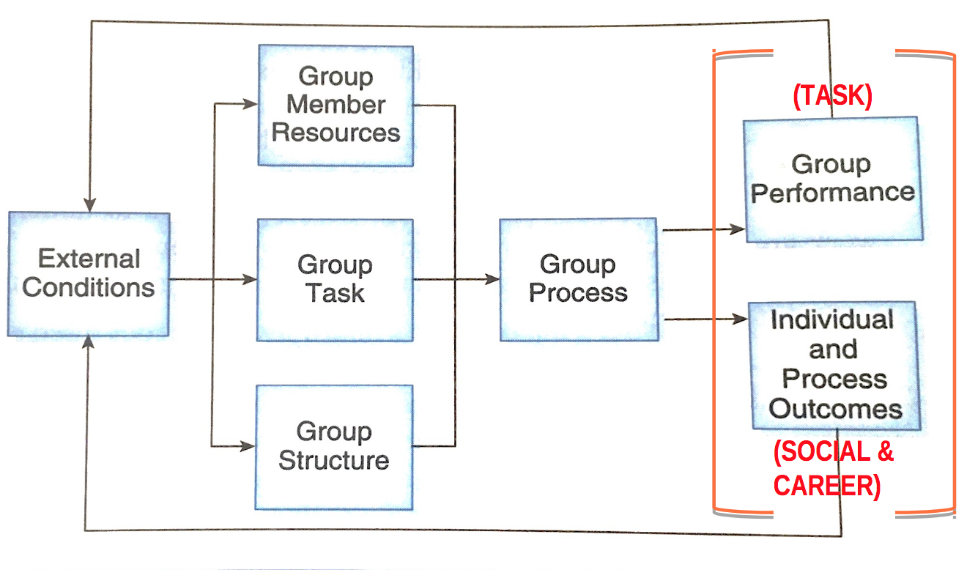
- Composition of the group

External Conditions
- Strategy of the organization
  - Work group status – high status groups increase feelings of self-worth and effectiveness for most cultures
  - Opportunities for self management – balancing sufficient direction and sense of empowerment
- Authority structures – HR policies
- Regulations

Resources of Group Members
- Personal attributes: personality, values, attributes
- Skills and abilities: technical and social
- Demographics (age, gender, nationality)
- Prior experience

Structure of the Group

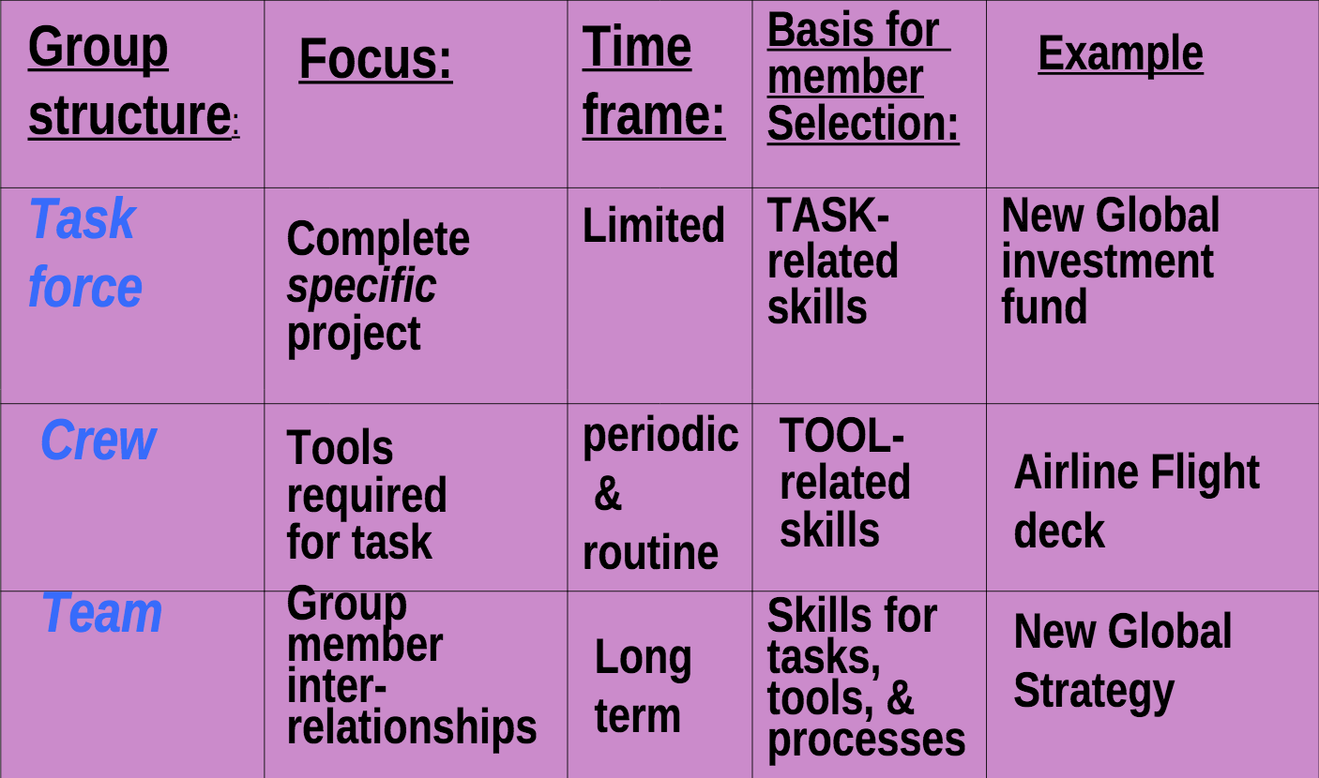

Effect of status systems in groups:
- Effect of a person’s status on his or her relationship with other group members
- The effect of a group members status on his or her evaluation by others
- The effect of status on a group members self esteem

Group Task
- Clearly defined production tasks (motor skills); Communication less important
- Cognitive or intellective tasks (problem-solving) – Rare
- Creative idea generation and decision making (reaching consensus) – Communication is critical

Group Process
Process Gain: positive synergy occurs (group effort > sum of individual efforts)
Process Loss: negative group process fails to meet its potential (Ex. groupthink and social loafing)
*Note: the effects of process losses and gains are not consistent across the life of the group*

Five Stages of Groups:
- Forming
- Storming
- Norming
- Performing
- Adjourning

Facilitators/Hindrances of Multicultural Groups’ Process Effectiveness:
- Task processes: clarify goals and roles; emphasize group members’ unique competencies
- Social processes
  - Communication
  - Negotiation/conflict management
  - Decision making

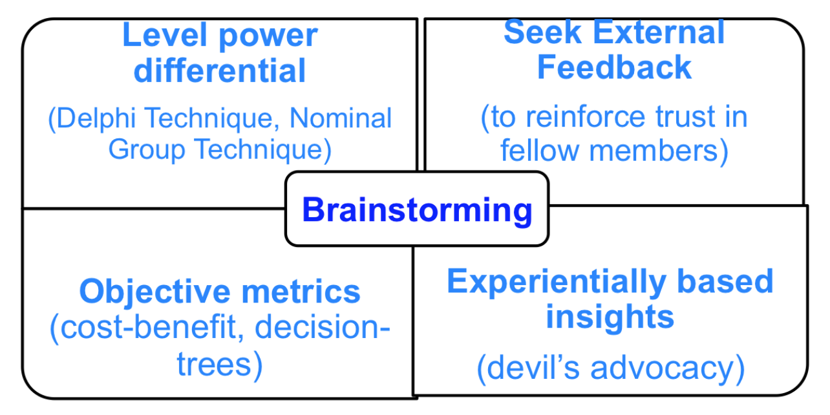

- Coordinating mechanism challenges
- Phase of group development

Composition of the Group
- Homogeneous
- Heterogeneous – high performance level but higher risk of process loss
  - Surface level diversity – gender, ethnicity
  - Deep level diversity – values and beliefs
- Minority-majority

Culture’s Influence on Work Groups

Three general mechanisms:
- Cultural norms: the orientations of the specific cultures represented in the group toward the functioning groups
- Cultural Diversity: the number of different cultures represented in the group
- Culturally diverse groups are more likely to have lower group performance and increased process losses
- Can develop cultural subgroups within the task group as a whole
- Faultlines develop when multiple demographic categories overlap
- Hybrid team culture: made up of selected norms of the group members; override the conflicting norms brought to the group by individuals
- Relative Cultural Distance: the extent to which group members are culturally different from each other
- The extent to which individuals were culturally different from other group members affects their assessments of group cohesiveness and satisfaction with the group process

Culture’s Effect on Different Group Structures and Tasks
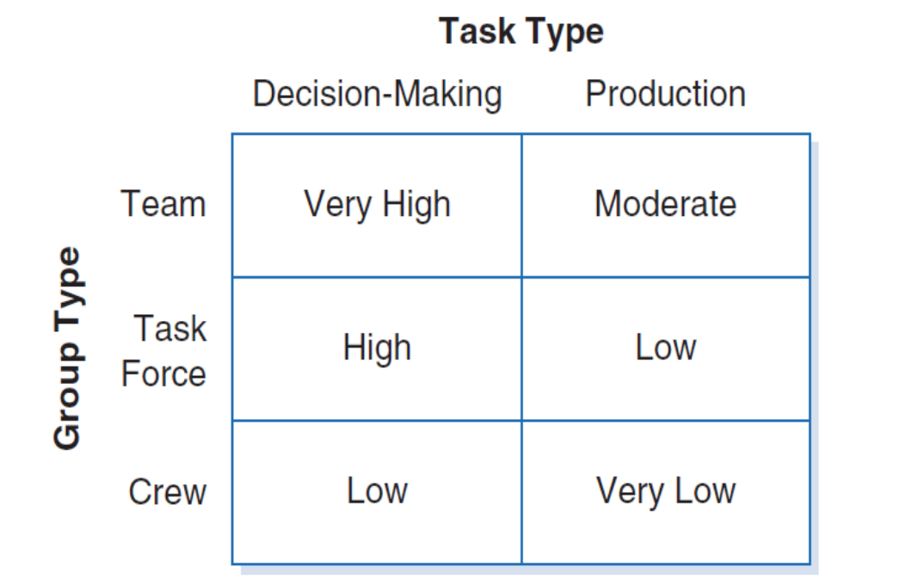

Global Virtual Teams

Advantages | Disadvantages
- No restrictions of time and space for working/hiring from home  - Non-visibility of surface level differences  - Less risk of bias due to appearance | - Asynchronous lag does not replicate face-to-face interaction  - Less natural and spontaneous interaction (& response to nonverbal)

Communication
- Affected by:
- The complexity or ambiguity of the task
- How easy or complex the media is to use
- Topic of conversation
- Goals of the parties communicating
- Communication takes place in an asynchronous manner, meaning there is a lag between one message being sent and another being received
- Electronically mediated groups tend to form slower
- Hinders openness of sharing information

Relationship Building and Conflict Management
- Affected by electronic intermediation and cultural diversity
- Lack of evidence of cultural diversity

Task Management
- Highly interdependent and urgent tasks require frequency
- The extent to which the task requires the exchange of tacit as opposed to explicit knowledge influences the characteristics of the interaction required among team members

Organizational Context and Culturally Diverse Work Groups

- Dominant characteristics of the organization influence the types of goals and methods that are acceptable for work groups

Key Factors that influence the ability of work groups to handle technological and geographic issues:
- Management support
  - Need to support diversity
  - Offer flexibility over control
  - Management support is positively related to task performance and work group attitudes
- Group-level rewards
  - Composition of rewards is influenced by the cultural composition of the work group
- Work group status
  - Being a member of a high-status group will increase members’ feelings of self-worth and effectiveness
  - The extent to which individuals from different cultures derive their self-esteem from work groups vary considerably
  - Collectivists are more likely to identify more strongly with their cultural or family groups than with strangers
- Training
  - Important when individuals can have different assumptions on how the work group should operate and when activities and tasks cannot be identified in advance
- Self management
  - If too much authority to the work group is delegated, work groups can charge off in inappropriate directions

Managing Multicultural Work Groups

- There is not universal prescription to apply to every multicultural work group

- Work Group Task and Structure
- Less structured tasks are more susceptible to process losses
- Cultural differences can be masked by production lines
- Broad evaluation criteria
- Multicultural work teams should be evaluated on task accomplishment, individual outcomes and group processes
- Multicultural groups take loner to reach their full potential
- Composition and task requirements
- Multicultural groups are very sensitive to the need for resources, including member resources
- The guiding principles for work group organization should be able to ensure that the work group has the task-related knowledge, skills, and abilities
- Common purpose
- Managers must be sensitive to calues, attitudes, and beliefs of culturally different work group members

Chapter 9: The Challenge of International Organizations

Organizations: social systems that are both intentionally structured to achieve goals and spontaneously develop apart from managerial intent
- Not independent of their surroundings but are open systems that continuously take inputs from the environment, such as raw materials, human resources, and ideas, transform them, and the exchange output with the environment in the form of products, services, or more resources

Structure: the degree of complexity, formalization, and centralization
- Complexity: the degree to which it is differentiated along three dimensions: horizontal, vertical, and spatial
- Horizontal: different types of jobs that exist in an organization
- Vertical: number of levels
- Spatial: the extent to which the organization’s physical facilities and personnel are dispersed
- Formalization: the extent to which rules and procedures govern the activities of organizational models
- Centralization: the extent to which decision making is concentrated at a single point

Approaches to coordinating organizations:
- Mutual adjustment – relies on organizational norms, colleagues, and subordinates own judgment to observe what others and doing and coordinate work
- Direct supervision – rely on supervision and judgment of others
- Standardization of work processes – extensive use of detailed written rules and procedures
- Standardization of outputs - specify goals
- Standardization of skills - rely on employee’s self guidance

5 Parts of Organizations:
- Operating core – basic tasks relating to the production of goods and services
- Middle line – managers who connect operating core to the strategic apex
- Support staff – provide advice, internal consulting, and other indirect support services
- Influential in Adhocracy: composed of highly skilled professionals who are organized into a variety of temporary, overlapping teams; depends on mutual adjustment
- Technostructure – technical analysts (Ex. accountants, engineers) responsible for formulating the procedures to standardize the work that is done by the operating core; strongest influence in machine bureaucracy
- Strategic apex- top-level managers who have overall responsibility for the organization (Ex. born global firms)

Ecological Theories: focus on strategies, structures, and management of whole populations or organizations, such as industries
- The environment determines organizational structure by selecting out those organizations that do not fit
- Actions by managers have little effect
Institutional Theories: the ways that organizations in shared environments come to adopt similar structures that are reinforced in interactions with other organizations; was developed to explain globalization
- Explains the structural similarity (isomorphism) that exists across organizations within an industry (Ex. hospitals, banks)
- Two factors influence organizational structure:
- Effect of environmental agents (Ex. professional societies and consulting firms)
- Processes within the firm that interpret certain externally validated structures as appropriate

Three categories of environmental pressures towards institutional isomorphism:
- Coercive isomorphism – imposed by outside authority (Ex. government)
- Normative isomorphism – professional bodies promote “proper” structure
- Mimetic isomorphism – copy the structure of firms that have been successful

Culture and Organizational Structure

Culture-Free Perspective:
- Considers culture irrelevant
- The design of the organization must fit with their size, technology, and strategy, regardless of culture
- Insight in terms of very general structural configurations
- Larger organizations tend to be more formalized, specialized, and less centralized

Structural Variation Across Cultures
Two mechanisms by which national culture influences organizational structure:
- Symptom of the management group’s cultural background
- National culture competes with the global forces to influence the extent to which different ways of organizing are accepted by the members of a society

- Organizational structure is less the product of conscious design than it is a reflection of the structures that society will accept as legitimate
- Culture and societal institutions are inevitably linked

In summary, manager’s choices in organizational structure are influenced by:
- Deeply held value and beliefs that influence what seems normal in terms of organization
- Organizations are open systems influenced by pressures from the environment

Cultural Influence on Organizational Design
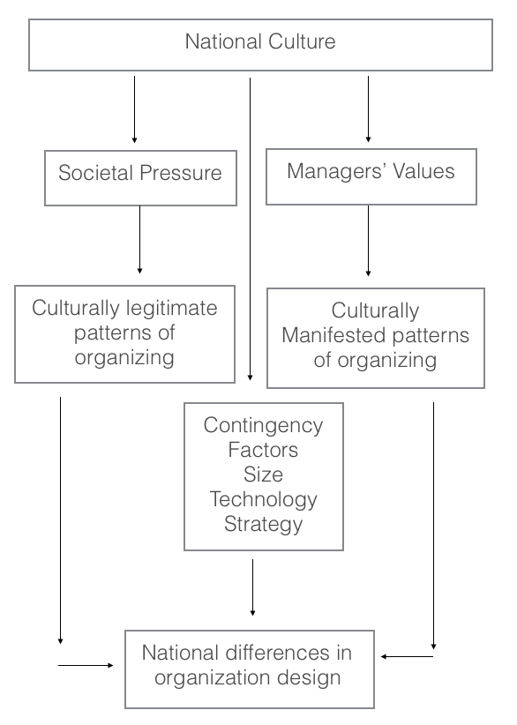

Informal Organization

Informal organization: refer to those elements of an organization that help to reduce individual variability in the behaviour of organization members but are not reflected in the formal organization chart

- Negative effects from culture can stem from the fact that organizational culture provides members with a set of behaviors that have served them well in the past
- Therefore, a strong organizational culture can be a barrier to change, can create conflict among subcultures, and make it difficult to merge smoothly

Five Dimensions of Organizational Cultures:
- Autonomy
- External orientation
- Interdepartmental coordination
- Human resources orientation
- Improvement orientation

Multinational Structures

- Requires broader organizational structure

Five ways of integrating international activity:
- International division – groups all international activities together
- Product division – all units involved with like products together around the world
- Functional division – expands its domestic functional units into its foreign counterparts based on geography
- Geographic division – all functional areas into geographic divisions – great deal of autonomy
- Matrix structure – each subsidiary reports to more than one group (product, geographic, or functional)

Organizational Characteristics | Multinational | Global | International | Transnational
Configuration of assets and capabilities | Decentralized and nationally self-sufficient | Centralized and globally scaled | Sources of core competencies centralized, others decentralized | Dispersed, interdependent, and specialized
Role of overseas operations | Sensing and exploiting local opportunities | Implementing parent company strategies | Adapting and leveraging parent company competencies | Differentiated contributions by national units to integrated worldwide operations
Development and diffusion of knowledge | Knowledge developed and retained within each unit | Knowledge developed and retained at the center | Knowledge developed at the center and transferred to overseas units | Knowledge developed jointly and shared worldwide

International Collaborative Alliances

- Choices based on task-related activities

3 types:
- Informal cooperative alliance – no contractual agreement
- Formal cooperative alliance – contractual agreement; broader environment
- International joint ventures – separate legal entities with joint ownership

International Mergers and Acquisitions

Double-layered acculturation: organizations must align both organizational and national cultures

Three preferences for integration:
- Absorbers
- Imperialists
- Preservers

Social Integration Mechanisms:
- Informal control
- Personnel rotation
- Training programs
- Cross-unit teams

- Outcomes of cross-border M&A depend not on whether the cultures are different, but on the nature and extent of culture differences and more important, on strategic intent, integration approach, and specific interventions chosen to manage the integration of the two entities across borders

MNO Subsidiary Structure

Pressures for consistency among subsidiaries in the international firm stem from 2 factors:
- Organizational replication: the tendency of the firm to duplicate, in new environments, existing structures and procedures that are effective
- Imperative for control: suggests that standardization of policies is used to reduce the complexity and uncertainty inherent in the control of international operations

- Constant battle between pressure for isomorphism with the local environment and pressure for consistency within the multinational enterprise

Relationship of the MNO to its Members

Two lenses have been used to examine the relationship of individuals to multinational organizations:

- Managerial Roles in MNOs – emphasis that managers place on different roles can be more susceptible to cultural influence
- Perceived role stress was found to be more heavily influenced by national culture than by personal or organizational factors
- Psychological contract: individual beliefs or perception concerning the terms of the exchange relationship between the individual and the organization (Ex. performance requirements, job security, training, compensation, and career development)
Transactional Contracts: emphasize specific, short-term, monetary obligations (Ex. payment for services provided by employees)
    - Require only limited involvement of the parties
Relational Contracts: emphasize broad, long-term, socioemotional obligations (Ex. commitment and loyalty)
    - Fundamentally tied to how people view themselves
- Cultural differences will exist in terms of the extent to which social cures are important in defining the contract, the extent to which characteristics of the contract are shared among organization members, and the extent to which the contract with the employer is perceived as transactional or relational
- Individualists would be more transactional and collectivists would be more relational
- Cultural variability can influence what is perceived as a violation of the contract and how such violation develops

