September 10th Lecture

Chapter 1: The Challenges of Organizational Communication

Challenges in our complicated world
- Globalization: from an economic viewpoint: going beyond national to do business with international companies, how in the long run can you succeed? Reality of the world, diversity, how to communicate with people with different cultures, religions
- Terrorism
- Climate change
- Changing demographics

Meeting these challenges
- Complication our thinking about organizations
- Complicating our thinking about communication

External challenges: things you don't have any control on
Internal challenges: what is happening within your company
Individual challenges: how do you relate?

Complication Thinking about Communication
Craig proposed seven domains of communication theory:
- Rhetorical: literal
- Semiotic: symbolic
- Phenomenological: science of study, ask, listen, understand, stories
- Cybernetic: systemic ways to communicate,
- Socio-psychological: observing, pay attention to environment, common sense, open your eyes
- Sociocultural: what works what doesn't , see what people do, how do they dress? Organization's culture? What kind of collective mental programming everyone has ? artifacts? Norms? Expectations? rituals , traditions?
- Critical: engaging in dialogue, you need to questions, policies regulations, justifications

Complication thinking about Organizations
Organizations have critical features:
- Existence of social collectivity
- Organizational and individual goals
- Coordinating activity
- Organizational structure
- Embedding of organization in environment ; need to stretch understanding

Communication styles ]
Effective: came here for one thing and one thing only I am doing what I came here for, with a goal in mind Vs. Instrumental: came with a goal but will judge my audience and decide

Best listening style: Active listening style; for the sake of understanding, not to criticize or debate, don't think of what you are going to say or do next, just listen.

Basic communication model:
SSCML, there is a source, receiver, a message, how you decode the message is up to you, how everyone interprets the message is different

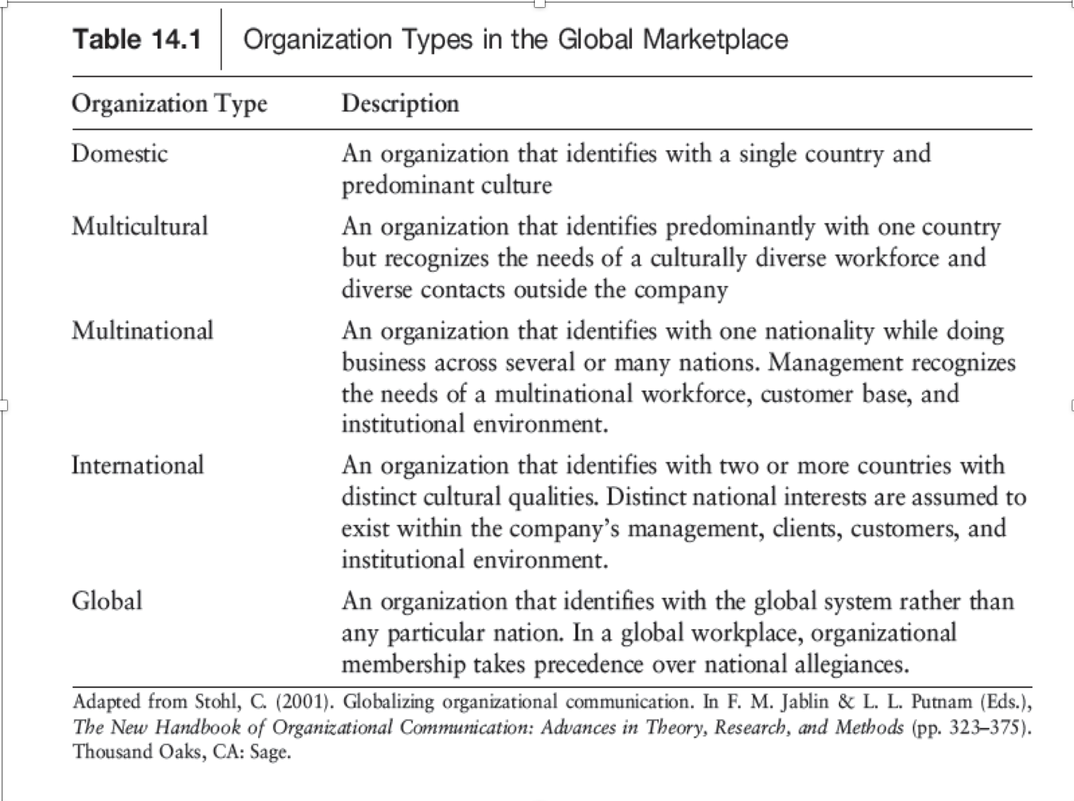

Many organizational types today not often considered in past
- Nonprofit organizations: not just there to contribute or make money, creating value, CSR, Stakeholders perspective, doing good, legal, economical, for profit organizations are the opposite
- Service organizations
- Non Governmental organizations
- Cooperatives
- Virtual organizations
- Social organizations

Domestic organization works within your city, local, what do people want in ottawa?
Multicultural organizations focuses mainly on your own but is sensitive to other cultures, diversity
Multinational: identified by one country but operates in different countries
International company: two or more countries involved
Global organizations: global

3 categories of diversity
- Demographics
- Psychographics
- Differences of skills and abilities: what makes us different

Chapter 2: Classical Approaches

Machine Metaphor: The guiding metaphor for classical approaches. Proponents of this metaphor argue that organizations are like machines because of the principles of specialization, standardization, replaceability, and predictability.
Major Classical Theories
- The theory of classical Management (Fayol):
- Considered to be the father of operational management theory.
- The core of his work helps to divide organizations into fictional units via:
- 5 Elements of management (what managers should do)
- 6 principles of management (how managers should apply these elements)
- Principles of organizational Power, Rewards, Attitudes

- The theory Bureaucracy (Weber)
- Clearly defined hierarchy of control
- Division of labour
- Centralization of decision making and power OR vertical coordination of authority
- Explicit set of rules
- Thorough training in a field of specialization
- A job as ones primary activity
- Written documentation/ file keeping
- Weber's type of authority: Traditional, Charismatic, Rational-legal

3) The theory of Scientific Management (Taylor)
- There is one best way to do every job
- The proper fit of the worker to the job is important and workers should be selected accordingly
- The proper fit of the world to the job requires training
- There is an inherent difference between management and workers

Communication in Classical Approaches
- Content of communication - task oriented
- Direction of communication flow - vertical (top-down) : people who sit at the top make most of the decisions, unity of command: one boss, one superior giving demands
- Mode/channel of communication - written
- Style of communication - formal

Classical Structure in Today’s Organizations
- Division of labour and strict hierarchy
- Military organizations
- Manufacturing and service organizations
- Non Profit organizations

Not all organizations use Classical Structure
- Division of labour blurred
- Cross-functional teams
- Matrixing of tasks
- Freer flow of communication

Classical Job Design and Rewards in today’s Organizations
- Often looking for one best way to accomplish tasks
- Fitting the job to the individual
- Concerned with rôle of financial rewards in motivation

Chapter 3: Human Relations and Human Resources Approaches

The Human Relations Approach (family metaphor):
- The Hawthorne
  - Studies: a series of research investigations in the late 1920s and early 1930s that served as a springboard to the human relations movement.
  - Studies included 4 phases: the illuminations of studies, the relay assembly test room studies, the interview program, and the bank wiring room studies
  - Hawthorne Effect: the influence of mere attention on changes in behaviour. This helped to bring attention to social factors, management style, satisfaction of human needs, the influence performance

- Maslow’s Hierarchy of Needs

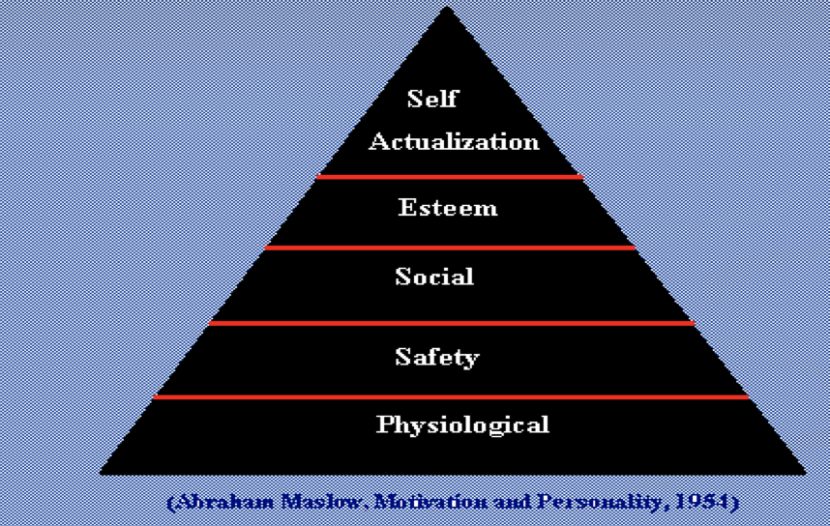

- McGregor's Theory X and Y:
Managers can have different kinds of assumptions about workers that will influence managerial behaviour

Communication in Human Relations Approaches
- Content of communication: Task and social
- Direction of communication Flow: vertical and horizontal
- Channel of communication: often F-T-F
- Style of communication: Informal

The human resources approach:
- Combines aspects of classical and human relations approaches
- ORG WORK + IND. FEELINGS = HUMAN RELATIONS APPROACH
- Emphasis on cognitive processes

Blake and Mouton’s Managerial Grid
- Improvised management
- Country club management
- Middle of the road management
- Authority - compliance management
- Team management

Likert’s System IV:
- Exploitive authoritative
- Benevolent authoritative
- Consultative organization
- Participative organization

Communications in Classical, Human Relations, and Human Resources Organizations
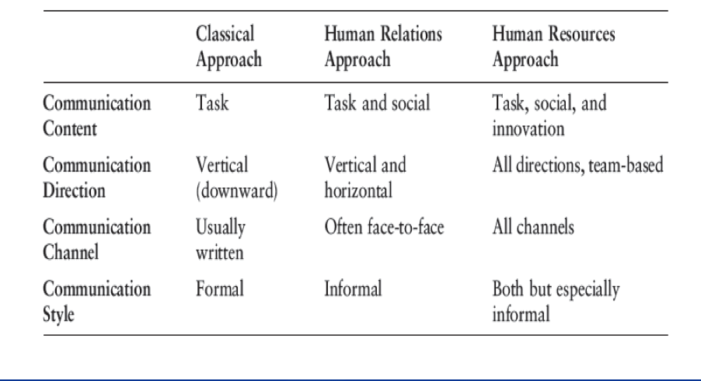

Chapter 4: Systems and Cultural Approaches September 17th

Systems Metaphor and Systems concepts

Systeme components:
- Hierarchical ordering
- Interdependence
- Permeable boundaries

System processes

Input-Throughput-Output Process
- Process of exchange
- Process of feedback
- Negative/corrective/deviation reduction feedback
- positive , growth or deviation amplifying feedback

Systems properties
- Holism; team, we are going to get through this together
- Equifinality
- Negative Entropy
- Requisite Variety: undertsnaidn 100% what is happening, no quick fix
Three Systems Theories
- Cybernetic systems theory: how can you have a focus? What goals do you want to achieve? Specific goals/by person
- Karl weick’s Theory of Organizing: “through communication cycles, organizational members introduce and react to ideas that help to make sense of the equivocal environment” ; context that determines how people will manage their goals
- New science systems theory: “New science systems are complex and adaptive systems in which order can emerge from disorder” ; alignment with chaos theory, environment is complicated, unpredictable but you can find order, how do we connect with people, how do we adjust
Cybernetics Theory
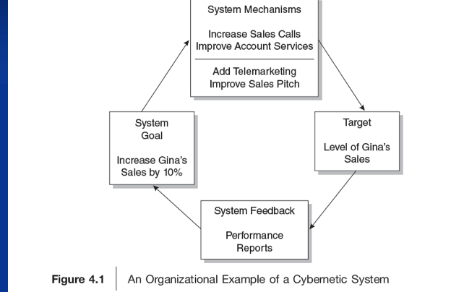

Wicks Model of Organizng

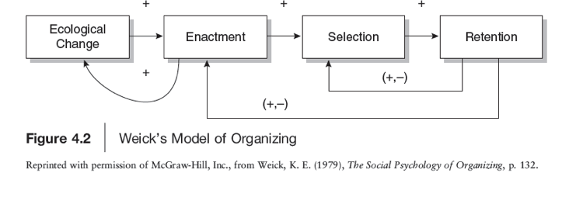
Methods for studying organizational systems
- Network analysis
- Modeling techniques
- Case studies

Prescriptive view of Culture
- Deal and Kennedy's “Strong Culture”
- Assumption: business success can be enhanced through the development of a strong culture
- Values are the beliefs and visions that members hold for an organization. For example, 3M Corporation espouses a value for innovation, whereas Prudential Insurance represents a value of stability.
- Heroes are the individuals who come to exemplify an organization’s values. These heroes become known through the stories and myths of an organization. For example, Bill Gates exemplifies entrepreneurship and philanthropy through his work at Microsoft and the foundation he directs with his wife, Melinda.
- Rites and rituals are the ceremonies through which an organization celebrates its values. An organization that values innovation may develop a ritualistic way of rewarding the new ideas of employees. In other organizations, rites and rituals might include a company picnic or an awards banquet for outstanding employees.
- Finally, the cultural network is the communication system through which cultural values are instituted and reinforced. The cultural network could consist of both formal organizatio

Peter and Waterman’s themes for organizational excellence cont...
- A bias for action
- Close relations to the customer
- Autonomy and entrepreneurship
- Productivity through people
- Hands on, value driven
- Stick to the knitting
- Simple forms, lean staff
- Simultaneous loose-tight properties

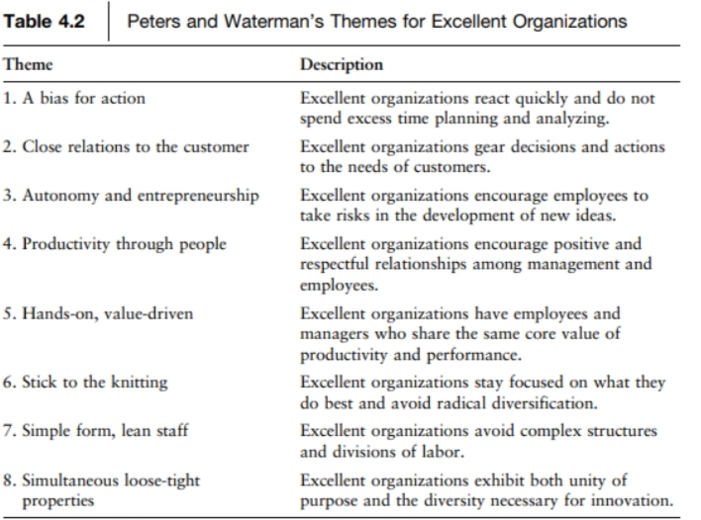

Alternative approaches to culture
- Organizational Cultures Are Complicated
- Organizational Cultures Are Emergent
- Organizational Cultures Are not Unitary
- Organizational Cultures Are Often Ambiguous

Schein's Model Of culture: The Onion Model
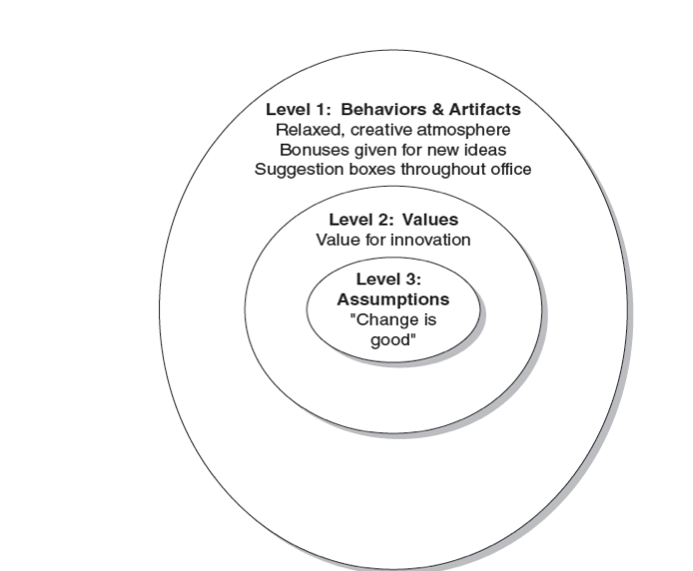

Ethnography: A research technique with the goal of representing a detailed depiction of a culture. Ethnographers attempt to minimize the distance between the researcher and the culture being studied using basic ethnographic techniques.

October 4th- Chapter 12 - Socialization Process

Models of Socialization
- Processes through which individuals adapt to organizational life are complicated
- Develop over span of time and involve organization members and activities

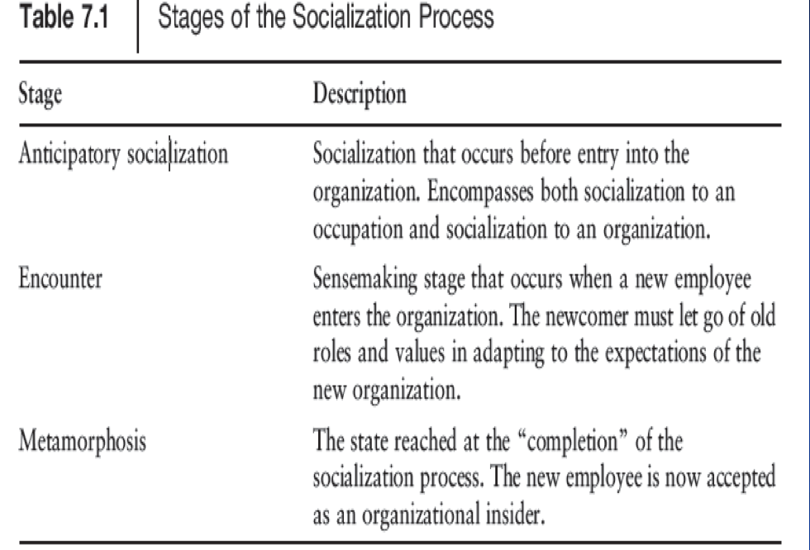

*Metamorphosis stage: people become very comfortable
You can't assume people know nothing, they are not blank slates

Content of Socialization: Louis - Two classes of information that must be grasped during socialization process
- Rôle related information
- Information about the organization

Mentoring: experienced employee to share their inside tactics tricks/tips, they have a king term focus on employee growth
Coaching: short term, no work related issues

Content of Socialization: Myers and Oetzel - Processes involved in socialization
- Developing familiarity with others
- Acculturation
- Feeling recognized by others
- Becoming involved
- Developing competency: investing in employees potential
- Rôle negotication

Acculturation: new employee coming in must learn what the job is about, how to fit in, habits
Holistic approach: people take time to change their habits

Show flexibility, understanding accommodating

Communication process during Assimilation/ Socialization
How you communicate will have an effect on how well your employees do
How proactive are your employees?
- The employment interview: Important step in anticipatory socialization process
- Interviewer is using interview to recruit and make decisions about recruits
- Applicant is using interview to find out more about the organization
- Point of first contact- socialization tool
- Situational questions means something that they cannot make up a hypothetical answer (ex, this happens: what are you doing now?)
- Interview can serve to ease newcomer’s adaptation to organization
- Funnel approach: general first, then very specific/difficult
- Inverted: specific/difficult first and then general
- Utilize time to make other feel comfortable
- Definitely ask questions, shows interest
- Newcomer information- seeking tactics
- 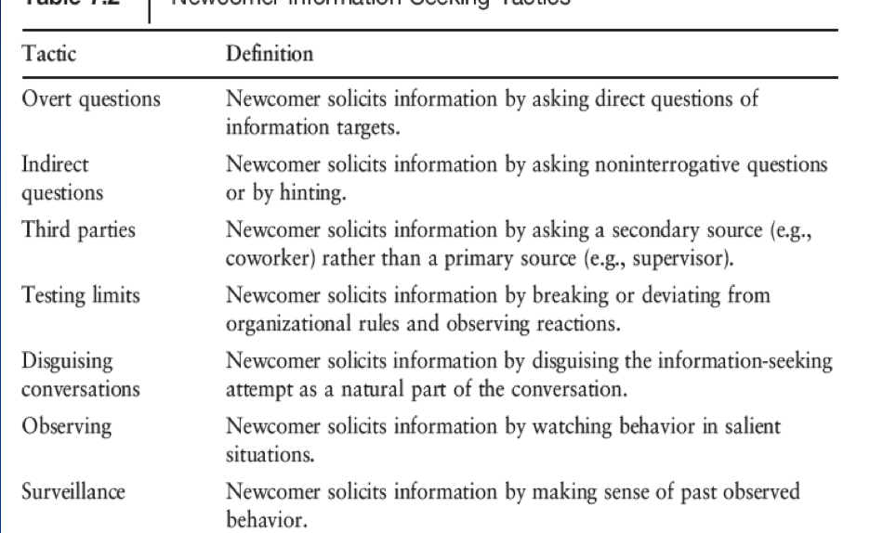
- Newcomers will test the limitations
- Rôle development Processes
- Graen- organizational mamebers accomplish their work through roles
- Individuals develop roles through interaction with others
- Supervisors-subordinate dyad is a critical in rôle development
- 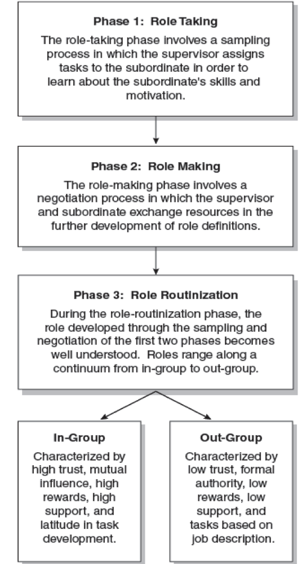
- Mentoring and orientation
- Organizational Exit
- Workers today more likely to make radical job switches
- Organizational exit process
- Influences those who leave and those who are left behind
- Organizational exist can have effects on families of those who have
- Communication plays rôle in disengagement process
- How you communicate in this disengagement process, will aid in how the company continues
- Handle situation really well
Socialization is about learning and adapting

Chapter 8: Decision Making Process
Some points to remember

Centralized VS. Decentralized decision making
Well structured VS. Ill Structured problems
Perfect VS. Bounded Rationality

Bounded Rationality: because it is not possible to make the ideal rational solution. Rather, organizational decision makers are characterized by bounded rationality. That is, decision makers attempt to make logical decisions, but they are limited cognitively (e.g., humans are not always perfectly logical) and by the practical aspects of organizational life (e.g., limits in time and resources).

Rational Decision Making Model

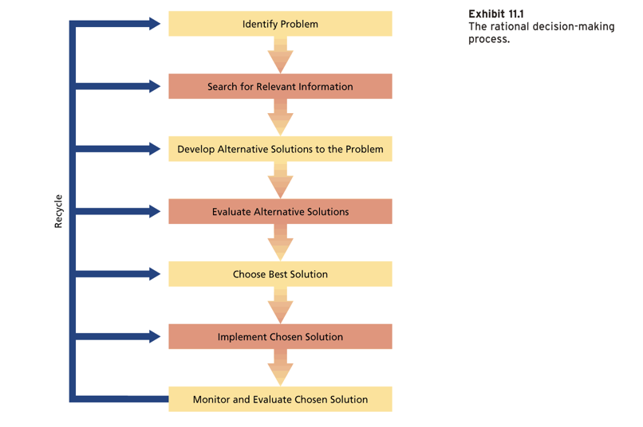

Alternatives to Rational Models:
Maximisation or Optimization:in which decision makers are attempting to find the single best solution to an organizational problem
Anchoring Effect: relying too heavily on on piece of information to make a decision
Satisficing process: in which the search is not for a single optimal solution but for a solution that will work well enough for dealing with the situation.
Intuitive processes/Experiential-based process: proposed that a great deal of organizational decision making can be attributed to the intuitive processes
Garbage can model: The garbage can model is a theory within the science of public administration that explains organizational decision making from a systemic-anarchic perspective. Decision-making is accidental and is the product of problems and solutions that get associated randomly.

Common Decision making techniques
- Delphi technique: method which relies on a panel of experts. The experts answer questionnaires in two or more rounds. After each round, a facilitator or change agent provides an anonymised summary of the experts' forecasts from the previous round as well as the reasons they provided for their judgments
- Nominal group technique: The nominal group technique is a group process involving problem identification, solution generation, and decision making. It can be used in groups of many sizes, who want to make their decision quickly, as by a vote, but want everyone's opinions taken into account. The method of tallying is the difference. First, every member of the group gives their view of the solution, with a short explanation. Then, duplicate solutions are eliminated from the list of all solutions, and the members proceed to rank the solutions, 1st, 2nd, 3rd, 4th, and so on.
- Brainstorming
- Pareto analysis: formal technique useful where many possible courses of action are competing for attention. In essence, the problem-solver estimates the benefit delivered by each action, then selects a number of the most effective actions that deliver a total benefit reasonably close to the maximal possible one.
- Decision trees/ PMI: formal technique useful where many possible courses of action are competing for attention. In essence, the problem-solver estimates the benefit delivered by each action, then selects a number of the most effective actions that deliver a total benefit reasonably close to the maximal possible one.
- Cost-Benefit analysis

Influences on decision making
- Organizational culture
- Nature of the problem
- Competencies of skills
- Process issues
- Selected technique/methods

Small group decision making:
Phased models
Fishers phase model:
- Orientation phase: members are acquainted with each other and the problem
- Conflict Phase: possible solutions are presented and debated
- Emergence phase: some level of consensus
- Reinforcement phase: decision supported
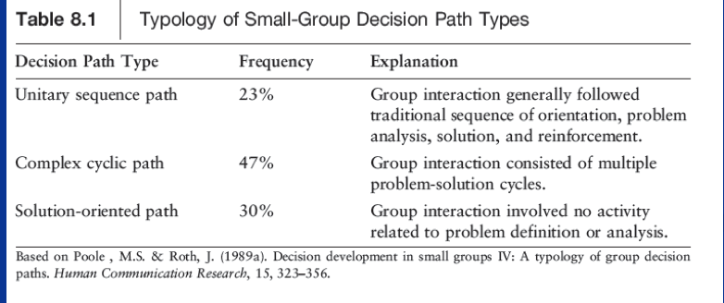

Groupthink and its symptoms: the practice of thinking or making decisions as a group in a way that discourages creativity or individual responsibility.

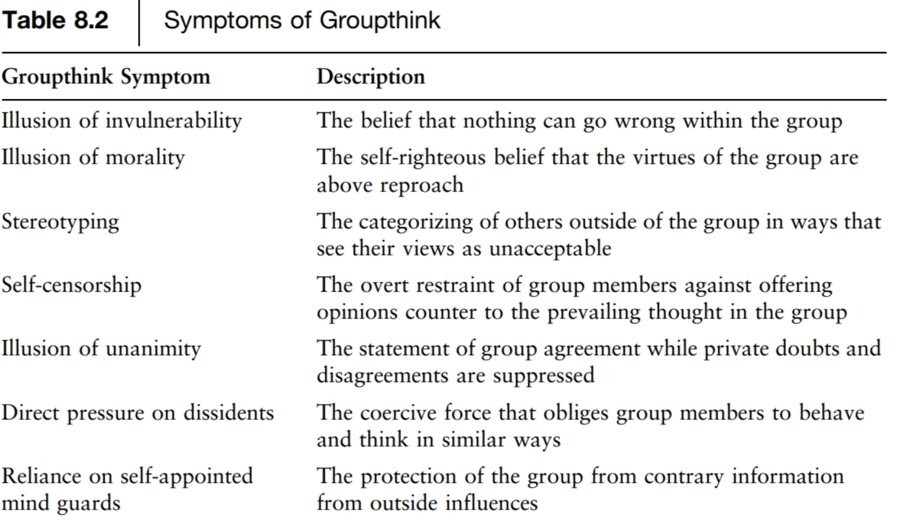
Group Decision Making:
Factors Enhancing group decision making:
- Positive social interdependence
- Positive and promotive interaction
- Individual accountability
- Social skills
Distributed power and participative leadership
Low-quality decisions can results from:
- Improper assessment,
- Flawed information base
- Faulty reasoning

Additional Factors hindering group decision making
- Relying too much on expert information
- Social loafing/Free riding/Sucker effect
- Defensive avoidance and group think
- Conflicting goals/Lack of individual incentives
- Lack of sufficient heterogeneity
- Lack of group maturity/relevant skills
- Inappropriate group size
- Premature closure
- Overestimating/underestimating the value of information received
- Prolonged deliberation about the chosen decision

Guidelines to group decision making:
- Correct understanding of issues & Gathering information
- Look at potential causes & Verify your understanding of the problem
- Understand your role & Identify alternative approaches
- Rate the risk of each alternative & Select one best approach with shared agreement
- Planning, implementation & Monitor implementation of the plan
- Verify if the problem has been resolved or not
- Modify or continue with the approach

Knowledge Management Systems:
Explicit Knowledge: Explicit knowledge is knowledge that can be readily articulated, codified, accessed and verbalized
Tacit knowledge: tacit knowledge is the kind of knowledge that is difficult to transfer to another person by means of writing it down or verbalizing it

A successful system can convert tacit knowledge into explicit knowledge and finds ways to make codified knowledge meaningful

Chapter 9: Changes and Leadership Processes in Organizations”
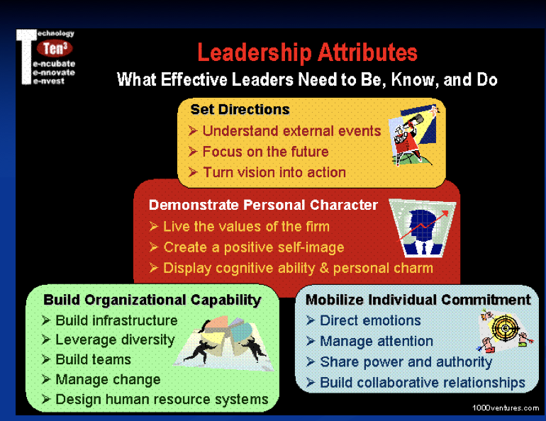

History of Leadership Theory:
- The Trait Era: late 1800s to mid 1940s
- Behavioural Era: Mid-1940s to early 1970s
- The Contingency Era: Early 1960s to present
- Rational Planning Models (E.G., MBO, MBR, SWOT, PPBS)
- Emergent Influences

Theories of leadership:
- Great man theory (evolved into trait theory): can be largely explained by the impact of great men, or heroes; highly influential individuals who, due to either their personal charisma, intelligence, wisdom, or political skill used their power in a way that had a decisive historical impact
- Behavioural theory of leadership: Behavioral theories of leadership are classified as such because they focus on the study of specific behaviors of a leader.
- Contingency Theory of Leadership (situational theory): A contingency theory is an organizational theory that claims that there is no best way to organize a corporation, to lead a company, or to make decisions. Instead, the optimal course of action is contingent upon the internal and external situation
- House path - goal theory (concerned with the leader behaviour): subordinates --------- path --------- goal - define goals, clarifies paths, removes obstacles, provides support

Specific kinds of leader behaviour: directive, supportive, participative, achievement oriented

Leadership Styles:
- Authoritarian(autocratic)
- Participative(democratic)
- Delegative(Laissez-faire)
- Machiavellian(unethical)
- Charismatic(inspirational)
- Transactional(result-oriented)
- Transformational(vision-builders)
- Developmental(constructive)
- Strategic(future-oriented)
- Global(empathetic)
10 Unnatural Traits of a Leader/Administrator:
- Refuse to be a prisoner of experience
- Expose your vulnerabilities
- Acknowledge your shadow side
- Develop a right-versus-right decision-making mentality
- Create teams that create discomfort
- Trust others before they earn it
- Coach and teach rather than lead and inspire
- Connect instead of create
- Give up some control
- Challenge the conventional wisdom
Organizational Change
- Forms of change: radical and incremental
- Types of change: planned, unplanned
Lewin’s three step Process to Organizational Change:
- Unfreezing
- Changing
- Refreezing
Forces for Change:
- Workforce
- Technology
- Economic shocks
- Competition
- Social Trends
- World politics
Common Change strategies Used in Organizations
- Force coercion strategy: This strategy uses power bases of legitimacy, rewards and punishments as primary inducements to change.
- Rational persuasion strategy: is exactly what it sounds like: without making threats, misusing your position, or ingratiating yourself to your team members, you present a logical, well-reasoned explanation of why you believe your idea represents the best option in a particular situation
- Shared Power strategy: engages people in a collaborative process of identifying values, assumptions, and goals from which support for change will naturally emerge
Why people resist Change
- Fear of the unknown.
- Lack of good information.
- Unclear goals and unrealistic expectations
- Lack of resources, training, management support
- Lack of ownership
- Inconsistent actions by the top managers
- Fear for loss of power.
- Bad timing, poor interpersonal relationships.
- No reason to change, Habit.
Managerial strategies for communicating about change
- Spray and Pray
- Tell and Sell
- Underscore and Explore
- Identify and Replay
- Withhold and Uphold

Chapter 10
Conflict and Stress in organizations
Modes of conflict
Types and levels of conflicts:
- Task conflicts: in regards to job requirements
- Process conflicts: how team is working towards goal
- Interpersonal conflicts: difficulty getting along, you don't like other person, because of relationships
Conflict Myths: not all bad, not a sign of poor interpersonal communication, diversity of opinions The ability to separate problem itself from opinions

Phases of organizational conflict FINAL EXAM
- Latent conflict: phase where you have to acknowledge the pre existing factors, incompatibility, something causing,
- Perceived conflict: frustration
- Felt conflict: both parties know that the conflict is affecting them personally, they are struggling
- Manifest conflict: resolution conflict management phase, approach the conflict, resolve, communicate
- Conflict Aftermath: evaluate the effects, follow up with parties

Causes of organizational conflict
- Personality , differences, disagreements and unrealistic expectations
- Stereotypes, prejudices
- Perceptual biases, self- fulfilling prophecies
- Intergroup biases and group norms
- Dependancy or scarcity of resources
- Power imbalances
- Ambiguous goals, jurisdictions or performance criteria
- Lack of support
- Triggering events

Conflict Dynamics
- Focus on winning: you don't wanna do this focus on keeping relationship
- Distorted information: be assertive, let people know what you want
- Group cohesiveness increases:
- Negative stereotypes of outsiders
- Emergent leaders: aggressive, vocal, strong people tend to become leader by default

Strategies for managing conflicts of interest
- Forcing: the shark image
- Withdrawal: turtle image
- Smoothing: teddy bear image
- Compromising: the fox image
- Problem solving: the owl image
Competing, collaborating, compromising: give and take, both parties have to give up something for something else avoiding, accommodating

Managing Conflict through Negotiation
- Distributive Negotiation tactics: threats and promises, persuasion and debate, self interest, personal goals, win-lose frame
- Integrative Negotiation Tactics: informative exchange, framing differences as opportunities, cutting costs and increasing resources, introducing superordinate goals
- Third Party Involvement: Mediation: less formal, no decisions, cannot inform solution, can impose an informal solution if parties agree and arbitration, conciliation: work with what court gave you then come back

Conflict Management Skills
- Manage emotions and your face
- Manage information: listening
- Manage goals: what can we do
- Manage the problem : evaluating

Chapter 11 Processes of Emotion in the workplace

Four factors
1.Culture
2.Gender
3. Rôle at organization
4.Social customs

Canadians are pretty neutral

Emotions as Part of the Job: Key terminologies
- Emotional labour: some people can’t “act”, surface level acting, follow rules and guidelines to display certain emotions
- Emotional Dissonance: related to emotional labour, you might feel happy or anxious about what you are doing is not consistent
- Emotional exhaustion: just so tired, i'm so done, emotionally exhausted
- Emotional support: certain people available, counselling services, talk about feelings, creating an environment where you feel as though you are cared about

Communication, empathy, burnout
- Emotional Contagion (feeling with another): emotions are contagious,
- Empathetic concern (feeling for another): you have to show concern, feel for them not feel with them
When it comes to managing yours and others emotions always feel with them.

Aspects of Work Relationship that Create Potential for emotions
- Tension between public and private: balance between obligations and friends
- Relational Networks and Emotional buzzing: how people are connected through different events, informal networks,
- Conflicting loyalties
- Emotional Rights and Obligations at work

Emotion Display Rules, Emotional Intelligence
- Express emotions in a professional manner
- Express emotions to improve situations
- Express emotions to the right people
- Express emotions to help individuals
- Express emotions for collective good not for personal benefits
- The expression of certain emotions is always inappropriate

Skills for recognizing and sharing emotions
- Skills for dealing with others emotions
- Suggestions for expressions and managing your own emotions
- Some difficult emotional states

Managing your own difficult emotions
- Be aware that you are becoming emotional
- Seek to understand why you are angry and emotional
- Breathe
- Restructure your thoughts and feelings
- Use positive self talk
- Get help
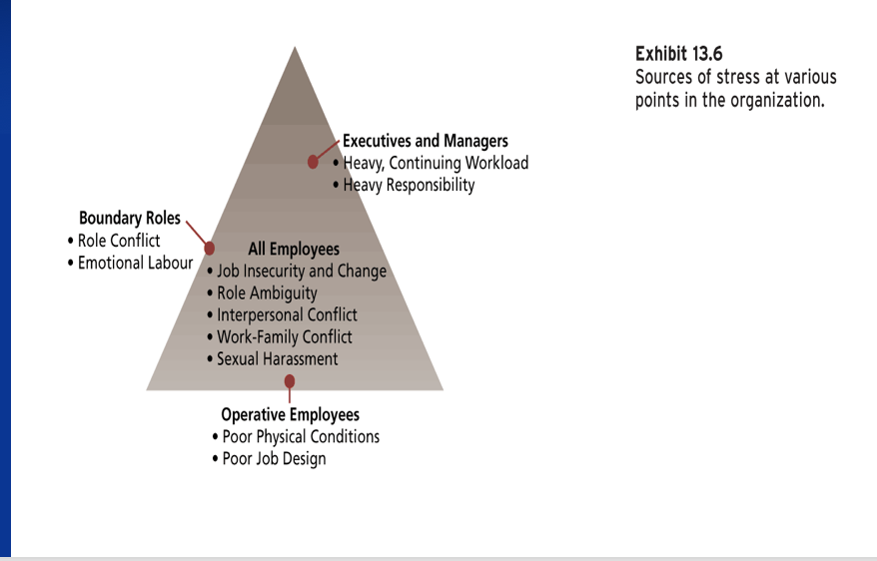

Organizational Stress and Stressors
Stressors:
- Environmental events or factors
- Organizational conditions
- Interpersonal relationships
- Personality

Sources of Stress at Various Points in the Organization
1)All employes:
- Job security and change
- Rôle ambiguity
- Interpersonal conflict
- Work-family conflict
- Sexual harassment
2)Operative employees
- Poor physical conditions
- Poor job design
3)Boundary Roles
- Rôle conflict
- Emotional Labour
4)Executive Managers:
- Heavy, continuing workload
- Heavy responsibility

Burnout
- Emotional exhaustion, depersonalization and reduced personal accomplishment among those who work with people.
- Burnout follows a process: Emotional exhaustion ----- Depersonalization ----- Low personal Accomplishment

Reaction to Stress
The reactions of people who experience organizational stress can be divided into three types:
- Behavioural reactions
- Psychological reactions
- Physiological reactions

Reducing or Coping with Stress:
- Job Redesign
- Social Support
- Family Friendly Human Resource Policies
- Stress Management programs
- Work-Life Balance programs
- Communication

Coping with burnout
- Problem-focused coping
- Appraisal focused coping
- Emotion centered coping
- Communicative coping: participation in decision making & social support

Organizational Diversity Processes

Loden’s Dimensions of Diversity:

Primary:
- Age
- Gender
- Mental physical abilities
- Race
- Ethnic heritage
- Sexual orientation

Secondary:
- Geographic location
- Military & work experience
- Family status
- Income, religion
- First language, education
- Organizations rôle & level
- Communication & work styles

Relational barriers in organizational systems:
- Limited access to or exclusion from informal communication networks
- Restricted access to power and optimal task assignments
- Difficulty establishing mentor-protégé relationship
- Tokenism
- Type of available work experience
- Reward Differentials

Barriers to interacting with diverse peers
- Stereotypes and prejudices
- Racism and sexism
- Sexual harassment
- Culture clash
- Ethnocentrisms
- Different communication codes
- Assuming similarity
Dimensions of describing a multicultural organization:
- Acculturation
- Structured integration
- Informal integration
- No cultural biases
- Organizational identification
- Intergroup conflict
Opportunities realized through diversity
- Cost argument
- Resource-acquisition argument
- Marketing argument
- Creativity argument
- Problem-solving argument
- System flexibility argument

Management of cultural diversity
- Organizational culture
- Mindset about diversity
- Cultural differences
- Educational programs
- High career involvement of all groups
- Bias free HRM systems [human capital approach]
- Best practices Vs. best fit approach to manage diversity!

Outcomes of diversity depends upon
- Recognition of diversity as valuable resource
- Understanding internal cognitive barriers
- Understanding inter-group conflict dynamics
- Context of the situation
- Procedure to resolve conflicts
- Learning and internalizing pluralistic and democratic values
Communication within a divers group
- Think before you speak
- Be careful with humour
- Avoid generalized language
When conflict arise
- Discuss the problem in private
- Remain calm and neutral
- Listen and don’t interrupt
- Encourage people to be less defensive and talk through concerns
- Probe other’s thought patterns, values and desires
- Clarify situation and try to create superordinate group identity

Understanding others who are different from us:
- Seek information
- Ask questions and listen carefully
- Develop a third culture

Accepting other who are different from us
- Tolerate ambiguity
- Develop mindfulness
- Avoid negative judgements about others

Strategies to adapt to other who are different from us
- Develop flexibility
- Become other - oriented
- Adapt your communication to others

Effective Leadership in Diverse Groups
- Humor
- Flexibility
- Patience
- Resourcefulness
- Consideration of others
- Equifinality - multiple paths to a solution
- Equality does not mean that all people are the same

Technological Processes

Types of Organizational Communication Technology
- Internet and world wide web
- Email
- Voicemail
- Fax
- Audio, video and computer conferencing
- Group decision support systems
- Networked computing
- Chat rooms and bulletin boards
- Newsgroups

- Theories of Communication media Usage
Linked with media richness model: criteria to measure the richness of communication- amount, availability of instant feedback. Number of cues. Variety of languages uses/use of natural language, potential for expressing emotions and feelings
- The social information processing theory: this approach sees the use of communication technology as a complex function of the objective, characteristics of the task & media, past experiences and knowledges, individual difference and social information
- Dual capacity model: The choice of communication channel will depend on both mediums date- carrying capacity, mediums symbol carrying capacity

Effects on Communication Technology:
- Effects on communication content
- Effects on communication patterns
- Effects on organizations structure

Changing landscape of organizations

Organization types in the global marketplace:
- Domestic
- multicultural
- Multi domestic
- Multinational: one country owns it but it operates in many
- International
- Global: you need to know how you can identify yourself in different cultures, have to do it in different way, can't do things canadian way in china

Effects of Globalization

- Time and space compression: everything moves quickly, what happens in one country can have an effect on the rest
- Global Consciousness and Reflexivity: being aware of different cultures
- Disembeddedness: concept that encourages people to understand issue, behaviors, reactions given the context/country, life them out of context, other factors
- Convergence
- Divergence: highlight the fact that there are lot of countries and groupes losing out because of globalization

13 & 14 not too many questions

