COMM 222 MIDTERM
Things you need to know

CHAPTER 1

Personality (genetics + environment)
- stable set of psychological characteristics that influence they way people interact with environments and how they feel, think or behave

3 Organizational behavioral approaches:
1. Dispositional Approach (traits = behavior):
- individuals possess traits/characteristics that influence their attitudes and behaviors (predisposed to behave a certain way)

2. Situational Approach (environment = behavior):
- characteristics of the organizational settings, such as reward and punishment, influence people’s feelings, attitudes, and behavior

3. Interactionist Approach (traits + environment = behavior):
- organizational behavior is a function of both dispositions/traits and the situation

*The extent to which personality influences people’s attitudes and behaviors depends on the situation:

Weak situations (personality has more impact in weak situations)
- not always clear how a person should behave
- loosely defined roles, few rules, and weak reward and punishment contingencies

Strong situations (personality has less impact)
- clear expectations for appropriate behavior
- have more defined roles, rules, and contingencies

Five Factor Model of Personality (OCEAN):

Openness to experience (receptive to new ideas – learning & creativity jobs - engineering):
- high score: creative, innovative, intellectual, curious, imaginative
- low score: favor the status quo

Conscientiousness (responsible and achievement-oriented – most jobs)
- high score: dependable, positively motivated, orderly, self-disciplined, hard-working
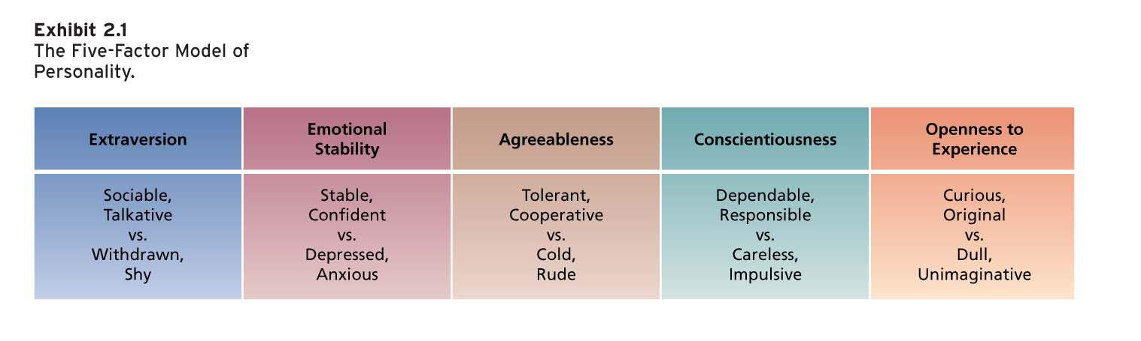
- low score: irresponsible, lazy, impulsive
- best predictor of job performance

Extraversion (interpersonal interaction jobs)
- high score = sociable, outgoing, energetic, joyful and assertive
- low score = introverts, shy

Agreeableness (friendly/approachable – teaching, salesperson)
- high score: warm, considerate, friendly, sympathetic, cooperative, eager to help
- low score: cold, aloof, argumentative, inflexible, uncooperative, uncaring

Neuroticism/nervousness (emotional stability – social interaction jobs – nurses, HR)
- high score: low neuroticism, self-confident, high self-esteem
- high emotional stability = low neuroticism
- low score: anxious, hostile, impulsive, depressed, insecure, and more prone to stress

Locus of Control (belief about the source of your behavior):
- a set of beliefs about whether one’s behavior is controlled mainly by internal or external forces
- high internals: internal forces control behavior (personal actions, free will, initiative)
challenging work, leadership, big projects, customer service, etc.
- high externals: external forces determine behavior (fate, luck, other people)
routine work, monitored, structure, something with expectations

Learning:
- practice/experience leads to a relatively permanent choice in behavior potential

WHAT do employees learn?
practical skills (knowledge), intrapersonal skills (problem solving), interpersonal skills (communication), cultural awareness (social norms)

HOW do employees learn?
1) Operant Learning Theory (Skinner)  - people learn from the consequences of their actions  PROBLEMS:  - Confusing rewards with reinforcers  - Neglecting diversity in preference for reinforcers  - Neglecting important sources of reinforcement (feedback and social recognition)  Fast acquisition  - continuous and immediate reinforcement  Persistent acquisition  - partial and delayed reinforcement | Positive Reinforcement (promote behavior):  - add positive reinforcers AFTER the behavior (ex: give candy or money after good work)  Negative Reinforcement (promote behavior):  - REMOVE unpleasant stimuli (ex: nagging boss to get work done)  Extinction (stop/decrease behavior):  - ignoring behavior to get it to stop (ex: not laughing at someone’s joke)  Punishment (stop/decrease behavior):  - follow unwanted behavior with punishment (ex: warnings, suspensions, removal of hrs, etc.)
2) Social Cognitive Theory (Bandura)  - emphasizes the role of cognitive process in regulating people’s behaviors  Triadic reciprocal causation:  - personal factors/environmental factors influence people’s behaviors | Observational learning:  - observing and imitative behaviors of others  Self-Efficacy:  - beliefs people have about ability to perform a certain task  - determinants: performance mastery, observation, verbal persuasion/social influence, and physiological/emotional state  Self-Regulation:  - learning principles to regulate one’s own behavior  - involves: collect self-observation data, observe models, set goals, rehearse and reinforce oneself

CHAPTER 2:

PERCEPTION:
- interpreting messages of our senses to provide order/meaning to the environment

Process of making a perception: Perceiver Situation Target

Perceptual defense:
- perceptual system defends perceiver against unpleasant emotions (“see what you want to see”)

Brunner’s Model of Perceptual Process (UOFTCC)

Perceptual Tendencies:
1) Selective (don’t use all cues and give special emphasis to some)
2) Constancy (target is perceived in the same way over time/across situations)
3) Consistency (select, ignore, and distort cues to form a standard picture of target)
Biases in Person Perception:
Primacy effect (ex: job interview) | - reliance on early cues/first impressions – often has lasting impact
Recency effect (ex: performance evaluation) | - reliance on recent cues or last impressions
Central Traits (attractive seen as “good”) | - personal characteristics of target are of special interest to perceiver
Implicity personality theories (A = B) | - you expect a hardworker (A) to be honest (B)
Projection | - attribute one’s own thoughts and feelings to others
Stereotyping | - generalize about people in a social category
Aspects to stereotyping:
- we distinguish some category of people
- assume that individuals in category have certain traits
- perceive that everyone in category possesses these traits

ATTRIBUTION
- causes or motives are assigned to explain people’s behavior

Dispositional attribution
- personality or intellectual characteristics of person responsible for behavior
- engages in behavior often, not many do same behavior, and does behavior in other situations

Situational attribution
- external situation/environment in which the target person exists was responsible for behavior
- does not do behavior often, a lot of people do behavior, doesn’t do behavior in other situations

*CUES on deciding whether it is dispositional or situational: consistency, consensus, distinctiveness
Dispositional attribution = high consistency + low consensus + low distinctiveness
Situational attribution = low consistency + high consensus + high distinctiveness

Biases in Attribution
Fundamental Attribution Error | Overemphasize dispositional explanations for behavior at the expense of situational explanations  Success = situation / Failure = disposition
Actor-Observer Effect | Actors and observers view the causes of behavior differently (ex: being late for work – actor will say its traffic and boss will say being lazy)
Self-serving Bias | Take credit for successful outcomes and deny failures  Success = disposition (me) / Failure = situation

Stereotype Threat:
- members of social group feel they might be judged/treated according to a stereotype
- scared their performance will confirm stereotype

Managing workforce diversity:
- Select enough minority members to get them beyond token status.
- Encourage teamwork that brings minority and majority members together.
- Ensure that those making career decisions about employees have accurate information about them.
- Train people to be aware of stereotypes.

Diversity Training Programs (BCDEE)
- Build senior management commitment and accountability.
- Conduct a thorough needs assessment.
- Develop a well-defined strategy tied to business results.
- Emphasize team-building and group process training.
- Establish metrics and evaluate the effectiveness of diversity initiatives.

CHAPTER 4

Values:
- prefer certain states of affairs over others (what we consider to be good or bad)
- “I dislike anything that can hurt my family”

Generations in Today’s Workplace (more similarities between them – all value hardwork):
- Traditionalists: hardworking, loyal, detail-oriented (leadership is fair, consistent, direct)
- Baby boomers: dedicated, experienced, service-oriented (leadership is fair, warm and caring)
- Generation X: independent, techno-literate, adaptable (leadership is direct, flexible, and results oriented)
- Millennials: optimistic, technologically savvy, team-oriented (leadership is educational, positive)

Hofstede’s Study:
- developed five basic dimensions along which work-related values differed across cultures
1) Power distance (accept unequal distribution of power)
2) Uncertainty avoidance (uncomfortable with uncertain situations)
3) Masculinity/Femininity (masculine cultures like Japan vs. feminine cultures like Scandinavia)
4) Individualism/Collectivism (reward individuals vs. groups)
5) LongTerm/ShortTerm orientation (stress persistence & perseverance vs. stability)

*Organizations need to tailor management practices to the home culture’s concerns

Attitudes = Beliefs + Values Behavior
- evaluation you have towards something (can be positive or negative)
- organizations often try to change employee attitudes since they tend to lead to behaviors
- use emotional or rational persuasion to modify beliefs/values

JOB SATISFACTION:
Aspects:
1) Facet satisfaction: employee is more or less satisfied with various facets/parts of job
2) Overall satisfaction: summary indicator of a person’s attitude toward job that cuts across various facets
Measures:
1) Job Descriptive Index (JDI) – 5 yes or no questions based around facets of job
2) Minnesota Satisfaction Questionnaire (MSQ) – 100 scale-like questions for various aspects of job

Determinants (DFDM) - Job Satisfaction is a function of:
1) Discrepancy
- discrepancy between outcomes people receive and those they want
- the larger the discrepancy = the less satisfied people are

2) Fairness (3 kinds)

1. Distributive fairness: fair when people receive the outcomes they think they deserve
- Equity Theory (my outcomes/my inputs = others outcomes/others inputs)
- need to compare to someone else in the same field or company

2. Procedural fairness: fair when people see the process used to determine outcomes as reasonable
- how are rewards distributed? (ex: selling $2000 = 10% bonus)
- if not fair, people are dissatisfied with system
- follow consistent procedures, use accurate info to appear unbiased, offer appeal

3. Interactional fairness: believe they have received respectful/informative info about outcome
- possible that fair outcomes/procedures are perceived as unfair is not explained properly
- if not fair, people are dissatisfied with boss

3) Disposition: People are predisposed to be more or less satisfied despite chances in discrepancy or fairness
- ex: extraverts, internal locus of control, high contentiousness, low neuroticism

4) Mood and emotion: feelings as determinants of job satisfaction
- emotions: intense, short-lived, caused by a particular event
- moods: less intense, longer-lived, more diffused feelings

Affective Events Theory:
- jobs consists of a series of events that have the potential to provoke emotions or influence moods depending on how we appraise them
- person’s disposition can interact with job events to influence satisfaction

Emotional contagion:
- tendency for moods and emotions to spread between people or a group
Emotional Regulation:
- requirement for people to manage their emotions in certain jobs

* People experience greater satisfaction when they meet/exceed the job outcomes they want, perceive the job outcomes they receive as equitable compared to others, and believe that fair procedures determine job outcomes

Other Contributors: mentally challenging work, adequate compensation, career opportunities, people/coworkers

Consequences:
1) Absence from work (less-satisfied employees are more likely to be absent)

2) Model of Employee Turnover (less-satisfied = more likely to quit)
- honeymoon-hangover effect: people who quit see a boost (honeymoon) in satisfaction in new job but bad facets are recognized (hangover) so overall satisfaction of new job decreases

3) Performance (satisfaction = better performance but dissatisfied employees might still work well)

4) Organizational citizenship behavior (voluntary behavior that is unrewarded = more satisfied people)

5) Customer satisfaction and profit (employee satisfaction will increase customer satisfaction and profits)
6) Organizational commitment (strength of linkage between employee and organization)
- Affective (want to stay – identification and involvement with organization)
- Continuance (have to stay – costs that would be incurred in leaving)
- Normative (should stay – feeling of obligation toward an organization)

Consequences: reduce actual turnover and intentions, conflicts between family/worklife, unethical behavior, lack of innovation and resistance to change

CHAPTER 5
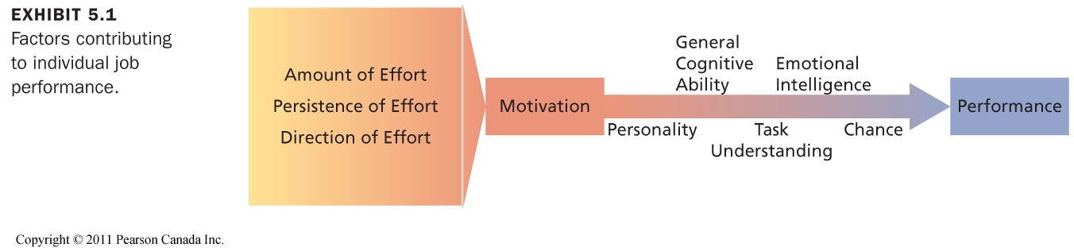
Motivation = putting effort towards accomplishment of a goal

Characteristics of motivation: effort, persistence, direction and goals

Self-Determination Theory (Deci&Ryan)
- Theory of motivation that considers whether people’s motivation is autonomous or controlled

Controlled Motivation:
- feeling obliged by a person
- when people are motivated to obtain a desired consequence or extrinsic reward, their motivation is controlled externally

Extrinsic:
- motivated for reason outside of task
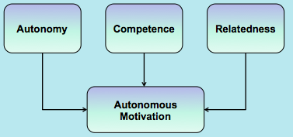
- may decrease intrinsic rewards

Autonomous Motivation:
- if task is motivating or you do it to get better
- any reason to do it on your own free will
- When people are motivated by intrinsic factors, they are in control of their motivation
- consequences: interest in task, effort, attainment, organizational commitment, positive attitudes, etc.

Intrinsic:
- motivated because of task itself

NEED THEORIES of work motivation (what motivates people?)

1) McClelland’s Theory of Needs
nAch | - strong desire to perform task well  - Sales jobs or entrepreneurial positions
nAff | - maintain friendly, interpersonal relationships (want others to like them and like to like others)  - Social work or customer relations
nPower | - desire to have strong influence over others  - Journalism and management
- nonhierarchical need theory of motivation that outlines the conditions under which certain needs result in particular patterns

PROCESS THEORIES of work motivation (how do you motivate people?)

1) Expectancy Theory (Vroom)
- motivation is determined by the outcomes that people expect to occur as a result of their actions on the job
- looking at what affects expectancy, instrumentality and 1st (performance) and 2nd level outcomes

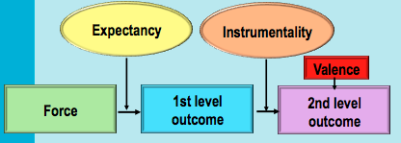

Implications of Expectancy Theory:
- Boost expectancies (ensure employees are able to reach 1st level outcomes)
- Clarify reward contingencies (make it clear on what employee needs to do to achieve 2nd level outcomes)
- Appreciate diverse needs (design individualized motivational packages)

2) Equity Theory (Adams)

My outcomes = Others outcomes
My inputs Others inputs

- If Ratios are equal = worker should feel that a fair and equitable exchange exists with the employing organization (contributes to job satisfaction)
- If Ratios are unequal = workers perceive inequity and experience job dissatisfaction

3) Goal Setting Theory (Locke & Latham)
- goals are motivational when:
- specific (direct attention)
- challenging (lead to greater effort)
- members are committed to them (increase and prolong persistence)
- feedback is provided (use task strategies for goal attainment)

Implications: enhance goal commitment through participation, rewards, and management support

Motivation Theories and Translation Across Cultures:
Self-determination | Effective in different cultures
Need theories | Face cultural limitations
Process theories | Equity theory: constrained by what is fair in cultures  Expectancy theory: effective in different cultures  Goal setting theory: must be adjusted to the cultures

CHAPTER 6:

Money = pay + fringe benefits

How effective is pay as a motivator?
- Can satisfy lower-level, social, self-esteem and self-actualization needs
- Should be highly valent
- Pay should be clearly tied to performance (instrumentality)

Production Jobs
- Piece-Rate: workers are paid a certain sum of money for each unit of production
- Wage Incentive Plans: various systems that link pay to performance on production jobs
Problems with Wage Incentive Plans:
- Lowered Quality (want a lot of quantity so they will give up some quality)
- Differential opportunity (old equipment vs. new equipment)
- Reduced Cooperation (pressure to produce makes workers not want to do other things)
- Incompatible job design (some jobs are difficult to implement wage incentives)
- Restriction of productivity (artificial limitation of work output)

White-Collar Jobs
“Merit pay plans”: evaluate performance and recommend an amount of merit pay to be awarded
Problems with merit pay plans:
- Low discrimination (unwilling/unable to discriminate between good/poor performers)
- Small Increases (increases are too small to be effective motivators)
- Pay secrecy (employees cannot compare own merit treatment to others)

Team Work
- Profit Sharing: return of profit to employees in cash bonus
Adv: sense of ownership, aligns employee goals with organizational goals
Dis: too many factors beyond the control of the workforce can affect profits

- Employee Stock Ownership Plans (ESOPs): allow employees to own a set amount of the company’s shares
Adv: sense of legal and psychological ownership, aligns employee goals with organizational goals
Dis: hard to see link to performance & profit and is unmotivational when economy is slow shares go down

- Gainsharing: when costs decrease, employees receive bonus
Adv: aligns employee goals with organizational goals, encourages teamwork
Dis: bonsuses might be paid even when organization does not make a profit

Skill-Based Pay: system where people are paid according to how much skills they have acquired
Adv: increase in productivity, lower labor costs per part
Dis: increases cost of training, labour costs can increase as employees acquire new skills

JOB DESIGN
- Goal of job design: identify the characteristics that make some tasks more motivating than others and capture characteristics in the design of a job

1) Scientific Management (low breadth and low depth)
- Job Simplification, Extreme division of labor and specialization, Careful standardization and regulation of work activities and rest pauses, Motivational strategies: close supervision and piece-rate pay

2) Job Scope
- breadth: number of different activities performed on the job
- depth: degree of control the worker has over how these tasks are performed (autonomy & control)

*Broad jobs = workers do a number of different tasks
*Deep jobs = emphasize freedom in planning how to do the work

High Scope Jobs = great breadth and depth (ex: professor, and management jobs)
- provide more intrinsic motivation
Low Scope Jobs = low breadth and depth (ex: assembly line job)

To Increase the Scope of a Job:
1) Stretch assignments offer employees challenging opportunities
2) Job rotation rotating employees to different tasks and jobs in company

3) The Job Characteristics Model (Hackman & Oldham)
- Several core job characteristics that have a certain psychological impact on workers
- several factors (moderators) influence the extent to which these relationships hold true

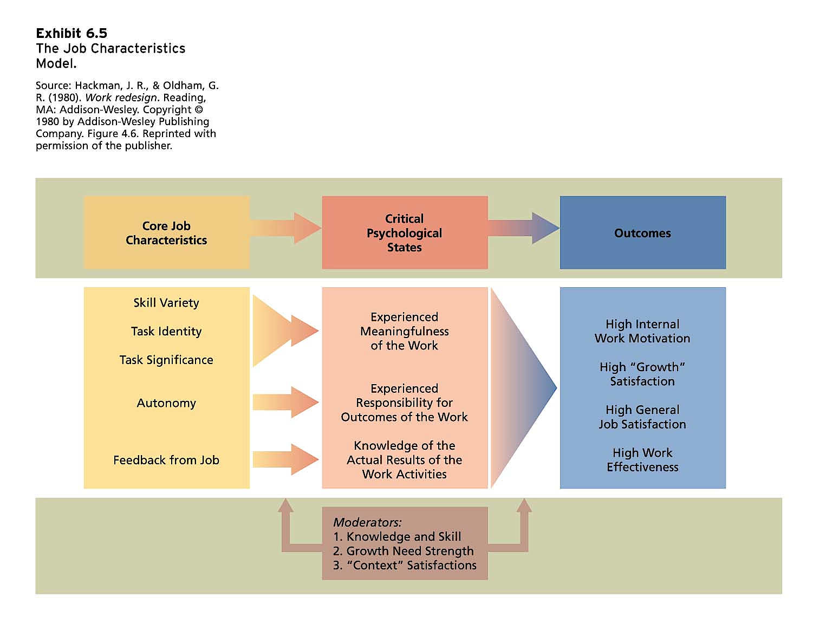
Core Job Characteristics (high levels = favorable outcomes):
1. Skill variety (job breadth) – different skills required for job
2. Task identity (completing job from beginning to end)
3. Task significance (impact job has on others)
4. Autonomy (job depth) – responsible for outcomes of work
5. Job Feedback (info about performance) – must come from specific job

Motivating Potential Score
- Job diagnostic survey to measure the core characteristics of jobs

Skill Task Task
MPS = variety + identity + significance x Autonomy x Feedback
3
4) Job Enrichment Procedures

Job enrichment: enhance intrinsic motivation, the quality of working life, and job involvement
- job design to increase the MPS
- involves increasing the motivating potential of jobs via the arrangement of their core characteristics

Job involvement: psychological identification with one’s job & importance of work to one’s total self-image
- challenging/enriched jobs = higher levels of job involvement

PROCEDURES:
- Combining tasks/skill variety
- Establishing external client relationships (in touch with people outside company)
- Establishing internal client relationships (in touch with people who depend on product)
- Reducing supervision or reliance on others
- Forming work teams
- Making feedback more direct

PROBLEMS:
- Poor diagnosis (not all jobs need to be redesigned since design may not be at fault)
- Lack of desire/skill (not everyone wants job enrichment)
- Demand for Rewards (workers ask for greater extrinsic rewards)
- Union resistance
- Supervisory Resistance (scared for own job)

5) Work Design
Work Design Characteristics:
- attributes of the task, job, and social/organizational environment

Motivational Characteristics | Task characteristics: autonomy, work scheduling autonomy, work methods autonomy, decision-making autonomy, skill variety, significance, task identity, feedback form others  Knowledge characteristics: information processing, job complexity, specializing, problem solving, skill variety
Social Characteristics | Interdependence, feedback from others, interaction outside office
Work Context Characteristics | Physical demands, working conditions, ergonomics, equipment use

Management by Objectives (MBO)
- elaborate, systematic, ongoing management program designed to facilitate goal establishment, goal accomplishment, and employee development

Alternative Working Schedules
Purpose: meet diverse workforce needs and promote job satisfaction
1) Flextime: alternative work schedule where arrival and departure times are flexible
2) Compressed Workweek: employees work fewer than the normal five days
3) Job and work sharing
- job sharing: two part-time employees divide the work of a full-time job
- work sharing: reducing # of hrs employees work to avoid layoffs
4) Telecommuting: work at home instead of going in to office

