Chapter 8: Helping Organizations Access, Share, and Use Information

TURNING INFORMATION INTO KNOWLEDGE
Knowledge management (KM)
- Capturing, classifying, evaluating, retrieving, and sharing info assets in a way that provides context for effective decisions and actions
- KM is the systematic, effective management and use of an organization’s info resources that contain or embody knowledge. The sources include
  - People
  - Paper documents
  - Electronic word docs
  - Presentations and spreadsheet
  - Data warehouse solutions

KM in business
- KMS supports capturing, organizing, and disseminating knowledge throughout an organization

Explicit and tacit knowledge
- Explicit knowledge: consists of anything that can be documented, archived, and codified, with the help of info systems
- Tacit knowledge: the knowledge contained in people’s head
- Shadowing: less experienced staff observe more experienced staff to learn how heir more experience counterparts approach their work
- Joint problem solving: the expert and the novice work hand in hand on a task
- KM technologies:
  - Knowledge repositories (database)
  - Expertise tools
  - E-learning applications
  - Discussion and chat technologies
  - Search and data mining tools

Knowledge management outside the organization
- Crowdsourcing: refers to the wisdom of the crowd
- Asynchronous communication: communications that occur at the same time

KM and social networking
- Social networking analysis: a process of mapping a groups’ contacts (personal/professional) to identify who knows whom and who works with whom
  - Is not a replacement for traditional KM tools such as knowledge database or portals, but it can provide companies with a starting point for how best to proceed with KM initiatives

Collaboration
- Gives people the tools to access, share, and use info better

Teams, Partnerships, and Alliances
- Organizations create and use teams, partnerships, and alliance to:
  - Undertake new initiatives
  - Address both minor and major problems
  - Capitalize on significant opportunities
- Organizations create teams, partnerships, and alliance both internally with employees and externally with other organizations.
- Information technology can make a business partnership easier to establish and manage
  - Information partnership: occurs when 2 or more organization cooperate by integrating there IS, thereby providing customers with the best of what each can offer
- The Internet has dramatically increased the ease and availability for IT-enabled organizational alliances and partnerships.
- Organizations form alliances and partnerships with other organizations based on their core competency:
  - Core competency: an organization’s key strength, a business function that it does better than any of its competitors
  - Core competency strategy: organization chooses to focus specifically on its core competency and form partnerships with other organizations to handle non-strategic business processes
    - The most common example of this is outsourcing payroll or accounting functions

Collaboration Systems
- Def. An IT-based set of tools that supports the work of teams by facilitating the sharing and flow of info
- Collaboration solves specific business tasks such as
  - Telecommuting
  - Online meetings
  - Deploying application
  - Remote project and sales management
- 2 categories of collaboration:

Unstructured collaboration  (info collaboration): | - Includes document exchange, shared whiteboards, discussion forums, and emails  - Benefits:  - Improve personal productivity  - Reduce time spend search for info and chasing answers
Structured collaboration  (process collaboration): | - Involves shared participation in business processes such as workflow in which knowledge is hardcoded as rules  - Improve automation and the routing of info

- Regardless of location or format – be it unstructured or structured – relevant accurate info must be readily and consistently available to those who need it – anytime, anywhere, and on any device.
- The strength of the collaboration process lie with the integration of many systems, including:
  - Content management systems
  - Workflow management systems
  - Groupware systems

Content Management System (CMS)
- Provides tools to manage the creation, storage, editing, and publication of info in a collaborative environment
- CMS marketplace includes: (p.250)
  - Document management system (DMS)
  - Digital asset management system (DAM)
  - Web content management system (WCM)
- In addition to commercial off the shelf software (COTS), there are Open Source Solutions (OSS) solutions such as Wiki’s, Drupal

Working Wikis
- Wikis: Web-based tools that make it easy for users to add, remove, and change online content
- Business wikis: collaborative Web pages that allow users to edit documents, share ideas, or monitors the status of a project

Workflow Management Systems
- Work activities can be performed in series or in parallel and involve people and automated computer systems.
- Workflow: defines all the steps or business rules, from beginning to end, required for a business process
- Workflow management systems: facilitates the automation and management of business processes and controls the movement of work through the business process
- 2 primary types of workflow systems:

Messaging-based: | send work assignments through an email system
Database- based: | store documents in a central location and automatically asks the team members to access the document when it is their turn to edit the document

  - Either type or workflow system helps present info in a unified format, improve teamwork by providing automated process support, and allows team members to communicate and collaborate within a unified environment

Groupware Systems
- Def. Software that support team interaction and dynamics including calendaring, scheduling, and videoconferencing
- Advantages:
  - Facilitating communication (faster, easier, clearer, more persuasive)
  - Enabling telecommuting
  - Reducing travel costs
  - Sharing expertise
  - Forming groups with common interest where it would not be possible to gather a sufficient number of people face-to-face
  - Saving time and cost in coordinating group work
  - Facilitating group problem solving
- Groupware technologies:
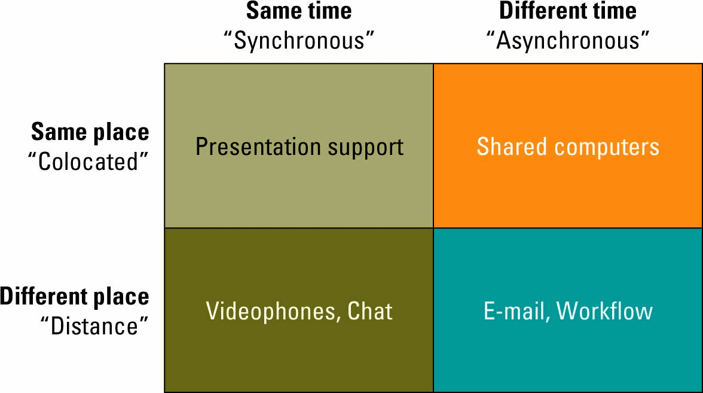

Video Conferencing
- Video conference: a set of interactive telecommunication technologies that allow 2 or more locations to interact via 2-way video and audio transmission simultaneously

Web Conferencing
- Blend audio, video, and document-sharing technologies to create virtual meeting rooms

Instant Messaging
- Def. A types of communication service that enables someone to create a kind of private chat room with another individual in order to communicate in real time over the Internet
- Most of the popular IM programs provide a variety of features:
  - Web links
  - Images
  - Sounds
  - Files
  - Talk
  - Streaming content
  - Instant messaging

The Role of Mobile Devices
- M-learning: uses portable computing devices with wireless capability to enable mobility and mobile learning

ENTERPRISE PORTALS

What Are Enterprise Portals?
- Are single-point Web browser interfaces used within an organization to promote the gathering, sharing, and dissemination of info throughout an enterprise
- Web browser interface facilitates navigation of the Enterprise Portal via:
  - Enterprise taxonomy or classification of info categories
  - Search engine
  - Hyperlinks to both internal and external resources
- Features that help support info access, sharing, and use: (p.257)
  - Publishing facility
  - Automatic indexing facility
  - Subscription facility
  - Intelligent agents
- 2 broad categories of enterprise portals:
  - Vertical enterprise portal: focus on accessing specific applications or business functions
  - Horizontal enterprise portal: seek to integrate and aggregate info from multiple cross-enterprise applications

The Potential of Enterprise Portals
- An information content space to facilitate info access and retrieval
- A communication space to support discussion among employees, esp. for negotiation collective interpretations and shared meanings about the info accessed and retrieved
- A work coordination space to support cooperative work action b/w employees, facilitate workflow process, and the accomplishment of work tasks

Factors Affecting Enterprise Portal Adoption and Use
- The information politics surrounding the design and development of the portal
- The system development process by which the portal was maintained
- The information culture of the organization: 5 sub factors affecting the adoption and use of the enterprise portal:
  - Information sharing
  - Information overload
  - Information access
  - Information control
  - Attitudes toward using the portal
- Insights into the challenges facing the implementation of enterprise portals in organizations can be derived from the field of computer-supported cooperative work (CSCW)
  - CSCW: a field of research concerned with the development and use of software to help groups increase their competency in working together
  - Insights include:
    - Ensure that everyone benefits
    - Create incentives for use
    - Promote multiple perspectives
    - Understand current work practice

