BIO1130A - Ch. 1 The Scientific Method
F. Chapleau

1.1 Introduction and definition of science
- Science
  - A coherent body of knowledge related to certain categories of facts, objects or phenomena obeying laws that are verifiable through experimental methods
- Scientific inquiry aims to acquire new knowledge
- Two approaches
  - 1) Description based
    - ie) describing nature
  - 2) Hypothesis based
    - ie) explaining nature

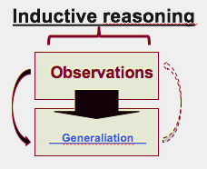
1.2 The scientific method

1.2.1 Inductive Reasoning
- Making a generalization often based on numerous specific observations
- Particular → general
  - ie) Sunny in the morning therefore good weather rest of the day

1.2.2 Deductive Reasoning
- Involves stating a hypothesis and drawing conclusions (after experimentation or observation) from this hypothesis
- General → Particular
  - Science usually uses this process
  - Hypothesis must be tested/verified

1.2.3 Scientific Process
- 3 Case studies

- Case 1: Inductive Reasoning
  - Orange
    - Observation: This orange is sweet
    - Generalization: All oranges are sweet
  - Massive fish death in a lagoon in Florida, USA
    - All scientific inquiry starts with one or multiple observations
      - Subsequently, the scientific process must be implemented
    - Observation: Many dead fish
    - Generalization: Due to lack of oxygen or pollution
      - There were no further investigation/testing (deductive reasoning)
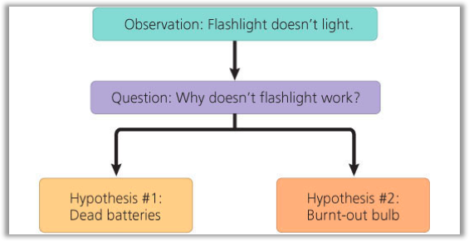
    - *Most news is based on inductive reasoning

- Case 2: Deductive Reasoning
  - Scientific hypotheses must be verifiable, refutable, reproducible
    - Scientific paper must have all steps to repeat the experiment
  - Hypothesis
    - A statement about nature/stating a fact
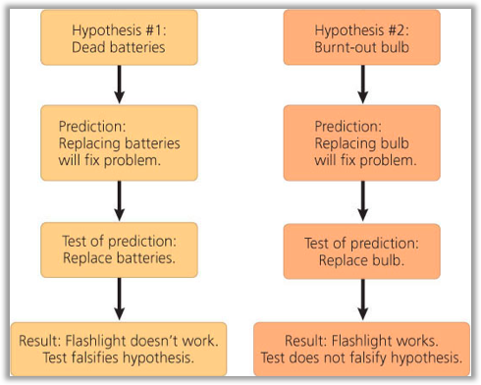
  - From hypothesis you can make a prediction
  - Prediction
    - Verify/test the hypothesis and give clear result
    - If...then… statement
  - Hypothesis can be falsified or not falsified
  - We can never prove that a hypothesis is the “scientific truth”
- Example 1: Orange
  - Observation: This orange is sweet
  - Hypothesis: All oranges are sweet
  - Prediction: If I taste all kinds of oranges, then they will always be sweet
  - Test: Tasting all kinds of oranges
    - Travel to Madagascar → tasted a very sour orange
    - Therefore hypothesis is falsified
      - Go back and change hypothesis to “All oranges are sweet except the one in Madagascar”
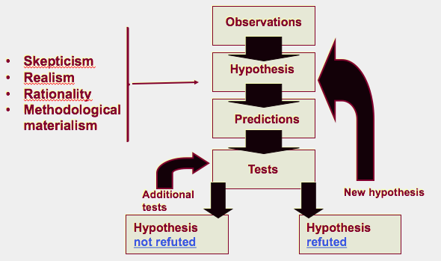

*Deductive: Continuously changing the hypothesis when it is not refuted (is falsified)

- Contract between science and knowledge (or the ability to know)
  - 1) Skepticism
    - Ask honest questions on facts and hypothesis (tangible/real things) and we always re-test what has been found
  - 2) Realism
    - Need to rely on reality to approach a scientific question
      - Using nature to describe nature
      - Need to be as objective as possible
    - The world is older and exists independently from my perception of it
      - Your realm of ideas does not have the priority over the real world
        - Get rid of what you’ve learned, culture/upbringing of the world
  - 3) Rationality
    - i) Logic
      - Demonstrations from a scientist must be the result of coherent steps
    - ii) Parsimony
      - Methodological principle which states that acceptable theories are hypothetically the most economical in assumptions
      - Choose the simplest explanation
      - ie) You’re in the countryside, behind you is a fence field. You’re not looking at the field, you hear galloping, you can assume there’s a zebra.
        - If in Canada, a Zebra is the least assumed
          - Best assumption would be a horse
  - 4) Methodological materialism
    - All that is experimentally accessible in the real world is material or has a material origin
    - Natural processes must be explained by real world
      - Verifiable with material origin
      - ie) Cannot say God
      - ie) Crop circle enigma
        - Complicated explanations to explain how they were made
        - Ended up being 2 guys in England who did it
        - Cannot use supernatural elements in your explanation (not testable)
- Example 2: Monarch and Viceroy butterfly
  - Predator and Prey Relationship
    - Monarch butterfly (Danaus plexippus) is toxic
      - Birds will not eat it, instantly spit it out because they are toxic
      - Milk wheat has toxic substance that monarch can eat
    - Viceroy butterfly (Limenitis archippus) is toxic
      - Old hypothesis
        - Batesian mimicry
          - Through experimentation → Mullerian mimicry
      - Mullerian mimicry
        - Imitate another species to have a shared protective device (stronger protection)
    - Experiment
      - Birds in an environment with both monarch and viceroy
      - Birds won’t eat viceroy → toxic
      - Not batesian mimicry but mullerian mimicry
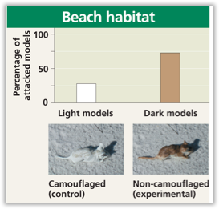
- Example 3: Fur colouration of Peromyscus polionotus, the oddfield mouse
  - Fur colour different between beach and inland population
    - Allows for camouflage against predators
      - Beach = pale colour
      - Inland = dark brown
  - Hypothesis: In this species, fur colouration patterns has evolved as camouflage in their native environments
  - Prediction: If mice have a coloration that does not match their habitat then they will be preyed on more heavily than the native, well-matched mice.
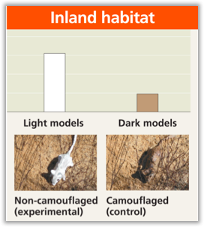
  - Test
    - Plasticine mice spray-painted in beach or colours
    - Spread both colors models (control and experimental) in equal numbers in both habitats
    - Count signs of attacks
  - Result
    - Prediction is true
      - On beach = dark model attacked more
      - In land = light model attacked more

- Example 4: Introduction of fish in Gatineau Park
  - Piscivores
    - Predatory fish, prey on other fish species, usually smaller
  - Observation: Small lakes in which recreational fishing species (piscivores) have been introduced do not have schools of small fish near shore
    - Simple observation, noticed no schools of fish
    - Experimental group
      - Lakes with introduced fish
    - Control group
      - Lakes without introduced fish
  - Hypothesis
    - Introduction of piscivore fish species in small lakes would result in a decline in the numbers of smaller species
  - Prediction: In lakes with the equivalent surface area, if lakes contain introduced piscivorous species then they will have fewer smaller fish species than lakes without introduced piscivorous fish species
  - Test: Determine the number of fish species in both types of lakes
    - A comparative analysis of fish species diversity in a region with small lakes with introduced piscivores and small lakes without piscivores
  - Result: Lakes without introduced piscivorous fish species have significantly more (50%) small-sized fish species than lakes where they were introduced
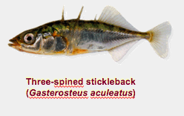
  - Recommendation: Banning the introduction of piscivorous species in Gatineau Park lakes to preserve the park’s biodiversity
    - Three-spined stickleback (Gaterosteus aculeatus) will be gone first
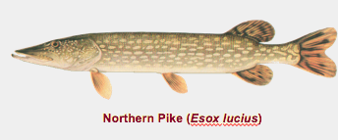
    - Northern Pike (Esox lucius) will eat the three-spined stickleback

1.3 Conclusion
- Established the definition of science and the validity of the scientific method/process
- A valid scientific process needs to respect the clauses of the contract between the acquisition of knowledge and science
  - Breaking one of the clauses invalidates the contract because the acquisition of knowledge does not correspond to an objective search for the scientific truth.
    - Thus, faulty and corrupted

