FINA 415: Quantitative (part 1)

Overview of Comparable Company Analysis

- Relative valuation using market comparables (comps): technique used to value businesses, business units, and other major investments.
  - Assumes similar assets should sell at similar prices.
  - Critical that the “comparable” assets/transactions are truly comparable to the investment being evaluated.
- Relative valuation ideally a complement to DCF
- The economic rationale underlying the method of comparables is the law of one price—the economic principle that two identical assets should sell at the same price.
- Peers are benchmarked against each other and the target based on various financial statistics and ratios
- Valuation multiples use a measure of value in the numerator and an operating metric in the denominator e.g. price/sq ft

Valuation Using Comparables:
Example of the simplest form:

- Consider the valuation of a service station in Tulsa. Here are comparable stations:

Station | Enterprise  Value | Net Operating Earnings | EV/NI  Ratio
A | $ 900,000 | $450,000 | 2
B | $1,200,000 | $100,000 | 12
 |  | Avg Ratio | 7

- At a first glance, if Tulsa has net operating earnings of $150,000, we might estimate a valuation of 7*($150,000)=$1,050,000
- However, esp. given the discrepancy in comps, we need to look into the details.

- In this example, road improvements near Station B depressed sales for the year; typically earnings are double and the valuation ratio is about 6; the average is thereby 4, and we arrive at a value of $600,000 for Tulsa

REVISED:
Station | Enterprise  Value | Net Operating Earnings | EV/NI  Ratio
A | $ 900,000 | $450,000 | 2
B | $1,200,000 | $200,000 | 6
 |  | Avg Val Ratio | 4

- With net operating earnings of $150,000, we might now estimate a valuation of 4*($150,000)=$600,000
- Ideally, we use more than 2 comparables, and have more in-depth information on the target and potential comps. We also consider a variety of ratios.
Real Estate Example
- Collect the ratio of prices from recent sales in the neighborhood
  - Multiply the price per square foot by the number of square feet in your house to get an estimate of what the home should sell for.
- Analysis should include differences in value from distinctive features of the real estate and intangibles.
  - Apply a premium or discount for location, size of property, view, amenities and specialty finishes, swimming pool, etc. I.E determine the differences in value drivers
- Commercial real estate analysis includes evaluation of cash flow ratios as well as prices per sq. ft. and features.
- Identification of appropriate comps is paramount.

Comparable Company Analysis
FIVE Key Steps:

Step 1: Select the Universe of Comparable Companies

- Study the target firm and industry-specific material
- For public targets, sources of information include SEC reports (10-K for yearly statments, 10-Q for quarterly statements, and 8-K for current statements), consensus (analysts) estimates, press releases, earnings call transcripts, etc.
- For private targets, it is more difficult to find information (unless firm has public debt), but sources of information include financials possibly provided by target, trade journals, research reports, etc.
- Key characteristics of the target for comparison purposes typically include business profile and financial profile traits.
- Such similarities may provide similarities in key drivers, cost structures, risks, and opportunities.

Business Profile:

- Sector (Industry/Market): can be divided into subsectors it even more compatible. Highly fragmented sectors may present growth opportunities that are unavailable to companies in more stable (mature) sectors. Analyze cyclicality of industry as well.
- Products and Services: a company’s products are the core of its business model
- Customers: companies with similar target market tend to share similar opportunities and risks (ex. same cyclicality and purchasing trends). Analyze quantity and diversity of target market; some serve a more niche segment. Having low customer concentration reduces risk. It is beneficial to have a stable customer core for visibility and stable future revenues
- End Markets: it’s the broad underlying markets into which it sells its products & services. EX. Plactic manufacturer may sell to many different markets such as construction, packaging, etc. Not the same as customers; for example, company may sell to the housing end market, but to retailers and suppliers, not the home builders. Generally companies who share the same end markets are subject to the same macroeconomic factors; for example, companies with a housing market end market are subject to interest rates and unemployment levels.
- Distribution Channels : are key drivers to operating strategy, performance, and value. For instance, companies selling to wholesale channels have a very different organizational and cost structure from those selling straight to retailers and customers. Ex. selling to wholesalers requires a smaller sales team than selling to super stores. Some may sell to at many levels of the distribution chain.
- Geography: different regions are affected by macroeconomic environment, growth rate, competitive dynamics, path-to-market, organizational and cost structure, and potential opportunities and risks. Demography embodies PESTEL (ex. trends, cultural and political norms, etc.). Geographic grouping is slightly less applicable for truly global industries such as oil and gas.

Financial Profile:

- Size: measured in market valuation (ex. EV) and in key financial statistics (ex. sales, gross profit, EBITDA, EBIT, and Net Income). Companies with similar size are more likely to have similar multiples. Moreover, they can be similar in many other aspects such as economies of scale, purchasing power, pricing leverage, customers, etc. Tiering into subgroups according to size is a good idea.
- Profitability: profitability measures its ability to convert sales into profit. Ex. using profitability ratios by using a measure of profit as a numerator (EBIT, EBITDA, NY). Comparing profitability to peers is a core component for bench-mark analysis
- Growth profile: Based on historical and estimated future performance. The higher the growth the higher the valuation multiple will be. Must determine whether growth is organic or acquisition-driven. Determine the growth rate of EPS, EBITDA, sales, etc. Analyzing growth of EPS is better for public, mature companies. EBITDA, and sales is better for smaller companies since they have little or no earnings.
- Return on Investment (ROI): Most commonly used ROI are ROI, ROE, and ROA. Dividend yield is pretty popular too
- Credit profile: Credit worthiness of company. Calculate their overall debt and their ability to make interest payments (coverage ratio) to determine sector-specific benefits and risk. Use credit rating agency (Standard & Poor’s, or Moody’s)

Step 2: Locate the Necessary Financial Information

- Valuation is driven on the basis of both historical performance i.e. LTM (last twelve months) and expected future performance (i.e. from consensus estimates, available on Bloomberg for example)
- Historical information sources include SEC filings:
- 10-K (Annual report): last year’s performance. Includes detailed business description, Management’s Discussion & Analysis (MD&A), audited financial statements, outstanding debt detail, shares outstanding, and more. Also includes info on target market, competitors, etc.
- 10-Q (Quarterly report): less comprehensive as 10-K. Compares the quarter with the prior’s year quarter. Includes statements, MD&A, and the updated # of shares.
- 8-k (Current report): for triggering events important to SHs. Ex. of events: earnings announcements, purchase/sale agreement, completion of acquisition of assets. Important to update ratios, and statements which may not be in the 10-K or 10-Q.
- Proxy statements: Let SHs know of the matter in which the SHs are expected to vote.
- Press releases and financial information services provide access to research reports as well
- Standard press releases includes earnings announcements, declaration of dividends, management changes, capital market transactions, and M&A. They are not mandatory.
- earnings statement is released before the 8-k, or 10-Q. Thus, banker rely on it most to update statements on a timely manner.

Step 3: Spread Key Statistics, Ratios, and Trading Multiples

- Financial data (for each firm) is entered into an “input page” which assists in calculating key ratios and feeds into summary pages used to benchmark the comparable companies

Five key categories of financials include:

- Size (equity value; enterprise value)

Equity Value** = Share Price x Fully diluted Shares Outstanding*

Fully diluted Shares Outstanding* = Basic Shares Outstanding + “In-the-Money” Options and Warrants + “In-The-Money” Convertible Securities

Enterprise Value (Firm Value)
- Sum of all ownership interests in company and claims on assets from both debt and equity holders
- Equity Value Component is calculated on fully diluted basis

EV = Equity Value** + Total D + Preferred Stock + Non-controlling Interest – Cash And Cash Equivalents

Enterprise V definition:

Think of enterprise value as the theoretical takeover price. In the event of a buyout, an acquirer would pay out shareholders and take on the company's debt, but would pocket any cash. EV is a capital-structure neutral metric, and many consider it to be a more accurate representation of a firm's value. The value of a firm's debt, for example, would need to be paid by the buyer when taking over a company, thus by including debt EV provides a much more accurate takeover valuation.

Calculating Fully Diluted Shares Outstanding:

To the basic shares outstanding, we should add the number of shares represented by in the money options, warrants, and convertible securities (available from 10-K or 10-Q).

For options and warrants, the Treasury Stock Method is used

This method assumes that all tranches of in-the-money options and warrants are exercised at their weighted average stock price with the firm’s option proceeds used to repurchase outstanding shares of stock at the firm’s current share price

Slide 14/ Exhibit 1.7:

- Profitability (Gross profit, NI margins, EBIT(DA))

- Growth Profile (Historical & estimate growth rates)

- Return on Investment (ROIC, ROE, ROA, Div Yield)

- Credit Profile (Leverage ratio, coverage, ratings)

Trading Multiples
In this last part of step 3, we need to determine which trading multiples are of interest to us.
- The most widely used multiples use a measure of market valuation in the numerator (e.g. enterprise value, price) and a measure of financial performance in the denominator (e.g. EBITDA, net income)
- Important that numerator and denominator are matching in terms of debt and equity holders
i.e. EnterpriseValue/EBITDA is good, as EBITDA reflects earnings available to both debt and equity holders which numerator reflects; Similarly Price/Earnings is appropriate as earnings are available to equity holders

(Slide 20)

Exhibit 1.33/ pg. 45/ Slide 21

Step 4: Benchmark the Comparable Companies
- Benchmarking centers on analyzing and comparing each of the comparable companies with one another and the target
- The ultimate objective is to determine the target’s relative ranking so as to frame valuation accordingly
- Typically the list of comparables is honed down to only those most similar to the target in terms of business and financial profile

Therefore two main steps:

A. Identify the closest comparable firms
- Consider core value drivers and compare firms on basis of size, profitability, growth, returns, and credit strength, as well as business profile characteristics of sector, products and services, customers and end markets, distribution channels, and geography.
- A thoughtful benchmarking analysis goes beyond quantitative analysis and requires a strong understanding of each comparable company’s story.
B. Analyze and compare trading multiples for the peer group
- Consider removing outliers
- Display an output page of relevant comparable firms and statistics (see next slides)
- Note the trading multiples for the BEST comparables

Pg. 66-69/ Slide 24-25

Step 5:
Determine Valuation
- Trading multiples serve as a basis for deriving an appropriate valuation range for the target
- Use means and medians of most relevant multiple for sector (e.g. EV/EBITDA or P/E) to extrapolate rage of multiples
- Focus on 3 - 5 or so closest comparables
- Must also determine which period financial data is most relevant for calculating multiples
  - This depends on sector, point in business cycle, and comfort with consensus estimates
- Determine valuation based upon trading multiples, recalling:

EV = Equity value* + total D – cash + preferred stock
+ non-controlling interest
Equity value* = Enterprise value - total debt + cash - preferred stock - non-controlling interest

- Assuming closest comps are within the 6.5 – 7.5 EV/EBITDA range

Pg.48/ Slide 27

- Similarly, with the financial metric representing firm net income:

Pg.49/ Slide 28

Supplemental Calculations

Adjustments for Non-Recurring Items
- To assess financials on a normalized basis, it is important to “scrub” financials
- This involves adding back or eliminating one-time charges and gains to gain a more accurate view of a company’s performance
- Some examples of non-recurring items (which may or may not be justifiable) include asset writedowns, restructuring charges, start-up costs, asset sale profit/loss, discontinued operations gains/expenses, strikes, catastrophes, product recalls, etc.

Example: Valuing a Privately Held Firm
- To explore the use of an EBITDA multiple, we consider the valuation of Helix Corporation, a privately owned company operating out of Phoenix, Arizona, that is a potential acquisition candidate.
- Because it is privately owned, a potential acquirer cannot observe its market value. However, the acquirer can use similar firms that are publicly traded to infer a value for Helix by using the appropriate EBITDA valuation ratio.
  - We are assuming that Helix’s EBITDA for the year just ended is known. This would be the case if Helix and Airgas had entered into negotiations.
  - Note that we can calculate the enterprise value for public firms using our *usual* formula
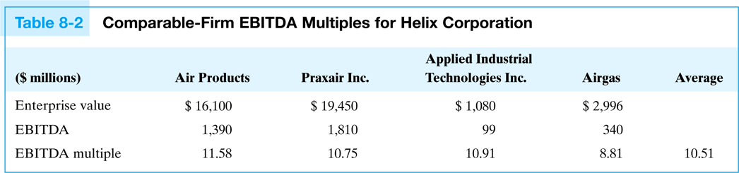

**EV/EBITDA=Multiple

- The average EBITDA multiple for comparable firms is 10.51.
- If Helix anticipates earning $10 million in EBITDA this year, then our initial estimate of the firm’s enterprise value is $10 million × 10.51 = $105.1 million.
- Helix has a cash balance of $2.4 million and owes interest-bearing debt totaling $21 million. The value of Helix’s equity is 105.1 – 21 + 2.4 = $86.5 million.
- Note typically discount for private firm valuation

Rationale for Liquidity Discount

- 20-30% liquidity discount for privately held firms:
  - Recommended adjustment if market-based EBITDA multiples (taken from a sample of publicly held firms) were used in the target company valuation.
    - Private companies often sell at a discount to their publicly traded counterparts since they cannot be sold as easily.
  - Discount is typically attributed to the fact that the shares of privately held firms are less liquid (i.e., harder to sell) than those of public firms.

Rationale for Control Premium

- 30%+ control premium for strategic acquisition
  - When there are benefits (or synergies) from control, valuations often feature control premiums, which can enhance the value of an acquisition target by 30% or more.
  - Don’t double-count!
- The amount of any control premium paid will depend upon the relative strength of the bargaining positions of the buyer and seller.
- Mergerstat® and SDC Platinum are two sources that publish premium data from past merger and acquisition transactions for controlling and minority equity interests

Example: Valuing XOM Chemical Division Using the P/E Method

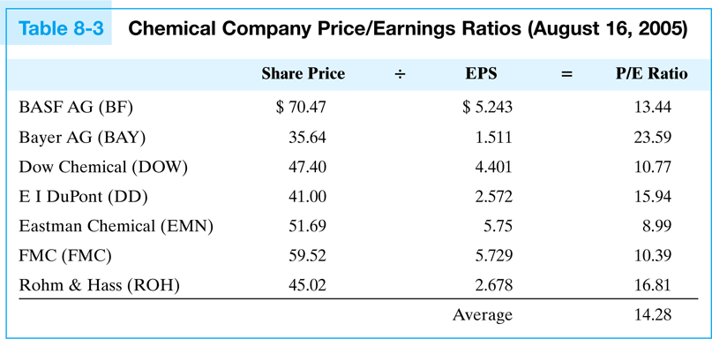

- Suppose that Exxon-Mobil (XOM) was considering the sale of its chemical division via an initial public offering.
- How much can they expect to receive for the sale of the equity?
- Applying an average P/E ratio of 14.28x from similar firms, to the chemical division’s earnings of $3.428B, implies that as a first approximation, ExxonMobil’s chemical division is likely to be worth about $48.94B

Refining the Valuation Estimate

- If we closely scrutinize the market comparables, are they really similar to ExxonMobil’s chemical division?
- Does Size Matter?
  - The revenues of ExxonMobil’s chemical division make it the 3rd largest chemical company in the world.
  - If firm size is an important determinant of P/E ratios, then the appropriate comparison group would consist of the very largest firms from the industry.
  - Based on market capitalizations, the 4 largest firms include BASF AG, Bayer AG, Dow Chemical, and E I DuPont. The average P/E multiple for these four firms is 15.935x
  - If we apply this multiple to the valuation of ExxonMobil’s equity in the chemical division, our valuation increases the estimate to $54.63B.

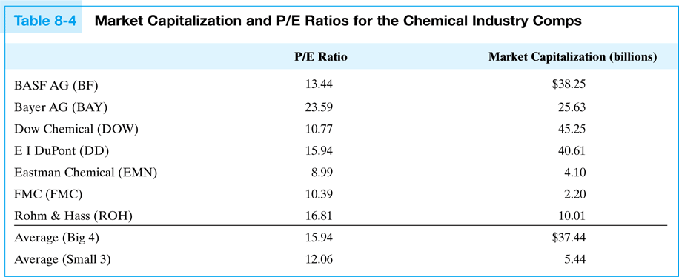

Pros and Cons of Comparable Company Analysis
Pros:
Market based – reflects market’s growth and risk expectations, as well as overall sentiment
Relative – Easily measurable and comparable to other companies
Quick and convenient
Current – Based on prevailing market data

