Analysis of correlation between diameter breast height, canopy cover, percentage of bare ground and abundance of ferns on the distribution of tree species and their levels of secondary succession in Gatineau Park, Quebec.

Section A3-A

Demonstrators:
Mark Giles, Olga Koppel and Dylan Longert

October 25, 2018

Department of Biology

University of Ottawa
Abstract:
The purpose of this lab was to have the ability to identify various trees within Gatineau Park and to analyze patterns in abundance of species based on factors of secondary succession within a temperate mixed-forest ecosystem. To observe these succession patterns, the number of species present in various sites in Gatineau Park, Quebec was counted. The sites observed were site 1 transect 4 and site 2 transect 2. Some of the measurements taken included diameter at breast height (dbh), through measuring the diameter of trees, and canopy cover using a densiometer. The results found that there was minimal variance within each transect, there is statistically significant variability in the distribution of species in the park, however sugar maple is abundant in both sampled locations, and finally the lack of variability between percentages of canopy cover, bare ground, and fern abundance leads to a correlation between these three factors.
Materials and Methods
Refer to (Currie et al. 2015)
Modification: Site 3b has the radius of each quadrat measured as 3.5m

Introduction: This lab is based on finding patterns of secondary succession based on biological information being collected in relation to the known human modifications within Gatineau Park. The human modifications to this area resulted in secondary succession due to each area being affected by a different modification and adopting a certain re-growth pattern based on the characteristics of the original ecosystem. The four different sites being sampled have all been affected by human activity and then abandoned at different periods in time. Site 1 was selectively logged at various times up until 1958. The site has been abandoned with minimal human disturbance for around 60 years. Site 2 was an agricultural field that was abandoned by 1950. Site 3a and 3b were part of a red pine plantation, however the soil was unsuitable for red pine growth and the plantation was abandoned in 1968. Site 4 was in an area where the vegetation was cut down due to a phone line going through it. The vegetation was cut until 1983, and then the line was abandoned. In each quadrat every tree species was identified, and the diameter breast height (dbh) of every tree with a dbh of 2 cm or greater was recorded. As well, for every quadrat the ground cover, cover canopy and amount of fern cover were estimated. T-tests and chi squared tests are used to determine relative abundance percentages.
There are 4 null hypotheses being tested in this study. The first being that there is no variability in the distribution of the quadrats within each transect. The second being that there is no variability of distribution of the three most common species at Site 1, transect 4 and Site 2, transect 2. The third being that there is no variability of distribution the most abundant species at Site 1, transect 4 and Site 2, transect 2. The fourth being that there is no variability between the percentage of canopy cover, bare ground and fern abundance between Site 1, transect 4 and Site 2, transect 2, respectively for each factor.
Keywords: succession, diameter breast height, t-test, chi squared test, abundance
a)

Table 1: This table includes a t-test comparison of quadrats 1+2, 1+3 and 2+3 of site 1 transect 4 for the mean dbh and standard deviation of the three most abundant tree species with a dbh greater than (or equal) to 2cm. (n=3)
b)
Figure 1: In part a), this figure represents the relative abundance percentage of all species with dbh greater than (or equal) to 2cm at Site 1, Transect 4 of old field, part b) represents relative abundance of all species with dbh smaller than 2cm at Site 1, Transect 4

Percentage of Relative Abundance (%)
ª – alpha = 5%, Critical T value varies with degrees of freedom (see appendix for calculation)
 |  |  |  | t-test
Tree species | Quadrat comparison (N) | Mean and (SD) | Calculated t value | Critical t valueª | Null Hypothesis
Sugar Maple | 1+2 | 1: 33.99 (24.795)  2: 16.24 (13.863) | 1.100785 | 2.5706 | Fail to Reject
 | 1+3 | 1: 33.99 (24.795)  3: 20.32 (19.015) | 1.096409 | 2.201 | Fail to Reject
 | 2+3 | 2: 16.24 (13.863)  3: 20.32  (19.015) | -0.3379 | 2.2281 | Fail to Reject
Ironwood | 1+2 | 1: 5.27 (1.739)  2: 7.565 (5.296) | -0.582219 | 4.3027 | Fail to Reject
 | 1+3 | 1: 5.27 (1.739)  3: 8.30  (2.687) | -1.338704 | 4.3027 | Fail to Reject
 | 2+3 | 2: 7.565 (5.296)  3: 8.30 (2.687) | -0.175025 | 4.3027 | Fail to Reject
Beech | 1+2 | 1: 5.85 (0.4950)  2: 5.20 (0.7332) | 1.067827 | 3.1824 | Fail to Reject
 | 1+3 | 1: 5.85 (0.4950)  3: 7.90  (0.9899) | -2.61939 | 4.3027 | Fail to Reject
 | 2+3 | 2: 5.20 (0.7332)  3: 7.90 (0.9899) | -3.56898 | 3.1824 | Reject

Figure 2: This figure is a comparison of the relative abundance percentage pooled over quadrats of the three most common tree species found in Site 1 Transect 4 and Site 2 Transect 2 with a dbh equal to or greater than 2 cm. n = 3.

Figure 3: This figure is a comparison of the relative abundance percentage pooled over quadrats of the three most common tree species found in Site 2 Transect 1 and Site 3b Transect 2 with a dbh equal to or less than 2 cm. n = 3

Table 2: dbh of equal to or greater than 2cm at site 1, transect 4 and site 2 transect 2 for the 3 most abundant species; Sugar Maple, Red Pine and Beech. Includes the expected species number, difference for all species, partial contribution to Chi², values critical Chi², values for total Chi² and a statistical conclusion, column total, row total and overall total. n = 3
Location | Most common species | Observed  count | Expected  count | Difference | Partial contribution to Chi² | Column total | Row total | Total | Critical chiª | Total chi | Null Hypothesis
Site 1  transect 4 | Sugar Maple | 16 | 13.24 | 2.76 | 0.57 | 16 | 23 | 66 | 5.99 | 15.95 | Reject
Site 1  transect 4 | Red Pine | 0 | 6.27 | -6.27 | 6.27 | 0
Site 1  transect 4 | Beech | 7 | 3.48 | 3.52 | 3.55 | 7
Site 2  transect  2 | Sugar Maple | 22 | 24.76 | -2.76 | 0.31 | 22 | 43
Site 2  transect  2 | Red Pine | 18 | 11.73 | 6.27 | 3.36 | 18
Site 2  transect  2 | Beech | 3 | 6.52 | -3.52 | 1.90 | 3
ª alpha = 0.05, degrees of freedom = 2

Table 3: This table includes a t-test comparison of the threeª most common species found in site 1 transect 4 and site 2 transect 2. Weighted mean dbh, and pooled standard deviation (SD) included. (n=3)
 |  |  | t-test
Species | Site | Weighted mean and SD | Calculated t value | Null Hypothesis^{b}
Sugar maple | 1 | 22.97 (19.848) | 0.827900999 | Fail to Reject
 | 2 | 12.42  (9.6795)
ª only one species (Sugar maple) is comparable between sites for this table. Other two species were not found to be abundant in both sites.
^{b} alpha = 0.05, degrees of freedom = 4, critical t = 2.7765

Table 4: This table includes a t-test comparison between site 1 transect 4 and site 2 transect 2 for percent bare ground, percent of quadrat covered by ferns and percent canopy closure. Mean and standard deviation (SD) are present. (n = 3)
 |  |  | t-test
 | Site | Mean and SD | Calculated t value | Null Hypothesisª
% bare ground | 1  2 | 67.51  (8.3134)  61.44618  (11.469) | 0.741926 | Fail to Reject
% fern coverage | 1  2 | 13.16  (5.1567)  25.78  (15.973) | -1.30282 | Fail to Reject
% canopy closure | 1  2 | 75.29  (5.0200)  64.34  (17.764) | 1.0279 | Fail to Reject
ª alpha= 0.05, degrees of freedom = 4, critical t = 2.7765

Results:
Figure 1 shows that sugar maple is the species with the highest abundance out of all species both with a dbh greater (or equal) to 2cm and with a dbh smaller than 2cm. Additionally, ironwood and white ash are abundant only relative to species with dbh greater (or equal) to 2cm. Glossy buckthorn is only abundant relative to species with dbh less than 2cm.
Figure 2 shows that sugar maple is the species with the highest relative abundance compared to other species in Site 1 and Site 2 with dbh greater (or equal to) 2cm and is more abundant in Site 2 than in Site 1. It also shows that beech is less abundant in Site 2 than in Site 1 and that ironwood is only abundant in Site 1 while red pine is only abundant in Site 2.
Figure 3 shows that sugar maple is the species with the highest relative abundance compared to other species in Site 1 and Site 2 with a dbh less 2cm, however it is more abundant in Site 1 than in Site 2. It also shows that glossy buckthorn and European buckthorn are more relatively abundant in Site 2 than in Site 1 for species with a dbh less than 2cm but both species in both sites are still much less abundant than sugar maple for these parameters
Table 1 shows that for the sugar maple, ironwood and beech, the three most abundant tree species with a presence in all three quadrats in site 1 transect 4, there is no significant difference in the distribution between these species in between the quadrats, except for in Beech between quadrat 1 and 2.
Table 2 shows that by comparing the critical chi and the total chi, there is a difference in distribution of the three most abundant species with dbh of greater (or equal) than 2cm between Site 1 and Site 2
Table 3 shows that for the sugar maple, the only one of the three most abundant tree species with an abundant presence in site 1 and site 2, there is no significant difference in the distribution of this species between the two sites.
Table 4 shows that there is not a significant difference between the % of bare ground, % of fern coverage and % of canopy coverage between Sites 1 and 2
Discussion:
Figure 1 shows that sugar maple, which is found on both graphs a) and b), has been present in the forest historically but also many new sugar maple trees are growing, due to the correlation between dbh and age. Species that are only found in graph a), such as ironwood, are due to them exceeding a dbh of 2cm early in growth or perhaps bacterial or fungal infection is preventing their growth, and conversely, species that are only found in graph b), like choke cherry, are due to plants that never reach a dbh of 2cm, or plants that have been newly introduced to the forest.
Table 1 show that sugar maple, ironwood and beech abundances do not differ between the quadrats most likely due to the quadrats being small within the same site. A single site will have the similar environmental conditions within its quadrats, leading to the same growth patterns, but for beech in quadrats 2+3, the difference may be due to local cutting or disease within quadrat 2. In Figure 2 displays that there is a higher abundance of sugar maples in site 2 than in site 1, which maybe due to the selective cutting of Site 1 in 1958, but also due to the abundance of Red Pine in Site 2. The abundance of Red Pine in Site 2 could be due to it proximity to the 1968 red pine plantation, but outside of the disappearance zone, while ironwood and beech preferring Site 1 could be due to differences in soil, water quantity or just lack of space to germinate, due to high levels of sugar maple. Figure 3 shows that Sugar Maple is by far the most abundant species with a dbh smaller than 2 cm, however it is more relatively abundant in Site 1, this is due to other abundant species under dbh 2cm being present in Site 2. Glossy buckthorn and European buckthorn are found more frequently in Site 2 due to the selective cutting in Site 1 in 1958. Table 2 shows that there is a difference in distribution between the 3 most abundant species found in Site 1 and Site 2, which is most likely due to human activity, soil characteristics and water quantities differing between the two sites. The change in distribution is most likely due to Site 2 being on an abandoned agricultural field, which affects soil quality and Site 1 being untouched for 60 years, though these happen over 50 years ago, the long lifespan of a tree ensures that these changes will continue for generations. Table 3 displays that the distribution of sugar maple is the same between Site 1 and Site 2, most likely due to the high abundance of sugar maple normalizing the effects of human activity and sugar maple’s tolerance to different types of soils. The high abundance of sugar maple leads to high fertilization and germination rates of the plant, so its abundance in site 1 allows the tree to normalize its distribution in other Sites due to the spread of its abundant seeds. Table 4 shows us that there is no significant difference between percentage of bare ground and percentage of fern coverage, which is most likely due to canopy closure, which can be associated with this lack of deviation because it correlates both factors, and it regulates amounts of light which reach the ground, affecting fern coverage and bare ground percentage. (Q1) Any differences that exist between quadrats in a transect would be due to different environmental conditions at each quadrat. Despite the proximity of each quadrat, factors such as canopy cover, elevation seed dispersal can vary. Canopy cover affects the amount of light that is available which can affect species distribution. Shade intolerant species will not be able to grow in forested areas with low levels of light. As well, seed dispersal is a random process that can affect the distribution of species in a certain transect. As for elevation, certain transects can be found on hills, such as Site 1, so its quadrats could differ in distribution due to species at the bottom and top of the hill receiving different amounts of water. (Q2) Site 1 and Site 2 differ in species composition, which can be seen in table 2, the three most abundant species in both sites have different distributions. This is due to the history of both sites, for example Site 1 was selectively logged until 1958 has had no human disturbance since then, while Site 2 was part of an agricultural field that was abandoned in 1950. (Q3) There are many physical differences between Site 1 and Site 2 that can be inferred based on their history and observations. Site 1 is on a hill, and its topography affects water drainage and the dispersal of seeds, so water can flow downwards through the hill and be shared more equally, and gravity aids the seeds of Site 1 to disperse further down the hill. Site 2 was an agricultural field in the past, so its soils are lacking in nutrients, which affects species survivability due to some species requiring more nutrients than others, this is an example of secondary succession. (Q4) The differences in sizes between the trees in different sites could be due to the time at which that site was abandoned in the past and how long it has gone without human modification. Larger trees would therefore be found in sites that have been left untouched longer. At sites that have been left untouched for a shorter amount of time they will contain smaller trees. (Q5+6) If there were no more major disturbances at these sites it would mean that they would attain their climax communities. Due to the light availability the species more tolerant to shade would be dominant. Shade intolerant species, on the other hand, would become scarcer. One would see that sugar maple as the dominant species at each of these sites. Due to this tree being a shade tolerant species (Snyder, 2010) and there being lots of canopy cover at these sites. (Q7) Even though site 1 has not been disturbed in many years the Eastern white pine has not recolonized this area because as a matured tree Eastern white pine is very shade intolerant. This means that in present conditions (high % canopy cover) at each of the sites, they would not thrive as mature trees and therefore cannot recolonize this area despite being a dominant tree in the past (Clatterbuck, 2006). (Q8) While other trees such as the sugar maple, which is very shade tolerant, dominate in this area. Site 3b is planted on top of an old ride pine plantation that was planted in the 1960’s. The needles of the pines cause a higher acidity in the soil when they fall on the ground. This in turn causes most species to not be able to thrive in these soils, explaining the lack of ground cover. However, ferns are well-adapted to soil acidity. (Hill and Silander, 2001). Overall the data did correlate with the hypotheses posed at the beginning of the report. Table 1 displayed that within quadrats, there is not a high level of variability for the average dbh of the species. Table 2 displays the trend that there is significant variability of the three most abundant species when comparing two different sites, so the null hypothesis is rejected through the chi squared test. Table 3 shows that there is no variability between the same species at different sites. Table 4 shows that bare ground, fern coverage and canopy closure respectively do not have a high variance in their percentages between sites 1 and 2. Some sources of error for this lab include incorrect identification of species and improper estimation of bare ground percentage and percent fern coverage. This could be improved by having the proper knowledge and background required to identify species. This becomes more apparent when considering the “unknown” label present in the raw data, it is possible that species that were being measured could have been altered by their environment and considered to be an unknown plant. As explained by (Horn, 1974), after a significant disturbance an ecosystem will undergo secondary succession, which can be seen by Site 2’s distribution in the past 50 years after the plantation was abandoned.
Accepting the null hypothesis for Table 1 helps this keeps the data consistent and allows comparison between different sites, knowing that within the sites the distribution is not variant. Rejecting the null hypothesis for Table 2 allows further interpretation of the variable distribution of compared. Accepting the null hypothesis for Table 3 is descriptive of the distribution of the forest because it illustrates the abundance and similarity of the sugar maple in Gatineau Park. Finally, the acceptance of the null hypotheses in Table 4 shows the correlation between these three environmental factors (canopy cover percentage, fern percentage and bare ground percentage) through their consistency through different sites throughout the forest.
Appendix:
T-test Calculation: t-test is based on Table 1 – comparing quadrats 1 and 2 of Sugar Maple
µ₁ = µ₂, (null hypothesis is 0),
Let Ȳ₁ = 33.99 Ȳ₂ = 16.24
s₁ = 24.795 s₂ = 13.863 $n_{1}$ = 3 $n_{2}$ = 3
$$t_{s}= \frac{\left(Y1-Y2\right)- {(µ}_{1}- µ_{2})}{\sqrt{(\frac{\left(n1-1\right)s1^{2}+\left(n2-1\right)s2^{2}}{\left(n1+n2-2\right)})(\frac{n1+n2}{n1n2})}}$$
$$= \frac{\left(33.99-16.24\right)-0}{\sqrt{(\frac{\left(3-1\right){24.795}^{2}+\left(3-1\right){13.863}^{2}}{\left(3+3-2\right)})(\frac{3+3}{3(3)})}}$$
= 1.100785
Sample Calculation - Weight Average and Pool Standards Deviation
Based off Table 1, for Sugar Maples in site 1
Weighted Average
$n_{1}$= 4 ${\overset{⃛}{x}}_{1}$= 33.99
$n_{2}$= 3 ${\overset{⃛}{x}}_{2}$= 16.24
$n_{3}$= 9 ${\overset{⃛}{x}}_{3}$= 20.32
$${\overline{x}}_{j}= \frac{1}{\sum_{j=1}^{3}{n_{j}}}\sum_{j=1}^{3}{n_{j}{\overset{⃛}{x}}_{j}}$$
$${\overline{x}}_{j}= \frac{1}{16}\left(4\left(33.99\right)+3\left(16.24\right)+9\left(20.32\right)\right)$$
= 22.2975
Pool Standard Deviation
$n_{1}$= 4 ${SS}_{1}$ = 24.795
$n_{2}$= 3 ${SS}_{2}$ = 13.863
$n_{3}$= 9 ${SS}_{3}$ = 19.015
$$S_{p}=\sqrt{\frac{\sum_{j=1}^{3}{SS_{j}}}{\sum_{j=1}^{3}{(n_{j}-1)}}}$$
$$= \sqrt{\frac{24.795+13.863+19.015}{\left(4-1\right)+\left(3-1\right)+(9-1)}}$$
$$s_{p}= 2.10627$$

Chi²Sqaure Sample Calculation – from Table 2 Species
Site A | 1 | 2 | 3 | Total
 | 16 | 0 | 7 | 23
Site B
 | 22 | 18 | 3 | 43
Total | 38 | 18 | 10 | 66

For Site A, Species 1
Expected Value = (row total of species 1 X column total of Site A)/overall total)
= (38x23)/66
= 13.24
Partial Contribution
Based off Site 1, species 1
Observed = 16 Expected = 13.24
Difference = (Observed-Expected)
= 2.76
Partial Contribution = (Observed-Expected)²/Expected)
= (16-13.24) ²/13.24
= 0.575
Total Chi² = Sum of all Partial Contributions
= Sugar Maple A + Red Pine A + Beech A + Sugar Maple B + Red Pine B + Beech B +
= 0.57 + 6.27 +3.55 + 0.31 + 3.36 + 1.90 = 15.95

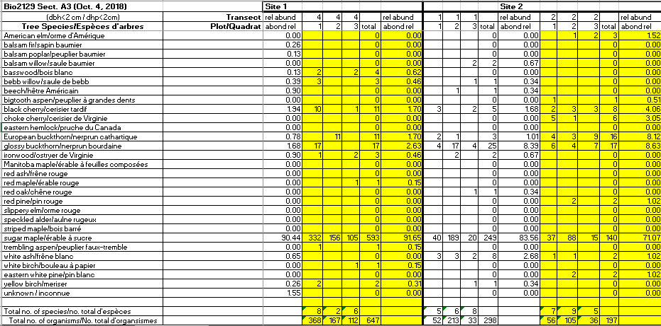
Raw Data:

:

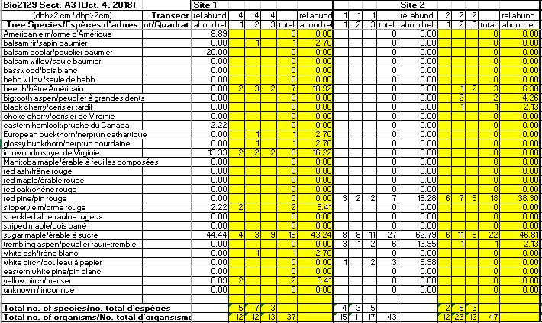
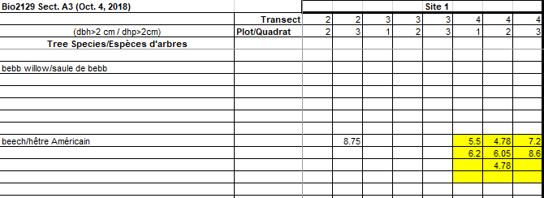

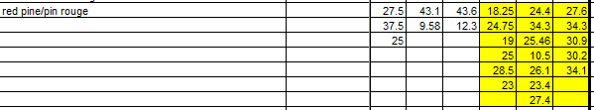

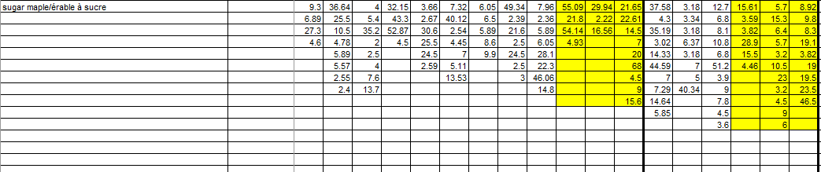

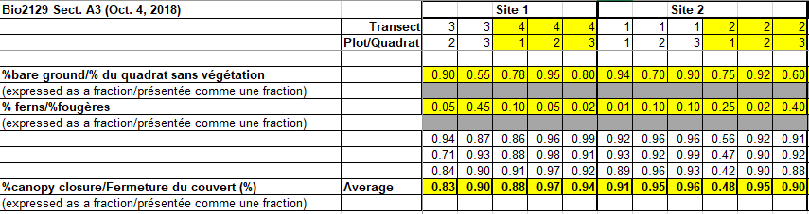

References:
Clatterbuck, W. (2006) Shade and Flood Tolerance of Trees. University of Tennessee Extension. Retrieved from; https://extension.tennessee.edu/publications/Documents/SP656.pdf
Currie, D., Findlay S., Heinermann, P., Kerr, J. (2017). BIO 2129 Ecology Lab Manual. Ottawa, ON: University of Ottawa
Hill, J. and Silaner, J. 2001. Distribution and dynamics of two ferns: Dennstaedtiaceae and Thelypteridaceae in a northeast mixed hardwoods-hemlock forest. American journal of Botany 88: 894-901
Horn, H. S. (1974). The Ecology of Secondary Succession. Annual Review of Ecology and Systematics, 5(1), 25-37. doi:doi.org/10.1146
Snyder, M. (2010). What is shade tolerance and why is it so important? Northern Woodlands. Retrieved from; http://northernwoodlands.org/articles/article/what-is-shade-tolerance-and-why-is-it-so-important

