Major Claim: ON BUSINESS SUCCESS
Successful firms capitalize on economies of scale and scope; they have a functional management structure and invest in research and development and grow from related diversification. This will allow them to stay ahead of competition.

Companies that initially dominate a market (through economies of scale and/or scope) can benefit from their “First Mover” advantage, but:
- Once a firm loses the opportunity to be a first mover, it is difficult to regain competitive advantage
- Entrepreneurial companies that do not make investments to create organizational capabilities cannot achieve long-term success
Growth through unrelated diversification is a poor corporate strategy
Business ownership patterns have diminishes the likelihood of long-term success
In competitive battles, Innovation and Strategy are more powerful weapons than Price

Flow of materials must be kept constant!
Economies of scale: doing things at a bigger scale reduces costs. Large plants can produce products at a
much lower cost than small ones
because the cost per unit drops as the
volume of output rises
Economies of scope: Large plants can use many of the same raw and semi-finished materials and intermediate production processes to make a variety of different products
Managerial enterprise: Making necessary investments in management, production and distribution in order to capitalize in economies of scale and scope.

Major Claims
To benefit from economies of scale and economies of scope, organizations invest in:
- National (and international) marketing and distribution functions
- Teams of lower and middle managers
- Innovation & Strategy (Research & Development)
= First movers: quickly dominated their industries by making large investments and gaining comp advantage. (high market share)
Major Claim: ON EVOLUTION AND GROWTH
Organizational growth is done in 5 phases and by implementing the right strategies and managerial structures, they can resolve the crisis and move on.
* Each phase begins with a period of evolution and has its moments of stability and growth but eventually ends with a revolutionary period.
* Managerial problems and practices are rooted in time – they do not last throughout the life of an organization
* Management practices that work well in one phase can bring crisis and chaos in another.
Chandler
Greiner
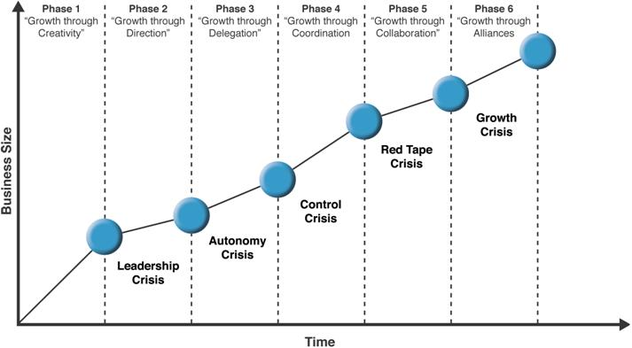
Secondary claim:
- Top managers should try to recognize where they are and anticipate where they need to go in the developmental sequence
- Organizations should not try to skip phases.
- Top managers whose style in no longer appropriate should remove themselves.
- Growth is not inevitable.
Solutions to crises:
1. Find strong manager with knowledge & skill to lead.
2. Work
3. Special coordination
4. Collaboration
5. ?
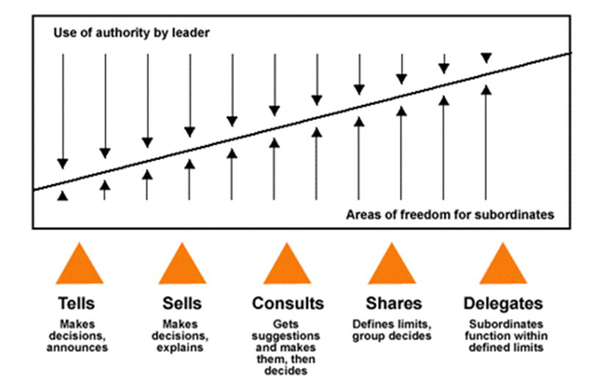
MAJOR CLAIM: ON LEADERSHIP
A successful are insightful and flexible and accurately assess the forces that determine appropriate behaviours at any given time and being able to act accordingly. He does not see problems of leadership as a dilemma.

Continuum leadership model shows the relationship between the level of freedom that a manager chooses to give to a team and the level of authority used by the manager.
Team’s freedom ↑ manager’s authority ↓
There are 3 forces that impact the manager’s choice of managerial style that are practical and desirable.
1. Forces in the manager:
(a) Their value system (how they feel about individuals making decisions).
(b) Their confidence in subordinates (can they be trusted?).
(c) Their leadership indicators (how they feel about giving orders).
(d) Their feelings of security in an uncertain situation.
2. Forces in the subordinate:
(a) High need for independence.
(b) Readiness to assume responsibility to decision making.
(c) Likes receiving orders VS likes more freedom. (d) Importance they put via company problems (their interest).
(e) Have necessary knowledge and experience to deal with problems.
(f) Expectations in decision making.
3. Forces in the situation:
(a) Types of organization (values & traditions).
(b) Group effectiveness (experience, degree of confidence).
(c) The problem itself (determine how much authority to give).
(d) Pressure of time.
(e) Long-run strategy (shift thinking from tactics to large-scale strategy).
(f) Objectives to be attained.
They will choose the behavioral style that will be the most effective in attaining immediate goals within limits facing them.

- TELLS - The manager makes the decision and announces it
  - Identifies the problem, considers options, makes the decision and presents it.
  - No opportunity for the subordinates to participate in the decision-making process
- SELLS - The managers `sells` his decision
  - Identifies the problem, considers options, makes the decision and presents it.
  - Explains the decision, hoping to persuade the subordinates to accept it.
- SUGGESTS - The manager presents the idea, invites questions
  - Identifies the problem, considers options, makes the decision and presents it.
  - Explains the decision, hoping to persuade the subordinates to accept it.
  - He invites questions, providing the subordinates with the opportunity to understand the reasoning behind the decision
- CONSULTS - The manager presents a tentative decision subject to change
  - Identifies the problem, considers options and makes the TENTATIVE decision.
  - Consults with the subordinates for possible issues with the decision
  - The final decision is still the manager`s
- JOINS - The manager presents the problem, gets suggestions and makes decision
  - Identifies the problem.
  - Consults subordinates for solutions.
  - Manager makes decision.
- DELEGATES - The manager defines the limits and requests the group to make a decision
  - Identifies the problem and the boundaries to be respected in the solution.
  - The group (including the manager as member) takes the decision.
- ABDICATES - The manager permits the group to make decision within prescribed limits
  - Same as above but manager is not part of the group

6
7
345
2
1
CONTINUUM LEVELS
Tannenbaum & Schmidt
Collin & Porras – Building your Company’s Vision
Vision: provides guidance about what core to preserve and what Future to simulate progress toward.

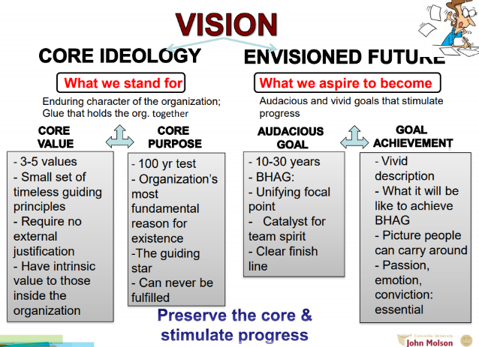

Core ideology
It is the glue that holds the organization together as it grows, diversifies, and expands globally. It is the consistent identity of the organization that transcends the product or market life cycles.

Core values:
Code of ethics, How we do business

Core purpose: (reason for existing)
Reason for being people’s; idealistic motivations for working at the company
Discovering Core Ideology:

- You do not create or set core ideology
- Description of what actually exists, not just what we wish existed
- Needs to be meaningful and inspirational only to people inside the organization
- Find people who are predisposed to share the organization’s core values and purpose
- More than creating a perfect statement!

* A clear and well-articulated ideology attracts people whose personal values are compatible with the company’s core values.

Core values & core purpose: attract & retain those people.
ON THE MANAGERS JOB
Myth: Managers plan, organize, coordinate and control
The manager’s job can be described in terms of various ‘’roles’’, or organized set of behaviours identified with a position
Henry Mintzberg

The Nature of Managerial Work (6 characteristics)
1. The manager’s job is a mixture of regular programmed jobs and unprogrammed jobs/tasks.
2. A manager is both a generalist and a specialist.
3. Managers rely on information from all sources but show a preference for that which is orally transmitted.
4. Managerial work is made up of activities that are characterized by brevity, variety, fragmentation.
5. Management work is more an art than a science and is reliant on intuitive processes and a feel for what is right.
6. Management work is becoming more complex.

3 categories of manager roles/expectations

3. Decisional: managing through action
a) Entrepreneur: seeks to improve organization and to adapt it to changing conditions in the environment.
b) Disturbance: deals with disputes or problems and takes corrective action.
c) Negotiator: negotiates with individuals and dealing with other organizations. Defends business interests.
2. Interpersonal: managing through people
a) Monitor: collecting all types of info that is relevant and useful to the organization.
b) Dissemination: transmit some privileged information directly to subordinates, who would otherwise have no access to it.
c) Spokesperson: transmit info from within the organization to outsiders.

1. Informational: managing by information
a) Figurehead: head of an organization, and must perform some ceremonial duties. Role may sometimes be routine, involving little serious communication.
b) Leader: Establish the atmosphere and motivate the subordinates. Are responsible for the work of its people
c) Liason: developing and maintaining webs of contacts outside the organization.

Becoming a more effective manager:

- Be aware of the roles you prefer. Stretch beyond those you’re most comfortable with, depending on what the situation demands.
- Reduce workload by giving subordinates the information they need to be more self-sufficient.
- Avoid superficial decision making by taking advantage of expert analysts.
- Force yourself to do things you believe are important.

ON SOCIAL POWER
Theory that identifies 5 bases or sources of social organizational power.
“who holds it over whom”

French & Raven

4. REFERENT power: based on one’s identification with the other
Is the influence one has on others from being well liked or respected by others.
Ex: Avoids discomfort or gains satisfaction from conformity
The greater the attraction, the greater the power.
5. EXPERT power: based on one’s perception that the other has some special knowledge or expertise
Ex: Conformity with major opinion
Credibility and trust necessary
Limited to field of knowledge

Range: on how many people O can exert his power
1. For all five types, the stronger the basis of power the greater the power.
2. For any type of power the size of the range may vary greatly, but in general referent power will have the broadest range.
3. Any attempt to utilize power outside the range of power will tend to reduce the power.
4. A new state of a system produced by reward power or coercive power will be highly dependent on O, and the more observable P's conformity the more dependent the state. For the other three types of power, the new state is usually dependent, at least in the beginning, but in any case the level of observability has no effect on the degree of dependence.
5. Coercion results in decreased attraction of P toward O and high resistance; reward power results in increased attraction and low resistance.
6. The more legitimate the coercion the less it will produce resistance and decreased attraction.

3. LEGITIMATE power: based on one’s perception that the other has a legitimate right to prescribe behaviour for him.
Obligation to accept influence
Bases:
1. Cultural values (age, intelligence, caste, physical charac)
2. Acceptance of social structure
3. Designation by legitimizing agent (ex: election)

1. REWARD power: based on one’s perception that the other has the ability to mediate rewards for him
Result in independent system. Increase attraction
Ex: Conforms in order to gain praise

2. COERSIVE power: based on one’s perception that the other has the ability to mediate punishments on him
Ex: Conforms in fear of ridicule

Not valuable = Competitive Disadvantage
Valuable, but not rare = Comparative equality
Valuable and Rare = Competitive advantage
Valuable, Rare, but not costly to imitate = Temporary competitive advantage
Valuable, rare, and costly to imitate = Sustained competitive advantage
* A firm’s resources and capabilities include all of the financial, physical, human and organizational assets used by a firm to develop, manufacture, and deliver products or services to its customers.
- Financial: debt, equity, retained earnings
- Physical: machines, manufacturing facilities.
- Human; experience, knowledge, judgement, wisdom.
- Organizational: history, relationships, trust, culture, formal reporting structure, patents.

ON INTERNAL RESOURCES AND CAPABILITIES
- A frim will have a sustained competitive advantage if its resources and capabilities are valuable, rare, inimitable, and organized in a way that allows to exploit potential opportunities.
- A firm will be successful if it has resources with the right attributes and characteristics.
- The most careful and complete analysis of firms’ competitive environments cannot, by itself, explain their success.
- Strategists also need to analyze the competitive implications of firms’ internal strengths and weaknesses.

Jay Barney

Four Important questions about resources and capabilities
1. The Question of Value: Does a firm’s resources and capabilities enable it to exploit an opportunity, and/or neutralize it?
2. The Question of Rareness: How many competing firms already possess these valuable resources and capabilities?

3. The Question of Imitability: Do firms without a resource or capability face a cost disadvantage in obtaining it compared to firms that already possess it? Duplication or Substitution
There are 3 reasons why resources can be hard to imitate:

4. The Question of Organization: Is a firm organized to exploit the full competitive potential of its resources and capabilities? Formal reporting structures, Management control system, Compensation policies, etc.

a. Historical conditions: Valuable and rare resources acquired of developed through unique historical circumstances can be costly to imitate and thus a source of sustained competitive advantage.

b. The importance of numerous small decisions: A firm’s competitive advantage seems to depend on numerous “small decisions” through which a firm’s resources and capabilities are developed and exploited in developing, nurturing and exploiting resources.

c. The importance of socially complex resources: The resources and capabilities that are based on a company’s culture or interpersonal relationships (reputation, trust, friendship, teamwork, and culture) (patents are much harder to imitate).

Kaplan and Norton
Major Claim: ON PERFORMANCE MEASUREMENT AND EVALUTATION
The scorecard tracks the key elements of a company’s strategy
Balanced Scorecard: Performance measurement tool
- A set of measures the gives top managers a fast but comprehensive view of the business
The balanced scorecard is a strategic planning and management system that is used extensively in business to align business activities to the vision and strategy of the organization, and monitor organization performance against strategic goals.

4 perspectives for a balanced scorecard

1. The Financial Perspective ‘bottom line’:
How can we ensure profitability for shareholders? How do we look to them? To succeed financially, how should we appear to our shareholders?

2. The internal business perspective:
Refers to the internal business process. Metrics based in this perspective is running, and whether its products and services conform to customer requirements. Metrics must develop and be designed by people within the company that knows these processes well. How can we produce to meet customer expectations?

4. The custom perspective:
What matters most to customers? How do customers see us? (Specific measures, includes numbers, that reflect the factors that really matter to customers) To achieve our vision, how should we appear to customers?
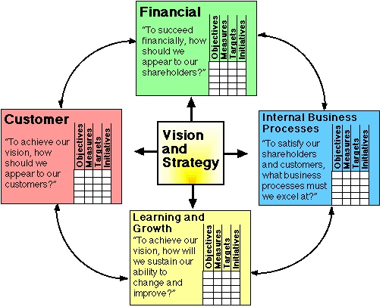

For competitive success

3. Innovation & learning perspective:
How can we make continual improvements? Can we continue to improve and create value? (Improve existing products, launch new ones, and create more value for customers.....)To achieve our vision, how will we sustain our ability to change and improve?
Learning and growth are the essential foundation to success of any knowledge-worker organization. (Relates to chandler continue to improve our products

Handy and the Sigmoid curve
Sigmoid curve: ON MANAGING CHANGE
The secret to constant growth is to start a new sigmoid curve before the first one begins to diminish. When a company is left at a point B, new people will be able to lift the organization to the second curve.
The second curve: (proceed by guess and assumption)

The discipline of the second curve
- requires that you always assume that you are near the peak of the first curve, at point A, and should therefore be starting to prepare for second curve.
If assumption turns out to be wrong, nothing has been lost. Only the exploration phase of the second curve has been done. No major commitments will have been done until curve 2 overtakes curve 1, which won’t happen if curve 1 is on the rise.

- Keeping the 2 curves going will become a habit.
- Benefits of the discipline of devising the 2nd curve. The discipline of the second curve keeps one skeptical, curious, and inventive- attitudes that are essential in a time of change.
- The second curve follows the traditional four-stage cycle of discovery:
- Questions start it off! Ideas, possibilities, hypotheses Experimenting Reviewing

- Let go of your past: DO NOT re-invent the same life because that would perpetuate the first curve. The second curve is always different, although it builds on and grows out of the first curve.

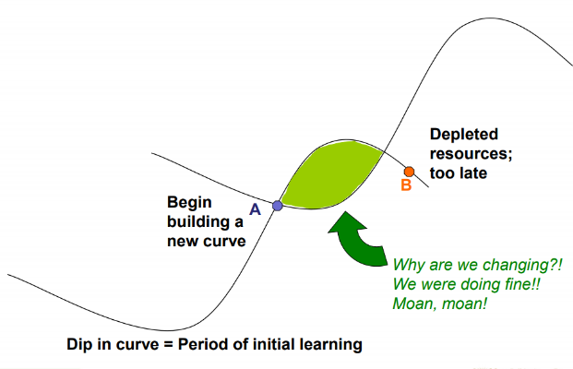
Conflict
Energy for a change but
Turmoil: time of great Confusion, anxiety
What got you where you are won’t keep you where you are
Paradox of success
Paradox of time
-By the time you know where you need to go, it is already too late.
-If you keep on going the way you are, you will miss the road to the future
Curvilinear logic:

• It is the conviction that the world is a sigmoid curve,
that everything has its ups and downs, and that
nothing lasts forever or was there forever.
• It means starting life again, and it is harder as you
become older
• Entrusting the curvilinear thinking to the next
generation
• « Kaizen »: Continuous Improvement
The secret of balance in a time of paradox is to allow the past and the future to co-exist in the present
• Must be warry not to abandon the 1st curve too
early
* Entrust the Curvilinear thinking to the next generation. Can see more clearly where the first curve is heading and what the next curve might look like.
Fertilizing the 2nd curve
- Allow the past and the future to co-exist in the present
- Important that Seniors (1st curve) give permission and encouragement to the next generation (2nd curve)
- 2nd curve needs the time and resources that only the 1st curve can provide (B too late)
2-factor theory: same importance ON MOTIVATION
1. Hygiene factors: These factors are extrinsic and do NOT provide job satisfaction. Hygiene factors are what employers do to get their employees to move. Hygiene factors are tied in with the KITA concepts. Hygiene factors include:
Ex. Working conditions, quality of supervision, status, security, salary, company policies, Relationship with supervisor, Relationship with peers, Personal life
2. Motivation factors:
Are intrinsic factors needed to motivate an employee into higher performance motivators are the primary source of satisfaction. Opportunities for growth and advancement.
Ex. Achievement, responsibility, growth, advancement for higher level task, interest in job, recognition, meaningful interesting work for achievement.

Hertzberg

1. Negative KITA: fear of what will happen if something is not done. Will never lead to motivation.
-Negative physical KITA-> It is a physical attack; it directly stimulates the autonomic nervous system and usually leads to negative feedback from employees.
-Negative psychological KITA-> This has more advantages over physical KITA because the cruelty is not visible (the hurting is internal). Those who use this type of KITA like managers receive ego satisfaction. If the employee complains, he or she can be accused of being paranoid because there is no tangible evidence of an attack.
2. Positive KITA: rewards, incentives, seduction to get and employee to “move” or “jump”.
“Do this for me or the company, and in return I will give you a reward, an incentive, more status, a promotion, all the quid pro quos that exist in the industrial organization”
**KITA is NOT motivation because we are kicking our employees each time to do something. For motivation, one needs no outside stimulation because one WANTS to do it. KITA results only in short-term movement

Combining hygiene & motivation factors
1. High hygiene & high motivation: Ideal situation where employees are highly motivated and have few complaints.
2. Hygiene & low motivation: Employees have few complains but are not motivated. Job seen as paycheck.
3. Low-hygiene: Employees are motivated but have lots of complaints. A situation where job is exciting and challenging but salaries and work conditions are poor.
4. Low-hygiene & low motivation: Unmotivated employees with lots of complaints.

Job Loading
Herzberg suggests that work be enriched (or 'vertically loaded') for true motivation to spark up. This is different from horizontal job loading, which reduces the personal contribution rather than giving opportunities for growth.
Planned rotation of staff between jobs to alleviate monotony (lack of interest and variety) and provide a fresh job challenge. Hertzberg says it is likely to improve job satisfaction but unlikely to create positive motivation.

Job rotation
Job Enrichment - vertical
a systematic attempt to motivate employees by manipulating the motivational factors.

Vertical job loading:
- Adding meaningful tasks that will lead to growth.
- Additional tasks that permit growth and provide motivating factors.

Principles - What might you do to ‘improve’ a job?
- Remove some controls while retaining accountability
- Assign workers to specialized tasks, enabling them to become experts
- Increase accountability of individuals for own work, responsible for self checking
- Give person a complete natural unit of work
- Grant additional authority/ job freedom
- Make information directly available to employees rather than send it through their managers.
- Enable people to take on new, more difficult tasks they haven’t before.
→ Employees gain an enhanced sense of responsibility and achievement, along with new opportunities to learn and grow.

Some Steps for Job Enrichment - How might you go about improving a job?
- Select jobs, approaching them with the conviction that they can be changed
- Brainstorm possible changes
- Screen to remove hygiene suggestions & horizontal loading
- Avoid direct participation by the employees whose jobs are to be enriched
- Be prepared for an initial drop in performance
- Expect first-line supervisors to experience some anxiety
Job enlargement
Horizontal job loading:
- Adding tasks to a job but not responsibilities.
- The meaning of the job is simply increased.

Widening the range of jobs at the same level in the organization and adding them to the existing job. Hertzberg says there is little motivation value in this approach.

