What is training evaluation?

The process to assess the value (the worthiness, the effectiveness) of training programs to employees & to organizations.

- Involves the analysis of data collected from trainees, supervisors, & through other stakeholders or forms of msmt
- Objective & subjective info is gathered at diff points: before, during, & after training.

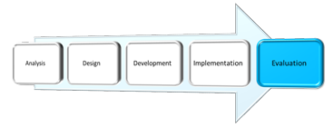

Why conduct training evaluations?

- Assist managers in identifying what, & who, should be trained.
- Determine cost-benefits of a program.
  - Will be explored in lesson 12.
- Determine if training program has achieved expected results.
- Diagnose strengths & weaknesses of a program & pinpoint needed improvements.
  - Go back to the design phase of ADDIE & re-evaluate to see if the improvements worked.
- Justify & reinforce the value of training.

Barriers to training evaluation

Barriers fall into 2 categories:

- Pragmatic: Requires time (loss of production) to organize the collection of the data & specialized knowledge to properly analyze & interpret it

- Political: Pressure from administration to justify the costs, potential to reveal ineffectiveness of training, conflict of interest (may require added resources to get external audit)

Types of training evaluations

Evaluations may be distinguished from each other in 2 fundamental ways:

- The data gathered & analyzed:
- Trainee perceptions, learning & behaviour at the conclusion of training.
- Assessing psychological forces that operate during training.
- Info about the work environment.
  - Transfer climate & learning culture.

- The purpose of the evaluation: TYPES OF TRAINING EVALUATIONS

- Formative evaluations: Provide data about various aspects of a training program.
- Tend to focus on the content & how it is presented w/ the goal of improving it.
- Based on feedback received during the design & development of the training experience.
  - Can be carried out on a regular basis (i.e. a progress report) or at the time of a given incident or problem.
- Of greater interest to instructors & instructional designers.

- Summative evaluations: Provide data about the worthiness or effectiveness of a training program.
  - Based on evidence (data) gathered at the conclusion of the training intervention (can also be carried out at mid-point).
    - Tend to focus on financial benefits to organization (return on investment).
  - Of greater interest to managers & administrators.

- Descriptive evaluations: Provide info that describes the trainee once he or she has completed a training program.

- Casual evaluations: Provide info to determine if training caused the post-training behaviours.

4 models of training evaluation

- KIRKPATRICK’S HIERARCHICAL MODEL:

- Donald Kirkpatrick 1st published his ideas about the evaluation of learning in 1959 in a series of articles he wrote for Training & Dev. He later published them in a 1975 book titled Eval Training Programs.
- “The 4 levels of training evaluation” remains to this day the seminal model used in the training industry.

The 4 levels of training

Level 1: Reactions
- Trainee perceptions of the training program &/or specific aspects of the course/experience
- Methods: the “smiley” sheets, post-training surveys

Level 2: Learning
- Trainee acquisition of the program material (procedural & declarative knowledge).
- Methods: before & after assessments.

Level 3: Behaviours
- Extent to which the new knowledge & skills are applied to the job (the transfer to the workplace).
- Methods: observation & interviews (over time), self-reports, supervisor reports, production records

Level 4: Results
- The effect on the business or the work environment by the trainee.
- Methods: Expenses, revenues, sales, & other existing business measures.

- Each increase in the level of evaluation also increases the complexity of the msmts & the costs associated w/ it.
  - Very few of the organizations surveyed carried out high-level evaluations. Most use Kirkpatrick level 1, but only to improve the overall efforts, not necessarily to improve performance (Bloom, 2003).
- In a study by the Conference Board of Canada (Hughes & Grant, 2007) about 75% of businesses evaluate at Level 1 (trainee reactions), 33% evaluate learning (Level 2), 15% assess changes in behaviour (Level 3), & very few look at results (Level 4).
  - Overall evaluation has been declining, likely due to barriers to evaluation.

Kirkpatrick’s 4 Levels – Common Critiques

Kirkpatrick’s guidelines are not without critics.

- Doubt about validity.
  - No evidence of correlation b/w the levels.
- Insufficient diagnostic.
- Reliance on the same variables & outcome measures.
- Lack of clarity.
  - What is meant by learning?
- Not a “one-size-fits-all” model.

- COMA Model

A training evaluation model that involves the msmt of 4 types of variables.
    - Cognitive
    - Organizational environment
    - Motivation
    - Attitudes

The COMA model improves on Kirkpatrick’s model in 3 ways:
- Integrates a greater number of measures
- Measures are causally related to training success
- Defines variables with greater precision

- DECISION-BASED EVALUATION MODEL

A training evaluation model that specifies the target, focus, & methods of evaluation.

Decision-based evaluation goes further than neither of the 2 preceding models:
- Identifying the target of the evaluation.
- General to any evaluation goals.
- Flexibility: guided by target of evaluation.

- THE LEARNING TRANSFER SYSTEM INVENTORY (LTSI)

Recall Holton’s LTSI from Lesson 5 – transfer of training.

This inventory contains all of the variables from COMA, plus additional ones such as: learner readiness, resistance/openness to change, & opportunity to use learning.

Training evaluation variables

Reactions
- Affective reactions: measures that assess trainees’ likes & dislikes of a training program
- Utility reactions: measures that assess the perceived usefulness of a training program.

Learning
Learning outcomes can be measured by:
- Declarative learning: refers to the acquisition of facts & info, & is by far the most frequently assessed learning measure.
- Procedural learning: refers to the organization of facts & info into a smooth behavioural sequence.

Behaviour
Behaviours can be measured using 3 approaches:
- Self-reports
- Observations
- Production indicators

Motivation
2 types of motivation in the training context:
- Motivation to learn
- Motivation to apply the skill on the job (transfer)

Self-efficacy
Refers to the beliefs that trainees have about their ability to perform the behaviours that were taught in a training program.

Perceived/anticipated support
2 important measures of support are:
- Perceived support: the degree to which the trainee reports receiving support in attempts to transfer the learned skills
- Anticipated support: the degree to which the trainee expects to be supported in attempts to transfer the learned skills

Organizational perceptions
2 scales designed to measure perceptions:
- Transfer climate: can be assessed via a questionnaire that identifies 8 sets of “cues”
- Continuous learning culture: can be assessed via questionnaire presented in Trainer’s Notebook in ch10 of your text.
Transfer climate cues include:
- Goal cues
- Social cues
- Task & structural cues
- Positive feedback
- Negative feedback
- Punishment
- No feedback
- Self-control

Organizational results
- Hard data: results that can be measured objectively (i.e., number of items sold)
- Soft data: results that are assessed through perceptions & judgements (i.e. attitudes)
- Return on expectations: msmt of a training program’s ability to meet managerial expectations

Data collection designs in training evaluation

- The manner in which the data collection is organized & how the data will be analyzed.
- All data collection designs compare the trained person to something.

- Non-experimental designs: comparison is made to a standard & not to another group of (untrained) ppl
- Experimental designs: trained group is compared to another group that doesn’t receive the training & when the assignment of ppl to the training group & the non-training group is random
- Quasi-experimental designs: trained group is compared to another group that does not receive the training, but when the assignment of ppl to the training group & the non-training group is not random

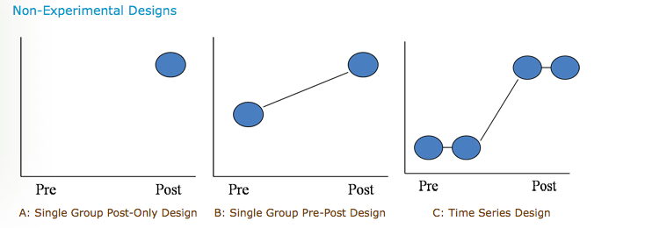
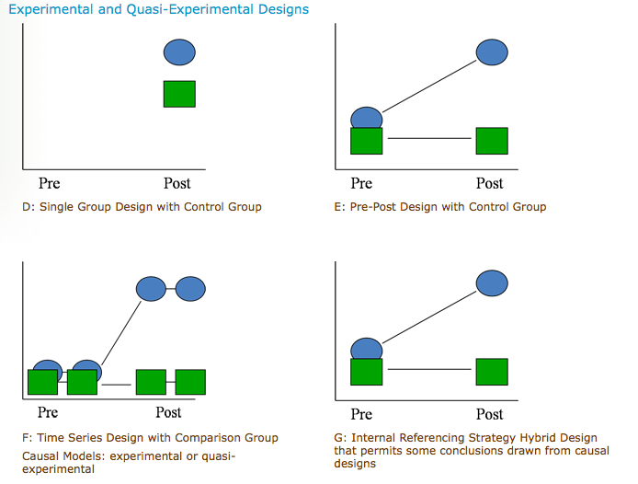

Key points

- Evaluating training interventions helps justify their costs & improve their effectiveness.
- Despite their obvious benefits, evaluations are not carried out for various reasons.
- In fact, they tend to be one of the least popular steps in the ADDIE model.
- Formative evaluations tend to focus on the content that is being developed whereas summative evaluations look at the results of the training experience.
- Kirkpatrick’s “4 levels of training evaluation” is considered the standard in the field.
- It is not w/out its critics & other models have been suggested (COMA, DBE).

VOCAB

Training evaluation | A process to assess the value–the worthiness–of training programs to employees & to organizations
Formative evaluations | Provide data about various aspects of a training program
Summative evaluations | Provide data about the worthiness or effectiveness of a training program
Descriptive evaluations | Provide information that describes the trainee once he or she has completed a training program
Causal evaluations | Provide information to determine whether training caused the post-training behaviours
COMA | A training evaluation model that involves the msmt of Cognitive, Organizational, Motivational, & Attitudinal variables
Decision-based Evaluation (DBE) | A training evaluation model that specifies the target, focus, & methods of evaluation
Affective reactions | Reaction measures that assess trainees’ likes & dislikes of a training program
Utility reactions | Reaction measures that assess the perceived usefulness of a training program
Declarative learning | Refers to the acquisition of facts & info & is by far the most frequently assessed learning measure
Procedural learning | Refers to the organization of facts & info into a smooth behavioural sequence
Perceived support | The degree to which the trainee reports receiving support in his or her attempts to transfer the learned skills
Anticipated support | The degree to which the trainee expects to be supported in his or her attempts to transfer the learned skills
Hard data | Results that are assessed objectively
Soft data | Results that are assessed through perceptions & judgements
Return on expectations | The msmt of a training program’s ability to meet managerial expectations
Data collection designs in training evaluations | The manner in which the data collection is organized & how the data will be analyzed
Non-experimental designs | When the comparison is not made to another group of (untrained) ppl
Experimental designs | When the trained group is compared to another group that does not receive the training & when the assignment of ppl to the training group & the untrained group is random
Quasi-experimental designs | When the trained group is compared to another group that does not receive the training but when the assignment of ppl to the training group & the untrained group is not random
Training evaluation designs | The process by which evaluation info is gathered

POST-TEST



