

If you’re not angry you’re not paying attention

NASTY WOMAN
If you’re not angry you’re not paying attention
ELYSSA KHOURY
ID: 4006169
SUNDAY OCTOBER 15th

Table of content
PROJECT DESCRIPTION 3
THE TIMELINE AND DELIVARABLES 4
4
THE BUDGET 5
THE LOCATION OF OUR BUSINESS 6
THE POTENTIIAL VALUE OF OUR BUSINESS 7
BIBLIOGRAPHY 8




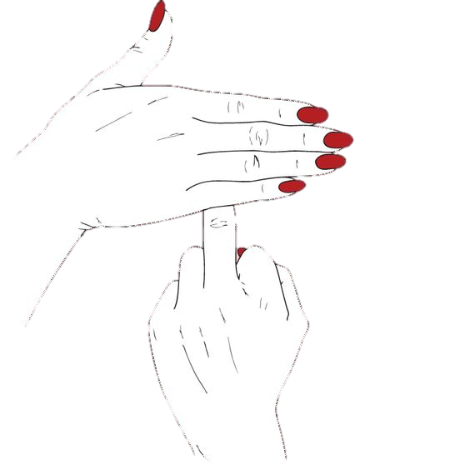

PROJECT DESCRIPTION

The Nasty Woman Project
The Nasty Woman is a weekly feminist newspaper. It would address controversial and current topics involving daily women struggles as well societal issues.

The design and graphics of the magazine will take several different form, each concerning the topic addressed in the specific page. The magazine would be designed in such a way that invokes curiosity. It would sort du common and be controversial, just like the topics discussed.

THE TIMELINE AND DELIVARABLES

The first edition of the magazine would be ready to be published 6 months after the funding is received. During that time, we would have the time to find all the staff required, an office space, write interesting articles, interview specialists and a lot more.




THE BUDGET

The project would require a budget in order to get it started, acquire some visibilities trough advertising, and to print multiple copies to sell. First of all, the Nasty Woman staff would need a studio or office as a work space to develop new ideas, write articles, exchange points of view, receive specialists for interviews, etc. In order to be productive and to make our project realisable, our organization would require office supplies such as computers, printers, desks and other kind of equipment a working space usually contains. Professional printing would also be a cost to consider in order for the paper to look professional and credible. Finally, personnel should be paid and, until the paper starts selling copies, we would need funding in order to continue motivating the employees.
Sample Project Budget Outline |  | Fund
Rent of the facilities | ≅500$/months *12months | 6000$
Printing fees | ≅1,20$/copy*100 copies | 120$
Equipment (computers, office supplies. Ect.) |  | 10000$
Personnel salary | ≅1000$/month*12months *5 employees | 60000$
Total |  | 76120$



THE LOCATION OF OUR BUSINESS

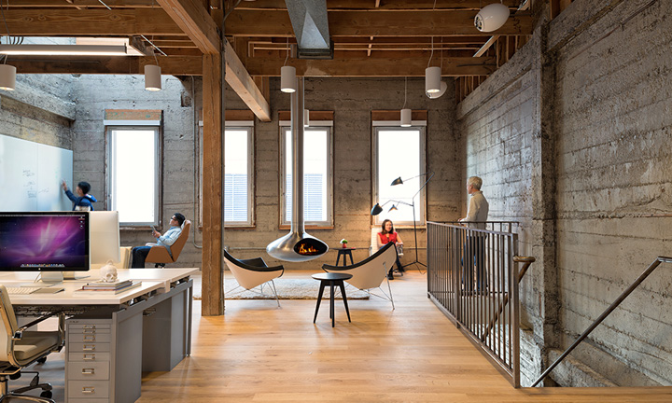
The business would be located in an office studio in the old part of Montreal. No major renovation would be required, only redecoration and installation of office space like a meeting space.

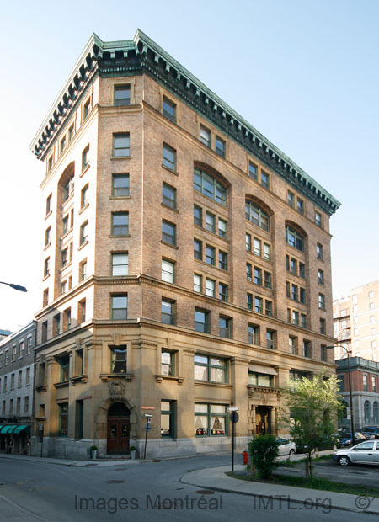

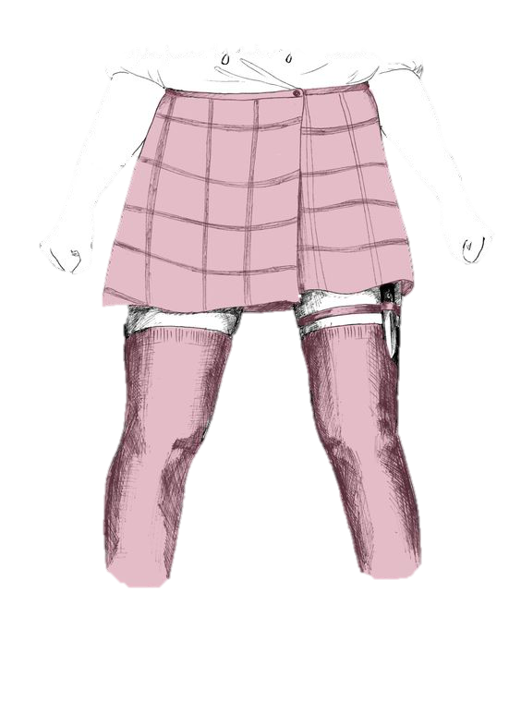
THE POTENTIIAL VALUE OF OUR BUSINESS

Nasty Woman is a project is aiming for the education, the consciousness raising and the knowledge deepening of the future readers and, eventually, the population that is now aware of women’s oppression in the twenty-first century. The magazine’s value would thus primarily be its repercussion on society and how it affects people’s view of patriarchy. However, with time, advertising, and sponsor, Nasty Woman would eventually become a source of revenue.

BIBLIOGRAPHY

- These beautiful feminist posters are seriously gorgeous and so empowering (2017, October 10). For All Womankind Illustration Poster. Retrieved from http://www.notey.com/@hellogiggles_unofficial/external/13758631/these-beautiful-feminist-posters-are-seriously-gorgeous-and-so-empowering.html?utm_content=buffer219a5&utm_medium=social&utm_source=pinterest.com&utm_campaign=buffer

- Feminist AF (2017, October 10). Retrieved online from https://www.pinterest.ca/pin/ARbqJ-953XhTRQA_mcXNKBB8tmCzML6O-WDDXvLL7nl8VSLX_Sg_Ws0/

- Something Kitten This Way Comes (2017, October 10). I’m a Girly Warrior. Retrieved online from http://thatwritererinoriordan.tumblr.com/post/123559628920

- The Moon Bacon (2017, October 10). Being Classy. Retrieved online from
http://themoonspells.tumblr.com/post/131753956893/being-classy-httpsinstagramcomthemoonbacon

- Traits pour traits (2017, October 10). You’re a Woman You Define Femininity. Retrieved online from http://traitspourtraits.tumblr.com/post/150879885894

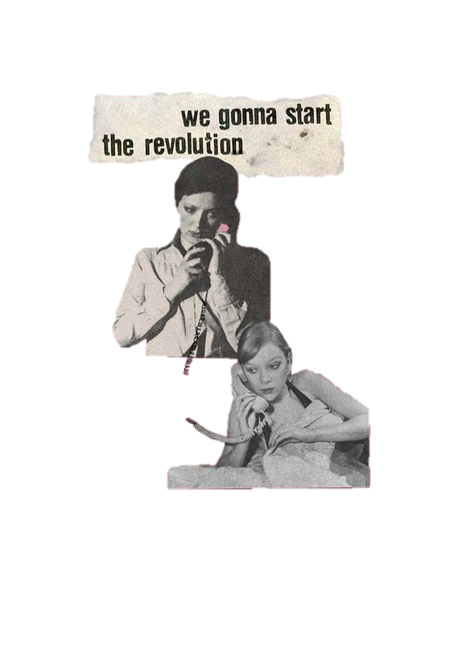
- Art Print (2017, October 10). GRL PWR X BLUE. Retrieved online from https://society6.com/product/grl-pwr-x-blue_print#s6-6627683p4a1v45

- Advertise (2017, October 10). Giant Pixel office by Studio O+A, San Francisco – California. Retrieved online from http://retaildesignblog.net/wp-content/uploads/2013/07/Giant-Pixel-office-by-Studio-O-A-San-Francisco-California.jpg

- Building (2017, October 10). C. P. R. Telegraph Building. Retrieved online from http://www.imtl.org/montreal/image.php?id=6332

