Plate Tectonics

Earth Layer Structure:
Inner Core (Solid) – Outer Core (liquid) – Mantle – Crust
The Core is predominantly Iron and Nickel
The Mantle (Less dense with abundant iron, magnesium, silicates)
i) Lower Mantle is rigid
ii) Athenosphere is plastic
iii) Uppermost Mantle is rigid

The Crust is filled with granitic and basaltic rocks

Lithosphere = Uppermost Mantle + Crust
- Ranges from 50km – 200 km
- 2 types of Crusts: Oceanic and Continental
- Divergent, convergent and transform

Lithosphere interact with one another is called ACTIVE MARGINS

Transitions between oceanic and continental crust where there is no
interaction between plates are referred to as Passive Margins
- Typically marked by thick accumulation of sediments between continental and oceanic crust.

Plate Tectonics II: Theory that Continents are moving
Fossil Distribution
- Range of organisms restricted by dispersal barriers are good indicators of connection of landmasses.
- Similar Fossils found in different continents

Evidence of Glaciation
- Debris left behind when glaciers melt
- Rocks called Tillite are found in south of different continents
- Glacial Striations (scratch marks) are found
- Movement of Continents was able to be predicted
Divergent boundaries = Plates pull apart
Paleomagnetism = Rocks can lock in the orientation and polarity of the magnetic field at the time that they form.

Proposals for moving plate:
Ridge Push: Movement of plates at ridges is propelled by sliding along the elevated lithosphere-asthenosphere boundary.

Slab Pull: Dense, subducting lithosphere “pulls” the plate along with it.

Minerals:
inorganic
naturally occurring
crystalline solid
fixed internal arrangement of atoms
fixed or variable chemical composition
-E.g., quartz, pyrite

Mineraloid:
Similar to a mineral but has no ordered arrangement of atoms (is amorphous, not crystalline)
- E.g., opal

Silicate Minerals
1/3 of all minerals but make up for 90-95% of the crust
Silica tetrahedron SiO₄⁻⁴, the basic building block of all silicate minerals
Dark silicates called ferromagnesian
- high Mg, Fe content
- E.g., pyroxene, amphibole
Light-colored silicates called felsic
- lack Fe
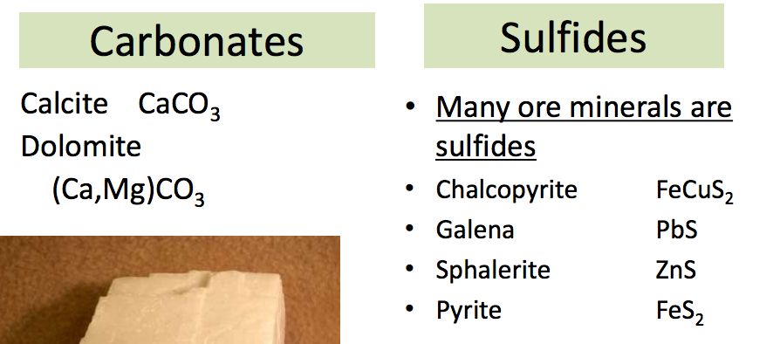
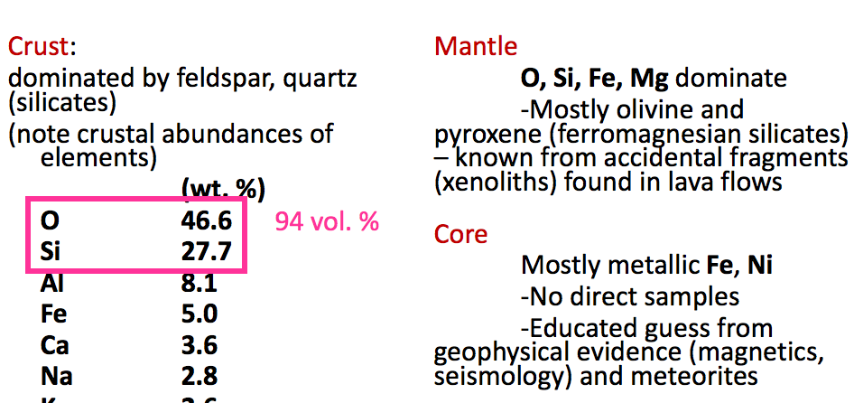
- E.g., quartz, feldspar

Identifying Minerals
Each mineral has its own unique set of physical properties
Hardness scale (Scratching minerals with each other)
Cleavage = ability to split one or more planes of weakness
Fracture = tendency to break along irregular surfaces
Depend on atomic structure and bonding
Taste and smell

Igneous Rocks

Rock = Aggregate of minerals
Igenous – derived from melts
Sedimentary – from weathering or precipitation
Metamorphic – preexisting rocks changed by higher pressure and temperature

Magma = melted rock before eruption
- High in Silica content
- Mafic (high in Mg and Fe) have more ferromagnesian silicate minerals than felsic rocks
- E.G. Gabbro, basalt
Lava = melted rock exposed at the surface

Extrusive Igneous Rocks
Form from fast cooling of:
– Molten rock (lava) at the earth’s surface, or
– within narrow intrusions (magma) near the earth’s surface.
Fast cooling (Days/months) = small crystal size

Intrusive Igneous Rocks
Form from slow cooling of molten rock (magma)
– this occurs deep below the earth’s surface
- slow cooling (100-10000 years) = large crystal size. Coarse grained (macroscopic)

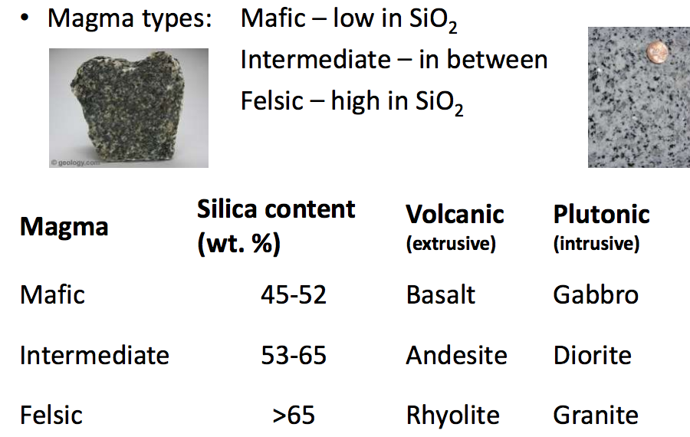

How Magma Forms:
1. Decompression melting – Move it to lower pressure
2. Increase Temperature
3. Add water/volatiles (depresses melting point)

Generation of Magma:
1) Heat is added (eg. a magma body from a deeper source intrudes crustal rock and the additional heat melts a portion of the rock)

2) Convective upwelling in the asthenosphere results in decompression melting

3) The introduction of volatiles at subduction zones lowers the melting temperature of overlying mantle material.

Distribution of Magma
Intermediate and Felsic Magmas
- Subduction zones (convergent margins)
Mafic Magmas
- Mid Ocean Ridges (divergent Plate margins) and hotspots

Instrusive Bodies
Diapirs: Rising bodies of magmas
Pluton: Large Igneous bodies that crystallize at depth within the Earth’s Crust
Batholith: Large igneous bodies formed by the coalescence of plutons

Surfacing:
Diapirs rise – Cools down – many diapirs form pluton – many pluton form batholith – Surface on top of batholith is taken away by erosion of both overlying and surrounding material – batholith is exposed.

Dykes – Cut across existing rocks
Sill – concordant with existing rocks

Volcanoes

Explosive Eruptions
High Viscosity magmas = high silicate content

Non-Explosive eruptions
Low viscosity magmas = low silicate content

Shield Volcano
Associated with Hot Spots
- Warm Regions of Mantle that generate mafic (low silica, low viscosity) magmas

Composite Volcano (stratovolcano)
km’s across, several km high
Interbedded lava flows, pyroclastic flows, lahars, sills and dykes
Full range of chemical compositions (mafic, intermediate, felsic)

Cinder Cone
100s of m high
Layers of pyroclastic ejecta (scoria, bombs)
Mafic

Domes
felsic lava eruptions
late-stage of a mature composite volcano

