Lecture 8 Minerals – Calcium, Iron
- Minerals
  - Minerals are elements (other than carbon, hydrogen, oxygen and nitrogen) found in foods
  - Minerals take up about 5-6% of body weight, the difference due mainly due to differences in skeletal mass
  - Minerals are classified as essential nutrients
  - Minerals serve the functions of structure in the body, as well as regulators of metabolism
  - Minerals are from the earth’s rocks, are incorporated into the plants and water we consume
- Are there any minerals that may contribute to the strength of bones and teeth? Healthy blood? Are there any that contribute to building the body?
- Are any of the minerals “electrolytes”?
- Minerals Through the Food Chain
  - The plants are either:
    - Eaten by animals that are then consumed by humans
    - Eaten directly by humans
  - Some plants growing in mineral-deficient soils will be deficient in some minerals necessary for human health
  - This is not of concern if the overall diet contains foods from a variety of regions
  - E.g.-iodine and zinc are some of the minerals that may be deficient in humans in certain areas of the world if the diet is not varied
- Macrominerals
  - These are defined as minerals that:
    - Are required in amounts greater than 100mg per day
    - Are present in the body at levels greater than 0.01% of body weight
    - Function in building body structure and in regulation of metabolism
- RDAs for Minerals
- Microminerals (Trace Minerals)
  - Microminerals are defined as minerals that:
    - Are required in amounts less than 50mg per day
    - Are present in the body at less than 0.01% of body weight
    - Function primarily in regulatory roles
- Bioavailability
  - The amount of the mineral available for absorption into the body
  - Most minerals have very low bioavailability-sometimes as low as 5%, or as much as 60% for sodium, for example
- Setting Nutrient Requirements
  - Nutrient requirements for any given nutrient depend on factors such as age, life stage, gender
  - Bioavailability is also a factor taken into account when setting requirements
- Calcium Mathematics
  - Person A just been saving up since the age of 14, is now 24, and has $10,000 in the bank that he/she wants to keep as long as possible. The catch is that $1000 is used every year due to taxes, expenses, credit card payments, etc. How long will the money last?
  - Person B started saving at the same age and is now also 24, and has $50,000 in the bank. This person is more of a saver, but still uses up the same amount each year-$1000. How long will the money last, in this case?
  - How does this equate to Peak Bone Mass?
- Calcium
  - Structure of the body
    - 99% of the body’s calcium is in the teeth and bones
    - A lattice of collagen is formed into which a calcium-phosphorus (hydroxyapatite) salt is deposited
    - During life, the bone is constantly being broken down by osteoclasts and being built up by osteoblasts (these are different bone cell types)

    - Osteoblasts & Osteoclasts
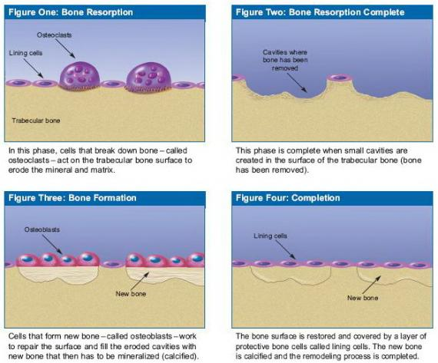
    - The relative action of the osteoclasts and osteoblasts determines bone growth and bone changes
    - During growth, the action of osteoblasts takes precedence up to about ages 25-30 (bone building to peak bone mass)
    - After this time, the action of osteoclasts increases over the action of osteoblasts, leading to bone loss with aging (bone resorption)
  - Regulation of metabolism
    - The regulatory functions of calcium, blood clotting, muscle contraction, nerve impulse transmission, are performed by 1% of the body’s calcium content
    - Calcium also plays a role in controlling cell division and cell secretions
- Calcium Deficiency
  - The regulatory roles of calcium are the most important functions of calcium in the body
  - With a dietary insufficiency of this mineral, calcium will be removed from the bones to keep the blood calcium at optimum levels
  - If there is dietary lack of calcium, intestinal absorption of calcium, with help of Vitamin D, improves in a bid to maintain blood levels
  - The hormone parathormone (also known as parathyroid hormone) sends a signal to the kidneys to keep more calcium rather than excrete it.
  - Parathormone also stimulates the osteoclasts to break down bone and release calcium into the blood
  - A chronic dietary calcium deficiency can lead to loss of bone calcium content
  - In children, this condition is called rickets
  - In adults, the result is osteoporosis, meaning weak, porous bones with low calcium content
    - Having osteoporosis means that bones break more easily, esp. the spine, hip and wrist
  - Microfractures in the vertebral bones means the bones break into small fragments and the person loses height
  - Another result is hip fractures which are a major cause of hospitalization and loss of independence in the elderly

- Peak Bone Mass is reached about age 25
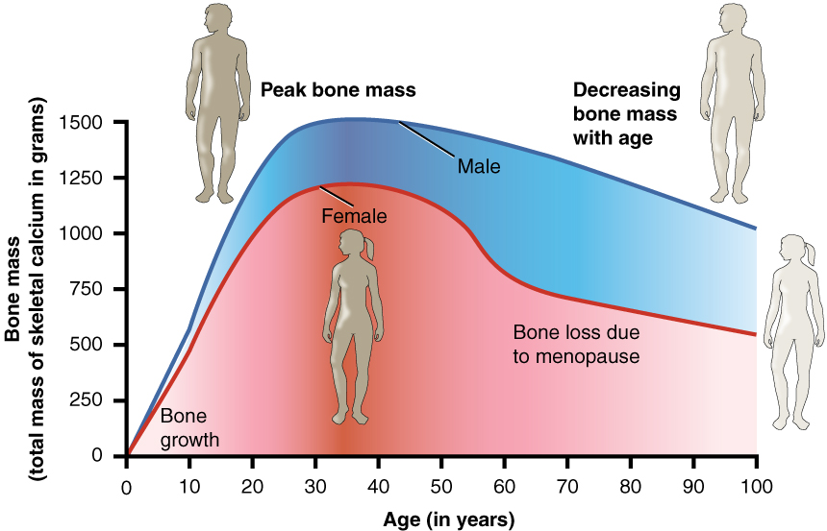
- Risks for Osteoporosis
  - Age increases the risk of osteoporosis, as does chronic low calcium intake
  - Women are at greater risk due to lower mineral density in their bones compared to me
  - After menopause, with less circulating estrogen, bone loss accelerates in women
  - Inactivity increases risk of osteoporosis
  - Weight-bearing exercises help build denser bones
  - Factors such as smoking and alcohol consumption increase the risk
  - High sodium intake and coffee may increase bone loss in some people
- Bioavailability of Calcium
  - Bioavailability reaches 30% for adults
  - During pregnancy, this level soars to 50%, as it does during rapid growth and during the teen years
  - Since Vitamin D is needed for the absorption of calcium, vitamin D status is an important factor
  - Certain components of the diet decrease calcium bioavailability
  - Phytates in whole grains and oxalic acid in leafy vegetables decrease calcium absorption
- Calcium Requirement
  - Calcium requirements are greatest during the teen years
  - Adult requirements are 1000mg/day
  - Requirements for adults over age 50 are 1200 mg/day
- Food Sources of Calcium
  - Dairy products, esp. non-fat dairy, are the best sources of calcium
  - Meats are generally a poor source of calcium
  - Calcium is found in plant sources, but bioavailability is poorer than from dairy products
- Calcium Supplementation & Excess
  - Supplements of calcium can be a source for those who do not eat dairy foods
  - The Tolerable Upper Limit (UL) of intake is 2500 mg/day
  - Calcium supplements are recommended to be no more than 500 mg in a single dose, and to be taken with food
- Trace Minerals
  - Trace minerals are present in minute quantities in the body
  - The requirement is less than 50 mg per day
  - Trace minerals fulfil the nutrient function of regulation of metabolism

- Iron
    - Iron deficiency is the most common nutrient deficiency worldwide
    - Iron is important in regulation of metabolism, important in carrying oxygen to the body’s tissues
  - Iron-Functions
    - Iron is part of the protein hemoglobin which carries oxygen from the lungs throughout the body
    - The similar compound myoglobin in the muscles’ cells picks up the oxygen from the hemoglobin and transfers it to the energy-producing parts of the cell
    - Iron is also part of some of the enzymes involved in energy metabolism, wherein energy is released from carbohydrate, fats and proteins
  - Iron Deficiency
    - The body has an efficient mechanism for ensuring that not much iron is lost in the urine or feces
    - Iron from worn out blood cells is recycled and reused
    - Bioavailability can change according to need for iron
    - The body can store extra iron in proteins called ferritin and hemosiderin
    - Iron deficiency can be the result of poor diet or excess blood loss
    - Anemia-the result of iron deficiency
    - Iron deficiency results in poor iron stores and low hemoglobin levels, a condition called iron deficiency anemia
    - Result is that in blood’s capacity for carrying oxygen is poor
    - Being anemic (having anemia) causes fatigue on exertion
    - Infants, children, teens are at risk, and esp. women of childbearing age due to menstrual blood loss
- Bioavailability of Iron
  - Bioavailability of iron is dependent on various interrelated factors
    - With poor iron status (low iron stores), iron absorption through the small intestine is increased
    - If iron status is good, iron absorption from the small intestine is reduced
    - The form of dietary iron affects bioavailability
    - Iron in heme form is bound to hemoglobin and myoglobin and easily absorbed
    - Non-heme iron is less absorbable-between 5 and 10%
  - What helps with iron absorption
    - Orange juice and steak
    - Vitamin C enhances the bioavailability of non-heme iron from 10% level to 20%
    - A special protein factor (called MPF-muscle protein factor) also enhances the absorption of iron from all the foods eaten at the same meal
  - What decreases iron absorption
    - Greens (salad) and grains
    - Oxalates (spinach) and phytates (whole grains) bind with the iron in the small intestine preventing its absorption
    - Very high fibre intakes can decrease absorbability of iron as the iron binds to the fibre which decreases bioavailability
    - Tannins in tea and coffee can decrease iron absorption
  - Iron Requirement
    - Women of childbearing age have high iron requirement due to menstrual losses, but still less than is required during pregnancy
    - An iron supplement is required during pregnancy to meet the requirement of this life stage
  - Food Sources of Iron
    - Meats, poultry and fish are sources of heme iron, as well as non-heme iron
    - Iron-fortified cereals are a major source of this mineral in the diet
    - Iron can also be found in dried beans, leafy green vegetables
    - Iron Supplementation (Centrum)
  - Iron Toxicity
    - Iron can be toxic in large doses if in supplements, as the body cannot easily excrete excesses
    - Hemochromatosis is a genetic disorder in which a person absorbs too much iron in the body
    - Young children ingesting abnormally high amounts of vitamins with iron or iron supplements can be acutely poisoned with iron
    - This level of intake can be fatal

Fun Fact Answer
Which dietary minerals can be toxic if not ingested in the correct amounts?
Iron, fluoride, zinc, copper, most of the trace minerals. Sodium, potassium, and calcium can also be toxic if taken at levels far above recommended values.
Encyclopedia of Children’s Health

Lecture 11 Carbohydrates – the energy nutrient
- Carbohydrates have glucose as a basic unit of their structure
- Carbohydrate Structure
  - Carbohydrates made up of the elements carbon (C), hydrogen (H), and oxygen (O)

Lecture 12 Carbohydrates – the energy nutrient
- Carbohydrates Energy Metabolism
  - Once carbohydrates are digested, there is a mix of monosaccharides in the digestive tract
  - After absorption, fructose and galactose are converted to glucose in the liver

REVIEW QUESTIONS

TOPIC 18
What is the basic definition of minerals?
[enter here]
Which of the three nutrient functions do minerals perform in the body?
[enter here]

What accounts for the difference in mineral content between males and females, and between people of African versus Asian descent?
[enter here]

Trace the path of minerals through the food chain.
[enter here]

Compare/contrast major (macro) minerals and trace (micro) minerals.
[enter here]

Explain bioavailability. What factors may increase or decrease bioavailability? What is the bioavailability of iron in contrast to the bioavailability of sodium?
[enter here]

What are the functions of calcium in the body? Which of these functions takes precedence for calcium use?
[enter here]

Name the significant dietary sources of calcium, and the dietary component that is necessary for adequate absorption of calcium from the intestines.
[enter here]

Young adults should build up their “peak bone mass”. What does this term mean and why is it important?
[enter here]

If a person does not build up his/her peak bone mass and does not take sufficient calcium in the diet, what is the name of the resulting condition? What are the implications of having this condition, and what are the factors that increase the risk of having this condition?
[enter here]

What factors affect iron’s bioavailability for the better? For the worse?
[enter here]

Review the food sources of iron.
[enter here]

