Chapter 1
Information System’ Impact on Business Operations
Business Functions Receiving Benefits from IT:
Customer service: 70%
Finance: 51%
Sales and marketing: 42%
IT operations: 39%
Operations management: 31%
HR: 17%
Security: 17%
IT Project goals:
Reduce costs/improve productivity: 81%
Improve customer satisfaction/loyalty: 71%
Create competitive advantage: 66%
Generate growth: 54%
Streamline supply chain: 37%
Global expansion: 16%
Common departments in an organization:
Accounting, marketing, operations management, HR, production management, finance, sales, MIS

Information systems basics:
Information systems (IS): any computer-based tool that people use to work with information and that supports the information and information-processing needs of an organization. IS can be an important enabler of business success and innovation.
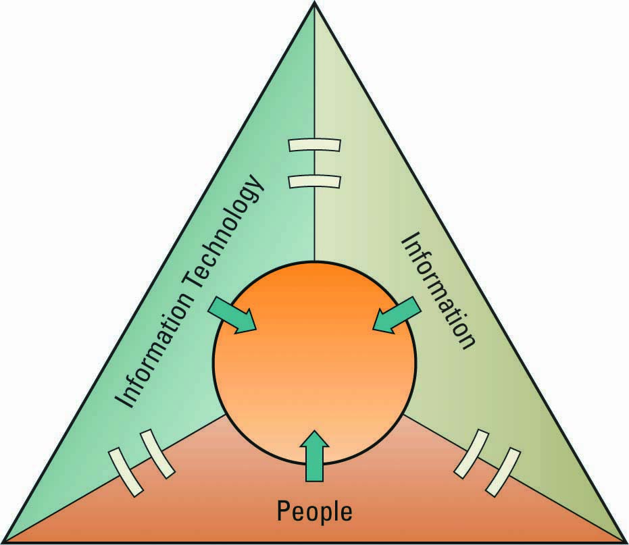
Management Information systems (MIS): the function that plans for, develops, implements, and maintains IS hardware, software, and applications that people use to support the goals of an organization.
Data: raw facts that describe the characteristic of an event
Information: data converted into a meaningful and useful context
Knowledge: information that can be enacted upon ex. Actionable information
IS Resources: people processes information systems = produce information.
IS Cultures
Information-functional culture
- use information as a means of exercising influence or power over others
Information-sharing culture
- departments trust each other to use information (especially about problems and failures) to improve performance.
Information-inquiring culture
- search for information to better understand the future and align themselves with current trends and new directions
Information-discovery culture
- open to new insights about crisis and radical changes and seek ways to create competitive advantage

Roles and responsibilities in IS
Chief Information Officer (CIO) – oversees all uses of IS and ensures the strategic alignment of IS with business goals and objectives. Broad CIO roles include:
- Manager – ensuring the delivery of all IS projects, on time and within budget
- Leader – ensuring the strategic vision of IS is in line with the strategic vision of the organization
- Communicator – building and maintaining strong executive relationships
Chief Technology Officer (CTO) – responsible for ensuring the throughput, speed, accuracy, availability, and reliability of IS
Chief Security Officer (CSO) – responsible for ensuring the security of information systems
Chief Privacy Officer (CPO) – responsible for ensuring the ethical and legal use of information
Chief Knowledge Office (CKO) - responsible for collecting, maintaining, and distributing the organization’s knowledge
Skills Required in IS Roles:
- Communication
- Strategic thinking and planning
- Understanding business process and operations
- Negotiation/sales skills
- Thorough knowledge of technology options
- Technical proficiency
Gap between business personnel and IS personnel:
Business personnel possess expertise in functional areas such as marketing, accounting, and sales
IS personnel have the technological expertise
Improving communications:
- Business personnel must seek to increase their understanding of IS and vice versa
- It is the responsibility of the CIO to ensure effective communication between business personnel and IS personnel

Measuring IS’s Success
Key performance indicator: measures that are tied to business drivers. Metrics are detailed measures that feed KPIs. Performance metrics fall into the nebulous area of business intelligence that is neither information systems, nor business centered, but requires input from both IS and business professionals.
Efficiency IS metric – measures the performance of the information system itself including throughput, speed, and availability
Effectiveness IS metric – measures the impact IS has on business processes and activities including customer satisfaction, conversion rates, and sell-through increases
Benchmarks – baseline values the system seeks to attain.
Benchmarking – a process of continuously measuring system results, comparing those results to optimal system performance (benchmark values), and identifying steps and procedures to improve system performance.
Interrelationships of efficiency and effectiveness IS metrics:
Efficiency IS metrics focus on:
- Throughput: the amount of information that can travel through a system at any point in time.
- Transaction speed: the amount of time a system takes to perform a transaction
- System availability: the number of hours a system is available for users
- Web traffic: includes a host of benchmarks such as the number of page views, number of unique visitors, average time spent viewing the web page
- Response time: the time is take to respond to user interactions ex. Mouse clicks
Effectiveness IS metrics focus on:
- Usability: the ease with which people perform transactions/find information. Ex. Degrees of freedom measures number of clicks required to find desired info.
- Customer satisfaction: measured by benchmarks such as satisfaction surveys
- conversion rates: number of customers an organization “touches” for the first time and persuades to purchase products/services. Ex. Banners, popups.
- Financial: return on investment, cost-benefit analysis and breakeven analysis
Identifying competitive advantages:
Competitive  Scope | Cost Strategy
Competitive  Scope |  | Low Cost | High Cost
Competitive  Scope | Broad Market | Cost Leadership | Differentiation
Competitive  Scope | Narrow Market | Focused Strategy
Competitive advantage – a product or service that an organization’s customers place a greater value on than similar offerings from a competitor
First-mover advantage – occurs when an organization can significantly impact its market share by being first to market with a competitive advantage
Environmental scanning – the acquisition and analysis of events and trends in the environment external to an organization
Tools to analyze and develop competitive advantage:
1. Porter’s Five Forces Model: determines the relative attractiveness of an industry
- Buyer power
- Supplier Power
- Threat of substitute products/services
- Threat of new entrants
- Rivalry among existing competitors
2. Porter’s three generic strategies: strategies for entering a new market
- broad cost leadership
- broad differentiation
- focus strategy
3. Value Chains:
- Business process: a standardized set of activities that accomplish a specific task, such as processing a customer’s order
- Value chain: views an organization as a series of processes, each of which adds value to the product or service for each customer

Chapter 2
Decision Making
Reasons for growth of decision making IS:
- People need to analyze large amounts of information
- People must make decisions quickly
- People must apply sophisticated analysis techniques, such as modeling and forecasting, to make good decisions
- People must protect the corporate asset of organizational information
Transactional data and analytical info:
Moving up through the organizational pyramid, users move from requiring transactional information to analytical information
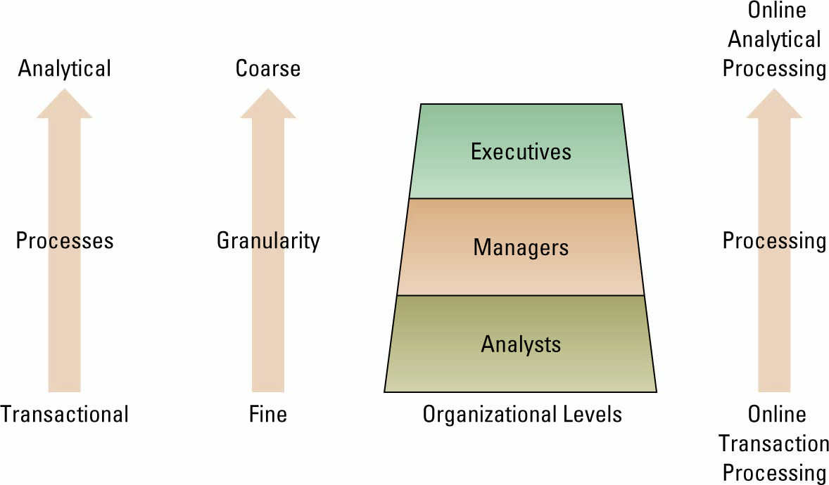

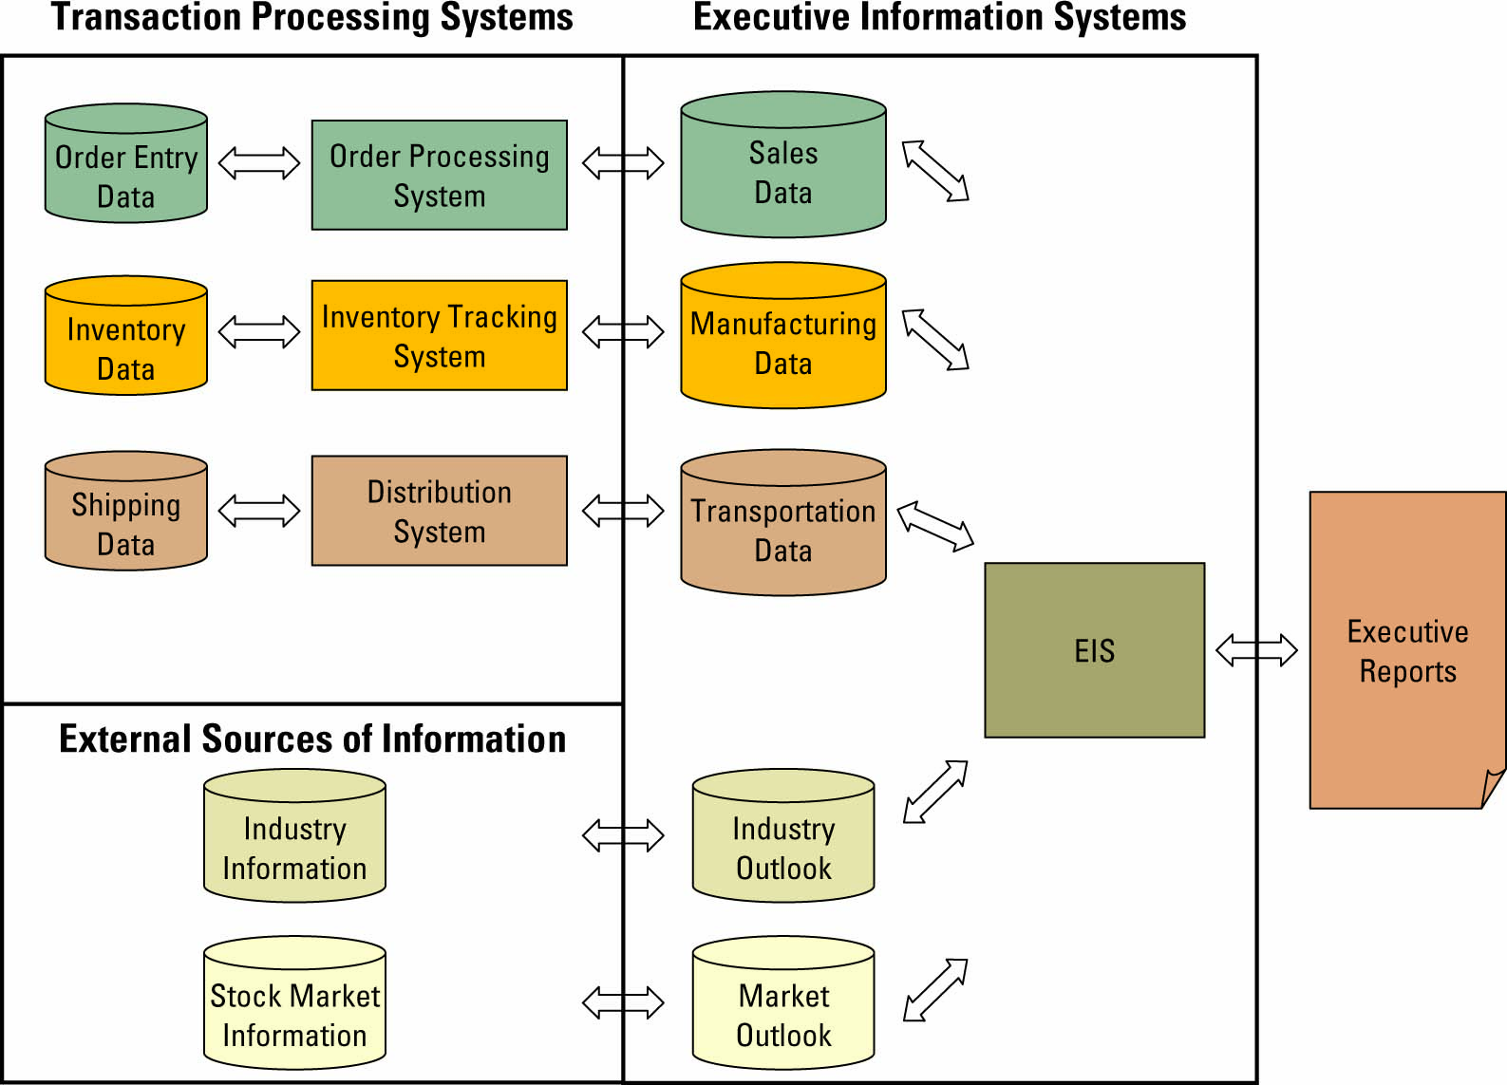
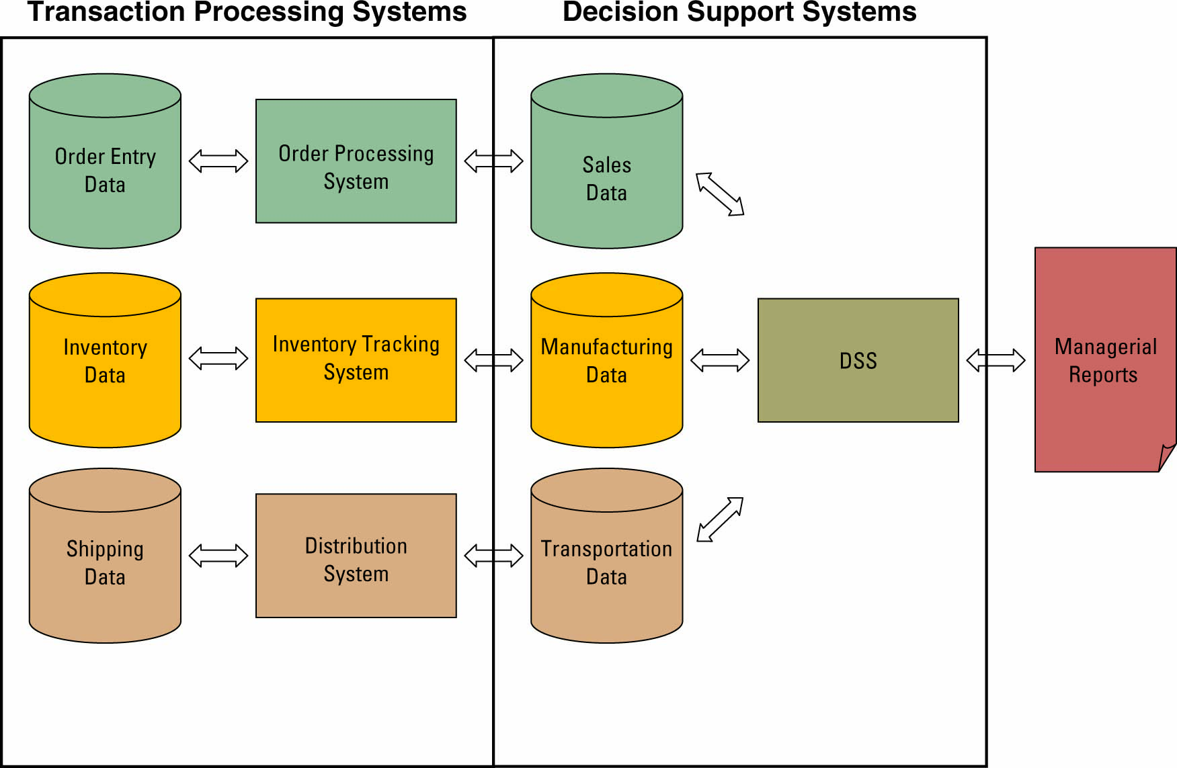
TPS, DSS and EIS
Transaction processing system (TPS) - the basic business system that serves the operational level (analysts) in an organization
Online transaction processing (OLTP) – the capturing of transaction and event information using technology to (1) process the information according to defined business rules, (2) store the information, (3) update existing information to reflect the new information
Decision support system (DSS) – models information to support managers and business professionals during the decision-making process.
Online analytical processing (OLAP) – the manipulation of information to create business intelligence in support of strategic decision making. Three quantitative models used by DSSs include:
1. Sensitivity analysis – the study of the impact that changes in one (or more) parts of the model have on other parts of the model
2. What-if analysis – checks the impact of a change in an assumption on the proposed solution
3. Goal-seeking analysis – finds the inputs necessary to achieve a goal such as a desired level of output
Executive information system (EIS) – a specialized DSS that supports senior level executives within the organization
Digital dashboard – integrates information from multiple components and presents it in a unified display
Artificial intelligence (AI)
Intelligent system: various commercial applications of artificial intelligence
Artificial intelligence (AI): simulates human intelligence such as the ability to reason and learn. The ultimate goal is to build a system that can mimic human intelligence. 4 common categories of AI include:
- Expert system: computerized advisory programs that imitate the reasoning processes of experts in solving difficult problems
- Neural Network: attempts to emulate the way the human brain works
- Fuzzy logic – a mathematical method of handling imprecise or subjective information
- Genetic algorithm: an artificial intelligent system that mimics the evolutionary, survival-of-the-fittest process to generate increasingly better solutions to a problem
- Intelligent agent: special-purposed knowledge-based information system that accomplishes specific tasks on behalf of its users
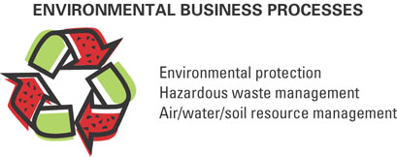
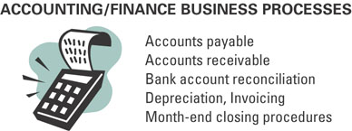
Understanding the importance of business process
Sample business process:

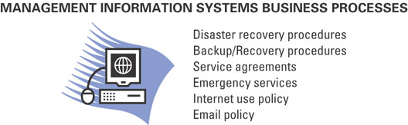
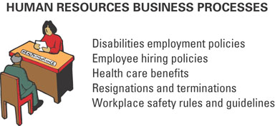

Customer facing processes – result in a product or service that is received by an organization’s external customer.
Business facing processes – are invisible to the external customer but are essential to the effective management of the business
Business process reengineering
Business process: a standardized set of activities that accomplish a specific task, such as processing a customer’s order
Business process reengineering (BPR): the analysis and redesign of workflow within and between enterprises. The purpose of BPR is to make all business processes best-in-class
Finding opportunity using BPR:
- A company can improve the way it travels the road by moving from foot to horse and then horse to car
- BPR looks at taking a different path, such as an airplane which ignores the road completely
Business process modeling
Business process modeling (or mapping): is the activity of creating a detailed flow-chart or process map of a work process showing its inputs, tasks, and activities, in a structured sequence.
Business process model: is a graphic description of a process, showing the sequence of process tasks, which is developed for a specific purpose and from a selected viewpoint. Ex. Customer goes to cash, orders burger, fries, drink, customer pays.
Business process management
Business Process Management (BPM) – integrates all of an organization’s business processes to make individual processes more efficient.
Key reasons for using BPM:
- to introduce greater efficiencies/improve productivity
-to improve service
-to reduce operational costs
- to improve organizational agility
- to improve process visibility
- to meet regulatory compliances
- to deal with integration issues
Chapter 3
Disruptive technology
Why did Polaroid go bankrupt?
Digital Darwinism – implies that organizations which cannot adapt to the new demands placed on them for surviving in the information age are doomed to extinction
Disruptive technology – a new way of doing things that initially does not meet the needs of existing customers
Sustaining technology – produces an improved product customers are eager to buy
Innovator’s Dilemma - discusses how established companies can take advantage of disruptive technologies without hindering existing relationships with customers, partners, and stakeholders
The internet – Business disruption:
- One of the biggest forces changing business is the Internet
- Organizations must be able to transform as markets, economic environments, and technologies change
- Focusing on the unexpected allows an organization to capitalize on the opportunity for new business growth from a disruptive technology
Evolution of the internet
- The Internet began as an emergency military communications system operated by the U.S. Department of Defense
- Gradually the Internet moved from a military pipeline to a communication tool for scientists to businesses
  - Internet – computer networks that pass information from one to another using common computer protocols
  - Protocol – standards that specify the format of data as well as the rules to be followed during transmission
World Wide Web (WWW) – a global hypertext system that uses the Internet as its transport mechanism
Hypertext transport protocol (HTTP) – the Internet standard that supports the exchange of information on the WWW
Reasons for growth of the WWW:
- the microcomputer revolution make it possible for an average person to own a computer
-advancements in networking, software and media made it possible for business PCs to be inexpensively connected to larger networks
- browser software such as Internet Explorer gave computer users an easy-to-use graphical interface to find, download and display webpages
Internet’s impact on info:
- easy to compile
- increased richness
- increased reach
- improves connect
Digital divide – when those with access to technology have great advantages over those without access to technology
Web 2.0 is a set of economic, social, and technology trends that collectively form the basis for the next generation of the Internet.
Accessing internet info
Tools for accessing internet info:
1. Intranet – internalized portion of the Internet, protected from outside access, for employees
2. Extranet – an intranet that is available to strategic allies
3. Portal – Web site that offers a broad array of resources and services
4. Kiosk – publicly accessible computer system that allows interactive information browsing
Providing internet info
1. Internet service provider (ISP) –provides individuals and other companies’ access to the Internet
2. Online service provider (OSP) – offers an extensive array of unique Web services
3. Application service provider (ASP) – offers access over the Internet to systems and related services that would otherwise have to be located in organizational computers
Service level agreements (SLA) which define the specific responsibilities of the service provider and set the customer expectations
E-business
E-commerce: the buying and selling of goods and services over the Internet
E-business: the conducting of business on the Internet including not only buying and selling, but also serving customers and collaborating with business partners
Advantages of E-business:
- Expanding global reach
- Opening new markets
- Reducing costs
- Improving operations
- Improving effectiveness
E-business Models:
1. B2B: Electronic marketplace:
2. B2C: e-shop
3. C2B
4. C2C
Organization strategies for E-business
Generating revenue on the internet:
Online ad (banner ad) - box running across a Web page that contains advertisements
Pop-up ad - a small Web page containing an advertisement
Associate program (affiliate program) - businesses generate commissions or royalties
Viral marketing - a technique that induces Web sites or users to pass on a marketing message
Mass customization - gives customers the opportunity to tailor products or services
Personalization - occurs when a Web site can fashion offers that are more likely to appeal to that person
Blog - Web site in which items are posted on a regular basis and displayed in reverse chronological order
Real simple syndications (RSS) - a Web feed format used for Web syndication of content
Podcasting - the distribution of audio or video files, such as radio programs or music videos, over the Internet to play on mobile devices
Search engine optimization (SEO) - a set of methods aimed at improving the ranking of a Web site in search engine listings
E-procurement: the B2B purchase and sale of supplies and services over the Internet
Electronic catalogue: presents customers with information about goods and services offered for sale, bid, or auction on the Internet
Customer Service:
- Customer service is the business process where the most human contact occurs between a buyer and a seller
- E-business strategists are finding that customer service via the Web is one of the most challenging and potentially lucrative areas of e-business
- The primary issue facing customer service departments using e-business is consumer protection
Intermediaries – agents, software, or businesses that bring buyers and sellers together that provide a trading infrastructure to enhance e-business
Reintermediation – using the Internet to reassemble buyers, sellers, and other partners in a traditional supply chain in new ways
E-business challenges:
- Protecting consumers
- Leveraging existing systems
- Increasing liability
- Providing security
- Adhering to taxation rules
E-business advantages:
- Transaction fees
- License fees
- Subscription fees
- Advertising fees
E-government - involves the use of strategies and technologies to transform government(s) by improving the delivery of services and enhancing the quality of interaction between the citizen-consumer within all branches of government
Mobile-commerce - the ability to purchase goods and services through a wireless Internet-enabled device
Chapter 4
Ways to go green:
use outside air for cooling
cool high-density areas
low-power processors
cooling solutions
use service power management
buy high-efficiency UPS
virtualization to consolidate services
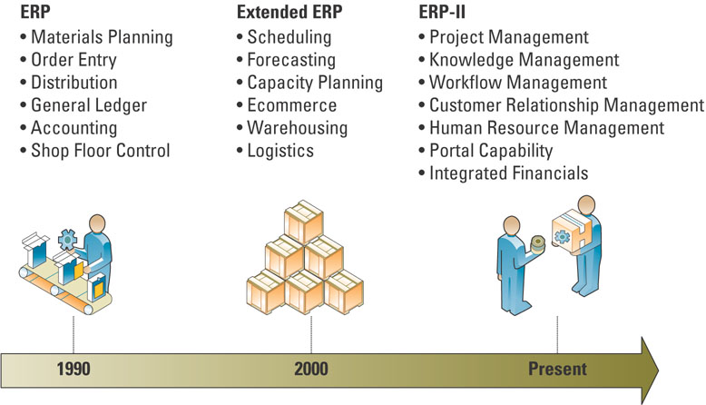
Enterprise resource planning (ERP) – integrates all departments and functions throughout an organization into a single IT system (or integrated set of IT systems) so that employees can make enterprise-wide decisions by viewing enterprise-wide information on all business operations
Reasons ERP systems are powerful tools:
- ERP is a logical solution to the mess of incompatible applications that had sprung up in most businesses
- ERP addresses the need for global info sharing and reporting
- ERP is used to avoid the pain and expense of fixing legacy systems
Heart of ERP:
At the heart of all ERP systems is a database; when a user enters or updates information in one module, it is immediately and automatically updated throughout the entire system
Evolution of EPR:
Core ERP component – traditional components included in most ERP systems and they primarily focus on internal operations
1. Accounting and finance ERP component – manages accounting data and financial processes within the enterprise with functions such as general ledger, accounts payable, accounts receivable, budgeting, and asset management
2. Production and materials management ERP component – handles the various aspects of production planning and execution such as demand forecasting, production scheduling, job cost accounting, and quality control
3. Human resource ERP component – tracks employee information including payroll, benefits, compensation, performance assessment, and assumes compliance with the legal requirements of multiple jurisdictions and tax authorities
Extended ERP component – extra components that meet the organizational needs not covered by the core components and primarily focus on external operations
1. Business intelligence
2. Customer relationship management
3. Supply chain management
4. E-business
E-logistics – manages the transportation and storage of goods
E-procurement – the business-to-business (B2B) purchase and sale of supplies and services over the Internet
Integrating SCM, CRM and ERP
Middleware – several different types of software which sit in the middle of and provide connectivity between two or more software applications
Enterprise application integration (EAI) middleware – packages together commonly used functionality which reduced the time necessary to develop solutions that integrate applications from multiple vendors
Measuring ERP success
Balanced scorecard is a management system, in addition to a measurement system, that enables organizations to clarify their vision and strategy and translate them into action.
Choosing ERP Software
Successful ERP projects share 3 attributes
1. Overall fit
- Off the rack
- Off the rack and tailored to fit
- Custom made
2. Proper business analysis
- Successful companies spend up to 10 percent of the project budget on a business analysis
3. Solid implementation plans
- A plan is needed to monitor the quality, objectives, and timelines
Chapter 5
Operational management fundamentals
Production management describes all the activities managers do to help companies create goods.
Operations management (OM) is the management of systems or processes that convert or transform resources (including human resources) into goods and services.
A transformation process is often referred to as the technical core, especially in manufacturing organizations, and is the actual conversion of inputs to outputs.
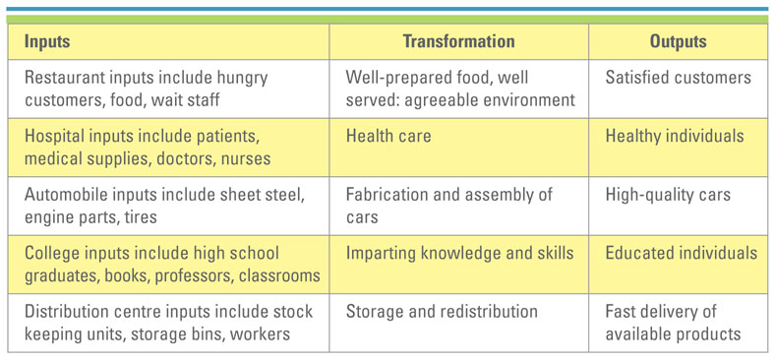
OM in business
Typical OM activities include:
Forecasting
Capacity planning
Scheduling
Managing inventory
Assuring quality
Motivating and training employees
Locating facilities
IS role in OM
Hierarchy of operation planning
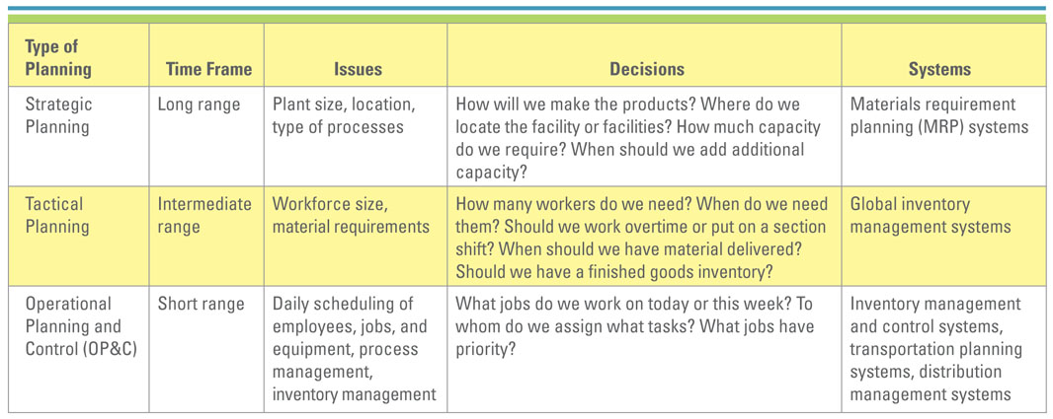
Competitive OM strategy
Five key competitive priorities:
1. Cost
2. Quality
3. Delivery
4. Flexibility
5. Service
Om and the supply chain
Supply chain consists of all parties involved, directly or indirectly, in the procurement of a product or raw material
Supply chain management (SCM) involves the management of information flows between and among stages in a supply chain to maximize total effectiveness and profitability.
- The four basic components of Supply chain management are:
1. Supply chain strategy
2. Supply chain partners
3. Supply chain operation
4. Supply chain logistics
Typical manufacturing supply chain:
Supplier storage (raw material) manufacturing storage (finished goods) distribution retailer customer
Typical service supply chain:
supplier storage (raw materials) service customer
Supply chain fundamentals
The supply chain has three main links:
1. Materials flow from suppliers and their “upstream” suppliers at all levels
2. Transformation of materials into semi-finished and finished products through the organization’s own production process
3. Distribution of products to customers and their “downstream” customers at all levels
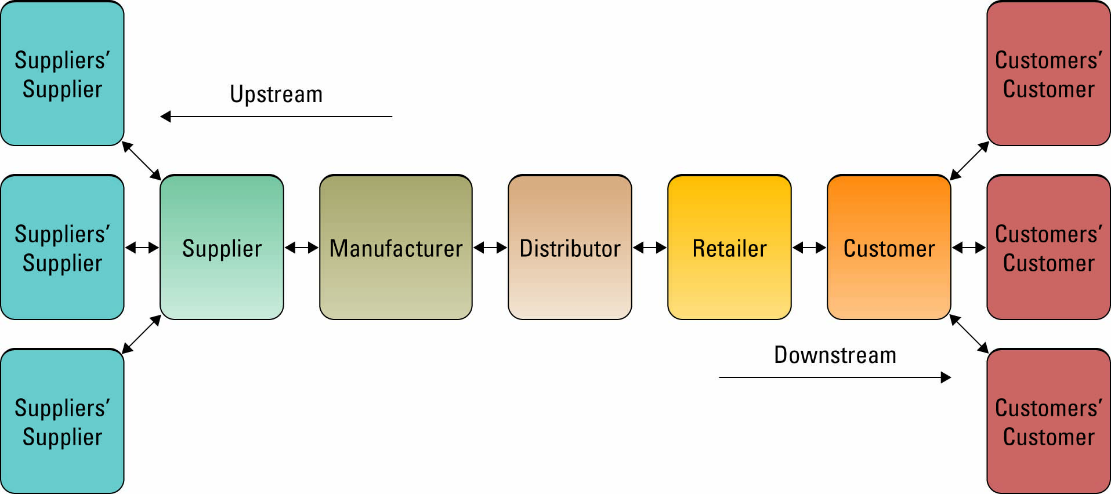
Five basic supply chain management components:
Plan source make deliver return
IS’s role in the supply chain
IS’s primary role is to create integrations or tight process and information linkages between functions within a firm
Factors Driving SCM:
1. Visibility:
- Supply chain visibility – the ability to view all areas up and down the supply chain
- Bullwhip effect – occurs when distorted product demand information passes from one entity to the next throughout the supply chain
2. Consumer Behaviour
- Companies can respond faster and more effectively to consumer demands through supply chain enhances
- Demand planning software – generates demand forecasts using statistical tools and forecasting techniques
3. Competition
- Supply chain planning (SCP) software– uses advanced mathematical algorithms to improve the flow and efficiency of the supply chain
- Supply chain execution (SCE) software – automates the different steps and stages of the supply chain
4. Speed
SCM success factor
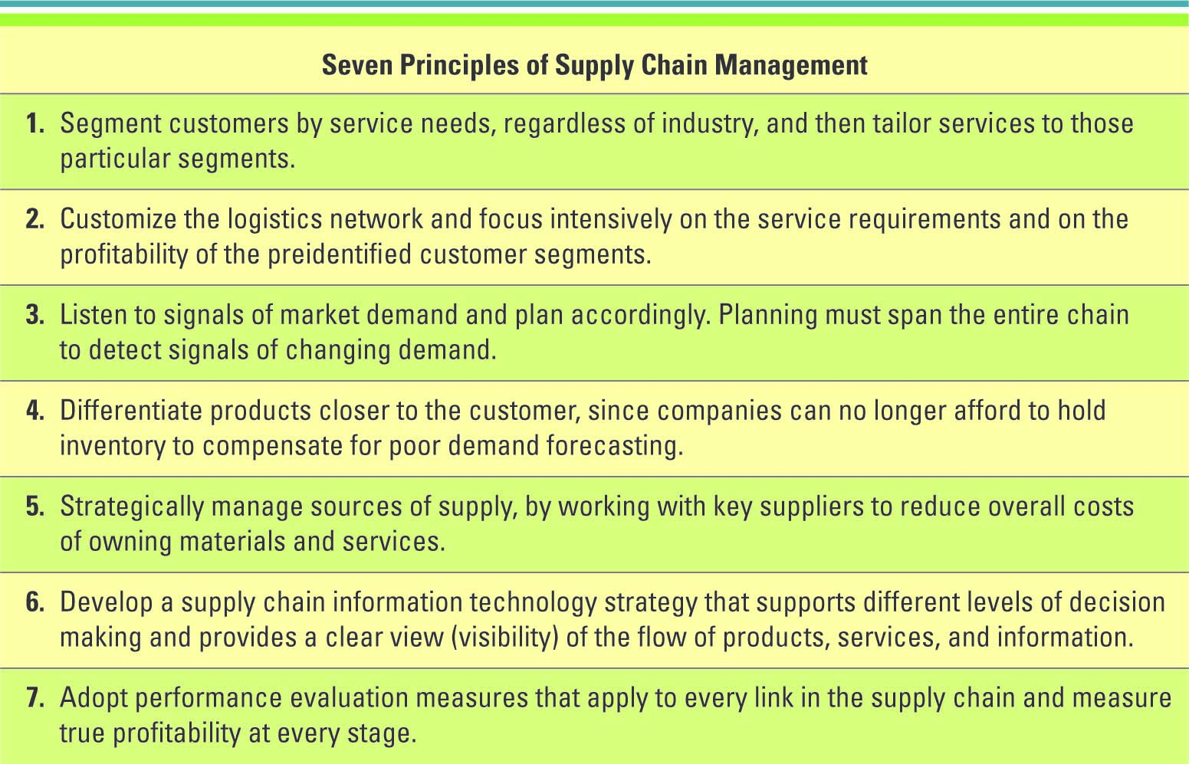
SCM industry best practices include:
1. Make the sale to suppliers
2. Wean employees off traditional business practices
3. Ensure the SCM system supports the organizational goals
4. Deploy in incremental phases and measure and communicate success
5. Be future oriented
CSM Benefits:
Cost control/savings
productivity improvements
inventory reductions/improvements
improved visibility into demand/supply
process cycle time reductions
quality improvements
maintain/gain competitive advantage
Future supply chain trends

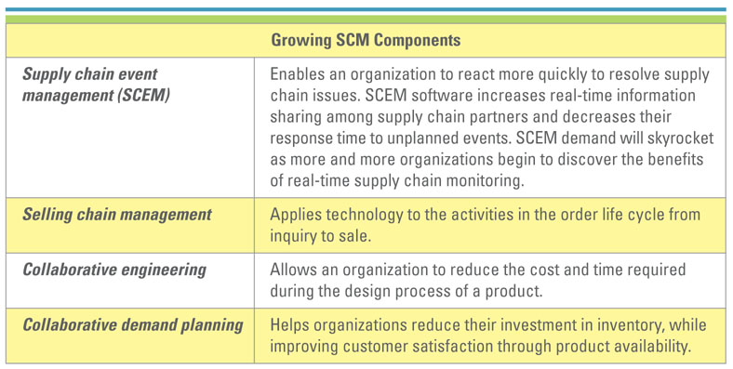
Chapter 6
Customer relationship management (CRM): involves managing all aspects of a customer’s relationship with an organization to increase customer loyalty and retention and an organization’s profitability
Business benefits of CRM:
CRM enables an organization to:
- Provide better customer service
- Make call centers more efficient
- Cross-sell products more effectively
- Help sales staff close deals faster
- Simplify marketing and sales processes
- Discover new customers
- Increase customer revenues
RFM
Organizations can find their most valuable customers through “RFM” - Recency, Frequency, and Monetary value
- How recently a customer purchased items (Recency)
- How frequently a customer purchased items (Frequency)
- How much a customer spends on each purchase (Monetary Value)
The evolution of CRM
1. CRM reporting technology – help organizations identify their customers across other applications
2. CRM analysis technologies – help organizations segment their customers into categories such as best and worst customers
3. CRM predicting technologies – help organizations make predictions regarding customer behaviour such as which customers are at risk of leaving
Operational and analytical CRM
- Operational CRM – supports traditional transactional processing for day-to-day front-office operations or systems that deal directly with the customers
- Analytical CRM – supports back-office operations and strategic analysis and includes all systems that do not deal directly with the customers
Using IS to drive operational CRM
Marketing and operational CRM:
Three marketing operational CRM technologies:
1. List generator – compiles customer information from a variety of sources and segments the information for different marketing campaigns
2. Campaign management system – guides users through marketing campaigns
3. Cross-selling and up-selling
-. Cross-selling – selling additional products or services
- Up-selling – increasing the value of the sale
Sales and operation CRM:
- The sales department was the first to begin developing CRM systems with sales force automation – a system that automatically tracks all of the steps in the sales process
1. Sales management CRM system
- automates each phase of the sales process, helping individual sales representatives coordinate and organize all of their accounts
2. Contact management CRM system
- maintains customer contact information and identifies prospective customers for future sales
3. Opportunity management CRM system
- targets sales opportunities by finding new customers or companies for future sales
Customer service and CRM:
Three customer service operational CRM technologies:
1. Contact centre (call centre)
2. Web-based self-service system
- Click-to-talk
3. Call scripting system
Using IS to drive analytical CRM
- Personalization – when a Web site knows enough about a person’s likes and dislikes that it can fashion offers that are more likely to appeal to that person
- Analytical CRM relies heavily on data warehousing technologies and business intelligence to glean insights into customer behavior
- These systems quickly aggregate, analyze, and disseminate customer information throughout an organization
- Analytical CRM information examples
1. Give customers more of what they want
2. Find new customers similar to the best customers
3. Find out what the organization does best
4. Beat competitors to the punch
5. Reactivate inactive customers
6. Let customers know they matter
Implementing CRM
CRM industry best practices include:
1. Clearly communicate the CRM strategy
2. Define data needs and flows
3. Build an integrated view of the customer
4. Implement in iterations
5. Scalability for organizational growth
Eight building blocks of CRM:
1. Creating a CRM vision that provides a “big picture” of what the customer-centric organization should look like.
2. Defining and weaving a CRM strategy that aligns with broader marketing and sales strategies, and informs operational and production strategies.
3. Understanding and engaging the customer.
CRM metrics
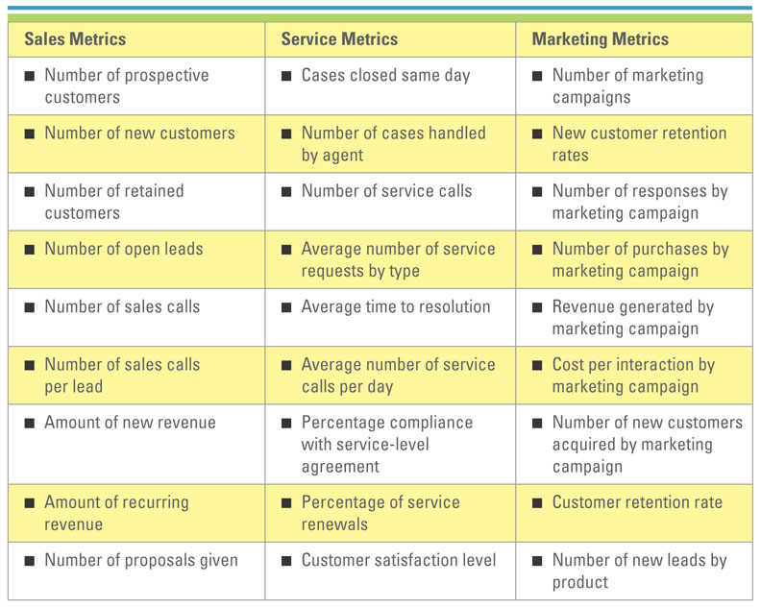
Managing other relationships
Supplier Relationship Management (SRM) focuses on keeping suppliers satisfied by evaluating and categorizing suppliers for different projects.
Partner Relationship Management (PRM) focuses on keeping vendors satisfied by managing alliance partner, dealer, retailer, and reseller relationships that provide customers with an optimal sales channel.
Employee Relationship Management (ERM) is a management activity that focuses on managing an organization’s relationships with its employees.
Future CRM trends
CRM future trends include:
- CRM applications will continue to evolve and be used by a wide variety of partners
- CRM will continue to be a major strategic focus for companies
- CRM applications will continue to adapt wireless capabilities supporting mobile sales and mobile customers
- CRM suites will incorporate SRM, PRM and ERM modules

