Accounting
- information system that identifies and records the economic events of an organization, and then communicates them to a wide variety of interested users.
Internal users
- have access within a company or organization to financial information
  - ceo, chairman, account
external users
- don’t have private information
  - investors
investors= share holders
creditors= lenders
interest revenue= finance income
TYPES OF BUSINESSES
- proprietorship
  - is a business owned by one person, known as a proprietor. It is often called a “sole” proprietorship because there is a single owner.
    - The business income is reported as self-employment income and taxed on the owner’s personal income tax return.
    - Reporting entity concept
- Partnership
  - a business owned by more than one person
  - Reported as self income
- Corporation
  - is a business organized as a separate legal entity owned by shareholders and is the most complex form of business to establish.
  - Life is indefinite
  - Identified by name ending in inc., LTD.,corp, co
Public corporations
- are required to distribute their financial statements to investors, lenders, other creditors, other interested parties, and the general public on a quarterly (every three months) and annual basis
- must use International Financial Reporting Standards (IFRS)
Private corporations
- also issue shares, but they do not make them available to the general public nor are they traded on public stock exchanges.
- These shares are often said to be “closely held.”
- Sobeys is one of the few private companys that voluntarily discloses fincial information
- choice between using IFRS or Accounting Standards for Private Enterprises (ASPE)

The reporting entity concept
- requires that the economic activity that can be identified with a particular business be kept separate and distinct from the activities of the owner and of all other economic entities.
generally accepted accounting principles
- commonly abbreviated as GAAP.
- includes broad policies and practices as well as rules and procedures that have substantive authoritative support and agreement about how to record and report economic events
liabilities
- Amounts owed to lenders and other creditors—in the form of debt and other obligation
Goodwill
- results when a company acquires another company, paying a price that is higher than the value of the purchased company’s net identifiable assets.
Accounts receivable
- right to receive money in the future
- Accounts receivable are assets because they represent an economic resource—cash—which will be received when the amounts owed are eventually collected.
Supplies
- Short term assets that wont be sold to customers
Inventory
- Short term assets that will be sold to customers
Integible asset
- Non current assets that don’t have a physical value
  - Patents, trademarks, licenses
Current liabilities
- obligations that are to be paid or settled within one year of the company’s statement date or its operating cycle, whichever is longer.
non-current liabilities,
- Obligations that are expected to be paid or settled after one year are classified as
  - Lease obligations, pensions, notes payable
Notes receivable
- amounts owed to the company by customers or others that are supported by a written promise to repay. Loans receivable are a type of note receivable. Notes receivable are normally interest-bearing, whereas accounts receivable are not.
Prepaid expenses
- represent the cost of expenses like rent and insurance paid in advance of use. They are current assets because they reflect unused benefits such as office space and insurance coverage available for future use during the year.

Deficit
- Net loss exceeds net income

Income statement
- An income statement reports revenues and expenses, showing how a company’s operations performed during a period of time.
Statement of changes in equity
- A statement of changes in equity shows the changes in each component of shareholders’ equity (including common shares and retained earnings), as well as total equity, during a period of time.
Statement of financial position
- A statement of financial position presents a picture of what a company owns (its assets), what it owes (its liabilities), and the resulting difference (its shareholders’ equity) at a specific point in time. Statement of cash flows: A statement of cash flows shows where a company obtained cash during a period of time and how that cash was used.
Costs of goods sold= cost of inventory sold
Quarterly financial statements are also called interim financial statements.
The statement of financial position is dated at a specific point in time. The income statement, statement of changes in equity, and statement of cash flows cover a period of time.
The annual report
- a document that includes financial information, as well as useful nonfinancial information about the company, for the previous fiscal year. Nonfinancial information may include the company’s mission, goals and objectives, products, and people.
three main types of business activity
fincial activity
- The two primary ways of raising outside funds for corporations are (1) issuing (selling) shares (equity financing) in exchange for cash (or other assets) and (2) borrowing money (debt financing).
- if a corporation was wound up (ceased operations), all debts have to be repaid before shareholders would have any legal right to a return of the capital they invested.

Investing activitys
- Investing activities involve the purchase (or sale) of long-lived assets that a company needs in order to operate.
- Property, plant, and equipment is also known as capital assets or fixed assets.
- Most investment acrtivitys is the purchase and sale of long term assets
Operating activity
- Includes everything like buying inventory and supplies, paying taxes, net income, etc.

Chapter 2

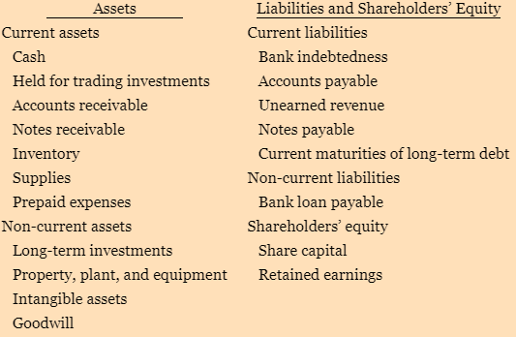
Intracompany comparisons
- covering two or more periods for the same company
Intercompany comparisons
- based on comparisons with a competitor in the same industry
Industry average comparisons
- based on average ratios for particular industries with specific company ratios
accrual basis of accounting
- Under the accrual basis of accounting, the effects of transactions on a company’s economic resources and claims are recorded in the period when a transaction occurs and not when cash is received or paid.

Financial Information must have three characteristics
- Complete, neutral, free of error
cost constraint
- is a pervasive constraint that ensures that the value of the information provided in financial reporting is greater than the cost of providing it. That is, the benefits of financial reporting information should justify the costs of providing and using it.
The going concern assumption
- assumes that a company will continue to operate for the foreseeable future. Fulfilling all outstanding services and commitments
elements of financial statements
- assets, liabilities, equity, income (including gains), and expenses (including losses).
Assets
- An asset is an economic resource controlled by the company as a result of past events. An economic resource is a right that has the potential to produce economic benefits.
Liabilities
- A liability is a present obligation of the company to transfer an economic resource as a result of past events.
Equity
- Equity is the residual interest in the assets of the company after deducting all its liabilities.
Income
- Income includes both revenue and gains. Revenue arises in the course of the ordinary activities of the company while gains may or may not arise from ordinary activities. Income is the increases in economic benefits during the accounting period in the form of inflows or increases in assets or decreases in liabilities that result in increases in equity, other than those relating to contributions from equity participants.
Expenses
- Expenses include losses as well as those expenses that arise from ordinary activities of the company. Losses may or may not arise from ordinary activities. Expenses are decreases in economic benefits during the accounting period in the form of outflows or decreases in assets or increases in liabilities that result in decreases in equity, other than those relating to distributions to equity participants.
historical cost basis of accounting
- states that assets and liabilities should be recorded at their cost at the time of acquisition. This is true not only at the time when the item is purchased, but also during the time that an asset or liability is held.
  - Even if the value increases after a year, the original value is still recorded

Chapter 3
Accoutning cycle
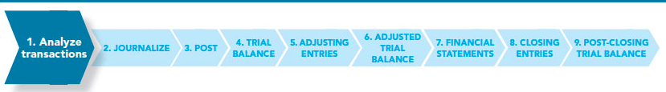

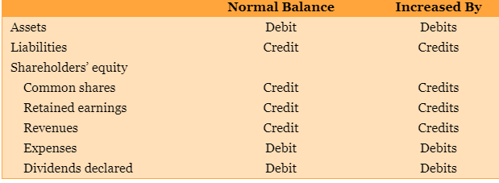
Posting
- involves transferring information from the general journal to the general ledger.

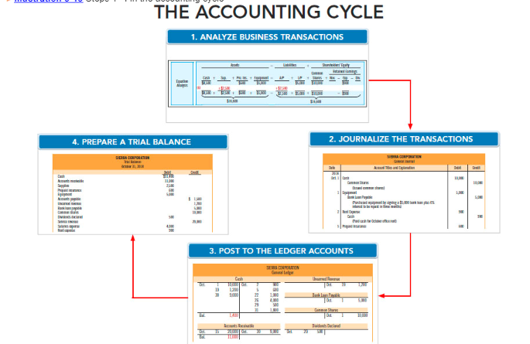

Accrual basis accounting
- means that transactions affecting a company’s financial statements are recorded in the periods in which the events occur, rather than when the company actually receives or pays cash
cash basis accounting
- revenue is recorded only when cash is received, and an expense is recorded only when cash is paid.
Retailers(Walmart)
- Merchandising companies that purchase and sell directly to consumers
Wholesalers (walmarts supplier)
- Merchandising companies that sell to retailers
Manufactures( the actual creator)
- Companies that produce goods for sale to wholesalers (or others)
FOB ( free on board) destination(perp only)
- Seller pays shipping fee, considered in their inventory until the shipment is delivered
- Destination, as it is the buyers once it reaches the destination
FOB ( free on board) Shipping point (perp only)
- Buyer pays for shipping, considered in their inventory as soon as it is shipped
- Shipping point, as it is the buyers as soon as it is shipped
Perpetual inventory system
- Updates constantly and up to date
Periodic inventory system
- Not up to date
- No guide lines on when to enter inventory changes
quantity discount
- is an incentive offered to a buyer that results in a decreased cost per unit of goods or materials when purchased in greater numbers.
- is often offered by sellers to entice buyers to purchase in largerquantities.
purchase discount
- is offered to encourage customers to pay for goods purchased on account prior to the due date. A purchase discount offers advantages to both parties: the purchaser saves money, and the seller is able to shorten its operating cycle by converting accounts receivable into cash quicker.

Calculating purchase discount
- If you are given the terms 3/10, n/30, this means 3-ten, net 30, which basically means if the amount owed is payed within 10 days, you will receive a 3% discount, the net 30 means you have a max 30 days to pay before interest starts,
- so if I owed 100, and paid it in 4 days, id only have to pay $97
- If I paid in 14 days, id have to pay $100
- If I paid in 43 days, id pay $100+ interest accumulated

If I bought somthings for $3500 on the terms 2/10, n/30, and paid within 10 days, id debit accounts payable, as it’s a liability that is decrasing by 3500, credit cash, as it is an asset that is decreasing by 3430, and credit inventory, as it is an expense that is decreasing
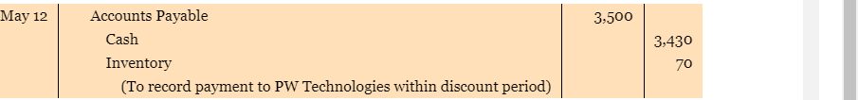
On the contrary, this is what the supplies journal would look like
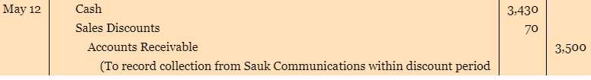
Based on the example above, if I took more then 10 days, but less then or equal to 30 days, I would debit 3500 to accounts payable, as the liability is decreasing, and I would credit cash, as it in decreasing
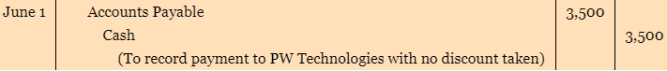

If you receive a product back from a customer that they returned in working condition and could be resold, debit the amount received back to sales returns and allowances, and credit accounts recievable, pretty much undoing the added amount to accounts recievable
Then, debit the inventory back the amount you took, and credit the cost of goods sold for what was sold
If the item is returned damaged, and cant be resoled, you just do the first step, as you cant include damaged inventory in your inventory, this is just a loss the business would have to eat

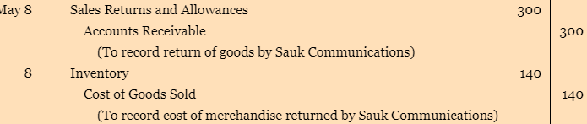
When starting a business, if you invest 20000$, then cash is debited 20000, and capital, which is a category of equity, is credited 20000, meaning ur businesses has 20000 to use to finance. You don’t record anything to do with u losing 20000, only the company
single-step income statement
- all data are classified into two categories: (1) revenues and (2) expenses. Revenues include both operating and non-operating revenues. Non-operating revenues are items not related to the company’s main operations, such as interest revenue and gains. We will learn more about non-operating revenues (and expenses) in the next section of this chapter.
The multiple-step income
- several steps are presented in determining net income (or loss). It is considered more useful because it highlights the components of income separately
- statement shows five main steps:
  - Net sales: Gross sales less sales returns and allowances and sales discounts.
  - Gross profit: Net sales less cost of goods sold.
  - Income from operations: Gross profit less operating expenses.
  - Income before income tax: Income from operations + non-operating revenues - non-operating expenses.
  - Net income: Income before income tax - income tax expense.
Types of cost formula
The specific identification cost formula
- tracks the actual physical flow of the goods in a perpetual inventory system. Each item of inventory is marked, tagged, or coded with its specific unit cost so that, at any point in time, the cost of the ending inventory and the cost of the goods sold can be determined. This cost formula is only used for inventories that are composed of unique, identifiable items. These items are typically also of high value.
- Used for stuff like cars, houses, used equipment, which are all valued indiviusally, and can be indiviusally disguished
FIFO ( first in, first out)
- What ever the price of the first time purchase price is, is what your COGS is, until that unit of shirts is gone
- Ex. If your begining inventory was 10 shirts, which you paid 10$ each for, then purchased 15 shirts for 12$ each,
- Say you sold 6 shirts at 20$ each, revenue would be $120, COGS would be 60$, and gross profit would be $60

LIFO (last in, first out)
- What ever the last purchase price of a product was, is the cost of good sold until those units are gone
- Ex. . If your begining inventory was 10 shirts, which you paid 10$ each for, then purchased 15 shirts for 12$ each,
- Say you sold 6 shirts at 20$ each, revenue would be 120$, cogs would be 72, and gross profit would be 48
- Ending inventory would be 9 shirts at 12$ each, and 10 shirts at 10$ each
Average method
- Take the amount of the product of you had and multiply it by what u paid per unit, and add all of these together and find the total
- Say you bought 10 shirts for 10$ each, and 15 for 12$ each
  - Total = ((10X10)+(15x12))/25
Inventory turnover
- a measure of the number of times inventory is sold or used in a time period such as a year.
- Inventory turnover = cost of goods sold/ avg. inventory
- Days in inventory = 365 days/ inventory turnover
Contra asset account
- Includes things like depreciation, and other things that take away from assets value
- Carrying amounts is what that asset is worth after the deprication is taking awayd

Chapter 6
Reminder
- Perpetual
  - Constantly updates the inventory accounting records to show the quantity and cost of inventory that should be on hand
When accounting inventory
- At year end there is a physical count for both perp and periodic, to accounting for theft and destroyed inventory
- Inventory is only counted If you own it, meaning if you have a product that has been sold, or you are holding someone elses inventory, this is not counted
  - If the case were you ordered something on FOB shipping point before the fiscal year end, that inventory is included because you have paid for it in full, and is on route, doesn’t matter if you physically posses it
Cosigned goods
- When a company sells another companys inventory, for example a art house sells other artists painting, they get a profit, but never actually own the painting, meaning it cant be included in inventory, unless you were the artist
Internal controls
- are systems designed to help an organization achieve reliable financial reporting, effective and efficient operations, and compliance with relevant laws and regulations.
- Includes control activitys
  - Physically counting inventory

The specific identification cost formula
- tracks the actual physical flow of the goods in a perpetual inventory system.
- This cost formula is only used for inventories that are composed of unique, identifiable items.
  - Such as cars, hand made anything really, interchangeable things
  - These items are typically also of high value.
A company can use more then one cost formula
- A car company would use specific for idenfication, but the parts the company has might us FIFO
Beginning inventory+ Purchases = cost of goods sold + inventory
Beginning inventory + Cost of goods purchased = Cost of goods available for sale
Cost of goods sold + Ending inventory = Cost of goods available for sale
Beginning inventory + Cost of goods purchased = Cost of goods sold + Ending inventory
Cost of goods available for sale/ total units for sale= weighted avg unit cost

FIFO
- When using FIFO, in perpedual you calulate everything at the date it happens,
- where as periodic you simply find COGS by calculating cost of goods available for sale ending inventory
average inventory
- Cost of goods available for sale/ total units for sale= weighted avg unit cost
- In perp accounting, you must redo the calculation for avg cost after each sale, meaning disregard what was sold, and focus on how much

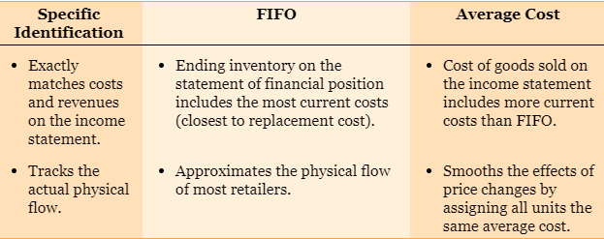

DURING PERIOD WHERE COST OF INVENTORY HAS RISSEN SINCE THE START OF THE PERIOD
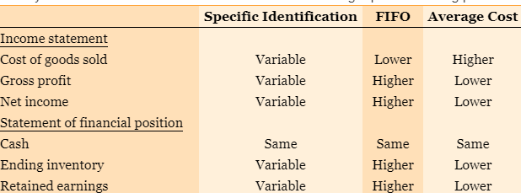
It is also worth remembering that all three cost formulas will give exactly the same result over the life cycle of the business or its product.
- That is, the allocation between the cost of goods sold and ending inventory may vary annually, but it will produce the same cumulative results over time.
  - ALL SYSTEMS PRODUCE SAME CASH FLOW BEFORE INCOME TAX
when the net realizable value of inventory is lower than its cost, inventory is written down to its net realizable value
- And vice versa
  - So if you find that your realizable value is higher then what it cost, you would just write down what it cost

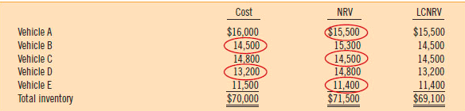
Subtract LCNRV from COST to find difference, and then do adjusting entry

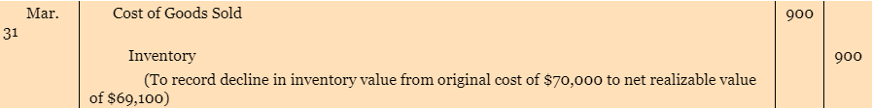
Inventory turn over= cost of goods sold/ avg inventory cost (beginning+ ending inventory/2)
Section 6-A explains the 3 systems well, with an example

