There are 3 parts to this test
- ADD YOUR NAME TO ALL SECTIONS and IF-AT SHEET
- THIS TEST HAS 11 PAGES
PART A = 18 multiple choice questions (1 point each)
- OPTION 1 : RANK ORDER YOUR MCQ ANSWER SELECTIONS
- OPTION 2: Use the IF-AT sheet provided – ADD YOUR NAME AND STUDENT # AT TOP
- NOTE – Scratch ALL or NOTHING
- Partial scratches will count as a WHOLE SCRATCH = ANSWER
- CONTINUE TO SCRATCH UNTIL YOU HAVE THE RIGHT ANSWER (*)
  - 1 SCRATCH = 1 POINT
  - 2 SCRATCHES = 0.5 POINT
  - 3 SCRATCHES = 0.1 POINT
  - 4 SCRATCHES = 0 POINT
- ADD YOUR SCORE PER QUESTION AND IF TIME ALLOWS ADD UP THE MARKS (out of 20)
PARTS B and C = 4 SHORT ANSWER QUESTIONS at 5 points per answer!!!
Part B – 4 Short Answer questions – YOU DO THREE (3) (15 points total).
Part C – 1 Case Study – YOU DO ONE (1) (5 points total).
- Use the space provided to answer these questions.
- If I ask for 5 things and you give 6, only the first 5 are answered.
- Answers in pencil cannot be remarked.
Total Points = 38 points!

SUBMIT THE WHOLE TEST WITH IF-AT SHEET AT END OF TEST

PLEASE READ :
Cellular phones, unauthorized electronic devices or course notes (unless an open-book exam) are not allowed during this exam. Phones and devices must be turned off and put away in your bag. Do not keep them in your possession, such as in your pockets. If caught with such a device or document, the following may occur: you will be asked to leave immediately the exam, academic fraud allegations will be filed which may result in you obtaining a 0 (zero) for the exam.

By signing below, you acknowledge that you have ensured that you are complying with the above statement.
__________________________________________________________
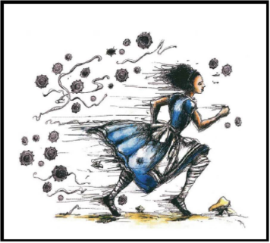
- In the video from PBS on the Evolution of Sex, the researchers discovered an isolated pool with sexually dividing minnows where they noted that the sexual reproducers had as much parasite as the asexual reproducers. The sex advantage was lost! Which statement below BEST explains what happened?

- The sexual reproducers lost their ability to recombine chromosomes during meiosis and consequently all their offspring were genetically the same (clones).They were not diverse!
- The sexual reproducers in the pool were few and, because of their isolation, became clone-like (inbred) despite sex. Consequently, they lost the genetic diversity.
- The asexual reproducers were able to change to sexual reproducers and therefore match the benefits afforded by sex to help combat the parasite.
- The isolated pool was created due to a drought in the area. The pool was too warm and the O₂ levels dropped so the sexual reproducers were too sedentary. They did not mate as much and that is why the asexual reproducers outcompeted them.
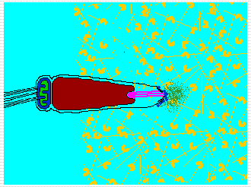
- Four students have provided their separate interpretations of the following image (a to d; 1 each) to the situation depicted on the left. One of them needs to revise their notes. Which ONE?
- This “activation” of this sperm involves very specific receptor-ligand interactions.
- This is a great model for the acrosome reaction that occurs in mammals.
- This is a great model for exocytosis of a vacuole with the outer membrane.
- This is a scenario that requires the flux of Ca2+ within the sperm.
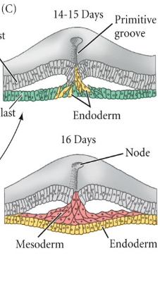
- Interestingly, the movement of the cells through the primitive groove in amniotes (such as birds and mammals for example) is described as “invagination”. That being said, based on how it is depicted in cartoons, which other major morphogenic movement more accurately describes the movement of the cells?
  - Dispersion
  - Ingression
  - Delamination
  - Involution

- Which statement about fertilization is TRUE?
  - In sea urchins, the bindin protein on sperm has fusogenic properties, containing hydrophobic domains that allow for sperm-egg fusion.
  - In mammals, the acrosomal process on sperm is made up of actin filaments and requires Ca2+ to initiate polymerization.
  - The flux in Ca2+ across the other membrane of the egg results in a rapid polarity shift, a necessary step for the fast block in polyspermy in sea urchins.
  - In mammals the acrosome reaction is only initiated upon binding to proteins in the zona pellucida.

- Syncytiotrophoblasts are multinucleated progeny of trophoblasts. Which ONE of the following scenarios would NOT make a multinucleated cell?
  - A cell undergoing karyokinesis but no cytokinesis.
  - A cell treated with cytochalasin B during mitosis.
  - A cell treated with colchicine during mitosis.
  - Two similar cells expressing fusogenic proteins on their membranes.

- Which ONE of the following would NOT play a direct role in starting and lengthening the archenteron in sea urchin? PROBLEM WITH THIS QUESTION AS ALL ANSWERS ARE ARGUABLY INVOLVED IN ELONGATION
- invagination of the vegetal plate
- convergent extension of cells in archenteron
- ingression of secondary mesenchyme cells
- mitotic division of archenteron cells

- Which statement about sperm is FALSE?
  - The sperm was once considered a parasite residing in the testes.
  - The sperm activity has been shown to be sensitive to soluble factors.
  - The sperm needs mitochondria to drive its flagellum for motion.
  - The sperm contributes only a pronucleus after fertilization.

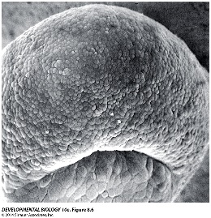
- Which term MOST ACCURATELY summarizes this stage in embryogenesis?
- Zygote
- Morula
- Blastula
- Gastrula

- Which one of the following is NOT analogous to the Spemann-Mangold organizer?
- Sea urchin mesomeres
- Mammalian node
- Chicken Hensen’s node
- Amphibian Grey crescent

Q10-13: A scientist has identified a new sexually-reproducing, animal species X. She decides to investigate the gametes, fertilization, and embryogenesis.
- Investigation of the eggs reveal that the eggs are moderate in yolk distribution. Based on what you know, which statement is TRUE?
  - The eggs are isolecithal that will likely show holoblastic cleavage.
  - The eggs are telolecithal that will likely show meroblastic cleavage.
  - The eggs are mesolecithal that will likely show holoblastic cleavage.
  - The eggs are centrolecithal that will likely show meroblastic cleavage.

- Further examination reveals that the fertilization of the eggs is external to the animal. Which statement is likely FALSE?
  - The receptor-ligand interactions between sperm-egg are highly species specific to prevent inter-species fertilization.
  - The change in the action potential across the sperm membrane is an important step to block polyspermy.
  - Ca2+ fluxes in both the egg and sperm are required for both the activation of both gametes.
  - The egg attracts the sperm to it with the help of juxtacrine receptor-ligand interactions.

- Upon fertilization, the zygote is examined in vitro. It is noted that the rate of cleavage drops significantly as of the 8-cell stage onwards. Which statement is likely TRUE?
  - The level of transcription begins to increase at the 8 cell stage.
  - The cell divisions after the 8-cell stage will generate smaller blastomeres.
  - The genome of the cells at the 8-cell stage are likely in a heterochromatin state.
  - The cell cycle of the blastomeres at the 8-cell stage has only two stages.

- Which ONE of the following would not contribute to the anterior (pro-rostral) extension of the primitive streak in amniotes?
  - Mitotic cell division
  - Intercalation
  - Cell lengthening
  - Invagination

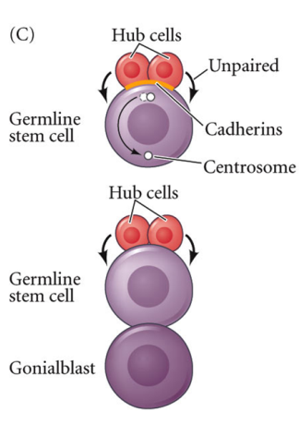
- Recall the role of hub cells in Drosophila testes. With the help of your understanding of signaling processes and this drawing, which one of the following is LIKELY involved in maintaining the stem cell population?
- Wnt-Frizzled signaling pathway
- BMP-RTK signaling pathway
- Delta-Notch pathway
- Shh-RTK signaling pathway

- Which statement about sea urchin gastrulation is FALSE :
- Ingression of primary mesenchyme cells is in part due to changes in binding affinities.
- Nodal proteins are responsible for the left-right axis determination and placement of the imaginal rudiment.
- Secondary mesenchyme cells are derived from micromeres and enter the blastocoel.
- The archenteron will ultimately form the anus, gut and mouth of the pluteus larva.

- Which ONE of these statements is TRUE?
- Thermotaxis is a key mechanism used in guiding Sea Urchin sperm to the egg.
- Fast block involves conversion of the vitelline envelope to the fertilization envelope.
- Ca2+ is removed and stored away in the endoplasmic reticulum of the newly fertilized egg.
- Proteolytic degradation is involved in the asymmetric distribution of maternal factors in sea urchin.

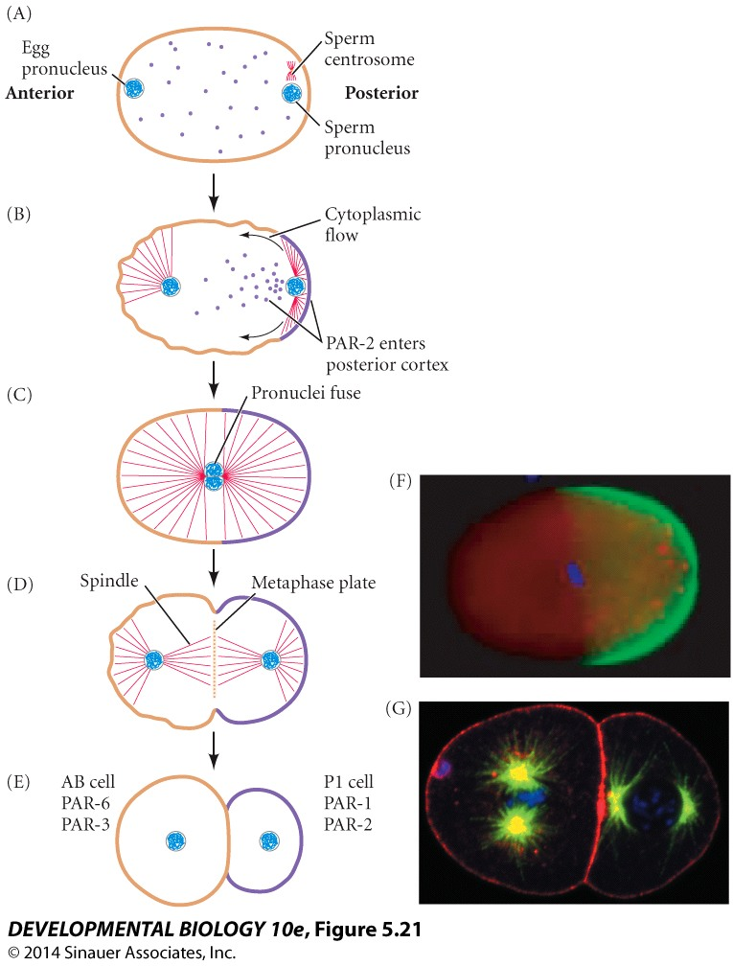
- What was the purpose of this image?
  - It was used to highlight the movement of the nuclei after fertilization.
  - It was used to showcase karyokinesis as mediated by cellular microtubules.
  - It showcases the redistribution of cytosolic factors with the help of cytoskeletal elements.
  - It was used to highlight the steps prior to cleavage and the clonal proliferation of this parent cell.

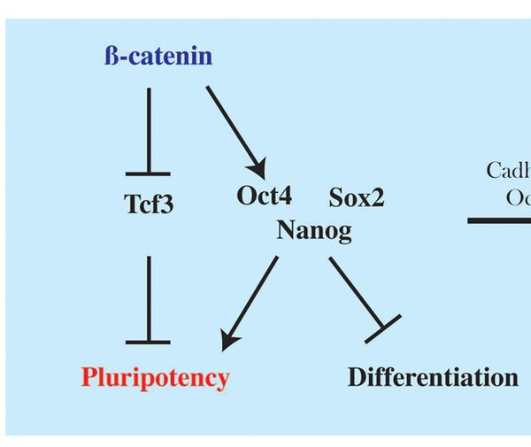
- So here is a signaling pathway that occurs in the ICM, specifically in the ES cells. Which of the following statements is TRUE?
  - Shh-to-RTK treatment of blastocysts will maintain pluripotency.
  - Wnt-to-Frizzled treatment of blastocysts will maintain pluripotency.
  - Delta-to-Notch treatment of blastocyts will maintain pluripotency.
  - A gain-of-function, dominant positive (non-suppressable) Tcf3 will keep the ES cells pluripotent.

Short Answer questions PART B: ANSWER ONLY 3 OUT OF 4 (5 points each)

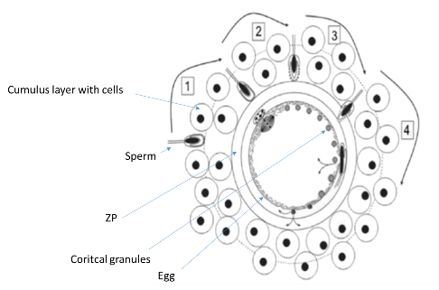
  - Recall this figure to the left dealing with our most recent understanding of mammalian fertilization as of 2016. On the image here, identify the cumulus layer, ZP, the egg (oocyte), the cortical granules, and the sperm. In the space provided for written answers, describe what is going on in steps 1 to 4 (one sentence per number).

------------------------------------------------------------------------------------------------------------
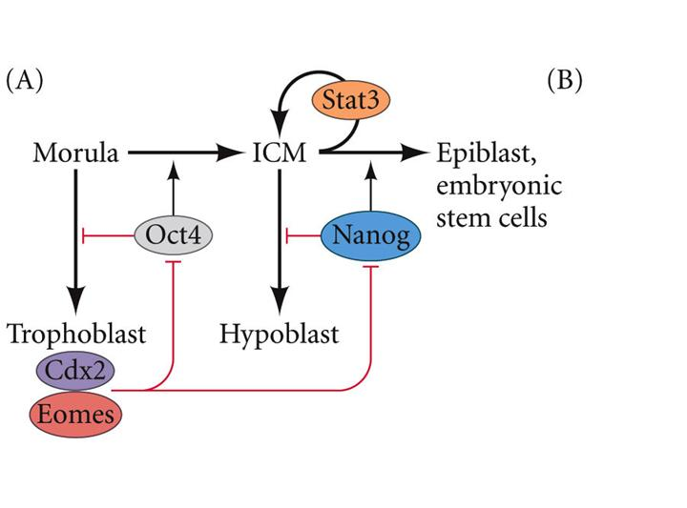
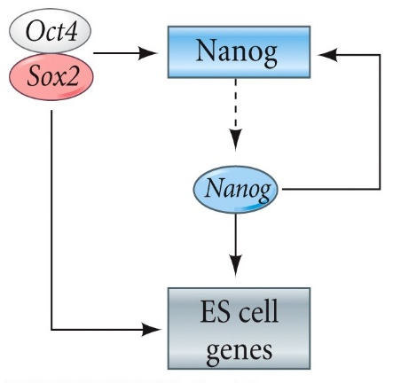
  - Here are some models that explain the creation of the different cell types in the mammalian embryo (A) and the induction of ES cells (B); these mechanisms take place as of compaction at the 8 cell morula stage. All the ovals are different transcription factors. I want you to come up with an explanation that relies on polarization mechanisms to explain the ICM vs Trophoblast, and, Epiblast (ES) vs Hypoblast commitment using the information provided here. Either with the help of drawings and/or a written story, incorporate elements from both mechanisms above as well as any details that you learned in the course to describe how blastomeres become polarized in a way that fits the models above. FYI – Question 4’s picture is an example of a cartoon that depicts what I talked about on the last day before this test.

  - Ca2+ plays an important signaling role in both sperm and eggs. I) Briefly, state two ways by which Ca2+ enters into the cytosol of a hypothetical cell. II) Give 2 consequences per gamete for removing Ca2+ from the system and III) what bearing this would have on the state of the gamete, fertilization, and/or state of the zygote (where applicable). (State = ability to do/initiate some event for example)

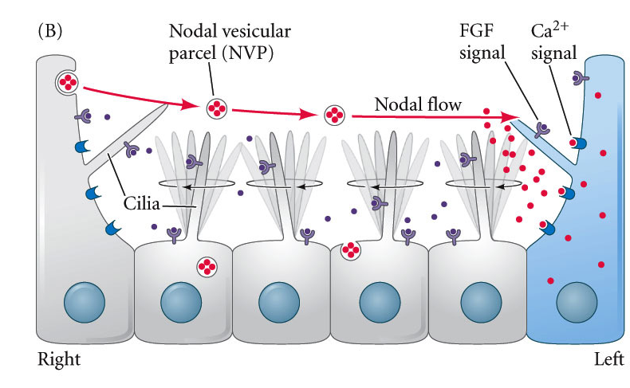

  - Above is a cartoon of ciliated nodal cells. In a sense, this cartoon endeavors to explain a subject that I taught in class although here are some added details, including NVPs (they carry Nodal in vesicles = exosomes), FGF, and Ca2+. Based on what you learned up to this point, integrate the details shown here as a way to teach the subject in question. Be sure to specify the context (e.g. species, relevance to development patterning.).

- CASE STUDY EXERCISE: DO THIS QUESTION FOR 5 POINTS

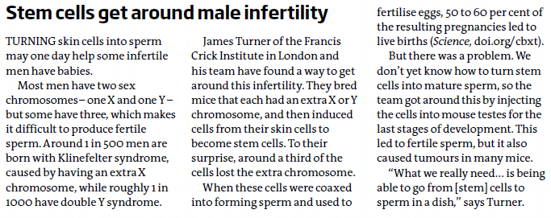

Background : Klinefelter Syndrome does result in physical and cognitive defects while Double Y (Jacobs) Syndrome has minimal visible and mental defects. Moreover, Klinefelter results in infertility, unlike males with Jacobs Syndrome (normal).

On a separate note: Testes contain somatic cells known as Sertoli cells that drive sperm production by germ cells with the help of testosterone and follilcle stimulatijng hormone (FSH)..

Q1. So briefly explain the function of the testes in the context of the study using the information provided. Essentially, what is it about the testes that gives them what they want in the article? (1 points)

Q2. So the last part of the article quotes the scientist by stating how they want to do it all in vitro. Provide a step-by-step mock protocol starting with a Klinefelter skin cell, converting it to an iPSC, then to a sperm in vitro. Include the pertinent components for each of the steps from mature cell to sperm in vitro. (3 points)

Q3. Note that 33% of skin cells lose the extra chromosome when converted to iPSCs and, of these “corrected” sperm, 50 to 60% led to live births. Also the iPSCs injected into the testes caused tumours. Can you provide explanations for these effects? (1 point)

Question ____

________________________________________________________________________Question ___

Question____

________________________________________________________________________Question____

