Lab report 3
ACID BASE TITRATION

By:
Robert Naim (300069096)

Work presented to
Karine Ghosti
CHM1711
Section Z03

University of Ottawa
Thursday 8 November 2018
Table of contents
Introduction: 3
Procedure: 4
Results: 4
Observations: 10
Calculations: 10
Discussion: 13
Conclusion 14

Introduction:

This lab revolves around the uncovering the concentration of an unknown acid, through use of known chemistry principles. By using an already known reaction, such as the titration of HCl with NaOH, it becomes easy to identify the unknown acid through comparison. All my solution throughout this lab have been prepared by means of dilution.
To begin, the understanding of acids and bases is primordial to this experiment. Acids are determined as “compounds that break up in water to give off hydronium (H⁺) ions.” according to Arrhenius. This proton is transferred between an acid and a base. As an example, the reaction of HNO₃ in water is defined as such:

HNO3 (aq) → H⁺ (aq) + NO3⁻ (aq)

A base on the other hand donates an OH⁻ when diluted in water, take NaOH as an example:

NaOH (aq) → Na⁺ (aq) + OH⁻ (aq)

Acids and bases are either strong or weak. For the purpose of this laboratory I will only be using strong acids and bases. These can be identified as molecules that completely disassociate when in contact with water. Therefore, NaOH and HCl, both of which are being used in this experiment are strong. Adding water to bases or acids dilutes the mixtures causing a difference in their concentration. Concentration is determined in this experiment through molarity (M). This is defined “as the number of moles of solute present in exactly 1 L of solution”. This is calculated with the following reaction:

Concentration (mol/L) = Amount of solute (mol) / Volume of solution (L)

In addition, the concept of titration should also be understood. When an acid and a base react to the point where there is an even amount of H⁺ and OH⁻ ions, this is called neutralisation. Another way of looking at it is when all the acids and bases have fully reacted to form salt and water. The equivalent point is when the added amount of acid is exactly enough to neutralize the base. Another important stage in titration is the endpoint. This stage is identifiable using an indicator such as phenolphthalein which is used in this experiment. The endpoint is shown when the indicator retains its colour showing the endpoint and the equivalent point.
Using theses concepts and other calculations given in the handout provided to us (pages 76-77) I will be able to identify the diprotic acid given to me.

Procedure:

Please see page. 77 of the chemistry lab manual by Dr. Rashmy

Results:

- Tables

Distillation of NaOH
Concentration of NaOH (M) | Volume of NaOH used for dilution (mL) | Volume of distilled water used for dilution (mL) | Volume of diluted NaOH in graduated cylinder (mL) | Number of drops counted for change in volume of dilute NaOH
6 | 5 | 200 | 2.2 | 44

Distillation of NaOH (after messing up)
Concentration of NaOH (M) | Volume of NaOH used for dilution (mL) | Volume of distilled water used for dilution (mL) | Volume of diluted NaOH in graduated cylinder (mL) | Number of drops counted for change in volume of dilute NaOH
6 | 5 | 200 | 2.6 | 51

Titration of HCl
 | Attempt #1 | Attempt #2 | Attempt #3
Initial volume of HCl in the burette (mL) | 20.00 | 20.00 | 20.00
Final volume of HCl in the burette (mL) | 10.00 | 10.00 | 10.00
Volume of HCl (mL) | 20-10 = 10.00 | 20-10 = 10.00 | 20-10 = 10.00
Volume of NaOH added to reach endpoint (mL) | 8.00 | 7.65 | 7.40
Number of phenolphthalein drops | 2 | 2 | 2

Titration of diprotic acid
 | Attempt #1 | Attempt #2 | Attempt #3
Initial volume of diprotic acid in the burette (mL) | 20.00 | 20.00 | 20.00
Final volume of diprotic acid in the burette (mL) | 10.00 | 10.00 | 10.00
Volume of diprotic acid (mL) | 20-10 = 10.00 | 20-10 = 10.00 | 20-10 = 10.00
Volume of NaOH added to reach endpoint (mL) | 7.80 | 8.00 | 7.90
Number of phenolphthalein drops | 2 | 2 | 2

pH of HCl as volume (mL) of NaOH is added
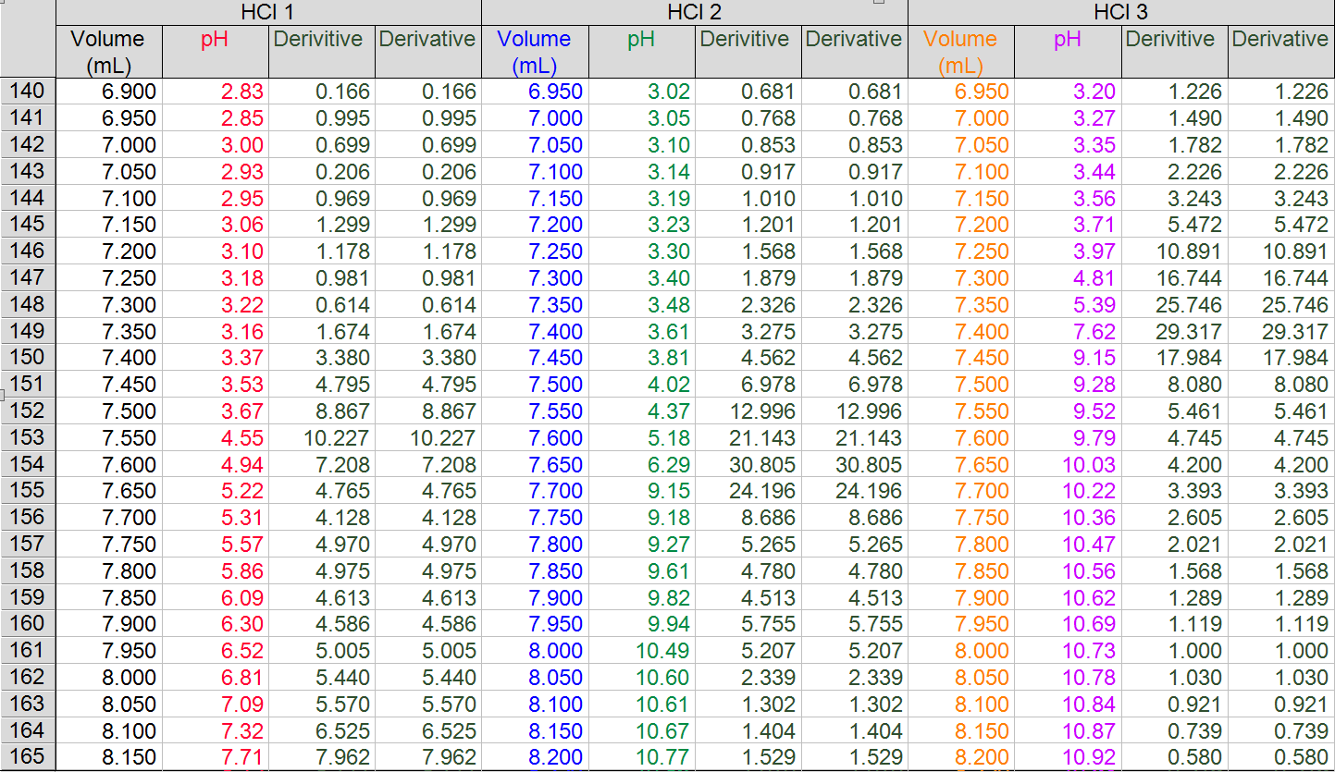

pH of diprotic acid as volume (mL) of NaOH is added
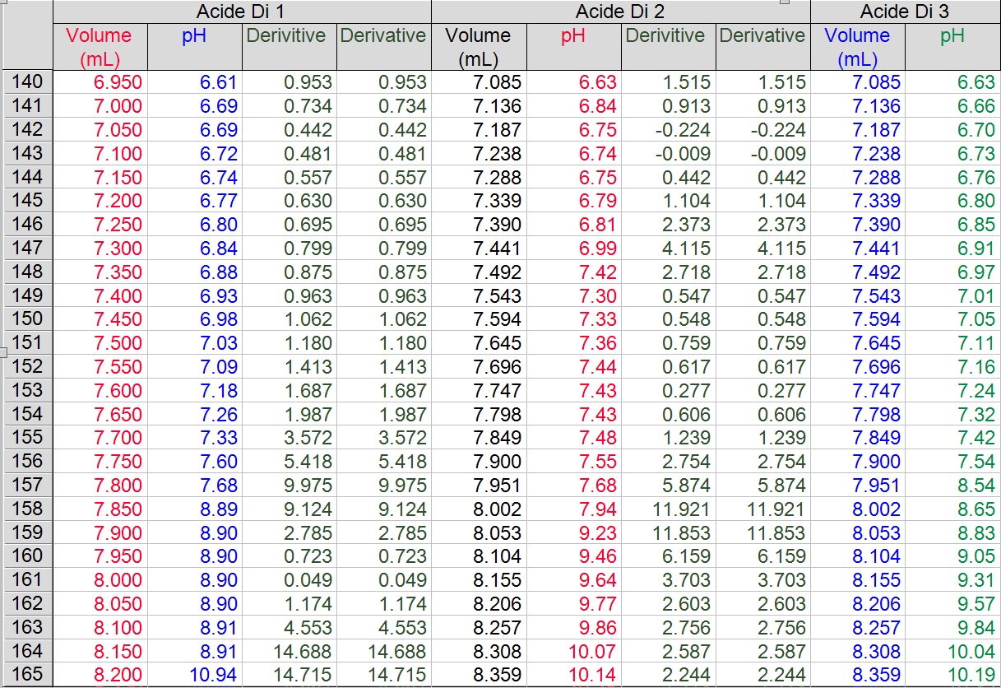

- Graphs
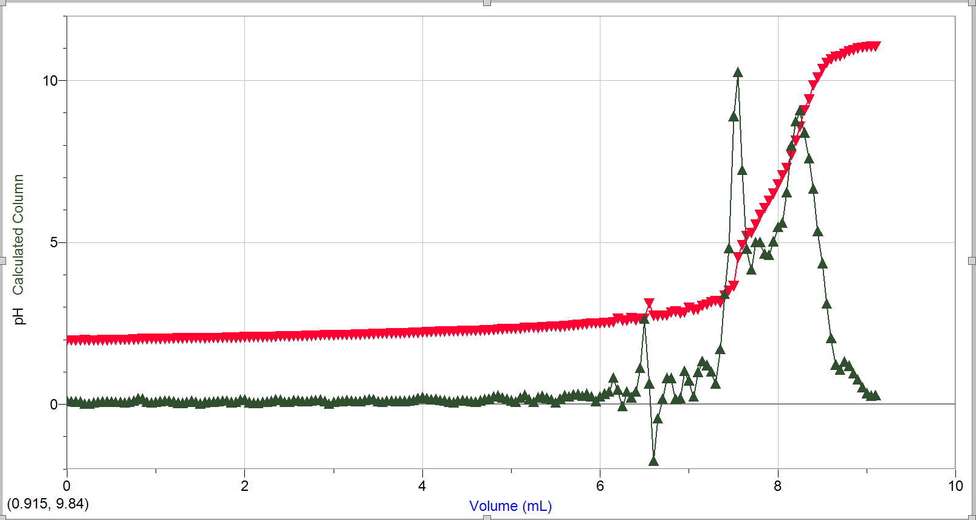
pH of HCl as volume (mL) of NaOH is added (Attempt #1)

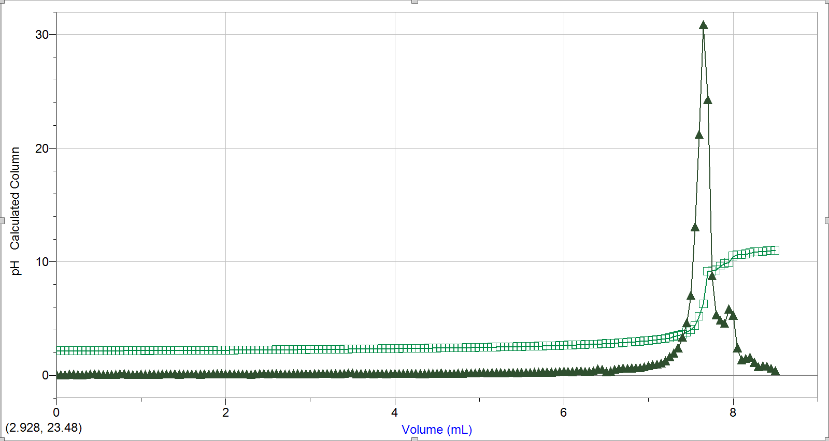
pH of HCl as volume (mL) of NaOH is added (Attempt #2)

pH of HCl as volume (mL) of NaOH is added (Attempt #3)
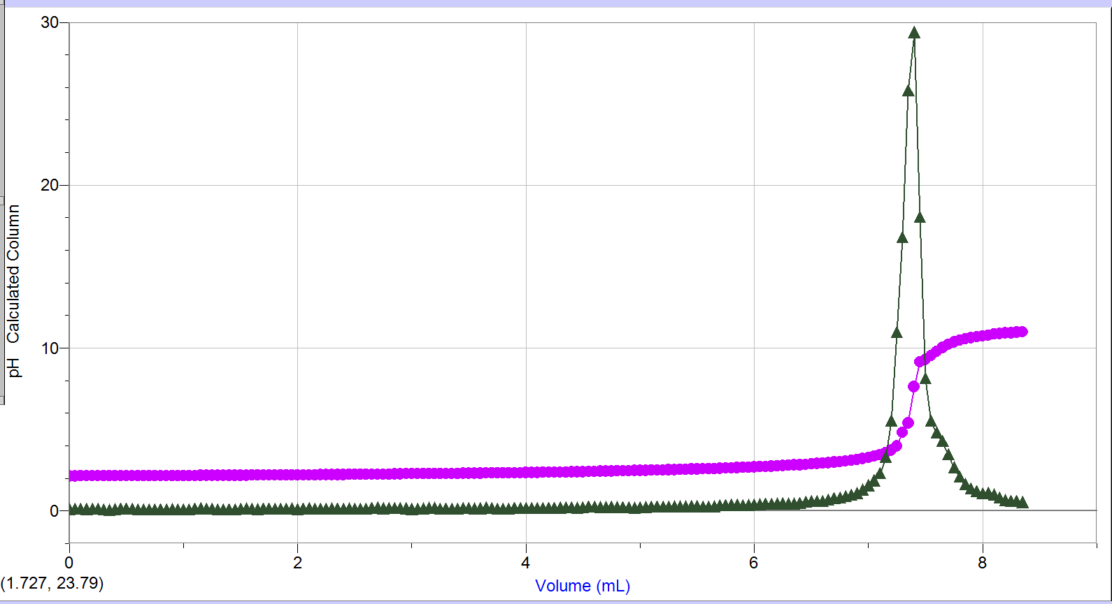

pH of diprotic acid as volume (mL) of NaOH is added (Attempt #1)
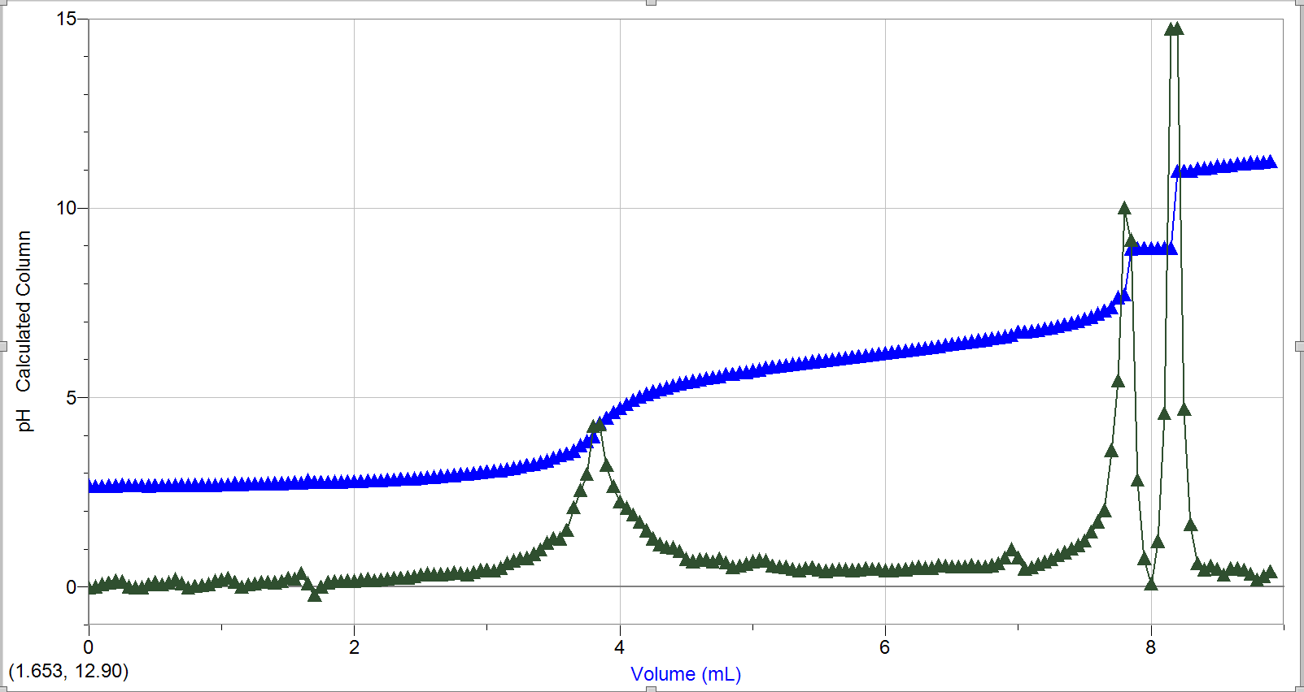

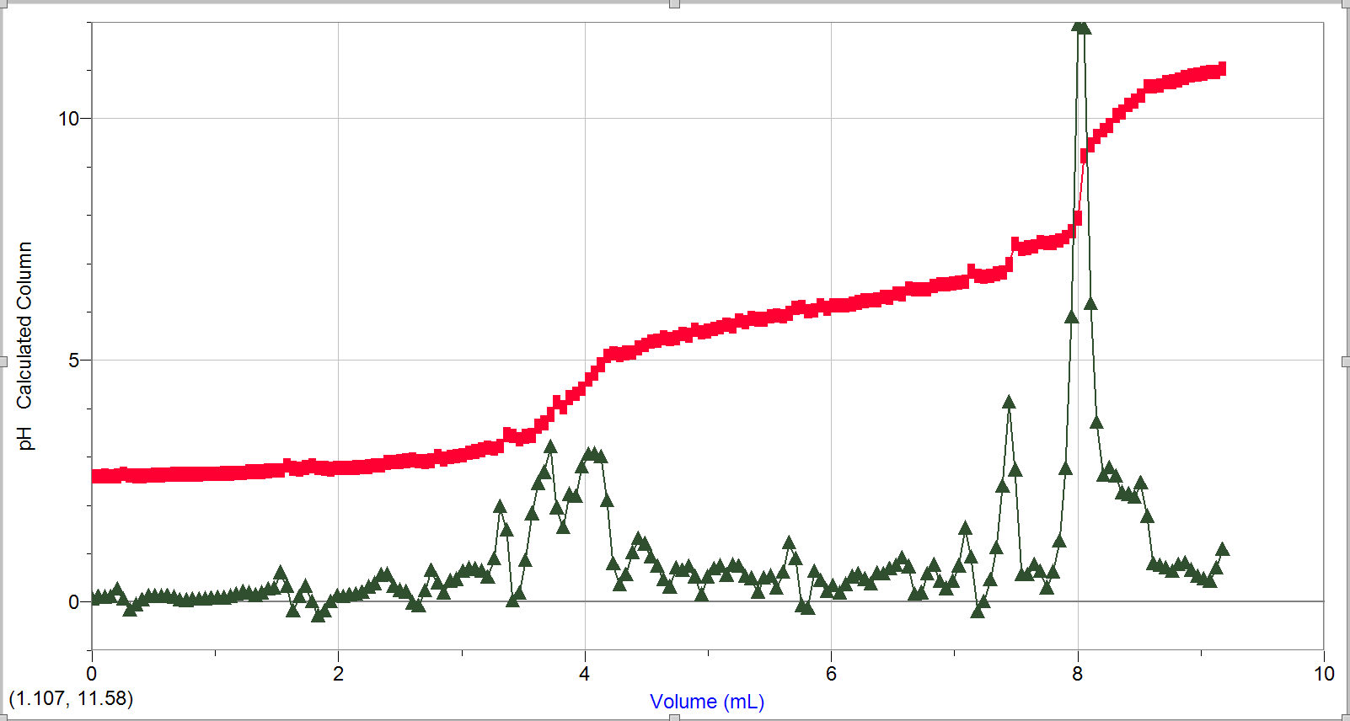
pH of diprotic acid as volume (mL) of NaOH is added (Attempt #2)

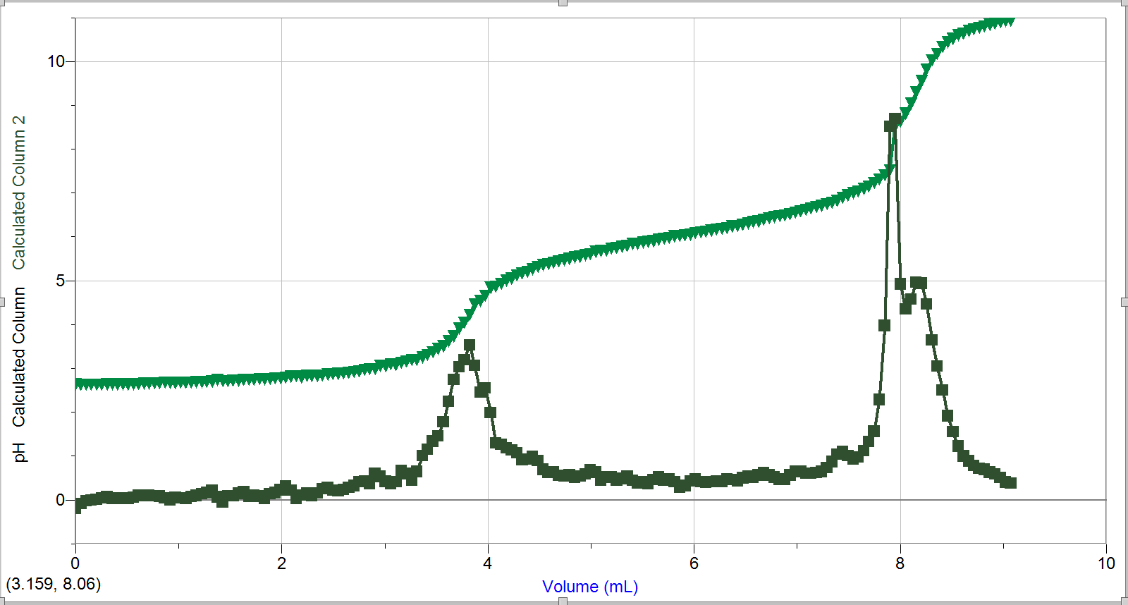
pH of diprotic acid as volume (mL) of NaOH is added (Attempt #3)

Observations:

Over the course of the experiment many observations have been made. To begin with, while diluting the NaOH in distilled water I noticed a few white specs swirl in the water as it was being mixed by the magnet. Although bizarre, this only happened when mixing at the highest level (10). Aside this, I also noticed that while calibrating the sensor, it needed to be uncomfortably close to the drops and the sensor kept slipping in certain positions. The whole set up was bothering me, but it was the best that could be done with the material given to me.
The experiment itself presented a multitude of observations for me. Firstly, although the HCl and the diprotic acid are both very different a lot of similarities stand out to me. Even though HCl is not a diprotic acid since it can only give away a single H⁺ ion, they both seemed to hit the endpoint at around the same point (at around 8 mL of NaOH). I also noticed that they both seem to plateau indefinitely no matter how much NaOH I add at a pH of around 11. Another observation that I made is that all the pHs of all attempts slowly rise with each drop until they suddenly jump (twice for the diprotic acid). Although, unlike the endpoint, the graph for the diprotic acid shows two humps rather than the 1 for HCl.

Calculations:

Approximate concentration of NaOH used:

Theoretical equivalence point for HCl: volume used is the volume associated with the highest point of the derivative:

Attempt #1:

Equivalence point:

Attempt #2:

Equivalence point:

Attempt #3:

Equivalence point:

Average concentration of NaOH:

Theoretical equivalence point for diprotic acid: volume used is the volume associated with the highest point of the derivative:

Attempt #1:

Attempt #2:

Attempt #3

Average concentration of unknown acid:

Discussion:

#1) Does it matter what volume of concentrated NaOH you use in the beginning?
Yes, the volume of concentrated NaOH I used in the beginning matters. The volume has a direct impact on the concentration of the eventual diluted base. This is caused by the fact that C₁V₁ = C₂V₂. This in turn would affect the titration of my acids, since I may need more or less of the base in order to reach the equivalent point (depending on weather I increased or decreased the volume).
#2) Why do we determine the concentration of the NaOH just before we use it?
By determining the concentration of the NaOH just before we use it, we can determine easily determine the concentration of the unknown acid 1. This can easily be done by comparing both concentrations with the equation C₁V₁ = C₂V₂. This can be seen done in my calculation section.
#3) How do the volumes at equivalence point determined by Logger Pro compare to the volumes at which you observed the colour change?
The volumes at equivalence point determined by LoggerPro were very similar to a lot of the volumes I observed colour change. For HCl, other than the first attempt that was off by about 0.5 mL, our observation matched exactly that of LoggerPro. As for the unknown acid 1, the same trend can be seen. The first attempt was off by 0.4 mL to that of which I observed, but as for the other two attempts they were exactly what I had observed in the lab myself.

#4) What are the sources of error inherent in the experiment? How does each source of error contribute to the result?

All throughout the experiment there have been many opportunities for errors. To begin, one of the major errors that could affect our results has to do with pouring different solution into beakers. Although I tried my best to maintain accuracy all throughout the experiment, there is a high chance that the amount of what is being poured such as acids can change from attempt to attempt. This can be an even bigger problem when it comes to the dilution of the NaOH solution, since it changes the concentration on a minimum level. This humane incertitude can change my numbers by a minimum amount but nothing drastic. On the other hand, I did mess up with the calibration of NaOH. Halfway through the experiment I accidentally messed up the rate at which my NaOH was dripping. Hence why I made another table indicating another drop count to volume. Although the change was not too big, it did change the consistency of my numbers while working with the unknown acid 1. Thankfully, this error did not change much other than the fact that I had to use arbitrary numbers. Aside from theses factors, the rest of the variables in this experiment was well controlled.

Conclusion

In conclusion, this experiment has helped me understand the connection between acids and bases on more thorough level. At the end, I found out that the concentration of the unknown acid 1 is 0.008246 M. Compared to HCl, this value is a lot smaller. Considering the severity of my errors, I would say that my results are valid.

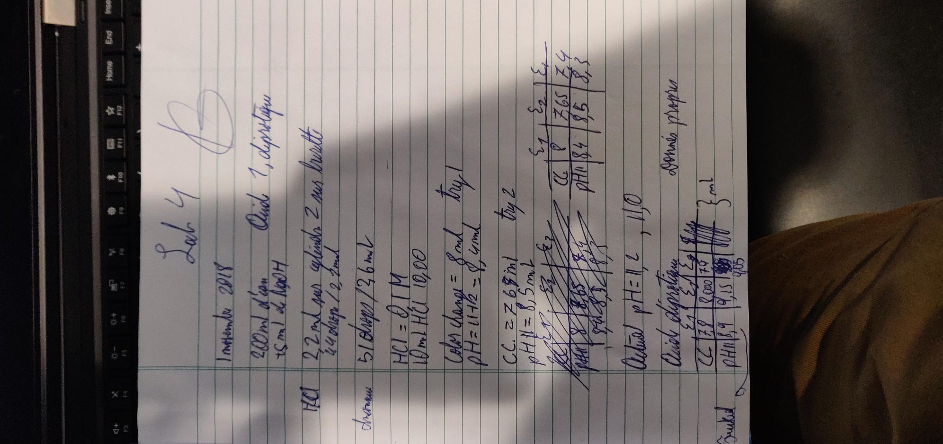
Work Cited

Chemistry LibreTexts. (2018). 4.5: Concentration of Solutions. [online] Available at: https://chem.libretexts.org/Textbook_Maps/General_Chemistry/Map:_Chemistry_-_The_Central_Science_(Brown_et_al.)/04._Reactions_in_Aqueous_Solution/4.5:_Concentration_of_Solutions [Accessed 6 Nov. 2018].

InfoPlease. (2018). Chemistry: What Are Acids and Bases?. [online] Available at: https://www.infoplease.com/science/chemistry/chemistry-what-are-acids-and-bases [Accessed 6 Nov. 2018].

Chemistry: What Are Acids and Bases?. (2018). InfoPlease. Retrieved 6 November 2018, from https://www.infoplease.com/science/chemistry/chemistry-what-are-acids-and-bases
4.5: Concentration of Solutions - Chemistry LibreTexts. (2018). Chem.libretexts.org. Retrieved 6 November 2018, from https://chem.libretexts.org/Textbook_Maps/General_Chemistry/Map%3A_Chemistry_-_The_Central_Science_(Brown_et_al.)/04._Reactions_in_Aqueous_Solution/4.5%3A_Concentration_of_Solutions

